UNITED STATES

SECURITIES AND EXCHANGE COMMISSION
Washington, D.C. 20549

FORM 8-K

CURRENT REPORT

Pursuant to Section 13 or Section 15(d) of the

Securities Exchange Act of 1934

Date of Report (Date of earliest event reported): March 9, 2011

VRINGO, INC.

(Exact name of registrant as specified in its charter)

Delaware | 1-34785 | 20-4988129
(State or other jurisdiction | (Commission | (IRS Employer
of incorporation) | File Number) | Identification No.)
 | 18 East 16th Street, 7th Floor
 | New York, New York | 10003
 | (Address of principal executive offices) | (Zip Code)
 | Registrant’s telephone number, including area code: (646) 525-4319

Check the appropriate box below if the Form 8-K filing is intended to simultaneously satisfy the filing obligation to the registrant under any of the following provisions:

- Written communications pursuant to Rule 425 under the Securities Act (17 CFR 230.425)

- Soliciting material pursuant to Rule 14a-12 under the Exchange Act (17 CFR 240.14a-12)

- Pre-commencement communications pursuant to Rule 14d-2(b) under the Exchange Act (17 CFR 240.14d-2(b))

- Pre-commencement communications pursuant to Rule 13e-4(c) under the Exchange Act (17 CFR 240.13e-4(c))

Item 7.01 Regulation FD Disclosure.

On March 9, 2011, senior management of Vringo, Inc. (the “Company”) delivered a presentation at the Wedbush Securities 2011 Technology, Media & Telecommunications Conference. A copy of the presentation materials used at the conference is furnished herewith as Exhibit 99.1.

The information contained in this Current Report on Form 8-K, including Exhibit 99.1, shall not be deemed “filed” for purposes of Section 18 of the Securities Exchange Act of 1934, as amended (the “Exchange Act”), and shall not be deemed to be incorporated by reference into any filings under the Securities Act of 1933, as amended, or the Exchange Act, except to the extent the Company specifically incorporates the information by reference.

Item 9.01. Financial Statements and Exhibits.

(d) Exhibits

99.1 Presentation Materials for the Wedbush Securities 2011 Technology, Media & Telecommunications Conference

SIGNATURE

Pursuant to the requirements of the Securities Exchange Act of 1934, the registrant has duly caused this report to be signed on its behalf by the undersigned hereunto duly authorized.

Dated: March 9, 2011 VRINGO, INC.

By: /s/ Andrew Perlman

Name: Andrew Perlman

Title: President

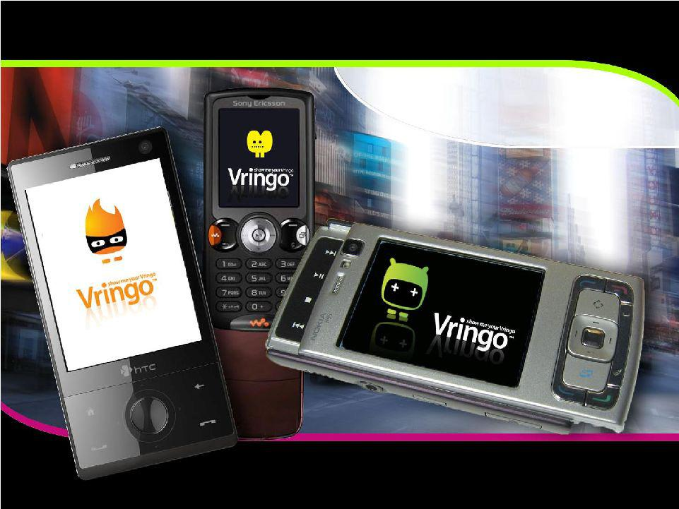
Exhibit 99.1
Investor Presentation

March 9, 2011

Wedbush Investment Conference

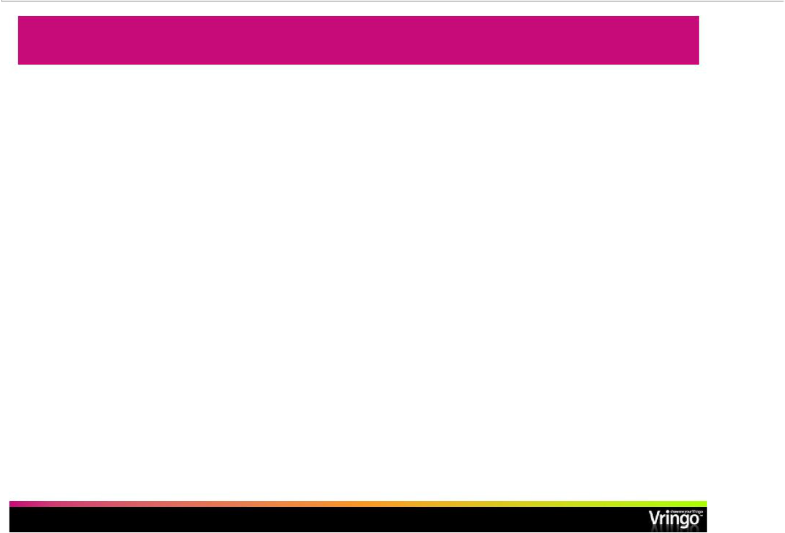
Safe Harbor Statement

This presentation contains certain statements that may be deemedto be “forward-looking statements”within the meaning of Section 27A of the Securities Act of 1933, as amended, and Section 21E of the Securities Exchange Act of 1934, as amended.

All statements, other than statements of historical facts, that address activities, events or developments that the Company expects, projects, believes or anticipates will or may occur in the future, including, without limitation, the outlook for general industry conditions, future operating results, capital expenditures, expansion and growth opportunities, financing activities and other such matters, are forward-looking statements.

Although the Company believes that its expectations stated in this presentation are based on reasonable assumptions, actual results may differ from those projected in the forward-looking statements. For a more detailed discussion of risk factors, please refer to the Company’s Registration Statement on Form S-1 and its periodic reports filed with the United States Securities and Exchange Commission (“SEC”).

Vringo expressly disclaims any obligations or undertaking to update or revise any forward-looking statements contained herein to reflect any change in Vringo’s expectations with respect thereto or any change in events, conditions or circumstances on which any statement is based.

- Page 2 -

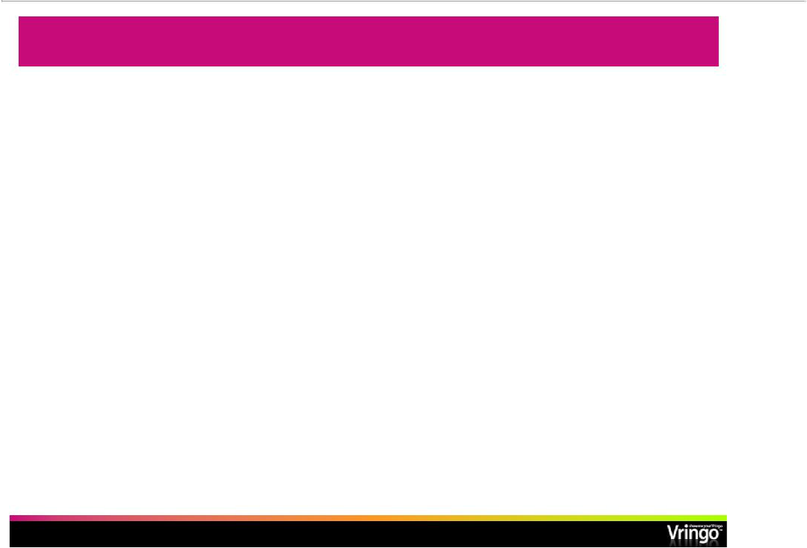
Vringo: The Name for Video Ringtones

- We provide a comprehensive platform of video ringtones for mobile phones

  - Software allows users to create, download and share mobile entertainment content

  - WAP and Web sites encompass robust content integration and distribution systems

  - 200+ Vringo-enabled handsets (Windows, BlackBerry, Android, Symbian, J2ME)

  - Library of over 5,000 video ringtones; over 40 content partners
  - 23 patents pending for software platform and mobile applications(one patent issued)

  - Launched in six territories with carrier and other partners

  - 240,000 monthly subscribers in these paid launches

- Founded in 2006

  - 30 Employees

  - Headquarters located in New York

  - R&D based out of Israel

- Strong early stage investors

  - Angel round of $2.4 M in 2006

  - Warburg Pincus invested $12 M in 2007

  - Bridge round of $3.0 M in Dec. 2009

- IPO June 2010 raised $11 M with Maxim, Ladenburg, and Chardan

    - Page 3 -

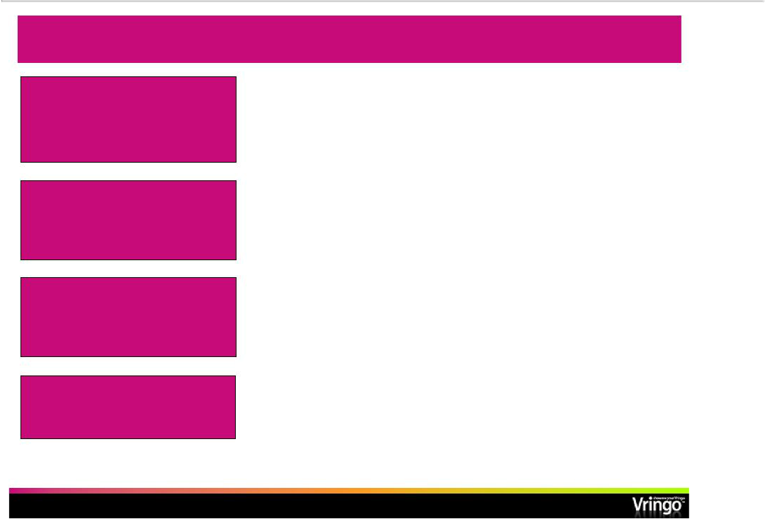
Investment Highlights

 | • | Proven technology and products
 | • | Scalable business model
 | • | Major contracts signed with international mobile carriers
Strong Platform for Growth |  | and content providers
 | • | Robust Video Ringtone platform ready to deploy as turnkey
 | • | (1)
Fast Growing Markets | • | 4.6 B global mobile subscribers
Fast Growing Markets | • | 534 M global mobile video subscribers by 2014
 | • | (2)(4)
 | • | $25 B mobile application market by 2014
 | • | (3)(5)
 | • | $29 B mobile content market by 2012
 |  | (2)
Established and Well | • | Strong management team and BOD with experience in the
Established and Well |  | U.S. financial markets
Seasoned Management | • | Track record of creating, running, investing and exiting
 |  | successful technology companies

 | Will grow organically and |  |  | • Have announced signing of LOI for m-Wise acquisition
 | through acquisition |  |  | • Real opportunity for consolidation in mobile service arena
(1) | United Nations estimate | (3) | Juniper Research
(2) | Multimedia Intelligence | (4) | Not a projection for Vringo subscribers
 |  | (5) | Not a projection for Vringo market size

- Page 4 -

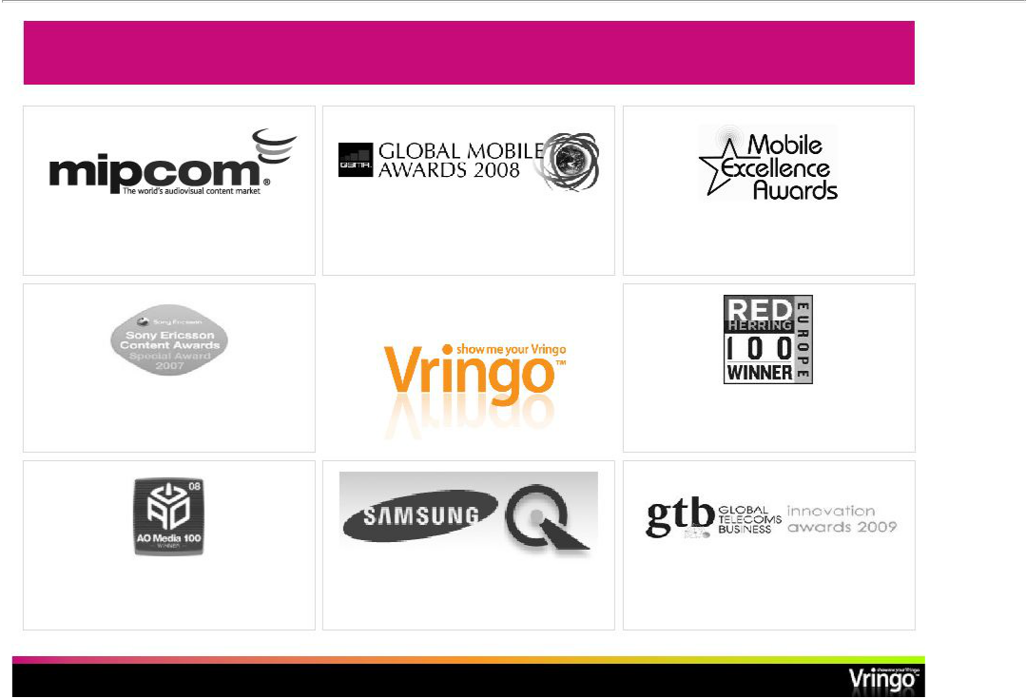
Consistently Winning Industry Awards

Best mobile service for social community and user generated content

- October 2007

Best use of phone functionality - December 2007

nd
Best mobile social networking service, 2 place

- January 2008

Best mobile community/fan content

- November 2008

Winner Red Herring 100

- April 2009

Always On Top 100 Media winner Finalist Best ringtone innovation

- January 2008 - March 2008 - June 2008

- Page 5 -

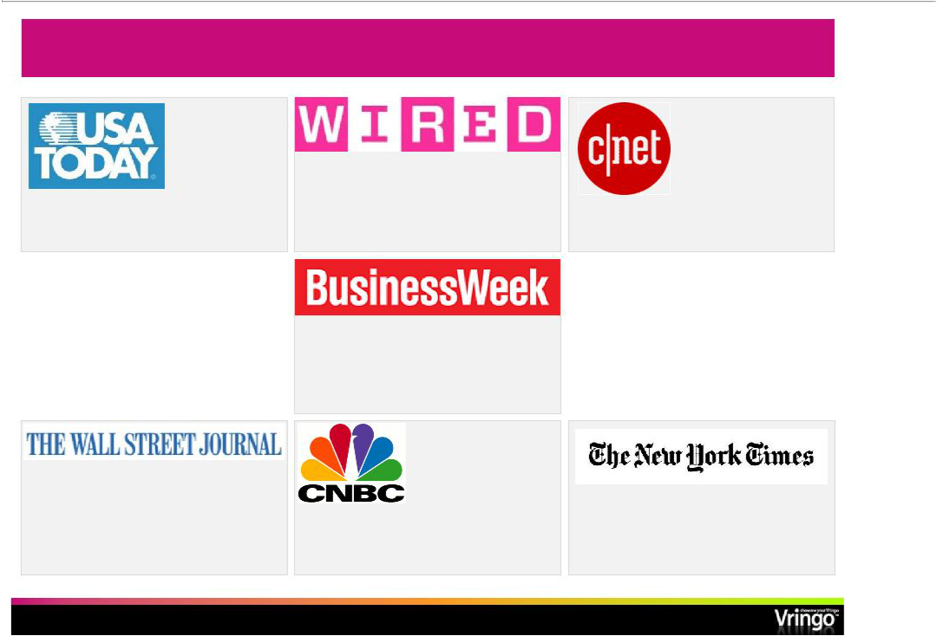
Major Outlet Media Coverage

“offers an eyeful…has to be seen to be “Vringo has something that others lack…the “the next level ringtone…this company’s fun

believed” caller has the power” and unusual product is just getting better

and better”

“every call thus becomes an opportunity to

share content and to establish

identity…Vringo has a head start over

competitors”

“the service aims to tap consumer’s obsession with creating their own content”

“the next big thing in ringtones…soon | “Next big thing in the ringtone wave”
everyone could have a Vringo, a | “Next big thing in the ringtone wave”
personalized video ringtone”

- Page 6 -

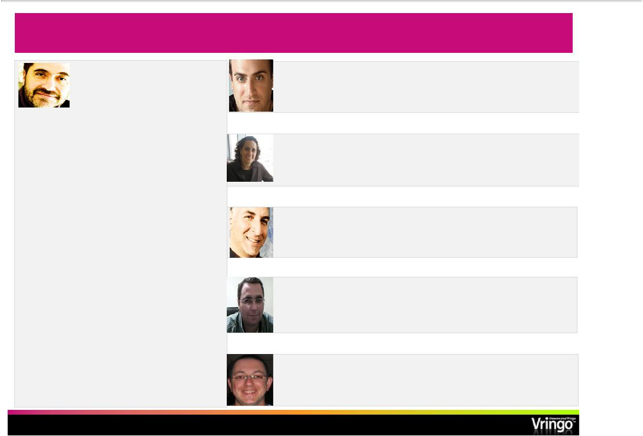
Seasoned Management & Governance

Jon Medved

Founder & CEO, Board

member

“One of Israel’s leading venture capitalists”

(Washington Post)

Founder of Israel Seed Partners, managing $260 M in 4 funds-exits include:

- Shopping.com (acquired by eBay Inc.) for $640 M
- Answers Corp. (NasdaqCM: ANSW)

- Native Networks (acquired by Alcatel (NYSE: ALA))
- Compugen (Nasdaq: CGEN)

- Xacct Technologies (acquired by Amdocs Ltd. (NYSE: DOX))
- Business Layers (acquired by CA, Inc. (NasdaqGS: CA))

- Cyota (acquired by RSA/CA NasdaqGS: CA)

Manager of several startups with exits including:

- MERET (acquired by Amoco/BP)

- Accent (Nasdaq: ACNTF)

Andrew Perlman

President and Board member

Ellen Cohl

VP Finance & Governance

Dov Frohlich

COO

Josh Wolff

VP Services & Solutions

Eshed Doni

VP Products

Formerly

EMI Music

Formerly

Arthur Andersen

Formerly

NMS Communications

Formerly

NMS Communications

Formerly

eyeSight Mobile

- Page 7 -

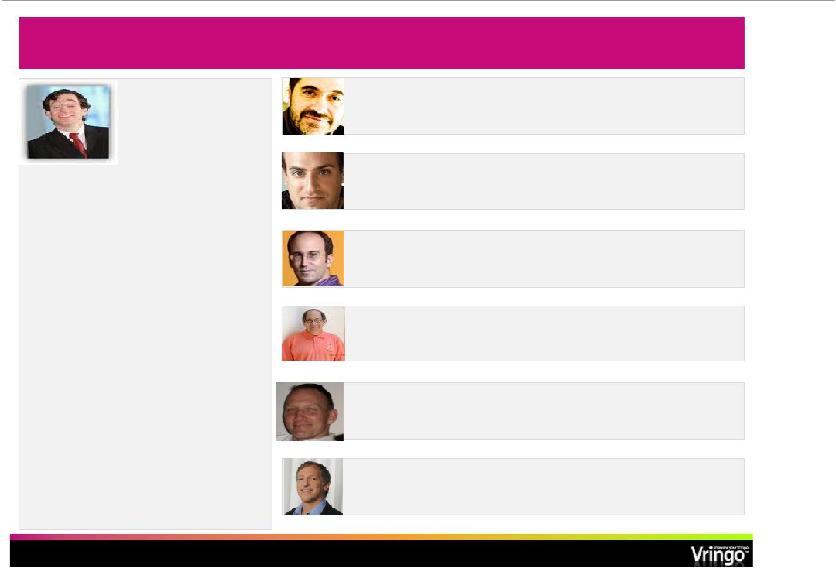
Vringo Board of Directors

Seth (“Yossi”) Siegel

Chairman of the Board

Was Founder, Chairman and CEO of the Beanstalk Group, the world’s largest independent licensing agency, now part of the Omnicom Group. Served leading Brands such as:

- AT&T

- IBM

- Harley Davidson

- Unilever

- Ford Motor Company

Several time LIMA and Clio award winner

Marketing and brand commentary appears in the NY Times, BrandWeek, Wall Street Journal, etc.

Jon Medved

CEO and Board member

Andrew Perlman

President and Board member

Edo Segal

Board Member

Ralph Simon

Board Member

John Engleman

Board Member

Phil Serlin

Board Member

Chairman, Audit Committee

- Page 8 -

Formerly

Founder and GP Israel Seed

Formerly

SVP, EMI Music

Founder and CEO Relegance, sold to AOL

Chairman Emeritus Founder MEFAmericas-

Classic Media

Co-CEO

CFO BiolineRX Formerly Coopers, SEC

Vringo in Middle of Rapidly Growing Markets and Trends

- Mobile video has arrived
• Mobile video data usage is expected to grow at a 131% CAGR from 201409⁽¹⁾-
    - 534 M global mobile video subscribers by 2014⁽²⁾

      - Five-fold increase since 2008

      - $16 B in revenues projected in the ⁽²⁾US
  - Mobile social networking is growing exponentially

    - Facebook and Twitter at the forefront of the phenomenon

    - Growing mobile social networking and user-generated content revenue

    - $1.8 B in 2008 to $11.8 B in 2013⁽³⁾

    - Approximately 1 out of every 8 people world-wide has used a digital social network⁽⁴⁾

  - User generated content continues to grow
    - YouTube revolution

    - Advances in technology that facilitate the creation of user-generated content

  - Rise of smart phones

    - Global Smartphone shipments experienced 72% growth YOY from 2009⁽⁵⁾-2010

    - Increased bandwidth enables rich media transfer across many devices

    - Apps everywhere…with Android unit growth of 888% from 2009 to ⁽⁵⁾2010
    - Global 3G penetration expected to exceed 20% by the end of⁽⁴⁾2010

- Cisco Visual Networking Index: Global Mobile Data Traffic Forecast Update, 2009-2014, 2/10
- Pyramid Research
- Juniper Research
- Morgan Stanley’s Internet Trends, 04/10; comScore Global, 12/09
- Gartner

        - Page 9 -

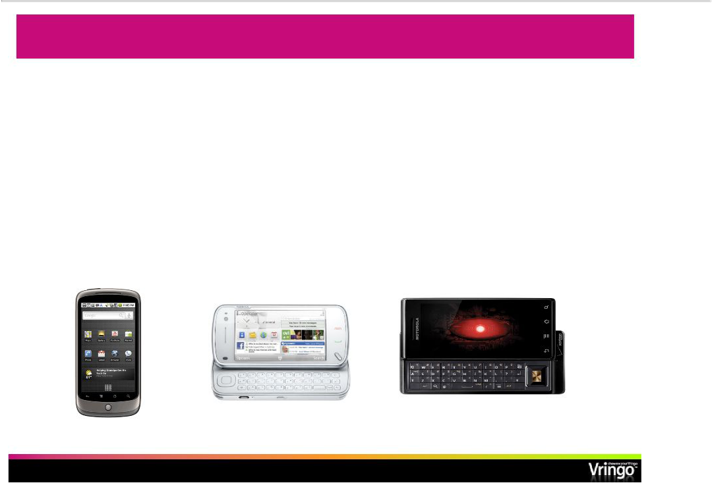
Ring Tone Market-Ready for Vringo’s Innovation

- Ringtone business was created in 1997

  - Further developed in 2002 with the creation of truetone and mastertone

- Ringback tone was created in 2004

  - $4.7 B ringback tone market by 2012⁽¹⁾

    - 3x growth from 2008

- More than one-third of mobile users download ringtones from various⁽¹⁾ sources
  - 40% of such users frequently change their ringtones

- Ringtone business has seen little innovation since 2004

  - Traditional suppliers of ringtones are hurting

  - Market ready for next evolution of products and services

- Ipsos MediaCT

- Page 10 -

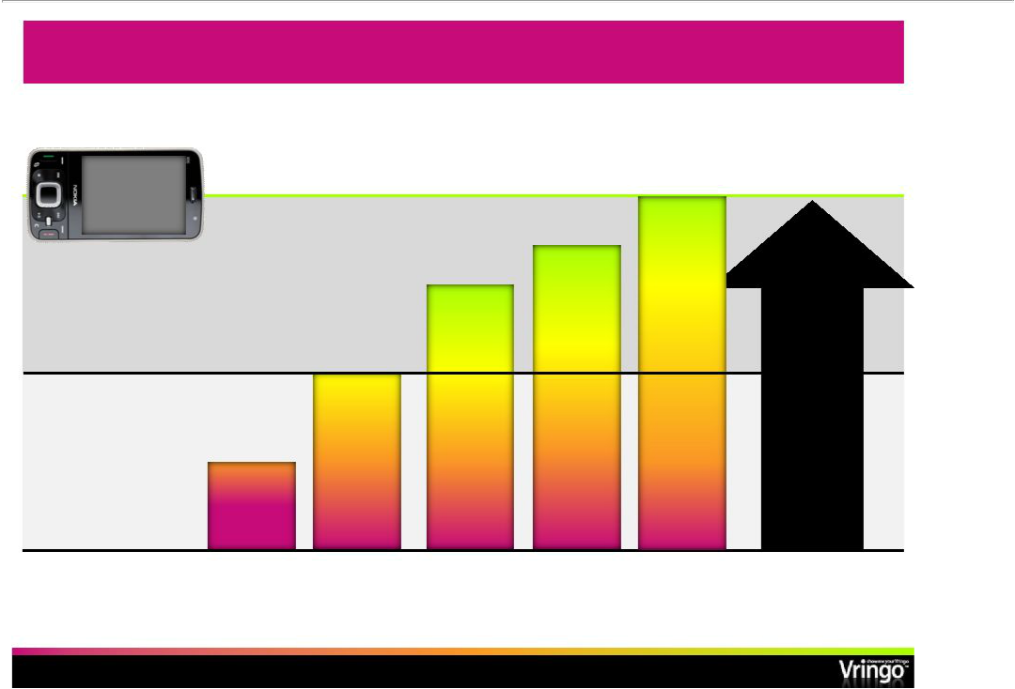
Future of Mobile Personalization

Phone

capabilities

Vringo’s market

Audio ringtone market today

audio

ring

tone

 |  | social | Better user
 |  | personal- | Better user
 | video | personal- | experience
 | video | ization | experience
video | ringback/ | tools | New revenue
video | ring |  | New revenue
ringtone | ring |  | opportunities
ringtone | forward |  | opportunities

audio

ring back

tone

- Page 11 -

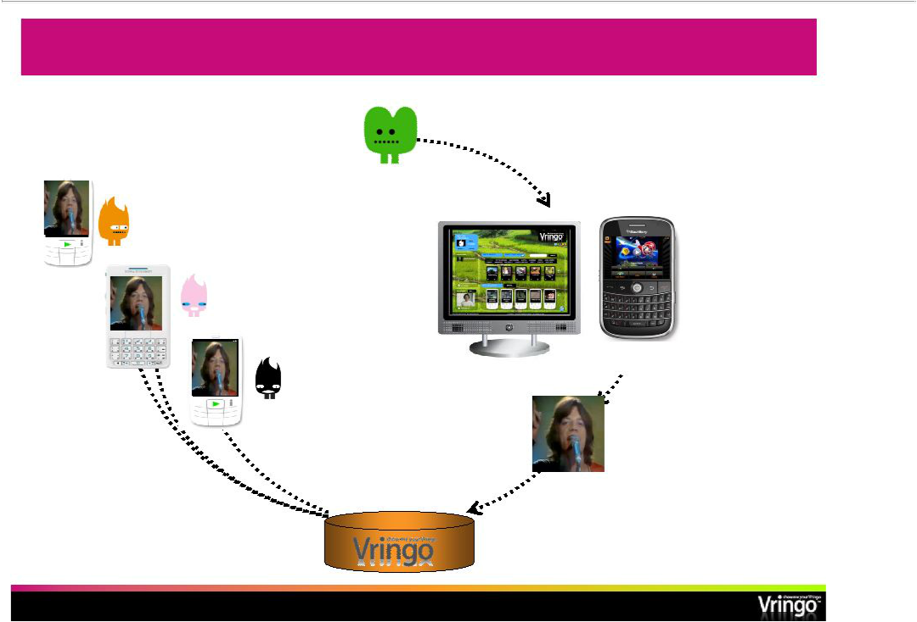
Getting a New Vringo Onto a Phone

Justin

5. New Vringo is cached on

handsets, ready to be played _{HTTP} whenever Justin calls

- Justin logs onto Vringo.com on his PC/mobile or browses through his Vringo application for a new clip

Vringo clients

Vringo.com

Vringo Mobile App

- Justin’s new Vringo is automatically sent to all of Justin’s buddies

2. Justin picks out a

Rolling Stones clip and

makes it his phone’s
^{TCP/IP} ringtone

HTTP

Vringo server

- Vringo server is updated immediately

- Page 12 -

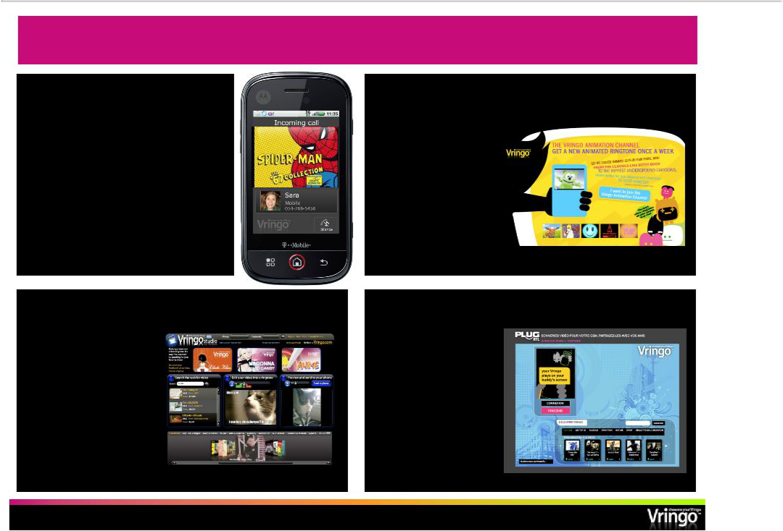
Four Product Platform Components

Mobile application Channelsautomatic- content delivery

• Customer store front • Video ringtones have a

• Viral marketing engine shorter shelf life

• 300+ handsets • Customers can

• Java, Blackberry, Windows Mobile, subscribe to automatic

Android, Symbian content refreshes

• Opportunity exists to sell premium

content bundles based on the core

application

Studio online- ringtone editor

- World’s first Web-based video ringtone editor
- Can be customized for partners (e.g., Marvel)

Custom store fronts

- Customizable web/mobile store front

- TV networks, retailers, political campaigns, live events
- Opportunity exists to set up advertising-
supported storefronts – _{Indicative}
“free” to consumers example

- Page 13 -

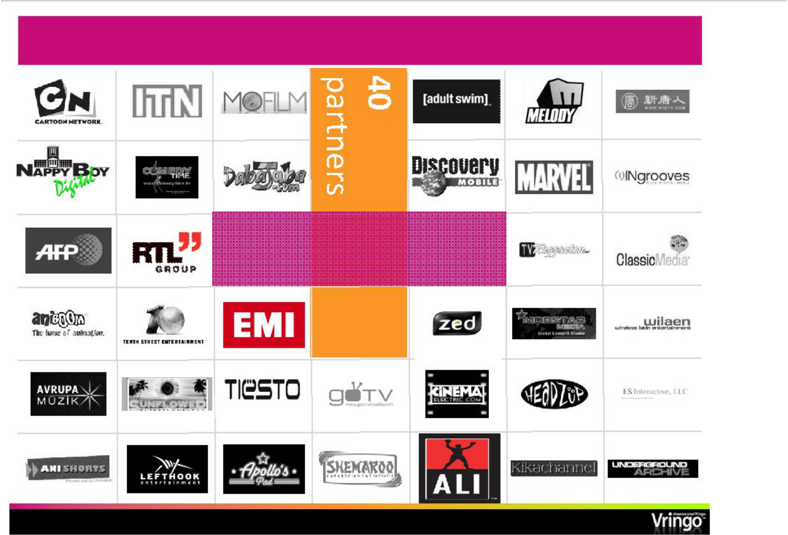
World’s Largest Video Ringtone Library

5,000+ video clips

- Page 14 -

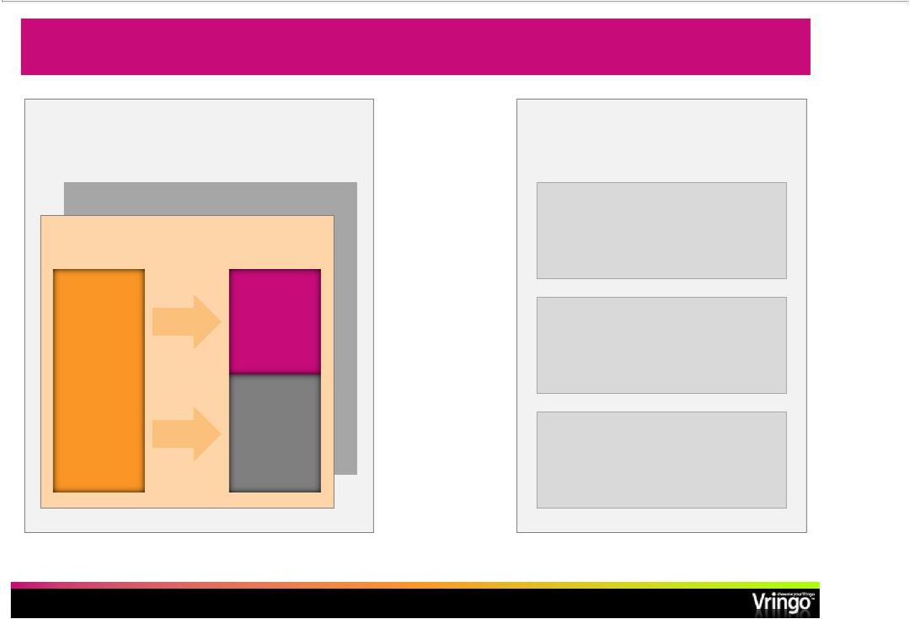
Simple, Scalable Business Model

Target: $12 $-30 per user per year for

Net Vringo ARPU

Premium: $1-3 per clip

Monthly user subscription

User | Vringo | X
 | $0.3*-$3.5 | X
$1.0 -$5.0 |  | X
No data | Operator
traffic | Operator
charges | $0.6 -$2.5

Operator penetration

Target

4-6%

Modeling assumptions

1-2%**

Current audio RBT ~15%

- Effective revenue of $0.15 per subscribernet- of uncollected subscription fees

- Page 15 -

- Average Penetration of addressable market within 1 year of new market launch

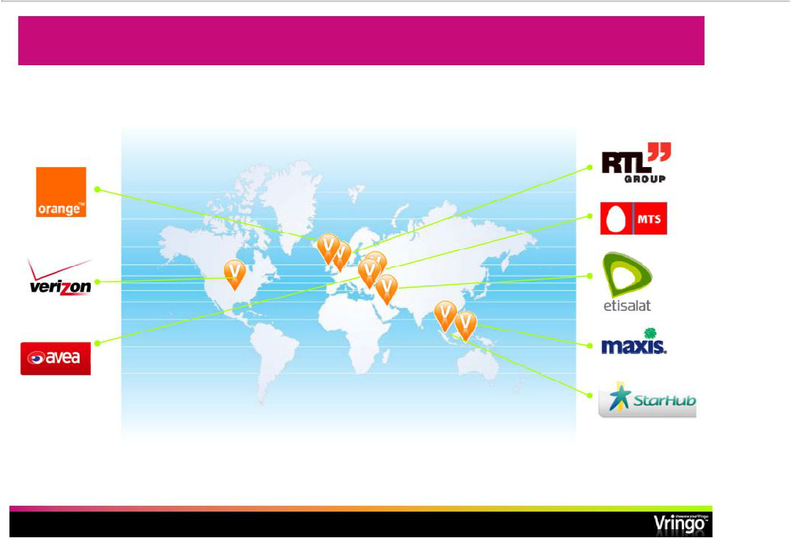
Signed Revenue Deals: Initial Basis for Growth

Markets in which we have launched or will launch our service through carriershaveseveralhundredmillionmobilesubscribers⁽¹⁾

 | Currently in discussions with several other carriers pursuing
(1) Source: United Nations | additional agreements over the next2412months-
 | - Page 16 -

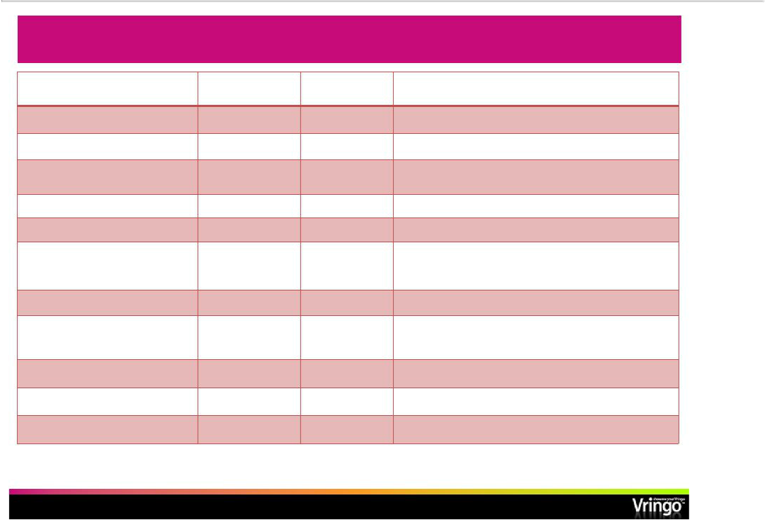
6 Carrier Launches So Far…others pending

Name of Operator/Partner | Launch Date | Operator | Growth Potential
 |  | Subscribers (M)
MTSGroup/Vivacell(Armenia) | July 2009 | 2 | Part of MTS Group which has 100 M subs
Maxis(Malaysia) | October 2009 | 11.4 | Largest operator in Malaysia
Avea(Turkey) | November 2009 | 12.1 | Third largest operator in Turkey; subsequently replaced by
 |  |  | agreement with Retromedya
Etisalat(UAE) | March 2010 | 7.3 | Group includes 16 countries, 94 M global subs
RTL(Belgium) | May 2010 | 11 | Service runs on all 3 major carriers
VodaphoneShop(Germany, | October 2010 |  | Initial free app launch in 8 countries in Europe, with a paid
Greece, Ireland, Italy, Netherlands, |  |  | service expected to launch soon
Portugal, Spain, UK)
OviStore(UK) | November 2010 |  | Advanced Nokia phones in UK
Orange(UK)[Everything | February 2011 | > 30* | Orange is subsidiary of UK’s biggest communications
Everywhere Ltd.] |  |  | company jointly-owned by Deutsche and France Telecom
Verizon(US) | Pending | > 92 | Initial launch for Blackberry & Android phones
StarHub(Singapore) | Pending | > 2 | Initial launch for Android phones
Hungama | Pending | >400 | Launching with 15 operators

- 30m includes combined subscribers for Orange (UK) and T-Mobile (UK) parent Everything Everywhere; initial launchOrangeiswith (UK) subscribers

  - Page 17 -

Marketing the Service: Sample Collateral

- Page 18 -

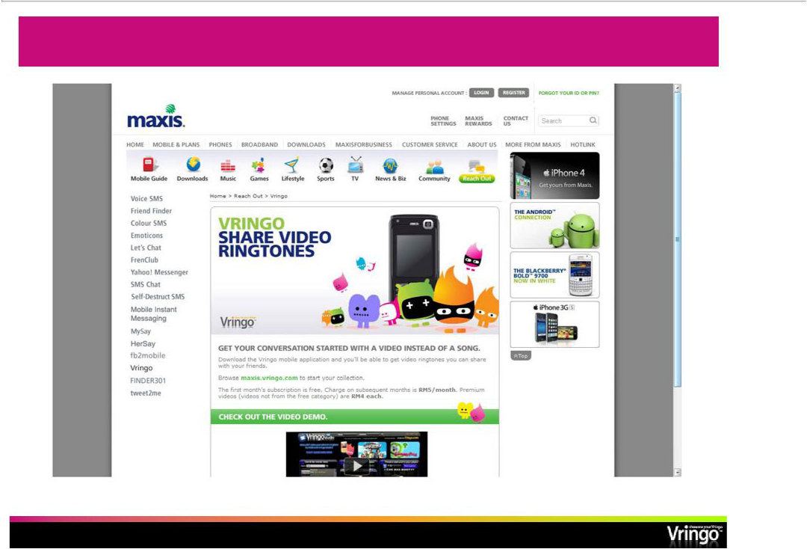
Integrated Slots in Carrier Portal

- Page 19 -

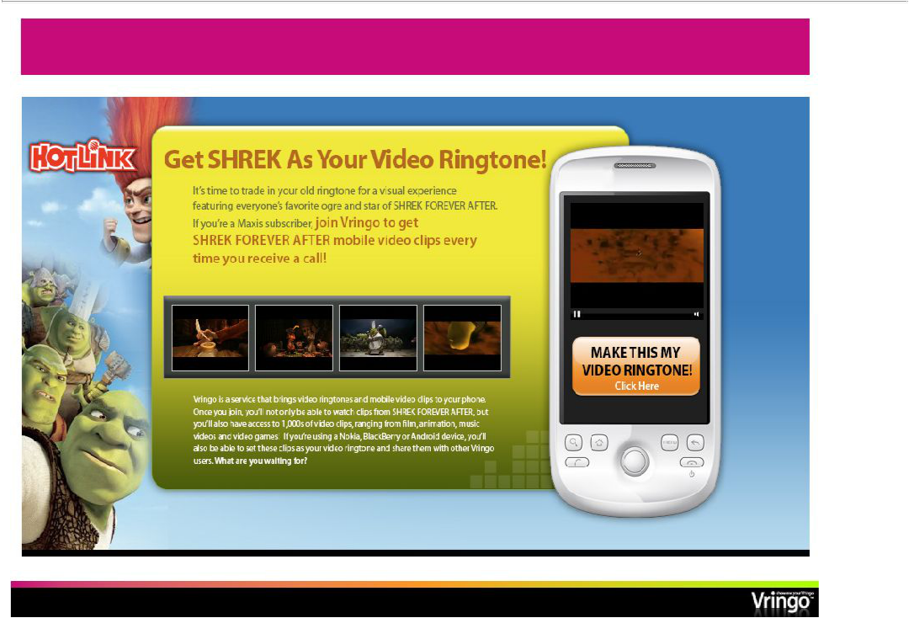
Hot New Releases in User-Friendly Formats

- Page 20 -

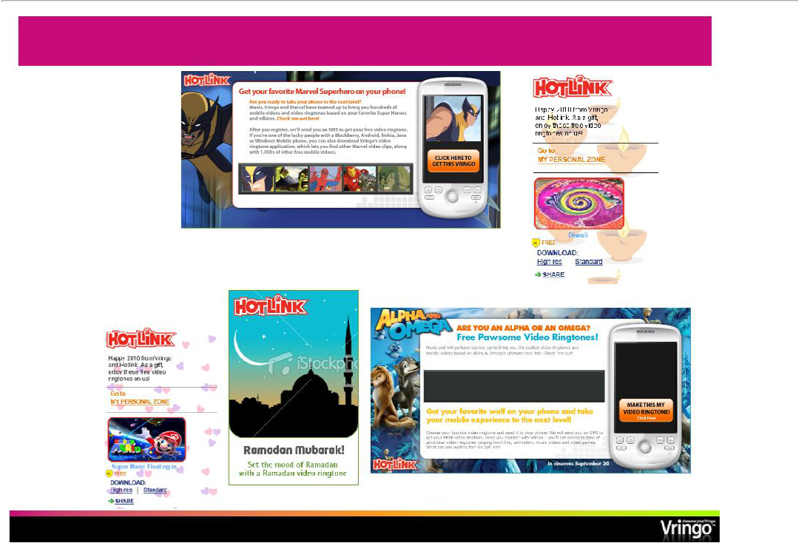
Timely User Acquisition Tools

Vringo’s Creative Team renews the storefront, refeshes the content, and continually pushes timely attractions

- Page 21 -

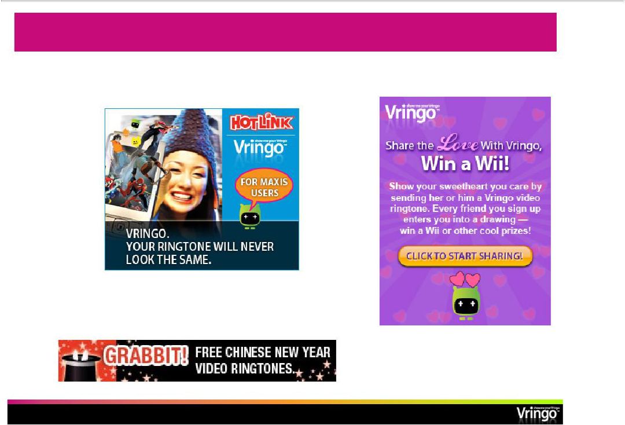
Marketing Tools –“Made for Maxis”

• Refreshed New-Look Monthly Banner Ads

•Holiday Contest Promotions and Banners Tailored for WAP Portal and Carrier Microsite

- Page 22 -

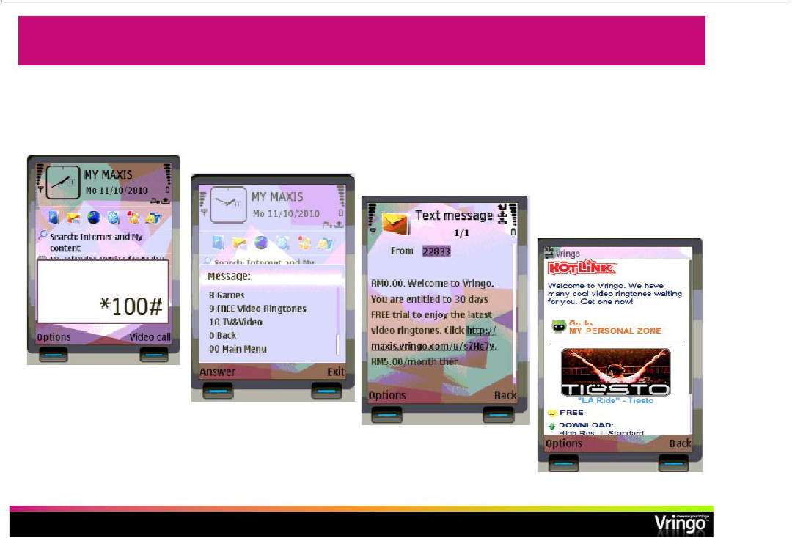
Increasing The Scale: Subscribing to Vringo via USSD Menu*

Dial *100# to open USSD menu

Select 9 for

FREE video ringtones Subscription Info and terms of Service

Logged in

- Abbreviated Format for Presentation Purposes

  - Page 23 -

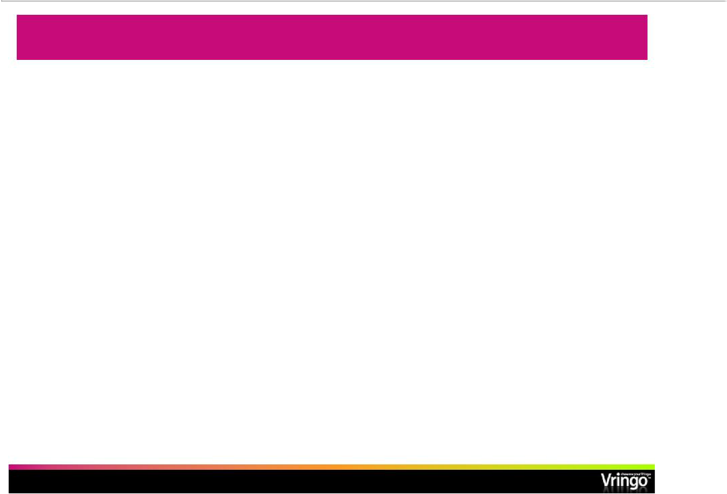
Three Drivers of Growth

- Growing our business in the countries where we have launched

  - Continue to grow organically in each, driving subscription revenue

  - Adding new customer acquisition techniques, such as:

    - Brand sponsorships, USSD, advertising

  - Add additional carriers in the territory

- Rolling out new countries and partners

  - Continuous development of a rich pipeline

  - Add 2-3 territories/partners per quarter

  - Migration to wealthier markets

- Bring new monetization models into play

  - Advertising-based Vringo may become important

  - App stores and content bundles

  - Brand supported apps

  - Leverage carrier relationships for new services

      - Page 24 -

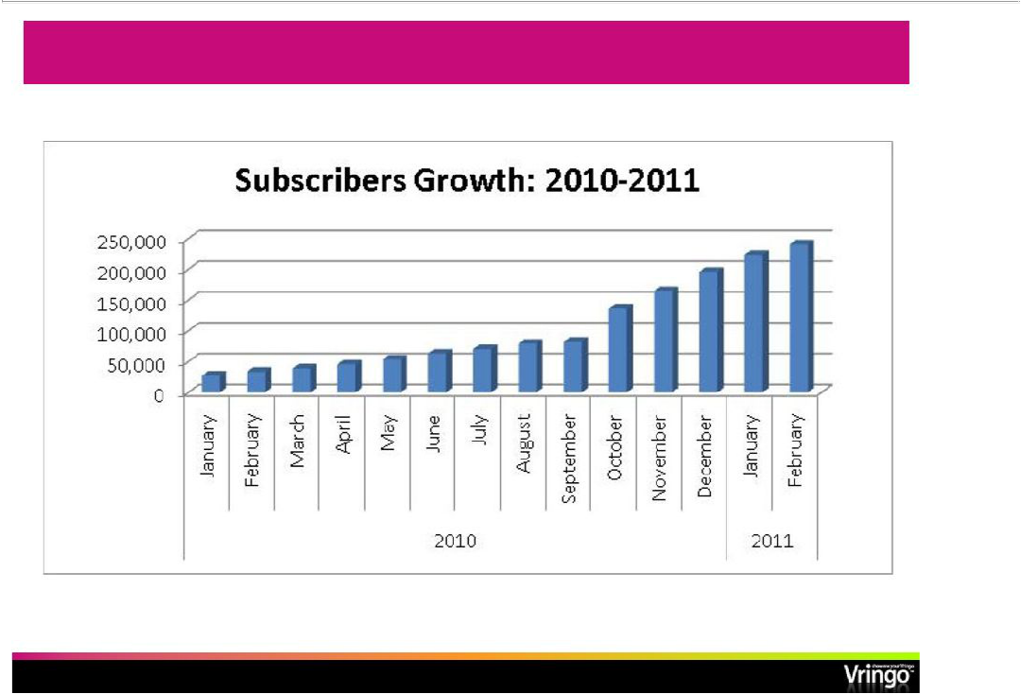
Vringo Cumulative Subscriber Growth Across All Carriers

- Page 25 -

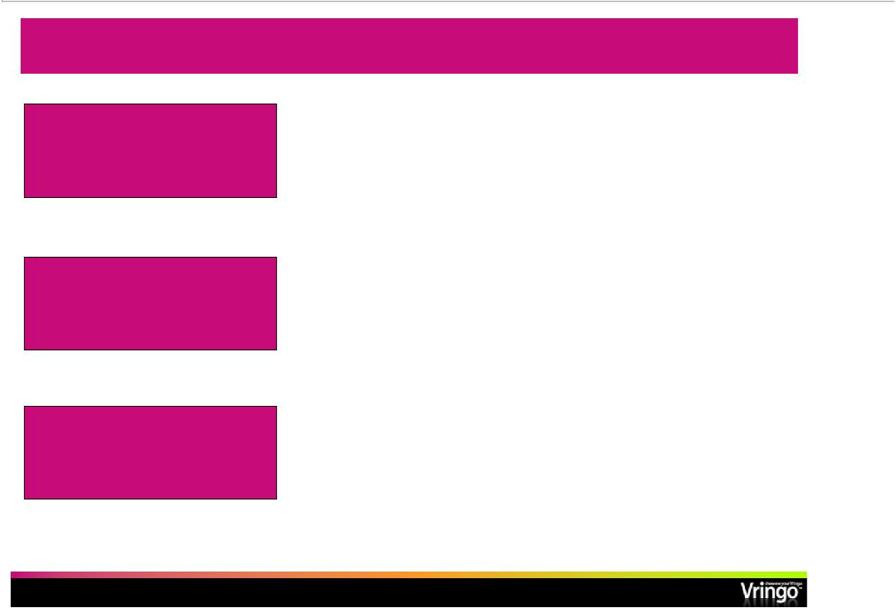
Driving Subscriber Growth and Revenue

Initial Launches

demonstrate viable subscription model

Moving to higher subscription rates

- 240,000 subscribers in paid subscription services world-wide

- Added 100,000 subscribers over last four months, 70% growth

- Average net monetization $0.13 per subscriber per month
- 6 paid launches so farmany— more to come

- Intend gradual shift in subscriber pricing to 4$.99.92 - monthly fee, depending on currency and territory

- Will start seeing revenue from more lucrative markets of North America and Western Europe

- Shift to these markets which are mostly post-paid, as opposed to pre-paid, will have positive effect on billing efficiency

 | •
Leverage relationships for
additional services | •
additional services | •

Will launch new Vringo services with carrier partners
New services will also be on subscription basis

New services developed in-house or acquired

- Page 26 -

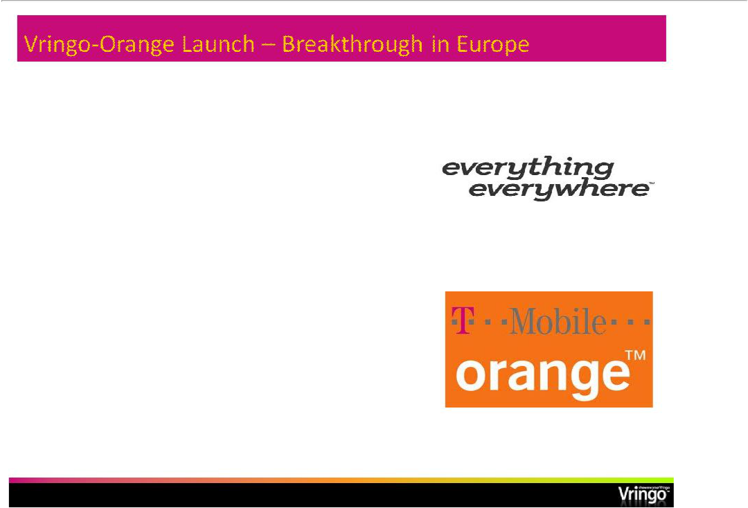
Deal with Everything Everywhere Ltd.; UK’s largest mobile company to launch Vringo together in the UK market

Everything Everywhere operates both Orange (UK) and T-Mobile (UK) with combined total of over 30 M subscribers, and is owned by France Telecom and Deutsche Telekom

Have first launched with Orange

(UK)

- Page 27 -

Importance of Orange Launch

- First major launch in the strategic European market

- UK is a vibrant and active mobile content and application market

- Vringo has until now focused on proving its business model in smaller, less developed markets

- Terms: Orange branded service, revenue split, zero rating for data, promotion of service on Orange properties

- Page 28 -

Orange UK Launch: Mobile Ecosystem Partners in Place to Maximize Performance
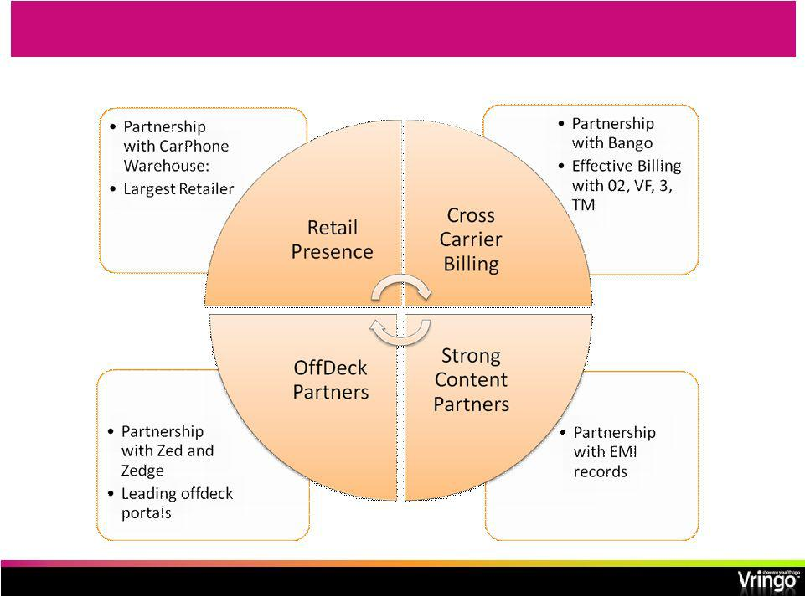

- Page 29 -

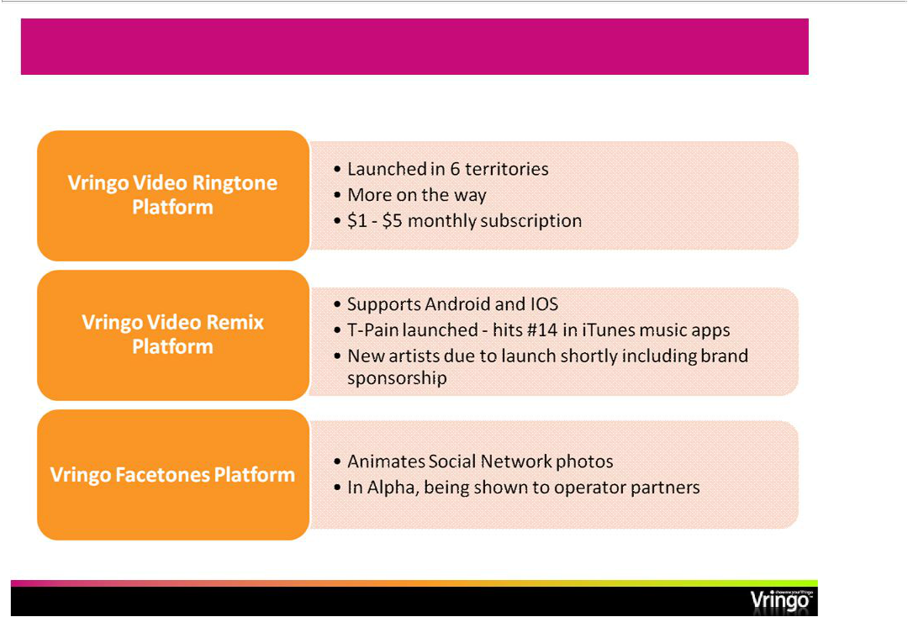
Vringo Platform Expansion

- Page 30 -

Vringo LOI for Asset Purchase of m-Wise (OTC.BB: MWIS)

- Vringo has announced the signing of a non-binding Letter of Intent (“LOI”) that sets forth terms for asset purchase of m-Wise, Inc.

- Transaction is contingent on definitive agreement, approval of respective Boards and shareholders, and regulatory approval.

- m-Wise provides a mobile content management, delivery and monetization platform used by major suppliers of mobile content and services

- m-Wise platform is used for over 3 M daily mobile service transactions and has supported over 1 B such transactions cumulatively

- Nine months 2010 reported m-Wise revenue was $2.1 M

- Vringo will provide m-Wise with 1,900,000 shares, a management retention option of 500 K shares, cover $615 K expenses over two years and assume certain other liabilities of m-Wise , and provide a $325 K promissory note convertible into 200 K shares

  - Page 31 -

Strategic and Market Rationale

- Mobile apps and services, in particular video and imaging, are fragmented and in need of consolidation

- Carriers, content owners and brands are seeking an end-to-end array of mobile turnkey services and want to buy these services from trusted suppliers due to lack of internal development resources

- Solutions are sought that include Server-side components, transport, client apps and wap properties

- Customers are focused on delivery of rich media services including video, imaging (pictures), music, social apps, etc.

- Traditional suppliers of these services have not moved effectively to the “cloud”or embraced the app revolution

- A company with strong server, transport, and application footprint will be a desirable partner for major customers

- Servicesandcarriergroupsarelargelyglobal—onecanleverageinitial successes elsewhere

- We have already seen validation of this in initial discussions with customers

  - Page 32 -

m-Wise: why?

- Powerful platform that will allow us to offer cloud based end-to-end mobile services and solutions to our customers
- Utilizing Vringo’s public currency will allow us to grow faster through acquisitions like m-Wise

- Few pure play mobile companies with pedigree public listings

- Strong Synergies:

  - Product Synergy: m-Wise back-end together with Vringo app expertise
  - Customer Synergy: m-Wise has a good group of leading companies as customers

  - Geographic Synergy: Focus on complimentary territories

  - Revenue and Margin contribution: m-Wise will immediately impact our revenue and help us move towards profitability
  - m-Wise platform is used to host app stores which is a frequent carrier request

    - Page 33 -

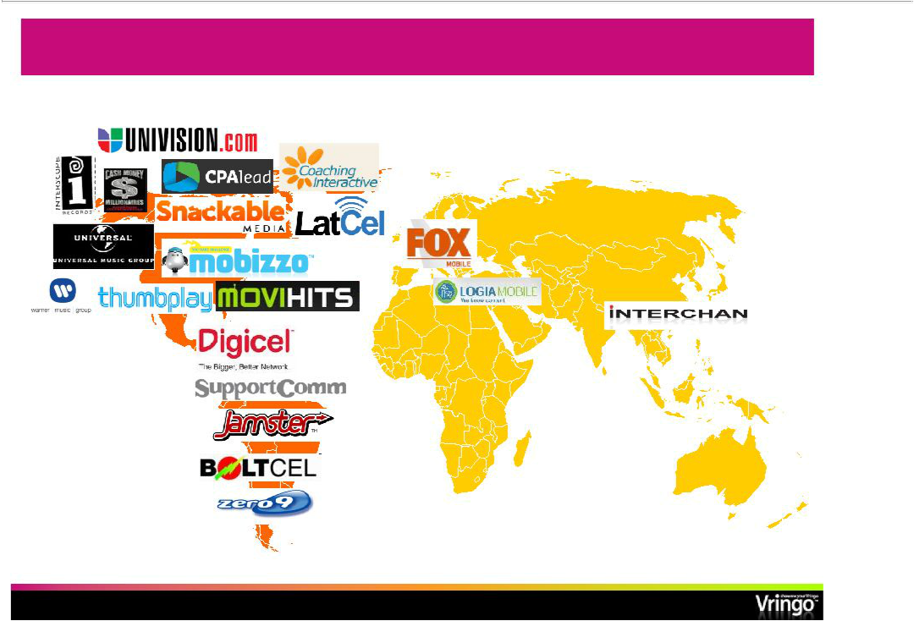
m-Wise Client Base

- Page 34 -

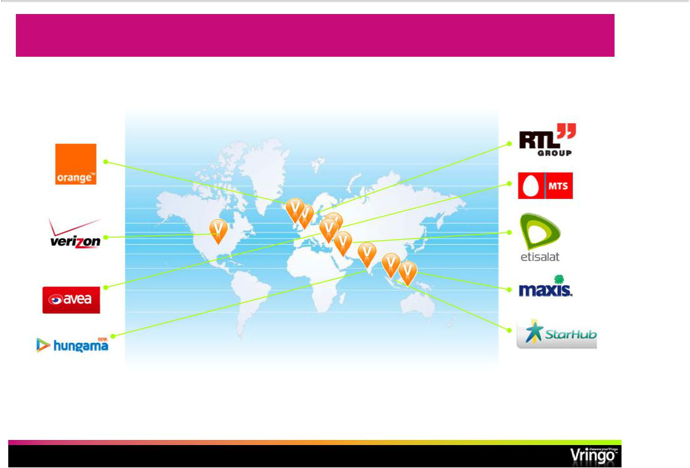
Signed Revenue Deals: Initial Basis for Growth

Markets in which we have launched or will launch our service through carriershaveseveralhundredmillionmobilesubscribers⁽¹⁾

 | Currently in discussions with several other carriers pursuing
(1) Source: United Nations | additional agreements over the next2412months-
 | - Page 35 -

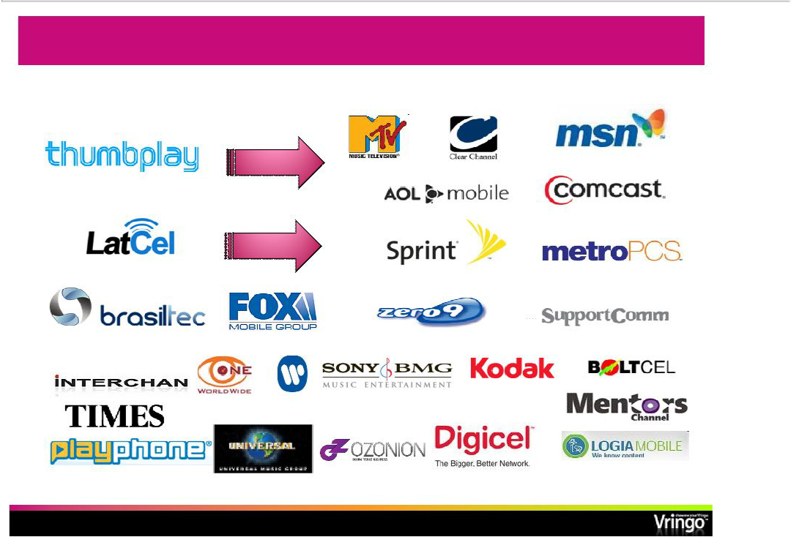
m-Wise Mobile Content Clients

- Page 36 -

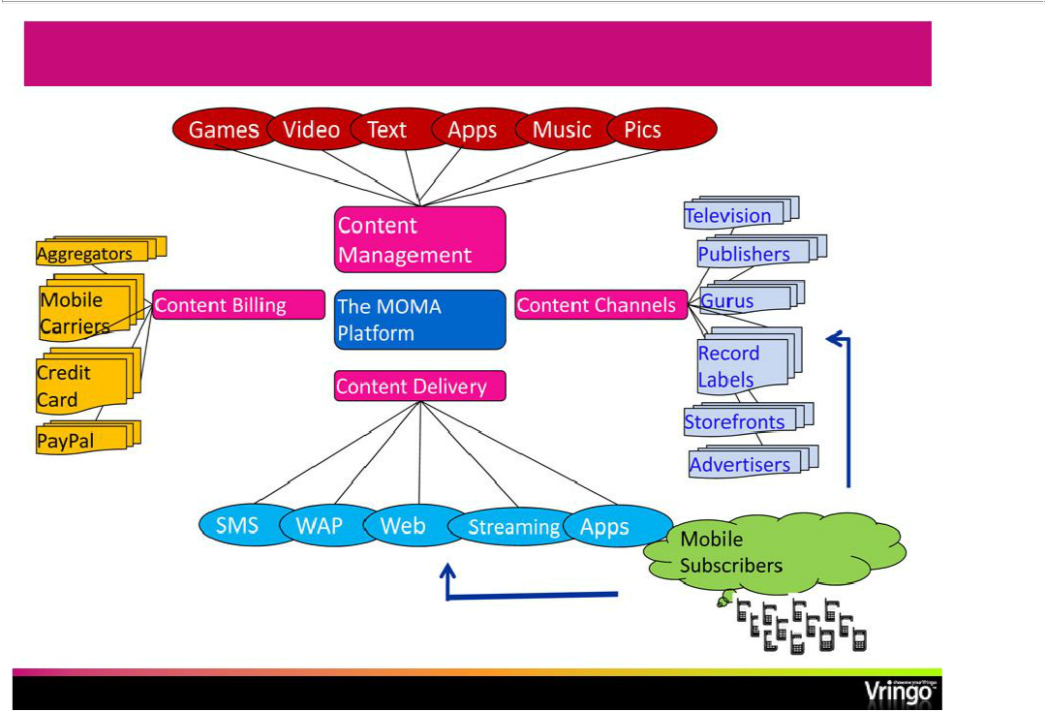
m-Wise Platform Overview

- Page 37 -

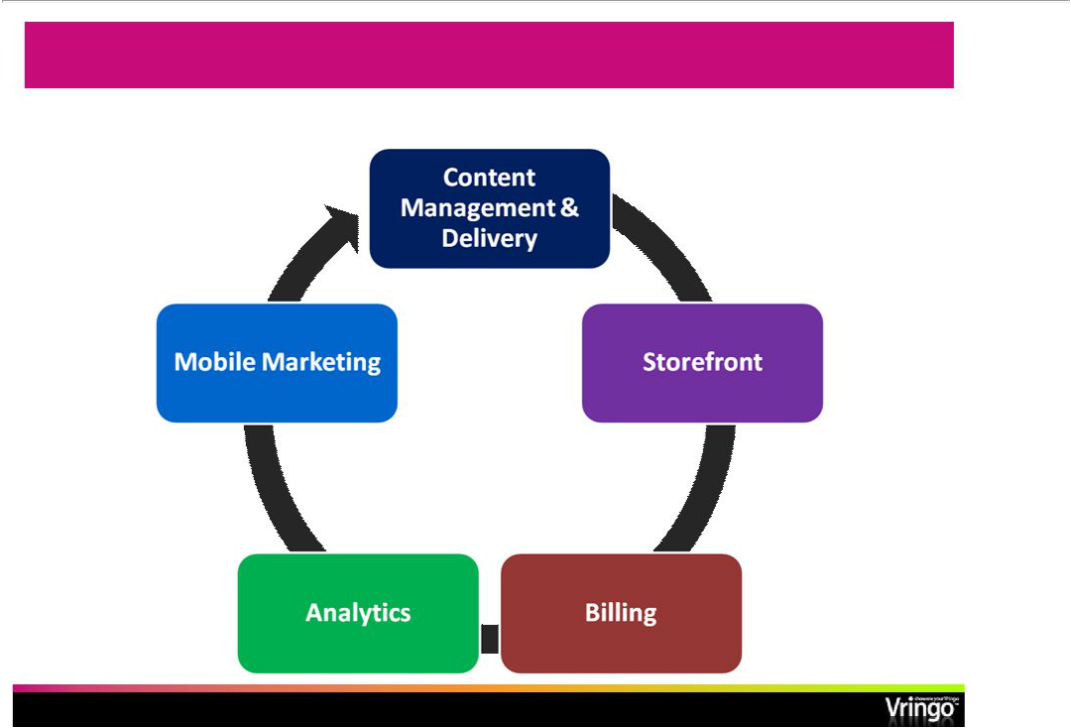
m-Wise Platform Overview

One-Stop-Shop for Online & Mobile Content Solutions

- Page 38 -

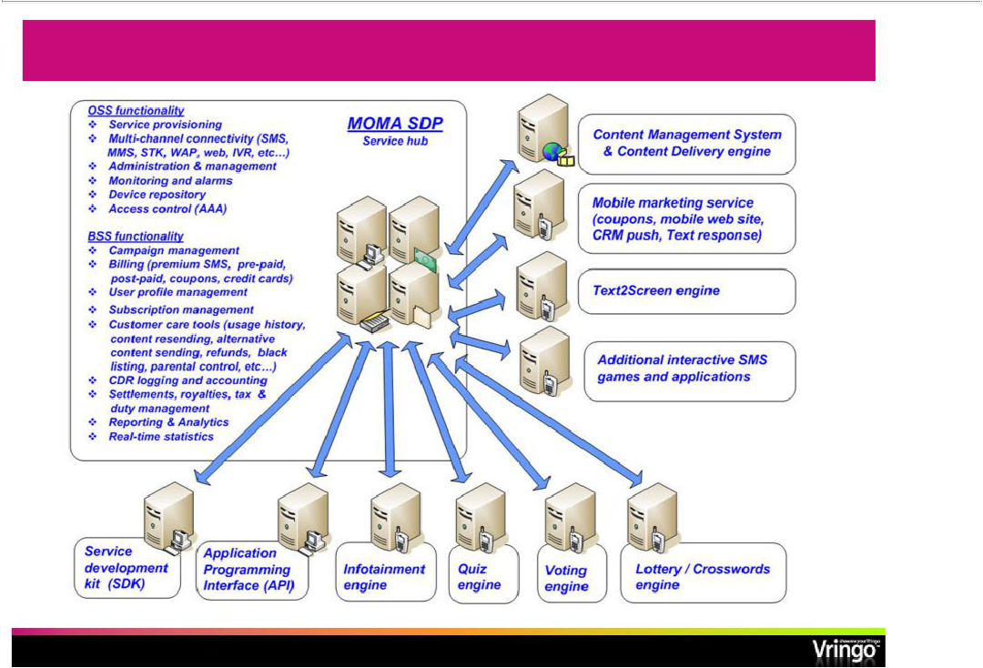
MOMA Service Delivery Platform

- Page 39 -

The MOMA SDP Main– Functionality

The MOMA Service Delivery Platform (SDP)

- Multi-territory, multi-country, multi-currency, multi-lingual, multi-timezone, cross network platform messaging and billing

- Central management and maintenance

- Service provisioning (Quiz, Voting, Binary content, coupons, etc…)

- Management and delivery of any type of binary content, including music, videos, pictures, games and applications

- Medium independentoperates– on SMS, MMS, WAP, web, IVR, and email simultaneously

- Flexible rating, pricing and billing

- Comprehensive reporting, analytics and CDRs records

- Extensive customer care tools

- OpenAPIforweb/WAPdevelopers,3rd partiesapplication developers

  - Page 40 -

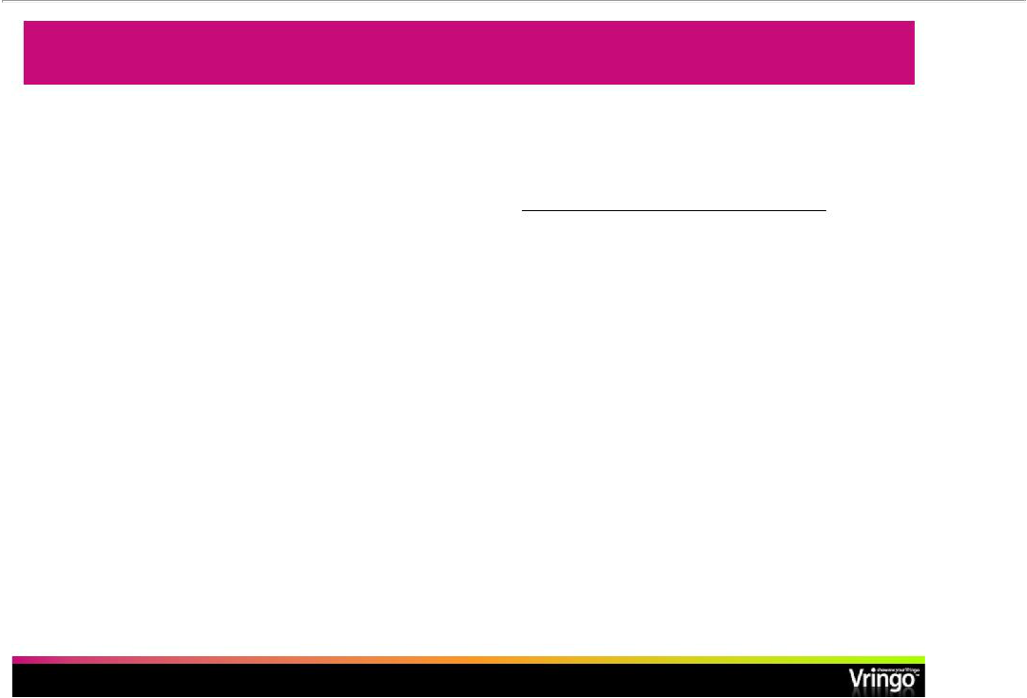
Vringo Financial Position

($ 000) | September 30, | December 31,
 | 2010 | 2009
 | (Unaudited) | (Audited)
Cash and cash equivalents | 7,394 | 744
Total current assets | 7,704 | 3,518
Total assets | 7,982 | 3,789
Total current liabilities | 2,076 | 3,649
Total long-term liabilities | 5,830 | 4,550
Total stockholders’equity | 76 | (16,378)

- Page 41 -

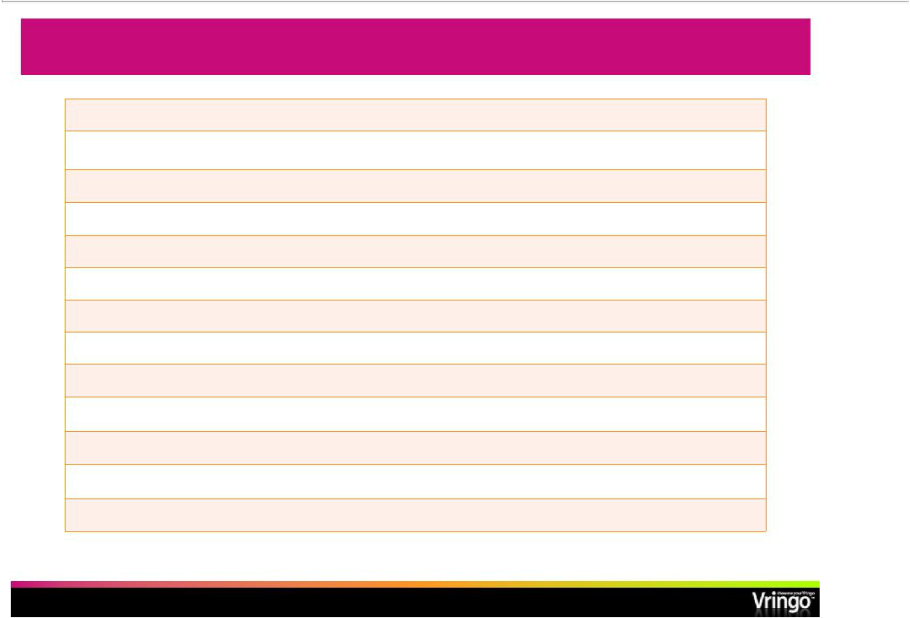
Company Snapshot

Stock Exchange/Ticker: | NYSE Amex: VRNG
VRNG Recent Price (3/8/11): |  | $2.10
Shares Outstanding: (3/8/11) |  | 5.7 M
Market Cap: |  | $12 M
3Q10 Revenue / Sequential growth rate: |  | $54 K / 23%
Special Bridge/Bank warrants at $2.75 exercise price (3/8/11) |  | 1.1M
Out-of-the-money warrants (3/8/11) |  | 6.6 M
3Q 10 Net Income (Loss): |  | ($2.8 M)
Net Granted stock options |  | 3.1 M
Director and Officer Ownership: |  | 8.7%
Warrant Exchange/Ticker: | NYSE Amex: VRNG-W
VRNG-W Recent Price (3/8/11): |  | $0.14
VRNG-W exercise price & expiration | $5.06; 6/21/15

- Page 42 -

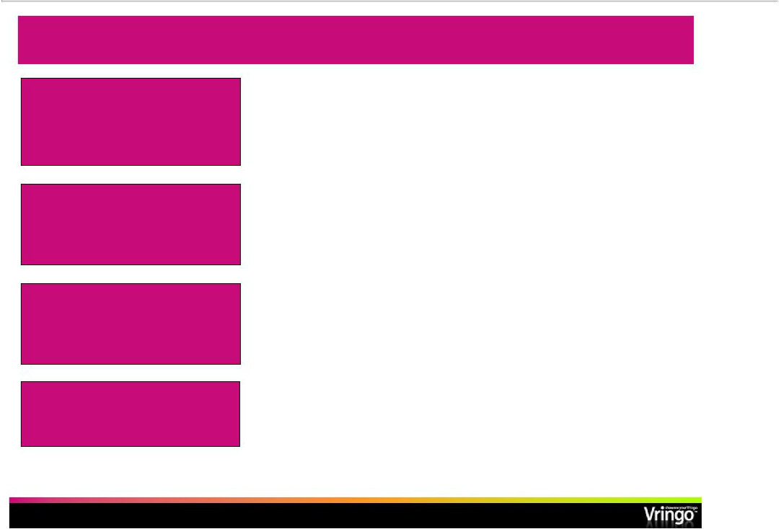
Investment Highlights: Recap

 | • | Proven technology and products
 | • | Scalable business model
 | • | Major contracts signed with international mobile carriers
Strong Platform for Growth |  | and content providers
 | • | Robust Video Ringtone platform ready to deploy as turnkey
 | • | (1)
Fast Growing Markets | • | 4.6 B global mobile subscribers
Fast Growing Markets | • | 534 M global mobile video subscribers by 2014
 | • | (2)(4)
 | • | $25 B mobile application market by 2014
 | • | (3)(5)
 | • | $29 B mobile content market by 2012
 |  | (2)
Established and Well | • | Strong management team and BOD with experience in the
Established and Well |  | U.S. financial markets
Seasoned Management | • | Track record of creating, running, investing and exiting
 |  | successful technology companies

 | Will grow organically and |  |  | • Have announced signing of LOI for m-Wise acquisition
 | through acquisition |  |  | • Real opportunity for consolidation in mobile service arena
(1) | United Nations estimate | (3) | Juniper Research
(2) | Multimedia Intelligence | (4) | Not a projection for Vringo subscribers
 |  | (5) | Not a projection for Vringo market size

- Page 43 -

