UNITED STATES

SECURITIES AND EXCHANGE COMMISSION
Washington, D.C. 20549

FORM 8-K

CURRENT REPORT

Pursuant to Section 13 or Section 15(d) of the

Securities Exchange Act of 1934

Date of Report (Date of earliest event reported): September 13, 2010

VRINGO, INC.

(Exact name of registrant as specified in its charter)

Delaware | 1-34785 | 20-4988129
(State or other jurisdiction | (Commission | (IRS Employer
of incorporation) | File Number) | Identification No.)
 | 18 East 16th Street, 7th Floor
 | New York, New York | 10003
 | (Address of principal executive offices) | (Zip Code)
 | Registrant’s telephone number, including area code: (646) 525-4319

Check the appropriate box below if the Form 8-K filing is intended to simultaneously satisfy the filing obligation to the registrant under any of the following provisions:

- Written communications pursuant to Rule 425 under the Securities Act (17 CFR 230.425)

- Soliciting material pursuant to Rule 14a-12 under the Exchange Act (17 CFR 240.14a-12)

- Pre-commencement communications pursuant to Rule 14d-2(b) under the Exchange Act (17 CFR 240.14d-2(b))

- Pre-commencement communications pursuant to Rule 13e-4(c) under the Exchange Act (17 CFR 240.13e-4(c))

Item 7.01 Regulation FD Disclosure.

On August 24, 2010, Vringo, Inc. (the “Company”) issued a press release announcing that it will be presenting at the Rodman & Renshaw Annual Global Investment Conference in New York City on September 13, 2010. The presentation to be used at the conference is furnished herewith as Exhibit 99.1 and a copy of the press release is furnished herewith as Exhibit 99.2, both of which are incorporated herein by reference.

The information contained in this Current Report on Form 8-K, including the exhibits hereto, shall not be deemed “filed” for purposes of Section 18 of the Securities Exchange Act of 1934, as amended, and shall not be incorporated by reference into any filings under the Securities Act of 1933, as amended, or the Securities Exchange Act of 1934, as amended, except to the extent the Company specifically incorporates the information by reference.

Item 9.01. Financial Statements and Exhibits.

- Exhibits

99.1 Presentation Materials for the Rodman & Renshaw Annual Global Investment Conference

99.2 Press Release, dated August 24, 2010

SIGNATURE

Pursuant to the requirements of the Securities Exchange Act of 1934, the registrant has duly caused this report to be signed on its behalf by the undersigned hereunto duly authorized.

Dated: September 13, 2010 VRINGO, INC.

By: /s/ Andrew Perlman

Name: Andrew Perlman

Title: President

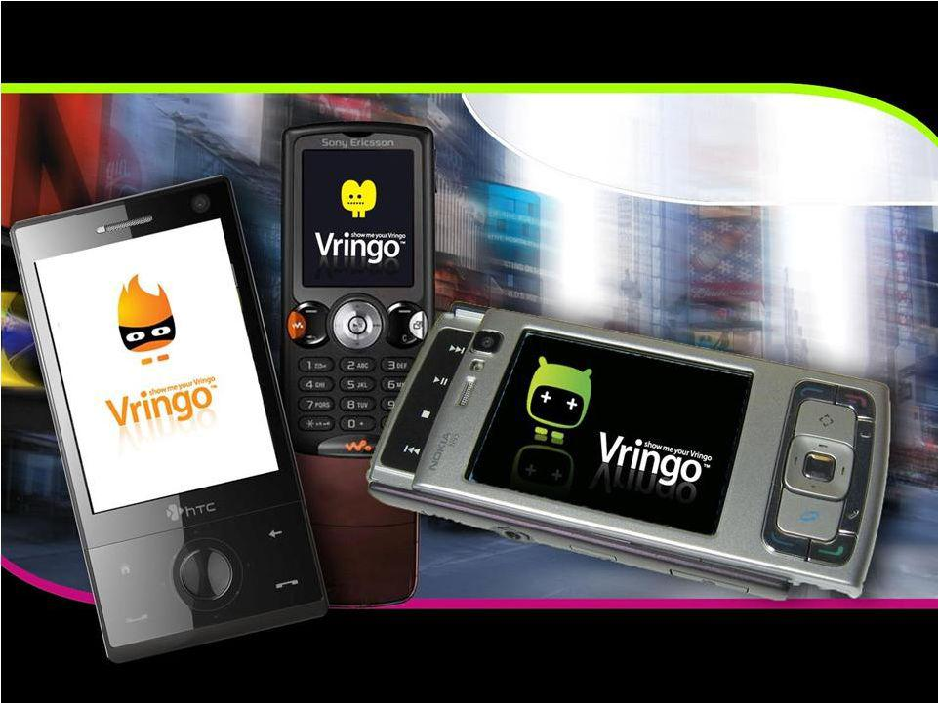
Exhibit 99.1

Investor Presentation

Rodman & Renshaw Annual Global Investment Conference September 13, 2010


Safe Harbor Statement

This presentation contains certain statements that may be deemed to be “forward-looking statements” within the meaning of Section 27A of the Securities Act of 1933, as amended, and Section 21E of the Securities Exchange Act of 1934, as amended.

All statements, other than statements of historical facts, that address activities, events or developments that the Company expects, projects, believes or anticipates will or may occur in the future, including, without limitation, the outlook for general industry conditions, future operating results, capital expenditures, expansion and growth opportunities, financing activities and other such matters, are forward-looking statements.

Although the Company believes that its expectations stated in this presentation are based on reasonable assumptions, actual results may differ from those projected in the forward-looking statements. For a more detailed discussion of risk factors, please refer to the Company’s Registration Statement on Form S-1 and its periodic reports filed with the United States Securities and Exchange Commission (“SEC”).

Vringo expressly disclaims any obligations or undertaking to update or revise any forward-looking statements contained herein to reflect any change in Vringo’s expectations with respect thereto or any change in events, conditions or circumstances on which any statement is based.

- Page 2-


Vringo: Synonym for Video Ringtones

- We provide a comprehensive platform of video ringtones for mobile phones

  - Software allows users to create, download and share mobile entertainment content

  - WAP and Web sites encompass robust content integration and distribution systems

  - 200+ Vringo-enabled handsets (Windows, BlackBerry, Android, Symbian, J2ME)

  - Library of over 5,000 video ringtones
  - 23patentspendingfor softwareplatform andmobile applications(onepatent issued)

  - Present on major app stores (Nokia’s Ovi; coming to Verizon’s Android App Store)

  - Pre-linked on Sony Ericsson handsets (SE Walkman)

- Founded in 2006

  - 35 Employees

  - Headquarters located in New York

  - Sales office in Oxford (UK)
  - R&D based out of Israel

- Strong early stage investors

  - Angel round of $2.4 M in 2006

  - Warburg Pincusinvested $12 M in 2007

  - Bridge round of $3.0 M in Dec. 2009

- IPO in June 2010 raised $11 M with Maxim, Ladenburg, and Chardan

    - Page 3-

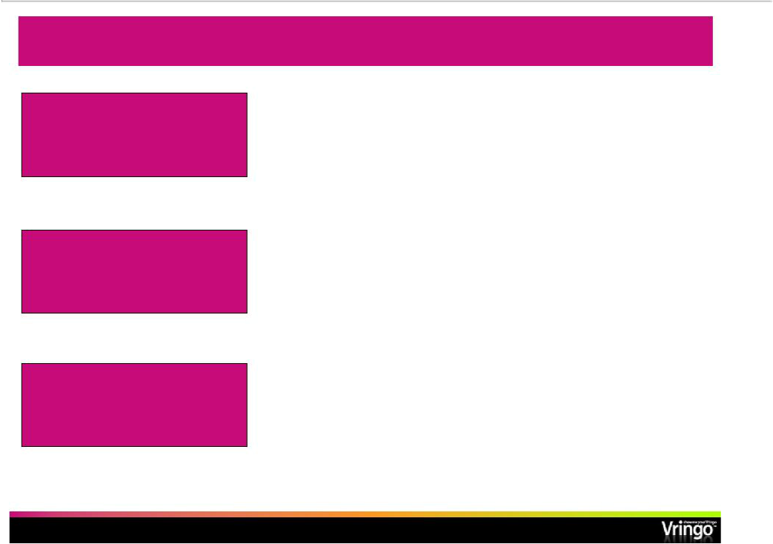
Investment Highlights

- Scalable business model

_{Strong Platform for Growth}• Major contracts signed with international mobile carriers and content providers

• Largest video ringtone library in the world (over 5,000 titles)

 |  | • | Only 17.6 M viewed mobile video in the US in Q4 2009
 |  |  | (1)
 |  | • | 4.6 B global mobile subscribers
Nascent and Fast Growing |  |  | (2)
 |  |  | (3)(5)
Markets |  | • | 534 M global mobile video subscribers by 2014
 |  | • | (4)(6)
 |  | • | $25 B mobile application market by 2014
 |  | • | (3)
 |  | • | $29 B mobile content market by 2012
 |  | • | Strong management team and BOD with experience in the
Established and Well |  |  | U.S. financial markets
Seasoned Management • |  |  | Track record of creating, running, investing and exiting
 |  |  | successful technology companies
(1) Nielsen/New York Times | (4) Juniper Research
(2) United Nations estimate | (5) Not a projection for Vringo subscribers
(3) Multimedia Intelligence | (6) Not a projection for Vringo market size

- Page 4 -

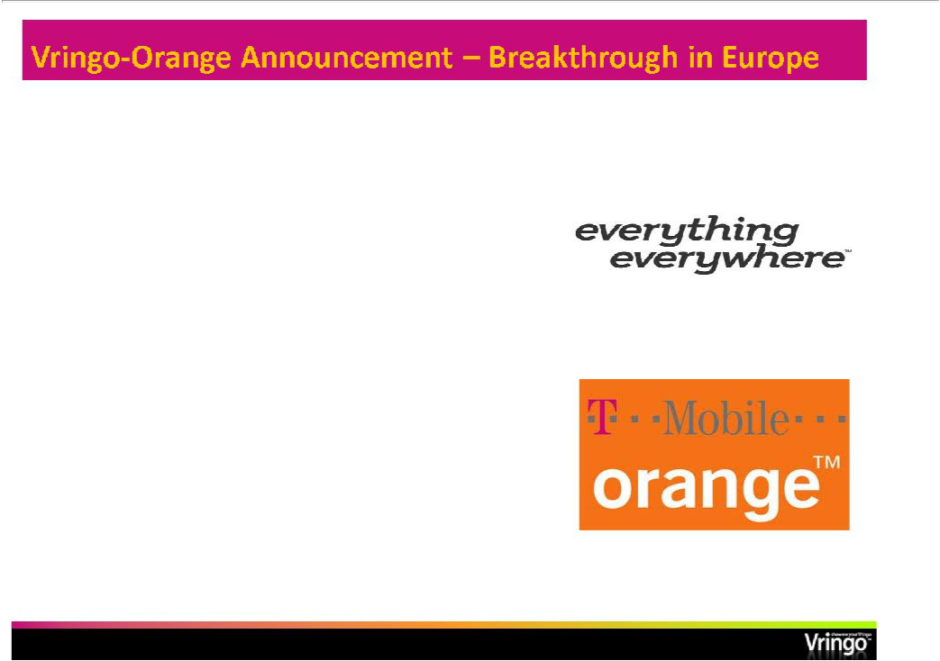
STAY TUNED--NEWS TO FOLLOW

Deal with Everything Everywhere Ltd.; UK’s largest mobile company to launch Vringo together in the UK market

Everything Everywhere operates both Orange (UK) and T-Mobile (UK) with combined total of over 30 M subscribers, and is owned by France Telecom and Deutsche Telekom

First will launch with Orange (UK)

subscribers in Q4

Working hard to ensure top notch content for this critical launch

- Page 5 -


Importance of Orange Launch

STAY TUNED--NEWS TO FOLLOW

- First major launch in the strategic European market

- UK is a vibrant and active mobile content and application market

- Vringo has until now focused on proving its business model in smaller, less developed markets

- Terms: Orange branded service, revenue split, zero rating for data, promotion of service on Orange properties

- Page 6 -

Aug 12, 2010 Business Week
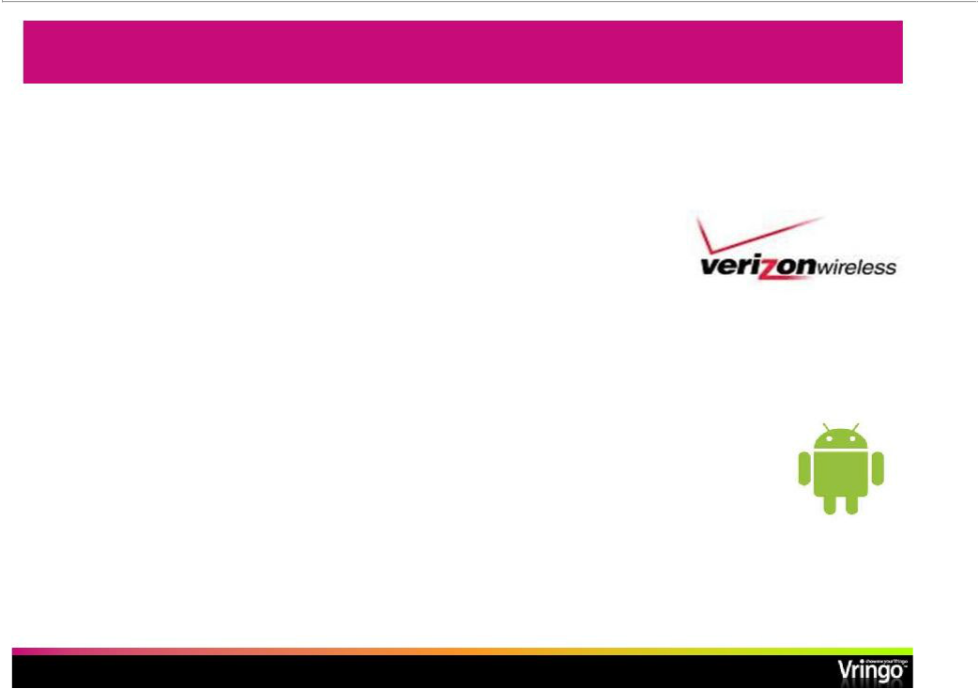
Starting in North America---with Verizon and Android

STAY TUNED--NEWS TO FOLLOW

Vringohas been approved to launch on the Verizon Android App Store in Q4

Verizon has 90 M subscribers and has a culture of app promotion and usage among subscribers

Verizon has sold the most Android phones in North America

Android has now overtaken iPhonein North American unit shipments according to Gartner

- Page 7-

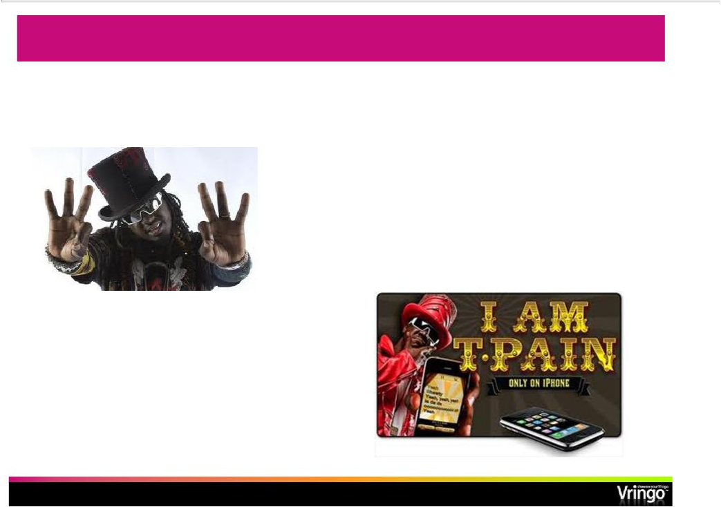
Time for T-Pain……

STAY TUNED--NEWS TO FOLLOW

Vringolaunching new

application for iPhoneand

Android with T-Pain in Q4

T-Pain’s earlier iPhoneapp “I

am T-Pain”became one of

the most popular music apps

of all time selling 1.5 M

copies

- Page 8-

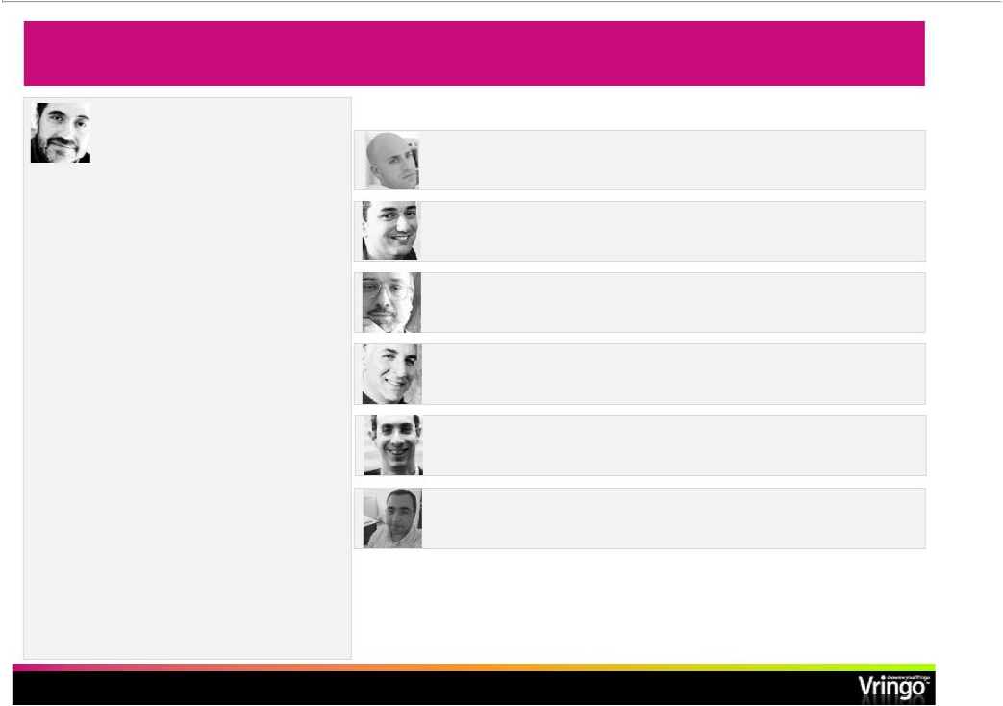
Seasoned Management & Governance

Jon Medved

Founder & CEO, Board member

“One of Israel’s leading venture capitalists”

(Washington Post)

Founder of Israel Seed Partners, managing $260 M in 4 funds-exits include:

- Shopping.com(acquired by eBay Inc.) for $640 M

- Answers Corp. (NasdaqCM: ANSW)

- Native Networks (acquired by Alcatel (NYSE: ALA))

- Compugen(Nasdaq: CGEN)

- XacctTechnologies (acquired by Amdocs Ltd. (NYSE: DOX))

- Business Layers (acquired by CA, Inc. (NasdaqGS: CA))
- Cyota(acquired by RSA/CA NasdaqGS: CA)

Manager of several startups with exits including:

- MERET (acquired by Amoco/BP)

- Accent (Nasdaq: ACNTF)

Andrew Perlman

President and Board member

David Corre

VP Finance

David Goldfarb

CTO

DovFrohlich

COO

HaimCohen-Mintz

VP Europe

Josh Wolff

VP Services & Solutions

Formerly

EMI Music

Formerly

Siemens

Formerly

Degel Software

Formerly

NMS Communications

Formerly

Neustar

Formerly

NMS Communications

- Page 9-

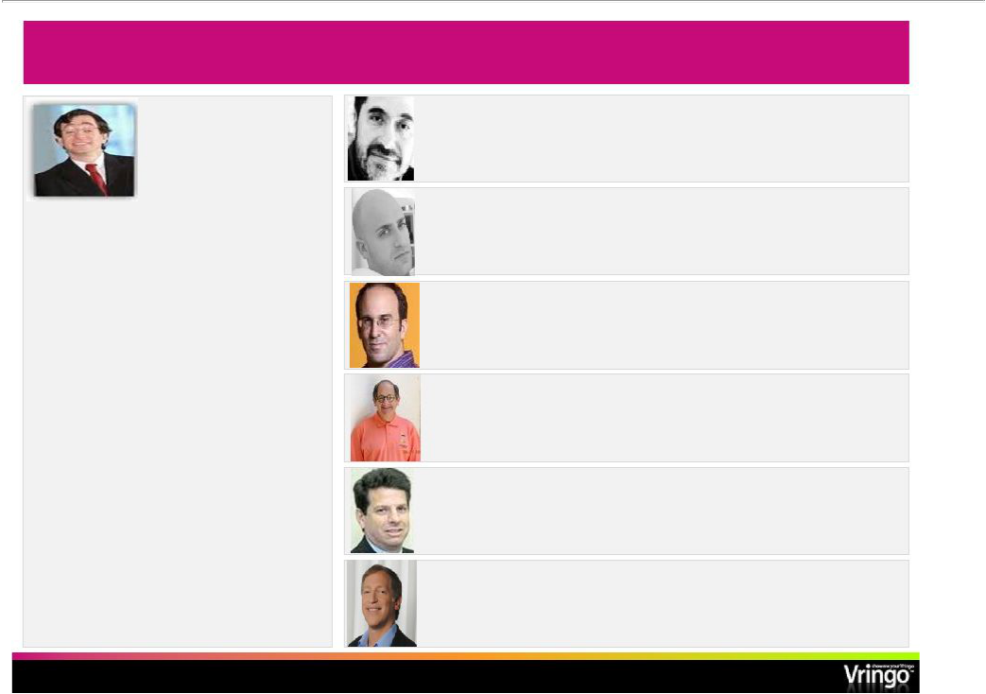
VringoBoard of Directors

Seth (“Yossi”) Siegel

Chairman of the Board

Was Founder, Chairman and CEO of the Beanstalk Group, the world’s largest independent licensing agency, now part of the Omnicom Group. Served leading Brands such as:

- AT&T

- IBM

- Harley Davidson

- Unilever

- Ford Motor Company

Several time LIMA and Clio award winner

Marketing and brand commentary appears in the NY Times, BrandWeek, Wall Street Journal, etc.

Jon Medved

CEO and Board member

Andrew Perlman

President and Board member

Edo Segal

Board Member

Ralph Simon

Board Member

Gary Ginsberg

Board Member

Phil Serlin

Board Member

Chairman, Audit Committee

- Page 10-

Formerly

Founder and GP Israel Seed

Formerly

SVP, EMI Music

Founder and CEO Relegance, sold to AOL

Chairman Emeritus Founder MEFAmericas-

Executive VP, Time Warner, Formerly NewsCorpBoard

CFO BiolineRX Formerly Coopers, SEC

Vringoin Middle of Rapidly Growing Markets and Trends

- Mobile video has arrived
• Mobile video data usage is expected to grow at a 131% CAGR from 201409⁽¹⁾-
  - 534 M global mobile video subscribers by 2014⁽²⁾

    - Five-fold increase since 2008

    - $16 B in revenues projected in the ⁽²⁾US

- Mobile social networking is growing exponentially

  - Facebookand Twitter at the forefront of the phenomenon

  - Growing mobile social networking and user-generated content revenue

  - $1.8 B in 2008 to $11.8 B in 2013⁽³⁾
  - Approximately 1 out of every 8 people world-wide has used a digital social network⁽⁴⁾
- User generated content continues to grow
  - YouTube revolution

  - Advances in technology that facilitate the creation of user-generated content

- Rise of smart phones
• Global Smartphone shipments experienced 50% growth YOY in Q1⁽⁵⁾ 2010
  - Increased bandwidth enables rich media transfer across many devices

  - Apps everywhere…with Android growing % of market share by 150% in Q4⁽⁶⁾ 2009
  - Global 3G penetration expected to exceed 20% by the end of⁽⁴⁾2010
- Cisco Visual Networking Index: Global Mobile Data Traffic Forecast Update, 2009-2014, 2/10

- Pyramid Research

- Juniper Research
- Morgan Stanley’s Internet Trends, 04/10; comScore Global, 12/09

- Strategy Analytics

- Comscore

    - Page 11-

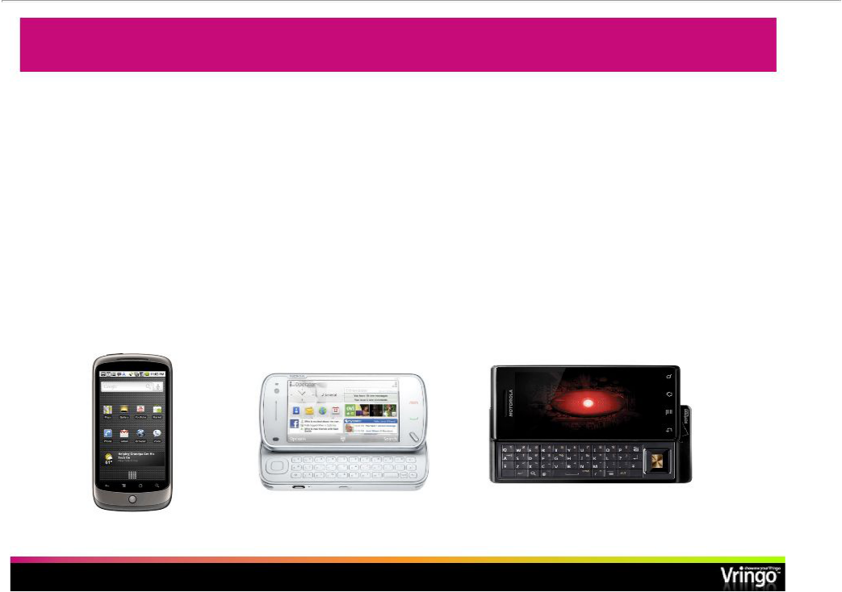
Ring Tone Market-Ready for Vringo’sInnovation

- Ringtone business was created in 1997

  - Further developed in 2002 with the creation of truetoneand mastertone

- Ringbacktone was created in 2004

  - $4.7 B ringbacktone market by 2012⁽¹⁾

    - 3x growth from 2008

- Morethanone-thirdofmobileusersdownloadringtonesfromvarioussources⁽¹⁾
  - 40% of such users frequently change their ringtones

- Ringtone business has seen little innovation since 2004

  - Market ready for next evolution of products and services

- IpsosMediaCT

- Page 12-

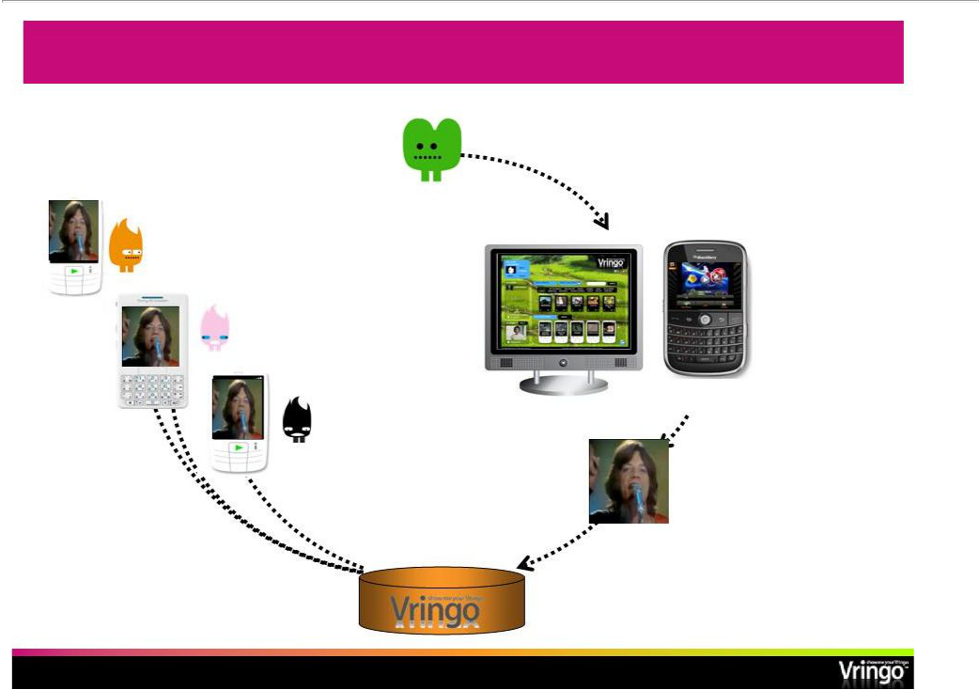
Getting a New VringoOnto a Phone

Justin

5. New Vringois cached on

handsets, ready to be played _{HTTP} whenever Justin calls

- Justin logs onto Vringo.comon his PC/mobile or browses through his Vringo application for a new clip

Vringoclients

Vringo.com

VringoMobile App

- Justin’s new Vringois automatically sent to all of Justin’s buddies

2. Justin picks out a

Rolling Stones clip and

makes it his phone’s
^{TCP/IP} ringtone

HTTP

Vringoserver

- Vringoserver is updated immediately

- Page 13-

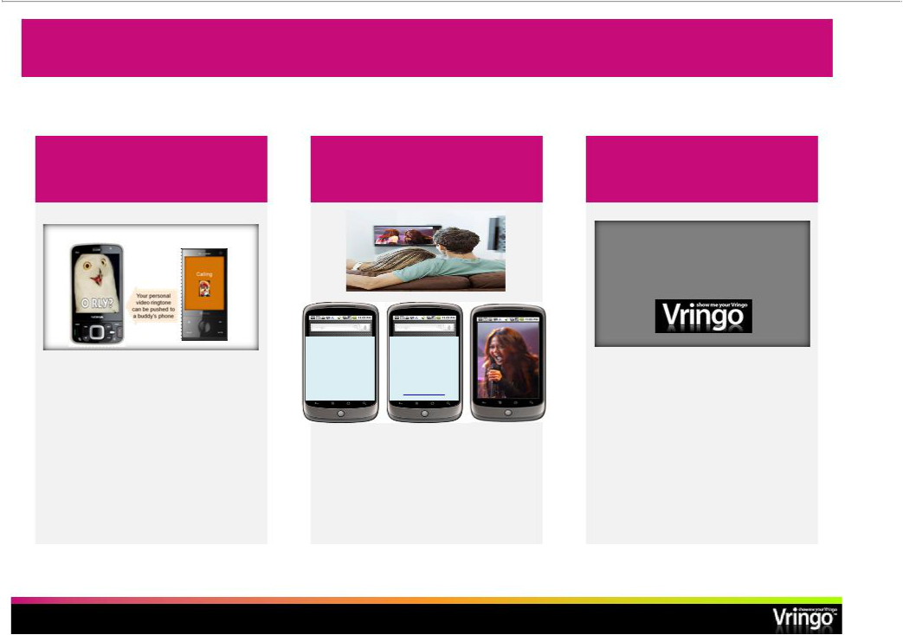
SpecialFeaturesSupportedby VringoTechnology

VringForward™

Mobile Video Voting Context-Appropriate

Rewards Advertising

- Decide what ringtone friends see when you call them

Thanks for
voting! Get

Vote!!! an exclusive

video clip at:

http://URL

- Get video ringtones as rewards for voting on contest shows

Your Favorite Brand

Brought to you by

- Receive relevant commercial messages (post-, pre-roll, post-call)

- Page 14-

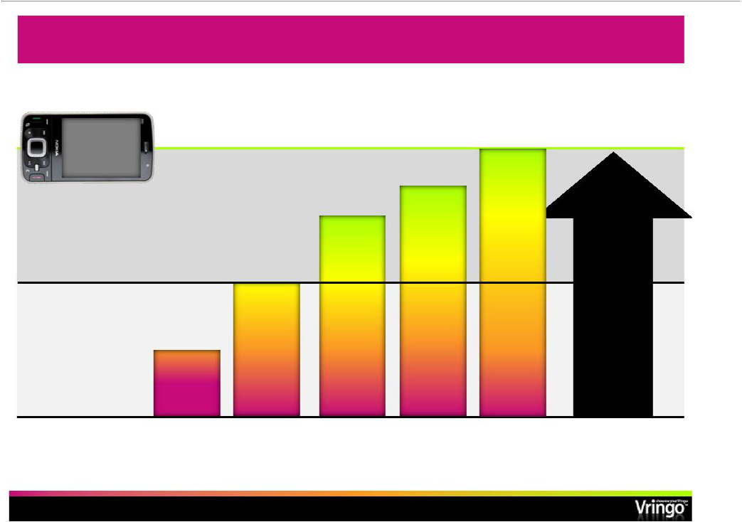
Future of Mobile Personalization

Phone

capabilities

Vringo’s market

Audio ringtone market today

audio

ring

tone

audio

ring back

tone

 |  | social | Better user
 |  | personal- | Better user
 | video | personal- | experience
 | video | ization | experience
video | ringback/ | tools | New revenue
video | ring |  | New revenue
ringtone | ring |  | opportunities
ringtone | forward |  | opportunities

- Page 15 -

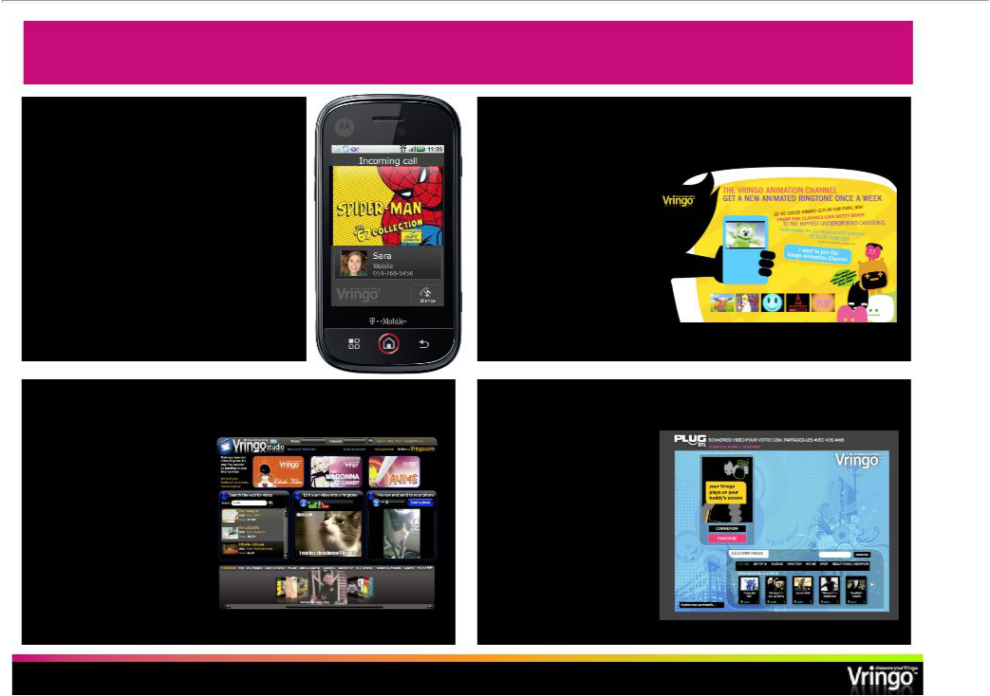
Four Product Platform Components

Mobile application Channelsautomatic- content delivery

• Customer store front • Video ringtones have a

• Viral marketing engine shorter shelf life

• 300+ handsets • Customers can

• Java, Blackberry, Windows Mobile, subscribe to automatic

Android, Symbian content refreshes

• Opportunity exists to sell premium

content bundles based on the core

application

Studio online- ringtone editor

- World’s first Web-based video ringtone editor
- Can be customized for partners (e.g., Marvel)

Custom store fronts

- Customizable web/mobile store front
- TV networks, retailers, political campaigns, live events

- Opportunity exists to set up advertising-
supported storefronts – _{Indicative}
“free” to consumers example

- Page 16 -

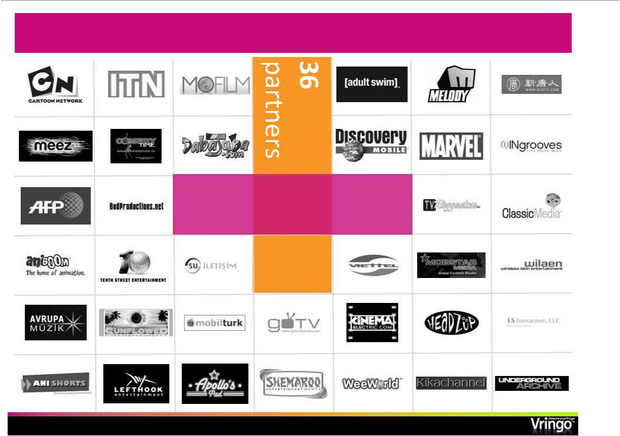
World’s Largest Video Ringtone Library

5,000+ video clips

- Page 17-

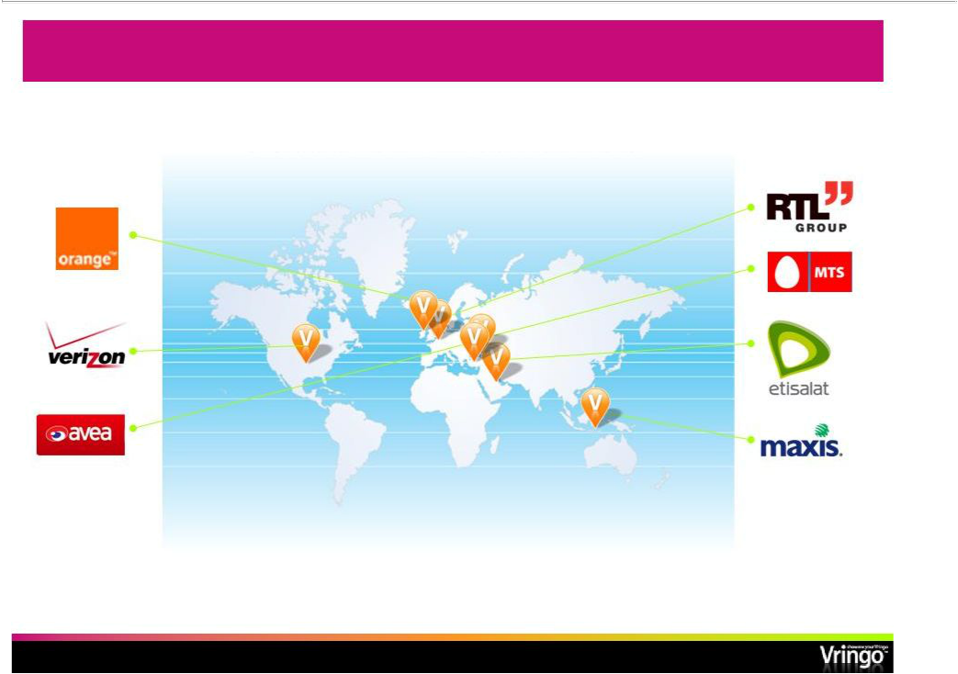
Signed Revenue Deals: Initial Basis for Growth

Markets in which we have launched or will launch our service have severalhundredmillionmobilesubscribers⁽¹⁾

 | Currently in discussions with several other carriers pursuing
(1) Source: United Nations | additional agreements over the next2412months-
 | - Page 18-

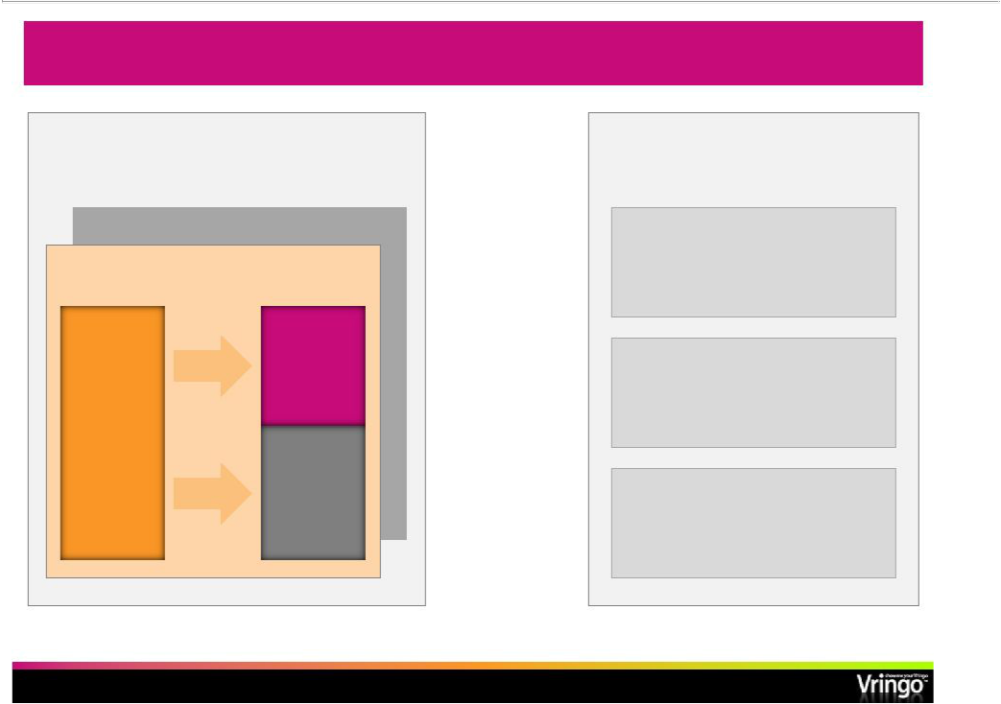
Simple, Scalable Business Model

Target: $6 $-12 per user per year for

Net Vringo ARPU

Premium: $1-3 per clip

Monthly user subscription

User | Vringo | X
 | $0.3*-$1.5 | X
$1.0 -$3.0 |  | X
No data | Operator
traffic | Operator
charges | $0.6 -$2.0

Operator penetration

Target

4-6%

Modeling assumptions

1-2%**

Current audio RBT ~15%

- Effective revenue of $0.15 per subscribernet- of uncollected subscription fees

- Page 19 -

- Penetration of addressable market within 1 year of new market launch

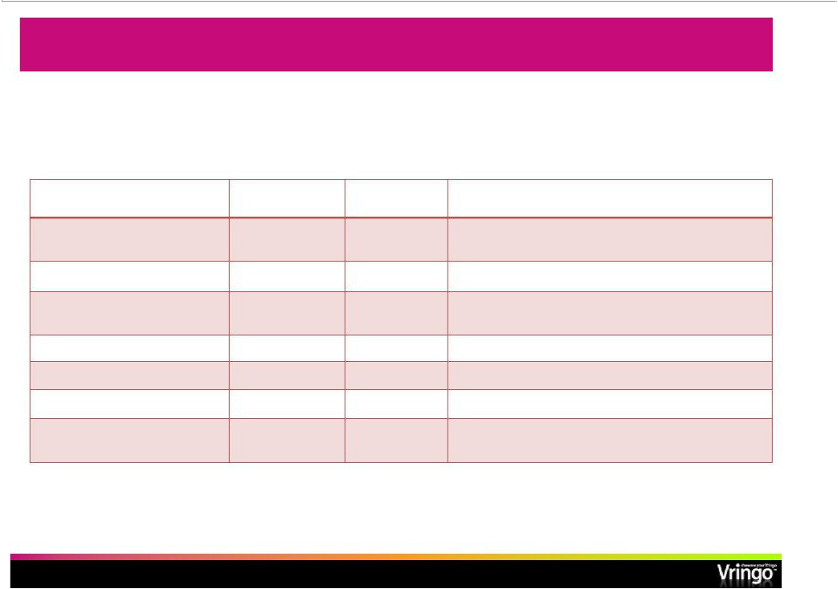
5 Launches So Far…

• 2 Pending Launches will Grow Addressable Market by 3X

Name of Operator/Partner | Launch Date |  | Operator | Growth Potential
 |  |  | Subscribers (M)
MTS Group/Vivacell | July 2009 |  | 2 | Part of MTS Group which has 100 M subs
(Armenia)
Maxis(Malaysia) | October 2009 |  | 11.4 | Largest operator in Malaysia
Avea(Turkey) | November 2009 |  | 12.1 | Third largest operator in Turkey; subsequently
 |  |  |  | replaced by agreement with Retromedya
Etisalat(UAE) | March 2010 |  | 7.3 | Group includes 16 countries, 94 M global subs
RTL(Belgium) | May 2010 |  | 11 | Launching via TV ads, etc. on all 3 major carriers
Verizon(US) | Pending: 4Q 10 |  | > 92 | Initial launch for Blackberry & Android phones
Everything Everywhere LtdPending:. |  | 4Q 10 | > 30 | UK’s biggest communications company
(Orange (UK) / T-Mobile (UK)) |  |  |  | jointly-owned by Deutsche and France Telecom

- Page 20-

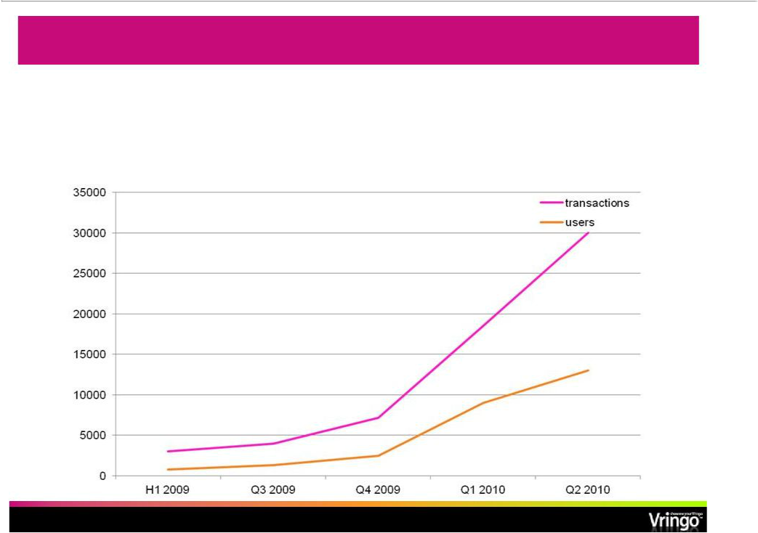
Promising Results: Carrier #1

- Since service launch with mid-tier carrier, user acquisitions have grown

  - 3x per quarter and transactions have expanded at 4x per quarter

- 70% conversion to paid subs after free trial period

- Opt-out rates of less than 5%

- Page 21-

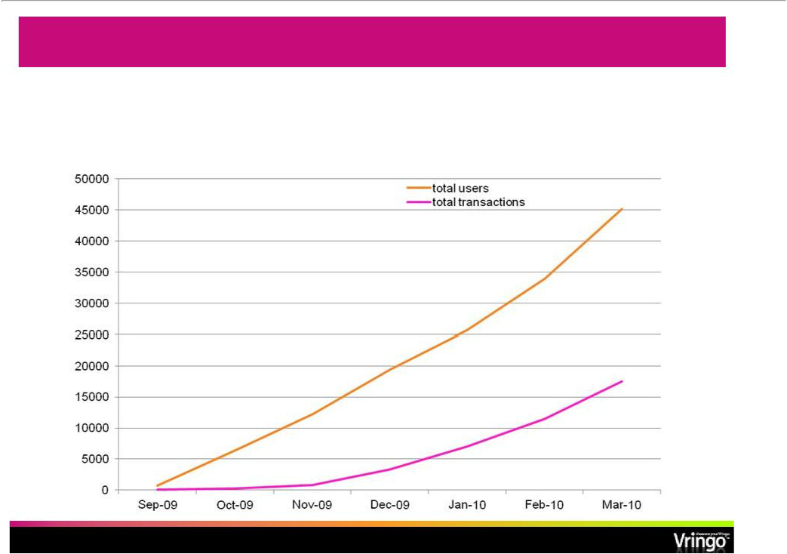
User Growth: Carrier #2

- Since launch in 2009, new registrations have grown steadily

  - Over 40 K registrations in 6 months

- Carrier reports Vringois among its fastest growing paid services

- Page 22-

Marketing the Service: Sample Collateral

- Page 23 -

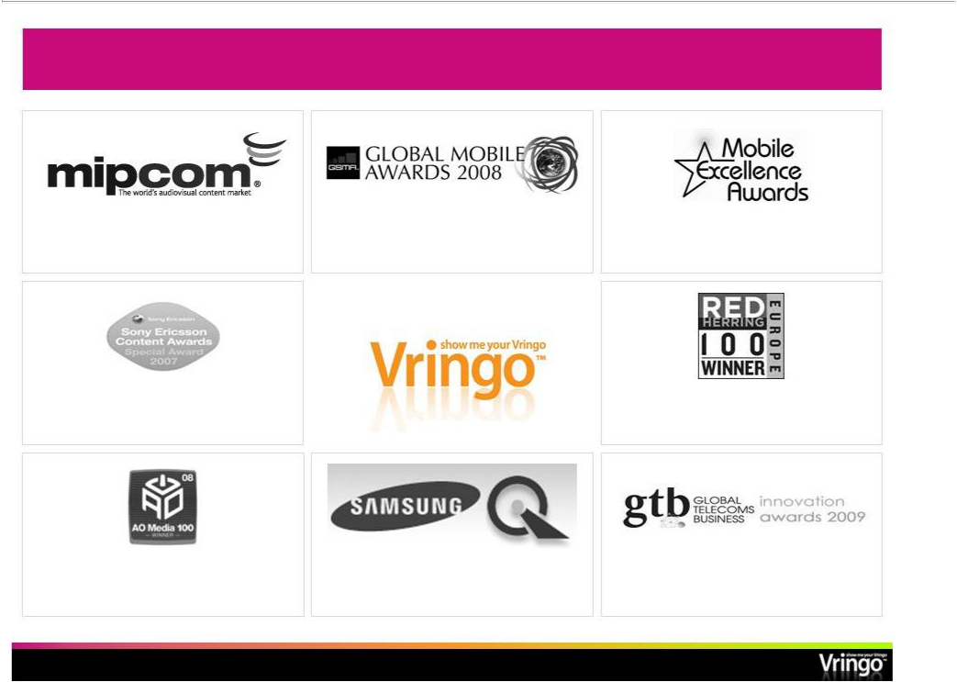
Consistently Winning Industry Awards

Best mobile service for social community and user generated content

- October 2007

nd | Best mobile community/fan content
Best mobile social networking service, 2 | Best mobile community/fan content
place
- January 2008 | - November 2008

Best use of phone functionality Winner Red Herring 100

- December 2007 - April 2009

Always On Top 100 Media winner Finalist Best ringtone innovation

- January 2008 - March 2008 - June 2008

- Page 24-

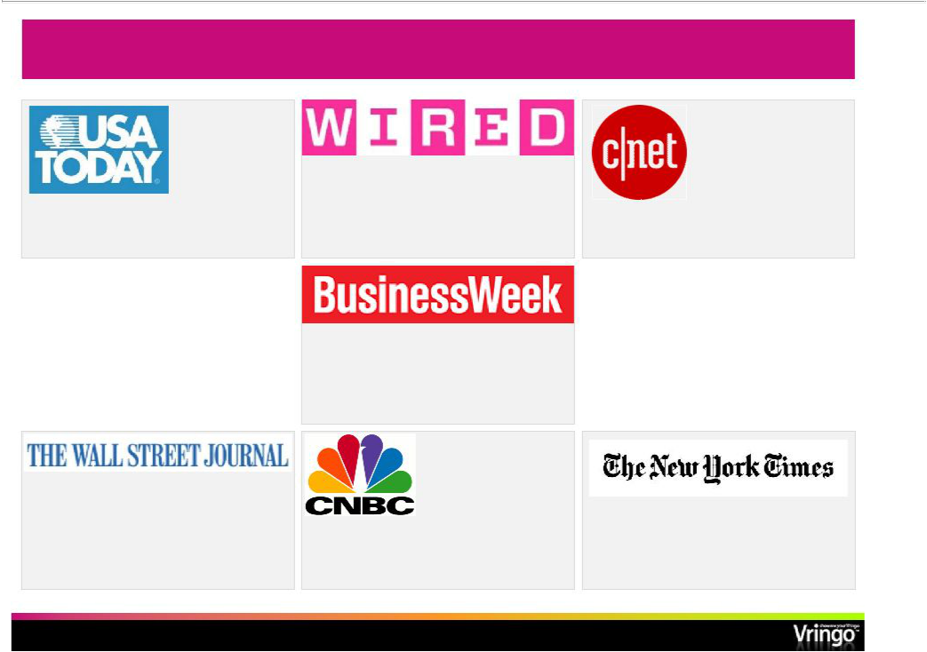
Major Outlet Media Coverage

“offers an eyeful…has to be seen to be “Vringo has something that others lack…the “the next level ringtone…this company’s fun

believed” caller has the power” and unusual product is just getting better

and better”

“every call thus becomes an opportunity to

share content and to establish

identity…Vringo has a head start over

competitors”

“the service aims to tap consumer’s obsession with creating their own content”

“the next big thing in ringtones…soon | “Next big thing in the ringtone wave”
everyone could have a Vringo, a | “Next big thing in the ringtone wave”
personalized video ringtone”

- Page 25 -

Three Drivers of Growth

- Growing our business in the countries where we have launched

  - Continue to grow organically in each, driving subscription revenue

  - Adding new customer acquisition techniques, such as:

    - Voting, USSD, advertising

  - Add additional carriers in the territory

- Rolling out new countries and partners

  - Continuous development of a rich pipeline

  - Add 2-3 territories/partners per quarter

  - Migration to wealthier markets

- Bring new monetization models into play

  - Advertising-based Vringo will become important

  - App stores and content bundles

  - Leverage carrier relationships for new services

- Page 26 -

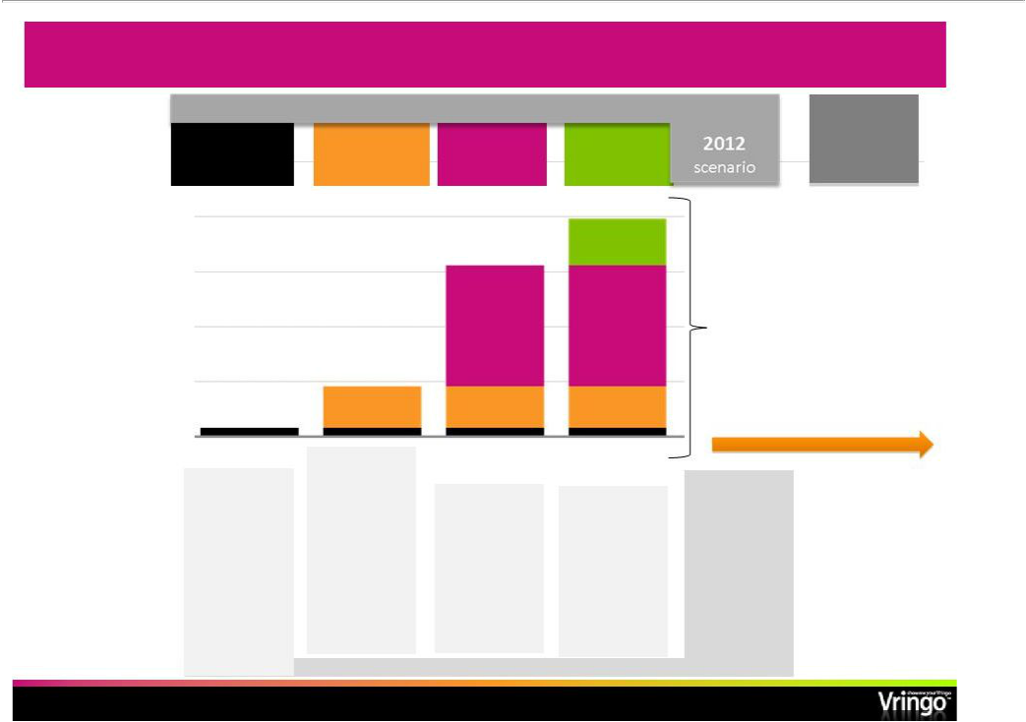
Multiple Waves of Growth Via New Operators

ONE | TWO | THREE | FOUR
deployment | discussions | signed | engaged
 |  |  | +
Operator |  |  | 200 M
Subscriber
Base |  | 440 M
44 M | 150 M

FIVE

upside

The rest

4.6 B

_{~ 800 M} mobile subscribers

Driving to Quarterly Breakeven by end 2011

Operators

Geographical Focus

5 | 6⁺
One country of | Other countries
One country of | + in the same +
a multi-country | + in the same +
operator | group/other
operator | operators in
 | same country

11 | 10⁺
Leading | EU, NA, and
South Asian | EU, NA, and
South Asian | + APAC operators=
operator
aggregator
(Hungama)

~ 20

- Page 27-

2Q 2010 Operational Summary

- SuccessfullycompletedU.S.initialpublicofferingraising$11Mingross proceedsIssued2,392,000units(1sharecommon,2. warrants)atIPOoffering price of $4.60 per unit.

  - Units separated July 27 into common (VRNG) and warrants (VRNG-W)

- Second quarter revenues of $44,000 compared to $0 in the second quarter of 2009

- Finished quarter with $9.7 million of cash on hand

- Number of commercial subscribers increased to 66,000

  - 61% sequential increase from previous quarter

- Signed partnership with T-Pain for new app anticipated to launch in 4Q 2010

- Announced intent to offer Vringoon Verizon Android App Store

- Page 28-

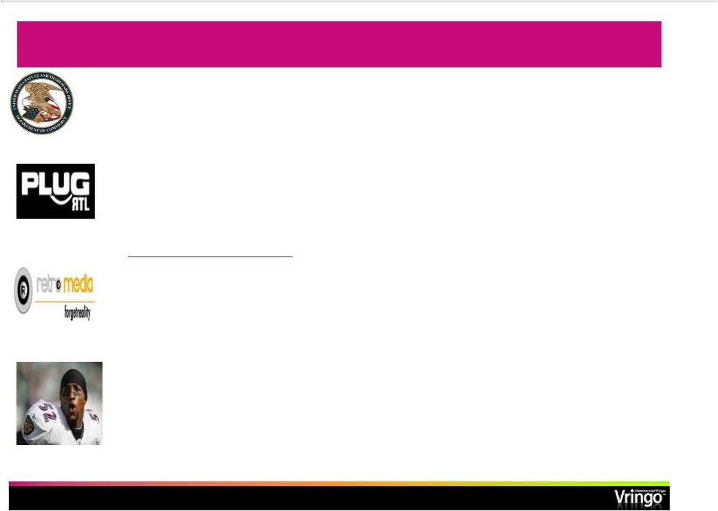
Recent VringoNews

- Issuance of first patentU.--S. Patent No. 7,761,816 (ApplicationNo.11/544,938)-- 7/20/10

- Launch broadcast marketing campaign with RTL Belgium (division of Bertelsmann) with new exclusive content from Nouvelle Star, Twilight, Desperate Housewives (www.myvringo.be)

- Retromedyaagreement to expand Vringo’sbilling coverage in the Turkish mobile market making Vringoavailable to substantially all 64 million Turkish mobile subscribers

- FusionSportsMarketing Group exclusive content from

clients including: Ray Lewis; Derrick Johnson; Donnie Avery; RashardLewis; Doc Patton; Kenny “The Jet”Smith; MarshevetMyers

  - Page 29-

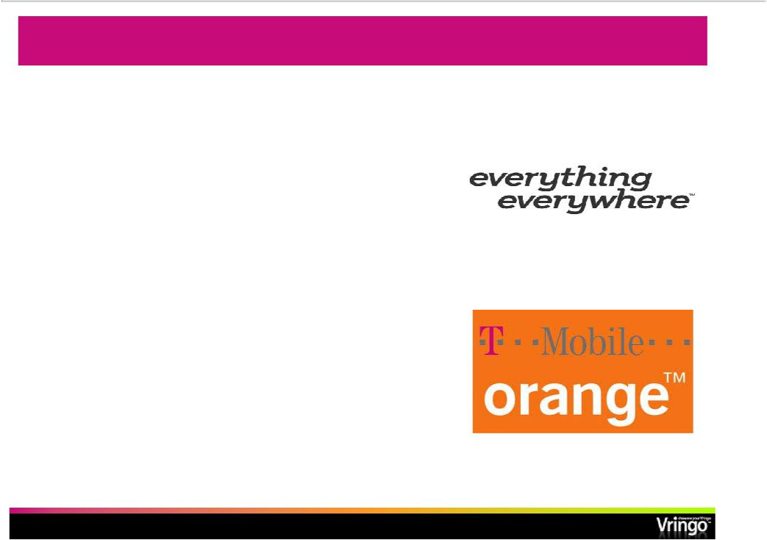
Vringo-OrangeAnnouncement– BreakthroughinEurope

Deal with Everything Everywhere Ltd.; UK’s largest mobile company to launch Vringotogether in the UK market

Everything Everywhere operates both Orange (UK) and T-Mobile (UK) with combined total of over 30 M subscribers, and is owned by France Telecom and Deutsche Telekom

First will launch with Orange (UK)

subscribers in Q4

Working hard to ensure top notch content for this critical launch

- Page 30-

Importance of Orange Launch

- First major launch in the strategic European market

- UK is a vibrant and active mobile content and application market

- Vringo has until now focused on proving its business model in smaller, less developed markets

- Terms: Orange branded service, revenue split, zero rating for data, promotion of service on Orange properties

- Page 31 -

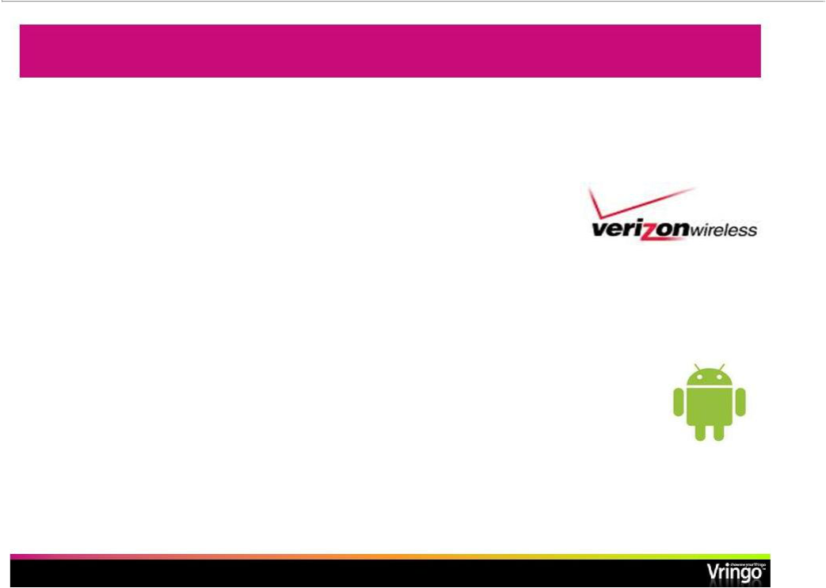
Starting in North America---with Verizon and Android

Vringohas been approved to launch on the Verizon Android App Store in Q4

Verizon has 90 M subscribers and has a culture of app promotion and usage among subscribers

Verizon has sold the most Android phones in North America

Androidhasnow overtakeniPhonein North American

unit shipments according to Gartner Aug 12, 2010 Business Week

- Page 32-

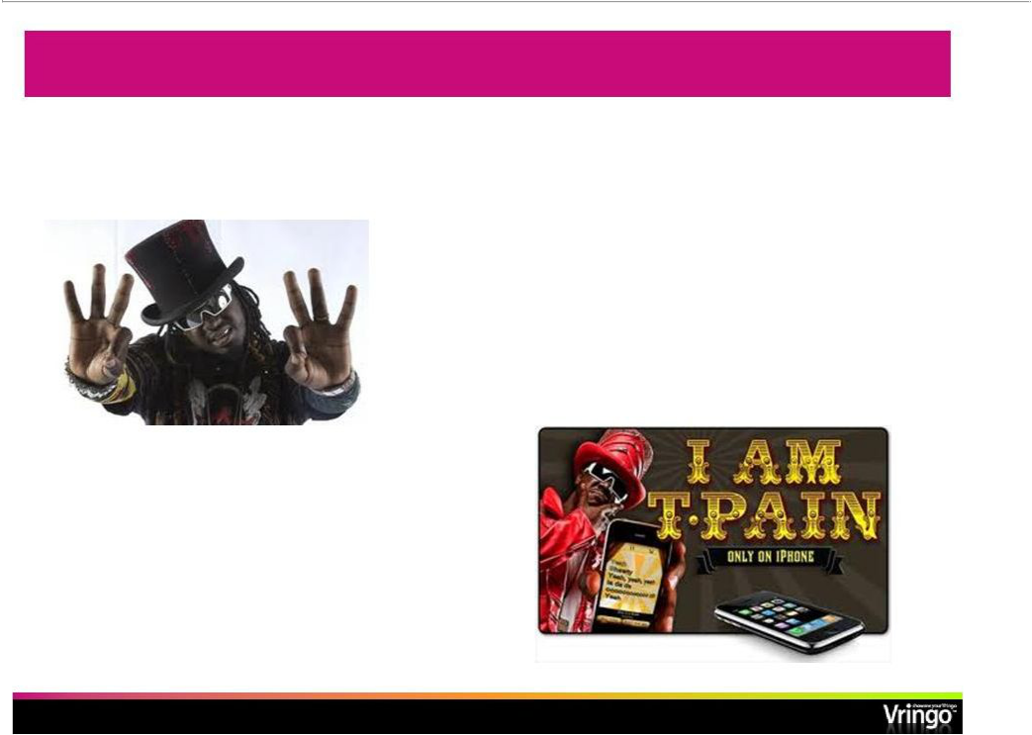
Time for T-Pain……

Vringolaunching new

application for iPhoneand

Android with T-Pain in Q4

T-Pain’s earlier iPhoneapp “I am T-Pain”became one of the most popular music apps of all time selling 1.5 M copies

- Page 33-

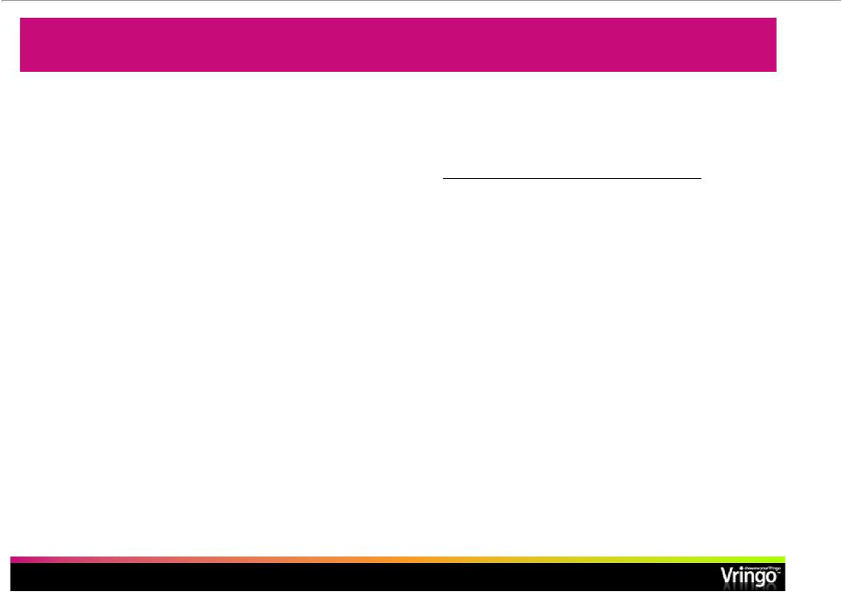
Strong Financial Position to Finance Growth

($ 000) | June 30, | December 31,
 | 2010 | 2009
 | (Unaudited) | (Audited)
Cash and cash equivalents | 9,692 | 744
Total current assets | 9,847 | 3,518
Total assets | 10,105 | 3,789
Total current liabilities | 2,320 | 3,649
Total long-term liabilities | 5,168 | 4550
Total stockholders’equity | 2,617 | (16,378)
Total liabilities and stockholders’equity | 10,105 | 3,789

- Page 34 -

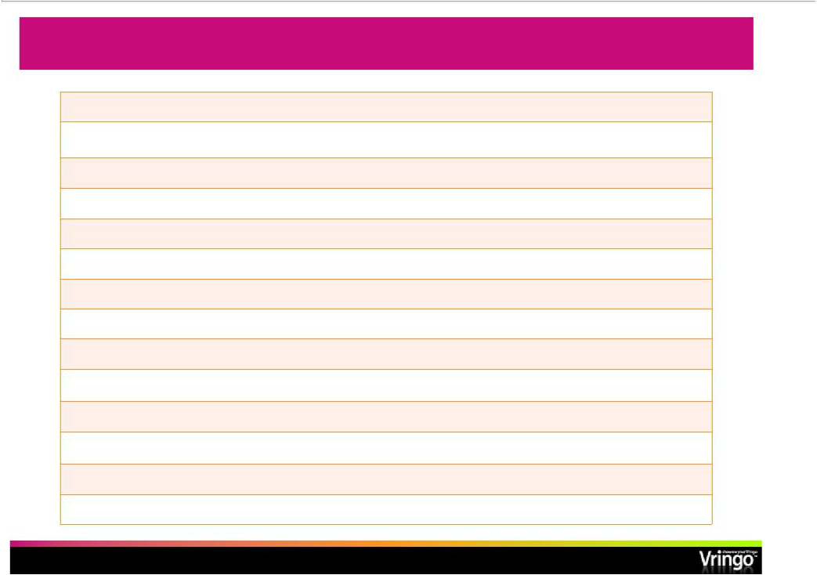
Company Snapshot

Stock Exchange/Ticker: | NYSE Amex: VRNG
VRNG Recent Price (9/8/10): | $1.25
Shares Outstanding: (6/30/10) | 5.1 M
Market Cap: | $6.4 M
2Q10 Revenue / Sequential growth rate: | $44 K / 47%
In-the-money warrants (6/30/10) | 482,346
Out-of-the-money warrants (6/30/10) | 7.7 M
2Q 10 Net Income (Loss): | ($4.6 M)
Granted stock options | 3.1 M
Total Liabilities (6/30/10): | $7.5 M
Director and Officer Ownership: | 8.7%
Warrant Exchange/Ticker: | NYSE Amex: VRNG-W
VRNG-W Recent Price (9/8/10): | $0.25
VRNG-W exercise price & expiration | $5.06; 6/21/15

- Page 35 -

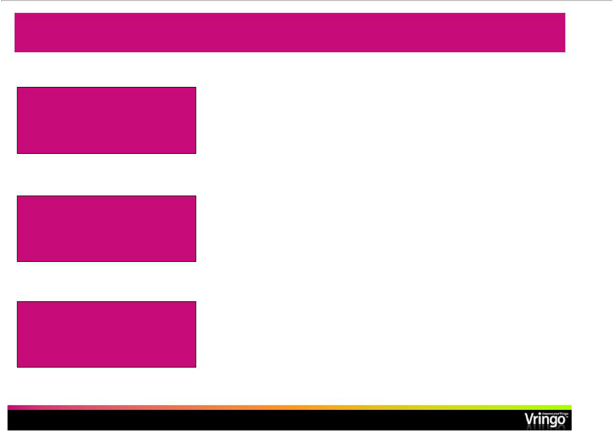
Investment Highlights

 | • | Scalable business model
 | • | Major contracts signed with international mobile carriers
Strong Platform for Growth _{and content providers}
 | • | Largest video ringtone library in the world (over 5,000 titles)
 | • | Only 17.6 M viewed mobile video in the US in Q4 2009
 |  | (1)
 | • | 4.6 B global mobile subscribers
Nascent and Fast Growing |  | (2)
 |  | (3)
Markets | • | 534 M global mobile video subscribers by 2014
Markets |  | (4)
 | • | $25 B mobile application market by 2014
 | • | $29 B mobile content market by 2012
 |  | (3)
Established and Well | • | Strong management team and BOD with experience in the
Established and Well |  | U.S. financial markets
Seasoned Management • |  | Track record of creating, running, investing and exiting
 |  | successful technology companies
- Neilsen/New York Times

- United Nations

- Multimedia Intelligence

- Juniper Research

- Page 36 -

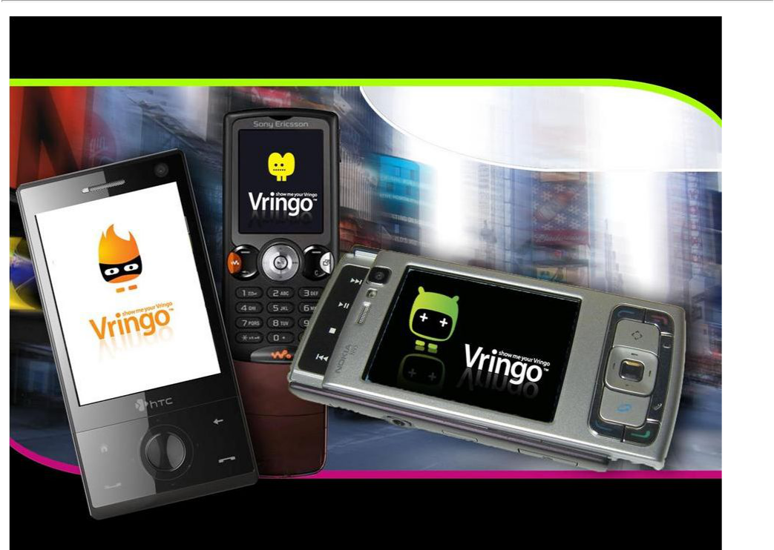
Investor Presentation

Rodman & Renshaw Annual Global Investment

Conference

September 13, 2010

Exhibit 99.2

Vringo to Present at the Rodman & Renshaw Annual Global Investment Conference in New York NEW YORK, Aug 24, 2010 (GlobeNewswire via COMTEX) —
Vringo, Inc. (NYSE Amex:VRNG), a provider of video ringtones and personalization solutions for mobile devices, today announced that Jon Medved, Chief Executive Officer of Vringo, will present at the Rodman & Renshaw Annual Global Investment Conference taking place at the New York Palace Hotel in New York City on September 12 - 15, 2010. The Company’s presentation is scheduled for Monday, September 13, at 11:40 a.m. Eastern Time.

The presentation will be broadcast live via the internet. The broadcast will include slides and an audio webcast that can be accessed from the investor relations section of the Company’s website: http://ir.vringo.com. A broadcast replay (slides and audio) will become available within approximately one hour of the live presentation and will remain available for 90 days following the conference.

About Rodman & Renshaw

Rodman & Renshaw is a full-service investment bank dedicated to providing corporate finance, strategic advisory and related services to public and private companies across multiple sectors and regions. Rodman also provides research and sales and trading services to institutional investors. Rodman is the leader in the PIPE (private investment in public equity) and RD (registered direct offering) transaction markets. According to Sagient Research Systems, Rodman has been ranked the #1 Placement Agent in terms of the aggregate number of PIPE and RD financing transactions completed every year since 2005. For more information please visit: http://www.rodm.com.

About Vringo

Founded in 2006, Vringo is bringing about the evolution of ringtones. With its award-winning video ringtone application and mobile software platform, Vringo transforms the basic act of making and receiving mobile phone calls into a highly visual, social experience. By installing Vringo’s application, which is compatible with more than 200 handsets, users can create or take video, images and slideshows from virtually anywhere and make it into their personal call signature. Vringo’s patented VringForward(TM) technology allows users to share video clips with friends with a simple call. Vringo has launched its service with various international mobile operators and dozens of content partners, and maintains a library of more than 5,000 video ringtones. For more information, visit http://ir.vringo.com.

For more information about how video ringtones work, visit www.vringo.com/p_video_ringtones.html.

Forward-Looking Statements

This press release includes forward-looking statements that involve risks and uncertainties. Forward-looking statements are statements that are not historical facts. Such forward-looking statements are

subject to risks and uncertainties, which could cause actual results to differ from the forward-looking statements. Vringo expressly disclaims any obligation to publicly update any forward-looking statements contained herein, whether as a results of new information, future events or otherwise, except as required by law.

This news release was distributed by GlobeNewswire, www.globenewswire.com

SOURCE: Vringo, Inc.

CONTACT: Vringo, Inc.

Jonathan Medved, CEO

+1 646-525-4319 x 2501

jon@vringo.com

Crescendo Communications, LLC

Investor Relations

John J. Quirk

David K. Waldman

+1 212-671-1020

vrng@crescendo-ir.com

