UNITED STATES

SECURITIES AND EXCHANGE COMMISSION

Washington, D.C. 20549

FORM 8-K

Current Report

Pursuant to Section 13 or 15(d) of the

Securities Exchange Act of 1934

Date of Report (Date of earliest event reported): March 14, 2012 (March 8, 2012)

VRINGO, INC.

(Exact Name of Registrant as Specified in its Charter)

Delaware | 001-34785 | 20-4988129
(State or other jurisdiction | (Commission | (I.R.S. Employer
of incorporation) | File Number) | Identification No.)
 | 44 W. 28th Street
 | New York, New York 10001
 | (Address of Principal Executive Offices and Zip Code)
 | Registrant’s telephone number, including area code: (646) 525-4319

Check the appropriate box below if the Form 8-K filing is intended to simultaneously satisfy the filing obligation of the registrant under any of the following provisions:

- Written communications pursuant to Rule 425 under the Securities Act (17 CFR 230.425)

- Soliciting material pursuant to Rule 14a-12 under the Exchange Act (17 CFR 240.14a-12)

- Pre-commencement communications pursuant to Rule 14d-2(b) under the Exchange Act (17 CFR 240.14d-2(b))

- Pre-commencement communications pursuant to Rule 13e-4(c) under the Exchange Act (17 CFR 240.13e-4(c))

Item 1.01. Entry Into a Material Definitive Agreement.

On March 12, 2012, Vringo, Inc., a Delaware corporation (“Vringo”), entered into an Agreement and Plan of Merger (the “Merger Agreement”) with VIP Merger Sub, Inc., a Delaware corporation and wholly-owned subsidiary of Vringo (“Merger Sub”), and Innovate/Protect, Inc., a Delaware corporation (“Innovate/Protect”), pursuant to which Innovate/Protect will merge with and into Merger Sub, with Merger Sub being the surviving corporation (the “Surviving Corporation”) through an exchange of capital stock of Innovate/Protect for capital stock of Vringo (the “Merger”).

Upon completion of the Merger, (i) each share of then-outstanding common stock of Innovate/Protect, par value $0.0001 per share (“Innovate/Protect Common Stock”) (other than shares held by Vringo, Innovate/Protect or any of their respective subsidiaries, which will be cancelled at the completion of the Merger) will be automatically converted into the right to receive the number of shares of Vringo common stock, par value $0.01 per share (“Vringo Common Stock”) equal to the Common Stock Exchange Ratio (as defined below) and (ii) each share of then-outstanding Series A Convertible Preferred Stock of Innovate/Protect, par value $0.0001 per share (total 6,968 shares outstanding) (“Innovate/Protect Series A Stock” and together with the Innovate/Protect Common Stock, “Innovate/Protect Capital Stock”) (other than shares held by Vringo, Innovate/Protect or any of their respective subsidiaries, which will be cancelled at the completion of the Merger) will be automatically converted into the right to receive the same number of shares of Vringo Series A Convertible Preferred Stock (“Vringo Preferred Stock”), which 6,968 shares shall be convertible into an aggregate of 21,026,637 shares of Vringo Common Stock. The Common Stock Exchange Ratio initially is 3.0176, subject to adjustment as set forth in the Merger Agreement. In addition, at the effective time of the Merger, Vringo will issue to the holders of Innovate/Protect Capital Stock and the holder of Innovate/Protect’s issued and outstanding warrant (on a pro rata as-converted basis) an aggregate of 15,959,838 warrants to purchase an aggregate of 15,959,838 shares of Vringo Common Stock with an exercise price of $1.76 per share. The issued and outstanding warrant to purchase Innovate/Protect Common Stock shall be exchanged for 250,000 shares of Vringo common stock and 850,000 warrants to purchase 850,000 shares of Vringo Common Stock with an exercise price of $1.76 per share.

The Vringo Preferred Stock will have the powers, designations, preferences and other rights as will be set forth in a Certificate of Designations, Preferences and Rights of Series A Convertible Preferred Stock to be filed by Vringo prior to closing, which rights include, among other things, a liquidation preference of $6,968,000 and the right to participate in any dividends and distributions paid to common stockholders on an as-converted basis. The Vringo Preferred Stock will be non-voting. Vringo may not create a class of capital stock senior or pari passu to the Vringo Preferred Stock. The Vringo Preferred Stock shall be convertible into an aggregate of 21,026,637 shares of Vringo Common Stock (subject to a provision that restricts conversion in the event the holder will acquire more than 9.99% of Vringo Common Stock after such conversion but shall be non-voting, except as required by law and in certain defined instances, including a change of control. In addition, except for certain excluded issuances, the Vringo Preferred Stock will be adjusted for issuances below the initial conversion price (as adjusted for stock splits, stock dividends and similar events) until the date Vringo Common Stock has traded an aggregate of 100,000,000 shares at above $3.00 per share (as adjusted for stock splits, stock dividends and similar events). On a change of control, except for a change of control where the holder receives all publicly traded stock, the holder of the Vringo Preferred Stock will be able to require Vringo to redeem the shares of Vringo Preferred Stock. The Vringo Preferred Stock also contains a covenant prohibiting Vringo, for a period of 18 months following the closing, from incurring indebtedness senior to the Vringo Preferred Stock in excess of $6 million (in the aggregate, including the then outstanding principal amount of existing Innovate/Protect indebtedness); provided, that, this covenant shall not apply to indebtedness secured by assets of Vringo acquired after the closing in which the lender expressly subordinates to the holder of the Vringo Preferred Stock. The holder of the Vringo Preferred Stock shall be indemnified against losses due to a buy-in following a conversion failure and Vringo shall pay the holders of the Vringo Preferred Stock a penalty of one-quarter of one percent (0.25%) for each full 15 day period during which Vringo's Common Stock is suspended from trading or if the Vringo Common Stock is delisted.

No fractional shares of Vringo Common Stock or Vringo Preferred Stock will be issued in connection with the Merger. Instead, each Innovate/Protect stockholder who would be otherwise entitled to receive a fractional share will receive from Vringo, in lieu thereof, the next highest whole number shares of Vringo Common Stock or Vringo Preferred Stock, as applicable.

At the effective time of the Merger, each outstanding and unexercised option to purchase Innovate/Protect Common Stock (each a “Innovate/Protect Stock Option”), whether vested or unvested will be converted into and become an option to purchase Vringo Common Stock and Vringo will assume such Innovate/Protect Stock Option in accordance with the terms of the Innovate/Protect 2011 Equity Incentive Plan. After the effective time of the Merger, (a) each Innovate/Protect Stock Option assumed by Vringo may be exercised solely for shares of Vringo Common Stock and (b) the number of shares of Vringo Common Stock and the exercise price subject to each Innovate/Protect Stock Option assumed by Vringo shall be determined by the Common Stock Exchange Ratio.

Immediately following the completion of the Merger, the former stockholders of Innovate/Protect are expected to own approximately 55.41% of the outstanding common stock of the combined company and the current stockholders of Vringo are expected to own approximately 44.59% of the outstanding common stock of the combined company (without taking into account any shares of Vringo common stock held by Innovate/Protect stockholders prior to the completion of the Merger and without giving effect to shares of Vringo Common Stock issuable upon conversion of the Vringo Preferred Stock or the exercise of warrants and options).

The Merger Agreement contains customary representations and warranties of each of Vringo and Innovate/Protect (many of which are qualified by concepts of knowledge, materiality and/or dollar thresholds and are further modified and limited by confidential disclosure schedules exchanged by the parties), as applicable, relating to, among other things, (a) organization and qualification; (b) subsidiaries; (c) capital structure; (d) authorization, performance and enforceability of the Merger Agreement; (e) board approval and required vote; (f) financial statements;

- absence of undisclosed liabilities and minimum cash; (h) absence of changes or events; (i) agreements, contracts and commitments; (j) material permits; (k) employee and employee benefit plans; (l) taxes; (m) tangible assets; (n) insurance; (o) intellectual property; (p) interested party transactions; (q) brokers; and (r) information related to the Proxy Statement (as defined below).

Subject to certain exceptions described below, prior to the completion of the Merger or the earlier termination of the Merger Agreement, each of Vringo and Innovate/Protect has agreed that it will not, and it will not authorize or permit its subsidiaries and/or their respective officers, directors, employees, investment bankers, attorneys, accountants and other advisors or representatives to directly or indirectly: (a) solicit, initiate, induce or take any action to facilitate, encourage, solicit, initiate or induce any action relating to, or the submission any Innovate/Protect Acquisition Proposal (as defined below) or Vringo Acquisition Proposal (as defined below), as the case may be; (b) enter into, participate or engage in discussions or negotiations in any way with any person concerning any Innovate/Protect Acquisition Proposal or Vringo Acquisition Proposal, as the case may be; (c) furnish to any person (other than the other party) any information relating to the other party or its subsidiaries or afford to any person (other than the other party) access to the business, properties, assets, books, records or other information, or to any personnel of either party or its subsidiaries, with the intent to induce or solicit the making, submission or announcement of, or the intent to encourage or assist, an Innovate/Protect Acquisition Proposal or Vringo Acquisition Proposal, as the case may be or the making of any proposal that would reasonably be expected to lead to an Innovate/Protect Acquisition Proposal or Vringo Acquisition Proposal, as the case may be; (d) approve, enforce or recommend an Innovate/Protect Acquisition Proposal or Vringo Acquisition Proposal, as the case may be; (e) enter into any agreement in principle, letter of intent, term sheet, merger agreement, acquisition agreement or other similar instrument or contract relating to an Innovate/Protect Acquisition Proposal or a Vringo Acquisition Proposal, as the case may be, or requiring either party to abandon or terminate the Merger Agreement; or (f) grant any approval pursuant to any “moratorium,” “control share acquisition,” “business combination,” “fair price” or other form of anti-takeover law to any person or transaction (other than the Merger) or waiver or release any standstill or similar agreement with respect to the equity securities of either party. “Company Acquisition Proposal” means, in summary any offer, proposal, discussions, negotiations by any person in a transaction or series of related transactions relating to issuance, sale or other disposition of securities representing 20% or more of the voting power or economic interests of Innovate/Protect or its subsidiaries. “Parent Acquisition Proposal” means any offer, proposal, discussions, negotiations by any person in a transaction or series of related transactions relating to issuance, sale or other disposition of securities representing 20% or more of the voting power or economic interests of Vringo or its subsidiaries. Notwithstanding the foregoing, in the event that either Innovate/Protect or Vringo receives an Innovate/Protect Acquisition Proposal or a Vringo Acquisition Proposal, the board of directors of each company may under certain circumstances change its recommendation for approval of the Merger if, after reviewing with outside counsel, either board determines that such Innovate/Protect Acquisition Proposal or Vringo Acquisition Proposal, as the case may be, is a superior proposal or an event, development or change in circumstances that occurs or arises following the date of the Merger Agreement, and/or the failure to effect a board recommendation change would be inconsistent with such company’s board of directors’ fiduciary duties to its stockholders.

The Merger Agreement contains certain other agreements of the parties including, among other things, that (a) Vringo will prepare and file with the Securities and Exchange Commission (“SEC”) a registration statement (the “Registration Statement”) containing a proxy statement (the “Proxy Statement”) for the vote of the Vringo stockholders to approve the Merger; (b) Vringo will take all action necessary to hold a special meeting of its stockholders to vote on the Merger; (c) each party will allow reasonable access to their books and records until the closing of the Merger; (d) each party will maintain in confidence any non-public information received from the other party; (e) individuals who are employed on a full time basis by Innovate/Protect at the time of the Merger will remain employees of the Surviving Corporation; (f) Vringo will use its reasonable best efforts to cause the shares of Vringo Common Stock to be issued pursuant to the Merger to be approved for listing on the NYSE Amex; (g) each party will continue to indemnify its own present and former directors and officers; (h) the parties will take all action to appoint certain individuals to serve on the board of directors of Vringo and as officers of Vringo; and (i) Innovate/Protect will use is commercially reasonable efforts to receive all necessary consents required to disclose to Vringo the terms and conditions of certain agreements.

The obligations of each of Vringo and Innovate/Protect to consummate the Merger are subject to the satisfaction or waiver of certain additional conditions, including, among other things, (a) the stockholders of each of Vringo and Innovate/Protect have approved the Merger and the Merger Agreement; (b) the Registration Statement has become effective; (c) the shares of Vringo Common Stock shall have been approved for listing on the NYSE Amex; (d) Vringo or Innovate/Protect, as applicable, shall have entered into certain agreements amending and restating the existing indebtedness of Innovate/Protect; (e) the representations and warranties of the other party contained in the Merger Agreement are true and correct in all material respects;
- the other party shall have performed or complied in all material respects with all agreements and covenants under the Merger Agreement; (g) the receipt of all necessary consents or approvals, including the approval of Innovate/Protect’s majority stockholder, Hudson Bay Master Fund Ltd. (which is also the holder (i) of a warrant to purchase 250,000 shares of Innovate/Protect Common Stock and (ii) a secured promissory note from Innovate/Protect in the original principal amount of $3,200,000); (h) the absence of a Material Adverse Effect (as defined in the Merger Agreement); (i) Vringo shall have received written resignations from all of the directors and officers of Innovate/Protect and its subsidiaries and (j) a letter agreement between Vringo and Hudson Bay, providing for, among other things, restrictions on the number of shares of Vringo Common Stock that Hudson Bay may sell and a right of Hudson Bay to participate in up to 25% of certain offerings conducted by Vringo, shall be effective at closing.

The closing of the Merger will take place no later than the second business day after the satisfaction or waiver of the conditions to the completion of the Merger contained in the Merger Agreement, other than the conditions which by their terms can be satisfied only as of the closing of the Merger. The completion of the Merger will occur at the time that the parties file a certificate of merger with the Secretary of State of the State of Delaware on the closing date or on such later date as Vringo, Merger Sub and Innovate/Protect mutually agree (and set forth in the certificate of merger). Since the completion of the Merger is subject to the satisfaction of other conditions, Vringo and Innovate/Protect cannot predict the exact time at which the Merger will become effective.

The Merger Agreement may be terminated at any time prior to the closing of the Merger, as follows: (a) by mutual written consent of Vringo, Merger Sub and Innovate/Protect; (b) by either Vringo or Innovate/Protect if the closing has not occurred on or before September 30, 2012; (c) by either Vringo or Innovate/Protect if any law enacted by a governmental authority prohibits the consummation of the Merger, or any governmental authority has issued an order or taken any other action which restrains, enjoins or otherwise prohibits the Merger; (d) by either Vringo or Innovate/Protect if the other party’s stockholders do not approve the Merger, unless the failure to obtain approval is attributable to a failure on the part of such party seeking to terminate the Agreement; (e) by Vringo if (i) the Innovate/Protect’s board of directors changes its recommendation for approval of the Merger, (ii) the board of directors of Innovate/Protect or any authorized committee has failed to present or recommend the approval of the Merger Agreement and the Merger to the stockholders, (iii) Innovate/Protect shall have entered or caused itself or its subsidiaries to enter, into any letter of intent, agreement in principle, term sheet, merger agreement, acquisition agreement or other similar agreement related to any Innovate/Protect Acquisition Proposal or (iv) Innovate/Protect shall have breached any term of the non-solicitation provision of the Merger Agreement; (f) by Innovate/Protect if (i) the Vringo board of directors changes their recommendation for approval of the Merger, (ii) the board of directors of Vringo or any authorized committee has failed to present or recommend the approval of the Merger Agreement and the Merger to the stockholders, (iii) Vringo shall have entered or caused itself or its subsidiaries to enter, into any letter of intent, agreement in principle, term sheet, merger agreement, acquisition agreement or other similar agreement related to any Vringo Acquisition Proposal or (iv) Vringo shall have breached any term of the non-solicitation provision of the Merger Agreement; (g) by either party if the other party, or in the case of Innovate/Protect, Vringo or Merger Sub, is in material breach of its obligations or representations or warranties under the Agreement; (h) by either Vringo or Innovate/Protect if prior to obtaining stockholder approval such party determines to enter into a definitive agreement relating to a superior proposal; or (i) by Innovate/Protect, at any time, upon payment to Vringo of a fee equal to $5,000,000.

Under certain circumstances, if the merger is terminated by either Vringo or Innovate/Protect, then Innovate/Protect shall pay to Vringo, a fee in cash equal to $5,000,000.

Under certain circumstances, if the merger is terminated by either Vringo or Innovate/Protect in connection with or due to Vringo entering into an alternate transaction constituting a superior offer, then Vringo shall pay to Innovate/Protect, a fee equal to 5% of the consideration paid to all security holders of Vringo in connection with the superior proposal in the same form as such consideration is paid to such security holders.

The foregoing summary of the Merger Agreement and the transactions contemplated thereby, does not purport to be complete and is subject to, and qualified in its entirety by, the full text of the Merger Agreement, which is filed as Exhibit 2.1 to this Current Report on Form 8-K and incorporated herein by reference. Additional information regarding Innovate/Protect can be found on its website at www.innovateprotect.com.

The Merger Agreement and the above description thereof have been included to provide investors and security holders with information regarding the terms of the agreement. They are not intended to provide any other factual information about Vringo, Innovate/Protect or their respective subsidiaries or affiliates or stockholders. The representations, warranties and covenants contained in the Merger Agreement were made only for purposes of such agreement and as of specific dates; were solely for the benefit of the parties to the Merger Agreement; and may be subject to limitations agreed upon by the parties, including being qualified by confidential disclosures made by each contracting party to the other for the purposes of allocating contractual risk between them that differ from those applicable to investors. Investors should not rely on the representations, warranties and covenants or any description thereof as characterizations of the actual state of facts or condition of Vringo, Innovate/Protect or any of their respective subsidiaries, affiliates, businesses, or stockholders. Moreover, information concerning the subject matter of the representations, warranties and covenants may change after the date of the Merger Agreement, which subsequent information may or may not be fully reflected in public disclosures by Vringo or Innovate/Protect. Accordingly, investors should read the representations and warranties in the Merger Agreement not in isolation but only in conjunction with the other information about Vringo or Innovate/Protect and their respective subsidiaries that Vringo includes in reports, statements and other filings it makes with the SEC.

Item 2.02. Results of Operations and Financial Condition.

On March 14, 2012, Vringo announced certain of its estimated unaudited financial results for the full year ended December 31, 2011, a copy of which is attached hereto as Exhibit

99.4. Such estimated results are preliminary as Vringo has not completed all of the procedures that it would normally conduct in connection with the year-end compilation of its financial results

and Vringo’s independent auditors have not completed their normal audit procedures for the year ended December 31, 2011. There can be no assurance that Vringo's final results for this period

will not differ from these estimates. These estimates should not be viewed as a substitute for full year-end financial statements prepared in accordance with accounting principles generally

accepted in the United States of America.

The information in Exhibit 99.4 is furnished pursuant to Item 2.02 and shall not be deemed to be “filed” for the purposes of Section 18 of the Securities Exchange Act of 1934, as amended, (the “Exchange Act”) or otherwise subject to the liabilities of that section, nor shall it be deemed incorporated by reference in any filing under the Securities Act of 1933, as amended, or the Exchange Act.

Item 5.02. Departure of Directors or Certain Officers; Election of Directors; Appointment of Certain Officers; Compensatory Arrangements of Certain Officers.

- Mr. Jonathan Medved resigned from his position as Chief Executive Officer and a director of Vringo effective March 8, 2012. In connection with his resignation, Mr. Medved and Vringo (Israel) Ltd. entered into a Separation Letter Agreement (the “Separation Agreement”) effective March 8, 2012. Under the terms of the Separation Agreement, and consistent with Mr. Medved’s employment agreement and amendment thereto, Mr. Medved will be entitled to receive salary and benefits until February 6, 2013, and continue to vest stock options after his termination. In addition, options granted to Mr. Medved at $0.01 will fully vest as of June 21, 2012 and the expiration date for exercising all options vested on or before June 21, 2013 is extended to September 21, 2013. Furthermore, Vringo’s Board of Directors granted Mr. Medved an additional 100,000 options at an exercise price of $1.72 per share.

The foregoing description of the terms of the Separation Agreement does not purport to be complete and is qualified in its entirety by reference to the Separation Agreement, a copy of which is attached to this Report as Exhibit 99.5 and is incorporated by reference to this Report.

- On March 11, 2012, the Board of Directors promoted Andrew D. Perlman to the position of Vringo’s Chief Executive Officer, effective March 11, 2012, to fill the vacancy created by the resignation of Jonathan Medved. Mr. Perlman will continue to serve as the President and a director of Vringo. Mr. Perlman’s biographical information is set forth below.

Andrew D. Perlman, Age 34, has served as a director of Vringo since September 2009 and as the President since April 2010. From February 2009 to March 2010, Mr. Perlman served as vice president of global digital business development at EMI Music Group, where he was responsible for leading distribution deals with digital partners for EMI’s music and video content. From May 2007 to February 2009, Mr. Perlman served as Vringo’s General Manager of our U.S. operations as well as Senior Vice President Content & Community. In this position,

Mr. Perlman managed Vringo’s United States operations and led Vringo’s content and social community partnerships. From June 2005 to May 2007, Mr. Perlman was senior vice president of digital media at Classic Media, Inc., a global media company with a portfolio of kids, family and pop-culture entertainment brands. In his position with Classic Media, Mr. Perlman led the company’s partnerships across video gaming, online and mobile distribution. From June 2001 to May 2005, Mr. Perlman served as general manager for the Rights Group, LLC and its predecessors, a mobile content and mobile fan club company, where he oversaw mobile marketing campaigns for major international brands such as Visa and Pepsi. In this role, Mr. Perlman developed and negotiated relationships with technology vendors such as Comverse, Mobile 365 and Mobliss. He was also responsible for selling and executing mobile products including the Britney Spears mobile fan club and Justin Timberlake and American Idol branded karaoke. In addition he also participated in sponsorship deals between Britney Spears and Samsung and Justin Timberlake and Orange U.K. Mr. Perlman holds a Bachelor of Arts in Business Administration from the School of Business and Public Management at George Washington University.

In connection with his appointment as Chief Executive Officer, Vringo’s Board of Directors approved an increase in Mr. Perlman’s salary to $250,000 per year and the payment of severance for one year in the event he is no longer the Chief Executive Officer in connection with a change of control. In addition, the Board approved the grant of options to purchase 450,000 shares at an exercise price of $1.72 per share. Vringo and Mr. Perlman expect to enter into an amendment to his employment agreement to memorialize the foregoing terms.

Item 7.01. Regulation FD Information.

On March 14, 2012, Vringo and Innovate/Protect made available the following supplemental information regarding Innovate/Protect’s litigation in the United States District Court, Eastern District of Virginia, Norfolk Division against the defendants AOL, Inc., Google, Inc., IAC Search & Media, Inc., Gannett Company, Inc., and Target Corporation for patent infringement regarding two of the Patents purchased from Lycos, Inc. (U.S. Patent Nos. 6,314,420 and 6,775,664):

- Attached hereto as Exhibit 99.6 is a copy of the complaint filed by I/P Engine, Inc. (“I/P Engine”), a wholly-owned subsidiary of Innovate/Protect, against the defendants AOL, Inc., Google, Inc., IAC Search & Media, Inc., Gannett Company, Inc., and Target Corporation.

- Attached hereto as Exhibit 99.7 is a description of I/P Engine’s litigation in the United States District Court, Eastern District of Virginia, against the defendants AOL, Inc., et al.

- Attached hereto as Exhibit 99.8 is a copy of the Rule 16(b) Scheduling Order, dated February 15, 2012, in the matter of I/P Engine v. AOL, Inc., et. al. In addition, on March 14, 2012, Vringo and Innovate/Protect made available the following information regarding Innovate/Protect:
- certain biographical information regarding the directors, management and a significant consultant of Innovate Protect, a copy of which is attached hereto as Exhibit 99.9.

- Innovate/Protect’s Consolidated Financial Statements as of December 31, 2011 and for the period from June 8, 2011 (inception) to December 31, 2011, together with the report of Independent Registered Public Accounting Firm, Grant Thornton LLP, dated March 2, 2012, a copy of which is attached hereto as Exhibit 99.10.

The information furnished by Vringo and Innovate/Protect pursuant to this Item, including Exhibits 99.6, 99.7, 99.8, 99.9 and 99.10, shall not be deemed “filed” for purposes of Section 18 of the Securities Exchange Act of 1934, as amended (the “Exchange Act”), or otherwise subject to the liability of that section, and shall not be deemed to be incorporated by reference into any filing under the Securities Act of 1933, as amended (the “Act”), or the Exchange Act.

Item 8.01. Other Events.

On March 14, 2012, Vringo issued a joint press release with Innovate/Protect announcing the entry into the Merger Agreement. A copy of the joint press release is attached hereto as Exhibit 99.1.

Also on March 14, 2012, Vringo and Innovate/Protect will hold a joint conference call with investors, analysts and other interested parties to provide supplemental information regarding the proposed transaction. The slides to be used in connection with the conference call are attached hereto as Exhibit 99.2 and the press release for the conference call is attached hereto as Exhibit 99.3.

Each of the joint press release, slides and conference call press release is incorporated by reference herein.

Cautionary Note Regarding Forward-Looking Statements

Statements in this report regarding the proposed transaction between Vringo, Merger Sub and Innovate/Protect; the expected timetable for completing the transaction; the potential value created by the proposed merger for Vringo's and Innovate/Protect's stockholders; the potential of the combined companies' technology platform; our respective or combined ability to raise capital to fund our combined operations and business plan; the continued listing of Vringo's or the combined company's securities on the NYSE Amex; market acceptance of Vringo products; our collective ability to protect our intellectual property rights; competition from other providers and products; our ability to license and monetize the patents owned by Innovate/Protect, including the outcome of the litigation against online search firms and other companies; the combined company's management and board of directors; and any other statements about Vringo's or Innovate/Protect's management teams' future expectations, beliefs, goals, plans or prospects constitute forward-looking statements within the meaning of the Private Securities Litigation Reform Act of 1995. Any statements that are not statements of historical fact (including statements containing the words "believes," "plans," "could," "anticipates," "expects," "estimates," "plans," "should," "target," "will," "would" and similar expressions) should also be considered to be forward-looking statements. There are a number of important factors that could cause actual results or events to differ materially from those indicated by such forward-looking statements, including: the risk that Vringo and Innovate/Protect may not be able to complete the proposed transaction; the inability to realize the potential value created by the proposed merger for Vringo's and Innovate/Protect's stockholders; our respective or combined inability to raise capital to fund our combined operations and business plan; Vringo's or the combined company's inability to maintain the listing of our securities on the NYSE Amex; the potential lack of market acceptance of Vringo's products; our collective inability to protect our intellectual property rights; potential competition from other providers and products; our inability to license and monetize the patents owned by Innovate/Protect, including the outcome of the litigation against online search firms and other companies; and other risks and uncertainties more fully described in Vringo's Annual Report on Form 10-K for the year ended December 31, 2010 and its Quarterly Reports on Form 10-Q for the quarters ended March 31, 2011, June 30, 2011 and September 30, 2011, each as filed with the SEC, as well as the other filings that Vringo makes with the SEC. Investors and stockholders are also urged to read the risk factors set forth in the proxy statement/prospectus carefully when they are available.

In addition, the statements in this report reflect our expectations and beliefs as of the date of this release. We anticipate that subsequent events and developments will cause our expectations and beliefs to change. However, while we may elect to update these forward-looking statements publicly at some point in the future, we specifically disclaim any obligation to do so, whether as a result of new information, future events or otherwise. These forward-looking statements should not be relied upon as representing our views as of any date after the date of this report.

Important Additional Information Will Be Filed with the SEC

This communication does not constitute an offer to sell or the solicitation of an offer to buy any securities of Vringo, or Innovate/Protect or the solicitation of any vote or approval. In connection with the proposed transaction, Vringo will file with the SEC a Registration Statement on Form S-4 containing a proxy statement/prospectus. The proxy statement/prospectus will contain important information about Vringo, Innovate/Protect, the transaction and related matters. Vringo will mail or otherwise deliver the proxy statement/prospectus to its stockholders and the stockholders of Innovate/Protect when it becomes available. Investors and security holders of Vringo and Innovate/Protect are urged to read carefully the proxy statement/prospectus relating to the merger (including any amendments or supplements thereto) in its entirety when it is available, because it will contain important information about the proposed transaction.

Investors and security holders of Vringo will be able to obtain free copies of the proxy statement/prospectus for the proposed merger (when it is available) and other documents filed with the SEC by Vringo through the website maintained by the SEC at www.sec.gov. In addition, investors and security holders of Vringo and Innovate/Protect will be able to obtain free copies
of the proxy statement/prospectus for the proposed merger (when it is available) by contacting Vringo, Inc., Attn.: Cliff Weinstein, VP Corporate Development, at 44 W. 28th Street, New York, New York 10001, or by e-mail at cliff@vringo.com. Investors and security holders of Innovate/Protect will also be able to obtain free copies of the proxy statement/prospectus for the merger by contacting Innovate/Protect, Attn.: Chief Operating Officer, 380 Madison Avenue, 22nd Floor, New York, NY 10017, or by e-mail at info@innovateprotect.com.

Vringo and Innovate/Protect, and their respective directors and certain of their executive officers, may be deemed to be participants in the solicitation of proxies in respect of the transactions contemplated by the agreement between Vringo and Innovate/Protect. Information regarding Vringo's directors and executive officers is contained in Vringo's Annual Report on Form 10-K for the fiscal year ended December 31, 2010, which was filed with the SEC on March 31, 2011, and in its proxy statement prepared in connection with its 2011 Annual Meeting of Stockholders, which was filed with the SEC on May 25, 2011. Information regarding Innovate/Protect's directors and officers and a more complete description of the interests of Vringo's directors and officers in the proposed transaction will be available in the proxy statement/prospectus that will be filed by Vringo with the SEC in connection with the proposed transaction.

Item 9.01. Financial Statements and Exhibits.

(d) Exhibits
2.1 | Agreement and Plan of Merger by and among Vringo, Inc., VIP Merger Sub, Inc. and Innovate/Protect, Inc., dated as of March 12, 2012
99.1 | Joint Press Release, dated March 14, 2012
99.2 | Investor Presentation Slides, dated March 14, 2012
99.3 | Press Release for Conference Call with Investors and Analysts, dated March 14, 2012
99.4 | Vringo unaudited financial results for the year ended December 31, 2011
99.5 | Separation Agreement between Jonathan Medved and Vringo (Israel) Ltd., dated as of March 8, 2012
99.6 | I/P Engine Complaint
99.7 | Description of I/P Engine Litigation
99.8 | Rule 16(b) Scheduling Order, dated February 15, 2012, relating to the I/P Engine Litigation
99.9 | Innovate/Protect Directors/Management/Significant Consultant Biographies
99.10 | Innovate/Protect’s Consolidated Financial Statements as of December 31, 2011 and for the period from June 8, 2011 (inception) to December 31, 2011, together with the
 | report of Independent Registered Public Accounting Firm, Grant Thornton LLP, dated March 2, 2012

SIGNATURES

Pursuant to the requirements of the Securities Exchange Act of 1934, the registrant has duly caused this report to be signed on its behalf by the undersigned hereunto duly authorized.

 | VRINGO, INC.
Dated: March 14, 2012 | By: | /s/ Andrew D. Perlman
 |  | Name: | Andrew D. Perlman
 |  | Title: | Chief Executive Officer

 | EXHIBIT INDEX
2.1 | Agreement and Plan of Merger by and among Vringo, Inc., VIP Merger Sub, Inc. and Innovate/Protect, Inc., dated as of March 12, 2012
99.1 | Joint Press Release, dated March 14, 2012
99.2 | Investor Presentation Slides, dated March 14, 2012
99.3 | Press Release for Conference Call with Investors and Analysts, dated March 14, 2012
99.4 | Vringo unaudited financial results for the year ended December 31, 2011
99.5 | Separation Agreement between Jonathan Medved and Vringo (Israel) Ltd., dated as of March 8, 2012
99.6 | I/P Engine Complaint
99.7 | Description of I/P Engine Litigation
99.8 | Rule 16(b) Scheduling Order, dated February 15, 2012, relating to the I/P Engine Litigation
99.9 | Innovate/Protect Directors/Management/Significant Consultant Biographies
99.10 | Innovate/Protect’s Consolidated Financial Statements as of December 31, 2011 and for the period from June 8, 2011 (inception) to December 31, 2011, together with the
 | report of Independent Registered Public Accounting Firm, Grant Thornton LLP, dated March 2, 2012

EXECUTION COPY

AGREEMENT AND PLAN OF MERGER

BY AND AMONG

VRINGO, INC.,

VIP MERGER SUB, INC.

AND

INNOVATE/PROTECT, INC.

Dated as of March 12, 2012

EXHIBITS

EXHIBIT A

EXHIBIT B

EXHIBIT C

EXHIBIT D

EXHIBIT E

EXHIBIT F

EXHIBIT G

EXHIBIT H

EXHIBIT I

EXHIBIT J

EXHIBIT K

EXHIBIT L

EXHIBIT M

Reserved

Form of Certificate of Merger

Form of Certificate of Designations

Reserved

Reserved

Form of Series 1 Warrant

Form Series 2 Warrant

Form of Amended and Restated Senior Secured Promissory Note

Form of Amended and Restated Pledge and Security Agreement

Form of Amended and Restated Guaranty

Form of Certificate of Incorporation of Surviving Corporation

Form of Bylaws of Surviving Corporation

Form of Hudson Bay Letter Agreement

- i -

 | DEFINED TERMS INDEX
Agreement |  | Preamble
Business Day | 1.2
Certificate of Merger | 1.3
Closing | 1.2
Closing Date | 1.2
Code |  | Preamble
Common Stock Exchange Ratio |  | 1.7(a)
Company |  | Preamble
Company Capital Stock |  | 1.7(c)
Company Certificate |  | 1.7(c)
Company Certificates |  | 1.7(c)
Company Common Stock |  | 1.7(a)
Company Disclosure Schedule |  | Article II
Company Employee Plans |  | 2.16(a)
Company Intellectual Property |  | 2.20(a)
Company Material Adverse Effect |  | Article II
Company Material Contracts |  | 2.9(a)
Company Option Plan |  | 1.10(a)
Company Stock Options |  | 2.3(b)
Company Warrant |  | 2.3(b)
DGCL |  | Preamble
Effective Time | 1.3
Equitable Exceptions |  | 2.4(b)
ERISA |  | 2.16(a)
ERISA Affiliate |  | 2.16(a)
Governmental Authority |  | 2.4(d)
Insurance Policies |  | 2.19(a)
Interim Period |  | 4.1(a)
knowledge of the Company |  | Article II
Liens |  | 2.2(d)
Material Permits |  | 2.11(a)
Merger |  | Preamble
Merger Consideration |  | 1.7(c)
Merger Shares |  | 1.7(c)
Merger Sub |  | Preamble
Merger Sub Common Stock | 1.11
Most Recent Balance Sheet | 2.6
Most Recent Balance Sheet Date | 2.6
Other Filings |  | 5.1(b)
Parent |  | Preamble
Parent Common Stock |  | 1.7(a)
Parent Disclosure Schedule |  | Article III
Parent Material Contracts |  | 3.9(a)

- ii -

Parent SEC Reports | 3.5(a)
Parent’s Most Recent Balance Sheet | 3.6
Parent’s Most Recent Balance Sheet Date | 3.6
Parties | Preamble
Party | Preamble
Personal Property | 3.24(b)
Returns | 2.15(b)
Securities Act | 2.2(d)
Series A Stock | 1.7(b)
Subsidiary | 2.2(f)
Surviving Corporation | 1.1
Takeover Laws | 4.2(a)
Tax | 2.15(a)
Termination Fee | 7.3(b)

- iii -

AGREEMENT AND PLAN OF MERGER (this “Agreement”), made and entered into as of March 12, 2012 by and among VRINGO, INC., a Delaware corporation (“Parent”), VIP MERGER SUB, INC., a Delaware corporation and wholly owned Subsidiary of Parent (“Merger Sub”), and INNOVATE/PROTECT, INC., a Delaware corporation (the “Company”). Parent, Merger Sub and the Company are sometimes referred to herein each individually as a “Party” and, collectively, as the “Parties.”

WHEREAS, the Boards of Directors of Parent, Merger Sub and the Company have each declared it to be advisable and in the best interests of each corporation and their respective stockholders that Parent and the Company combine in order to advance their long-term business interests;

WHEREAS, the Boards of Directors of Parent, Merger Sub and the Company have each approved this Agreement and the merger of the Company with and into Merger Sub (the “Merger”), in accordance with the General Corporation Law of the State of Delaware (the “DGCL”) and the terms and conditions set forth herein, which Merger will result in, among other things, the surviving company becoming a wholly owned subsidiary of Parent and the Company stockholders becoming stockholders of Parent; and

WHEREAS, for federal income tax purposes, it is intended that the Merger qualify as a tax-free reorganization within the meaning of Section 368(a) of the Internal Revenue Code of 1986, as amended (the “Code”) and the regulations promulgated thereunder.

NOW, THEREFORE, in consideration of the foregoing and the mutual representations, warranties, covenants and agreements herein contained, and other good and valuable consideration, the receipt and sufficiency of which is hereby acknowledged, the Parties hereby agree as follows:

ARTICLE I

THE MERGER

1.1 The Merger. At the Effective Time (as defined in Section 1.3), in accordance with the DGCL and the terms and conditions of this Agreement, the Company shall be merged with and into Merger Sub. From and after the Effective Time, the separate corporate existence of the Company shall cease and Merger Sub, as the surviving corporation in the Merger, shall continue its existence under the DGCL as a wholly owned subsidiary of Parent. Merger Sub as the surviving corporation after the Merger is hereinafter sometimes referred to as the “Surviving Corporation.”

1.2 Closing. Unless this Agreement shall have been terminated and the transactions contemplated by this Agreement abandoned pursuant to the provisions of Article VIII, and subject to the satisfaction or waiver, as the case may be, of the conditions set forth in Article VI, the closing of the Merger and other transactions contemplated by this Agreement (the “Closing”) shall take place at 10:00 a.m. (eastern standard time) on a date to be mutually agreed upon by the Parties (the “Closing Date”), which date shall be no later than the second Business Day (as defined below) after all the conditions set forth in Article VI (excluding conditions that, by their nature, cannot be satisfied until the Closing) shall have been satisfied or waived in accordance with Section 7.5, unless another time and/or date is agreed to in writing by the Parties. The Closing shall take place at the offices of Mintz, Levin, Cohn, Ferris, Glovsky and Popeo, P.C., 666 Third Avenue, New York, New York 10017. For purposes of this Agreement, “Business Day” shall mean any day on which banks are permitted to be open in New York, New York.

1.3 Effective Time. Subject to the provisions of this Agreement, on the Closing Date or as soon thereafter as is practicable the Parties shall cause the Merger to become effective by

executing and filing in accordance with the DGCL a certificate of merger with the Secretary of State of the State of Delaware in substantially the form of Exhibit B attached hereto (the

“Certificate of Merger”), the date and time of such filing, or such later date and time as may be agreed upon by the Parties and specified therein, being hereinafter referred to as the “Effective

Time.”

1.4 Effect of the Merger. At the Effective Time, the Merger shall have the effects set forth in this Agreement and in the applicable provisions of the DGCL. Without limiting the generality of the foregoing, and subject thereto, at the Effective Time all the assets, properties, rights, privileges, immunities, powers and franchises of the Company and Merger Sub shall vest in the Surviving Corporation, and all debts, liabilities and duties of the Company and Merger Sub shall become the debts, liabilities and duties of the Surviving Corporation.

1.5 Certificate of Incorporation and Bylaws of the Surviving Corporation. From and after the Effective Time and without further action on the part of the Parties, the Certificate of Incorporation and Bylaws of Merger Sub immediately prior to the Effective Time shall be the Certificate of Incorporation and Bylaws of the Surviving Corporation, in the forms attached as Exhibit K and Exhibit L hereto, respectively, until amended in accordance with the respective terms thereof; provided, however, that, notwithstanding the foregoing, the parties shall take all action necessary to amend the Certificate of Incorporation of the Surviving Corporation so that Article First of the Certificate of Incorporation of the Surviving Corporation shall be amended to read as follows: “The name of the corporation is Innovate/Protect, Inc.”

1.6 Directors and Officers. The initial directors and officers of the Surviving Corporation, each to hold office in accordance with the Certificate of Incorporation and the Bylaws of the Surviving Corporation shall be as set forth in Section 5.11 hereto.

1.7 Conversion of Company Common Stock, Etc. At the Effective Time, by virtue of the Merger and without any action on the part of the Parties or the holders of the following securities:

- Each share of the Company’s common stock, par value $0.0001 per share (“Company Common Stock”) issued and outstanding immediately prior to the Effective Time (other than any shares of Company Common Stock to be canceled and retired pursuant to Section 1.8) shall be converted automatically into the right to receive that number (expressed as a decimal) of fully paid and non-assessable shares of common stock of Parent, par value $0.01 per share (the “Parent Common Stock”) equal to the Common Stock Exchange Ratio. For purposes of this Agreement, the “Common Stock Exchange Ratio” shall initially be 3.0176, subject to adjustment as set forth in Section 1.13.

  - 2 -

- Each share of the Company’s Series A Convertible Preferred Stock, par value $0.0001 per share (the “Series A Stock”), issued and outstanding immediately prior to the Effective Time (other than any shares of Series A Stock to be canceled and retired pursuant to Section 1.8) shall be converted automatically into the right to receive that number (expressed as a decimal) of fully paid and non-assessable shares of Parent Series A Convertible Preferred Stock (“Parent Preferred Stock”) equal to the Series A Exchange Ratio. For purposes of this Agreement, the “Series A Exchange Ratio” shall be 1.0. The Parent Preferred Stock to be issued to the holders of the Company Series A Stock shall be convertible into an aggregate of 21,026,637 shares of Parent Common Stock (the “Conversion Shares”) (subject to adjustment as set forth in Section 1.13) and shall have the rights, preferences and privileges as set forth in the Certificate of Designations as set forth in Exhibit C attached hereto.

- From and after the Effective Time, all shares of Company Common Stock and Series A Stock (together, “Company Capital Stock”) (other than any shares of Company Capital Stock to be canceled and retired pursuant to Section 1.8) shall be deemed canceled and shall cease to exist, and each holder (each, a “Company Stockholder”) of a certificate which previously represented any such share of Company Capital Stock (each, a “Company Certificate” and, collectively, the “Company Certificates”) shall cease to have any rights with respect thereto except for the right to receive the Merger Consideration in accordance with Section 1.15 or as otherwise set forth herein or under applicable law. The holders of Company Capital Stock immediately prior to the Effective Time shall be entitled to receive the shares of Parent Common Stock and Parent Preferred Stock into which the shares of Company Capital Stock held by each of them were converted pursuant to this Section 1.7 upon delivery of the certificates representing such shares of Company Capital Stock to Parent, such shares of Parent Common Stock and Parent Preferred Stock are collectively referred to herein as the “Merger Shares.” The Merger Shares, together with the Series 1 Warrants and Series 2 Warrants are collectively referred to herein as the “Merger Consideration.”

1.8 Cancellation of Shares. At the Effective Time, each share of Company Capital Stock either held in the Company’s treasury or owned by Parent or any direct or indirect wholly owned Subsidiary (as defined in Section 2.2(f)) of Parent or the Company, in each case, immediately prior to the Effective Time, if any, shall be canceled and extinguished without any conversion thereof or payment therefor.

1.9 No Further Ownership Rights in Company Stock. The Merger Consideration to be issued upon the surrender for exchange of Company Capital Stock in accordance with the terms of this Article I (together with any cash in lieu of fractional shares paid in respect thereof) shall be deemed to have been issued in full satisfaction of all rights pertaining to such Company Capital Stock under this Article I. If, after the Effective Time, Company Certificates are presented to Parent or Surviving Corporation for any reason, they shall be canceled and exchanged as provided in this Article I.

- 3 -

1.10 Company Stock Options And Warrants. At the Effective Time:

- Each Company Stock Option that is outstanding and unexercised immediately prior to the Effective Time, whether or not vested, shall be converted into and become an option to purchase Parent Common Stock (a “New Company Option”) as set forth in this Section 1.10, and Parent shall assume such Company Stock Option in accordance with the terms of the Company’s 2011 Equity Incentive Plan (the “Company Option Plan”) and the terms of the agreement under which such Company Stock Option was issued (except that the call feature of such Company Stock Option shall cease to be of any force and effect), except that the form of the New Company Option shall be substantially similar to the Series 2 Warrant (as defined below). All rights with respect to Company Common Stock under Company Stock Options assumed by Parent shall thereupon be converted into rights with respect to Parent Common Stock. Accordingly, from and after the Effective Time: (i) each Company Stock Option assumed by Parent may be exercised solely for shares of Parent Common Stock; (ii) the number of shares of Parent Common Stock subject to each Company Stock Option assumed by Parent shall be determined by multiplying the number of shares of Company Common Stock that were subject to such Company Stock Option immediately prior to the Effective Time by the Common Stock Exchange Ratio, and rounding the resulting number in accordance with Section 1.14 hereof; (iii) the per share exercise price for the Parent Common Stock issuable upon exercise of each Company Stock Option assumed by Parent shall be determined by dividing the per share exercise price of Company Common Stock subject to such Company Stock Option, as in effect immediately prior to the Effective Time, by the Common Stock Exchange Ratio, and rounding the resulting exercise price up to the nearest whole cent; and (iv) any restriction on the exercise of any Company Stock Option assumed by Parent shall continue in full force and effect and the term, exercisability, vesting schedule and other provisions of such Company Stock Option shall otherwise remain unchanged as a result of the assumption of such Company Stock Option; provided, however, that the board of directors of Parent or a committee thereof shall succeed to the authority and responsibility of the board of directors of the Company or any committee thereof with respect to each Company Stock Option assumed by Parent. Prior to the Effective Time, the Company and Parent shall take all action that may be necessary (under the Company Stock Plans and otherwise) to effectuate the provisions of this Section 1.10(a) and to ensure that, from and after the Effective Time, holders of Company Stock Options have no rights with respect thereto other than those specifically provided in this Section 1.10(a).

- The Company Warrant that is outstanding and unexercised immediately prior to the Effective Time, shall be exchanged for 250,000 shares of Parent Common Stock and 850,000 warrants to purchase 850,000 shares of Parent Common Stock with an exercise price of $1.76 per share (“New Company Warrant”), with the form of the New Company Warrant to be in the form of the Series 2 Warrant. Prior to the Effective Time, the Company shall take all actions necessary or reasonably requested by Parent (including obtaining any necessary consents) to effectuate the provisions of this Section 1.10(b).

1.11 Capital Stock of Company. Each share of common stock of Merger Sub, par value $0.01 per share (the “Merger Sub Common Stock”) issued and outstanding immediately prior to the Effective Time shall, from and after the Effective Time, remain outstanding and shall constitute the only outstanding shares of common stock of the Surviving Corporation.

- 4 -

1.12 Issuance of Parent Warrants. At the Effective Time, Parent will issue to the Company stockholders including the holder of the Company Warrants, (on a pro rata as-converted basis) the following:

- an aggregate of 8,299,116 warrants to purchase an aggregate of 8,299,116 shares of Parent Common Stock with an exercise price of $1.76 per share, in the form attached hereto as Exhibit F (the “Series 1 Warrants”); and

- an aggregate of 7,660,722 warrants to purchase an aggregate of 7,660,722 shares of Parent Common Stock with an exercise price of $1.76 per share, in the form attached hereto as Exhibit G (the “Series 2 Warrants”).

1.13 Adjustments to Exchange Ratios. Notwithstanding any other provision of this Agreement, the Common Stock Exchange Ratio and the number of Conversion Shares shall not be adjusted, without the prior written consent of the Company; provided, however, that such prior written consent shall not be unreasonably conditioned, withheld or delayed with regard to any such adjustments being made with respect to a reverse split of the equity securities of the Parent undertaken for the purpose of maintaining Parent’s listing on NYSE Amex or as contemplated by Section 3.4.

1.14 No Fractional Shares. No certificate or scrip representing fractional shares of Parent Common Stock or Parent Preferred Stock shall be issued upon the surrender of Company Certificates for exchange, and such fractional share interests will not entitle the owner thereof to vote or to any other rights of a stockholder of Parent. Notwithstanding any other provision of this Agreement, each holder of shares of Company Capital Stock who would otherwise be entitled to receive a fraction of a share of Parent Common Stock or Parent Preferred Stock (after taking into account all Company Certificates delivered by such holder) shall receive from Parent, in lieu thereof, the next highest number of whole shares of Parent Common Stock or Parent Preferred Stock, as applicable.

1.15 Exchange of Certificates. As promptly as practicable before or after the Effective Time, Parent (or its designee or exchange agent, if reasonably determined by the parties to be necessary) will send to each Company Stockholder a letter of transmittal (the form of which shall be mutually agreed by and between the Parent and the Company, each acting reasonably) for use in enabling Parent to issue one or more certificates representing the prescribed number of shares of Parent Common Stock or Parent Preferred Stock to which such Company Stockholder may be entitled as determined in accordance with the provisions of this Agreement. Upon delivery of a duly executed letter of transmittal, such Company Stockholder will be entitled to receive the portion of the Merger Consideration to which such Company Stockholder may be entitled (as determined in accordance with the provisions of this Agreement). It is intended that such letter of transmittal will contain provisions requiring each executing Company Stockholder thereof to (a) acknowledge and agree to be bound by the terms and conditions applicable to the Company Stockholders, including, without limitation Section 1.7 of this Agreement, (b) make representations and warranties with respect to ownership of the Company Capital Stock owned or held by such Company Stockholder at that time, and (c) waive all appraisal or dissenter’s rights, in each case, in a form reasonably satisfactory to Parent and as a condition precedent to Parent’s obligation to issue shares of Parent Common Stock to such Company Stockholder.

- 5 -

1.16 No Liability. Notwithstanding any other provision of this Agreement, none of the Parent or the Surviving Corporation shall be liable to a holder of shares of Company Capital Stock for any shares of Parent Common Stock or any amount of cash properly paid to a public official pursuant to any applicable abandoned property, escheat or similar law.

1.17 Lost Certificates. If any Company Certificate shall have been lost, stolen or destroyed, upon the making of an affidavit (in form and substance reasonably acceptable to Parent) of that fact by the Person claiming such Company Certificate to be lost, stolen or destroyed and, if reasonably required by Parent, the posting by such Person of a bond, in such reasonable amount as Parent may direct, as indemnity against any claim that may be made against it with respect to such Company Certificate, the Parent will issue, in exchange for such lost, stolen or destroyed Company Certificate, the applicable portion of the Merger Consideration as contemplated by this Article I. For purposes of this Agreement, “Person” means any natural person, Governmental Authority, corporation, general or limited partnership, limited liability company, joint venture, trust, association or unincorporated entity of any kind.

1.18 Taking of Necessary Action; Further Action. If, at any time and from time to time after the Effective Time, any further action is necessary or desirable to carry out the purposes of this Agreement and to vest in the Surviving Corporation full right, title and possession of all assets, properties, rights, privileges, powers and franchises of the Company and Merger Sub, the officers and directors of the Surviving Corporation shall be and are fully authorized and directed, in the name of and on behalf of the Company and Merger Sub, to take, or cause to be taken, all such lawful and necessary action as is not inconsistent with this Agreement.

ARTICLE II

REPRESENTATIONS AND WARRANTIES OF THE COMPANY

Except as set forth in the disclosure schedule provided by the Company to Parent on the date hereof and accepted in writing by Parent (the “Company Disclosure Schedule”), the Company, on behalf of itself and its Subsidiaries (as defined in Section 2.2(f)) represents and warrants to Parent that the statements contained in this Article II are true, complete and correct. The Company Disclosure Schedule shall be arranged in paragraphs corresponding to the numbered and lettered paragraphs contained in this Article II, and the disclosure in any paragraph shall be deemed to qualify only the corresponding paragraph of this Article II, unless a reasonable person would determine that the disclosure contained in such paragraph contains enough information to qualify or otherwise apply to other paragraphs of this Article II. As used in this Agreement, a “Company Material Adverse Effect” means any change, event or occurrence that has a material adverse effect on the condition (financial or otherwise), business, operations, properties, assets or liabilities of the Company and its Subsidiaries, taken as a whole; provided, that, none of the following, in and of itself or themselves, nor any effect arising out of or resulting from the following shall constitute or be taken into account in determining whether a Company Material Adverse Effect has occurred or may, would or could occur: (A) changes, events, occurrences or effects generally affecting the economy or financial, credit, banking, currency, commodities or capital markets generally in the United States or other countries or regions, including changes in currency exchange rates, interest rates, monetary policy or inflation; (B) changes, events, occurrences or effects generally affecting the industries in which the Company and its Subsidiaries conduct operations; (C) changes or prospective changes in law, in applicable regulations of any Governmental Authority, in United States generally accepted accounting principles or other applicable accounting standards or changes or prospective changes in the interpretation or enforcement of any of the foregoing, or any changes or prospective changes in general legal, regulatory or political conditions; (D) any act of God or other calamity, national or international, political or social conditions (including the engagement by any country in hostilities, whether commenced before or after the date hereof, and whether or not pursuant to the declaration of a national emergency or war), or the occurrence of any military or terrorist attack (E) the negotiation, execution, announcement or performance of this Agreement or the consummation of the transactions contemplated by the Agreement, including the impact thereof on relationships, contractual or otherwise, with customers, suppliers, distributors, partners, employees or regulators; (F) any action taken by the Company or its Subsidiaries that is required by this Agreement or taken at Parent's written request, or the failure to take any action by the Company or its Subsidiaries if that action is prohibited by this Agreement; or (G) any change resulting or arising from the identity of, or any facts or circumstances relating to, Parent, Merger Sub or their respective Affiliates. Whenever a representation or warranty made by the Company herein refers to the “knowledge of the Company,” or words to such effect, such knowledge shall be deemed to consist only of the actual knowledge of the executive officers of the Company.

- 6 -

2.1 Organization and Qualification

.

- The Company is a corporation duly organized, validly existing and in corporate and tax good standing under the laws of the State of Delaware. The Company is duly qualified or licensed as a foreign corporation to conduct business, and is in corporate and tax good standing in each jurisdiction is listed in Section 2.1(a) of the Company Disclosure Schedule, which is a complete list of all such jurisdictions, where the character of the properties and other assets owned, leased or operated by it, or the nature of its activities, makes such qualification or licensing necessary, except where the failure to be so qualified, licensed or in good standing, individually or in the aggregate, has not had and would not have a Company Material Adverse Effect. Each such jurisdiction is listed in Section 2.1(a) of the Company Disclosure Schedule.

- The Company has all requisite corporate power and authority to carry on the businesses in which it is engaged and to own and use the properties owned and used by it. The Company has made available to Parent true, complete and correct copies of its Certificate of Incorporation and Bylaws, each as amended to date. The Company is not in default under or in violation of any provision of its Certificate of Incorporation or Bylaws.

2.2 Subsidiaries.

- Section 2.2(a) of the Company Disclosure Schedule sets forth a true, complete and correct list of each Subsidiary of the Company.

- Each Subsidiary of the Company is a corporation duly organized, validly existing and in corporate and tax good standing under the laws of the jurisdiction of its incorporation, and is duly qualified or licensed as a foreign corporation to conduct business, and is in corporate and tax good standing, in each jurisdiction listed in Section 2.2(b) of the Company Disclosure Schedule, which is a complete list of all such jurisdictions, where the character of the properties and other assets owned, leased or operated by it, or the nature of its activities, makes such qualification or licensing necessary, except where the failure to be so qualified, licensed or in good standing, individually or in the aggregate, has not had and would not reasonably be expected to have a Company Material Adverse Effect.

  - 7 -

- Each Subsidiary of the Company has all requisite corporate power and authority to carry on the businesses in which it is engaged and to own and use the properties owned and used by it. The Company has made available to Parent true, complete and correct copies of the Certificate of Incorporation and Bylaws or similar organizational documents of each Subsidiary, each as amended to date. No Subsidiary is in default under or in violation of any provision of its Certificate of Incorporation or Bylaws or similar organizational documents.

- Except as set forth on Section 2.2(d) of the Company Disclosure Schedule, all of the issued and outstanding shares of capital stock of, or other equity interests in, each Subsidiary of the Company are: (i) duly authorized, validly issued, fully paid, non-assessable; (ii) owned, directly or indirectly, by the Company free and clear of all liens, claims, security interests, pledges and encumbrances of any kind or nature whatsoever (collectively, “Liens”); and (iii) free of any restriction, including, without limitation, any restriction which prevents the payment of dividends to the Company or any other Subsidiary of the Company, or which otherwise restricts the right to vote, sell or otherwise dispose of such capital stock or other ownership interest, other than restrictions under the Securities Act of 1933, as amended (the “Securities Act”) and state securities laws. There are no outstanding or authorized options, warrants, rights, agreements or commitments to which the Company or its Subsidiaries is a party or which are binding on any of them providing for the issuance, disposition or acquisition of any capital stock of any Subsidiary of the Company. There are no outstanding stock appreciation, phantom stock or similar rights with respect to any Subsidiary of the Company. Except as set forth on Section 2.2(d) of the Company Disclosure Schedule, there are no voting trusts, proxies or other agreements or understandings with respect to the voting of any capital stock of any Subsidiary of the Company.

- The Company does not control, directly or indirectly, or have any direct or indirect equity participation or similar interest in any corporation, partnership, limited liability company, joint venture, trust or other business association which is not set forth on Section 2.2(e) of the Company Disclosure Schedule.

- For purposes of this Agreement, the term “Subsidiary” means, with respect to any Person, any corporation or other organization, whether incorporated or unincorporated, of which: (i) such Person (or any other Subsidiary of such Person) is a general partner (excluding partnerships, the general partnerships of which held by such Person or Subsidiary of such Person do not have a majority of the voting interest of such partnership); or (ii) at least a majority of the securities or other equity interests having by their terms ordinary voting power to elect a majority of the Board of Directors or others performing similar functions with respect to such corporation or other organization, is directly or indirectly owned or controlled by such Person or by any one or more of its Subsidiaries, or by such Person and one or more of its Subsidiaries.

  - 8 -

2.3 Capital Structure.

- The authorized Company Capital Stock consists of (i) 100,000,000 shares of Company Common Stock; and (ii) 10,000,000 shares of Series A Stock.

- As of the date hereof: (i) 5,624,661 shares of Company Common Stock are issued and outstanding; (ii) 6,968 shares have been designated as Series A Stock, of which 6,968 shares are issued and outstanding, and 9,058,400 shares of Company Common Stock are duly reserved for future issuance pursuant to conversions thereunder; (iii) no shares of Company Common Stock are held in the treasury of the Company; (iv) 13,646 shares of Company Common Stock are duly reserved for future issuance pursuant to stock options granted pursuant to the Company Option Plan or otherwise (the “Company Stock Options”); and (v) 250,000 shares of Company Common Stock are duly reserved for future issuance upon exercise of warrants to purchase shares of the Company Capital Stock (the “Company Warrants”). Except as described above, as of the date hereof, there are no shares of voting or non-voting capital stock, equity interests or other securities of the Company authorized, issued, reserved for issuance or otherwise outstanding. Section 2.3(b) of the Company Disclosure Schedule sets forth a true, complete and correct list of all holders of Company Capital Stock indicating the number and class or series of Company Capital Stock held by each of them and, for holders of Series A Stock, the number of shares of Company Common Stock (if any) into which such Series A Stock is convertible.

- All outstanding shares of Company Capital Stock are, and all shares which may be issued pursuant to the Company Stock Options and Company Warrants, will be, when issued against payment therefore in accordance with the terms thereof, duly authorized, validly issued, fully paid and non-assessable, and not subject to, or issued in violation of, any kind of preemptive, subscription or of similar rights, and were or will be issued in compliance in all material respects with all applicable federal and state securities laws.

- There are no bonds, debentures, notes or other indebtedness of the Company having the right to vote (or convertible into securities having the right to vote) on any matters on which the Company stockholders may vote. Except as described in subsection (b) above, there are no outstanding securities, options, warrants, calls, rights, commitments, agreements, arrangements or undertakings of any kind (contingent or otherwise) to which the Company is a party or bound obligating the Company to issue, deliver or sell, or cause to be issued, delivered or sold, additional shares of capital stock or other voting securities of the Company or obligating the Company to issue, grant, extend or enter into any agreement to issue, grant or extend any security, option, warrant, call, right, commitment, agreement, arrangement or undertaking. Except as set forth on Section 2.3(d) of the Company Disclosure Schedule, neither the Company nor its Subsidiaries is subject to any obligation or requirement to provide funds for or to make any investment (in the form of a loan or capital contribution) to or in any Person.

- Section 2.3(e) of the Company Disclosure Schedule sets forth a true, complete and correct list of the holders of all Company Stock Options and Company Warrants,

including: (i) the number and class of Company Capital Stock subject to each such Company Stock Option or Company Warrant; (ii) the date of grant; (iii) the exercise price; (iv) the date of grant, the vesting schedule, as applicable, and expiration date; and (v) any other material terms, including, without limitation, any terms regarding the acceleration of vesting.

  - 9 -

- There are no outstanding contractual obligations of the Company to repurchase, redeem or otherwise acquire any shares of capital stock (or options to acquire any such shares) or other security or equity interest of the Company. Except as set forth in Section 2.3(f) of the Company Disclosure Schedule, there are no stock-appreciation rights, security-based performance units, phantom stock or other security rights or other agreements, arrangements, commitments or understandings of any character (contingent or otherwise) pursuant to which any Person is or may be entitled to receive any payment or other value based on the revenues, earnings or financial performance, stock price performance or other attribute of the Company or its Subsidiaries or assets or calculated in accordance therewith or to cause the Company or its Subsidiaries to file a registration statement under the Securities Act, or which otherwise relate to the registration of any securities of the Company or its Subsidiaries.

- Except as set forth in Section 2.3(g) of the Company Disclosure Schedule, there are no voting trusts, proxies or other agreements, arrangements, commitments or understandings of any character to which the Company or its Subsidiaries or, to the knowledge of the Company, is a party or by which the Company is bound with respect to the issuance, holding, acquisition, voting or disposition of any shares of capital stock or other security or equity interest of the Company or its Subsidiaries.

2.4 Authority; No Conflict; Required Filings. (a) The Company has all requisite corporate power and authority to execute and deliver this Agreement, to perform its obligations hereunder and to consummate the Merger and other transactions contemplated hereby. The execution and delivery of this Agreement, the performance of its obligations hereunder and the consummation of the Merger and other transactions contemplated hereby, have been duly authorized by all corporate action on the part of the Company and no other corporate proceedings are necessary other than, with respect to this Agreement and the Merger, the approval and adoption by by the affirmative vote each of (i) the holders of a majority of the outstanding Company Common Stock together with the holders of a majority of the outstanding shares of Series A Stock, voting as a single class; and (ii) the holders of a majority of the outstanding shares of Series A Stock, voting separately as a class in accordance with the DGCL and the Company’s Certificate of Incorporation (collectively, the “Company Stockholder Approval”).

  - This Agreement has been duly executed and delivered by the Company and constitutes a valid and binding obligation of the Company, enforceable against it in accordance with its terms, subject only to: (i) the effects of bankruptcy, insolvency, fraudulent conveyance, reorganization, moratorium and other similar laws relating to or affecting the enforcement of creditors’ rights generally; (ii) general equitable principles (whether considered in a proceeding in equity or at law); (iii) an implied covenant of good faith and fair dealing; and
- the extent that any provision relating to indemnity and/or contribution is contrary to law or public policy as interpreted or applied by any court or governmental agency (collectively, the “Equitable Exceptions”).

    - 10 -

- The execution and delivery of this Agreement do not, and the performance by the Company of its obligations hereunder and the consummation of the Merger and other transactions contemplated hereby will not, conflict with or result in any violation of, or default (with or without notice or lapse of time, or both) under, or give rise to a right of termination, cancellation or acceleration of any obligation or to a loss of a material benefit, or require the consent of any Person to, or result in the creation of any Liens in or upon any of the properties or other assets of the Company or its Subsidiaries under any provision of: (i) the Certificate of Incorporation, Bylaws of the Company or other equivalent organizational documents of any of its Subsidiaries; (ii) subject to the governmental filings and other matters referred to in paragraph (d) below, any (A) permit, license, franchise, statute, law, ordinance or regulation or (B) judgment, decree or order, in each case applicable to the Company or its Subsidiaries, or by which any of their respective properties or assets may be bound or affected; or (iii) any loan or credit agreement, note, bond, mortgage, indenture, contract, agreement, lease or other instrument or obligation to which the Company or its Subsidiaries is a party or by which any of their respective properties or assets may be bound or affected, except, in the case of clauses (ii) or (iii) above, for any such conflicts, violations, defaults or other occurrences, if any, that could not, individually or in the aggregate, reasonably be expected to (x) result in a Company Material Adverse Effect or (y) impair in any material respect the ability of the Parties to consummate the Merger and the other transactions contemplated hereby on a timely basis.

- No consent, approval, order or authorization of, or registration, declaration or filing with, any government, governmental, statutory, regulatory or administrative authority, agency, body or commission or any court, tribunal or judicial body, whether federal, state, local or foreign (each, a “Governmental Authority”) is required by or with respect to the Company or its Subsidiaries in connection with the execution and delivery of this Agreement or the consummation of the Merger and other transactions contemplated hereby except for: (i) the filing of the Certificate of Merger with the Secretary of State of the State of Delaware in accordance with the DGCL; and (ii) such consents, approvals, orders or authorizations, or registrations, declarations or filings which if not obtained or made, could not reasonably be expected to (A) result in a Company Material Adverse Effect or (B) impair in any material respect the ability of the Parties to consummate the Merger and the other transactions contemplated hereby on a timely basis.

2.5 Board Approval; Required Vote.

- The Board of Directors of the Company has, at a meeting duly called and held, by a unanimous vote of all directors: (i) approved and declared advisable this Agreement; (ii) determined that the Merger and other transactions contemplated by this Agreement are advisable, fair to and in the best interests of the Company and its stockholders; (iii) recommended to the Company stockholders (A) the approval of the Merger and the other transactions contemplated hereby and (B) the approval and adoption of this Agreement; and (iv) directed that this Agreement be submitted to the Company stockholders for their approval and adoption.

  - 11 -

- The Company Stockholder Approval is the only vote of the holders of any class or series of the Company Capital Stock necessary to approve and adopt this Agreement, the Merger or the other transactions contemplated hereby.

2.6 Financial Statements and Information. The Company has previously delivered to Parent true, complete and correct copies of its (i) audited balance sheet and the related audited consolidated statements of income, changes in stockholders’ equity, and cash flow for the fiscal year ended December 31, 2011 (the “Most Recent Balance Sheet Date”) (including the notes thereto, the “Most Recent Balance Sheet”), and the related consolidated statements of income, changes in stockholders’ equity, and cash flow as of the Most Recent Balance Sheet Date, including in each case the notes thereto, together with the report thereon of Grant Thornton LLP, independent certified public accountants. Such financial statements and notes (i) fairly present the consolidated financial condition and the results of operations, changes in stockholders’ equity and cash flow of the Company and its Subsidiaries as of the respective dates of and for the periods referred to in such financial statements, all in accordance with generally accepted accounting principles (“GAAP”), subject, in the case of interim financial statements, to normal recurring and non-material year-end adjustments; (ii) contain and reflect all necessary adjustments, accruals, provisions and allowances for a fair presentation of its financial condition and the results of its operations for the periods covered by such financial statement; and (iii) to the extent applicable, contain and reflect adequate provisions for all reasonably anticipated liabilities for all Taxes (as defined in Section 2.15) with respect to the periods then ended and all prior periods. The financial statements referred to in this Section 2.6 reflect the consistent application of such accounting principles throughout the periods involved, except as disclosed in the notes to such financial statements.

2.7 Absence of Undisclosed Liabilities; Cash. The Company and its Subsidiaries do not have any liabilities or obligations, whether fixed, contingent, accrued or otherwise, liquidated or unliquidated and whether due or to become due, other than: (i) liabilities reflected or reserved against on the Most Recent Balance Sheet; (ii) obligations under any agreement disclosed in Section 2.9 of the Company Disclosure Schedule; (iii) liabilities or obligations incurred since the Most Recent Balance Sheet Date in the ordinary course of business, consistent with past practice in both type and amount; and (iv) liabilities or obligations not required to be reported by GAAP. As of the date hereof the Company has at least $4,000,000 in cash on hand and at the Effective Time will have at least $2,500,000 in cash on hand and the Company and its Subsidiaries (taken as a whole) are solvent, able to pay their indebtedness as it matures and has capital sufficient to carry on its business.

2.8 Absence of Certain Changes or Events. Since the Most Recent Balance Sheet Date, the Company and its Subsidiaries have conducted their respective businesses only in the ordinary course of business consistent with past practice, and there has not been: (i) any action, event or occurrence which has had, or could reasonably be expected to result in, a Company Material Adverse Effect; (ii) any action, event or occurrence which has had a loss or liability to the Company in excess of $500,000 or (iii) any other action, event or occurrence that would have required the consent of Parent pursuant to Section 4.1 had such action, event or occurrence taken place after the execution and delivery of this Agreement.

- 12 -

2.9 Agreements, Contracts and Commitments.

  - Section 2.9(a) of the Company Disclosure Schedule set forth each agreement (or series of related agreements), contract or commitment (whether written or oral) to which the Company or its Subsidiaries is a party that (i) provides for payments to third parties which cannot be terminated by the Company without penalty or payment upon notice of thirty
- days or less; (ii) grants any third party rights to license, market or sell any of the Company’s or its Subsidiaries products or services; (iii) grants any third party “most favored nation” pricing status; (iv) establishes a partnership or joint venture; (vi) creates, incurs, assumes or guarantees any obligation or indebtedness; (v) creates a security interest in, or allows for the transfer of, any assets of the Company or its Subsidiaries, whether tangible or intangible; (vii) provides for employment or consulting; (viii) involves any officer, director, stockholder or Affiliate (as defined in Section 2.21(a)) of the Company; (ix) imposes upon the Company or its Subsidiaries any obligation of confidentiality, non-competition or non-solicitation; (x) requires the Company or its Subsidiaries to indemnify any party thereto; (xi) could reasonably be expected to result in a Company Material Adverse Effect in the event of default or termination of such agreement; and (xii) any other agreement which was not entered into in the ordinary course of business (collectively, the “Company Material Contracts”).

  - Neither the Company nor its Subsidiaries has breached, or received in writing any claim or threat that it has breached, any of the terms or conditions of any Company Material Contract in such a manner as would permit any other party thereto to cancel or terminate the same or to collect material damages from the Company or its Subsidiaries.

  - Each Company Material Contract that has not expired or otherwise been terminated in accordance with its terms is valid, binding, enforceable and in full force and effect and, to the knowledge of the Company, no other party to such contract is in default in any material respect.

  - The Company has delivered to Parent a true, complete and correct copy of each agreement listed in Section 2.9(a) of the Company Disclosure Schedule.

2.10 Compliance with Laws. Each of the Company and its Subsidiaries has at all times complied with all federal, state, local and foreign statutes, laws and regulations, and is not in violation of, and has not received any written claim or notice of violation of, any such statutes, laws and regulations with respect to the conduct of its business or the ownership and operation of its properties and other assets, except for such instances of non-compliance or violation, if any, which could not reasonably be expected to result in a Company Material Adverse Effect.

2.11 Material Permits.

- Section 2.11(a) of the Company Disclosure Schedule sets forth a true, complete and correct list of all federal, state, local and foreign governmental licenses, permits, franchises and authorizations issued to or held by the Company or its Subsidiaries (collectively, the “Material Permits”).

- Each of the Company and its Subsidiaries is in compliance in all material respects with the terms and conditions of the Material Permits.

  - 13 -

- Each Material Permit is in full force and effect and no action, proceeding, revocation proceeding, amendment procedure, writ, injunction or claim is pending or, to the knowledge of the Company, threatened, which seeks to revoke or limit any Material Permit.

- The rights and benefits of each Material Permit will be available to the Surviving Corporation and its Subsidiaries immediately after the Effective Time on terms substantially identical to those enjoyed by the Company and its Subsidiaries immediately prior to the Effective Time.

2.12 Litigation. Except as set forth in Section 2.12 of the Company Disclosure Schedule, there is no suit, action, arbitration, claim, governmental or other proceeding (collectively, “Action”) pending or, to the knowledge of the Company, threatened, against the Company or any of its Subsidiaries which, if decided adversely would (i) be considered reasonably likely to result in (A) a Company Material Adverse Effect or (B) damages payable by the Company or any of its Subsidiaries in excess of $500,000 in the aggregate; or (ii) otherwise impair in any material respect the ability of the Parties to consummate the Merger and other transactions contemplated by this Agreement on a timely basis.

2.13 Restrictions on Business Activities. Other than as contemplated by this Agreement, there is no agreement, judgment, injunction, order or decree binding upon or otherwise applicable to the Company or its Subsidiaries which has, or could reasonably be expected to have, the effect of prohibiting or materially impairing (i) any current or reasonably foreseeable business practice of the Company or its Subsidiaries; or (ii) any acquisition of any Person or property by the Company or its Subsidiaries.

2.14 Employees.

  - Section 2.14(a) of the Company Disclosure Schedule sets forth a true, complete and correct list of all employees of the Company and its Subsidiaries, along with their position and actual rate of compensation. All full-time employees have entered into nondisclosure/assignment of inventions agreements with the Company or its Subsidiaries, true, complete and correct copies of which have previously been delivered to Parent. To the knowledge of the Company, no key employee or group of employees has any plans to terminate employment with the Company or its Subsidiaries.

  - Neither the Company nor its Subsidiaries is a party to or bound by any collective bargaining agreement, nor has any of them experienced any strikes, grievances, claims of unfair labor practices or other collective bargaining disputes.

  - Neither the Company nor its Subsidiaries is a party to any written or oral: (i) union or collective bargaining agreement; (ii) agreement with any current or former employee the benefits of which are contingent upon, or the terms of which will be materially altered by, the consummation of the Merger or other transactions contemplated by this Agreement;
- agreement with any current or former employee of the Company or its Subsidiaries providing any term of employment or compensation guarantee extending for a period longer than one year from the date hereof or for the payment of cash compensation in excess of $400,000 per annum; or (iv) agreement or plan the benefits of which will be increased, or the vesting of the benefits of which will be accelerated, upon the consummation of the Merger.

    - 14 -

2.15 Taxes.

- For purposes of this Agreement, a “Tax” means any and all federal, state, local and foreign taxes, assessments and other governmental charges, duties, impositions and liabilities, including, without limitation, taxes based upon or measured by gross receipts, income, profits, sales, use and occupation, value added, ad valorem, transfer, franchise, withholding, payroll, recapture, employment, excise and property taxes, together with all interest, penalties and additions imposed with respect to such amounts and any obligations under any agreements or arrangements with any other Person with respect to such amounts and including any liability for Taxes of a predecessor entity.

- The Company and its Subsidiaries have accurately prepared and have or will timely, including within extended deadlines, file all federal, state, local and foreign returns, estimates, information statements and reports required to be filed by it (collectively, “Returns”) relating to any and all Taxes concerning or attributable to the Company or its Subsidiaries or to their operations, and all such Returns are or will be, to the knowledge and belief of the signer, true, complete and correct in all material respects. Copies of all such returns have been previously provided to Parent or will be provided to Parent when filed.

- Each of the Company and its Subsidiaries: (i) has paid all Taxes it is obligated to pay as reflected on the Returns or otherwise; and (ii) has withheld all federal, state, local and foreign Taxes required to be withheld with respect to its employees or otherwise.

- There is no Tax deficiency outstanding, proposed or assessed against the Company or its Subsidiaries that is not accurately reflected as a liability on the Most Recent Balance Sheet, nor has the Company or its Subsidiaries executed any waiver of any statute of limitations on or extending the period for the assessment or collection of any Tax.

- Neither the Company nor its Subsidiaries has any liability for unpaid Taxes that has not been properly accrued for under GAAP and reserved for on the Most Recent Balance Sheet, whether asserted or unasserted, contingent or otherwise.

- Except as listed in Section 2.15 of the Company Disclosure Schedule, neither the Company nor its Subsidiaries is a party to any agreement, plan, arrangement or other contract covering any employee or independent contractor or former employee or independent contractor that, individually or collectively with any other such contracts, would reasonably be expected to give rise directly or indirectly to the payment of any amount that would not be deductible pursuant to Section 280G or Section 162(m) the Code (or any comparable provision of state or foreign tax laws).

- Neither the Company nor its Subsidiaries is, or has ever been, a party to or bound by any tax indemnity agreement, tax sharing agreement, tax allocation agreement or similar contract or agreement.

  - 15 -

2.16 Employee Benefit Plans.

- The Company does not participate in any employee benefit plans (as defined in Section 3(3) of the Employee Retirement Income Security Act of 1974, as amended (“ERISA”) or any bonus, stock option, stock purchase, incentive, deferred compensation, supplemental retirement, severance and other similar employee benefit plans, and all unexpired severance agreements (pursuant to which any payments are still due and payable by the Company), written or otherwise (together, the “Company Employee Plans”), for the benefit of, or relating to, any current or former employee of the Company or its Subsidiaries or any trade or business (whether or not incorporated) which is a member or which is under common control with the Company within the meaning of Section 414 of the Code (an “ERISA Affiliate”).

2.17 Tangible Assets.

- Each of the Company and its Subsidiaries owns or leases all tangible assets necessary for the conduct of its businesses as currently conducted and as is reasonably foreseeable to be conducted. Each such tangible asset is in a good state of maintenance and repair, free from material defects and in good operating condition (subject to normal wear and tear) and is suitable for the purposes for which it presently is used.

- Section 2.17(b) of the Company Disclosure Schedule sets forth (i) a true, complete and correct list of all items of tangible personal property owned by the Company or its Subsidiaries as of the date hereof, or not owned by the Company or its Subsidiaries but in the possession of or used in the business of the Company or its Subsidiaries with a book value in excess of $10,000 (the “Personal Property”); and (ii) a description of the owner of, and any agreement relating to the use of, each item of Personal Property not owned by the Company or its Subsidiaries and the circumstances under which such Personal Property is used.

- Each item of Personal Property not owned by the Company or its Subsidiaries is in such condition that upon the return of such property to its owner in its present condition at the end of the relevant lease term or as otherwise contemplated by the applicable agreement between the Company or its Subsidiaries and the owner or lessor thereof, the obligations of the Company or its Subsidiaries to such owner or lessor will be discharged.

- Immediately after the Effective Time, the tangible assets owned or leased by the Surviving Corporation and its Subsidiaries, together with its intangible assets, when utilized by a labor force substantially similar to that employed by the Company and its Subsidiaries on the date hereof, will be adequate to conduct the business and operations of the Surviving Company and its Subsidiaries as currently conducted by the Company.

2.18 Real Property Leases. Section 2.18 of the Company Disclosure Schedule sets forth all real property leases or subleases or license agreements for the use of real property to or by the Company or its Subsidiaries, including the term of such lease, any extension and expansion options and the rent payable under it. The Company has delivered to the Parent true, complete and correct copies of the leases and subleases (as amended to date) listed in Section 2.18 of the Company Disclosure Schedule. With respect to each agreement listed in Section 2.18 of the Company Disclosure Schedule:

- 16 -

- the agreement is legal, valid, binding, enforceable and in full force and effect and will continue to be legal, valid, binding, enforceable and in full force and effect immediately following the Closing in accordance with the terms thereof as in effect immediately prior to the Closing;

- neither the Company nor its Subsidiaries nor, to the knowledge of the Company, any other party, is in breach or violation of, or default under, any such agreement, and no event has occurred, is pending or, to the knowledge of the Company, is threatened, which, after the giving of notice, with lapse of time, or otherwise, would constitute a breach or default by the Company or its Subsidiaries or, to the knowledge of Company, any other under such agreement;

  - neither the Company nor its Subsidiaries has assigned, transferred, conveyed, mortgaged, deeded in trust or encumbered any interest in any lease, sublease

or license; and

  - there are no Liens, easements, covenants or other restrictions applicable to the real property subject to such lease, except for recorded easements, covenants and other restrictions which do not materially impair the Intended Use or the occupancy by the Company or its Subsidiaries of the property subject thereto.

2.19 Insurance.

  - Section 2.19(a) of the Company Disclosure Schedule sets forth each insurance policy (including fire, theft, casualty, general liability, workers compensation, business interruption, environmental, product liability and automobile insurance policies and bond and surety arrangements) to which the Company or its Subsidiaries is a party (the “Insurance Policies”). The Insurance Policies are in full force and effect, maintained with reputable companies against loss relating to the business, operations and properties and such other risks as companies engaged in similar business as the Company and its Subsidiaries would, in accordance with good business practice, customarily insure. All premiums due and payable under the Insurance Policies have been paid on a timely basis and the Company and its Subsidiaries are in compliance in all material respects with all other terms thereof. True, complete and correct copies of the Insurance Policies have been made available to Parent.

  - There are no material claims pending as to which coverage has been questioned, denied or disputed. Neither the Company nor its Subsidiaries has been refused insurance for which it has applied or had any policy of insurance terminated (other than at its request), nor has the Company or its Subsidiaries received notice from any insurance carrier that:
- such insurance will be canceled or that coverage thereunder will be reduced or eliminated; or (ii) premium costs with respect to such insurance will be increased, other than premium increases in the ordinary course of business applicable on their terms to all holders of similar policies.

    - 17 -

2.20 Intellectual Property.

- Neither the Company nor any of its Subsidiaries owns, is licensed or otherwise possesses legally enforceable rights, to any copyrights, trademarks, service marks, trade names, Uniform Resource Locators and Internet URLs, designs, slogans or general intangibles of like nature. Each of the Company and its Subsidiaries owns, is licensed or otherwise possesses legally enforceable rights, to all computer programs or other computer software, databases, technology, trade secrets and other confidential information, know-how, proprietary technology, processes, formulae, algorithms, models, user interfaces, customer lists, inventions, source codes and object codes and methodologies, architecture, structure, display screens, layouts, development tools, instructions, templates, inventions, trade dress, logos and designs and all documentation and media constituting, describing or relating to each of the foregoing, together with all goodwill related to any of the foregoing, in each case as is used to conduct their respective businesses as presently conducted and as is reasonably foreseeable to be conducted. Each of the Company and its Subsidiaries owns, is licensed or otherwise possesses legally enforceable rights, to all patents (including, without limitation, any registrations, continuations, continuations in part, renewals and applications therefor) (collectively, the “Company Intellectual Property”). Except for United States Patent Nos. 6,314,420 and 6,775,664, none of the Company Intellectual Property is the subject of any pending or, to the knowledge of the Company, threatened suit, action or proceeding. None of the Company Intellectual Property is subject to any outstanding injunction, judgment, final order or settlement.

- Section 2.20(b) of the Company Disclosure Schedule sets forth a true, complete and correct list of each patent owned by the Company or any of its Subsidiaries. All patents which are held by the Company or its Subsidiaries and which are material to the business of the Company and its Subsidiaries are presumed valid pursuant to 35 U.S.C. 282. Except for United States Patent Nos. 6,314,420 and 6,775,664, no allegation of invalidity has been received by the Company.

- Except as set forth on Section 2.20(c) of the Company Disclosure Schedule, neither the Company nor its Subsidiaries is a party to any license, sublicense or other agreement that provides any revenue to the Company or any Subsidiary or that contains any obligations or potential liabilities on the Company or its Subsidiaries.

2.21 Additional Tax Matters.

- Neither the Company nor, to the knowledge of the Company, any of its affiliates (“Affiliates”), as defined by Rule 12b-2 of the Securities Exchange Act of 1934, as amended (the “Exchange Act”), knows of any fact or has taken or agreed to take any action, failed to take any action or is aware of any fact or circumstance, that could reasonably be expected to prevent the Merger from constituting a reorganization within the meaning of Section 368(a) of the Code.

- Section 2.21(b) of the Company Disclosure Schedule sets forth a true, complete and correct list of all Persons who, to the knowledge of the Company, may be deemed to be Affiliates of the Company, excluding its Subsidiaries but including all directors and executive officers of the Company as of the date hereof.

2.22 Certain Business Practices. Neither the Company, its Subsidiaries nor, to the knowledge of the Company, any director, officer, employee or agent of the Company or Affiliate thereof has: (i) used any funds for unlawful contributions, gifts, entertainment or other unlawful payments relating to political activity; (ii) made any unlawful payment to any foreign or domestic government official or employee or to any foreign or domestic political party or campaign or violated any provision of the Foreign Corrupt Practices Act of 1977, as amended; or (iii) made any other unlawful payment.

- 18 -

2.23 Powers of Attorney. There are no outstanding powers of attorney executed on behalf of the Company or its Subsidiaries.

2.24 Interested Party Transactions. Since January 1, 2011, no event has occurred that would be required to be reported by the Company as a Certain Relationship or Related Transaction pursuant to Item 404 of Regulation S-K, if the Company and its Subsidiaries were required to report such information in periodic reports pursuant to the Exchange Act.

2.25 Books and Records. The minute books and other similar records of the Company and each of its Subsidiaries contains true, complete and correct records of all actions taken at any meetings of the Company stockholders or its Subsidiaries, Board of Directors or any committee thereof and of all written consents in lieu of the holding of any such meeting. The books and records of the Company and its Subsidiaries accurately reflect in all material respects the assets, liabilities, business, financial condition and results of operations of the Company or such Subsidiary and have been maintained in accordance with good business and bookkeeping practices.

2.26 Brokers. No broker, financial advisor, investment banker or other Person is entitled to any fee, commission or expense reimbursement in connection with the Merger or other transactions contemplated by this Agreement based upon arrangements made by or on behalf of the Company.

2.27 Proxy Statement. The information regarding the Company and the Company Subsidiaries supplied by the Company for inclusion in the Registration Statement (and any amendment or supplement thereto), at the time the Registration Statement (and any amendment or supplement thereto) is filed, at the time the Registration Statement (and any amendment or supplement thereto) is declared effective by the SEC and at the Effective Time, will not contain any untrue statement of a material fact or omit to state any material fact required to be stated therein or necessary in order to make the statements therein, in light of the circumstances under which they were made, not misleading. The information regarding the Company and the Company Subsidiaries supplied by the Company for inclusion in the proxy statement to be sent to Parent’s stockholders in connection with the solicitation of proxies in favor of the approval of the issuance of shares of Parent Common Stock pursuant to this Agreement (and any amendment or supplement thereto) (the “Proxy Statement”), at the date the Proxy Statement (and any amendment or supplement thereto) is first mailed to Parent stockholders and at the time of the Parent Special Meeting (or any adjournment or postponement thereof), will not contain any untrue statement of a material fact or omit to state any material fact required to be stated therein or necessary in order to make the statements therein, in light of the circumstances under which they were made, not misleading. The representations and warranties contained in this Section 2.27 will not apply to statements or omissions included in the Proxy Statement (and, in each case, any amendment or supplement thereto) based upon information regarding Parent supplied to the Company in writing by Parent for use therein.

- 19 -

ARTICLE III

REPRESENTATIONS AND WARRANTIES OF PARENT AND MERGER SUB

Except as set forth in the disclosure schedule provided by Parent to the Company on the date hereof and accepted in writing by the Company (the “Parent Disclosure Schedule”), Parent, on behalf of itself and its Subsidiaries, represents and warrants to the Company that the statements contained in this Article III are true, complete and correct. The Parent Disclosure Schedule shall be arranged in paragraphs corresponding to the numbered and lettered paragraphs contained in this Article III, and the disclosure in any paragraph shall be deemed to qualify only the corresponding paragraph of this Article III, unless a reasonable person would determine that the disclosure contained in such paragraph contains enough information to qualify or otherwise apply to other paragraphs of this Article III. As used in this Agreement, a “Parent Material Adverse Effect” means any change, event or occurrence that has a material adverse effect on the condition (financial or otherwise), business, operations, properties, assets or liabilities of the Parent and its Subsidiaries, taken as a whole; provided, that, none of the following, in and of itself or themselves, nor any effect arising out of or resulting from the following shall constitute or be taken into account in determining whether a Parent Material Adverse Effect has occurred or may, would or could occur: (A) changes, events, occurrences or effects generally affecting the economy or financial, credit, banking, currency, commodities or capital markets generally in the United States or other countries or regions, including changes in currency exchange rates, interest rates, monetary policy or inflation; (B) changes, events, occurrences or effects generally affecting the industries in which the Parent and its Subsidiaries conduct operations; (C) changes or prospective changes in law, in applicable regulations of any Governmental Authority, in United States generally accepted accounting principles or other applicable accounting standards or changes or prospective changes in the interpretation or enforcement of any of the foregoing, or any changes or prospective changes in general legal, regulatory or political conditions; (D) any act of God or other calamity, national or international, political or social conditions (including the engagement by any country in hostilities, whether commenced before or after the date hereof, and whether or not pursuant to the declaration of a national emergency or war), or the occurrence of any military or terrorist attack (E) the negotiation, execution, announcement or performance of this Agreement or the consummation of the transactions contemplated by the Agreement, including the impact thereof on relationships, contractual or otherwise, with customers, suppliers, distributors, partners, employees or regulators; (F) any action taken by the Parent or its Subsidiaries that is required by this Agreement or taken at Company's written request, or the failure to take any action by the Parent or its Subsidiaries if that action is prohibited by this Agreement; or (G) any change resulting or arising from the identity of, or any facts or circumstances relating to the Company or its Subsidiaries or their respective Affiliates. Whenever a representation or warranty made by the Parent herein refers to the “knowledge of the Parent,” or words to such effect, such knowledge shall be deemed to consist only of the actual knowledge of the executive officers of the Parent or Merger Sub.

- 20 -

3.1 Organization and Qualification. Parent is a corporation duly organized, validly existing and in corporate and tax good standing under the laws of the State of Delaware. Parent is duly qualified or licensed as a foreign corporation to conduct business, and is in corporate and tax good standing, under the laws of each jurisdiction where the character of the properties owned, leased or operated by it, or the nature of its activities, makes such qualification or licensing necessary, except where the failure to be so qualified, licensed or in good standing, individually or in the aggregate, has not had and would not have a Parent Material Adverse Effect. Parent has all requisite corporate power and authority to carry on the businesses in which it is engaged and to own and use the properties owned and used by it. Parent has made available to the Company true, complete and correct copies of its Certificate of Incorporation and Bylaws, each as amended to date. Parent is not in default under or in violation of any provision of its Certificate of Incorporation or Bylaws.

3.2 Subsidiaries. Exhibit 21 to Parent’s Annual Report on Form 10-K for the fiscal year ended December 31, 2010 sets forth a true, complete and correct list of each Subsidiary of Parent that is a Significant Subsidiary (as defined in Rule 1-02 of Regulation S-X).

3.3 Capital Structure.

- The authorized capital stock of Parent consists of (i) 28,000,000 shares of Parent Common Stock; and (ii) 5,000,000 shares of preferred stock, $0.01 par value per

share.

- As of the close of business on the date hereof: (i) 13,861,423 shares of Parent Common Stock were issued and outstanding; (ii) no shares of preferred stock were issued or outstanding; (iii) no shares of Parent Common Stock were held in the treasury of Parent; (iv) 4,718,450 shares of Parent Common Stock were duly reserved for future issuance pursuant to stock options granted pursuant to Parent’s 2006 Stock Option Plan; and (v) 7,885,042 shares of Parent Common Stock were duly reserved for future issuance pursuant to warrants issued by Parent. Except as described above, as of such date, there were no shares of voting or non-voting capital stock, equity interests or other securities of Parent authorized, issued, reserved for issuance or otherwise outstanding.

- All outstanding shares of Parent Common Stock are, and all shares of Parent Common Stock to be issued in connection with the Merger will be, when issued in accordance with the terms hereof, duly authorized, validly issued, fully paid and non-assessable, and not subject to, or issued in violation of, any kind of preemptive, subscription or similar rights and were or will be issued in compliance in all material respects with all applicable federal and state securities laws.

3.4 Authority; No Conflict; Required Filings.

- Each of Parent and Merger Sub has all requisite corporate power and authority to execute and deliver this Agreement, to perform its obligations hereunder and to consummate the Merger and other transactions contemplated hereby. The execution and delivery of this Agreement, the performance of its obligations hereunder and the consummation of the Merger and other transactions contemplated hereby, have been duly authorized by all corporate action on the part of Parent and Merger Sub and no other corporate proceedings are necessary other than, with respect to the Merger, the approval and adoption of this Agreement, the adoption of an amended and restated certificate of incorporation of the Parent (the “Restated Parent Certificate”), increasing the number of authorized shares of Parent Common Stock to up to 150,000,000 shares and effecting a reverse split of the shares of Parent Common Stock, if the Parent reasonably believes that such reverse split is required as a result of the Merger in order to comply with the applicable listing requirements of the NYSE Amex, in each case by the affirmative vote of the holders of a majority of the outstanding shares of Parent Common Stock (the “Parent Stockholder Approval”).

  - 21 -

- The Board of Directors of each of Parent and Merger Sub has, at meetings duly called and held, by unanimous vote of their respective directors: (i) approved and declared advisable this Agreement; (ii) determined that the Merger and other transactions contemplated by this Agreement are advisable, fair to and in the best interests of the Parent and its stockholders; (iii) in the case of the Board of Directors of the Parent, resolved to recommend to the Parent stockholders (A) the approval of the Merger and the other transactions contemplated hereby, (B) the approval and adoption of this Agreement, (C) the adoption of the Restated Parent Certificate and (D) the issuance of the Parent Common Stock as contemplated herein; (v) resolved that Section 203 of the DGCL or any other applicable “takeover” statute, regulation or law be rendered inapplicable to the transactions contemplated hereby, including, without limitation, the Merger, and (v) directed that this Agreement be submitted to the Parent stockholders for their approval and adoption. This Agreement has been duly executed and delivered by Parent and Merger Sub and constitutes a valid and binding obligation of Parent and Merger Sub, enforceable against each of them in accordance with its terms, subject only to the Equitable Exceptions.

- The execution and delivery of this Agreement do not, the performance by either Parent or Merger Sub of its obligations hereunder and the consummation of the Merger and other transactions contemplated hereby will not, conflict with or result in any violation of, or default (with or without notice or lapse of time, or both) under, or give rise to a right of termination, cancellation or acceleration of any obligation or to a loss of a material benefit, or require the consent of any Person, or result in the creation of any Liens in or upon any of the properties or other assets of Parent or any of its Subsidiaries under any provision of: (i) the Certificate of Incorporation, Bylaws or other equivalent organizational documents of Parent or any of its Subsidiaries; (ii) subject to the governmental filings and other matters referred to in paragraph (d) below, any (A) permit, license, franchise, statute, law, ordinance or regulation or (B) judgment, decree or order, in each case applicable to Parent or any of its Subsidiaries, or by which any of their respective properties or assets may be bound or affected; or (iii) any loan or credit agreement, note, bond, mortgage, indenture, contract, agreement, lease or other instrument or obligation to which Parent or any of its Subsidiaries is a party or by which any of their respective properties or assets may be bound or affected, except, in the case of clauses (ii) or (iii) above, for any such conflicts, violations, defaults or other occurrences, if any, that could not, individually or in the aggregate, reasonably be expected to result in (x) a Parent Material Adverse Effect or (y) impair in any material respect the ability of the Parties to consummate the Merger and the other transactions contemplated hereby on a timely basis.

  - 22 -

  - No consent, approval, order or authorization of, or registration, declaration or filing with, any Governmental Authority is required by or with respect to Parent or its Subsidiaries in connection with the execution and delivery of this Agreement or the consummation of the Merger or other transactions contemplated hereby except for: (i) the filing of the Certificate of Merger with the Secretary of State of the State of Delaware in accordance with the DGCL; (ii) compliance with any applicable requirements under the Securities Act; (iii) compliance with any applicable requirements under the Exchange Act; (iv) compliance with any applicable state securities, takeover or so-called “Blue Sky” Laws; (v) compliance with any applicable requirements of the Financial Industry Regulatory Authority, Inc., the NYSE Amex or other exchange on which the Parent Common Stock is traded; and (vi) such consents, approvals, orders or authorizations, or registrations, declarations or filings which if not obtained or made, could not reasonably be expected to (A) result in a Parent Material Adverse Effect; or

- impair in any material respect the ability of the Parties to consummate the Merger and the other transactions contemplated hereby on a timely basis.

3.5 SEC Filings; Financial Statements.

- Parent has timely filed all forms, reports and documents required to be filed by Parent with the SEC since June 21, 2010, including, without limitation, all exhibits required to be filed therewith, and has made available to the Company true, complete and correct copies of all of the same so filed (including any forms, reports and documents filed after the date hereof, the “Parent SEC Reports”), other than the unredacted version of documents for which confidential treatment has been granted by the SEC or for which such treatment has been applied and is pending. The Parent SEC Reports: (i) at the time filed complied (or will comply when filed, as the case may be) in all material respects with the applicable requirements of the Securities Act and/or the Exchange Act; and (ii) did not at the time they were filed (or, if later filed, amended or superseded, then on the date of such later filing) contain any untrue statement of a material fact or omit to state a material fact required to be stated therein or necessary in order to make the statements contained therein, in the light of the circumstances under which they were made, not misleading.

- Each of the consolidated financial statements (including, in each case, any related notes thereto) contained in the Parent SEC Reports, complied or will comply, as the case may be, as to form in all material respects with the applicable published rules and regulations of the SEC with respect thereto, was or will be prepared in accordance with GAAP applied on a consistent basis throughout the periods involved except as may otherwise be indicated in the notes thereto or, in the case of unaudited interim financial statements, as permitted by Form 10-Q promulgated by the SEC, and fairly presented or will fairly present, as the case may be, in all material respects, the consolidated financial position of Parent and its Subsidiaries as at the respective dates and the consolidated results of operations and cash flows for the periods therein indicated, except, in the case of the unaudited interim financial statements for the absence of footnotes and normal year-end adjustments which were not and will not be material in amount.

3.6 Absence of Undisclosed Liabilities; Cash. Parent and its Subsidiaries do not have any liabilities or obligations, whether fixed, contingent, accrued or otherwise, liquidated or unliquidated and whether due or to become due, other than: (i) liabilities reflected or reserved against on the balance sheet contained in Parent’s Quarterly Report on Form 10-Q (the “Parent’s Most Recent Balance Sheet”) for the quarter ended September 30, 2011 (the “Parent’s Most Recent Balance Sheet Date”); (ii) obligations under any Parent Material Contract (as defined in Section 3.8); (iii) liabilities or obligations incurred since Parent’s Most Recent Balance Sheet Date in the ordinary course of business, consistent with past practice in both type and amount; and
- liabilities or obligations not required to be reported by GAAP. As of the date hereof Parent has at least $4,200,000 in cash on hand and at the Effective Time will have at least $2,000,000 in cash on hand and Parent and its Subsidiaries (taken as a whole) are solvent, able to pay their indebtedness as it matures and has capital sufficient to carry on its business.

  - 23 -

3.7 Absence of Certain Changes or Events. Since Parent’s Most Recent Balance Sheet Date, Parent and its Subsidiaries have conducted their respective businesses only in the ordinary course of business consistent with past practice and there has not been any action, event or occurrence which (i) except as otherwise set forth in Section 3.7 of the Parent Disclosure Schedule, would require disclosure in a periodic report filed pursuant to the Exchange Act; (ii) has had, or could reasonably be expected to result in, a Parent Material Adverse Effect; (iii) any action, event or occurrence which has had a loss or liability to Parent in excess of $500,000 or (iv) any other action, event or occurrence that would have required the consent of Company pursuant to Section 4.1 had such action, event or occurrence taken place after the execution and delivery of this Agreement.

3.8 Compliance with Laws. Each of Parent and its Subsidiaries has at all times complied with all federal, state, local and foreign statutes, laws and regulations, and is not in violation of, and has not received any written claim or notice of violation of, any such statutes, laws and regulations with respect to the conduct of its business or the ownership and operation of its properties and other assets, except for such instances of non-compliance or violation, if any, which could not reasonably be expected to result in a Parent Material Adverse Effect.

3.9 Agreements, Contracts and Commitments.

- Parent has made available to the Company true, complete and correct copies of each agreement, contract or commitment that (i) is required to be filed as an exhibit to, or otherwise incorporated by reference in, the Parent SEC Reports pursuant to Regulation S-K; or (ii) except as otherwise set forth in Section 3.7 of the Parent Disclosure Schedule, which has been entered into by Parent or any of its Subsidiaries since Parent’s Most Recent Balance Sheet Date and is required to be filed by Parent with the SEC pursuant to Item 601(a)(1) of Regulation S-K (collectively, the “Parent Material Contracts”).

- Neither Parent nor any of its Subsidiaries has breached, or received in writing any claim or threat that it has breached, any of the terms or conditions of any Parent Material Contract in such a manner as would permit any other party thereto to cancel or terminate the same or to collect material damages from Parent or any of its Subsidiaries.

- Each Parent Material Contract that has not expired or otherwise been terminated in accordance with its terms is valid, binding, enforceable and in full force and effect and, to the knowledge of the Parent, no other party to such contract is in default in any material respect.

3.10 Material Permits.

- Section 3.10(a) of the Parent Disclosure Schedule sets forth a true, complete and correct list of all federal, state, local and foreign governmental licenses, permits, franchises and authorizations issued to or held by Parent or its Subsidiaries (collectively, the “Parent Permits”).

  - 24 -

- Each of the Parent and its Subsidiaries is in compliance in all material respects with the terms and conditions of the Parent Permits.

- Each Parent Permit is in full force and effect and no action, proceeding, revocation proceeding, amendment procedure, writ, injunction or claim is pending or, to the knowledge of the Parent, threatened, which seeks to revoke or limit any Parent Permit.

- The rights and benefits of each Parent Permit will be available to the Surviving Corporation and its Subsidiaries immediately after the Effective Time on terms substantially identical to those enjoyed by the Parent and its Subsidiaries immediately prior to the Effective Time.

3.11 Litigation. There is no Action pending or, to the knowledge of Parent, threatened, against Parent or any of its Subsidiaries which, if decided adversely would (i) be considered reasonably likely to result in (A) a Parent Material Adverse Effect or (B) damages payable by Parent or any of its Subsidiaries in excess of $500,000 in the aggregate; or (ii) otherwise impair in any material respect the ability of the Parties to consummate the Merger and other transactions contemplated by this Agreement on a timely basis.

3.12 Restrictions on Business Activities. Other than as contemplated by this Agreement, there is no agreement, judgment, injunction, order or decree binding upon or otherwise applicable to the Parent or its Subsidiaries which has, or could reasonably be expected to have, the effect of prohibiting or materially impairing (i) any current or reasonably foreseeable business practice of the Parent or its Subsidiaries; or (ii) any acquisition of any Person or property by the Parent or its Subsidiaries.

3.13 Employees.

- Section 3.13(a) of the Parent Disclosure Schedule sets forth a true, complete and correct list of all key employees of the Parent and its Subsidiaries, along with their position and actual annual rate of compensation. All key employees have entered into nondisclosure/assignment of inventions agreements with the Parent or its Subsidiaries, true, complete and correct copies of which have previously been delivered to the Company. To the knowledge of Parent, no key employee or group of employees has any plans to terminate employment with the Parent or its Subsidiaries.

- Neither the Parent nor its Subsidiaries is a party to or bound by any collective bargaining agreement, nor has any of them experienced any strikes, grievances, claims of unfair labor practices or other collective bargaining disputes.

- Neither the Parent nor its Subsidiaries is a party to any written or oral: (i) union or collective bargaining agreement; (ii) agreement with any current or former employee the benefits of which are contingent upon, or the terms of which will be materially altered by, the consummation of the Merger or other transactions contemplated by this Agreement; (iii) agreement with any current or former employee of the Parent or its Subsidiaries providing any term of employment or compensation guarantee extending for a period longer than one year from the date hereof or for the payment of compensation in excess of $350,000 per annum; or (iv) agreement or plan the benefits of which will be increased, or (except with respect to acceleration of certain outstanding options) the vesting of the benefits of which will be accelerated, upon the consummation of the Merger.

  - 25 -

3.14 Taxes.

- The Parent and its Subsidiaries have accurately prepared and have or will timely, including within extended deadlines, file all Returns relating to any and all Taxes concerning or attributable to the Parent or its Subsidiaries or to their operations, and all such Returns are or will be, to the knowledge and belief of the signer, true, complete and correct in all material respects. Copies of all such returns have been previously provided to the Company or will be provided to the Company when filed.

- Each of the Parent and its Subsidiaries: (i) has paid all Taxes it is obligated to pay as reflected on the Returns or otherwise; and (ii) has withheld all federal, state, local and foreign Taxes required to be withheld with respect to its employees or otherwise.

- There is no Tax deficiency outstanding, proposed or assessed against the Parent or its Subsidiaries that is not accurately reflected as a liability on the Most Recent Balance Sheet, nor has the Parent or its Subsidiaries executed any waiver of any statute of limitations on or extending the period for the assessment or collection of any Tax.

- Neither the Parent nor its Subsidiaries has any liability for unpaid Taxes that has not been properly accrued for under GAAP and reserved for as reflected in the Parent SEC Reports, whether asserted or unasserted, contingent or otherwise.

- Neither the Parent nor its Subsidiaries is a party to any agreement, plan, arrangement or other contract covering any employee or independent contractor or former employee or independent contractor that, individually or collectively with any other such contracts, would reasonably be expected to give rise directly or indirectly to the payment of any amount that would not be deductible pursuant to Section 280G or Section 162(m) the Code (or any comparable provision of state or foreign tax laws).

- Neither the Parent nor its Subsidiaries is, or has ever been, a party to or bound by any tax indemnity agreement, tax sharing agreement, tax allocation agreement or similar contract or agreement.

3.15 Intellectual Property.

- Each of Parent and its Subsidiaries owns, is licensed or otherwise possesses legally enforceable rights to use, all patents, registered trademarks, service marks and copyrights as is necessary to conduct their respective businesses as presently conducted and as is reasonably foreseeable to be conducted, the absence of which would not reasonably be expected to result in a Parent Material Adverse Effect.

- All patents, registered trademarks, service marks and copyrights, which are held by Parent and its Subsidiaries and which are material to the business of Parent and its Subsidiaries, taken as a whole, are valid, enforceable and subsisting and no allegation of invalidity or conflicting ownership, or inventorship with respect to patents, in whole or in part, has been received by Parent or any of its Subsidiaries.

  - 26 -

3.16 Brokers. Except for Etico Capital (a division of Olympus Securities LLC), no broker, financial advisor, investment banker or other Person is entitled to any fee, commission or expense reimbursement in connection with the Merger or other transactions contemplated by this Agreement based upon arrangements made by or on behalf of Parent.

3.17 Interim Operations of Merger Sub. Merger Sub was formed solely for the purpose of engaging in the transactions contemplated by this Agreement, has engaged in no other business activities and has conducted its operations only as contemplated in this Agreement.

3.19 Registration Statement. The registration statement on Form S-4 to be filed with the SEC by Parent in connection with the issuance of Parent Common Stock pursuant to this Agreement which shall include for registration (a) the Parent Common Stock issued pursuant to this Agreement, (b) the Parent Common Stock issuable upon the conversion of such Parent Preferred Stock issued pursuant to this Agreement, (c) the Parent Common Stock issuable upon the exercise of any New Company Options (to the extent permitted to be registered on a Form S-4) or New Company Warrants (the “Registration Statement”) (and any amendment or supplement thereto), at the time the Registration Statement (and any amendment or supplement thereto) is filed, at the time the Registration Statement (and any amendment or supplement thereto) is declared effective by the SEC and at the Effective Time, will not contain any untrue statement of a material fact or omit to state any material fact required to be stated therein or necessary in order to make the statements therein, in light of the circumstances under which they were made, not misleading. The Proxy Statement, at the date the Proxy Statement (and any amendment or supplement thereto) is first mailed to Parent and Company stockholders and at the time of the Parent Special Meeting and the Company Special Meeting (or any adjournment or postponement thereof), will not contain any untrue statement of a material fact or omit to state any material fact required to be stated therein or necessary in order to make the statements therein, in light of the circumstances under which they were made, not misleading. The representations and warranties contained in this Section 3.18 will not apply to statements or omissions included in the Registration Statement or Proxy Statement (and, in each case, any amendment or supplement thereto) based upon information regarding the Company or any Company Subsidiary supplied to Parent in writing by the Company for use therein (it being understood that all other information in the Registration Statement and Proxy Statement (and, in each case, any amendment or supplement thereto) will be deemed to have been supplied by Parent). The Registration Statement and Proxy Statement (and, in each case, any amendment or supplement thereto) will, when filed, comply as to form in all material respects with the applicable requirements of the Exchange Act and, subject to Section 4.3, the Proxy Statement will include the Parent Board Recommendation.

3.20 Certain Business Practices. Neither the Parent, its Subsidiaries nor, to the knowledge of the Parent, any director, officer, employee or agent of the Parent or Affiliate thereof

has: (i) used any funds for unlawful contributions, gifts, entertainment or other unlawful payments relating to political activity; (ii) made any unlawful payment to any foreign or domestic government official or employee or to any foreign or domestic political party or campaign or violated any provision of the Foreign Corrupt Practices Act of 1977, as amended; or (iii) made any other unlawful payment.

- 27 -

3.21 Powers of Attorney. There are no outstanding powers of attorney executed on behalf of the Parent or its Subsidiaries.

3.22 Books and Records. The minute books and other similar records of the Parent and each of its Subsidiaries contains true, complete and correct records of all actions taken at any meetings of the Parent stockholders or its Subsidiaries, Board of Directors or any committee thereof and of all written consents in lieu of the holding of any such meeting. The books and records of the Parent and its Subsidiaries accurately reflect in all material respects the assets, liabilities, business, financial condition and results of operations of the Parent or such Subsidiary and have been maintained in accordance with good business and bookkeeping practices.

3.23 Employee Benefit Plans. Section 3.23 of the Parent Disclosure Schedule sets forth the employee benefit plans (as defined in Section 3(3) of the Employee Retirement Income Security Act of 1974, as amended (“ERISA”) or any bonus, stock option, stock purchase, incentive, deferred compensation, supplemental retirement, severance and other similar employee benefit plans, and all unexpired severance agreements (pursuant to which any payments are still due and payable by the Parent), written or otherwise (together, the “Parent Employee Plans”), for the benefit of, or relating to, any current or former employee of the Parent or its Subsidiaries or any trade or business (whether or not incorporated) which is a member or which is under common control with the Parent within the meaning of Section 414 of the Code (an “ERISA Affiliate”).

3.24 Tangible Assets.

- Each of the Parent and its Subsidiaries owns or leases all tangible assets necessary for the conduct of its businesses as currently conducted and as is reasonably foreseeable to be conducted. Each such tangible asset is in a good state of maintenance and repair, free from material defects and in good operating condition (subject to normal wear and tear) and is suitable for the purposes for which it presently is used.

- Section 3.24(b) of the Parent Disclosure Schedule sets forth (i) a true, complete and correct list of all items of tangible personal property owned by the Parent or its Subsidiaries as of the date hereof, or not owned by the Parent or its Subsidiaries but in the possession of or used in the business of the Parent or its Subsidiaries with a book value in excess of $10,000 (the “Personal Property”); and (ii) a description of the owner of, and any agreement relating to the use of, each item of Personal Property not owned by the Parent or its Subsidiaries and the circumstances under which such Personal Property is used.

3.25 Real Property Leases. Section 3.25 of the Parent Disclosure Schedule sets forth all real property leases or subleases or license agreements for the use of real property to or by the Parent or its Subsidiaries, including the term of such lease, any extension and expansion options and the rent payable under it. The Parent has delivered true, complete and correct copies of the leases and subleases (as amended to date) listed in Section 3.25 of the Parent Disclosure Schedule With respect to each agreement listed in Section 3.25 of the Parent Disclosure Schedule:

- 28 -

- the agreement is legal, valid, binding, enforceable and in full force and effect and will continue to be legal, valid, binding, enforceable and in full force and effect immediately following the Closing in accordance with the terms thereof as in effect immediately prior to the Closing;

- neither the Parent nor its Subsidiaries nor, to the knowledge of the Parent, any other party, is in breach or violation of, or default under, any such agreement, and no event has occurred, is pending or, to the knowledge of the Parent, is threatened, which, after the giving of notice, with lapse of time, or otherwise, would constitute a breach or default by the Parent or its Subsidiaries or, to the knowledge of Parent, any other under such agreement;

- neither the Parent nor its Subsidiaries has assigned, transferred, conveyed, mortgaged, deeded in trust or encumbered any interest in any lease, sublease or license;

- there are no Liens, easements, covenants or other restrictions applicable to the real property subject to such lease, except for recorded easements, covenants and other restrictions which do not materially impair the Intended Use or the occupancy by the Parent or its Subsidiaries of the property subject thereto.

3.26 Insurance.

- Section 3.26(a) of the Parent Disclosure Schedule sets forth each insurance policy (including fire, theft, casualty, general liability, workers compensation, business interruption, environmental, product liability and automobile insurance policies and bond and surety arrangements) to which the Parent or its Subsidiaries is a party (the “Insurance Policies”). The Insurance Policies are in full force and effect, maintained with reputable companies against loss relating to the business, operations and properties and such other risks as companies engaged in similar business as the Parent and its Subsidiaries would, in accordance with good business practice, customarily insure. All premiums due and payable under the Insurance Policies have been paid on a timely basis and the Parent and its Subsidiaries are in compliance in all material respects with all other terms thereof. True, complete and correct copies of the Insurance Policies have been made available to Parent.

- There are no material claims pending as to which coverage has been questioned, denied or disputed. Neither the Parent nor its Subsidiaries has been refused insurance for which it has applied or had any policy of insurance terminated (other than at its request), nor has the Parent or its Subsidiaries received notice from any insurance carrier that: (i) such insurance will be canceled or that coverage thereunder will be reduced or eliminated; or (ii) premium costs with respect to such insurance will be increased, other than premium increases in the ordinary course of business applicable on their terms to all holders of similar policies.

  - 29 -

ARTICLE IV

CONDUCT OF BUSINESS PENDING THE MERGER

4.1 Conduct of Business Pending the Merger.

- Each of the Parent and the Company covenants and agrees with the other that, between the date hereof and the earlier to occur of the Effective Time or such earlier time as this Agreement is terminated in accordance with Article VIII (such period being hereinafter referred to as the “Interim Period”), except as expressly required by this Agreement or unless Parent or the Company, as applicable, shall otherwise consent in writing, which consent shall not be unreasonably withheld, conditioned or delayed, each of the Company and its Subsidiaries on the one hand and the Parent and its Subsidiaries on the other hand: (x) shall conduct its business only in the ordinary course of business, consistent with past practice; (y) shall not take any action, or fail to take any action, except in the ordinary course of business, consistent with past practice; and (z) shall use their reasonable best efforts to preserve intact their business organization, properties and assets, keep available the services of their officers, employees and consultants, maintain in effect all Company Material Contracts and the Parent Material Contracts, as applicable, and preserve their relationships, customers, licensees, suppliers and other Persons with which they have business relations. By way of amplification and not limitation, except as expressly permitted by this Agreement, neither the Company nor its Subsidiaries on the one hand nor the Parent and its Subsidiaries on the other hand shall, during the Interim Period, directly or indirectly, do any of the following without the prior written consent of the other:

  - amend its Certificate of Incorporation, Bylaws or other equivalent organizational documents, or otherwise alter its corporate structure through merger, liquidation, reorganization or otherwise;

  - issue, transfer, pledge or encumber any shares of capital stock of any class, or any options, warrants, convertible securities or other rights of any kind to acquire any shares of capital stock, or any other ownership interest (except for the issuance of shares of Company Common Stock or Parent Common Stock issuable pursuant to options or warrants);

  - redeem, repurchase or otherwise acquire, directly or indirectly, any shares of their capital stock or interest in or securities of its Subsidiaries;

  - transfer, lease, license, mortgage, pledge, encumber or incur or assume any Lien on any properties, facilities, equipment or other tangible or intangible assets, except in the ordinary course of business and consistent with past practice;

  - declare, set aside or pay any dividend or other distribution in respect of any of its capital stock or other equity interests;

  - split, combine or reclassify any shares of its capital stock or other securities or equity interests, or issue any other securities in respect of, in lieu of or in substitution for shares of its capital stock or equity interests;

    - 30 -

    - acquire (by merger, consolidation, acquisition of stock or assets or otherwise) any Person;

    - incur indebtedness for borrowed money or issue debt securities or assume, guarantee or endorse or become responsible for the obligations of any Person, or make any loans, advances or enter into any financial commitments;

    - authorize any capital expenditure in excess of $50,000 individually or $125,000 in the aggregate;

    - take or permit to be taken any action to: (A) increase employee compensation or grant any severance or termination compensation, except in accordance with agreements entered into prior to the date of this Agreement; (B) enter into any collective bargaining agreement; (C) hire or terminate any employees, independent contractors or consultants, having a total salary or severance package that is individually in excess of $50,000, or that collectively is in excess of $50,000; or (D) establish, adopt, enter into or amend in any material respect any bonus, profit sharing, thrift, compensation, stock option, restricted stock, pension, retirement, deferred compensation, employment, termination, severance or other plan, trust, fund, policy, agreement or arrangement for the benefit of any of its directors, officers or employees, except in accordance with the provisions of Sections 1.10, 5.4, 5.9 and 5.10 of this Agreement;

    - change any accounting policies or procedures unless required by statutory accounting principles or GAAP;

    - make any payments to any Affiliate, except normal recurring payments pursuant to any existing employment agreement as of the date of this Agreement;

    - fail to make any expenditures that are necessary and sufficient to maintain or, to the extent budgeted or consistent with the past practice, improve the conditions of its properties, facilities and equipment, including, without limitation, budgeted expenditures relating to maintenance, repair and replacement;

    - take any action or fail to take any action permitted by this Agreement if such action or failure to take action could reasonably be expected to result in either

- any of their representations and warranties of set forth in this Agreement becoming untrue or (B) any of the conditions to the Closing set forth in Article VI not being satisfied; or

    - authorize, recommend, propose, announce or enter into any agreement, contract, commitment or arrangement to do any of the foregoing.

  - During the Interim Period, each of the Parent and the Company shall, and shall cause each of its Subsidiaries to: (i) solicit and accept customer orders in the ordinary course of business; and (ii) cooperate with the other in communicating with suppliers and customers to accomplish the orderly transfer of the business and operations of the Company and its Subsidiaries to the control of Parent on the Closing Date.

      - 31 -

4.2 No Solicitation of Other Proposals by Company.

  - Company agrees that it will, and will cause its Subsidiaries and Affiliates and each of their respective officers, directors, employees, investment bankers, attorneys, accountants and other advisors or representatives (collectively, “Representatives”) to, immediately cease and cause to be terminated any and all existing activities, discussions or negotiations with any persons conducted heretofore with respect to any Company Acquisition Proposal (as defined herein). Except as expressly provided in this Section 4.2, Company and each of its Subsidiaries and Affiliates shall not, and shall not authorize, permit or direct any of their respective Representatives to, directly or indirectly: (i) solicit, initiate, induce or take any action to facilitate, encourage, solicit, initiate or induce any relating to, or the submission, any Company Acquisition Proposal; (ii) enter into, participate or engage in discussions or negotiations in any way with any Person concerning, any Company Acquisition Proposal, (iii) furnish to any Person (other than the Parent and its designees) any information relating to Company or any of its Subsidiaries, or afford to any Person (other than the Parent or its designees) access to the business, properties, assets, books, records or other information, or to any personnel, of Company or any of its Subsidiaries, in any such case, with the intent to induce or solicit the making, submission or announcement of, or the intent to encourage or assist, a Company Acquisition Proposal or any inquiries or the making of any proposal that would reasonably be expected to lead to a Company Acquisition Proposal, (iv) approve, endorse or recommend a Company Acquisition Proposal; (v) enter into any agreement in principle, letter or intent, term sheet, merger agreement, acquisition agreement or other similar instrument (whether binding or not) or contract constituting or otherwise relating to a Company Acquisition Proposal or requiring it to abandon, terminate or fail to consummate, or that is intended to or that would reasonably be expected to result in the abandonment of, termination of or failure to consummate, the Merger (other than executed non-disclosure agreement having provisions no less favorable to the party hereto delivering such agreement than that certain Non-Disclosure Agreement (the “NDA”), by and between the Company and the Parent, dated as of February 3, 2012 (an “Acceptable NDA”)); or

- grant any approval pursuant to any "moratorium," "control share acquisition," "business combination," "fair price" or other form of anti-takeover law (collectively, “Takeover Laws”), including without limitation Section 203 of the DGCL, to any Person (other than as contemplated herein) or transaction (other than the Merger) or any waiver or release under any standstill or any similar agreement with respect to equity securities of Company. Notwithstanding the foregoing sentence or any other provision of this Agreement, subject to compliance with Section 4.2(b), the Company or its Board of Directors may enter into discussions with any Person in response to an unsolicited bona fide written Company Acquisition Proposal by such Person, which Company Acquisition Proposal was made after the date of this Agreement and did not result from a breach of this Section 4.2(a), if and only to the extent that and prior to engaging in any such discussions with such Person (x) the Board of Directors of the Company determines in good faith after consultation with its outside legal counsel and other advisors, that such Company Acquisition Proposal either constitutes or could reasonably be expected to lead to a Company Superior Proposal and (y) the Company’s Board of Directors receives from such Person an Acceptable NDA.

    - 32 -

- The Company shall notify the Parent orally as soon as practicable, and in writing, promptly (and in any event within 24 hours) after receipt by the Company of (i) any Company Acquisition Proposal or (ii) any inquiry or request for access to the properties, books, records or other information of the Company by any Person that relates to or could reasonably be expected to lead to a Company Acquisition Proposal and such notice shall indicate in reasonable detail the identity of the offeror, the terms and conditions of such proposal or inquiry and a copy of any written Company Acquisition Proposal. The Company shall promptly notify the Parent of any discussions with any such Person regarding a Company Acquisition Proposal and shall disclose the substance of such discussions and Company shall otherwise keep the Parent reasonably informed of the status of such Company Acquisition Proposal, and any material changes to the terms thereof, and shall provide to the Parent as soon as practicable and in any event within 24 hours after receipt by the Parent copies of all written correspondence or other written material relating to such Company Acquisition Proposal.

- Subject to the provisions of this Section 4.2, neither the Company's Board of Directors nor any committee thereof shall (i) (A) withhold, withdraw, amend, qualify or modify in a manner adverse to Parent, or publicly propose to withhold, withdraw, amend, qualify or modify in a manner adverse to the Parent, the Company Board Recommendation, or (B) approve, adopt or recommend, or publicly propose to approve, adopt or recommend, any Company Acquisition Proposal (any action described in clauses (A) and (B) or (ii) enter into any agreement in principle, letter of intent, term sheet, merger agreement, acquisition agreement or other similar instrument (whether binding or not) or contract constituting or otherwise relating to a Company Acquisition Proposal (other than an Acceptable NDA).

- Notwithstanding the foregoing or anything to the contrary set forth in this Agreement, at any time prior to obtaining the Company Stockholder Approval, Company's Board of Directors (or any committee thereof) may effect a Company Board Recommendation Change if, at any time prior to the receipt of the Company Stockholder Approval, (1) the Company has complied with its obligations under this Section 4.2 and (2) the Company's Board of Directors (or any committee thereof) determines in good faith (after consultation with outside legal counsel) that as a result of a (x) Parent Superior Proposal or (y) an event, development or change in circumstances that occurs or arises following the date of this Agreement, the failure to effect a Company Board Recommendation Change would be inconsistent with its fiduciary duties to the Company's stockholders.

- For purposes of this Agreement:

  - “Company Acquisition Proposal” means any offer, proposal, discussions, negotiations, indication of interest or inquiry (whether in writing or otherwise) by any Person (other than Parent or any Affiliate thereof) in a transaction or series of related transactions (other than the transactions contemplated by this Agreement) relating to: (i) any issuance, sale or other disposition of (including by way of merger, consolidation, business combination, share exchange, recapitalization, joint venture, partnership or any similar transaction) securities (or options, rights or warrants to purchase, or securities convertible into or exchangeable for, such securities) representing 20% or more of the voting power or economic interests of Company or any Subsidiary (including, for the avoidance of doubt, any issuance of equity securities of Company), (ii) any direct or indirect sale, transfer, acquisition or disposition of more than 20% of the consolidated assets of Company and its Subsidiaries taken as a whole (measured by the fair market value thereof), including by way of purchase of stock or other equity interests of the Subsidiaries or (iv) any merger, consolidation, share exchange, business combination, recapitalization, reorganization, liquidation, joint venture, dissolution or any similar transaction involving the Company or any Subsidiary.

    - 33 -

- “Company Superior Proposal” means any bona fide offer or proposal that constitutes a Company Acquisition Proposal on terms that the Company Board of Directors (or any committee thereof) shall have determined in good faith (after consultation with its financial advisor and outside legal counsel), taking into account all relevant legal (including conditions), financial, regulatory, timing and other aspects of such Company Acquisition Proposal, is reasonably likely to be consummated and would be more favorable to Company's stockholders (in their capacity as such) than the Merger, if consummated (including after taking into account any changes to the terms of this Agreement proposed by the Parent in response to such Company Acquisition Proposal); provided that, for purposes of the definition of “Company Superior Proposal, ” the references to “20%” in the definition of “Company Acquisition Proposal” shall be deemed to be references to “more than 50%.”

4.3 No Solicitation of other Proposals by Parent.

- Parent agrees that it will, and will cause its Subsidiaries and Affiliates and each of their respective Representatives to, immediately cease and cause to be terminated any and all existing activities, discussions or negotiations with any persons conducted heretofore with respect to any Parent Acquisition Proposal (as defined herein). Except as expressly provided in this Section 4.3, Parent and each of its Subsidiaries and Affiliates shall not, and shall not authorize, permit or direct any of their respective Representatives to, directly or indirectly,: (i) solicit, initiate, induce or take any action to facilitate, encourage, solicit, initiate or induce any relating to, or the submission, any Parent Acquisition Proposal; (ii) enter into, participate or engage in discussions or negotiations in any way with any Person concerning, any Parent Acquisition Proposal, (iii) furnish to any Person (other than the Company and its designees) any information relating to Parent or any of its Subsidiaries, or afford to any Person (other than the Company or its designees) access to the business, properties, assets, books, records or other information, or to any personnel, of Parent or any of its Subsidiaries, in any such case, with the intent to induce or solicit the making, submission or announcement of, or the intent to encourage or assist, a Parent Acquisition Proposal or any inquiries or the making of any proposal that would reasonably be expected to lead to a Parent Acquisition Proposal, (iv) approve, endorse or recommend a Parent Acquisition Proposal; (v) enter into any agreement in principle, letter or intent, term sheet, merger agreement, acquisition agreement or other similar instrument (whether binding or not) or Contract constituting or otherwise relating to a Parent Acquisition Proposal or requiring it to abandon, terminate or fail to consummate, or that is intended to or that would reasonably be expected to result in the abandonment of, termination of or failure to consummate, the Merger (other than an Acceptable NDA); or (vi) grant any approval pursuant to any Takeover Laws, including without limitation Section 203 of the DGCL, to any Person (other than as contemplated herein) or transaction (other than the Merger) or any waiver or release under any standstill or any similar agreement with respect to equity securities of Parent. Notwithstanding the foregoing sentence or any other provision of this Agreement, subject to compliance with Section 4.3(b), Parent or its Board of Directors may enter into discussions with any Person in response to an unsolicited bona fide written Parent Acquisition Proposal by such Person, which Parent Acquisition Proposal was made after the date of this Agreement and did not result from a breach of this Section 4.3(a), if and only to the extent that and prior to engaging in any such discussions with such Person (x) the Board of Directors of the Parent determines in good faith after consultation with its outside legal counsel and other advisors, that such Parent Acquisition Proposal either constitutes or could reasonably be expected to lead to a Parent Superior Proposal and (y) the Parent’s Board of Directors receives from such Person an Acceptable NDA.

  - 34 -

  - The Parent shall notify the Company orally as soon as practicable, and in writing, promptly (and in any event within 24 hours) after receipt by the Parent of (i) any Parent Acquisition Proposal or (ii) any inquiry or request for access to the properties, books, records or other information of the Parent by any Person that relates to or could reasonably be expected to lead to a Parent Acquisition Proposal and such notice shall indicate in reasonable detail the identity of the offeror, the terms and conditions of such proposal or inquiry and a copy of any written Parent Acquisition Proposal. The Parent shall promptly notify the Company of any discussions with any such Person regarding a Parent Acquisition Proposal and shall disclose the substance of such discussions and Parent shall otherwise keep the Company reasonably informed of the status of such Parent Acquisition Proposal, and any material changes to the terms thereof, and shall provide to the Company as soon as practicable and in any event within 24 hours after receipt by the Company copies of all written correspondence or other written material relating to such Parent Acquisition Proposal.

  - Subject to the provisions of this Section 4.3, neither the Parent's Board of Directors nor any committee thereof shall (i) (A) withhold, withdraw, amend, qualify or modify in a manner adverse to the Company, or publicly propose to withhold, withdraw, amend, qualify or modify in a manner adverse to the Company, the Parent Board Recommendation, or
- approve, adopt or recommend, or publicly propose to approve, adopt or recommend, any Parent Acquisition Proposal (any action described in clauses (A) and (B) as well as any failure by the Company to timely respond to the commencement of (i) a tender or exchange offer relating to any shares of Parent Common Stock by issuing a public statement reaffirming, filing a Schedule 14D-9 pursuant to Rule 14e-2 and Rule 14d-9 promulgated under the Exchange Act a statement reaffirming, and sending to Parent's stockholders, within 10 Business Days after the commencement of such tender or exchange offer, a statement reaffirming, the Parent Board Recommendation and (in the case of each such communication) disclosing that Parent's Board of Directors recommends rejection of such tender offer or exchange offer or (ii) a publicly announced Parent Acquisition Proposal by issuing, within 10 Business Days after such Parent Acquisition Proposal is announced, a press release that reaffirms the recommendation of Parent's Board of Directors that Parent's stockholders vote in favor of the Merger and the other transactions contemplated hereby, being referred to as a “Parent Board Recommendation Change”) or (ii) enter into any agreement in principle, letter of intent, term sheet, merger agreement, acquisition agreement or other similar instrument (whether binding or not) or contract constituting or otherwise relating to a Parent Acquisition Proposal (other than an Acceptable NDA pursuant to Section 4.3(a)); provided, however, that a “stop, look and listen” communication by the Parent's Board of Directors (or committee thereof) to Parent's stockholders pursuant to Rule 14d-9(f) of the Exchange Act, or any substantially similar communication, shall not be deemed to be a Parent Board Recommendation Change. Notwithstanding the foregoing or anything to the contrary set forth in this Agreement, at any time prior to obtaining the Parent Stockholder Approval, the Parent's Board of Directors (or any committee thereof) may effect a Parent Board Recommendation Change if, at any time prior to the receipt of the Parent Stockholder Approval, (1) Parent has complied with its obligations under this Section 4.3 and (2) the Parent's Board of Directors (or any committee thereof) determines in good faith (after consultation with outside legal counsel) that as a result of (A) a Parent Superior Proposal or (B) an event, development or change in circumstances that occurs or arises following the date of this Agreement, the failure to effect a Parent Board Recommendation Change would be inconsistent with its fiduciary duties to Parent's stockholders.

    - 35 -

- Nothing in this Agreement shall prohibit Parent's Board of Directors (or any committee thereof) from (i) taking and disclosing to Parent's stockholders a position contemplated by Rule 14e-2(a) under the Exchange Act or complying with the provisions of Rule 14d-9 promulgated under the Exchange Act with respect to any tender offer or exchange offer not made in violation of this Section 4.3, and/or (ii) making any disclosure to Parent's stockholders if Parent's Board of Directors (or any committee thereof) determines in good faith (after consultation with its outside legal counsel) that the failure to make such disclosure would violate applicable law or be inconsistent with its fiduciary duties to Parent's stockholders.

- For purposes of this Agreement:

  - “Parent Acquisition Proposal” means any offer, proposal, discussions, negotiations, indication of interest or inquiry (whether in writing or otherwise) by any Person (other than Company or any Affiliate thereof) in a transaction or series of related transactions (other than the transactions contemplated by this Agreement) relating to: (i) any issuance, sale or other disposition of (including by way of merger, consolidation, business combination, share exchange, recapitalization, joint venture, partnership or any similar transaction) securities (or options, rights or warrants to purchase, or securities convertible into or exchangeable for, such securities) representing 20% or more of the voting power or economic interests of Parent or any Subsidiary (including, for the avoidance of doubt, any issuance of equity securities of Parent), (ii) any tender offer, exchange offer, stock purchase or other transaction in which, if consummated, any person or “group” (as such term is defined under the Exchange Act) shall acquire beneficial ownership (as such term is defined in Rule 13d-3 under the Exchange Act), or the right to acquire beneficial ownership, of 20% or more of the voting power or economic interests of Parent or any Subsidiary, (iii) any direct or indirect sale, transfer, acquisition or disposition of more than 20% of the consolidated assets of Parent and its Subsidiaries taken as a whole (measured by the fair market value thereof), including by way of purchase of stock or other equity interests of the Subsidiaries or (iv) any merger, consolidation, share exchange, business combination, recapitalization, reorganization, liquidation, joint venture, dissolution or any similar transaction involving the Parent or any Subsidiary.

  - “Parent Superior Proposal” means any bona fide offer or proposal that constitutes a Parent Acquisition Proposal on terms that the Parent Board of Directors (or any committee thereof) shall have determined in good faith (after consultation with its financial advisor and outside legal counsel), taking into account all relevant legal (including conditions), financial, regulatory, timing and other aspects of such Parent Acquisition Proposal, is reasonably likely to be consummated and would be more favorable to Parent's stockholders (in their capacity as such) than the Merger, if consummated (including after taking into account any changes to the terms of this Agreement proposed by the Company in response to such Parent Acquisition Proposal); provided that, for purposes of the definition of “Parent Superior Proposal,”, the references to “20%” in the definition of “Parent Acquisition Proposal” shall be deemed to be references to “more than 50%.”

    - 36 -

ARTICLE V

ADDITIONAL AGREEMENTS

5.1 Stockholder Approvals.

- Following the date hereof, as soon as reasonably practicable, but in no event to exceed 15 Business Days from the date hereof, Parent shall prepare and file with the SEC the Registration Statement containing the Proxy Statement (which Registration Statement and Proxy Statement shall comply with the rules and regulations promulgated by the SEC), and each of Parent and the Company shall use its reasonable best efforts to have the Registration Statement containing the Proxy Statement declared effective by the SEC as promptly as practicable thereafter and to keep the Registration Statement containing the Proxy Statement effective through the Effective Time in order to permit the consummation of the Merger. In connection with the foregoing, each party shall promptly notify the other of the receipt of all comments of the SEC with respect to the Registration Statement containing the Proxy Statement and of any request by the SEC for any amendment or supplement thereto or for additional information and shall promptly provide to the other party copies of all correspondence between such party and/or any of its Representatives and the SEC with respect to the Registration Statement containing the Proxy Statement. The Company and its representatives will be given a reasonable opportunity to be involved in the drafting of the Registration Statement containing the Proxy Statement and any amendment or supplement thereto and any such correspondence prior to its filing with the SEC. Parent and the Company shall each use its reasonable best efforts to promptly provide responses to the SEC with respect to all comments received on the Registration Statement containing the Proxy Statement from the SEC. Each of Parent and the Company shall promptly furnish to each other all information, and take all such other actions (including using its reasonable best efforts to obtain any required consents of their respective independent auditors), as may reasonably be requested in connection with any action by any of them in connection with the preceding sentences of this Section 5.1(a). Whenever any Party hereto learns of the occurrence of any event or the existence of any fact which is required to be set forth in an amendment or supplement to the Registration Statement containing the Proxy Statement pursuant to applicable law, such party shall promptly inform the other of such event or fact and comply with all of its obligations pursuant to this Section 5.1(a) relating to effecting such amendment or supplement to the Registration Statement containing the Proxy Statement.

- As promptly as practicable after the date of this Agreement, the Parent shall prepare and file any other filings required under the Exchange Act, the Securities Act or any other federal or state securities laws relating to the Merger and other transactions contemplated by this Agreement (collectively, the “Other Filings”). Parent shall also take any action (other than qualifying to do business in any jurisdiction in which it is not now so qualified or filing a general consent to service of process) required to be taken under any applicable state securities laws in connection with the issuance of shares of Parent Common Stock in the Merger, and the Company shall furnish all information concerning the Company and the holders of Company Common Stock as may be reasonably required in connection with the foregoing. At least five (5) days prior to Closing, Parent shall prepare a draft Form 8-K announcing the Closing, together with, or incorporating by reference, the financial statements prepared by the Company and its accountant, and such other information that may be required to be disclosed with respect to the Merger in any report or form to be filed with the SEC (“Merger Form 8-K”), which shall be in a form reasonably acceptable to the Company and in a format acceptable for EDGAR filing. Prior to Closing, Parent and the Company shall prepare the press release announcing the consummation of the Merger hereunder (“Press Release”). Simultaneously with the Closing, Parent shall file the Merger Form 8-K with the SEC and distribute the Press Release. Prior to execution and delivery of this Agreement, Parent and the Company shall prepare the press release announcing the execution and delivery of this agreement (“Agreement Press Release”). Parent shall, within the time period required by applicable securities laws, issue and distribute such Agreement Press Release. Concurrent with the Agreement Press Release, the Parent shall have publicly disclosed any material non-public information of Parent or Parent’s Subsidiaries that has been provided to Company or any representative thereof, whether in writing or otherwise.

  - 37 -

- The Parties shall use their respective reasonable best efforts to cause the Proxy Statement, the Registration Statement and the Other Filings to comply in all material respects with all requirements of applicable law. Whenever any event occurs which is required under the Securities Act, the Exchange Act or other applicable law to be set forth in an amendment or supplement to the Proxy Statement, the Registration Statement or any Other Filing, each Party, as the case may be, shall promptly inform the other of such occurrence, provide the other Party reasonable opportunity to review and comment, and cooperate in filing with the SEC, its staff or any other Governmental Authority, as applicable, and/or mailing to stockholders of the Company, such amendment or supplement.

- Following the date hereof, Parent will take all action necessary in accordance with the DGCL and its certificate of incorporation and bylaws to duly call, give notice of, convene and hold as promptly as practicable a special meeting of Parent’s stockholders (the “Parent Special Meeting”) to seek the Parent Stockholder Approval, including mailing the Proxy Statement to its stockholders as promptly as reasonably practicable after the Registration Statement is declared effective under the Securities Act. Parent, subject to Section 4.3(a), will use its reasonable best efforts to solicit from its stockholders proxies in favor of the approval of the issuance of shares of Parent Common Stock pursuant to this Agreement, the adoption of the Restated Parent Certificate and any other approvals required to effect the Merger required hereunder and will take all other action necessary or advisable to obtain the Parent Stockholder Approval. Notwithstanding anything to the contrary contained in this Agreement, Parent may adjourn or postpone the Parent Special Meeting to the extent necessary to ensure that any necessary supplement or amendment to the Proxy Statement (as determined by Parent in good faith and upon the advice of outside counsel) is provided to Parent’s stockholders a reasonable time in advance of the Parent Special Meeting (or at any adjournment or postponement thereof), or if as of the time for which the Parent Special Meeting (or any adjournment or postponement thereof) is scheduled there are insufficient shares of Parent Common Stock represented in person or by proxy to constitute a quorum necessary to conduct the business of the Parent Special Meeting or to adopt this Agreement and approve the transactions contemplated hereby, including the Merger. Subject to Section 4.3: (i) the board of directors of Parent shall recommend that Parent’s stockholders vote in favor of the Parent Stockholder Approval, the adoption of the Restated Parent Certificate and otherwise approve all actions contemplated hereby pursuant to this Agreement at the Parent Special Meeting (or any adjournment or postponement thereof) (the “Parent Board Recommendation”); and (ii) the Proxy Statement shall include the Parent Board Recommendation.

  - 38 -

- Following the date hereof, the Company will take all action necessary in accordance with the DGCL and its certificate of incorporation and bylaws to duly call, give notice of, convene and hold as promptly as practicable following the date hereof, a special meeting of the Company’s stockholders (the “Company Special Meeting”) to seek the Company Stockholder Approval. The Company, subject to Section 4.2(a), will use its reasonable best efforts to obtain the Company Stockholder Approval. Notwithstanding anything to the contrary contained in this Agreement, the Company may adjourn or postpone the Company Special Meeting to the extent necessary to ensure that any necessary information statement or similar communication (as determined by the Company in good faith and upon the advice of outside counsel) is provided to the Company’s stockholders a reasonable time in advance of the Company Special Meeting (or at any adjournment or postponement thereof), or if as of the time for which the Company Special Meeting (or any adjournment or postponement thereof) is scheduled there are insufficient shares of Company Stock represented in person or by proxy to constitute a quorum necessary to conduct the business of the Company Special Meeting or to adopt this Agreement and approve the transactions contemplated hereby, including the Merger. Except as permitted by Section 4.2(a): (i) the board of directors of the Company shall recommend that the Company’s stockholders vote in favor of (A) the adoption of this Agreement and (B) the approval of the transactions contemplated by this Agreement, including the Merger (the “Company Board Recommendation”); and (ii) any written communication to the Company’s stockholders regarding the Company Special Meeting shall include the Company Board Recommendation..

5.2 Access to Information; Confidentiality.

- Upon reasonable notice, each party shall (and shall cause each of its Subsidiaries to) afford to the officers, employees, accountants, counsel and other representatives of the other reasonable access, during the Interim Period, to all its properties, books, contracts, commitments and records and, during such period, furnish promptly to the other all information concerning its business, properties and personnel as the requesting party may reasonably request; provided, however, that any request for materials subject to attorney-client privilege, work-product doctrine, or the Protective Order, or any other applicable privilege, immunity, or restriction, and related to the lawsuit captioned I/P Engine, Inc. v. AOL, Inc., Civ. Action No. 2:11-cv-512, filed in United States District Court for the Eastern District of Virginia, Norfolk Division on September 15, 2011 (the “Litigation”) shall be deemed unreasonable. Each party shall make available to the other the appropriate individuals for discussion of its business, properties and personnel as the requesting party may reasonably request. No investigation pursuant to this Section 5.2(a) shall affect any representations or warranties of a party contained herein or the conditions to the obligations of the other party hereto.

  - 39 -

- Each party agrees to maintain in confidence any non-public information received from the other party (such information, “Confidential Information”), and to use such Confidential Information only for purposes of consummating the transactions contemplated by this Agreement. Confidential Information will not include (i) information which was known to the one party or their respective agents prior to receipt from the other party; (ii) information which is or becomes generally known; (iii) information acquired by a party or their respective agents from a third party who was not bound to an obligation of confidentiality; and (iv) disclosure required by applicable law. In the event this Agreement is terminated as provided in Article VII hereof, each party (x) will return or cause to be returned to the other all documents and other material obtained from the other in connection with the Merger contemplated hereby, and (y) will use its reasonable best efforts to delete from its computer systems all documents and other material obtained from the other in connection with the Merger contemplated hereby.

5.3 Reasonable Efforts; Further Assurances.

- Parent and the Company shall use their reasonable best efforts to satisfy or cause to be satisfied all of the conditions precedent set forth in Article VI, as applicable to each of them. Each of Party and the Company, at the reasonable request of the other, shall execute and deliver such other instruments and do and perform such other acts and things as may be necessary or desirable for effecting completely the consummation of the Merger and other transactions contemplated by this Agreement.

- Subject to the terms and conditions hereof, the Company and Parent agree to use their respective reasonable best efforts to take, or cause to be taken, all action and to do, or cause to be done, all things necessary, proper or advisable to consummate and make effective, in the most expeditious manner practicable, the Merger and other transactions contemplated by this Agreement including, without limitation, using their respective reasonable best efforts: (i) to obtain prior to the Closing Date all licenses, certificates, permits, consents, approvals, authorizations, qualifications and orders of Governmental Authorities and parties to contracts with the Company or its Subsidiaries as are necessary for the consummation of the transactions contemplated hereby; (ii) to effect all necessary registrations and filings required by any Governmental Authority (in connection with which Parent and the Company shall cooperate with each other in connection with the making of all such registrations and filings, including, without limitation, providing copies of all such documents to the non-filing party and its advisors prior to the time of such filing and, if requested, will accept all reasonable additions, deletions or changes suggested in connection therewith); (iii) to furnish to each other such information and assistance as reasonably may be requested in connection with the foregoing; and (iv) to lift, rescind or mitigate the effects of any injunction, restraining order or other ruling by a Governmental Authority adversely affecting the ability of any Party to consummate the Merger or other transactions contemplated hereby and to prevent, with respect to any threatened or such injunction, restraining order or other such ruling, the issuance or entry thereof.

5.4 Employee Benefits.

- Parent agrees that individuals who are employed on a full-time basis by the Company or its Subsidiaries immediately prior to the Effective Time (each such employee, a “Company Employee”) shall remain employees of the Surviving Corporation or any of its Subsidiaries upon the Effective Time; provided, however, that this Section 5.4(a) shall not be construed to limit the ability of the Surviving Corporation, Parent or any of its Subsidiaries to terminate the employment of any Company Employee at any time.

  - 40 -

- After the Effective Time the Company Employees shall be eligible to participate in the employee benefit plans of Parent to the same extent as any similarly situated and geographically located employee of Parent.

5.5 Reorganization.

- The Company shall not knowingly take, and shall use its reasonable best efforts not to permit any Affiliate of the Company to take, any actions that could prevent the Merger from being treated as a “reorganization” within the meaning of Section 368 of the Code.

- Parent shall not knowingly take, and shall use its reasonable best efforts not to permit any Affiliate of Parent to take, any actions that could prevent the Merger from being treated as a “reorganization” within the meaning of Section 368 of the Code.

5.6 Notification of Certain Matters.

- Each of the Company and Parent shall give prompt notice to the other of the occurrence or non-occurrence of: (i) any event the occurrence, or non-occurrence of which could reasonably be expected to result in any representation or warranty contained in this Agreement to be untrue or inaccurate in any material respect (or, in the case of any representation or warranty qualified by its terms by materiality, then untrue or inaccurate in any respect); and (ii) any failure of the Company, Parent or Merger Sub, as the case may be, to comply with or satisfy in any material respect any covenant, condition or agreement to be complied with or satisfied by it hereunder; provided, however, that the delivery of any notice pursuant to this Section 5.6(a) shall not limit or otherwise affect the remedies available hereunder to the Party receiving such notice.

- Each of the Company and Parent shall give prompt notice to the other of: (i) any notice or other communication from any Person alleging that the consent of such Person is or may be required in connection with the Merger or other transactions contemplated by this Agreement; (ii) any notice or other communication from any Governmental Authority in connection with the Merger or other transactions contemplated by this Agreement; (iii) any litigation, relating to or involving or otherwise affecting the Company or its Subsidiaries or Parent that relates to the Merger or other transactions contemplated by this Agreement; (iv) the occurrence of a default or event that, with notice or lapse of time or both, will become a default under either a Company Material Contract or a Parent Material Contract; and (v) any change that would be considered reasonably likely to result in a Company Material Adverse Effect or Parent Material Adverse Effect, as the case may be, or is likely to impair in any material respect the ability of either Parent or the Company to consummate the transactions contemplated by this Agreement.

5.7 Quotation on the NYSE Amex. Parent shall use its reasonable best efforts to cause the shares of Parent Common Stock to be issued in the Merger to be approved for quotation on the NYSE Amex.

5.8 Public Announcements. Except as otherwise required by applicable law, court process or the rules of the NYSE Amex, or as provided elsewhere herein, prior to the Closing or the earlier termination of this Agreement pursuant to Article VIII, neither the Company nor Parent shall, nor shall permit any of their respective Subsidiaries to, issue or cause the publication of any press release or other public announcement with respect to the Merger or other transactions contemplated by this Agreement without the consent of the other Party, which consent shall not be unreasonably withheld, conditioned or delayed.

- 41 -

5.9 Indemnification of Parent Directors and Officers.

- From and after the Effective Time, Parent shall continue to indemnify and hold harmless each present and former director or officer of Parent or any Parent Subsidiary (each, together with such Person’s heirs, executors or administrators, a “Parent Indemnified Person”) against any damages incurred in connection with any Action arising out of or pertaining to matters existing or occurring at or prior to the Effective Time or any Action instituted by any Parent Indemnified Person to enforce this Section 5.9 or any other indemnification or advancement right of such Parent Indemnified Person, whether asserted or claimed prior to, at or after the Effective Time, to the fullest extent that Parent is currently permitted to indemnify such Parent Indemnified Person under applicable law and under its certificate of incorporation and bylaws as in effect on the date of this Agreement (including the advancing of expenses to the fullest extent permitted under applicable law); provided, however, that the Parent Indemnified Person to whom such expenses are advanced shall be required to provide an undertaking to Parent to repay such advances if it is ultimately determined that such Parent Indemnified Person is not entitled to indemnification. From and after the Effective Time, Parent will continue to honor and fulfill all obligations of Parent or any Parent Subsidiary pursuant to any written indemnification agreements with any Parent Indemnified Persons in effect as of the date hereof.

- [RESERVED]

- The rights of each Parent Indemnified Person hereunder shall be in addition to, and not in limitation of, any other rights such Parent Indemnified Person may have under the certificate of incorporation and bylaws of Parent or any other similar organizational documents of Parent or any of its Subsidiaries, any other indemnification agreement or arrangement, the DGCL or otherwise. This Section 5.9 shall survive the consummation of the Merger, and is intended to be for the benefit of, and shall be enforceable by, the Parent Indemnified Persons, their heirs and personal representatives, shall be binding on Parent, the Surviving Corporation and their successors and assigns and may not be amended, altered or repealed after the Effective Time without the prior written consent of the affected Parent Indemnified Persons. In the event that Parent, the Surviving Corporation or any of their successors or assigns: (i) consolidates with or merges into any other Person and shall not be the continuing or surviving corporation or entity in such consolidation or merger; or (ii) transfers all or substantially all of its properties and assets to any Person, then, and in each case, proper provision shall be made so that the successors and assigns of Parent or the Surviving Corporation (as the case may be) are obligated to honor the indemnification obligations set forth in this Section 5.9. Nothing in this Agreement is intended to, shall be construed to or shall release, waive or impair any rights to directors’ and officers’ insurance claims under any policy that is or has been in existence with respect to Parent or any of the Parent Subsidiaries or their respective officers, directors and employees, it being understood and agreed that the indemnification provided for in this Section 5.9 is not prior to, or in substitution for, any such claims under any such policies.

  - 42 -

5.10 Indemnification of Company Directors and Officers.

- Parent and Merger Sub agree that all rights to exculpation, indemnification and advancement of expenses for acts or omissions occurring at or prior to the Effective Time, whether asserted or claimed prior to, at or after the Effective Time, now existing in favor of the current or former directors, officers or employees, as the case may be, of the Company or its Subsidiaries as provided in their respective certificates of incorporation or by-laws or other organization documents or in any agreement shall survive the Merger and shall continue in full force and effect. Parent and the Surviving Corporation shall maintain in effect any and all exculpation, indemnification and advancement of expenses provisions of the Company’s and any of its Subsidiaries’ certificate of incorporation and by-laws or similar organization documents in effect immediately prior to the Effective Time or in any indemnification agreements of the Company or its Subsidiaries with any of their respective current or former directors, officers or employees in effect as of the date hereof, and shall not amend, repeal or otherwise modify any such provisions in any manner that would adversely affect the rights thereunder of any individuals who at the Effective Time were current or former directors, officers or employees of the Company or any of its Subsidiaries, and all rights to indemnification in respect of any Action pending or asserted or any claim made within such period shall continue until the disposition of such Action or resolution of such claim.

- From and after the Effective Time, Parent and the Surviving Corporation shall continue to indemnify and hold harmless each present and former director, officer or employee of the Company or any of its Subsidiaries (each, together with such Person’s heirs, executors or administrators, a “Company Indemnified Person”) against any damages incurred in connection with any Action arising out of or pertaining to any action or omission occurring or alleged to have occurred whether before or after the Effective Time (including acts or omissions in connection with such Persons serving as an officer, director or other fiduciary in any entity if such service was at the request or for the benefit of the Company) or any Action instituted by any Company Indemnified Person to enforce this Section 5.10, including, in each case, the advancing of expenses to the fullest extent permitted under applicable law; provided, however, that the Company Indemnified Person to whom such expenses are advanced shall be required to provide an undertaking to Parent to repay such advances if it is ultimately determined that such Company Indemnified Person is not entitled to indemnification.

- Prior to the Effective Time, Company shall purchase, and for a period of six (6) years following the Effective Time Parent shall continue in effect, a directors’ and officers’ liability “tail” insurance policy or policies covering the Company’s directors and officers for events occurring at or prior to the Effective Time, which insurance shall be of at least the same coverage and amounts and contain terms and conditions which are no less advantageous to the Company’s directors and officers than the coverage, amounts, terms and conditions of the directors’ and officers’ liability insurance policy maintained by the Company as of the date of this Agreement.

  - 43 -

  - The rights of each Company Indemnified Person hereunder shall be in addition to, and not in limitation of, any other rights such Company Indemnified Person may have under the certificate of incorporation and bylaws of the Company or any other similar organizational documents of the Company or any of its Subsidiaries or the Surviving Corporation, any other indemnification agreement or arrangement, the DGCL or otherwise. This Section 5.10 shall survive the consummation of the Merger, and is intended to be for the benefit of, and shall be enforceable by, the Company Indemnified Persons, their heirs and personal representatives, shall be binding on Parent, the Surviving Corporation and their successors and assigns and may not be amended, altered or repealed after the Effective Time without the prior written consent of the affected Company Indemnified Persons. In the event that Parent, the Surviving Corporation or any of their successors or assigns: (i) consolidates with or merges into any other Person and shall not be the continuing or surviving corporation or entity in such consolidation or merger; or

- transfers all or substantially all of its properties and assets to any Person, then, and in each case, proper provision shall be made so that the successors and assigns of Parent or the Surviving Corporation (as the case may be) are obligated to honor the indemnification obligations set forth in this Section 5.10. Nothing in this Agreement is intended to, shall be construed to or shall release, waive or impair any rights to directors’ and officers’ insurance claims under any policy that is or has been in existence with respect to the Company or any of its Subsidiaries or their respective officers, directors and employees, it being understood and agreed that the indemnification provided for in this Section 5.10 is not prior to, or in substitution for, any such claims under any such policies.

5.11 Directors and Officers of Parent. Parent and the Company shall take all necessary action so that following the Effective Time the board of directors of the Parent shall consist of: Seth “Yossi” Siegel (Chairman), Andrew D. Perlman, John Engelman, Andrew Kennedy Lang, Alexander R. Berger, Donald E. Stout and H. Van Sinclair, and that the following persons are appointed to the following positions of Parent: Andrew D. Perlman (Chief Executive Officer), Andrew Kennedy Lang (Chief Technology Officer and President), Alexander R. Berger (Chief Operating Officer and Secretary), Ellen Cohl (Chief Financial Officer and Treasurer), and Clifford Weinstein (Chief Strategy Officer), each to serve in such positions effective immediately after the Closing. H. Van Sinclair shall serve as Chairman of the audit committee and John Engelman shall serve as Chairman of the Compensation Committee.

5.12 Disclosure of Licenses. The shall use its commercially reasonable efforts to receive all necessary consents required to disclose to Parent the terms and conditions of each license or other agreement (or type of license or other agreement) pursuant to which the Company or its Subsidiaries has licensed, distributed or otherwise granted any rights to any third party with respect to, any Company Intellectual Property.

ARTICLE VI

CONDITIONS OF MERGER

6.1 Conditions to Obligation of Each Party to Effect the Merger. The obligations of each Party to effect the Merger and consummate the other transactions contemplated hereby shall be subject to the satisfaction at or prior to the Closing of the following conditions, any of which may be waived in writing by the Party entitled to the benefit thereof, in whole or in part, to the extent permitted by the applicable law:

- 44 -

  - Stockholder Approval. The Parent Stockholder Approval and the Company Stockholder Approval shall have been obtained;

  - Effectiveness of Registration Statement. The Registration Statement shall have become effective in accordance with the provisions of the Securities Act, no stop order shall have been issued by the SEC and shall remain in effect with respect to the Registration Statement and no proceeding seeking such a stop order shall have been initiated by the SEC and remain pending or shall be threatened by the SEC.

  - Approval for Listing of Shares. The shares of Parent Common Stock shall have been approved for listing (subject only to notice of issuance) on the NYSE Amex, effective at the Effective Time.

  - Hudson Bay Letter Agreement. Hudson Bay Master Fund Ltd. (“Hudson Bay”) will enter into a letter agreement with the Parent that provides for (i) a leak out schedule with respect to the stock underlying the preferred and (ii) a right of participation in the form attached hereto as Exhibit M.

  - No Injunctions or Restraints; Illegality. No temporary restraining order, preliminary or permanent injunction or other order (whether temporary, preliminary or permanent) issued by any court of competent jurisdiction, or other legal restraint or prohibition shall be in effect which prevents the consummation of the Merger on substantially identical terms and conferring upon Parent substantially all the rights and benefits as contemplated herein, nor shall any proceeding brought by any Governmental Authority, domestic or foreign, seeking any of the foregoing be pending, and there shall not be any action taken, or any law, regulation or order enacted, entered, enforced or deemed applicable to the Merger, which makes the consummation of the Merger on substantially identical terms and conferring upon Parent substantially all the rights and benefits as contemplated herein illegal;

  - Company Debt Instruments. Parent or the Company, as applicable, shall have executed and delivered to Hudson Bay (i) the Amended and Restated Senior Secured Promissory Note in substantially the form of Exhibit H attached hereto, (ii) the Amended and Restated Pledge and Security Agreement in substantially the form of Exhibit I attached hereto, and
- the Amended and Restated Guaranty in substantially the form of Exhibit J attached hereto.

6.2 Additional Conditions to Obligations of Parent. The obligations of Parent to effect the Merger are also subject to the following conditions, any and all of which may be waived in writing by Parent, in whole or in part, to the extent permitted by the applicable law:

- Representations and Warranties. The representations and warranties of the Company contained in Article II shall be true, complete and correct in all material respects on and as of the Effective Time, with the same force and effect as if made on and as of the Effective Time, except for those (i) representations and warranties that are qualified by materiality, which representations and warranties shall be true, complete and correct in all respects and (ii) representations and warranties which address matters only as of a particular date;

  - 45 -

  - Agreements and Covenants. The Company shall have performed or complied in all material respects with all agreements and covenants required by this Agreement to be performed or complied with by it on or prior to the Effective Time, except for any failure to perform or comply with such agreements and covenants which would not, individually or in the aggregate, reasonably be expected to have a Company Material Adverse Effect;

  - Third Party Consents. Parent shall have received evidence, in form and substance reasonably satisfactory to it, that (i) those approvals of Governmental Authorities described on the Company Disclosure Schedule (or not described on the Company Disclosure Schedule but required to be so described) shall have been obtained; (ii) those approvals of other third parties described in Sections 2.4(c) and 2.4(d) (or not described in Sections 2.4(c) and 2.4(d) of the Company Disclosure Schedule but required to be so described) have been obtained, except where the failure to have been obtained, either individually or in the aggregate, has not had and could not reasonably be expected to result in a Company Material Adverse Effect;

  - New Company Options: Warrants. The holders of Company Stock Options shall have agreed to have such Company Stock Options be exercisable or exchangeable for New Company Options as set forth in Section 1.10(a) and the holders of Company Warrants shall have agreed to exchange such Company Warrants for the consideration set forth in Section 1.10(b);

  - No Company Material Adverse Effect. Since the date of this Agreement there shall not have occurred any Company Material Adverse Effect;

  - Litigation. Since the date of this Agreement, (a) neither the Company nor any Company Subsidiary has (i) settled, discharged or released any of its claims, causes of action, or defenses in the Litigation nor (ii) assigned, promised, transferred, conveyed, encumbered, or granted a security interest in any of those claims and (b) there has been no dismissal (including, without limitation, by motion to dismiss or summary judgment) of the Litigation. For purposes of this Section, the word “claims” means all claims or counterclaims that arise out of the same facts and circumstances that are at issue in the Litigation.

  - Dissenters’ Rights. Holders of no more than 10% of the issued and outstanding Company Capital Stock shall have demanded and perfected their right to an appraisal of the Company Capital Stock in accordance with the DGCL;

  - Resignation of Directors and Officers. Parent shall have received written resignations from all of the directors and officers of the Company and its Subsidiaries, as applicable effective as of the Effective Time and the directors and officers set forth in Section 5.11 shall have been appointed as set forth therein;

  - Officer’s Certificate. The Company shall have delivered to Parent and Merger Sub a certificate, signed by the chief executive officer of the Company, to the effect that

- each of the conditions specified in clause (a) of Section 6.1 and clauses (a) through (f) and clause (j) of this Section 6.2 are satisfied in all respects and (ii) the Company has not paid any of Hudson Bay’s costs and expenses, including any attorneys fees, in connection with the consummation of the transactions contemplated by this Agreement;

    - 46 -

- Patents. Neither U.S. Patent Nos. 6,314,420 nor 6,775,664, held by the Company or any Company Subsidiary, shall, as of the Effective Date, be held unpatentable, invalid or unenforceable by an unappealed or unappealable judgment of a court of competent jurisdiction;

- Subscription Agreement. The Subscription Agreement, dated as of June 22, 2011, by and between the Company and Hudson Bay shall have been terminated and of no

further force or effect;

- Registration Rights Agreement. The Registration Rights Agreement, dated as of June 22, 2011, by and between the Company and Hudson Bay shall have been terminated and of no further force or effect;

- Hudson Bay Certificate. Parent shall have received a certificate, in form and substance reasonably acceptable to Parent, from Hudson Bay to the effect that, as of the Effective Time (i) they have been paid all amounts due to them under the existing loan documents between Hudson Bay and the Company and (ii) that the Company has complied with all of its obligations (and there are no breaches or defaults) under the existing loan documents and (iii) that the Company has not paid any of Hudson Bay’s cost and expenses, including any attorneys fees, in connection with the consummation of the transactions contemplated by this Agreement; and

- Other Deliveries. Parent shall have received such other certificates and instruments (including without limitation certificates of good standing of the Company and its Subsidiaries in their jurisdiction of organization and the various foreign jurisdictions in which they are qualified, certified charter documents, certificates as to the incumbency of officers and the adoption of authorizing resolutions) as it shall reasonably request in connection with the Closing.

6.3 Additional Conditions to Obligations of the Company. The obligation of the Company to effect the Merger is also subject to the following conditions, any and all of which may be waived in writing by the Company, in whole or in part, to the extent permitted by the applicable law:

- Representations and Warranties. The representations and warranties of Parent contained Article III shall be true, complete and correct in all material respects as of when made and on and as of the Effective Time, except for those (i) representations and warranties that are qualified by materiality, which representations and warranties shall be true, complete and correct in all respects; and (ii) representations and warranties which address matters only as of a particular date;

- Agreements and Covenants. Parent and Merger Sub shall have performed or complied in all material respects with all agreements and covenants required by this Agreement to be performed or complied with by them on or prior to the Effective Time, except for any failure to perform or comply with such agreements and covenants which would not, individually or in the aggregate, reasonably be expected to have a Parent Material Adverse Effect;

  - 47 -

- Third Party Consents. The Company shall have received evidence, in form and substance reasonably satisfactory to it, that (i) those approvals of Governmental Authorities described on the Parent Disclosure Schedule (or not described on the Parent Schedule but required to be so described) shall have been obtained; (ii) those approvals of other third parties described in Sections 3.4(c) and 3.4 (d) (or not described in Sections 3.4(c) and 3.4 (d) but required to be so described) have been obtained, except where the failure to have been so obtained, either individually or in the aggregate, could not reasonably be expected to result in a Parent Material Adverse Effect and (iii) the persons set forth on Section 6.3(c) of the Parent Disclosure Schedule shall have delivered consents and/or waivers of their anti-dilution or change of control provisions set forth in certain securities of Parent held by such persons;

- Parent Material Adverse Effect. Since the date of this Agreement, there shall not have occurred any Parent Material Adverse Effect;

- Officer’s Certificate. Parent shall have delivered to the Company a certificate, signed by the chief executive officer of Parent, to the effect that each of the conditions specified in clauses (a) through (d) of this Section 6.3 is satisfied in all respects;

- Employment and Board Agreements. The (i) employment and board agreements set forth on Schedule 2.14 and (ii) client service agreement with Ambrose Employer Group each shall have been assigned to, and assumed by, Parent; and

- Other Deliveries. The Company shall have received such other certificates and instruments (including without limitation, if reasonably available, certificates of good standing of the Parent and its Subsidiaries in their jurisdiction of organization and the various foreign jurisdictions in which they are qualified, certified charter documents, certificates as to the incumbency of officers and the adoption of authorizing resolutions) as it shall reasonably request in connection with the Closing.

ARTICLE VII

TERMINATION, AMENDMENT AND WAIVER

7.1 Termination. This Agreement may be terminated and the Merger and other transactions contemplated hereby may be abandoned at any time prior to the Effective Time:

- by mutual written consent of the Company, Parent and Merger Sub duly authorized by each of the Boards of Directors of each;

- by either Parent or the Company if the Merger shall not have been consummated on or before September 30, 2012; provided, however, that the right to terminate this Agreement under this Section 7.1(b) shall not be available to a Party whose failure to fulfill any obligation under this Agreement has been the cause of, or resulted in, the failure of the Merger to have been consummated on or before such date;

  - 48 -

- by either Parent or the Company, if there shall have been any law enacted by a Governmental Authority prohibiting the consummation of the Merger, or any Governmental Authority having competent jurisdiction shall have issued an order or taken any other action, in each case, which restrains, enjoins or otherwise prohibits the Merger;

- by Parent or the Company if the Parent Special Meeting shall have been held and completed (including any adjournments or postponements thereof), Parent’s stockholders shall have taken a final vote on a proposal to adopt this Agreement and approve the transactions contemplated hereby, including the Merger, and the Parent Stockholder Approval shall not have been obtained; provided, however, that a party shall not be permitted to terminate this Agreement pursuant to this Section 7.1(d) if the failure to obtain the Parent Stockholder Approval is attributable to a failure on the part of such party seeking to terminate this Agreement to perform any material obligation required to be performed by such party at or prior to the Effective Time pursuant to this Agreement;

- by Parent or the Company if the Company Special Meeting shall have been held and completed (including any adjournments or postponements thereof), the Company’s stockholders shall have taken a final vote on a proposal to adopt this Agreement and approve the transactions contemplated hereby, including the Merger, and the Company Stockholder Approval shall not have been obtained; provided, however, that a party shall not be permitted to terminate this Agreement pursuant to this Section 7.1(e) if the failure to obtain the Company Stockholder Approval is attributable to a failure on the part of such party seeking to terminate this Agreement to perform any material obligation required to be performed by such party at or prior to the Effective Time pursuant to this Agreement;

- by Parent, if (i) the Board of Directors of the Company, or any authorized committee thereof, shall have effected a Company Board Recommendation Change; (ii) the Board of Directors of the Company, or any authorized committee thereof shall have failed to present and recommend the approval and adoption of this Agreement and the Merger to the stockholders of the Company, or withdrawn or modified in a manner adverse to Parent, its recommendation or approval of the Merger and this Agreement; (iii) Company shall have entered, or caused the Company or its Subsidiaries to enter, into any letter of intent, agreement in principle, term sheet, merger agreement, acquisition agreement or other similar agreement related to any Company Acquisition Proposal; (iv) Company shall have breached Section 4.2; or (v) the Board of Directors of Company, or any authorized committee thereof shall have resolved to do any of the foregoing;

- by Company, if (i) the Board of Directors of Parent, or any authorized committee thereof, shall have effected a Parent Board Recommendation Change; (ii) the Board of Directors of Parent, or any authorized committee thereof shall have failed to present and recommend the approval and adoption of this Agreement and the Merger to the stockholders of Parent, or withdrawn or modified in a manner adverse to Company, its recommendation or approval of the Merger and this Agreement; (iii) Parent shall have entered, or caused the Parent or its Subsidiaries to enter, into any letter of intent, agreement in principle, term sheet, merger agreement, acquisition agreement or other similar agreement related to any Parent Acquisition Proposal; (iv) Parent shall have breached Section 4.3; (v) Parent shall have failed to include the Parent Board Recommendation in the Proxy Statement or (vi) the Board of Directors of Parent, or any authorized committee thereof shall have resolved to do any of the foregoing;

  - 49 -

- by Parent, if neither Parent nor Merger Sub is then in material breach of its obligations or representations and warranties under this Agreement, and if (i) the Company breaches its representations and warranties herein such that Section 6.2(a) would not be satisfied or (ii) there has been a breach on the part of the Company of any of its covenants or agreements contained in this Agreement such that Section 6.2(b) would not be satisfied, and, in both case (i) and case (ii), such breach cannot be cured or has not been cured within fifteen (15) days after notice thereof to the Company;

- by the Company, if it is not then in material breach of its obligations, representations and warranties under this Agreement, and if (i) either Parent or Merger Sub breaches its representations and warranties herein such that Section 6.3(a) would not be satisfied; or (ii) there has been a breach on the part of Parent or Merger Sub of any of their respective covenants or agreements contained in this Agreement such that Section 6.3(b) would not be satisfied, and, in both case (i) and case (ii), such breach cannot be cured or has not been cured within fifteen (15) days after notice thereof to Parent;

- (A) by Parent, if at any time prior to obtaining the Parent Stockholder Approval, Parent determines to enter into a definitive agreement relating to a Parent Acquisition Proposal that the Board of Directors of Parent has determined constitutes a Parent Superior Proposal; provided that the (i) the Board of Directors of Parent shall have effected a Parent Board Recommendation Change in accordance with Section 4.3(c) and shall have complied with all provisions of Section 4.3; (ii) Parent is not in breach in any material respect with the terms of this Agreement; (iii) Parent shall have entered into a definitive agreement relating to the Parent Acquisition Proposal and (iv) concurrently with the termination of this Agreement, Parent pays the Termination Fee payable to the Company pursuant to Section 7.3(c) or (B) by Company, if Company determines to enter into a definitive agreement relating to a Company Acquisition Proposal that the Board of Directors of Company has determined constitutes a Company Superior Proposal; provided that the (i) the Board of Directors of Company shall have effected a Company Board Recommendation Change in accordance with Section 4.2(c) and shall have complied with all provisions of Section 4.2; (ii) Company is not in breach in any material respect with the terms of this Agreement; (iii) Company shall have entered into a definitive agreement relating to the Company Acquisition Proposal and (iv) concurrently with the termination of this Agreement, Company pays the Company Termination Fee payable to the Parent pursuant to Section 7.3(b); or

- by the Company, at any time, upon the payment to Parent of the fee set forth in Section 7.3(b).

7.2 Effect of Termination. Except as provided in this Section 7.2, in the event of the termination of this Agreement pursuant to Section 7.1, this Agreement (other than this Section 7.2 and Sections 5.2(b), 5.8, 7.3 and Article VIII, each of which shall survive such termination) will forthwith become void, and there will be no liability on the part of Parent, Merger Sub or the Company or any of their respective officers or directors to the other and all rights and obligations of any Party will cease, except, subject to Section 7.3(g), that nothing herein will relieve any Party from liability for any breach, prior to termination of this Agreement in accordance with its terms, of any representation, warranty, covenant or agreement contained in this Agreement or from any obligation to pay, if and as applicable, the Company Termination Fee or the Parent Termination Fee.

- 50 -

7.3 Fees and Expenses.

  - Except as set forth in this Section 7.3, all fees and expenses incurred in connection with this Agreement and the transactions contemplated hereby shall be paid by the Party incurring such fees and expenses, whether or not the Merger is consummated.

  - In the event that either (A) the Company terminates this Agreement pursuant to Section 7.1(j)(B) or 7.1(k) or (B) the Parent or the Company validly terminates this Agreement pursuant to Section 7.1(e) or Section 7.1(f), then the Company shall pay to Parent, simultaneously with such termination of this Agreement, a fee in cash equal to $5,000,000 (the “Company Termination Fee”), which Company Termination Fee shall be payable by wire transfer of immediately available funds to an account specified by Parent.

  - In the event that (i) the Company validly terminates this Agreement pursuant to Section 7.1(g) or (ii) Parent validly terminates this Agreement pursuant to Section 7.1(j) (A), then, in any such case, Parent shall pay to the Company, simultaneously with such termination of this Agreement, a fee (the “Parent Termination Fee”) equal to 5% of the consideration paid to all security holders of Parent in connection with the Parent Superior Proposal in the same form as such consideration is paid to such security holders (i.e., 5% of the cash, securities and any other form of consideration paid in connection with the Parent Superior Proposal), which Parent Termination Fee, to the extent it is cash, shall be payable by wire transfer of immediately available funds to an account specified by the Company; provided, that, notwithstanding anything to the contrary set forth herein, a Parent Termination Fee shall only be payable if the termination of this Agreement is in connection with or solely due to the Parent entering into an agreement for a Parent Superior Proposal.

  - In the event that this Agreement is validly terminated by Parent pursuant to Section 7.1(b), Section 7.1(d) or Section 7.1(h), and at or prior to the time of such termination, a Parent Acquisition Proposal has either previously been publicly announced (or has become publicly known) or has been proposed or communicated to Parent and (ii) within six
- months following the termination of this Agreement, (y) Parent enters into a definitive agreement with respect to such previously proposed, communicated, known or announced Parent Acquisition Proposal or (z) such previously proposed, communicated, known or announced Parent Acquisition Proposal is otherwise consummated, then, in any such case, Parent shall pay to the Company the Parent Termination Fee, by wire transfer of immediately available funds to an account or accounts designated in writing by the Company, within two (2) Business Days after the execution of such agreement or after such transaction is consummated, as applicable (provided that for purposes of the foregoing clause (B) each reference to “20%” in the definition of Parent Acquisition Proposal shall be deemed to be a reference to “35%”).

    - 51 -

- In the event that this Agreement is validly terminated by the Company pursuant to Section 7.1(b) or Section 7.1(i) and at or prior to the time of such termination, a Company Acquisition Proposal has either previously been publicly announced (or has become publicly known) or has been proposed or communicated to the Company and (ii) within six (6) months following the termination of this Agreement, (A) the Company enters into a definitive agreement with respect to such previously proposed, communicated, known or announced Company Acquisition Proposal or (B) such previously proposed, communicated, known or announced Company Acquisition Proposal is otherwise consummated, then, in any such case, Company shall pay to the Parent the Company Termination Fee, by wire transfer of immediately available funds to an account or accounts designated in writing by the Parent, within two (2) Business Days after the execution of such agreement or after such transaction is consummated, as applicable (provided that for purposes of the foregoing clause (B) each reference to “20%” in the definition of Company Acquisition Proposal shall be deemed to be a reference to “35%”).

- Each of the Company and Parent acknowledges and agrees that the agreements contained in this Section 7.3 are an integral part of the transactions contemplated by this Agreement, and that, without these agreements, neither the Company nor Parent would have entered into this Agreement; accordingly, if the Company or Parent fails promptly to pay the Parent Termination Fee or the Company Termination Fee when due pursuant to Section 7.3, and, in order to obtain such payment, either Parent or the Company, as applicable, commences an Action that results in an award against the Company or Parent, as applicable, for such fee, the Company or Parent, as applicable, shall pay the other Party its costs and expenses (including reasonable attorneys' fees and expenses) in connection with such Action, together with interest on the amount of the applicable fee from the date such payment was required to be made until the date of payment at the prime lending rate as published in The Wall Street Journal in effect on the date such payment was required to be made. Under no circumstances shall any Party be required to may more than one fee in respect of termination under this Section 7.3.

- Notwithstanding anything to the contrary in this Agreement, (i) each of Parent and Merger Sub acknowledges and agrees that if Parent is entitled to receive the Company Termination Fee, the right to receive such payment shall be the sole and exclusive remedy for the termination of this Agreement and such payment shall be the full and final payment for any such termination pursuant to Section 7.1 hereof and Parent and Merger Sub shall be deemed to have waived any and all claims and held Company harmless in exchange for such payment, and (ii) the Company acknowledges and agrees that if the Company is entitled to receive the Parent Termination Fee, the right to receive such payment shall be the sole and exclusive remedy for the termination of this Agreement and such payment shall be the full and final payment for any such termination pursuant to Section 7.1 hereof and the Company shall be deemed to have waived any and all claims and held Parent and Merger Sub harmless in exchange for such payment

7.4 Amendment. This Agreement may be amended by the Parties by action taken by or on behalf of their respective Boards of Directors at any time prior to the Effective Time subject to the applicable provisions of the DGCL. This Agreement may not be amended except by an instrument in writing signed by all of the Parties.

- 52 -

7.5 Waiver. At any time prior to the Effective Time, any Party may extend the time for the performance of any of the obligations or other acts required hereunder, waive any inaccuracies in the representations and warranties contained herein or in any document delivered pursuant hereto and waive compliance with any of the agreements or conditions contained herein. Any such extension or waiver shall be valid only if set forth in an instrument signed by the Party to be bound thereby.

- 53 -

ARTICLE VIII

GENERAL PROVISIONS

8.1 Notices. All notices or other communications which are required or permitted hereunder shall be in writing and sufficient if delivered personally or sent by nationally-recognized overnight courier or by registered or certified mail, postage prepaid, return receipt requested, or by electronic mail, with a copy thereof to be delivered by mail (as aforesaid) within
24 hours of such electronic mail, or by telecopier, with confirmation as provided above addressed as follows:

- If to Parent or Merger Sub:

VRINGO, INC.

44 West 28th Street, Suite 1414

New York, NY 10001

Telecopier: 509-271-5246

E-Mail: andrew.perlman@vringo.com

Attention: Andrew Perlman

With copies to:

Mintz, Levin, Cohn, Ferris, Glovsky and Popeo, P.C.

666 Third Avenue

New York, NY 10017

Telecopier: 212-983-3115

E-Mail: KKoch@mintz.com

Attention: Ken Koch

- If to the Company:

INNOVATE/PROTECT, INC.

380 Madison Avenue, 22nd Floor

New York, NY 10017

Telecopier: (646) 532-6775

E-Mail: aberger@innovateprotect.com

Attention: Alexander R. Berger

- 54 -

With a copies to:

Weinberg Zareh & Geyerhahn LLP

161 West 61st Street, Suite 12G

New York, New York 10023

E-Mail: seth@wzgllp.com

Attention: Seth Weinberg

Hudson Bay Master Fund Ltd.

777 Third Avenue, 30th Floor

New York, NY 10017

Telecopier: (212) 571-1325

E-Mail: investments@hudsonbaycapital.com

Attention: Yoav Roth

Schulte Roth & Zabel LLP

919 Third Avenue

New York, New York 10022

Telecopier: (212) 593-5955

E-Mail: eleazer.klein@srz.com

Attention: Eleazer Klein

or to such other address as the party to whom notice is to be given may have furnished to the other party in writing in accordance herewith. All such notices or communications shall be deemed to be received (i) in the case of personal delivery, on the date of such delivery; (ii) in the case of nationally-recognized overnight courier, on the next Business Day after the date when sent; (iii) in the case of facsimile transmission or telecopier or electronic mail, upon confirmed receipt; and (iv) in the case of mailing, on the third Business Day following the date on which the piece of mail containing such communication was posted.

8.2 Interpretation. When a reference is made in this Agreement to Sections, subsections, Schedules or Exhibits, such reference shall be to a Section, subsection, Schedule or Exhibit to this Agreement unless otherwise indicated. The words “include,” “includes” and “including” when used herein shall be deemed in each case to be followed by the words “without limitation.” The word “herein” and similar references mean, except where a specific Section or Article reference is expressly indicated, the entire Agreement rather than any specific Section or Article. The table of contents and the headings contained in this Agreement are for reference purposes only and shall not affect in any way the meaning or interpretation of this Agreement.

8.3 Severability. If any term or other provision of this Agreement is invalid, illegal or incapable of being enforced by any rule of law, or public policy, all other conditions and provisions of this Agreement shall nevertheless remain in full force and effect so long as the economic or legal substance of the transactions contemplated hereby is not affected in any manner adverse to any party. Upon such determination that any term or other provision is invalid, illegal or incapable of being enforced, the Parties shall negotiate in good faith to modify this Agreement so as to effect the original intent of the parties as closely as possible in an acceptable manner to the end that transactions contemplated hereby are fulfilled to the extent possible.

- 55 -

8.4 Entire Agreement. This Agreement (including all exhibits and schedules hereto and thereto), any non-disclosure or other agreement pertaining to the treatment of confidential information by and between the parties hereto (or any of them), and any other documents and instruments delivered in connection herewith constitute the entire agreement and supersede all prior agreements and undertakings, both written and oral, among the Parties with respect to the subject matter hereof.

8.5 Assignment. This Agreement shall not be assigned by operation of law or otherwise, except that Parent and Merger Sub may assign all or any of their rights hereunder to any Affiliate, provided that no such assignment shall relieve Parent or Merger Sub, as the case may be, of its obligations hereunder.

8.6 Parties in Interest. This Agreement shall be binding upon and inure solely to the benefit of each Party hereto, and nothing in this Agreement, express or implied, is intended to or shall confer upon any other Person any right, benefit or remedy of any nature whatsoever under or by reason of this Agreement; provided, however, that the provisions of Article I and Sections 5.9 and 5.10 are intended for the benefit of each of the individuals specified therein and their successors and assigns.

8.7 Failure or Indulgence Not Waiver; Remedies Cumulative. No failure or delay on the part of any Party in the exercise of any right hereunder will impair such right or be construed to be a waiver of, or acquiescence in, any breach of any representation, warranty or agreement herein, nor will any single or partial exercise of any such right preclude other or further exercise thereof or of any other right. All rights and remedies existing under this Agreement are cumulative to, and not exclusive to, and not exclusive of, any rights or remedies otherwise available.

8.8 Governing Law; Enforcement.

  - This Agreement and the rights and duties of the Parties hereunder shall be governed by, and construed in accordance with, the law of the State of New York, except to the extent required under Delaware law.

  - The Parties agree that irreparable damage would occur in the event that any of the provisions of this Agreement were not performed in accordance with their specific terms or were otherwise breached. It is accordingly agreed that the Parties shall be entitled to an injunction or injunctions to prevent breaches of this Agreement and to enforce specifically the terms and provisions of this Agreement in the state courts in the State of New York, this being in addition to any other remedy to which they are entitled at law or in equity. In addition, each of the Parties: (i) consents to submit itself to the personal jurisdiction of the state courts of the State of New York in the event any dispute arises out of this Agreement or any transaction contemplated hereby; (ii) agrees that it will not attempt to deny or defeat personal jurisdiction by motion or other request for leave from any such court; (iii) waives any right to trial by jury with respect to any action related to or arising out of this Agreement or any transaction contemplated hereby; (iv) consents to service of process by delivery pursuant to Section 8.1 hereof; and

- irrevocably and unconditionally waives (and agrees not to plead or claim) any objection to the laying of venue of any action, suit or proceeding arising out of this Agreement or the transactions contemplated hereby in any New York State court or any Federal Court of the United States of America sitting in New York City, New York.

    - 56 -

8.9 Counterparts. This Agreement may be executed in one or more counterparts, and by the different Parties in separate counterparts, each of which when executed shall be deemed to be an original but all of which taken together shall constitute one and the same agreement.

[REMAINDER OF PAGE INTENTIONALLY LEFT BLANK]

- 57 -

IN WITNESS WHEREOF, Parent, Merger Sub and the Company have caused this Agreement to be executed as of the date first written above by their respective officers thereunto duly authorized.

VRINGO, INC.

By | /s/ Andrew D. Perlman
Name: | Andrew D. Perlman
Title: CEO
VIP MERGER SUB, INC.
By | /s/ Andrew D. Perlman
Name: Andrew D. Perlman
Title: President

INNOVATE/PROTECT, INC.

By /s/ Alexander Berger

Name: Alexander Berger
Title: COO and Director

- 58 -

Exhibit B

CERTIFICATE OF MERGER

OF

INNOVATE/PROTECT, INC.

(a Delaware Corporation)

INTO

VIP MERGER SUB, INC.

(a Delaware Corporation)

Pursuant to the provisions of Section 251(c) of the General Corporation Law of the State of Delaware (the “DGCL”), the undersigned corporation hereby certifies as follows:

- The constituent corporations are VIP Merger Sub, Inc., a Delaware corporation (sometimes referred to hereafter as the “Surviving Corporation”) and Innovate/Protect, Inc., a Delaware corporation (together with the Surviving Corporation, the “Constituent Corporations”).

- An Agreement and Plan of Merger, dated as of March __, 2012, (the “Merger Agreement”) has been approved, adopted, certified, executed and acknowledged by each of the Constituent Corporations in accordance with Section 251 and 228 of the DGCL.

- VIP Merger Sub, Inc. shall be the surviving corporation in the merger except that the name of the Surviving Corporation will become Innovate/Protect, Inc.

- The Certificate of Incorporation of Merger Sub shall be the Certificate of Incorporation of the Surviving Corporation, except that Article First thereof shall be amended to read as follows: “The name of the Corporation is Innovate/Protect, Inc.”.

- A copy of the executed Merger Agreement is on file at the office of the Surviving Corporation, the address of which is as follows:

44 West 28th Street, Suite 1414
New York, NY 10001

- A copy of the Merger Agreement will be furnished by the Surviving Corporation, on request and without cost, to any stockholder of either Constituent Corporation.

- This Certificate of Merger (“Certificate”) shall be effective at such time as this Certificate is filed with the Secretary of the State of Delaware in accordance with the provisions of Section 103 and 251(c) of the DGCL.

1

IN WITNESS WHEREOF, the Surviving Corporation has caused this Certificate of Merger to be executed by a duly authorized officer as of _____________ __, 2012.

VIP MERGER SUB, INC.

By

Name:
Title:

2

Exhibit C

CERTIFICATE OF DESIGNATIONS, PREFERENCES

AND RIGHTS OF SERIES A CONVERTIBLE PREFERRED STOCK

OF VRINGO, INC.

Vringo, Inc. (the "Corporation"), a corporation organized and existing under the General Corporation Law of the State of Delaware (the "DGCL"), does hereby certify that, pursuant to authority conferred upon the Board of Directors of the Corporation (the "Board") by the Amended and Restated Certificate of Incorporation, as amended, of the Corporation, and pursuant to Sections 151 and 141 of the DGCL, the Board adopted resolutions (i) designating a series of the Corporation's previously authorized preferred stock, par value $0.01 per share, and

- providing for the designations, preferences and relative, participating, optional or other rights, and the qualifications, limitations or restrictions thereof, of six thousand nine hundred and sixty eight (6,968) shares of Series A Convertible Preferred Stock of the Corporation, as follows:

RESOLVED, that the Corporation is authorized to issue six thousand nine hundred and sixty eight (6,968) shares of Series A Convertible Preferred Stock (the "Series A Preferred Stock"), par value $0.01 per share, which shall have the following powers, designations, preferences and other special rights:

- Designation and Amount. The class of preferred stock hereby classified shall be designated the "Series A Preferred Stock". The initial number of authorized shares of the Series A Preferred Stock shall be six thousand nine hundred and sixty eight (6,968), which shall not be subject to increase without the consent of the holders of a majority of the then outstanding shares of Series A Preferred Stock. Each share of the Series A Preferred Stock shall have a par value of $0.01.

- Ranking. The Series A Preferred Stock shall rank prior and superior to all of the common stock, par value $0.01 per share, of the Corporation ("Common Stock") and any other capital stock of the Corporation (other than the Series A Preferred Stock) with respect to the preferences as to dividends, distributions and payments upon the liquidation, dissolution and winding up of the Corporation. The rights of the shares of Common Stock and other capital stock of the Corporation (other than the Series A Preferred Stock) shall be subject to the preferences and relative rights of the Series A Preferred Stock.

- Dividends. From and after the first date of issuance of any shares of Series A Preferred Stock (the "Initial Issuance Date"), the holders of Series A Preferred Stock (each, a "Holder" and collectively, the "Holders") shall be entitled to receive such dividends paid and distributions made to the holders of Common Stock, which right shall be prior to the rights of the holders of capital stock of the Corporation, including the Common Stock, junior in rank to the Series A Preferred Stock in respect of the preferences as to distributions and payments upon a Liquidation Event (such stock, including the Common Stock, being referred to hereinafter collectively as "Junior Stock") (if any) (but after and subject to the rights of holders of Senior Preferred Stock (as defined below), if any, and pari passu to the rights of holders of capital stock of the Corporation pari passu in rank to the Series A Preferred Stock in respect of the preferences as to distributions and payments upon a Liquidation Event (such stock being referred to hereinafter collectively as "Pari Passu Stock") (if any)), to the same extent as if such Holders had converted the Series A Preferred Stock into Common Stock (without regard to any limitations on conversion herein or elsewhere) and had held such shares of Common Stock on the record date for such dividends and distributions (provided, however, to the extent that a Holder's right to participate in any such dividend or distribution would result in the Holder exceeding the Maximum Percentage (as defined below), then the Holder shall not be entitled to participate in such dividend or distribution to such extent (or in the beneficial ownership of any shares of Common Stock as a result of such dividend or distribution to such extent) and the portion of such dividend or distribution shall be held in abeyance for the benefit of the Holder until such time, if ever, as its right thereto would not result in the Holder exceeding the Maximum Percentage, at which time such Holder shall be delivered such dividend or distribution to the extent as if there had been no such limitation). Payments under the preceding sentence shall be made concurrently with the dividend or distribution to the holders of Common Stock. Following the occurrence of a Liquidation Event (as defined below) and the payment in full to a Holder of its applicable liquidation preference, other than as set forth in Section 4 below, such Holder shall cease to have any rights hereunder to participate in any future dividends or distributions made to the holders of Common Stock. The Corporation shall not declare or pay any dividends on any other shares of Junior Stock or any Pari Passu Stock unless the holders of Series A Preferred Stock then outstanding shall simultaneously receive a dividend on a pro rata basis as if the shares of Series A Preferred Stock had been converted into shares of Common Stock pursuant to Section 7 immediately prior to the record date for determining the stockholders eligible to receive such dividends.

- Liquidation Preference. Upon any Liquidation Event, the Holders shall be entitled to be paid out of the assets of the Corporation available for distribution to its stockholders, after and subject to the payment in full of all amounts required to be distributed to the holders of any other Preferred Stock of the Corporation ranking on liquidation prior and in preference to the Series A Preferred Stock (such Preferred Stock being referred to hereinafter as "Senior Preferred Stock") upon such liquidation, dissolution or winding up, but before any payment shall be made to the holders of Junior Stock, an amount in cash equal to the Stated Value. If upon any such Liquidation Event, the remaining assets of the Corporation available for the distribution to its stockholders after payment in full of amounts required to be paid or distributed to holders of Senior Preferred Stock shall be insufficient to pay the holders of shares of Series A Preferred Stock the full amount to which they shall be entitled, the holders of shares of Series A Preferred Stock and any class of stock ranking on liquidation on a parity with the Series A Preferred Stock, shall share ratably in any distribution of the remaining assets and funds of the Corporation in proportion to the respective amounts which would otherwise be payable in respect to the shares held by them upon such distribution if all amounts payable on or with respect to said shares were paid in full. For purposes of this Certificate of Designations, the term "Stated Value" shall mean one thousand dollars ($1,000) per share, subject to adjustment for stock splits, stock dividends, recapitalizations, reorganizations, reclassifications, combinations, reverse stock splits or other similar events relating to the Series A Preferred Stock after the Initial Issuance Date. For purposes of this Certificate of Designations, a "Liquidation Event" means the voluntary or involuntary liquidation, dissolution or winding up of the Corporation or its Subsidiaries, the assets of which constitute all or substantially all of the assets of the business of the Corporation and its Subsidiaries taken as a whole, in a single transaction or series of transactions.

2

- Fundamental Transactions; Put Triggering Event.

  - Certain definitions. For purposes of this Certificate of Designations, the following definitions shall apply:

    - "Business Day" means any day other than Saturday, Sunday or other day on which commercial banks in The City of New York are authorized or

required by law to remain closed.

    - "Cash Conversion Amount" means the product of (A) the percentage of the consideration in the Put Triggering Event (in relation to all consideration being paid in such Put Triggering Event) being paid in cash multiplied by (B) the Conversion Amount as to which a Put Triggering Event Redemption Notice is being delivered.

    - "Exchange Act" means the Securities Exchange Act of 1934, as amended.

    - "Eligible Market" means The New York Stock Exchange, Inc., the NYSE Amex Equities, The NASDAQ Global Select Market, The NASDAQ Global Market or The NASDAQ Capital Market.

    - "Change of Control" means any Fundamental Transaction other than (A) any reorganization, recapitalization or reclassification of the Common Stock in which holders of the Corporation's voting power immediately prior to such reorganization, recapitalization or reclassification continue after such reorganization, recapitalization or reclassification to hold publicly traded securities and, directly or indirectly, the voting power of the surviving entity or entities necessary to elect a majority of the members of the board of directors (or their equivalent if other than a corporation) of such entity or entities, or (B) pursuant to a migratory merger effected solely for the purpose of changing the jurisdiction of incorporation of the Corporation.

    - "Eligible Successor Common Stock" means common stock of a Successor Entity that is a publicly traded corporation, whose common stock is quoted or listed for trading on an Eligible Market, and that assumes in writing all obligations of the Corporation under this Certificate of Designations in accordance with Section 5(b) hereof such that the applicable Series A Preferred Stock shall be convertible into publicly traded common stock (or its equivalent) of such Successor Entity.

3

- "Fundamental Transaction" means that the Corporation shall (or in the case of clause (F) any "person" or "group" (as these terms are used for purposes of Sections 13(d) and 14(d) of the Exchange Act)), directly or indirectly, in one or more related transactions, (A) consolidate or merge with or into (whether or not the Corporation is the surviving corporation) another entity, or (B) sell, assign, transfer, convey or otherwise dispose of all or substantially all of the properties or assets of the Corporation to another entity, or (C) allow another entity or entities to make a purchase, tender or exchange offer that is accepted by the holders of more than 50% of the outstanding shares of Voting Stock (not including any shares of Voting Stock held by the entity or entities making or party to, or associated or affiliated with the entity or entities making or party to, such purchase, tender or exchange offer), or (D) consummate a stock purchase agreement or other business combination (including, without limitation, a reorganization, recapitalization, spin-off or scheme of arrangement) with another entity whereby such other entity acquires more than the 50% of the outstanding shares of Voting Stock (not including any shares of Voting Stock held by the other entity or other entities making or party to, or associated or affiliated with the other entities making or party to, such stock purchase agreement or other business combination), or (E) reorganize, recapitalize or reclassify its Common Stock, or (F) become the "beneficial owner" (as defined in Rule 13d-3 under the Exchange Act), directly or indirectly, of more than 50% of the aggregate ordinary voting power represented by issued and outstanding Voting Stock.

- "Parent Entity" of a Person means an entity that, directly or indirectly, controls the applicable Person and whose common stock or equivalent equity security is quoted or listed on an Eligible Market, or, if there is more than one such Person or Parent Entity, the Person or Parent Entity with the largest public market capitalization as of the date of consummation of the Fundamental Transaction.

- "Put Triggering Event" means any Change of Control other than one in which a Successor Entity that is a publicly traded corporation, whose common stock is quoted or listed for trading on an Eligible Market, assumes in writing all obligations of the Corporation under this Certificate of Designations in accordance with Section 5(b) hereof such that the Series A Preferred Stock shall be convertible into publicly traded common stock (or its equivalent) of such Successor Entity.

- "Required Holders" means the holders of record of a majority of the outstanding shares of Series A Preferred Stock.

- "Securities Conversion Amount" means the product of (A) the percentage of the consideration in the Put Triggering Event (in relation to all consideration being paid in such Put Triggering Event) being paid in securities (other than in Eligible Successor Common Stock) multiplied by (B) the Conversion Amount as to which a Put Triggering Event Redemption Notice is being delivered.

- "Successor Entity" means the Person, which may be the Corporation, formed by, resulting from or surviving any Fundamental Transaction or the Person with which such Fundamental Transaction shall have been made, provided that if such Person is not a publicly traded entity whose common stock or equivalent equity security is quoted or listed for trading on an Eligible Market, Successor Entity shall mean such Person's Parent Entity.

- "Successor Entity Conversion Amount" means the product of (A) the percentage of the consideration in the Put Triggering Event (in relation to all consideration being paid in such Put Triggering Event) being paid in Eligible Successor Common Stock multiplied by (B) the Conversion Amount as to which a Put Triggering Event Redemption Notice is being delivered.

4

  - "Trading Day" means any day on which the Common Stock is traded on the Principal Market, or, if the Principal Market is not the principal trading market for the Common Stock, then on the principal securities exchange or securities market on which the shares of Common Stock are then traded; provided that "Trading Day" shall not include any day on which the shares of Common Stock are scheduled to trade on such exchange or market for less than 4.5 hours or any day that the shares of Common Stock are suspended from trading during the final hour of trading on such exchange or market (or if such exchange or market does not designate in advance the closing time of trading on such exchange or market, then during the hour ending at 4:00:00 p.m., New York Time).

  - "Voting Stock" means capital stock of the class or classes pursuant to which the holders thereof have the general voting power to elect or the general power to appoint, at least a majority of the board of directors, managers or trustees thereof (irrespective of whether or not at the time capital stock of any other class or classes shall have or might have voting power by reason of the happening of any contingency).

- Assumption. The Corporation shall not enter into or be party to a Fundamental Transaction unless (i) the Successor Entity assumes in writing all of the obligations of the Corporation under this Certificate of Designations in accordance with the provisions of this Section 5 pursuant to written agreements in form and substance satisfactory to the Required Holders and approved by the Required Holders prior to such Fundamental Transaction, including agreements to deliver to each Holder of Series A Preferred Stock in exchange for such Series A Preferred Stock a security of the Successor Entity evidenced by a written instrument substantially similar in form and substance to this Certificate of Designations including, without limitation, having a stated value equal to the Stated Value of the Series A Preferred Stock held by such Holder and having similar ranking to the Series A Preferred Stock, and satisfactory to the Required Holders and (ii) the Successor Entity (including its Parent Entity) is a publicly traded corporation whose common stock is quoted on or listed for trading on an Eligible Market. Upon the occurrence of any Fundamental Transaction, the Successor Entity shall succeed to, and be substituted for (so that from and after the date of such Fundamental Transaction, the provisions of this Certificate of Designations referring to the "Corporation" shall refer instead to the Successor Entity), and may exercise every right and power of the Corporation and shall assume all of the obligations of the Corporation under this Certificate of Designations with the same effect as if such Successor Entity had been named as the Corporation herein. Upon consummation of the Fundamental Transaction, the Successor Entity shall deliver to the Holder confirmation that there shall be issued upon conversion of the Series A Preferred Stock at any time after the consummation of the Fundamental Transaction, in lieu of the shares of Common Stock (or other securities, cash, assets or other property) issuable upon the conversion of the Series A Preferred Stock prior to such Fundamental Transaction (without regard to any limitations on the conversion of the Series A Preferred Stock), such shares of publicly traded common stock (or their equivalent) of the Successor Entity, as adjusted in accordance with the provisions of this Certificate of Designations, which the Holder would have been entitled to receive had such Holder converted the Series A Preferred Stock in full (without regard to any limitations on conversion, including without limitation, the Maximum Percentage) immediately prior to such Fundamental Transaction (provided, however, to the extent that a Holder’s right to receive any such shares of publicly traded common stock (or their equivalent) of the Successor Entity would result in the Holder exceeding the Maximum Percentage, then the Holder shall not be entitled to receive such shares to such extent (or to beneficially own any shares of publicly traded common stock (or their equivalent) of the Successor Entity as a result of such consideration to such extent) and the portion of such shares shall be held in abeyance for the benefit of the Holder until such time, if ever, as its right thereto would not result in the Holder exceeding the Maximum Percentage, at which time such Holder shall be delivered such shares to the extent as if there had been no such limitation). The provisions of this Section shall apply similarly and equally to successive Fundamental Transactions and shall be applied without regard to any limitations on the conversion of the Series A Preferred Stock.

5

- Put Triggering Event. No sooner than fifteen (15) days nor later than ten (10) days prior to the consummation of a Change of Control, but not prior to the public announcement of such Change of Control, the Corporation shall deliver written notice thereof via facsimile and overnight courier to the Holders (a "Change of Control Notice"). At any time during the period beginning after a Holder's receipt of a Change of Control Notice with respect to a Put Triggering Event and ending on the date that is twenty (20) Trading Days after such Put Triggering Event, such Holder may require the Corporation to redeem all or any portion of such Holder's Series A Preferred Stock by delivering (such date of delivery, the "Put Triggering Event Redemption Notice Date") written notice thereof ("Put Triggering Event Redemption Notice") to the Corporation, which Put Triggering Event Redemption Notice shall indicate the Conversion Amount the Holder is electing to be redeemed and/or assumed as provided below. Any Series A Preferred Stock subject to redemption pursuant to this Section 5(c) shall be redeemed by the Corporation in cash at a price equal to (I) in the event of a Put Triggering Event that provides for cash payments to the Corporation or the equity holders of the Corporation, the greater of (i) 100% of the Cash Conversion Amount and (ii) the product of (x) the Conversion Rate in effect at such time as the Holder delivers a Put Triggering Event Redemption Notice with respect to such Cash Conversion Amount and (y) the highest amount of cash consideration to be paid to a holder of one share of Common Stock upon consummation of such Put Triggering Event (or, if such cash consideration is paid to the Corporation, that would be payable to a holder of one share of Common Stock after consummation of such Put Triggering Event and distribution of such cash by the Corporation to its holders of Common Stock), (II) in the event of a Put Triggering Event that provides for payments in securities (other than in Eligible Successor Common Stock) to the Corporation or the equity holders of the Corporation, the greater of (i) 100% of the Securities Conversion Amount and (ii) the product of (x) the Conversion Rate in effect at such time as the Holder delivers a Put Triggering Event Redemption Notice with respect to such Securities Conversion Amount and (y) the last Closing Sale Price of the Common Stock in effect immediately prior to the consummation of the Put Triggering Event (the "Put Triggering Event Redemption Price"), and (III) in the event of a Triggering Event that provides for payments in Eligible Successor Common Stock to the Corporation or the equity holders of the Corporation, the Successor Entity shall assume the Successor Entity Conversion Amount in accordance with the provisions of Section 5(b) above. Upon the Corporation's receipt of a Put Triggering Event Redemption Notice(s) from any Holder, the Corporation shall within one (1) Business Day of such receipt notify each other Holder by facsimile of the Corporation's receipt of such notice(s). The Corporation shall make payment of the Put Triggering Event Redemption Price concurrently with the consummation of such Put Triggering Event to all Holders that deliver a Put Triggering Event Redemption Notice prior to the consummation of such Put Triggering Event and within five (5) Trading Days after the Corporation's receipt of such notice otherwise (the "Put Triggering Event Redemption Date"). To the extent redemptions required by this Section 5(c) are deemed or determined by a court of competent jurisdiction to be prepayments of the Series A Preferred Stock by the Corporation, such redemptions shall be deemed to be voluntary prepayments. Notwithstanding anything to the contrary in this Section 5(c), until the Put Triggering Event Redemption Price (together with any interest thereon) is paid in full, the Conversion Amount submitted for redemption under this Section 5(c) may be converted, in whole or in part, by the Holder into shares of Common Stock, or in the event the Conversion Date is after the consummation of the Put Triggering Event, shares or equity interests of the Successor Entity substantially equivalent to the Corporation's Common Stock pursuant to Section 7(c)(i). The Holders and the Corporation agree that in the event of the Corporation's redemption of any Series A Preferred Stock under this Section 5(c), the Holder's damages would be uncertain and difficult to estimate because of the parties' inability to predict future dividend rates and the uncertainty of the availability of a suitable substitute investment opportunity for the Holder. Accordingly, any redemption premium due under this Section 5(c) is intended by the parties to be, and shall be deemed, a reasonable estimate of the Holder's actual loss of its investment opportunity and not as a penalty. In the event that the Corporation does not pay the Put Triggering Event Redemption Price on the Put Triggering Event Redemption Date, then the Holder shall have the right to void the redemption pursuant to Section 5(d).

6

- Void Redemption. In the event that the Corporation does not pay a Put Triggering Event Redemption Price within the time period set forth in this Certificate of Designations, at any time thereafter and until the Corporation pays such unpaid applicable Put Triggering Event Redemption Price in full, a Holder shall have the option to, in lieu of redemption, require the Corporation to promptly return to such Holder any or all of the Series A Preferred Stock that were submitted for redemption by such Holder and for which the applicable Put Triggering Event Redemption Price has not been paid, by sending written notice thereof to the Corporation via facsimile (the "Void Redemption Notice"). Upon the Corporation's receipt of such Void Redemption Notice, (i) the applicable Redemption Notice shall be null and void with respect to the Series A Preferred Stock subject to the Void Redemption Notice, (ii) the Corporation shall immediately return any Series A Preferred Stock subject to the Void Redemption Notice, and (iii) the Conversion Price of such returned Series A Preferred Stock shall be adjusted to the lesser of (A) the Conversion Price as in effect on the date on which the Void Redemption Notice is delivered to the Corporation and (B) the lowest Weighted Average Price of the Common Stock during the period beginning on the date on which the applicable Redemption Notice is delivered to the Corporation and ending on the date on which the Void Redemption Notice is delivered to the Corporation, as applicable, subject to further adjustment as provided in this Certificate of Designations.

- Disputes. In the event of a dispute as to the determination of the arithmetic calculation of the Put Triggering Event Redemption Price, such dispute shall be resolved pursuant to Section 7(e) with the term " Put Triggering Event Redemption Price " being substituted for the term "Conversion Rate". A Holder's delivery of a Void Redemption Notice and exercise of its rights following such notice shall not effect the Corporation's obligations to make any payments which have accrued prior to the date of such notice.

7

  - Voting Rights.

    - Certain definitions. For purposes of this Certificate of Designations, the following definitions shall apply:

      - "Contingent Obligation" means, as to any Person, any direct or indirect liability, contingent or otherwise, of that Person with respect to any Indebtedness, lease, dividend or other obligation of another Person if the primary purpose or intent of the Person incurring such liability, or the primary effect thereof, is to provide assurance to the obligee of such liability that such liability will be paid or discharged, or that any agreements relating thereto will be complied with, or that the holders of such liability will be protected (in whole or in part) against loss with respect thereto.

      - "GAAP" means United States generally accepted accounting principles, consistently applied.

      - "Indebtedness" of any Person means, without duplication (i) all indebtedness for borrowed money, (ii) all obligations issued, undertaken or assumed as the deferred purchase price of property or services, including (without limitation) "capital leases" in accordance with GAAP (other than trade payables entered into in the ordinary course of business), (iii) all reimbursement or payment obligations with respect to letters of credit, surety bonds and other similar instruments, (iv) all obligations evidenced by notes, bonds, debentures or similar instruments, including obligations so evidenced incurred in connection with the acquisition of property, assets or businesses, (v) all indebtedness created or arising under any conditional sale or other title retention agreement, or incurred as financing, in either case with respect to any property or assets acquired with the proceeds of such indebtedness (even though the rights and remedies of the seller or bank under such agreement in the event of default are limited to repossession or sale of such property), (vi) all monetary obligations under any leasing or similar arrangement which, in connection with GAAP, consistently applied for the periods covered thereby, is classified as a capital lease,

- all indebtedness referred to in clauses (i) through (vi) above secured by (or for which the holder of such Indebtedness has an existing right, contingent or otherwise, to be secured by) any mortgage, lien, pledge, charge, security interest or other encumbrance upon or in any property or assets (including accounts and contract rights) owned by any Person, even though the Person which owns such assets or property has not assumed or become liable for the payment of such indebtedness, and (viii) all Contingent Obligations in respect of indebtedness or obligations of others of the kinds referred to in clauses (i) through (vii) above.

      - "Person" means an individual, a limited liability company, a partnership, a joint venture, a corporation, a trust, an unincorporated organization, any other entity and a government or any department or agency thereof.

8

- General. The Holders shall not be entitled to vote, except (i) as otherwise required by applicable law and (ii) subject to Section 7(i), that each issued and outstanding share of Series A Preferred Stock shall be entitled to the number of votes equal to the number of shares of Common Stock into which each such share of Series A Preferred Stock is convertible (as adjusted from time to time pursuant to Section 8 hereof), at each meeting of stockholders of the Corporation (or pursuant to any action by written consent) with respect to matters presented to the stockholders of the Corporation for their action or consideration in connection with (A) a Change of Control of the Corporation or (B) the issuance by the Corporation, directly or indirectly, in one or more transactions or series of transactions, of shares of Common Stock, Options or Convertible Securities if, in the aggregate, the number of such shares of Common Stock together with the number of shares of Common Stock issuable upon the conversion or exercise, as applicable, of such Options and Convertible Securities is more than 20% of the number of shares of Common Stock issued and outstanding prior to any such issuance (such issuance, the "Twenty Percent Issuance").

- Series A Preferred Stock Protective Provisions. In addition to any other rights provided by law, the Corporation shall not and shall not permit any direct or indirect Subsidiary of the Corporation to, without first obtaining the affirmative vote or written consent of the holders of a majority of the outstanding shares of Series A Preferred Stock:

  - increase the authorized number of shares of Series A Preferred Stock;

  - amend, alter or repeal the preferences, special rights or other powers of the Series A Preferred Stock so as to affect adversely the Series A Preferred

Stock;

  - on or prior to the 18th month anniversary of the Initial Issuance Date, create, or authorize the creation of, or issue, or authorize the issuance of any debt security or any equity security or incur, or authorize the incurrence of any other Indebtedness, if such debt security, equity security or other Indebtedness is (A) one with preference or priority over the rights of the Series A Preferred Stock as to the right to either receive dividends or amounts distributable upon liquidation, dissolution or winding up of the Corporation and (B) issued or incurred with net proceeds to the Corporation or will have outstanding principal amount incurred plus accrued interest, as applicable, in an amount, individually or in the aggregate, more than $6,000,000 less the then outstanding principal amount of Vringo Notes (as defined in the Agreement and Plan of Merger, dated as of [___], 2012 (the "Subscription Date"), by and among Vringo, Inc., a Delaware corporation ("Parent"), VIP Merger Sub, Inc., a Delaware corporation and wholly owned Subsidiary of Parent, and the Corporation; provided, that the Corporation and its Subsidiaries shall be permitted to incur Indebtedness, provided, that the liens or other encumbrances, if any, on such Indebtedness cover only assets acquired after the Initial Issuance Date, and the holder of such Indebtedness expressly subordinates to the Holders of the Series A Preferred Stock with respect to assets owned by the Corporation on or prior to the Initial Issuance Date pursuant to a subordination agreement in form and substance reasonably satisfactory to the Required Holders; or

9

    - in any manner, issue or sell any rights, warrants or options to subscribe for or purchase shares of Common Stock or securities directly or indirectly convertible into or exchangeable or exercisable for shares of Common Stock at a price which varies or may vary with the market price of the shares of Common Stock, including by way of one or more reset(s) to any fixed price, unless the conversion, exchange or exercise price of any such security cannot be less than the then applicable Conversion Price. Nothing herein shall prevent the Corporation from consummating an acquisition that does not result in capital raising for the Corporation and/or any of its Subsidiaries where the purchase price with respect thereto is a fixed price determined on or prior to the consummation of such transaction based on an average of recent market prices prior to such consummation, but only if all parties to any agreement with respect to such transaction and all Persons that are entitled to receive any securities pursuant to any such agreement are prohibited from selling, directly or indirectly, all equity and equity linked securities of the Corporation at all times after commencement of negotiations with respect to any such transaction until the consummation of any such transaction.

- Conversion. Subject to Section 7(i), each share of Series A Preferred Stock may be converted into shares of Common Stock at any time or times, at the option of any Holder as provided in this Section 7, provided, however, that in connection with any Liquidation Event, the right of conversion shall terminate at the close of business on the full business day next preceding the date fixed for the payment of any amounts distributable on liquidation to the holders of Series A Preferred Stock.

  - Certain definitions. For purposes of this Certificate of Designations, the following definitions shall apply:

    - "Bloomberg" means Bloomberg Financial Markets.

- "Conversion Amount" means the Stated Value.

- "Conversion Price" means $.33138918, subject to adjustment as provided herein.

- "Subsidiary" means, with respect to the Corporation, any entity in which the Corporation, directly or indirectly, owns any of the capital stock or

holds an equity or similar interest.

- "Weighted Average Price" means, for any security as of any date, the dollar volume-weighted average price for such security on the Principal Market during the period beginning at 9:30:01 a.m., New York City time, and ending at 4:00:00 p.m., New York City time, as reported by Bloomberg through its "Volume at Price" function or, if the foregoing does not apply, the dollar volume-weighted average price of such security in the over-the-counter market on the electronic bulletin board for such security during the period beginning at 9:30:01 a.m., New York City time, and ending at 4:00:00 p.m., New York City time, as reported by Bloomberg, or, if no dollar volume-weighted average price is reported for such security by Bloomberg for such hours, the average of the highest closing bid price and the lowest closing ask price of any of the market makers for such security as reported in the "pink sheets" by Pink Sheets LLC (formerly the National Quotation Bureau, Inc.). If the Weighted Average Price cannot be calculated for such security on such date on any of the foregoing bases, the Weighted Average Price of such security on such date shall be the fair market value as mutually determined by the Corporation and the Required Holders. If the Corporation and the Required Holders are unable to agree upon the fair market value of the Common Stock, then such dispute shall be resolved pursuant to Section 7(e) below with the term "Weighted Average Price" being substituted for the term "Conversion Rate." All such determinations shall be appropriately adjusted for any stock dividend, stock split, stock combination or other similar transaction during such period.

10

- Conversion. The number of shares of Common Stock issuable upon conversion of each share of Series A Preferred Stock pursuant to this Section 7 shall be determined according to the following formula (the "Conversion Rate"):

Conversion Amount

Conversion Price

No fractional shares of Common Stock are to be issued upon the conversion of any Series A Preferred Stock, but rather the number of shares of Common Stock to be issued shall be rounded up to the nearest whole number.

The applicable Conversion Rate and Conversion Price from time to time in effect is subject to adjustment as hereinafter provided.

- Mechanics of Conversion. The conversion of Series A Preferred Stock shall be conducted in the following manner:

  - Holder's Delivery Requirements. To convert Series A Preferred Stock into shares of Common Stock on any date (a "Conversion Date"), the Holder shall (A) transmit by facsimile (or otherwise deliver), for receipt on or prior to 11:59 p.m., New York City time, on such date, a copy of a properly completed notice of conversion executed by the registered Holder of the Series A Preferred Stock subject to such conversion in the form attached hereto as Exhibit I (the "Conversion Notice") to the Corporation and if the Corporation has appointed a registered transfer agent, the Corporations registered transfer agent (the "Transfer Agent") (if the Corporation does not have a registered transfer agent, references hereto to the "Transfer Agent" shall be deemed to be references to the Corporation) and (B) if required by Section 7(c)(iv), surrender to a common carrier for delivery to the Corporation as soon as practicable following such date the original certificates representing the Series A Preferred Stock being converted (or compliance with the procedures set forth in Section 11) (the "Preferred Stock Certificates").

11

- Corporation's Response. Upon receipt by the Corporation of a copy of a Conversion Notice, the Corporation shall (A) as soon as practicable, but in any event within two (2) Trading Days, send, via facsimile, a confirmation of receipt of such Conversion Notice to such Holder and the Transfer Agent, if applicable, which
confirmation shall constitute an instruction to the Transfer Agent to process such Conversion Notice in accordance with the terms herein and (B) on or before the third (3rd) Trading Day following the date of receipt by the Corporation of such Conversion Notice (the "Share Delivery Date"), (1) provided the Transfer Agent is participating in the DTC Fast Automated Securities Transfer Program, credit such aggregate number of shares of Common Stock to which the Holder shall be entitled to the Holder's or its designee's balance account with DTC through its Deposit/Withdrawal At Custodian system, or (2) if the Transfer Agent is not participating in the DTC Fast Automated Securities Transfer Program, issue and deliver to the address as specified in the Conversion Notice, a certificate, registered in the name of the Holder or its designee, for the number of shares of Common Stock to which the Holder shall be entitled. If the number of shares of Series A Preferred Stock represented by the Preferred Stock Certificate(s) submitted for conversion, as may be required pursuant to Section 7(c)(iv), is greater than the number of shares of Series A Preferred Stock being converted, then the Corporation shall, as soon as practicable and in no event later than five
- Business Days after receipt of the Preferred Stock Certificate(s) (the "Preferred Stock Delivery Date") and at its own expense, issue and deliver to the Holder a new Preferred Stock Certificate representing the number of shares of Series A Preferred Stock not converted.

  - Corporation's Failure to Timely Convert.

    - Cash Damages. If within three (3) Trading Days after the Corporation's receipt of the facsimile copy of a Conversion Notice the Corporation shall fail to credit a Holder's balance account with DTC or issue and deliver a certificate to such Holder for the number of shares of Common Stock to which such Holder is entitled upon such Holder's conversion of Series A Preferred Stock (a "Conversion Failure"), and if on or after such Trading Day the Holder purchases (in an open market transaction or otherwise) shares of Common Stock to deliver in satisfaction of a sale by the Holder of the shares of Common Stock issuable upon such conversion that the Holder anticipated receiving from the Corporation (a "Buy-In"), then the Corporation shall, within three (3) Trading Days after the Holder's request and in the Holder's discretion, either (i) pay cash to the Holder in an amount equal to the Holder's total purchase price (including brokerage commissions and out-of-pocket expenses, if any) for the shares of Common Stock so purchased (the "Buy-In Price"), at which point the Corporation's obligation to deliver such certificate (and to issue such Common Stock) shall terminate, or (ii) promptly honor its obligation to deliver to the Holder a certificate or certificates representing such Common Stock and pay cash to the Holder in an amount equal to the excess (if any) of the Buy-In Price over the product of (A) such number of shares of Common Stock, times (B) the Closing Sale Price on the Conversion Date. Nothing herein shall limit a Holder's right to pursue any other remedies available to it hereunder, at law or in equity including, without limitation, a decree of specific performance and/or injunctive relief with respect to the Corporation's failure to timely deliver certificates representing shares of Common Stock upon conversion of the Series A Preferred Stock as required pursuant to the terms hereof.

12

- Void Conversion Notice; Adjustment of Conversion Price. If for any reason a Holder has not received all of the shares of Common Stock

to which such Holder is entitled prior to the tenth (10th) Trading Day after the Share Delivery Date with respect to a conversion of Series A Preferred Stock, then the Holder, upon written notice to the Corporation, with a copy to the Transfer Agent, may void its Conversion Notice with respect to, and retain or have returned, as the case may be, any shares of Series A Preferred Stock that have not been converted pursuant to such Holder's Conversion Notice; provided that the voiding of a Holder's Conversion Notice shall not effect the Corporation's obligations to make any payments which have accrued prior to the date of such notice pursuant to Section 7(c)(iii)(A) or otherwise.

- Book-Entry. Notwithstanding anything to the contrary set forth herein, upon conversion of Series A Preferred Stock in accordance with the terms hereof, the Holder thereof shall not be required to physically surrender the certificate representing the Series A Preferred Stock to the Corporation unless (A) the full or remaining number of shares of Series A Preferred Stock represented by the certificate are being converted, in which case the Holder shall deliver such stock certificate to the Corporation promptly following such conversion, or (B) a Holder has provided the Corporation with prior written notice (which notice may be included in a Conversion Notice) requesting reissuance of Series A Preferred Stock upon physical surrender of any Series A Preferred Stock. The Holder and the Corporation shall maintain records showing the number of shares of Series A Preferred Stock so converted and the dates of such conversions or shall use such other method, reasonably satisfactory to the Holder and the Corporation, so as not to require physical surrender of the certificate representing the Series A Preferred Stock upon each such conversion. In the event of any dispute or discrepancy, such records of the Corporation establishing the number of shares of Series A Preferred Stock to which the record holder is entitled shall be controlling and determinative in the absence of manifest error. Notwithstanding the foregoing, if Series A Preferred Stock represented by a certificate are converted as aforesaid, a Holder may not transfer the certificate representing the Series A Preferred Stock unless such Holder first physically surrenders the certificate representing the Series A Preferred Stock to the Corporation, whereupon the Corporation will forthwith issue and deliver upon the order of such Holder a new certificate of like tenor, registered as such Holder may request, representing in the aggregate the remaining number of shares of Series A Preferred Stock represented by such certificate. A Holder and any assignee, by acceptance of a certificate, acknowledge and agree that, by reason of the provisions of this paragraph, following conversion of any Series A Preferred Stock, the number of shares of Series A Preferred Stock represented by such certificate may be less than the number of shares of Series A Preferred Stock stated on the face thereof. Each certificate for Series A Preferred Stock shall bear the following legend:

ANY TRANSFEREE OF THIS CERTIFICATE SHOULD CAREFULLY REVIEW THE TERMS OF THE CORPORATION'S CERTIFICATE OF DESIGNATIONS RELATING TO THE SERIES A PREFERRED STOCK REPRESENTED BY THIS CERTIFICATE, INCLUDING SECTION 7(c)(iv)
THEREOF. THE NUMBER OF SHARES OF SERIES A PREFERRED STOCK REPRESENTED BY THIS CERTIFICATE MAY BE LESS THAN THE NUMBER OF SHARES OF SERIES A PREFERRED STOCK STATED ON THE FACE HEREOF PURSUANT TO SECTION 7(c)(iv) OF THE CERTIFICATE OF DESIGNATIONS RELATING TO THE SERIES A PREFERRED STOCK REPRESENTED BY THIS CERTIFICATE.

13

- Reservation of Shares.

  - The Corporation shall have such number of its duly authorized and unissued shares of Common Stock for each Series A Preferred Stock equal to 130% of the number of shares of Common Stock necessary to effect the conversion at the Conversion Rate with respect to each such Series A Preferred Stock as of the Initial Issuance Date. The Corporation shall at all times when the Series A Preferred Stock shall be outstanding reserve and keep available out of its authorized but unissued stock, for the purposes of effecting the conversion of the Series A Preferred Stock, such number of its duly authorized and unissued shares of Common Stock as shall from time to time be sufficient to effect the conversion of all outstanding Series A Preferred Stock (the "Required Reserve Amount"). The initial number of shares of Common Stock reserved for conversions of the Series A Preferred Stock and each increase in the number of shares so reserved shall be allocated pro rata among the Holders based on the number of shares of Series A Preferred Stock held by each Holder at the time of issuance of the Series A Preferred Stock or increase in the number of reserved shares, as the case may be (the "Authorized Share Allocation"). In the event a Holder shall sell or otherwise transfer any of such Holder's Series A Preferred Stock, each transferee shall be allocated a pro rata portion of the number of reserved shares of Common Stock reserved for such transferor. Any shares of Common Stock reserved and allocated to any Person which ceases to hold any Series A Preferred Stock (other than pursuant to a transfer of Series A Preferred Stock in accordance with the immediately preceding sentence) shall be allocated to the remaining Holders of Series A Preferred Stock, pro rata based on the number of shares of Series A Preferred Stock then held by such Holders. Before taking any action that would cause an adjustment reducing the Conversion Price below the then par value of the shares of Common Stock issuable upon conversion of the Series A Preferred Stock, the Corporation will take any corporate action that may, in the opinion of its counsel, be necessary in order that the Corporation may validly and legally issue fully-paid and nonassessable shares of such Common Stock at such adjusted conversion price.

  - If at any time while any of the Series A Preferred Stock remain outstanding the Corporation does not have a sufficient number of duly authorized and unreserved shares of Common Stock to satisfy its obligation to reserve for issuance upon conversion of the Series A Preferred Stock at least a number of shares of Common Stock equal to the Required Reserve Amount (an "Authorized Share Failure"), then the Corporation shall immediately take all action necessary to increase the Corporation's authorized shares of Common Stock to an amount sufficient to allow the Corporation to reserve the Required Reserve Amount for the Series A Preferred Stock then outstanding. Without limiting the generality of the foregoing sentence, as soon as practicable after the date of the occurrence of an Authorized Share Failure, but in no event later than sixty (60) days after the occurrence of such Authorized Share Failure, the Corporation shall hold a meeting of its stockholders for the approval of an increase in the number of authorized shares of Common Stock. In connection with such meeting, the Corporation shall provide each stockholder with a proxy statement and shall use its best efforts to solicit its stockholders' approval of such increase in authorized shares of Common Stock and to cause its board of directors to recommend to the stockholders that they approve such proposal.

14

- Dispute Resolution. In the case of a dispute as to the arithmetic calculation of the Conversion Rate, the Corporation shall issue to the Holder the number of shares of Common Stock that is not disputed and shall transmit an explanation of the disputed determinations or arithmetic calculations to the Holder via facsimile within one (1) Business Day of receipt of such Holder's Conversion Notice or other date of determination. If such Holder and the Corporation are unable to agree upon the determination of the arithmetic calculation of the Conversion Rate within two (2) Business Days of such disputed determination or arithmetic calculation being transmitted to the Holder, then the Corporation shall within one (1) Business Day submit via facsimile the disputed arithmetic calculation of the Conversion Rate to any "big four" international accounting firm. The Corporation shall cause, at the Corporation's expense (unless the accounting firm determines in favor of the Corporation, in which case the Holder shall be responsible for such expense), the accountant to perform the determinations or calculations and notify the Corporation and the Holders of the results no later than five (5) Business Days from the time it receives the disputed determinations or calculations. Such accountant's determination or calculation, as the case may be, shall be binding upon all parties absent error.

- Record Holder. The Person or Persons entitled to receive the shares of Common Stock issuable upon a conversion of Series A Preferred Stock shall be treated for all purposes as the record holder or holders of such shares of Common Stock on the Conversion Date.

- Effect of Conversion. All shares of Series A Preferred Stock which shall have been surrendered for conversion as herein provided shall no longer be deemed to be outstanding and all rights with respect to such shares, including the rights, if any, to receive notices and to vote, shall forthwith cease and terminate except only the right of the holder thereof to receive shares of Common Stock in exchange therefor and payment of any accrued but unpaid dividends thereon (whether or not declared). Subject to Section 7(c)(iii)(B), any shares of Series A Preferred Stock so converted shall be retired and canceled and shall not be reissued, and the Corporation may from time to time take such appropriate action as may be necessary to reduce the authorized Series A Preferred Stock accordingly.

- Transfer Taxes. The issuance of certificates for shares of the Common Stock on conversion of this Series A Preferred Stock shall be made without charge to the Holder hereof for any documentary stamp or similar taxes that may be payable in respect of the issue or delivery of such certificates, provided that the Corporation shall not be required to pay any tax that may be payable in respect of any transfer involved in the issuance and delivery of any such certificate upon conversion in a name other than that of the Holder of such shares of Series A Preferred Stock so converted and the Corporation shall not be required to issue or deliver such certificates unless or until the person or persons requesting the issuance thereof shall have paid to the Corporation the amount of such tax or shall have established to the satisfaction of the Corporation that such tax has been paid.

15

- Maximum Percentage. Notwithstanding anything to the contrary set forth herein, the Corporation shall not effect any conversion of Series A Preferred Stock, and no Holder shall have the right to convert any Series A Preferred Stock, to the extent that after giving effect to such conversion, the beneficial owner of such shares (together with such Person's affiliates) would have acquired, through conversion of Series A Preferred Stock or otherwise, beneficial ownership of a number of shares of Common Stock that exceeds 9.99% (the "Maximum Percentage") of the number of shares of Common Stock outstanding immediately after giving effect to such conversion. The Corporation shall not give effect to any voting rights of the Series A Preferred Stock, and any Holder shall not have the right to exercise voting rights with respect to any Series A Preferred Stock pursuant hereto, to the extent that giving effect to such voting rights would result in such Holder (together with its affiliates) being deemed to beneficially own in excess of the Maximum Percentage of the number of shares of Common Stock outstanding immediately after giving effect to such exercise, assuming such exercise as being equivalent to conversion. For purposes of the foregoing, the number of shares of Common Stock beneficially owned by a Person and its affiliates shall include the number of shares of Common Stock issuable upon conversion of the Series A Preferred Stock with respect to which the determination of such sentence is being made, but shall exclude the number of shares of Common Stock which would be issuable upon (A) conversion of the remaining, nonconverted shares of Series A Preferred Stock beneficially owned by such Person or any of its affiliates and (B) exercise or conversion of the unexercised or unconverted portion of any other securities of the Corporation (including, without limitation, any notes or warrants) subject to a limitation on conversion or exercise analogous to the limitation contained in this Section 7(i) beneficially owned by such Person or any of its affiliates. Except as set forth in the preceding sentence, for purposes of this Section 7(i), beneficial ownership shall be calculated in accordance with Section 13(d) of the Securities Exchange Act of 1934, as amended. For purposes of this Section 7(i), in determining the number of outstanding shares of Common Stock, a Holder may rely on the number of outstanding shares of Common Stock as reflected in (1) the Corporation's most recent Form 10-K, Form 10-Q, or Form 8-K, as the case may be, (2) a more recent public announcement by the Corporation, or (3) any other notice by the Corporation or the Transfer Agent setting forth the number of shares of Common Stock outstanding. For any reason at any time, upon the written request of any Holder, the Corporation shall within one (1) Business Day following the receipt of such notice, confirm orally and in writing to any such Holder the number of shares of Common Stock then outstanding. In any case, the number of outstanding shares of Common Stock shall be determined after giving effect to the conversion or exercise of securities of the Corporation, including the Series A Preferred Stock, by such Holder and its affiliates since the date as of which such number of outstanding shares of Common Stock was reported. By written notice to the Corporation, the Holder may from time to time increase or decrease the Maximum Percentage to any other percentage not in excess of 9.99% specified in such notice; provided, that (i) any such increase will not be effective until the sixty-first (61st) day after such notice is delivered to the Corporation, and (ii) any such increase or decrease will apply only to the Holder providing such written notice and not to any other Holder. In the event that the Corporation cannot pay any portion of any dividend, distribution, grant or issuance hereunder (including pursuant to Sections 3, 5(b) or 8(f)) to a Holder solely by reason of this Section 7(i) (such shares, the "Limited Shares"), notwithstanding anything to the contrary contained herein, the Corporation shall not be required to pay cash in lieu of the payment that otherwise would have been made in such Limited Shares, but shall hold any such Limited Shares in abeyance for such Holder until such time, if ever, that the delivery of such Limited Shares shall not cause the Holder to exceed the Maximum Percentage, at which time such Holder shall be delivered such Limited Shares to the extent as if there had been no such limitation. The provisions of this paragraph shall be construed and implemented in a manner otherwise than in strict conformity with the terms of this Section 7(i) to correct this paragraph (or any portion hereof) which may be defective or inconsistent with the intended beneficial ownership limitation herein contained or to make changes or supplements necessary or desirable to properly give effect to such limitation.

16

- Anti-Dilution Provisions. The Conversion Price shall be subject to adjustment from time to time in accordance with this Section 8.

  - Certain Definitions. For purposes of this Certificate of Designations, the following definitions shall apply:

    - "Closing Sale Price" means, for any security as of any date, the last closing trade price for such security on the Principal Market, as reported by Bloomberg, or, if the Principal Market begins to operate on an extended hours basis and does not designate the closing trade price then the last trade price of such security prior to 4:00:00 p.m., New York City time, as reported by Bloomberg, or, if the Principal Market is not the principal securities exchange or trading market for such security, the last trade price of such security on the principal securities exchange or trading market where such security is listed or traded as reported by Bloomberg, or, if the foregoing do not apply, the last trade price of such security in the over-the-counter market on the electronic bulletin board for such security as reported by Bloomberg, or, if no last trade price is reported for such security by Bloomberg, the average of the ask prices of any market makers for such security as reported in the "pink sheets" by Pink Sheets LLC (formerly the National Quotation Bureau, Inc.). If the Closing Sale Price cannot be calculated for a security on a particular date on any of the foregoing bases, the Closing Sale Price of such security on such date shall be the fair market value as mutually determined by the Corporation and the Required Holders. If the Corporation and the Required Holders are unable to agree upon the fair market value of such security, then such dispute shall be resolved pursuant to Section 7(e). All such determinations to be appropriately adjusted for any stock dividend, stock split, stock combination or other similar transaction during the applicable calculation period.

    - "Convertible Securities" means any stock or securities (other than Options) directly or indirectly convertible into or exchangeable or exercisable

for Common Stock.

17

    - "Excluded Securities" means any capital stock issued or issuable: (i) upon conversion of the Series A Preferred Stock; (ii) as a dividend or distribution on the Series A Preferred Stock; (iii) upon conversion of any Options or Convertible Securities which are outstanding on the day immediately preceding the Subscription Date, provided that the terms of such Options or Convertible Securities are not amended, modified or changed on or after the Subscription Date; (iv) pursuant to any benefit plan, program or agreement approved by the Corporation's board of directors or any committee thereof pursuant to which the Corporation's securities may be issued to any employee, officer or director for bona fide services provided to the Corporation; and (v) securities issued pursuant to acquisitions or strategic transactions approved by a majority of the disinterested directors of the Corporation, provided that any such issuance shall only be to a Person (or to the equity holders of a Person) which is, itself or through its subsidiaries, an operating company or an owner of an asset in a business synergistic with the business of the Corporation and shall provide to Corporation additional benefits in addition to the investment of funds, but shall not include a transaction in which the Corporation is issuing securities for the purpose of raising capital or to an entity whose primary business is investing in securities.

    - "Options" means any rights, warrants or options to subscribe for or purchase Common Stock or Convertible Securities.

    - "Option Value" means the value of an Option based on the Black and Scholes Option Pricing model obtained from the "OV" function on Bloomberg determined (1) in the event the issuance of such Option is publicly announced, the day prior to the public announcement of the applicable Option for pricing purposes or
- in the event the issuance of such Option is not publicly announced, the day of issuance of such Option, and reflecting (i) a risk-free interest rate corresponding to the U.S. Treasury rate for a period equal to the remaining term of the applicable Option as of the applicable date of determination, (ii) an expected volatility equal to the lesser of 50% and the 100 day volatility obtained from the HVT function on Bloomberg as of the day immediately following the public announcement of the applicable Option, (iii) the underlying price per share used in such calculation shall be the highest Weighted Average Price during the period beginning on the day prior to the execution of definitive documentation relating to the issuance of the applicable Option and the public announcement of such issuance, (iv) a zero cost of borrow, and (v) a 250 day annualization factor.

    - "Principal Market" means the Eligible Market that is the principal securities exchange market for the Common Stock.

  - Adjustment of Series A Conversion Price Upon Issuance of Additional Shares of Common Stock. If and whenever after the Subscription Date the Corporation issues or sells, or in accordance with this Section 8(b) is deemed to have issued or sold, any Common Stock (including the issuance or sale of Common Stock owned or held by or for the account of the Corporation but excluding Excluded Securities) for a consideration per share (the "New Issuance Price") less than a price (the "Applicable Price") equal to the Conversion Price in effect immediately prior to such issue or sale or deemed issuance or sale (the foregoing, a "Dilutive Issuance"), then immediately after such Dilutive Issuance, the Conversion Price then in effect shall be reduced to an amount equal to the New Issuance Price. Notwithstanding anything to the contrary contained herein, from and after the date on which an aggregate of at least 100,000,000 shares of Common Stock have been traded on an Eligible Market from and after the Initial Issuance Date at a per share price above $3.00 (as adjusted for any stock dividend, stock split, stock combination or other similar transaction during such period), the provisions of this Section 8(b) shall no longer be applicable. For purposes of determining the adjusted Conversion Price under this Section 8(b), the following shall be applicable:

18

- Issuance of Options. If the Corporation in any manner grants or sells any Options and the lowest price per share for which one share of Common Stock is issuable upon the exercise of any such Option or upon conversion or exchange or exercise of any Convertible Securities issuable upon exercise of such Option is less than the Applicable Price, then each such share of Common Stock underlying such Option shall be deemed to be outstanding and to have been issued and sold by the Corporation at the time of the granting or sale of such Option for such price per share. For purposes of this Section 8(b)(i), the "lowest price per share for which one share of Common Stock is issuable upon the exercise of any such Option or upon conversion or exchange or exercise of any Convertible Securities issuable upon exercise of such Option" shall be equal to the sum of the lowest amounts of consideration (if any) received or receivable by the Corporation with respect to any one share of Common Stock upon granting or sale of the Option, upon exercise of the Option and upon conversion or exchange or exercise of any Convertible Security issuable upon exercise of such Option less any consideration paid or payable by the Corporation with respect to such one Ordinary Share upon the granting or sale of such Option, upon exercise of such Option and upon conversion exercise or exchange of any Convertible Security issuable upon exercise of such Option. No further adjustment of the Conversion Price shall be made upon the actual issuance of such share of Common Stock or of such Convertible Securities upon the exercise of such Options or upon the actual issuance of such Common Stock upon conversion or exchange or exercise of such Convertible Securities.

- Issuance of Convertible Securities. If the Corporation in any manner issues or sells any Convertible Securities and the lowest price per share for which one share of Common Stock is issuable upon such conversion or exchange or exercise thereof is less than the Applicable Price, then each such share of Common Stock underlying such Convertible Securities shall be deemed to be outstanding and to have been issued and sold by the Corporation at the time of the issuance or sale of such Convertible Securities for such price per share. For the purposes of this Section 8(b)(ii), the "lowest price per share for which one share of Common Stock is issuable upon such conversion or exchange or exercise" shall be equal to the sum of the lowest amounts of consideration (if any) received or receivable by the Corporation with respect to any one share of Common Stock upon the issuance or sale of the Convertible Security and upon the conversion or exchange or exercise of such Convertible Security less any consideration paid or payable by the Corporation with respect to such one Ordinary Share upon the issuance or sale of such Convertible Security and upon conversion, exercise or exchange of such Convertible Security. No further adjustment of the Conversion Price shall be made upon the actual issuance of such share of Common Stock upon conversion or exchange or exercise of such Convertible Securities, and if any such issue or sale of such Convertible Securities is made upon exercise of any Options for which adjustment of the Conversion Price had been or are to be made pursuant to other provisions of this Section 8(b), no further adjustment of the Conversion Price shall be made by reason of such issue or sale.

19

- Change in Option Price or Rate of Conversion. If the purchase or exercise price provided for in any Options, the additional consideration, if any, payable upon the issue, conversion, exchange or exercise of any Convertible Securities, or the rate at which any Convertible Securities are convertible into or exchangeable or exercisable for Common Stock changes at any time, the Conversion Price in effect at the time of such change shall be adjusted to the Conversion Price which would have been in effect at such time had such Options or Convertible Securities provided for such changed purchase price, additional consideration or changed conversion rate, as the case may be, at the time initially granted, issued or sold. For purposes of this Section 8(b)(iii), if the terms of any Option or Convertible Security that was outstanding as of the Subscription Date are changed in the manner described in the immediately preceding sentence, then such Option or Convertible Security and the Common Stock deemed issuable upon exercise, conversion or exchange thereof shall be deemed to have been issued as of the date of such change. No adjustment shall be made if such adjustment would result in an increase of the Conversion Price then in effect.

- Calculation of Consideration Received. In case any Option is issued in connection with the issue or sale of other securities of the Corporation, together comprising one integrated transaction (x) the Options will be deemed to have been issued for the Option Value of such Options and (y) the other securities issued or sold in such integrated transaction shall be deemed to have been issued for the difference of (x) the aggregate consideration received by the Corporation less any consideration paid or payable by the Corporation pursuant to the terms of such other securities of the Corporation, less (y) the Option Value of such Options. If any Common Stock, Options or Convertible Securities are issued or sold for a consideration other than cash, the amount of the consideration other than cash received by the Corporation will be the fair value of such consideration, except where such consideration consists of marketable securities, in which case the amount of consideration received by the Corporation will be the Closing Sale Price of such marketable securities on the date of receipt of such securities. If any Common Stock, Options or Convertible Securities are issued to the owners of the non-surviving entity in connection with any merger in which the Corporation is the surviving entity, the amount of consideration therefor will be deemed to be the fair value of such portion of the net assets and business of the non-surviving entity as is attributable to such Common Stock, Options or Convertible Securities, as the case may be. The fair value of any consideration other than cash or marketable securities will be determined jointly by the Corporation and the Required Holders. If such parties are unable to reach agreement within ten (10) days after the

occurrence of an event requiring valuation (the "Valuation Event"), the fair value of such consideration will be determined within five (5) Business Days after the tenth (10th) day following the Valuation Event by an independent, reputable appraiser jointly selected by the Corporation and the Required Holders. The determination of such appraiser shall be deemed binding upon all parties absent manifest error and the fees and expenses of such appraiser shall be borne by the Corporation.

20

- Adjustment of Conversion Price upon Subdivision or Combination of Common Stock. If the Corporation at any time after the Initial Issuance Date subdivides (by any stock split, stock dividend, recapitalization or otherwise) its outstanding shares of Common Stock into a greater number of shares, the Conversion Price in effect immediately prior to such subdivision will be proportionately reduced. If the Corporation at any time after the Initial Issuance Date combines (by combination, reverse stock split or otherwise) its outstanding shares of Common Stock into a smaller number of shares, the Conversion Price in effect immediately prior to such combination will be proportionately increased.

- Other Events. If any event occurs of the type contemplated by the provisions of this Section 8 but not expressly provided for by such provisions (including, without limitation, the granting of stock appreciation rights, phantom stock rights or other rights with equity features, other than the issuance of Excluded Securities), then the Corporation's Board of Directors will make an appropriate adjustment in the Conversion Price so as to protect the rights of the holders of Series A Preferred Stock; provided that no such adjustment will increase the Conversion Price as otherwise determined pursuant to this Section 8.

- Voluntary Adjustment By Corporation. The Corporation may at any time reduce the then current Conversion Price to any amount and for any period of time deemed appropriate and approved by the Board of Directors in accordance with Delaware law.

- Purchase Rights. If at any time the Corporation grants, issues or sells any Options, Convertible Securities or rights to purchase stock, warrants, securities or other property pro rata to the record holders of any class of Common Stock (the "Purchase Rights"), then the Holders will be entitled to acquire, upon the terms applicable to such Purchase Rights, the aggregate Purchase Rights which such Holder could have acquired if such Holder had held the number of shares of Common Stock acquirable upon complete conversion of the Series A Preferred Stock (without taking into account any limitations or restrictions on the convertibility of the Series A Preferred Stock) immediately before the date on which a record is taken for the grant, issuance or sale of such Purchase Rights, or, if no such record is taken, the date as of which the record holders of Common Stock are to be determined for the grant, issue or sale of such Purchase Rights (provided, however, that to the extent that a Holder's right to participate in any such Purchase Right would result in the Holder exceeding the Maximum Percentage, then the Holder shall not be entitled to participate in such Purchase Right to such extent (or beneficial ownership of such shares of Common Stock as a result of such Purchase Right to such extent) and such Purchase Right to such extent shall be held in abeyance for the Holder until such time, if ever, as its right thereto would not result in the Holder exceeding the Maximum Percentage, at which time the Holder shall be granted such right to the same extent as if there had been no such limitation).

- Notices.

  - Immediately upon any adjustment of the Conversion Rate and Conversion Price pursuant to Section 8 hereof, the Corporation will give written notice thereof sent by mail, first class, postage prepaid to each Holder at its address appearing on the stock register, setting forth in reasonable detail, and certifying, the calculation of such adjustment. In the case of a dispute as to the determination of such adjustment, then such dispute shall be resolved in accordance with the procedures set forth in Section 7(e).

21

  - Except as otherwise required by law, the Corporation will give written notice to each Holder at least ten (10) Business Days prior to the date on which the Corporation closes its books or takes a record (I) with respect to any dividend or distribution upon the Common Stock, (II) with respect to any pro rata subscription offer to holders of Common Stock or (III) for determining rights to vote with respect to any Change of Control, any Twenty Percent Issuance, any Fundamental Transaction or any Liquidation Event.

  - The Corporation will also give written notice to each Holder at least ten (10) Business Days prior to the date on which any Change of Control, any Twenty Percent Issuance, any Fundamental Transaction or any Liquidation Event will take place.

- Suspension from Trading. If on any day after the Initial Issuance Date, the sale of any of the shares of Common Stock issued or issuable upon the conversion of any shares of Series A Preferred Stock (the "Conversion Shares") (without giving effect to the Maximum Percentage) issuable hereunder cannot be made (i) because of the suspension of trading by the Principal Market, or, if the Principal Market is not the principal trading market for the Common Stock, then on the principal securities exchange or securities market on which the shares of Common Stock are then traded (a "Maintenance Failure"), then, as partial relief for the damages to any Holder by reason of any such delay in or reduction of its ability to sell the Conversion Shares (which remedy shall not be exclusive of any other remedies available at law or in equity, including, without limitation, specific performance), the Corporation shall pay to each Holder, for each full fifteen (15) day period during which there is a Maintenance Failure, an amount in cash equal to one quarter of one percent (0.25%) of the product of (I) the total number of Conversion Shares issuable hereunder (without giving effect to the Maximum Percentage) and (II) the highest Closing Sale Price of the Common Stock during the period beginning on the Trading Date immediately prior to the first date of the Maintenance Failure and ending on the date such Maintenance Failure is cured or (ii) because of a failure to maintain the listing of the Common Stock on one or more Eligible Markets (a "Delisting Maintenance Failure"), then, as partial relief for the damages to any Holder by reason of any such delay in or reduction of its ability to sell the Conversion Shares (which remedy shall not be exclusive of any other remedies available at law or in equity, including, without limitation, specific performance), the Corporation shall pay to each Holder, for each full fifteen (15) day period during which there is a Delisting Maintenance Failure, an amount in cash equal to one quarter of one percent (0.25%) of the Conversion Amount then held by such Holder. The payments to which a Holder shall be entitled pursuant to this Section 9 are referred to herein as "Suspension Payments". Suspension Payments shall be paid on the third Business Day after each full fifteen (15) day period during which there is a Maintenance Failure or a Delisting Maintenance Failure, as applicable.

22

- Status of Converted Stock. In the event any shares of Series A Preferred Stock shall be converted pursuant to Section 7 hereof, the shares so converted shall be canceled and shall not be issuable by the Corporation.

- Lost or Stolen Certificates. Upon receipt by the Corporation of evidence reasonably satisfactory to the Corporation of the loss, theft, destruction or mutilation of any Series A Preferred Stock Certificates representing the Series A Preferred Stock, and, in the case of loss, theft or destruction, of an indemnification undertaking by the holder thereof to the Corporation in customary form and, in the case of mutilation, upon surrender and cancellation of the Series A Preferred Stock Certificate(s), the Corporation shall execute and deliver new preferred stock certificate(s) of like tenor and date; provided, however, the Corporation shall not be obligated to re-issue preferred stock certificates if the holder contemporaneously requests the Corporation to convert such Series A Preferred Stock into Common Stock.

- Remedies, Characterizations, Other Obligations, Breaches and Injunctive Relief. The remedies provided in this Certificate of Designations shall be cumulative and in addition to all other remedies available under this Certificate of Designations, at law or in equity (including a decree of specific performance and/or other injunctive relief). No remedy contained herein shall be deemed a waiver of compliance with the provisions giving rise to such remedy. Nothing herein shall limit a holder of Series A Preferred Stock's right to pursue actual damages for any failure by the Corporation to comply with the terms of this Certificate of Designations. The Corporation covenants to each holder of Series A Preferred Stock that there shall be no characterization concerning this instrument other than as expressly provided herein. Amounts set forth or provided for herein with respect to payments, conversion and the like (and the computation thereof) shall be the amounts to be received by the holder of Series A Preferred Stock thereof and shall not, except as expressly provided herein, be subject to any other obligation of the Corporation (or the performance thereof). The Corporation acknowledges that a breach by it of its obligations hereunder will cause irreparable harm to the holders of Series A Preferred Stock and that the remedy at law for any such breach may be inadequate. The Corporation therefore agrees that, in the event of any such breach or threatened breach, the holders of Series A Preferred Stock shall be entitled, in addition to all other available remedies, to an injunction restraining any breach, without the necessity of showing economic loss and without any bond or other security being required.

- Notice. Whenever notice or other communication is required to be given under this Certificate of Designations, unless otherwise provided herein, such notice shall be given in accordance with contact information provided by each Holder to the Corporation and set forth in the register for the Series A Preferred Stock maintained by the Corporation as set forth in Section 16.

- Failure or Indulgence Not Waiver. No failure or delay on the part of any holder of Series A Preferred Stock in the exercise of any power, right or privilege hereunder shall operate as a waiver thereof, nor shall any single or partial exercise of any such power, right or privilege preclude other or further exercise thereof or of any other right, power or privilege.

- Transfer of Series A Preferred Stock. A Holder may assign some or all of the Series A Preferred Stock and the accompanying rights hereunder held by such Holder without the consent of the Corporation; provided that such assignment is in compliance with applicable securities laws.

23

- Series A Preferred Stock Register. The Corporation shall maintain at its principal executive offices (or such other office or agency of the Corporation as it may designate by notice to the Holders), a register for the Series A Preferred Stock, in which the Corporation shall record the name and address of the persons in whose name the Series A Preferred Stock have been issued, as well as the name and address of each transferee. The Corporation may treat the person in whose name any Series A Preferred Stock is registered on the register as the owner and holder thereof for all purposes, notwithstanding any notice to the contrary, but in all events recognizing any properly made transfers.

- Stockholder Matters. Any stockholder action, approval or consent required, desired or otherwise sought by the Corporation pursuant to the DGCL, this Certificate of Designations or otherwise with respect to the issuance of the Series A Preferred Stock or the Common Stock issuable upon conversion thereof may be effected by written consent of the Corporation's stockholders or at a duly called meeting of the Corporation's stockholders, all in accordance with the applicable rules and regulations of the DGCL. This provision is intended to comply with the applicable sections of the DGCL permitting stockholder action, approval and consent affected by written consent in lieu of a meeting.

- General Provisions. In addition to the above provisions with respect to Series A Preferred Stock, such Series A Preferred Stock shall be subject to and be entitled to the benefit of the provisions set forth in the Certificate of Incorporation of the Corporation with respect to preferred stock of the Corporation generally.

- Disclosure. Upon receipt or delivery by the Corporation of any notice in accordance with the terms of this Certificate of Designations, unless the Corporation has in good faith determined that the matters relating to such notice do not constitute material, nonpublic information relating to the Corporation or any of its Subsidiaries, the Corporation shall within one (1) Business Day after any such receipt or delivery publicly disclose such material, nonpublic information on a Current Report on Form 8-K or otherwise. In the event that the Corporation believes that a notice contains material, nonpublic information relating to the Corporation or its Subsidiaries, the Corporation so shall indicate to the Holders contemporaneously with delivery of such notice, and in the absence of any such indication, the Holders shall be allowed to presume that all matters relating to such notice do not constitute material, nonpublic information relating to the Corporation or its Subsidiaries.

24

IN WITNESS WHEREOF, the undersigned has signed this Certificate of Designation on the [__] day of [____] 2012, and affirms the statements contained therein as true

under the penalties of perjury.

VRINGO, INC.

By:
Name:

Its:

25

EXHIBIT I

VRINGO, INC.

Reference is made to the Certificate of Designations, Preferences and Rights of Series A Convertible Preferred Stock of Vringo, Inc. (the "Certificate of Designations"). In accordance with and pursuant to the Certificate of Designations, the undersigned hereby elects to convert the number of shares of Series A Convertible Preferred Stock, par value $0.01 per share (the "Series A Preferred Stock"), of Vringo, Inc., a Delaware corporation (the "Corporation"), indicated below into shares of Common Stock, par value $0.01 per share (the "Common Stock"), of the Corporation, as of the date specified below. The undersigned represents and warrants that such conversion is not prohibited by Section 7(i) of the Certificate of Designations.

Date of Conversion:

Number of shares of Series A Preferred Stock to be converted:

Stock certificate no(s). of Series A Preferred Stock to be converted:

Tax ID Number (If applicable):

Please confirm the following information:

Conversion Price:

Number of shares of Common Stock to be issued:

Please issue the Common Stock into which the Series A Preferred Stock are being converted in the following name and to the following address:

Issue to:

Address:

Telephone Number:

Facsimile Number:

Authorization:

By:

Title:

Dated:

Account Number (if electronic book entry transfer):

Transaction Code Number (if electronic book entry transfer):

26

ACKNOWLEDGMENT

The Corporation hereby acknowledges this Conversion Notice and hereby directs [______] to issue the above indicated number of shares of Common Stock.

VRINGO, INC.

By:

Name:

Title:

Exhibit F

(Form of Series 1 Warrant)

THE SECURITIES EVIDENCED BY THIS CERTIFICATE HAVE NOT BEEN REGISTERED UNDER THE SECURITIES ACT OF 1933, AS AMENDED (“SECURITIES ACT”), AND MAY NOT BE SOLD, TRANSFERRED, ASSIGNED OR HYPOTHECATED UNLESS THERE IS AN EFFECTIVE REGISTRATION STATEMENT UNDER SUCH ACT COVERING SUCH SECURITIES, THE SALE IS MADE IN ACCORDANCE WITH RULE 144 UNDER THE ACT, OR THE COMPANY RECEIVES AN OPINION OF COUNSEL FOR THE COMPANY STATING THAT SUCH SALE, TRANSFER, ASSIGNMENT OR HYPOTHECATION IS EXEMPT FROM THE REGISTRATION AND PROSPECTUS DELIVERY REQUIREMENTS OF SUCH ACT.

Warrant No. W-___ |  |  |  | Number of Shares: ____________
Date of Issuance: _________ __, 2012 (“Issuance Date”)
 |  |  | VRINGO, INC.
 |  |  | Common Stock Warrant

Vringo, Inc. (the “Company”), for value received, hereby certifies that ________, or its registered assigns (the “Registered Holder”), is entitled, subject to the terms of this Common

Stock Warrant (the “Warrant”) set forth below, to purchase from the Company, at any time after the date hereof and on or before ___________ __ 2017 (the “Expiration Date”), up to ________

(_______) shares of common stock of the Company (the “Warrant Stock”), par value $0.01 per share (the “Common Stock”), at a per share exercise price (the “Exercise Price”) equal to One

Dollar and Seventy-Six Cents ($1.76) per share (subject to adjustment as set forth in Section 2).

- Exercise.

  - Method of Exercise. This Warrant may be exercised by the Registered Holder, in whole or in part, by delivering the form appended hereto as Exhibit A duly executed by such Registered Holder (the “Exercise Notice”), at the principal office of the Company, or at such other office or agency as the Company may designate in writing prior to the date of such exercise, accompanied by payment in full of the Exercise Price payable with respect to the number of shares of Warrant Stock purchased upon such exercise. The Exercise Price must be paid by cash, check or wire transfer in immediately available funds for the Warrant Stock being purchased by the Registered Holder, except as provided in Section 1(c).

  - Effective Time of Exercise. Each exercise of this Warrant shall be deemed to have been effected immediately prior to the close of business on the day on which the Exercise Notice has been delivered to the Company (the “Exercise Date”) as provided in this Section 1. At such time, the person or persons in whose name or names any certificates for Warrant Stock shall be issuable upon such exercise as provided in Section 1(d) below shall be deemed to have become the holder or holders of record of the Warrant Stock represented by such certificates.

  - Cashless Exercise. Notwithstanding any provisions herein to the contrary, if at any time between the three (3) month anniversary of the Issuance Date and the Expiration Date, there is no effective Registration Statement under the Securities Act registering the resale of the Warrant Stock by the Registered Holder, then the Registered Holder may elect to exercise this Warrant, or a portion hereof, and to pay for the Warrant Stock by way of cashless exercise (a “Cashless Exercise”). If the Registered Holder wishes to effect a cashless exercise, the Registered Holder shall deliver the Exercise Notice duly executed by such Registered Holder or by such Registered Holder’s duly authorized attorney, at the principal office of the Company, or at such other office or agency as the Company may designate in writing prior to the date of such exercise, in which event the Company shall issue to the Registered Holder the number of shares of Warrant Stock computed according to the following equation:

- where
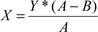

X = the number of shares of Warrant Stock to be issued to the Registered Holder.

Y = the Warrant Stock purchasable under this Warrant or, if only a portion of the Warrant is being exercised, the portion of the Warrant Stock being exercised.

A = the Fair Market Value (defined below) of one share of Common Stock on the Exercise Date.

B = the Exercise Price (as adjusted pursuant to the provisions of this Warrant).

For purposes of this Section 1(c), the “Fair Market Value” of one share of Common Stock on the Exercise Date shall have one of the following meanings:

- if the Common Stock is traded on a national securities exchange, the Fair Market Value shall be deemed to be the average of the Closing Prices over a five trading day period ending on the Exercise Date. For the purposes of this Warrant, “Closing Price” means the final price at which one share of Common Stock is traded during any trading day; or

- if the Common Stock is traded over-the-counter, the Fair Market Value shall be deemed to be the average of the closing sales price over the thirty (30) day period ending three (3) days before the Exercise Date; or

- if neither (1) nor (2) is applicable, the Fair Market Value shall be at the commercially reasonable price per share which the Company could obtain on the Exercise Date from a willing buyer (not a current employee or director) for shares of Common Stock sold by the Company, from authorized but unissued shares, as determined in good faith by the Company’s Board of Directors.

For illustration purposes only, if this Warrant entitles the Registered Holder the right to purchase 100,000 shares of Warrant Stock and the Holder were to exercise this Warrant for 50,000 shares of Warrant Stock at a time when the Exercise Price was reduced to $1.00 and the Fair Market Value of each share of Common Stock was $2.00 on the Exercise Date, as applicable, the cashless exercise calculation would be as follows:

X = 50,000 ($2.00-$1.00)

$2.00

X = 25,000

Therefore, the number of shares of Warrant Stock to be issued to the Holder after giving effect to the cashless exercise would be 25,000 shares of Warrant Stock and the Company would issue the Holder a new Warrant to purchase 50,000 shares of Warrant Stock, reflecting the portion of this Warrant not exercised by the Holder. For purposes of Rule 144 promulgated under the Securities Act of 1933, as amended (the “Securities Act”), it is intended, understood and acknowledged that the Warrant Stock issued in the cashless exercise transaction described pursuant to Section 1(c) shall be deemed to have been acquired by the Holder, and the holding period for the shares of Warrant Stock shall be deemed to have commenced, on the date of the Registered Holder’s acquisition of the Warrant.

- Delivery to Holder. As soon as practicable after the exercise of this Warrant in whole or in part, and in any event within three (3) business days thereafter (the “Warrant Stock Delivery Date”), the Company will cause to be issued in the name of, and delivered to, the Registered Holder, or as such Registered Holder (upon payment by such Registered Holder of any applicable transfer taxes) may direct:

  - a certificate or certificates for the number of shares of Warrant Stock to which such Registered Holder shall be entitled, and

  - in case such exercise is in part only, a new warrant or warrants (dated the date hereof) of like tenor, calling in the aggregate on the face or faces thereof for the number of shares of Warrant Stock equal (giving effect to any adjustment therein) to the number of such shares called for on the face of this Warrant minus the number of such shares purchased by the Registered Holder upon such exercise as provided in Section 1(a).

- Compensation for Buy-In on Failure to Timely Deliver Certificates Upon Exercise. In addition to any other rights available to the Registered Holder, if the Company fails to transmit to the Registered Holder a certificate or the certificates representing the Warrant Stock pursuant to an exercise on or before the Warrant Stock Delivery Date, and if after such date the Registered Holder is required by its broker to purchase (in an open market transaction or otherwise) or the Registered Holder’s brokerage firm otherwise purchases, shares of Common Stock to deliver in satisfaction of a sale by the Registered Holder of the Warrant Stock which the Registered Holder anticipated receiving upon such exercise (a “Buy-In”), then the Company shall (A) pay in cash to the Holder the amount by which (x) the Registered Holder’s total purchase price (including brokerage commissions, if any) for the shares of Common Stock so purchased exceeds (y) the amount obtained by multiplying (1) the number of shares of Warrant Stock that the Company was required to deliver to the Registered Holder in connection with the exercise at issue times (2) the price at which the sell order giving rise to such purchase obligation was executed, and (B) at the option of the Registered Holder, either reinstate the portion of the Warrant and equivalent number of shares of Warrant Stock for which such exercise was not honored or deliver to the Registered Holder the number of shares of Common Stock that would have been issued had the Company timely complied with its exercise and delivery obligations hereunder. For example, if the Registered Holder purchases Common Stock having a total purchase price of $11,000 to cover a Buy-In with respect to an attempted exercise of shares of Common Stock with an aggregate sale price giving rise to such purchase obligation of $10,000, under clause (A) of the immediately preceding sentence the Company shall be required to pay the Registered Holder $1,000. The Registered Holder shall provide the Company written notice indicating the amounts payable to the Registered Holder in respect of the Buy-In and, upon request of the Company, evidence of the amount of such loss.

  - Registered Holder’s Exercise Limitations. The Company shall not effect any exercise of this Warrant, and a Registered Holder shall not have the right to exercise any portion of this Warrant, pursuant to Section 2 or otherwise, to the extent (but only to the extent) that the Registered Holder or any of the Registered Holder’s affiliates, would beneficially own in excess of the Beneficial Ownership Limitation (as defined below). For purposes of this Section 1(e), beneficial ownership shall be calculated in accordance with Section 13(d) of the Exchange Act (as defined herein) and the rules and regulations promulgated thereunder, it being acknowledged by the Registered Holder that the Company is not representing to the Registered Holder that such calculation is in compliance with Section 13(d) of the Exchange Act and the Registered Holder is solely responsible for any schedules required to be filed in accordance therewith. To the extent that the limitation contained in this Section 1(f) applies, the determination of whether this Warrant is exercisable (in relation to other securities owned by the Registered Holder together with any Affiliates) and of which portion of this Warrant is exercisable shall be in the sole discretion of the Registered Holder, and the submission of an Exercise Notice shall be deemed to be the Registered Holder’s determination of whether this Warrant is exercisable (in relation to other securities owned by the Registered Holder together with any Affiliates) and of which portion of this Warrant is exercisable, in each case subject to the Beneficial Ownership Limitation, and the Company shall have no obligation to verify or confirm the accuracy of such determination. Upon the written or oral request of a Registered Holder, the Company shall within two business days confirm orally and in writing to the Registered Holder the number of shares of Common Stock then outstanding. In any case, the number of outstanding shares of Common Stock shall be determined after giving effect to the conversion or exercise of securities of the Company, including this Warrant, by the Registered Holder or its Affiliates since the date as of which such number of outstanding shares of Common Stock was reported. The “Beneficial Ownership Limitation” shall be 4.99% of the number of shares of Common Stock outstanding immediately after giving effect to the issuance of shares of Common Stock issuable upon exercise of this Warrant. The Registered Holder, upon not less than 61 days’ prior notice to the Company, may increase or decrease the Beneficial Ownership Limitation provisions of this Section 1(f), provided that the Beneficial Ownership Limitation shall in no event exceed 9.99% of the number of shares of Common Stock outstanding immediately after giving effect to the issuance of shares of Common Stock upon exercise of this Warrant held by the Registered Holder and the provisions of this Section 1(f) shall continue to apply. Any such increase or decrease will not be effective until the 61st day after such notice is delivered to the Company. The provisions of this paragraph shall be construed and implemented in a manner otherwise than in strict conformity with the terms of this Section 1(f) to correct this paragraph (or any portion hereof) which may be defective or inconsistent with the intended Beneficial Ownership Limitation herein contained or to make changes or supplements necessary or desirable to properly give effect to such limitation. The limitations contained in this paragraph shall apply to a successor holder of this Warrant.

- Adjustments.

  - Stock Splits and Dividends. If the outstanding shares of the Company’s Common Stock shall be subdivided into a greater number of shares or a dividend in Common Stock shall be paid in respect of Common Stock, the Exercise Price in effect immediately prior to such subdivision or at the record date of such dividend shall, simultaneously with the effectiveness of such subdivision or immediately after the record date of such dividend, be proportionately reduced and the number of Warrant Stock issuable upon exercise of the Warrant shall be proportionately increased. If the outstanding shares of Common Stock shall be combined into a smaller number of shares, the Exercise Price in effect immediately prior to such combination shall, simultaneously with the effectiveness of such combination, be proportionately increased and the number of shares of Warrant Stock issuable upon exercise of the Warrant shall be proportionately decreased.

    - Fundamental Transaction. If, at any time while this Warrant is outstanding, (i) the Company effects any merger or consolidation of the Company with or into another person, (ii) the Company effects any sale of all or substantially all of its assets in one or a series of related transactions, (iii) any tender offer or exchange offer (whether by the Company or another person) is completed pursuant to which holders of Common Stock are permitted to tender or exchange their shares for other securities, cash or property or (iv) the Company effects any reclassification of the Common Stock or any compulsory share exchange pursuant to which the Common Stock is effectively converted into or exchanged for other securities, cash or property (each, a “Fundamental Transaction”), then, upon any subsequent exercise of this Warrant, the Registered Holder shall have the right to receive, for each share of Warrant Stock that would have been issuable upon such exercise immediately prior to the occurrence of such Fundamental Transaction, the number of shares of Common Stock of the successor or acquiring corporation or of the Company, if it is the surviving corporation, and any additional consideration (the “Alternate Consideration”) receivable as a result of such merger, consolidation or disposition of assets by a holder of the number of shares of Common Stock for which this Warrant is exercisable immediately prior to such event. For purposes of any such exercise, the determination of the Exercise Price shall be appropriately adjusted to apply to such Alternate Consideration based on the amount of Alternate Consideration issuable in respect of one share of Common Stock in such Fundamental Transaction, and the Company shall apportion the Exercise Price among the Alternate Consideration in a reasonable manner reflecting the relative value of any different components of the Alternate Consideration. If holders of Common Stock are given any choice as to the securities, cash or property to be received in a Fundamental Transaction, then the Registered Holder shall be given the same choice as to the Alternate Consideration it receives upon any exercise of this Warrant following such Fundamental Transaction. To the extent necessary to effectuate the foregoing provisions, any successor to the Company or surviving entity in such Fundamental Transaction shall issue to the Registered Holder a new warrant consistent with the foregoing provisions and evidencing the Registered Holder’s right to exercise such warrant into Alternate Consideration. The terms of any agreement pursuant to which a Fundamental Transaction is effected shall include terms requiring any such successor or surviving entity to comply with the provisions of this Section 2(b) and insuring that this Warrant (or any such replacement security) will be similarly adjusted upon any subsequent transaction analogous to a Fundamental Transaction.

    - Adjustment Certificate. When any adjustment is required to be made in the Exercise Price pursuant to this Section 2, the Company shall promptly mail to the Registered Holder a certificate setting forth (i) a brief statement of the facts requiring such adjustment, (ii) the Exercise Price after such adjustment and (iii) the kind and amount of stock or other securities or property into which this Warrant shall be exercisable after such adjustment.

  - Transfers.

    - Unregistered Security. The holder of this Warrant acknowledges that this Warrant has not been registered under the Securities Act and agrees not to sell, pledge, distribute, offer for sale, transfer or otherwise dispose of this Warrant or any Warrant Stock issued upon its exercise in the absence of (i) an effective registration statement under the Securities Act as to this Warrant or such Warrant Stock and registration or qualification of this Warrant or such Warrant Stock under any applicable U.S. federal or state securities law then in effect or

- an opinion of counsel, reasonably satisfactory to the Company, that such registration and qualification are not required.

    - Transferability. Subject to the provisions of Section 3(a) hereof, this Warrant and all rights hereunder are transferable, in whole or in part, to (i) any entity controlling, controlled by or under common control of the Registered Holder, or (ii) to any other proposed transferee by surrendering the Warrant with a properly executed assignment (in the form of Exhibit B hereto) at the principal office of the Company.

    - Warrant Register. The Company will maintain a register containing the names and addresses of the Registered Holders of this Warrant. Until any transfer of this Warrant is made in the warrant register, the Company may treat the Registered Holder of this Warrant as the absolute owner hereof for all purposes; provided, however, that if this Warrant is properly assigned in blank, the Company may (but shall not be required to) treat the bearer hereof as the absolute owner hereof for all purposes, notwithstanding any notice to the contrary. Any Registered Holder may change such Registered Holder’s address as shown on the warrant register by written notice to the Company requesting such change.

- Redemption.

  - Redemption of Warrant. This Warrant may be redeemed, at the option of the Company, at any time after it becomes exercisable and prior to its expiration, at the office of the Company or, if appointed, the Company’s warrant agent, upon the notice referred to in Section 4(b) hereof, at the price of $0.01 per share underlying the Warrant (the “Redemption Price”), in the event that (i) the last closing sale price of the Common Stock has been equal to or greater than $5.00 per share (subject to adjustments for splits, dividends, recapitalizations and similar events) on each of twenty (20) trading days within any thirty (30) day trading period ending on the third business day prior to the date on which notice of redemption is given to the holder and

- during each day of the foregoing twenty (20) day trading period and through the date the Company exercises its redemption rights it must have an effective registration statement with a current prospectus in compliance with Sections 5 and 10 of the Securities Act on file with the Securities and Exchange Commission pursuant to which the underlying Common Stock may be sold.

  - Date Fixed for, and Notice of, Redemption. In the event the Company shall elect to redeem the Warrant, the Company shall fix a date for the redemption. Notice of redemption shall be mailed by first class mail, postage prepaid, by the Company not less than thirty (30) days prior to the date fixed for redemption to the Registered Holders of the Warrant to be redeemed at their last addresses as they shall appear on the registration books. Any notice mailed in the manner herein provided shall be conclusively presumed to have been duly given whether or not the Registered Holder received such notice.

  - Exercise After Notice of Redemption. The Warrants may be exercised in accordance with this Warrant at any time after notice of redemption shall have been given by the Company and prior to the time and date fixed for redemption. On and after the redemption date, the Registered Holder shall have no further rights except to receive, upon surrender of the Warrants, the Redemption Price.

- Superior Warrant. From the date hereof until December 31, 2014, in the event the Company shall issue or sell a warrant to purchase shares of Common Stock of the Company at an exercise price below $1.76 per share or which contain terms that, taken as a whole, are more favorable then the terms of the Warrant as determined in good faith by the Company’s Board of Directors (a “Superior Warrant”) in connection with a financing or a material transaction consummated by the Company, then the Company shall amend the terms of the Warrant to give you the benefit of the more favorable terms or conditions of the Superior Warrant (excluding the expiration date of the Superior Warrant). Notwithstanding the foregoing, no adjustments to the Warrant in accordance with this Section 5 shall be made upon the issuance of any Excluded Securities (as defined in the Company’s Certificate of Designations, Preferences and Rights of Series A Convertible Preferred Stock).

6. Termination. This Warrant (and the right to purchase securities upon exercise hereof) shall terminate at 5:00 p.m., Eastern time, on the Expiration Date.

- Notices of Certain Transactions. In case:

  - the Company shall take a record of the holders of its Common Stock (or other stock or securities at the time deliverable upon the exercise of this Warrant) for the purpose of entitling or enabling them to receive any dividend or other distribution, or to receive any right to subscribe for or purchase any shares of stock of any class or any other securities, or to receive any other right, to subscribe for or purchase any shares of stock of any class or any other securities, or to receive any other right, or

- of any capital reorganization of the Company, any reclassification of the capital stock of the Company, any consolidation or merger of the Company, any consolidation or merger of the Company with or into another corporation (other than a consolidation or merger in which the Company is the surviving entity), or any transfer of all or substantially all of the assets of the Company, or

- of the voluntary or involuntary dissolution, liquidation or winding-up of the Company, or

- of any Fundamental Transaction,

then, and in each such case, the Company will mail or cause to be mailed to the Registered Holder of this Warrant a notice specifying, as the case may be, (i) the date on which a record is to be taken for the purpose of such dividend, distribution or right, and stating the amount and character of such dividend, distribution or right, or (ii) the effective date on which such reorganization, reclassification, consolidation, merger, transfer, dissolution, liquidation, winding-up or Fundamental Transaction is to take place, and the time, if any is to be fixed, as of which the holders of record of Common Stock (or such other stock or securities at the time deliverable upon such reorganization, reclassification, consolidation, merger, transfer, dissolution, liquidation or winding-up) are to be determined. Failure to send such notice shall not act to invalidate any such transaction.

- Reservation of Stock. The Company covenants that at all times it will have authorized, reserve and keep available, solely for the issuance and delivery upon the exercise of this Warrant, such shares of Warrant Stock and other stock, securities and property, as from time to time shall be issuable upon the exercise of this Warrant. The Company covenants that all Warrant Stock that may be issued upon the exercise of the purchase rights represented by this Warrant will, upon exercise of the purchase rights represented by this Warrant, be duly authorized, validly issued, fully paid and nonassessable and free from all taxes, liens and charges in respect of the issue thereof (other than taxes in respect of any transfer occurring contemporaneously with such issue). The Company further covenants that its issuance of this Warrant shall constitute full authority to its officers who are charged with the duty of executing stock certificates to execute and issue the necessary certificates for the shares of Warrant Stock upon the exercise of the purchase rights under this Warrant by the Registered Holder. The Company will take all such reasonable action as may be necessary to assure that such Warrant Stock may be issued as provided herein without violation of any applicable law or regulation.

- Replacement of Warrants. Upon receipt of evidence reasonably satisfactory to the Company of the loss, theft, destruction or mutilation of this Warrant and (in the case of loss, theft or destruction) upon delivery of an indemnity agreement (with surety if reasonably required) in an amount reasonably satisfactory to the Company, or (in the case of mutilation) upon surrender and cancellation of this Warrant, the Company will issue, in lieu thereof, a new Warrant of like tenor.

- Notices. Any notice required or permitted by this Warrant shall be in writing and shall be deemed duly given upon receipt, when delivered personally or by courier, overnight delivery service or confirmed facsimile, or 48 hours after being deposited in the regular mail as certified or registered mail (airmail if sent internationally) with postage prepaid, addressed (a) if to the Registered Holder, to the address of the Registered Holder most recently furnished in writing to the Company and (b) if to the Company, to the address set forth on the signature page of this Warrant or as subsequently modified by written notice to the Registered Holder.

- No Rights as Stockholder. Until the exercise of this Warrant, the Registered Holder of this Warrant shall not have or exercise any rights by virtue hereof as a stockholder of

the Company.

- No Fractional Shares. No fractional shares of Common Stock will be issued in connection with any exercise hereunder. In lieu of any fractional shares which would otherwise be issuable, the Company shall round the amount of Warrant Stock issuable to the nearest whole share.

- Amendment or Waiver. Any term of this Warrant may be amended or waived upon written consent of the Company and the Registered Holder.

- Headings. The headings in this Warrant are for purposes of reference only and shall not limit or otherwise affect the meaning of any provision of this Warrant.

- Governing Law. This Warrant and all acts and transactions pursuant hereto and the rights and obligations of the parties hereto shall be governed, construed and interpreted in accordance with the laws of the State of New York, without giving effect to principles of conflicts of law.

- Representations and Covenants of the Registered Holder. This Warrant has been entered into by the Company in reliance upon the following representations and covenants of the Registered Holder:

  - Investment Purpose. The Registered Holder is acquiring the Warrant and the Warrant Stock issuable upon exercise of the Warrant for its own account, not as a nominee or agent and with no present intention of selling or otherwise distributing any part thereof.

  - Private Issue. The Registered Holder understands: (i) that the Warrant is not registered under the Securities Act or qualified under applicable state securities laws on the ground that the issuance contemplated by this Warrant will be exempt from the registration and qualifications requirements thereof pursuant to Section 4(2) of the Securities Act and any applicable state securities laws, and (ii) that the Company’s reliance on such exemption is predicated on the representations set forth in this Section 16.

  - Disposition of Registered Holder’s Rights. In no event will the Registered Holder make a disposition of the Warrant or the Warrant Stock issuable upon exercise of the Warrant in the absence of (i) an effective registration statement under the Securities Act as to this Warrant or such Warrant Stock and registration or qualification of this Warrant or such Warrant Stock under any applicable U.S. federal or state securities law then in effect or (ii) an opinion of counsel, reasonably satisfactory to the Company, that such registration and qualification are not required. Whenever the restrictions imposed hereunder shall terminate, as hereinabove provided, the Registered Holder or holder of a share of Common Stock then outstanding as to which such restrictions have terminated shall be entitled to receive from the Company, without expense to such holder, one or more new certificates for the Warrant or for such shares of Common Stock not bearing any restrictive legend.

  - Financial Risk. The Registered Holder has such business and financial experience as is required to give it the capacity to protect its own interests in connection

with its investment.

  - Accredited Investor. The Registered Holder is an “accredited investor” as defined by Rule 501 of Regulation D promulgated under the Securities Act.

[Signature Page Follows]

IN WITNESS WHEREOF, the parties have executed this Warrant as of the date first above written.

VRINGO, INC.

By:
Name:

Title:

Exhibit A

WARRANT EXERCISE FORM

The undersigned hereby irrevocably elects to exercise the within Warrant to the extent of purchasing ______ shares of Common Stock of Vringo, Inc., a Delaware corporation, and hereby

makes payment of $___________ in payment therefore (if a cashless exercise, insert “cashless”), all in accordance with the terms and conditions of the Warrant dated ________, 2012.

Name: ______________________________________

Signature: ___________________________________

Signature of joint holder (if applicable): _____________________________________________

Date: ___________________

INSTRUCTIONS FOR ISSUANCE OF STOCK

(if other than to the registered holder of the within Warrant)

Name: ______________________________________

Address: _____________________________________________________________________

Social Security or Taxpayer Identification Number of Recipient: _________________________

Exhibit B

ASSIGNMENT FORM

FOR VALUE RECEIVED, _____________________ hereby sells, assigns and transfers unto _______________________ the right to purchase Common Stock of Vringo, Inc., a Delaware

corporation, represented by this Warrant to the extent of shares as to which such right is exercisable and does hereby irrevocably constitute and appoint ______________________, Attorney, to

transfer the same on the books of the Company with full power of substitution in the premises.

Date:

Signature:

Signature of joint holder (if applicable):

Exhibit G

(Form of Series 2 Warrant)

THE SECURITIES EVIDENCED BY THIS CERTIFICATE HAVE NOT BEEN REGISTERED UNDER THE SECURITIES ACT OF 1933, AS AMENDED (“SECURITIES ACT”), AND MAY NOT BE SOLD, TRANSFERRED, ASSIGNED OR HYPOTHECATED UNLESS THERE IS AN EFFECTIVE REGISTRATION STATEMENT UNDER SUCH ACT COVERING SUCH SECURITIES, THE SALE IS MADE IN ACCORDANCE WITH RULE 144 UNDER THE ACT, OR THE COMPANY RECEIVES AN OPINION OF COUNSEL FOR THE COMPANY STATING THAT SUCH SALE, TRANSFER, ASSIGNMENT OR HYPOTHECATION IS EXEMPT FROM THE REGISTRATION AND PROSPECTUS DELIVERY REQUIREMENTS OF SUCH ACT.

Warrant No. W-___ |  |  |  | Number of Shares: ____________
Date of Issuance: ____________ __, 2012 (“Issuance Date”)
 |  |  | VRINGO, INC.
 |  |  | Common Stock Warrant

Vringo, Inc. (the “Company”), for value received, hereby certifies that ________, or its registered assigns (the “Registered Holder”), is entitled, subject to the terms of this Common

Stock Warrant (the “Warrant”) set forth below, to purchase from the Company, at any time after the date hereof and on or before __________ __, 2017 (the “Expiration Date”), up to ________

(_______) shares of common stock of the Company (the “Warrant Stock”), par value $0.01 per share (the “Common Stock”), at a per share exercise price (the “Exercise Price”) equal to One

Dollar and Seventy-Six Cents ($1.76) per share (subject to adjustment as set forth in Section 2).

- Exercise.

  - Method of Exercise. This Warrant may be exercised by the Registered Holder, in whole or in part, by delivering the form appended hereto as Exhibit A duly executed by such Registered Holder (the “Exercise Notice”), at the principal office of the Company, or at such other office or agency as the Company may designate in writing prior to the date of such exercise, accompanied by payment in full of the Exercise Price payable with respect to the number of shares of Warrant Stock purchased upon such exercise. The Exercise Price must be paid by cash, check or wire transfer in immediately available funds for the Warrant Stock being purchased by the Registered Holder, except as provided in Section 1(c).

  - Effective Time of Exercise. Each exercise of this Warrant shall be deemed to have been effected immediately prior to the close of business on the day on which the Exercise Notice has been delivered to the Company (the “Exercise Date”) as provided in this Section 1. At such time, the person or persons in whose name or names any certificates for Warrant Stock shall be issuable upon such exercise as provided in Section 1(d) below shall be deemed to have become the holder or holders of record of the Warrant Stock represented by such certificates.

  - Cashless Exercise. Notwithstanding any provisions herein to the contrary, if at any time between the three (3) month anniversary of the Issuance Date and the Expiration Date, there is no effective Registration Statement under the Securities Act registering the resale of the Warrant Stock by the Registered Holder, then the Registered Holder may elect to exercise this Warrant, or a portion hereof, and to pay for the Warrant Stock by way of cashless exercise (a “Cashless Exercise”). If the Registered Holder wishes to effect a cashless exercise, the Registered Holder shall deliver the Exercise Notice duly executed by such Registered Holder or by such Registered Holder’s duly authorized attorney, at the principal office of the Company, or at such other office or agency as the Company may designate in writing prior to the date of such exercise, in which event the Company shall issue to the Registered Holder the number of shares of Warrant Stock computed according to the following equation:

; where

X = the number of shares of Warrant Stock to be issued to the Registered Holder.

Y = the Warrant Stock purchasable under this Warrant or, if only a portion of the Warrant is being exercised, the portion of the Warrant Stock being exercised.

A = the Fair Market Value (defined below) of one share of Common Stock on the Exercise Date.

B = the Exercise Price (as adjusted pursuant to the provisions of this Warrant).

For purposes of this Section 1(c), the “Fair Market Value” of one share of Common Stock on the Exercise Date shall have one of the following meanings:

- if the Common Stock is traded on a national securities exchange, the Fair Market Value shall be deemed to be the average of the Closing Prices over a five trading day period ending on the Exercise Date. For the purposes of this Warrant, “Closing Price” means the final price at which one share of Common Stock is traded during any trading day; or

- if the Common Stock is traded over-the-counter, the Fair Market Value shall be deemed to be the average of the closing sales price over the thirty (30) day period ending three (3) days before the Exercise Date; or

- if neither (1) nor (2) is applicable, the Fair Market Value shall be at the commercially reasonable price per share which the Company could obtain on the Exercise Date from a willing buyer (not a current employee or director) for shares of Common Stock sold by the Company, from authorized but unissued shares, as determined in good faith by the Company’s Board of Directors.

For illustration purposes only, if this Warrant entitles the Registered Holder the right to purchase 100,000 shares of Warrant Stock and the Holder were to exercise this Warrant for 50,000 shares of Warrant Stock at a time when the Exercise Price was reduced to $1.00 and the Fair Market Value of each share of Common Stock was $2.00 on the Exercise Date, as applicable, the cashless exercise calculation would be as follows:

X = 50,000 ($2.00-$1.00)

$2.00

X = 25,000

Therefore, the number of shares of Warrant Stock to be issued to the Holder after giving effect to the cashless exercise would be 25,000 shares of Warrant Stock and the Company would issue the Holder a new Warrant to purchase 50,000 shares of Warrant Stock, reflecting the portion of this Warrant not exercised by the Holder. For purposes of Rule 144 promulgated under the Securities Act of 1933, as amended (the “Securities Act”), it is intended, understood and acknowledged that the Warrant Stock issued in the cashless exercise transaction described pursuant to Section 1(c) shall be deemed to have been acquired by the Holder, and the holding period for the shares of Warrant Stock shall be deemed to have commenced, on the date of the Registered Holder’s acquisition of the Warrant.

- Delivery to Holder. As soon as practicable after the exercise of this Warrant in whole or in part, and in any event within three (3) business days thereafter (the “Warrant Stock Delivery Date”), the Company will cause to be issued in the name of, and delivered to, the Registered Holder, or as such Registered Holder (upon payment by such Registered Holder of any applicable transfer taxes) may direct:

  - a certificate or certificates for the number of shares of Warrant Stock to which such Registered Holder shall be entitled, and

  - in case such exercise is in part only, a new warrant or warrants (dated the date hereof) of like tenor, calling in the aggregate on the face or faces thereof for the number of shares of Warrant Stock equal (giving effect to any adjustment therein) to the number of such shares called for on the face of this Warrant minus the number of such shares purchased by the Registered Holder upon such exercise as provided in Section 1(a).

- Compensation for Buy-In on Failure to Timely Deliver Certificates Upon Exercise. In addition to any other rights available to the Registered Holder, if the Company fails to transmit to the Registered Holder a certificate or the certificates representing the Warrant Stock pursuant to an exercise on or before the Warrant Stock Delivery Date, and if after such date the Registered Holder is required by its broker to purchase (in an open market transaction or otherwise) or the Registered Holder’s brokerage firm otherwise purchases, shares of Common Stock to deliver in satisfaction of a sale by the Registered Holder of the Warrant Stock which the Registered Holder anticipated receiving upon such exercise (a “Buy-In”), then the Company shall (A) pay in cash to the Holder the amount by which (x) the Registered Holder’s total purchase price (including brokerage commissions, if any) for the shares of Common Stock so purchased exceeds (y) the amount obtained by multiplying (1) the number of shares of Warrant Stock that the Company was required to deliver to the Registered Holder in connection with the exercise at issue times (2) the price at which the sell order giving rise to such purchase obligation was executed, and (B) at the option of the Registered Holder, either reinstate the portion of the Warrant and equivalent number of shares of Warrant Stock for which such exercise was not honored or deliver to the Registered Holder the number of shares of Common Stock that would have been issued had the Company timely complied with its exercise and delivery obligations hereunder. For example, if the Registered Holder purchases Common Stock having a total purchase price of $11,000 to cover a Buy-In with respect to an attempted exercise of shares of Common Stock with an aggregate sale price giving rise to such purchase obligation of $10,000, under clause (A) of the immediately preceding sentence the Company shall be required to pay the Registered Holder $1,000. The Registered Holder shall provide the Company written notice indicating the amounts payable to the Registered Holder in respect of the Buy-In and, upon request of the Company, evidence of the amount of such loss.

  - Registered Holder’s Exercise Limitations. The Company shall not effect any exercise of this Warrant, and a Registered Holder shall not have the right to exercise any portion of this Warrant, pursuant to Section 2 or otherwise, to the extent (but only to the extent) that the Registered Holder or any of the Registered Holder’s affiliates, would beneficially own in excess of the Beneficial Ownership Limitation (as defined below). For purposes of this Section 1(e), beneficial ownership shall be calculated in accordance with Section 13(d) of the Exchange Act (as defined herein) and the rules and regulations promulgated thereunder, it being acknowledged by the Registered Holder that the Company is not representing to the Registered Holder that such calculation is in compliance with Section 13(d) of the Exchange Act and the Registered Holder is solely responsible for any schedules required to be filed in accordance therewith. To the extent that the limitation contained in this Section 1(f) applies, the determination of whether this Warrant is exercisable (in relation to other securities owned by the Registered Holder together with any Affiliates) and of which portion of this Warrant is exercisable shall be in the sole discretion of the Registered Holder, and the submission of an Exercise Notice shall be deemed to be the Registered Holder’s determination of whether this Warrant is exercisable (in relation to other securities owned by the Registered Holder together with any Affiliates) and of which portion of this Warrant is exercisable, in each case subject to the Beneficial Ownership Limitation, and the Company shall have no obligation to verify or confirm the accuracy of such determination. Upon the written or oral request of a Registered Holder, the Company shall within two business days confirm orally and in writing to the Registered Holder the number of shares of Common Stock then outstanding. In any case, the number of outstanding shares of Common Stock shall be determined after giving effect to the conversion or exercise of securities of the Company, including this Warrant, by the Registered Holder or its Affiliates since the date as of which such number of outstanding shares of Common Stock was reported. The “Beneficial Ownership Limitation” shall be 4.99% of the number of shares of Common Stock outstanding immediately after giving effect to the issuance of shares of Common Stock issuable upon exercise of this Warrant. The Registered Holder, upon not less than 61 days’ prior notice to the Company, may increase or decrease the Beneficial Ownership Limitation provisions of this Section 1(f), provided that the Beneficial Ownership Limitation shall in no event exceed 9.99% of the number of shares of Common Stock outstanding immediately after giving effect to the issuance of shares of Common Stock upon exercise of this Warrant held by the Registered Holder and the provisions of this Section 1(f) shall continue to apply. Any such increase or decrease will not be effective until the 61st day after such notice is delivered to the Company. The provisions of this paragraph shall be construed and implemented in a manner otherwise than in strict conformity with the terms of this Section 1(f) to correct this paragraph (or any portion hereof) which may be defective or inconsistent with the intended Beneficial Ownership Limitation herein contained or to make changes or supplements necessary or desirable to properly give effect to such limitation. The limitations contained in this paragraph shall apply to a successor holder of this Warrant.

- Adjustments.

  - Stock Splits and Dividends. If the outstanding shares of the Company’s Common Stock shall be subdivided into a greater number of shares or a dividend in Common Stock shall be paid in respect of Common Stock, the Exercise Price in effect immediately prior to such subdivision or at the record date of such dividend shall, simultaneously with the effectiveness of such subdivision or immediately after the record date of such dividend, be proportionately reduced and the number of Warrant Stock issuable upon exercise of the Warrant shall be proportionately increased. If the outstanding shares of Common Stock shall be combined into a smaller number of shares, the Exercise Price in effect immediately prior to such combination shall, simultaneously with the effectiveness of such combination, be proportionately increased and the number of shares of Warrant Stock issuable upon exercise of the Warrant shall be proportionately decreased.

    - Fundamental Transaction. If, at any time while this Warrant is outstanding, (i) the Company effects any merger or consolidation of the Company with or into another person, (ii) the Company effects any sale of all or substantially all of its assets in one or a series of related transactions, (iii) any tender offer or exchange offer (whether by the Company or another person) is completed pursuant to which holders of Common Stock are permitted to tender or exchange their shares for other securities, cash or property or (iv) the Company effects any reclassification of the Common Stock or any compulsory share exchange pursuant to which the Common Stock is effectively converted into or exchanged for other securities, cash or property (each, a “Fundamental Transaction”), then, upon any subsequent exercise of this Warrant, the Registered Holder shall have the right to receive, for each share of Warrant Stock that would have been issuable upon such exercise immediately prior to the occurrence of such Fundamental Transaction, the number of shares of Common Stock of the successor or acquiring corporation or of the Company, if it is the surviving corporation, and any additional consideration (the “Alternate Consideration”) receivable as a result of such merger, consolidation or disposition of assets by a holder of the number of shares of Common Stock for which this Warrant is exercisable immediately prior to such event. For purposes of any such exercise, the determination of the Exercise Price shall be appropriately adjusted to apply to such Alternate Consideration based on the amount of Alternate Consideration issuable in respect of one share of Common Stock in such Fundamental Transaction, and the Company shall apportion the Exercise Price among the Alternate Consideration in a reasonable manner reflecting the relative value of any different components of the Alternate Consideration. If holders of Common Stock are given any choice as to the securities, cash or property to be received in a Fundamental Transaction, then the Registered Holder shall be given the same choice as to the Alternate Consideration it receives upon any exercise of this Warrant following such Fundamental Transaction. To the extent necessary to effectuate the foregoing provisions, any successor to the Company or surviving entity in such Fundamental Transaction shall issue to the Registered Holder a new warrant consistent with the foregoing provisions and evidencing the Registered Holder’s right to exercise such warrant into Alternate Consideration. The terms of any agreement pursuant to which a Fundamental Transaction is effected shall include terms requiring any such successor or surviving entity to comply with the provisions of this Section 2(b) and insuring that this Warrant (or any such replacement security) will be similarly adjusted upon any subsequent transaction analogous to a Fundamental Transaction.

    - Adjustment Certificate. When any adjustment is required to be made in the Exercise Price pursuant to this Section 2, the Company shall promptly mail to the Registered Holder a certificate setting forth (i) a brief statement of the facts requiring such adjustment, (ii) the Exercise Price after such adjustment and (iii) the kind and amount of stock or other securities or property into which this Warrant shall be exercisable after such adjustment.

  - Transfers.

    - Unregistered Security. The holder of this Warrant acknowledges that this Warrant has not been registered under the Securities Act and agrees not to sell, pledge, distribute, offer for sale, transfer or otherwise dispose of this Warrant or any Warrant Stock issued upon its exercise in the absence of (i) an effective registration statement under the Securities Act as to this Warrant or such Warrant Stock and registration or qualification of this Warrant or such Warrant Stock under any applicable U.S. federal or state securities law then in effect or

- an opinion of counsel, reasonably satisfactory to the Company, that such registration and qualification are not required.

    - Transferability. Subject to the provisions of Section 3(a) hereof, this Warrant and all rights hereunder are transferable, in whole or in part, to (i) any entity controlling, controlled by or under common control of the Registered Holder, or (ii) to any other proposed transferee by surrendering the Warrant with a properly executed assignment (in the form of Exhibit B hereto) at the principal office of the Company.

    - Warrant Register. The Company will maintain a register containing the names and addresses of the Registered Holders of this Warrant. Until any transfer of this Warrant is made in the warrant register, the Company may treat the Registered Holder of this Warrant as the absolute owner hereof for all purposes; provided, however, that if this Warrant is properly assigned in blank, the Company may (but shall not be required to) treat the bearer hereof as the absolute owner hereof for all purposes, notwithstanding any notice to the contrary. Any Registered Holder may change such Registered Holder’s address as shown on the warrant register by written notice to the Company requesting such change.

- Redemption.

  - Redemption of Warrant. This Warrant may be redeemed, at the option of the Company, at any time after it becomes exercisable and prior to its expiration, at the office of the Company or, if appointed, the Company’s warrant agent, upon the notice referred to in Section 4(b) hereof, at the price of $0.01 per share underlying the Warrant (the “Redemption Price”), in the event that (i) the last closing sale price of the Common Stock has been equal to or greater than $5.00 per share (subject to adjustments for splits, dividends, recapitalizations and similar events) on each of twenty (20) trading days within any thirty (30) day trading period ending on the third business day prior to the date on which notice of redemption is given to the holder and

- during each day of the foregoing twenty (20) day trading period and through the date the Company exercises its redemption rights it must have an effective registration statement with a current prospectus in compliance with Sections 5 and 10 of the Securities Act on file with the Securities and Exchange Commission pursuant to which the underlying Common Stock may be sold.

  - Date Fixed for, and Notice of, Redemption. In the event the Company shall elect to redeem the Warrant, the Company shall fix a date for the redemption. Notice of redemption shall be mailed by first class mail, postage prepaid, by the Company not less than thirty (30) days prior to the date fixed for redemption to the Registered Holders of the Warrant to be redeemed at their last addresses as they shall appear on the registration books. Any notice mailed in the manner herein provided shall be conclusively presumed to have been duly given whether or not the Registered Holder received such notice.

  - Exercise After Notice of Redemption. The Warrants may be exercised in accordance with this Warrant at any time after notice of redemption shall have been given by the Company and prior to the time and date fixed for redemption. On and after the redemption date, the Registered Holder shall have no further rights except to receive, upon surrender of the Warrants, the Redemption Price.

5. Termination. This Warrant (and the right to purchase securities upon exercise hereof) shall terminate at 5:00 p.m., Eastern time, on the Expiration Date.

- Notices of Certain Transactions. In case:

  - the Company shall take a record of the holders of its Common Stock (or other stock or securities at the time deliverable upon the exercise of this Warrant) for the purpose of entitling or enabling them to receive any dividend or other distribution, or to receive any right to subscribe for or purchase any shares of stock of any class or any other securities, or to receive any other right, to subscribe for or purchase any shares of stock of any class or any other securities, or to receive any other right, or

      - of any capital reorganization of the Company, any reclassification of the capital stock of the Company, any consolidation or merger of the Company, any consolidation or merger of the Company with or into another corporation (other than a consolidation or merger in which the Company is the surviving entity), or any transfer of all or substantially all of the assets of the Company, or

    - of the voluntary or involuntary dissolution, liquidation or winding-up of the Company, or

    - of any Fundamental Transaction,

then, and in each such case, the Company will mail or cause to be mailed to the Registered Holder of this Warrant a notice specifying, as the case may be, (i) the date on which a record is to be taken for the purpose of such dividend, distribution or right, and stating the amount and character of such dividend, distribution or right, or (ii) the effective date on which such reorganization, reclassification, consolidation, merger, transfer, dissolution, liquidation, winding-up or Fundamental Transaction is to take place, and the time, if any is to be fixed, as of which the holders of record of Common Stock (or such other stock or securities at the time deliverable upon such reorganization, reclassification, consolidation, merger, transfer, dissolution, liquidation or winding-up) are to be determined. Failure to send such notice shall not act to invalidate any such transaction.

- Reservation of Stock. The Company covenants that at all times it will have authorized, reserve and keep available, solely for the issuance and delivery upon the exercise of this Warrant, such shares of Warrant Stock and other stock, securities and property, as from time to time shall be issuable upon the exercise of this Warrant. The Company covenants that all Warrant Stock that may be issued upon the exercise of the purchase rights represented by this Warrant will, upon exercise of the purchase rights represented by this Warrant, be duly authorized, validly issued, fully paid and nonassessable and free from all taxes, liens and charges in respect of the issue thereof (other than taxes in respect of any transfer occurring contemporaneously with such issue). The Company further covenants that its issuance of this Warrant shall constitute full authority to its officers who are charged with the duty of executing stock certificates to execute and issue the necessary certificates for the shares of Warrant Stock upon the exercise of the purchase rights under this Warrant by the Registered Holder. The Company will take all such reasonable action as may be necessary to assure that such Warrant Stock may be issued as provided herein without violation of any applicable law or regulation.

- Replacement of Warrants. Upon receipt of evidence reasonably satisfactory to the Company of the loss, theft, destruction or mutilation of this Warrant and (in the case of loss, theft or destruction) upon delivery of an indemnity agreement (with surety if reasonably required) in an amount reasonably satisfactory to the Company, or (in the case of mutilation) upon surrender and cancellation of this Warrant, the Company will issue, in lieu thereof, a new Warrant of like tenor.

- Notices. Any notice required or permitted by this Warrant shall be in writing and shall be deemed duly given upon receipt, when delivered personally or by courier, overnight delivery service or confirmed facsimile, or 48 hours after being deposited in the regular mail as certified or registered mail (airmail if sent internationally) with postage prepaid, addressed (a) if to the Registered Holder, to the address of the Registered Holder most recently furnished in writing to the Company and (b) if to the Company, to the address set forth on the signature page of this Warrant or as subsequently modified by written notice to the Registered Holder.

- No Rights as Stockholder. Until the exercise of this Warrant, the Registered Holder of this Warrant shall not have or exercise any rights by virtue hereof as a stockholder of

the Company.

- No Fractional Shares. No fractional shares of Common Stock will be issued in connection with any exercise hereunder. In lieu of any fractional shares which would otherwise be issuable, the Company shall round the amount of Warrant Stock issuable to the nearest whole share.

- Amendment or Waiver. Any term of this Warrant may be amended or waived upon written consent of the Company and the Registered Holder.

- Headings. The headings in this Warrant are for purposes of reference only and shall not limit or otherwise affect the meaning of any provision of this Warrant.

- Governing Law. This Warrant and all acts and transactions pursuant hereto and the rights and obligations of the parties hereto shall be governed, construed and interpreted in accordance with the laws of the State of New York, without giving effect to principles of conflicts of law.

- Representations and Covenants of the Registered Holder. This Warrant has been entered into by the Company in reliance upon the following representations and covenants of the Registered Holder:

  - Investment Purpose. The Registered Holder is acquiring the Warrant and the Warrant Stock issuable upon exercise of the Warrant for its own account, not as a nominee or agent and with no present intention of selling or otherwise distributing any part thereof.

  - Private Issue. The Registered Holder understands: (i) that the Warrant is not registered under the Securities Act or qualified under applicable state securities laws on the ground that the issuance contemplated by this Warrant will be exempt from the registration and qualifications requirements thereof pursuant to Section 4(2) of the Securities Act and any applicable state securities laws, and (ii) that the Company’s reliance on such exemption is predicated on the representations set forth in this Section 15.

  - Disposition of Registered Holder’s Rights. In no event will the Registered Holder make a disposition of the Warrant or the Warrant Stock issuable upon exercise of the Warrant in the absence of (i) an effective registration statement under the Securities Act as to this Warrant or such Warrant Stock and registration or qualification of this Warrant or such Warrant Stock under any applicable U.S. federal or state securities law then in effect or (ii) an opinion of counsel, reasonably satisfactory to the Company, that such registration and qualification are not required. Whenever the restrictions imposed hereunder shall terminate, as hereinabove provided, the Registered Holder or holder of a share of Common Stock then outstanding as to which such restrictions have terminated shall be entitled to receive from the Company, without expense to such holder, one or more new certificates for the Warrant or for such shares of Common Stock not bearing any restrictive legend.

  - Financial Risk. The Registered Holder has such business and financial experience as is required to give it the capacity to protect its own interests in connection

with its investment.

  - Accredited Investor. The Registered Holder is an “accredited investor” as defined by Rule 501 of Regulation D promulgated under the Securities Act.

[Signature Page Follows]

IN WITNESS WHEREOF, the parties have executed this Warrant as of the date first above written.

VRINGO, INC.

By:
Name:

Title:

Exhibit A

WARRANT EXERCISE FORM

The undersigned hereby irrevocably elects to exercise the within Warrant to the extent of purchasing ______ shares of Common Stock of Vringo, Inc., a Delaware corporation, and hereby

makes payment of $___________ in payment therefore (if a cashless exercise, insert “cashless”), all in accordance with the terms and conditions of the Warrant dated ________, 2012.

Name:

Signature:

Signature of joint holder (if applicable):

Date:

INSTRUCTIONS FOR ISSUANCE OF STOCK

(if other than to the registered holder of the within Warrant)

Name:

Address:

Social Security or Taxpayer Identification Number of Recipient:

Exhibit B

ASSIGNMENT FORM

FOR VALUE RECEIVED, _____________________ hereby sells, assigns and transfers unto _______________________ the right to purchase Common Stock of Vringo, Inc., a Delaware

corporation, represented by this Warrant to the extent of shares as to which such right is exercisable and does hereby irrevocably constitute and appoint ______________________, Attorney, to

transfer the same on the books of the Company with full power of substitution in the premises.

Date:

Signature:

Signature of joint holder (if applicable):

Exhibit H

THE ISSUANCE AND SALE OF THE SECURITIES REPRESENTED BY THIS CERTIFICATE HAVE NOT BEEN REGISTERED UNDER THE SECURITIES ACT OF 1933, AS AMENDED, OR APPLICABLE STATE SECURITIES LAWS. THE SECURITIES MAY NOT BE OFFERED FOR SALE, SOLD, TRANSFERRED OR ASSIGNED (I) IN THE ABSENCE OF (A) AN EFFECTIVE REGISTRATION STATEMENT FOR THE SECURITIES UNDER THE SECURITIES ACT OF 1933, AS AMENDED, OR (B) AN OPINION OF COUNSEL, IN A GENERALLY ACCEPTABLE FORM, THAT REGISTRATION IS NOT REQUIRED UNDER SAID ACT OR (II) UNLESS SOLD PURSUANT TO RULE 144 OR RULE 144A UNDER SAID ACT. NOTWITHSTANDING THE FOREGOING, THE SECURITIES MAY BE PLEDGED IN CONNECTION WITH A BONA FIDE MARGIN ACCOUNT OR OTHER LOAN OR FINANCING ARRANGEMENT SECURED BY THE SECURITIES. ANY TRANSFEREE OF THIS NOTE SHOULD CAREFULLY REVIEW THE TERMS OF THIS NOTE, INCLUDING SECTION 13(a) HEREOF. THE PRINCIPAL REPRESENTED BY THIS NOTE MAY BE LESS THAN THE AMOUNTS SET FORTH ON THE FACE HEREOF.

INNOVATE/PROTECT, INC.

AMENDED AND RESTATED SENIOR SECURED NOTE

Original Issuance Date: June 22, 2011

Original Principal Amount: U.S. $3,200,000

Amendment and

Restatement Date: [________ ___,] 2012

FOR VALUE RECEIVED, INNOVATE/PROTECT, INC., a Delaware corporation (the "Company"), hereby promises to pay to HUDSON BAY MASTER FUND LTD. or registered assigns (the "Holder") the amount set out above as the Original Principal Amount (as reduced pursuant to the terms hereof pursuant to redemption or otherwise, the "Principal") when due, whether upon the Maturity Date (as defined below), acceleration, redemption or otherwise (in each case in accordance with the terms hereof) and to pay interest ("Interest") on any outstanding Principal at the applicable Interest Rate from the date set out above as the Original Issuance Date (the "Issuance Date") until the same becomes due and payable, whether upon an Interest Date (as defined below), the Maturity Date, acceleration, redemption or otherwise (in each case in accordance with the terms hereof). This Senior Secured Note (including all Senior Secured Notes issued in exchange, transfer or replacement hereof, this "Note") was issued pursuant to the Subscription Agreement on June 22, 2011. Certain capitalized terms used herein are defined in Section 25.

  - PAYMENTS OF PRINCIPAL. On the Maturity Date, the Company shall pay to the Holder an amount in cash representing all outstanding Principal, accrued and unpaid Interest and accrued and unpaid Late Charges on such Principal and Interest. The "Maturity Date" shall be June 22, 2013, as may be extended at the option of the Holder (i) in the event that, and for so long as, an Event of Default (as defined in Section 4(a)) shall have occurred and be continuing on the Maturity Date (as may be extended pursuant to this Section 1) or any event shall have occurred and be continuing on the Maturity Date (as may be extended pursuant to this Section 1) that with the passage of time and the failure to cure would result in an Event of Default and (ii) through the date that is ten (10) Business Days after the consummation of a Change of Control in the event that a Change of Control is publicly announced or a Change of Control Notice (as defined in Section 5(b)) is delivered prior to the Maturity Date. Other than as specifically permitted by this Note, the Company may not prepay any portion of the outstanding Principal, accrued and unpaid Interest or accrued and unpaid Late Charges on Principal and Interest, if any.

  - INTEREST; INTEREST RATE. (a) Interest on this Note shall commence accruing on the Issuance Date and shall be computed on the basis of a 360-day year and twelve 30-day months and shall be payable in arrears on the first calendar day of each Calendar Quarter after the Issuance Date (each, an "Interest Date") with the first Interest Date being July 1, 2011. Interest shall be payable in cash on each Interest Date, to the record holder of this Note on the applicable Interest Date ("Interest") It is understood and agreed that Interest has been paid through January 1, 2012.¹

    - From and after the occurrence and during the continuance of an Event of Default, the Interest Rate shall be increased to eighteen percent (18%). In the event that such Event of Default is subsequently cured, the adjustment referred to in the preceding sentence shall cease to be effective as of the date of such cure; provided that the Interest as calculated and unpaid at such increased rate during the continuance of such Event of Default shall continue to apply to the extent relating to the days after the occurrence of such Event of Default through and including the date of cure of such Event of Default.

  - REGISTRATION; BOOK-ENTRY. The Company shall maintain a register (the "Register") for the recordation of the names and addresses of the holders of each Note and the principal amount of the Notes held by such holders (the "Registered Notes"). The entries in the Register shall be conclusive and binding for all purposes absent manifest error. The Company and the holders of the Notes shall treat each Person whose name is recorded in the Register as the owner of a Note for all purposes, including, without limitation, the right to receive payments of Principal and Interest, if any, hereunder, notwithstanding notice to the contrary. A Registered Note may be assigned or sold in whole or in part only by registration of such assignment or sale on the Register. Upon its receipt of a request to assign or sell all or part of any Registered Note by a Holder, the Company shall record the information contained therein in the Register and issue one or more new Registered Notes in the same aggregate principal amount as the principal amount of the surrendered Registered Note to the designated assignee or transferee pursuant to Section 13. Notwithstanding anything to the contrary in this Section 3, the Holder may assign any Note or any portion thereof to an Affiliate of such Holder or a related fund of such Holder without delivering a request to assign or sell such Note to the Company and the recordation of such assignment or sale in the Register (a "Related Party Assignment"); provided, that (x) the Company may continue to deal solely with such assigning or selling Holder unless and until such Holder has delivered a request to assign or sell such Note or portion thereof to the Company for recordation in the Register; (y) the failure of such assigning or selling Holder to deliver a request to assign or sell such Note or portion thereof to the Company shall not affect the legality, validity, or binding effect of such assignment or sale and (z) such assigning or selling Holder shall, acting solely for this purpose as a non-fiduciary agent of the Company, maintain a register (the "Related Party Register") comparable to the Register on behalf of the Company, and any such assignment or sale shall be effective upon recordation of such assignment or sale in the Related Party Register.

¹ To be updated assuming the transaction closes after April 1.

      - 2 -

- RIGHTS UPON EVENT OF DEFAULT.

  - Event of Default. Each of the following events shall constitute an "Event of Default" upon receipt by the Company of a notice thereof by the Holder:

    - the Company's failure to pay to the Holder any amount of Principal (including, without limitation, any redemption payments), Interest, Late Charges or other amounts when and as due under this Note or any other Note Transaction Document (as defined below);

    - any default under, redemption of or acceleration prior to maturity of any Indebtedness of any Note Party or any of its Subsidiaries;

    - any Note Party or any of its Subsidiaries, pursuant to or within the meaning of Title 11, U.S. Code, or any similar Federal, foreign or state law for the relief of debtors (collectively, "Bankruptcy Law"), (A) commences a voluntary case, (B) consents to the entry of an order for relief against it in an involuntary case, (C) consents to the appointment of a receiver, trustee, assignee, liquidator or similar official (a "Custodian"), (D) makes a general assignment for the benefit of its creditors or (E) admits in writing that it is generally unable to pay its debts as they become due;

    - a court of competent jurisdiction enters an order or decree under any Bankruptcy Law that (A) is for relief against any Note Party or any of its Subsidiaries in an involuntary case, (B) appoints a Custodian of any Note Party or any of its Subsidiaries or (C) orders the liquidation of any Note Party or any of its Subsidiaries;

    - a final judgment or judgments for the payment of money aggregating in excess of $250,000 are rendered against any Note Party or any of its Subsidiaries and which judgments are not, within sixty (60) days after the entry thereof, bonded, discharged or stayed pending appeal, or are not discharged within sixty (60) days after the expiration of such stay; provided, however, that any judgment which is covered by insurance or an indemnity from a credit worthy party shall not be included in calculating the $250,000 amount set forth above so long as the Company provides the Holder a written statement from such insurer or indemnity provider (which written statement shall be reasonably satisfactory to the Holder) to the effect that such judgment is covered by insurance or an indemnity and such Person will receive the proceeds of such insurance or indemnity within thirty (30) days of the issuance of such judgment;

    - any Note Party breaches any material representation, warranty, covenant or other term or condition of any Note Transaction Document;

      - 3 -

  - any material breach or material failure in any respect to comply with Section 10 of this Note;

  - any Note Party or any of its Subsidiaries shall fail to perform or comply in any material respect with any covenant or agreement contained in the Security Documents to which it is a party;

  - any material provision of any Security Document (as determined by the Holder) shall at any time for any reason (other than pursuant to the express terms thereof) cease to be valid and binding on or enforceable against any Note Party or any Subsidiary intended to be a party thereto (except the guaranty obligations of Vringo, Ltd. with respect to the Guaranty to which it is a party), or the validity or enforceability thereof shall be contested by any party thereto, or a proceeding shall be commenced by any Note Party or any Subsidiary or any governmental authority having jurisdiction over any of them, seeking to establish the invalidity or unenforceability thereof, or any Note Party or any Subsidiary shall deny in writing that it has any liability or obligation purported to be created under any Security Document;

  - any Security Document, after delivery thereof pursuant hereto, shall for any reason fail or cease to create a valid and perfected (except as otherwise provided by Section 5(n) of the Security Agreement) and, except to the extent permitted by the terms hereof or thereof, first priority Lien in favor of the Holder for the benefit of the holders of the Notes on any Collateral (as defined in the Security Agreement) purported to be covered thereby;

  - any material damage to, or loss, theft or destruction of, a material amount of Collateral, whether or not insured, or any strike, lockout, labor dispute, embargo, condemnation, act of God or public enemy, or other casualty which causes, for more than fifteen (15) consecutive days, the cessation or substantial curtailment of revenue producing activities at any facility of any Note Party or any Subsidiary, if any such event or circumstance could reasonably be expected to have a Material Adverse Effect.

- Redemption Right. On and after a Default Date, with respect to this Note, the Company shall within one (1) Business Day deliver written notice thereof via facsimile and overnight courier (an "Event of Default Notice") to the Holder. At any time after the earlier of the Holder's receipt of an Event of Default Notice and the Default Date, the Holder may require the Company to redeem (an "Event of Default Redemption") all or any portion of this Note by delivering written notice thereof (the "Event of Default Redemption Notice") to the Company, which Event of Default Redemption Notice shall indicate the portion of this Note the Holder is electing to redeem; provided, that, an Event of Default Redemption Notice may only be delivered so long as an Event of Default is continuing. Each portion of this Note subject to redemption by the Company pursuant to this Section 4(b) shall be redeemed by the Company in cash at a price equal to 125% of the Redemption Amount to be redeemed (the "Event of Default Redemption Price"). Redemptions required by this Section 4(b) shall be made in accordance with the provisions of Section 8. To the extent redemptions required by this Section 4(b) are deemed or determined by a court of competent jurisdiction to be prepayments of the Note by the Company, such redemptions shall be deemed to be voluntary prepayments. The parties hereto agree that in the event of the Company's redemption of any portion of the Note under this Section 4(b), the Holder's damages would be uncertain and difficult to estimate because of the parties' inability to predict future interest rates and the uncertainty of the availability of a suitable substitute investment opportunity for the Holder. Accordingly, any Event of Default redemption premium due under this Section 4(b) is intended by the parties to be, and shall be deemed, a reasonable estimate of the Holder's actual loss of its investment opportunity and not as a penalty.

    - 4 -

- RIGHTS UPON FUNDAMENTAL TRANSACTION AND CHANGE OF CONTROL.

  - Assumption. The Company shall not enter into or be party to a Fundamental Transaction unless the Successor Entity assumes in writing all of the obligations of the Company under this Note and the other Note Transaction Documents in accordance with the provisions of this Section 5(a) pursuant to written agreements in form and substance reasonably satisfactory to the Holder and approved by the Holder prior to such Fundamental Transaction, including agreements to deliver to each holder of Notes in exchange for such Notes a security of the Successor Entity evidenced by a written instrument substantially similar in form and substance to the Notes, including, without limitation, having a principal amount and interest rate equal to the principal amounts and the interest rates of the Note then outstanding held by such holder, having similar ranking and security to the Note, and satisfactory to the Holder. Upon the occurrence of any Fundamental Transaction, the Successor Entity shall succeed to, and be substituted for (so that from and after the date of such Fundamental Transaction, the provisions of this Note referring to the "Company" shall refer instead to the Successor Entity), and may exercise every right and power of the Company and shall assume all of the obligations of the Company under this Note with the same effect as if such Successor Entity had been named as the Company herein. The provisions of this Section shall apply similarly and equally to successive Fundamental Transactions and shall be applied without regard to any limitations on the redemption of this Note.

  - Redemption Right. No sooner than fifteen (15) days nor later than ten (10) days prior to the consummation of a Change of Control, but not prior to the public announcement of such Change of Control, the Company shall deliver written notice thereof via facsimile and overnight courier to the Holder (a "Change of Control Notice"). At any time during the period beginning after the Holder's receipt of a Change of Control Notice and ending twenty (20) Business Days after the date of the consummation of such Change of Control, the Holder may require the Company to redeem (a "Change of Control Redemption") all or any portion of this Note by delivering written notice thereof ("Change of Control Redemption Notice", and the date thereof, the "Change of Control Redemption Notice Date") to the Company, which Change of Control Redemption Notice shall indicate the Redemption Amount the Holder is electing to require the Company to redeem. The portion of this Note subject to redemption pursuant to this Section 5(b) shall be redeemed by the Company in cash at a price equal to 125% of the Redemption Amount to be redeemed. Redemptions required by this Section 5 shall be made in accordance with the provisions of Section 8 and shall have priority to payments to stockholders in connection with a Change of Control. To the extent redemptions required by this Section 5(b) are deemed or determined by a court of competent jurisdiction to be prepayments of the Note by the Company, such redemptions shall be deemed to be voluntary prepayments. The parties hereto agree that in the event of the Company's redemption of any portion of the Note under this Section 5(b), the Holder's damages would be uncertain and difficult to estimate because of the parties' inability to predict future interest rates and the uncertainty of the availability of a suitable substitute investment opportunity for the Holder. Accordingly, any Change of Control redemption premium due under this Section 5(b) is intended by the parties to be, and shall be deemed, a reasonable estimate of the Holder's actual loss of its investment opportunity and not as a penalty.

    - 5 -

- OPTIONAL REDEMPTION RIGHT. From and after the date upon which (i) the Company and its Subsidiaries has more than $15,000,000 in the aggregate of cash and Cash Equivalents, the Holder may, within 10 days of receipt of the Optional Redemption Notice, require the Company to redeem up to 50% of the outstanding principal amount of this Note, (ii) the Company and its Subsidiaries has more than $20,000,000 in the aggregate of cash and Cash Equivalents, the Holder may, within 10 days of receipt of the Optional Redemption Notice, require the Company to redeem up to 100% of the outstanding principal of this Note, (iii) the Company and its Subsidiaries receives proceeds in excess of $500,000 in the aggregate (for all such transactions after the Amendment and Restatement Date of this Note) from the issuance of any equity or indebtedness of the Company or any of its Subsidiaries (excluding any proceeds received upon the exercise of options or warrants which are outstanding on the day immediately preceding the Amendment and Restatement Date, provided that the terms of such options or warrants are not amended, modified or changed on or after the Amendment and Restatement Date), the Holder may, within 10 days of receipt of the Optional Redemption Notice, require the Company to redeem the outstanding principal under this Note in an amount equal to up to 20% of the proceeds of the issuance of any such equity or indebtedness (each such occurrence described in clauses (i) through (iii) above, an "Optional Redemption"), in each case by delivering written notice thereof (the "Optional Redemption Notice") to the Company within the time periods set forth above, which Optional Redemption Notice shall indicate the portion of this Note the Holder is electing to redeem. Each portion of this Note subject to redemption by the Company pursuant to this Section 6 shall be redeemed by the Company in cash at a price equal to 100% of the Redemption Amount to be redeemed (the "Optional Redemption Price"). Redemptions required by this Section 6 shall be made in accordance with the provisions of Section 8. To the extent redemptions required by this Section 6 are deemed or determined by a court of competent jurisdiction to be prepayments of the Note by the Company, such redemptions shall be deemed to be voluntary prepayments. The parties hereto agree that in the event of the Company's redemption of any portion of the Note under this Section 6, the Holder's damages would be uncertain and difficult to estimate because of the parties' inability to predict future interest rates and the uncertainty of the availability of a suitable substitute investment opportunity for the Holder.

- NONCIRCUMVENTION. The Company hereby covenants and agrees that the Company will not, by amendment of its Certificate of Incorporation, Bylaws or through any reorganization, transfer of assets, consolidation, merger, scheme of arrangement, dissolution, issue or sale of securities, or any other voluntary action, avoid or seek to avoid the observance or performance of any of the terms of this Note, and will at all times in good faith carry out all of the provisions of this Note and take all action as may be required to protect the rights of the Holder of this Note.

  - 6 -

- REDEMPTIONS. The Company shall deliver the applicable Event of Default Redemption Price to the Holder within five (5) Business Days after the Company's receipt of the Holder's Event of Default Redemption Notice (the "Event of Default Redemption Date"). If the Holder has submitted a Change of Control Redemption Notice in accordance with Section 5(b), the Company shall deliver the applicable Change of Control Redemption Price to the Holder (i) concurrently with the consummation of such Change of Control if such notice is received prior to the consummation of such Change of Control and (ii) within five (5) Business Days after the Company's receipt of such notice otherwise (such date, the "Change of Control Redemption Date"). The Company shall deliver the applicable Optional Redemption Price to the Holder within five (5) Business Days after the Company's receipt of the Holder's Optional Redemption Notice (the "Optional Redemption Date"). In the event of a redemption of less than all of the Redemption Amount of this Note, the Company shall promptly cause to be issued and delivered to the Holder a new Note (in accordance with Section 13(d)) representing the outstanding Principal which has not been redeemed. In the event that the Company does not pay the applicable Redemption Price to the Holder within the time period required, at any time thereafter and until the Company pays such unpaid Redemption Price in full, the Holder shall have the option, in lieu of redemption, to require the Company to promptly return to the Holder all or any portion of this Note representing the Redemption Amount that was submitted for redemption and for which the applicable Redemption Price (together with any Late Charges thereon) has not been paid. Upon the Company's receipt of such notice, (x) the applicable Redemption Notice shall be null and void with respect to such Redemption Amount, (y) the Company shall immediately return this Note, or issue a new Note (in accordance with Section 13(d)) to the Holder representing such Redemption Amount to be redeemed. The Holder's delivery of a notice voiding a Redemption Notice and exercise of its rights following such notice shall not affect the Company's obligations to make any payments of Late Charges which have accrued prior to the date of such notice with respect to the Redemption Amount subject to such notice.

- VOTING RIGHTS. The Holder shall have no voting rights as the holder of this Note, except as required by law, including, but not limited to, the laws of the State of Delaware, and as expressly provided in this Note.

- COVENANTS.

  - Rank. All payments due under this Note shall be senior to all other Indebtedness of the Company and its Subsidiaries other than Permitted Senior

Indebtedness.

  - Incurrence of Indebtedness. So long as this Note is outstanding, the Company shall (and shall use its commercially reasonable efforts to cause the Parent and the Parent's other Subsidiaries) not, and the Company shall not permit any of its Subsidiaries to, directly or indirectly, incur or guarantee, assume or suffer to exist any Indebtedness, other than Permitted Indebtedness.

    - 7 -

- Existence of Liens. So long as this Note is outstanding, the Company shall (and shall use its commercially reasonable efforts to cause the Parent and the Parent's other Subsidiaries) not, and the Company shall not permit any of its Subsidiaries to, directly or indirectly, allow or suffer to exist any mortgage, lien, pledge, charge, security interest or other encumbrance upon or in any property or assets (including accounts and contract rights) owned by the Company or any of its Subsidiaries (collectively, "Liens") other than Permitted Liens.

- Restricted Payments. The Company shall (and shall use its commercially reasonable efforts to cause the Parent and the Parent's other Subsidiaries) not, and the Company shall not permit any of its Subsidiaries to, directly or indirectly, redeem, defease, repurchase, repay or make any payments in respect of, by the payment of cash or Cash Equivalents (in whole or in part, whether by way of open market purchases, tender offers, private transactions or otherwise), all or any portion of any Indebtedness (other than this Note), whether by way of payment in respect of principal of (or premium, if any) or interest on, such Indebtedness if at the time such payment is due or is otherwise made or, after giving effect to such payment, an event constituting, or that with the passage of time and without being cured would constitute, an Event of Default has occurred and is continuing.

- Restriction on Redemption. Until this Note has been redeemed or otherwise satisfied in accordance with its terms, the Company shall (and shall use its commercially reasonable efforts to cause the Parent and the Parent's other Subsidiaries) not, directly or indirectly, redeem or repurchase its capital stock without the prior express written consent of the Holder.

- [Intentionally Omitted]

- Intellectual Property. The Company shall (and shall use its commercially reasonable efforts to cause the Parent and the Parent's other Subsidiaries) not, and the Company shall not permit any of its Subsidiaries, directly or indirectly, to encumber or allow any Liens on, any of its copyright rights, copyright applications, copyright registrations and like protections in each work of authorship and derivative work, whether published or unpublished, any patents, patent applications and like protections, including improvements, divisions, continuations, renewals, reissues, extensions, and continuations-in-part of the same, trademarks, service marks and, to the extent permitted under applicable law, any applications therefor, whether registered or not, and the goodwill of the business of the Company and its Subsidiaries and the Parent and the Parent's other Subsidiaries connected with and symbolized thereby, know-how, operating manuals, trade secret rights, rights to unpatented inventions, and any claims for damage by way of any past, present, or future infringement of any of the foregoing, other than Permitted Liens.

- Preservation of Existence, Etc. The Company shall (and shall use its commercially reasonable efforts to cause the Parent and the Parent's other Subsidiaries to) maintain and preserve, and cause each of its Subsidiaries to maintain and preserve, its existence, rights and privileges, and become or remain, and cause each of its Subsidiaries to become or remain, duly qualified and in good standing in each jurisdiction in which the character of the properties owned or leased by it or in which the transaction of its business makes such qualification necessary.

  - 8 -

  - Maintenance of Properties, Etc. The Company shall (and shall use its commercially reasonable efforts to cause the Parent and the Parent's other Subsidiaries to) maintain and preserve, and cause each of its Subsidiaries to maintain and preserve, all of its properties which are necessary or useful in the proper conduct of its business in good working order and condition, ordinary wear and tear excepted, and comply, and cause each of its Subsidiaries to comply, at all times with the provisions of all leases to which it is a party as lessee or under which it occupies property, so as to prevent any loss or forfeiture thereof or thereunder.

  - Maintenance of Insurance. The Company shall (and shall use its commercially reasonable efforts to cause the Parent and the Parent's other Subsidiaries to) maintain, and cause each of its Subsidiaries to maintain, insurance with responsible and reputable insurance companies or associations (including, without limitation, comprehensive general liability, hazard, rent and business interruption insurance) with respect to its properties (including all real properties leased or owned by it) and business, in such amounts and covering such risks as is required by any governmental authority having jurisdiction with respect thereto or as is carried generally in accordance with sound business practice by companies in similar businesses similarly situated.

- VOTE TO ISSUE, OR CHANGE THE TERMS OF, NOTES. The consent of the Holder shall be required for any change or amendment to this Note.

- TRANSFER. This Note may be offered, sold, assigned or transferred by the Holder without the consent of the Company.

- REISSUANCE OF THIS NOTE.

  - Transfer. If this Note is to be transferred, the Holder shall surrender this Note to the Company, whereupon the Company will forthwith issue and deliver upon the order of the Holder a new Note (in accordance with Section 13(d)), registered as the Holder may request, representing the outstanding Principal being transferred by the Holder and, if less then the entire outstanding Principal is being transferred, a new Note (in accordance with Section 13(d)) to the Holder representing the outstanding Principal not being transferred. The Holder and any assignee, by acceptance of this Note, acknowledge and agree that, following redemption of any portion of this Note, the outstanding Principal represented by this Note may be less than the Principal stated on the face of this Note.

  - Lost, Stolen or Mutilated Note. Upon receipt by the Company of evidence reasonably satisfactory to the Company of the loss, theft, destruction or mutilation of this Note, and, in the case of loss, theft or destruction, of any indemnification undertaking by the Holder to the Company in customary form and, in the case of mutilation, upon surrender and cancellation of this Note, the Company shall execute and deliver to the Holder a new Note (in accordance with Section 13(d)) representing the outstanding Principal.

    - 9 -

  - Note Exchangeable for Different Denominations. This Note is exchangeable, upon the surrender hereof by the Holder at the principal office of the Company, for a new Note or Notes (in accordance with Section 13(d) and in principal amounts of at least $100,000) representing in the aggregate the outstanding Principal of this Note, and each such new Note will represent such portion of such outstanding Principal as is designated by the Holder at the time of such surrender.

  - Issuance of New Notes. Whenever the Company is required to issue a new Note pursuant to the terms of this Note, such new Note (i) shall be of like tenor with this Note, (ii) shall represent, as indicated on the face of such new Note, the Principal remaining outstanding (or in the case of a new Note being issued pursuant to Section 13(a) or Section 13(c), the Principal designated by the Holder which, when added to the principal represented by the other new Notes issued in connection with such issuance, does not exceed the Principal remaining outstanding under this Note immediately prior to such issuance of new Notes), (iii) shall have an issuance date, as indicated on the face of such new Note, which is the same as the Issuance Date of this Note, (iv) shall have the same rights and conditions as this Note, and (v) shall represent accrued and unpaid Interest and Late Charges, if any, on the Principal and Interest of this Note, from the Issuance Date.

- TAXES.

    - Any and all payments made by the Corporation hereunder, including any on account of Interest or Late Charges, must be made by it without any a deduction or withholding for or on account of any tax, levy, impost, duty or other charge or withholding of a similar nature (including any related penalty or interest) from a payment under this Note (a "Tax Deduction"), unless a Tax Deduction is required by law. If the Corporation is aware that it must make a Tax Deduction (or that there is a change in the rate or the basis of a Tax Deduction), it must notify the Holder promptly.

    - If the Corporation is required to make a Tax Deduction from or in respect to any sum payable hereunder to the Holder, (i) the sum payable shall be increased by the amount by which the sum payable would otherwise have to be increased (the "tax gross up amount") to ensure that after making all required deductions (including deductions applicable to the tax gross-up amount) the Holder would receive an amount equal to the sum it would have received had no such Tax Deductions been made, (ii) the Company shall make such Tax Deductions and (iii) the Company shall pay the full amount withheld or deducted to the applicable governmental authority within the time required. As soon as practicable after making a Tax Deduction or a payment required in connection with a Tax Deduction, the Corporation must deliver to the Holder any official receipt or form, if any, provided by or required by the taxing authority to whom the Tax Deduction was paid.

    - The obligations of the Corporation under this Section 14 shall survive the termination of this Note and the payment of the Note and all other

amounts payable hereunder.

      - 10 -

- REMEDIES, CHARACTERIZATIONS, OTHER OBLIGATIONS, BREACHES AND INJUNCTIVE RELIEF. The remedies provided in this Note shall be cumulative and in addition to all other remedies available under this Note and any of the other Note Transaction Documents at law or in equity (including a decree of specific performance and/or other injunctive relief), and nothing herein shall limit the Holder's right to pursue actual and consequential damages for any failure by the Company to comply with the terms of this Note. Amounts set forth or provided for herein with respect to payments, redemption and the like (and the computation thereof) shall be the amounts to be received by the Holder and shall not, except as expressly provided herein, be subject to any other obligation of the Company (or the performance thereof). The Company acknowledges that a breach by it of its obligations hereunder will cause irreparable harm to the Holder and that the remedy at law for any such breach may be inadequate. The Company therefore agrees that, in the event of any such breach or threatened breach, the Holder shall be entitled, in addition to all other available remedies, to an injunction restraining any breach, without the necessity of showing economic loss and without any bond or other security being required.

- PAYMENT OF COLLECTION, ENFORCEMENT AND OTHER COSTS. If (a) this Note is placed in the hands of an attorney for collection or enforcement or is collected or enforced through any legal proceeding or the Holder otherwise takes action to collect amounts due under this Note or to enforce the provisions of this Note or (b) there occurs any bankruptcy, reorganization, receivership of the Company or other proceedings affecting Company creditors' rights and involving a claim under this Note, then the Company shall pay the costs incurred by the Holder for such collection, enforcement or action or in connection with such bankruptcy, reorganization, receivership or other proceeding, including, but not limited to, attorneys' fees and disbursements.

- CONSTRUCTION; HEADINGS. This Note shall be deemed to be jointly drafted by the Company and the Holder and shall not be construed against any person as the drafter hereof. The headings of this Note are for convenience of reference and shall not form part of, or affect the interpretation of, this Note.

- FAILURE OR INDULGENCE NOT WAIVER. No failure or delay on the part of the Holder in the exercise of any power, right or privilege hereunder shall operate as a waiver thereof, nor shall any single or partial exercise of any such power, right or privilege preclude other or further exercise thereof or of any other right, power or privilege.

- DISPUTE RESOLUTION. In the case of a dispute as to the determination of any Redemption Price, the Company shall submit the disputed determinations or arithmetic calculations via facsimile within one (1) Business Day of receipt, or deemed receipt, of the Redemption Notice or other event giving rise to such dispute, as the case may be, to the Holder. If the Holder and the Company are unable to agree upon such determination or calculation within one (1) Business Day of such disputed determination or arithmetic calculation being submitted to the Holder, then the Company shall, within one (1) Business Day submit via facsimile the disputed arithmetic calculation of the Redemption Price to an independent, outside accountant, selected by the Holder and approved by the Company, such approval not to be unreasonably withheld or delayed. The Company, at the Company's expense, shall cause the accountant to perform the determinations or calculations and notify the Company and the Holder of the results no later than five (5) Business Days from the time it receives the disputed determinations or calculations. Such accountant's determination or calculation, as the case may be, shall be binding upon all parties absent demonstrable error.

  - 11 -

- NOTICES; PAYMENTS.

- Notices. Any notices, consents, waivers or other communications required or permitted to be given under the terms of this Note must be in writing and will be deemed to

have been delivered: (i) upon receipt, when delivered personally; (ii) upon receipt, when sent by facsimile (provided confirmation of transmission is mechanically or electronically generated and kept on file by the sending party); or (iii) one (1) Business Day after deposit with an overnight courier service, in each case properly addressed to the party to receive the same. The addresses and facsimile numbers for such communications shall be:

If to the Company:

Innovate/Protect, Inc.

c/o Vringo, Inc.

44 West 28th Street

New York, NY 10001

Telephone: (212) 571-1244

Facsimile: (646) 214-7946

E-mail: aberger@smartsearchlabs.com

Attention: Chief Operating Officer

With a copy to:

Ellenoff Grossman & Schole LLP

150 East 42nd Street

New York, NY 10017

Telephone: (212) 370-1300

Facsimile: (212) 370-7889

E-mail: bigrossman@egsllp.com

Attention: Barry I. Grossman, Esq.

If to the Buyer:

Hudson Bay Master Fund Ltd.

c/o Hudson Bay Capital Management LP

777 Third Avenue, 30th Floor

New York, NY 10017

Telephone: (212) 571-1244

Facsimile: (646) 214-7946

E-mail: investments@hudsonbaycapital.com

operations@hudsonbaycapital.com

Attention: Yoav Roth

- 12 -

With a copy (for informational purposes only) to:

Schulte Roth & Zabel LLP

919 Third Avenue

New York, New York 10022

Telephone: (212) 756-2000

Facsimile: (212) 593-5955

Attention: Eleazer N. Klein, Esq.

E-mail: eleazer.klein@srz.com

or to such other address and/or facsimile number and/or to the attention of such other Person as the recipient party has specified by written notice given to each other party five (5) days prior to the effectiveness of such change. Written confirmation of receipt (A) given by the recipient of such notice, consent, waiver or other communication, (B) mechanically or electronically generated by the sender's facsimile machine containing the time, date, recipient facsimile number and an image of the first page of such transmission or (C) provided by an overnight courier service shall be rebuttable evidence of personal service, receipt by facsimile or receipt from an overnight courier service in accordance with clause (i), (ii) or (iii) above, respectively. The Company shall provide the Holder with prompt written notice of all actions taken pursuant to this Note, including in reasonable detail a description of such action and the reason therefore. Without limiting the generality of the foregoing, the Company will give written notice to the Holder at least twenty (20) days prior to the date on which the Company closes its books or takes a record for determining rights to vote with respect to any Fundamental Transaction, dissolution or liquidation, provided in each case that such information shall be made known to the public prior to or in conjunction with such notice being provided to the Holder.

  - Payments. Whenever any payment of cash is to be made by the Company to any Person pursuant to this Note, such payment shall be made in lawful money of the United States of America by a check drawn on the account of the Company and sent via overnight courier service to such Person at such address as previously provided to the Company in writing; provided that the Holder may elect to receive a payment of cash via wire transfer of immediately available funds by providing the Company with prior written notice setting out such request and the Holder's wire transfer instructions. Whenever any amount expressed to be due by the terms of this Note is due on any day which is not a Business Day, the same shall instead be due on the next succeeding day which is a Business Day and, in the case of any Interest Date which is not the date on which this Note is paid in full, the extension of the due date thereof shall not be taken into account for purposes of determining the amount of Interest due on such date. Any amount of Principal or other amounts due under the Note Transaction Documents which is not paid when due shall result in a late charge being incurred and payable by the Company in an amount equal to interest on such amount at the rate of twenty four percent (24%) per annum from the Default Date due until the same is paid in full ("Late Charge").

- CANCELLATION. After all Principal, accrued Interest and other amounts at any time owed on this Note have been paid in full, this Note shall automatically be deemed canceled, shall be surrendered to the Company for cancellation and shall not be reissued.

- WAIVER OF NOTICE. To the extent permitted by law, the Company hereby waives demand, notice, protest and all other demands and notices in connection with the delivery, acceptance, performance, default or enforcement of this Note.

    - 13 -

- GOVERNING LAW; JURISDICTION; JURY TRIAL. This Note shall be construed and enforced in accordance with, and all questions concerning the construction, validity, interpretation and performance of this Note shall be governed by, the internal laws of the State of New York, without giving effect to any choice of law or conflict of law provision or rule (whether of the State of New York or any other jurisdictions) that would cause the application of the laws of any jurisdictions other than the State of New York. The Company hereby irrevocably submits to the non-exclusive jurisdiction of the state and federal courts sitting in The City of New York, Borough of Manhattan, for the adjudication of any dispute hereunder or in connection herewith or with any transaction contemplated hereby or discussed herein, and hereby irrevocably waives, and agrees not to assert in any suit, action or proceeding, any claim that it is not personally subject to the jurisdiction of any such court, that such suit, action or proceeding is brought in an inconvenient forum or that the venue of such suit, action or proceeding is improper. The Company hereby irrevocably waives personal service of process and consents to process being served in any such suit, action or proceeding by mailing a copy thereof to such party at the address it set forth on the signature page hereto and agrees that such service shall constitute good and sufficient service of process and notice thereof. Nothing contained herein shall be deemed to limit in any way any right to serve process in any manner permitted by law. Nothing contained herein shall be deemed or operate to preclude the Holder from bringing suit or taking other legal action against the Company in any other jurisdiction to collect on the Company's obligations to the Holder, to realize on any collateral or any other security for such obligations, or to enforce a judgment or other court ruling in favor of the Holder. THE COMPANY HEREBY IRREVOCABLY WAIVES ANY RIGHT IT MAY HAVE,

AND AGREES NOT TO REQUEST, A JURY TRIAL FOR THE ADJUDICATION OF ANY DISPUTE HEREUNDER OR IN CONNECTION WITH OR ARISING OUT OF THIS NOTE OR ANY TRANSACTION CONTEMPLATED HEREBY.

- SEVERABILITY. If any provision of this Note is prohibited by law or otherwise determined to be invalid or unenforceable by a court of competent jurisdiction, the provision that would otherwise be prohibited, invalid or unenforceable shall be deemed amended to apply to the broadest extent that it would be valid and enforceable, and the invalidity or unenforceability of such provision shall not affect the validity of the remaining provisions of this Note so long as this Note as so modified continues to express, without material change, the original intentions of the parties as to the subject matter hereof and the prohibited nature, invalidity or unenforceability of the provision(s) in question does not substantially impair the respective expectations or reciprocal obligations of the parties or the practical realization of the benefits that would otherwise be conferred upon the parties. The parties will endeavor in good faith negotiations to replace the prohibited, invalid or unenforceable provision(s) with a valid provision(s), the effect of which comes as close as possible to that of the prohibited, invalid or unenforceable provision(s).

- CERTAIN DEFINITIONS. For purposes of this Note, the following terms shall have the following meanings:

  - "Affiliate" has the meaning set forth in Rule 405 under the Securities Act of 1933, as amended.

    - 14 -

- "Business Day" means any day other than Saturday, Sunday or other day on which commercial banks in The City of New York are authorized or required

by law to remain closed.

- "Change of Control" means any Fundamental Transaction other than (i) any reorganization, recapitalization or reclassification of the Common Stock in which holders of the Company's voting power immediately prior to such reorganization, recapitalization or reclassification continue after such reorganization, recapitalization or reclassification to hold publicly traded securities and, directly or indirectly, are, in all material respect, the holders of the voting power of the surviving entity (or entities with the authority or voting power to elect the members of the board of directors (or their equivalent if other than a corporation) of such entity or entities) after such reorganization, recapitalization or reclassification or (ii) pursuant to a migratory merger effected solely for the purpose of changing the jurisdiction of incorporation of the Company.

- "Calendar Quarter" means each of: the period beginning on and including January 1 and ending on and including March 31; the period beginning on and including April 1 and ending on and including June 30; the period beginning on and including July 1 and ending on and including September 30; and the period beginning on and including October 1 and ending on and including December 31.

- "Cash Equivalents" means (a) marketable direct obligations issued or unconditionally guaranteed by the United States Government or issued by any agency thereof and backed by the full faith and credit of the United States, in each case, maturing within six months from the date of acquisition thereof; (b) commercial paper, maturing not more than 270 days after the date of issue rated P 1 by Moody's or A 1 by Standard & Poor's; (c) certificates of deposit maturing not more than 270 days after the date of issue, issued by commercial banking institutions and money market or demand deposit accounts maintained at commercial banking institutions, each of which is a member of the Federal Reserve System and has a combined capital and surplus and undivided profits of not less than $500,000,000; (d) repurchase agreements having maturities of not more than 90 days from the date of acquisition which are entered into with major money center banks included in the commercial banking institutions described in clause (c) above and which are secured by readily marketable direct obligations of the United States Government or any agency thereof; (e) money market accounts maintained with mutual funds having assets in excess of $2,500,000,000; and (f) marketable tax exempt securities rated A or higher by Moody's or A+ or higher by Standard & Poor's, in each case, maturing within six months from the date of acquisition thereof.

- "Common Stock" means the Company's common stock, par value $0.0001 per share.

- "Contingent Obligation" means, as to any Person, any direct or indirect liability, contingent or otherwise, of that Person with respect to any Indebtedness, lease, dividend or other obligation of another Person if the primary purpose or intent of the Person incurring such liability, or the primary effect thereof, is to provide assurance to the obligee of such liability that such liability will be paid or discharged, or that any agreements relating thereto will be complied with, or that the holders of such liability will be protected (in whole or in part) against loss with respect thereto.

  - 15 -

- "Default Date" means the date that is four (4) days after the Holder gives notice of the existence of an Event of Default that has occurred and continued for

at least eight (8) days.

  - "Exchange Act" means the Securities Exchange Act of 1934, as amended.

  - "Fundamental Transaction" means that (A) the Company shall, directly or indirectly, in one or more related transactions, (i) consolidate or merge with or into (whether or not the Company is the surviving corporation) another Person or Persons, or (ii) sell, assign, transfer, convey or otherwise dispose of all or substantially all of the properties or assets of the Company to another Person, or (iii) allow another Person to make a purchase, tender or exchange offer that is accepted by the holders of more than the 50% of the outstanding shares of Voting Stock (not including any shares of Voting Stock held by the Person or Persons making or party to, or associated or affiliated with the Persons making or party to, such purchase, tender or exchange offer), or (iv) consummate a stock purchase agreement or other business combination (including, without limitation, a reorganization, recapitalization, spin-off or scheme of arrangement) with another Person whereby such other Person acquires more than the 50% of the outstanding shares of Voting Stock (not including any shares of Voting Stock held by the other Person or other Persons making or party to, or associated or affiliated with the other Persons making or party to, such stock purchase agreement or other business combination), (v) reorganize, recapitalize or reclassify its Common Stock or (B) any "person" or "group" (as these terms are used for purposes of Sections 13(d) and 14(d) of the Exchange Act) is or shall become the "beneficial owner" (as defined in Rule 13d-3 under the Exchange Act), directly or indirectly, of 50% of the aggregate ordinary voting power represented by issued and outstanding Common Stock.

  - "GAAP" means United States generally accepted accounting principles, consistently applied.

  - "Indebtedness" of any Person means, without duplication (i) all indebtedness for borrowed money, (ii) all obligations issued, undertaken or assumed as the deferred purchase price of property or services, including (without limitation) "capital leases" in accordance with GAAP (other than trade payables entered into in the ordinary course of business), (iii) all reimbursement or payment obligations with respect to letters of credit, surety bonds and other similar instruments, (iv) all obligations evidenced by notes, bonds, debentures or similar instruments, including obligations so evidenced incurred in connection with the acquisition of property, assets or businesses, (v) all indebtedness created or arising under any conditional sale or other title retention agreement, or incurred as financing, in either case with respect to any property or assets acquired with the proceeds of such indebtedness (even though the rights and remedies of the seller or bank under such agreement in the event of default are limited to repossession or sale of such property), (vi) all monetary obligations under any leasing or similar arrangement which, in connection with GAAP, consistently applied for the periods covered thereby, is classified as a capital lease, (vii) all indebtedness referred to in clauses (i) through

- above secured by (or for which the holder of such Indebtedness has an existing right, contingent or otherwise, to be secured by) any mortgage, lien, pledge, charge, security interest or other encumbrance upon or in any property or assets (including accounts and contract rights) owned by any Person, even though the Person which owns such assets or property has not assumed or become liable for the payment of such indebtedness, and (viii) all Contingent Obligations in respect of indebtedness or obligations of others of the kinds referred to in clauses (i) through (vii) above.

    - 16 -

- "Interest Rate" means 0.46% per annum, subject to adjustment as set forth in Section 2.

- "Material Adverse Effect" means any material adverse effect on the business, properties, assets, operations, results of operations, condition (financial or otherwise) or prospects of the Parent and its Subsidiaries, individually or taken as a whole, or on the transactions contemplated hereby or on the other Note Transaction Documents or by the agreements and instruments to be entered into in connection herewith or therewith, or on the authority or ability of the Company to perform its obligations under the Note Transaction Documents.

- "Note Party" means each of the Company, the Parent and each other Subsidiary of the Parent party to any Note Transaction Document.

- "Note Transaction Documents" means this Note and the Security Documents.

- "Parent" means Vringo, Inc., a Delaware corporation.

- "Permitted Indebtedness" means (i) Indebtedness evidenced by this Note, (ii) unsecured Indebtedness incurred by the Parent or any of its Subsidiaries that is made expressly subordinate in right of payment to the Indebtedness evidenced by this Note, as reflected in a written agreement acceptable to the Holder and approved by the Holder in writing, and which Indebtedness does not provide at any time for (A) the payment, prepayment, repayment, repurchase or defeasance, directly or indirectly, of any principal or premium, if any, thereon until ninety-one (91) days after the Maturity Date or later and (B) total interest and fees at a rate in excess of 8% per annum, (iii) Specified Indebtedness and (iv) Indebtedness secured by Permitted Liens described in clauses (ii), (iii), (iv) and (v) of the definition of Permitted Liens.

  - 17 -

- "Permitted Liens" means (i) any Lien for taxes not yet due or delinquent or being contested in good faith by appropriate proceedings for which adequate reserves have been established in accordance with GAAP, (ii) any statutory Lien arising in the ordinary course of business by operation of law with respect to a liability that is not yet due or delinquent, (iii) any Lien created by operation of law, such as materialmen's liens, mechanics' liens and other similar liens, arising in the ordinary course of business with respect to a liability that is not yet due or delinquent or that are being contested in good faith by appropriate proceedings, (iv) Liens (A) upon or in any equipment acquired or held by the Parent or any of its Subsidiaries to secure the purchase price of such equipment or indebtedness incurred solely for the purpose of financing the acquisition or lease of such equipment, or (B) existing on such equipment at the time of its acquisition, provided that the Lien is confined solely to the property so acquired and improvements thereon, and the proceeds of such equipment, (v) Liens incurred in connection with the extension, renewal or refinancing of the indebtedness secured by Liens of the type described in clause (iv) above, provided that any extension, renewal or replacement Lien shall be limited to the property encumbered by the existing Lien and the principal amount of the Indebtedness being extended, renewed or refinanced does not increase, (vi) leases or subleases and licenses and sublicenses granted to others in the ordinary course of the Parent's business, not interfering in any material respect with the business of the Parent and its Subsidiaries taken as a whole, (vii) Liens in favor of customs and revenue authorities arising as a matter of law to secure payments of custom duties in connection with the importation of goods, and (viii) Liens arising from judgments, decrees or attachments in circumstances not constituting an Event of Default under Section 4(a)(v) and (ix) Liens securing Specified Indebtedness as described in such definition.

- "Permitted Senior Indebtedness" means the following Indebtedness (with applicable lien priorities which may be senior or junior, as the case may be and with payment priorities to the extent, but only to the extent, of any proceeds from the collateral which the holders of Permitted Senior Indebtedness have a lien on and which lien is senior to the liens by which this Note is secured): (i) Indebtedness permitted under clause (iii) of the definition of Permitted Indebtedness and (ii) Indebtedness permitted under clause (iv) of the definition of Permitted Indebtedness.

- "Person" means an individual, a limited liability company, a partnership, a joint venture, a corporation, a trust, an unincorporated organization, any other entity and a government or any department or agency thereof.

- "Public Company Date" means the date the shares of Common Stock of the Company (or its successor by merger, recapitalization, reorganization, or otherwise) are registered under the Exchange Act.

- "Redemption Amount" means the sum of (A) the portion of the Principal to be redeemed or otherwise with respect to which this determination is being made, (B) accrued and unpaid Interest with respect to such Principal and (C) accrued and unpaid Late Charged with respect to such Principal and Interest.

- "Redemption Notices" means, collectively, the Event of Default Redemption Notices, the Change of Control Redemption Notices and the Optional Redemption Notices, each of the foregoing, individually, a Redemption Notice.

- "Redemption Prices" means, collectively, the Event of Default Redemption Price, the Change of Control Redemption Price and the Optional Redemption Prices, each of the foregoing, individually, a Redemption Price.

  - 18 -

- "Security Documents" means (i) that certain Amended and Restated Pledge and Security Agreement, dated as of the date hereof, by and among Parent and its Subsidiaries pursuant to which Parent and its Subsidiaries granted security interests in and liens on their assets in favor of the Buyer (as defined therein) to secure their respective obligations under the Note Transaction Documents, (ii) that certain Amended and Restated Guaranty, dated as of the date hereof, by and among Parent and certain of its Subsidiaries pursuant to which Parent and such Subsidiaries guaranteed all of the obligations of the Company under the Note Transaction Documents in favor of the Buyer, and (iii) any ancillary agreements, instruments and other documents relating to the enforcement or protection of the Collateral, including, agreements, instruments and other documents to create or further the attachment, perfection or priority of the liens on and security interests in the Collateral.

- "Specified Indebtedness" means, on or prior to the date that is 18 months after the first issuance of the Series A Preferred Stock (the “Series A Preferred Stock”) of the Parent to the Holder, Indebtedness, to the extent such Indebtedness (i) is issued or incurred with net proceeds to the Parent or (ii) will have an outstanding principal amount incurred plus accrued interest, as applicable, in an amount, individually or in the aggregate, up to $6,000,000 less the then outstanding principal amount of this Note; provided, that the Parent and its Subsidiaries shall be permitted to incur Indebtedness, provided, that the liens or other encumbrances, if any, on such Indebtedness cover only assets acquired after the initial issuance date of the Series A Preferred Stock, and the holder of such Indebtedness expressly subordinates to the holders of the Series A Preferred Stock with respect to assets owned by the Parent on or prior to such initial issuance date pursuant to a subordination agreement in form and substance reasonably satisfactory to the Required Holders (as defined in the instrument governing the Series A Preferred Stock).

- "Subscription Agreement" means that certain subscription agreement dated as of June 22, 2011 by and among the Company and the Holder pursuant to which the Company issued to the Holder this Note and certain shares of convertible preferred stock, as the same may be amended, restated, supplemented or otherwise modified from time to time.

- "Subsidiary" means any entity in which the Parent, directly or indirectly, owns at least a majority of the voting stock or voting securities.

- "Successor Entity" means the Person, which may be the Company, formed by, resulting from or surviving any Fundamental Transaction or the Person with which such Fundamental Transaction shall have been made.

- "Voting Stock" of a Person means capital stock of such Person of the class or classes pursuant to which the holders thereof have the general voting power to elect, or the general power to appoint, at least a majority of the board of directors, managers or trustees of such Person (irrespective of whether or not at the time capital stock of any other class or classes shall have or might have voting power by reason of the happening of any contingency).

  - 19 -

  - DISCLOSURE. Upon receipt or delivery by the Company of any notice in accordance with the terms of this Note after the Public Company Date, unless the Company has in good faith determined that the matters relating to such notice do not constitute material, nonpublic information relating to the Company or its Subsidiaries, the Company shall within one (1) Business Day after any such receipt or delivery publicly disclose such material, nonpublic information on a Current Report on Form 8-K or otherwise. In the event that the Company believes that a notice contains material, nonpublic information relating to the Company or its Subsidiaries, the Company so shall indicate to such Holder contemporaneously with delivery of such notice, and in the absence of any such indication, the Holder shall be allowed to presume that all matters relating to such notice do not constitute material, nonpublic information relating to the Company or its Subsidiaries. In addition, contemporaneously with the occurrence of either event described in Sections 6(i) or 6(ii), the Company shall publicly disclose the occurrence of such event (whether by press release or otherwise).

  - ASSUMPTION; AMENDMENT AND RESTATEMENT. This Note amends and restates in its entirety the Senior Secured Note, dated June 22, 2011, as amended, originally made by the Company (as successor to Labrador Search Corporation) to the order of the Holder (the "Original Note"). This Note shall not in any way constitute
- an extinguishment of the indebtedness of the Company under the Original Note, (ii) a release or other discharge of the Company from any of its obligations and liabilities under the Original Note or any documents related thereto, or (iii) a novation of the Original Note.

[Signature Page Follows]

- 20 -

IN WITNESS WHEREOF, the Company has caused this Note to be duly executed as of the Amendment and Restatement Date set out above.

INNOVATE/PROTECT, INC.

By:
Name:

Title:

Exhibit I

AMENDED AND RESTATED PLEDGE AND SECURITY AGREEMENT

AMENDED AND RESTATED PLEDGE AND SECURITY AGREEMENT, dated as of [_______ __], 2012 (this "Agreement"), made by VRINGO, INC., a Delaware

corporation (the "Company"), and each of its existing "Subsidiaries" (as defined in the Note defined below) as named on the signature pages hereto (collectively, the "Existing Subsidiaries") and each other Subsidiary of the Company hereafter becoming party hereto (each individually referred to herein as a "New Subsidiary" and collectively as the "New Subsidiaries," together with the Company and the Existing Subsidiaries, each a "Grantor" and, collectively, the "Grantors"), in favor of Hudson Bay Master Fund Ltd. (the "Buyer").

WITNESSETH:

WHEREAS, Innovate/Protect, Inc., a Delaware corporation formerly known as Labrador Search Corporation ("I/P"), and the Buyer are parties to the Subscription Agreement, dated as of June 22, 2011 (as amended, restated, supplemented or otherwise modified from time to time, the "Subscription Agreement"), pursuant to which I/P sold, and the Buyer purchased the Senior Secured Note in the original principal amount of $3,200,000 (as such note may be amended, restated, replaced or otherwise modified from time to time in accordance with the terms thereof, the "Note");

WHEREAS, pursuant to a Pledge and Security Agreement dated as of June 22, 2011 (as amended or supplemented prior to the date hereof, the "Existing Security Agreement"), I/P, I/P Engine, Inc., a Virginia corporation formerly known as Smart Search Labs, Inc. ("I/P Engine"), I/P Labs, Inc., a Delaware corporation formerly known as Scottish Terrier Capital, Inc. ("I/P Labs" and together with I/P, I/P Engine, each individually referred to herein as an "Existing Grantor" and collectively as the "Existing Grantors"), granted liens and security interests in the collateral described therein to the Buyer as security for the Existing Grantors' obligations under, among other things, the Subscription Agreement, the Note issued pursuant thereto and the other "Transaction Documents" (as defined in the Subscription Agreement), and has agreed to continue to secure certain of the Existing Grantor's obligations thereunder pursuant to this amended and restated Agreement;

WHEREAS, the Company, I/P and Vringo Merger Sub, Inc. ("Merger Sub"), a wholly-owned subsidiary of the Company, have entered into that certain Agreement and Plan of Merger, dated as of March [__], 2012 (the "Merger Agreement") pursuant to which, among other things, I/P shall be merged with and into Merger Sub (the "Merger Transaction");

WHEREAS, the Company, as part of the Merger Transaction, has agreed to grant liens on and security interest in the collateral described hereunder, and the Company has agreed to cause Vringo, Ltd., an Israeli corporation ("Vringo Israel"), and Vringo Israel has agreed, to grant liens on and security interest in the collateral described hereunder;

WHEREAS, it is a condition precedent to the Buyer entering into certain transactions more fully described in the Merger Agreement that (i) the Existing Grantors confirm, ratify and reaffirm the liens on and security interests granted pursuant to the Existing Security Agreement in all personal property of each of the Existing Grantors to secure the obligations under the Note, and the other Note Transaction Documents, and (ii) the Company and each of the New Subsidiaries (each individually referred to herein as a "New Grantor" and collectively as the "New Grantors"), grant to the Buyer a security interest in all personal property of each of the New Subsidiaries to secure I/P's obligations under the Note and the other Note Transaction Documents, and that each future Subsidiary of the Company becomes a party to this Agreement;

WHEREAS, each of the Existing Subsidiaries, the Company and each other Grantor are or will be mutually dependent on each other in the conduct of their respective businesses as an integrated operation, with the credit needed from time to time by one often being provided through financing obtained by the other and the ability to obtain such financing being dependent on the successful operations of each of the Existing Subsidiaries, the Company and each other Grantor and the Note; and

WHEREAS, the Company and each other Grantor has determined that the execution, delivery and performance of this Agreement directly benefits, and are in the best interest of the Company and each other Grantor; and

NOW, THEREFORE, in consideration of the premises and the agreements herein and in order to induce the Buyer to perform under the Debt Assumption Agreement, each

Grantor agrees with the Buyer as follows:

SECTION 1. Definitions.

- Reference is hereby made to the Note for a statement of the terms thereof. All terms used in this Agreement and the recitals hereto which are defined in the Note or in Articles 8 or 9 of the Uniform Commercial Code (the "Code") as in effect from time to time in the State of New York, and which are not otherwise defined herein shall have the same meanings herein as set forth therein; provided that terms used herein which are defined in the Code as in effect in the State of New York on the date hereof shall continue to have the same meaning notwithstanding any replacement or amendment of such statute except as the Buyer may otherwise determine.

- The following terms shall have the respective meanings provided for in the Code: "Accounts", "Cash Proceeds", "Chattel Paper", "Commercial Tort Claim", "Commodity Account", "Commodity Contracts", "Deposit Account", "Documents", "Equipment", "Fixtures", "General Intangibles", "Goods", "Instruments", "Inventory", "Investment Property", "Letter-of-Credit Rights", "Noncash Proceeds", "Payment Intangibles", "Proceeds", "Promissory Notes", "Security", "Record", "Security Account", "Software", and "Supporting Obligations".

- As used in this Agreement, the following terms shall have the respective meanings indicated below, such meanings to be applicable equally to both the singular and plural forms of such terms:

"Collateral" shall have the meaning set forth in Section 2 hereof.

-2-

"Copyright Licenses" means all licenses, contracts or other agreements, whether written or oral, naming any Grantor as licensee or licensor and providing for the grant of any right to use or sell any works covered by any copyright (including, without limitation, all Copyright Licenses set forth in Schedule II hereto).

"Copyrights" means all domestic and foreign copyrights, whether registered or not, including, without limitation, all copyright rights throughout the universe (whether now or hereafter arising) in any and all media (whether now or hereafter developed), in and to all original works of authorship fixed in any tangible medium of expression, acquired or used by any Grantor (including, without limitation, all copyrights described in Schedule II hereto), all applications, registrations and recordings thereof (including, without limitation, applications, registrations and recordings in the United States Copyright Office or in any similar office or agency of the United States or any other country or any political subdivision thereof), and all reissues, divisions, continuations, continuations in part and extensions or renewals thereof.

"Event of Default" means (i) any defined event of default under any one or more of the Note Transaction Documents, in each instance, after giving effect to any notice, grace, or cure periods provided for in the applicable Note Transaction Document, (ii) the failure by the Company to pay any amounts when due under the Note or any other Note Transaction Document, or (iii) the breach of any representation, warranty or covenant by any Grantor under this Agreement.

"Existing Issuer" has the meaning specified therefor in the definition of the term "Pledged Shares".

"Guaranty" means the Amended and Restated Guaranty, dated as of the date hereof, by the Existing Subsidiaries in favor of the Buyer.

"Insolvency Proceeding" means any proceeding commenced by or against any Person under any provision of the Bankruptcy Code (Chapter 11 of Title 11 of the United States Code) or under any other bankruptcy or insolvency law, assignments for the benefit of creditors, formal or informal moratoria, compositions, or extensions generally with creditors, or proceedings seeking reorganization, arrangement, or other similar relief.

"Intellectual Property" means the Copyrights, Trademarks and Patents.

"Licenses" means the Copyright Licenses, the Trademark Licenses and the Patent Licenses.

"Lien" means any mortgage, deed of trust, pledge, lien (statutory or otherwise), security interest, charge or other encumbrance or security or preferential arrangement of any nature, including, without limitation, any conditional sale or title retention arrangement, any capitalized lease and any assignment, deposit arrangement or financing lease intended as, or having the effect of, security.

"Obligations" shall have the meaning set forth in Section 3 hereof.

-3-

"Patent Licenses" means all licenses, contracts or other agreements, whether written or oral, naming any Grantor as licensee or licensor and providing for the grant of any right to manufacture, use or sell any invention covered by any Patent (including, without limitation, all Patent Licenses set forth in Schedule II hereto).

"Patents" means all domestic and foreign letters patent, design patents, utility patents, industrial designs, inventions, trade secrets, ideas, concepts, methods, techniques, processes, proprietary information, technology, know-how, formulae, rights of publicity and other general intangibles of like nature, of any Grantor, now existing or hereafter acquired (including, without limitation, all domestic and foreign letters patent, design patents, utility patents, industrial designs, inventions, trade secrets, ideas, concepts, methods, techniques, processes, proprietary information, technology, know-how and formulae described in Schedule II hereto), all applications, registrations and recordings thereof (including, without limitation, applications, registrations and recordings in the United States Patent and Trademark Office, or in any similar office or agency of the United States or any other country or any political subdivision thereof), and all reissues, divisions, continuations, continuations in part and extensions or renewals thereof.

"Permitted Liens" shall have the meaning as ascribed to such term in the Note.

"Pledged Debt" means the indebtedness described in Schedule VII hereto and all indebtedness from time to time owned or acquired by a Grantor, the promissory notes and other Instruments evidencing any or all of such indebtedness, and all interest, cash, Instruments, Investment Property, financial assets, securities, capital stock, other equity interests, stock options and commodity contracts, notes, debentures, bonds, promissory notes or other evidences of indebtedness and all other property from time to time received, receivable or otherwise distributed in respect of or in exchange for any or all of such indebtedness.

"Pledged Interests" means, collectively, (a) the Pledged Debt, (b) the Pledged Shares and (c) all security entitlements in any and all of the foregoing.

"Pledged Issuer" has the meaning specified therefor in the definition of the term "Pledged Shares".

"Pledged Shares" means (a) the shares of capital stock or other equity interests described in Schedule VIII hereto, whether or not evidenced or represented by any stock certificate, certificated security or other Instrument, issued by the Persons described in such Schedule VIII (the "Existing Issuers"), (b) the shares of capital stock or other equity interests at any time and from time to time acquired by a Grantor of any and all Persons now or hereafter existing (such Persons, together with the Existing Issuers, being hereinafter referred to collectively as the "Pledged Issuers" and each individually as a "Pledged Issuer"), whether or not evidenced or represented by any stock certificate, certificated security or other Instrument, and (c) the certificates representing such shares of capital stock, all options and other rights, contractual or otherwise, in respect thereof and all dividends, distributions, cash, Instruments, Investment Property, financial assets, securities, capital stock, other equity interests, stock options and commodity contracts, notes, debentures, bonds, promissory notes or other evidences of indebtedness and all other property (including, without limitation, any stock dividend and any distribution in connection with a stock split) from time to time received, receivable or otherwise distributed in respect of or in exchange for any or all of such capital stock.

-4-

"Trademark Licenses" means all licenses, contracts or other agreements, whether written or oral, naming any Grantor as licensor or licensee and providing for the grant of any right concerning any Trademark, together with any goodwill connected with and symbolized by any such trademark licenses, contracts or agreements and the right to prepare for sale or lease and sell or lease any and all Inventory now or hereafter owned by any Grantor and now or hereafter covered by such licenses (including, without limitation, all Trademark Licenses described in Schedule II hereto).

"Trademarks" means all domestic and foreign trademarks, service marks, collective marks, certification marks, trade names, business names, d/b/a's, Internet domain names, trade styles, designs, logos and other source or business identifiers and all general intangibles of like nature, now or hereafter owned, adopted, acquired or used by any Grantor (including, without limitation, all domestic and foreign trademarks, service marks, collective marks, certification marks, trade names, business names, d/b/a's, Internet domain names, trade styles, designs, logos and other source or business identifiers described in Schedule II hereto), all applications, registrations and recordings thereof (including, without limitation, applications, registrations and recordings in the United States Patent and Trademark Office or in any similar office or agency of the United States, any state thereof or any other country or any political subdivision thereof), and all reissues, extensions or renewals thereof, together with all goodwill of the business symbolized by such marks and all customer lists, formulae and other Records of any Grantor relating to the distribution of products and services in connection with which any of such marks are used.

SECTION 2. Grant of Security Interest. As collateral security for all of the Obligations, each New Grantor hereby pledges and assigns to the Buyer and grants to the Buyer a continuing security interest in, all personal property of such Grantor, wherever located and whether now or hereafter existing and whether now owned or hereafter acquired, of every kind and description, tangible or intangible (collectively, the "Collateral"), including, without limitation, the following:

- all Accounts;

- all Chattel Paper (whether tangible or electronic);

- the Commercial Tort Claims specified on Schedule VI hereto;

- all Deposit Accounts (including, without limitation, all cash, and all other property from time to time deposited therein and the monies and property in the possession or under the control of the Buyer or any affiliate, representative, agent or correspondent of the Buyer;

- all Documents;

- all Equipment;

-5-

- all Fixtures;

- all General Intangibles (including, without limitation, all Payment Intangibles);

- all Goods;

- all Instruments (including, without limitation, Promissory Notes and each certificated Security);

- all Inventory;

- all Investment Property;

- all Copyrights, Patents and Trademarks, and all Licenses;

- all Letter-of-Credit Rights;

- all Supporting Obligations;

- all Pledged Interests;

- all other tangible and intangible personal property of such Grantor (whether or not subject to the Code), including, without limitation, all bank and other accounts and all cash and all investments therein, all proceeds, products, offspring, accessions, rents, profits, income, benefits, substitutions and replacements of and to any of the property of such Grantor described in the preceding clauses of this Section 2 (including, without limitation, any proceeds of insurance thereon and all causes of action, claims and warranties now or hereafter held by such Grantor in respect of any of the items listed above), and all books, correspondence, files and other Records, including, without limitation, all tapes, desks, cards, Software, data and computer programs in the possession or under the control of such Grantor or any other Person from time to time acting for such Grantor that at any time evidence or contain information relating to any of the property described in the preceding clauses of this Section 2 or are otherwise necessary or helpful in the collection or realization thereof; and

- all Proceeds, including all Cash Proceeds and Noncash Proceeds, and products of any and all of the foregoing Collateral;

in each case howsoever such Grantor's interest therein may arise or appear (whether by ownership, security interest, claim or otherwise).

Each Existing Grantor hereby confirms, ratifies and reaffirms that the liens on and security interests granted pursuant to the Existing Security Agreement are continuing and are and shall remain unimpaired and continue to constitute fully perfected, first priority Liens in favor of the Buyer, with the same force, effect and priority in effect both immediately prior to and after entering into this Security Agreement and the other Transaction Documents entered into on or as of the date hereof. Each Existing Grantor hereby confirms and agrees that such Liens granted pursuant to the Existing Security Agreement will continue to secure all of the Obligations.

-6-

SECTION 3. Security for Obligations. The security interest created hereby in the Collateral constitutes continuing collateral security for all of the following obligations, whether now existing or hereafter incurred (collectively, the "Obligations"):

- the prompt payment by each Grantor, as and when due and payable (by scheduled maturity, required prepayment, acceleration, demand or otherwise), of all amounts from time to time owing by it in respect of the Note, the Guaranty and the other Note Transaction Documents, including, without limitation, (A) all principal of and interest on the Note (including, without limitation, all interest that accrues after the commencement of any Insolvency Proceeding of any Grantor, whether or not the payment of such interest is unenforceable or is not allowable due to the existence of such Insolvency Proceeding), and (B) all amounts from time to time owing by such Grantor under the Guaranty; and

- the due performance and observance by each Grantor of all of its other obligations from time to time existing in respect of any of the Note Transaction Documents for so long as the Note are outstanding.

SECTION 4. Representations and Warranties. Each Grantor (that is not an Existing Grantor) represents and warrants as to itself as follows:

- Schedule I hereto sets forth (i) the exact legal name of such Grantor, and (ii) the organizational identification number of such Grantor or states that no such organizational identification number exists.

- There is no pending or written notice threatening any action, suit, proceeding or claim affecting such Grantor before any governmental authority or any arbitrator, or any order, judgment or award by any governmental authority or arbitrator, that may adversely affect the grant by such Grantor, or the perfection, of the security interest purported to be created hereby in the Collateral, or the exercise by the Buyer of any of its rights or remedies hereunder.

- All Federal, state and local tax returns and other reports required by applicable law to be filed by such Grantor have been filed, or extensions have been obtained, and all taxes, assessments and other governmental charges imposed upon such Grantor or any property of such Grantor (including, without limitation, all federal income and social security taxes on employees' wages) and which have become due and payable on or prior to the date hereof have been paid, except to the extent contested in good faith by proper proceedings which stay the imposition of any penalty, fine or Lien resulting from the non-payment thereof and with respect to which adequate reserves have been set aside for the payment thereof in accordance with generally accepted accounting principles consistently applied ("GAAP").

-7-

- All Equipment, Fixtures, Goods and Inventory of such Grantor now existing are, and all Equipment, Fixtures, Goods and Inventory of such Grantor hereafter existing will be, located and/or based at the addresses specified therefor in Schedule III hereto, except that such Grantor will give the Buyer not less than 30 days' prior written notice of any change of the location of any such Collateral, other than to locations set forth on Schedule III and with respect to which the Buyer has filed financing statements and otherwise fully perfected its Liens thereon, subject to Section 5(n) hereof. Such Grantor's chief place of business and chief executive office, the place where such Grantor keeps its Records concerning Accounts and all originals of all Chattel Paper are located at the addresses specified therefor in Schedule III hereto. None of the Accounts is evidenced by Promissory Notes or other Instruments. Set forth in Schedule IV hereto is a complete and accurate list, as of the date of this Agreement, of (i) each Promissory Note, Security and other Instrument owned by each Grantor and (ii) each Deposit Account, Securities Account and Commodities Account of each Grantor, together with the name and address of each institution at which each such Account is maintained, the account number for each such Account and a description of the purpose of each such Account. Set forth in Schedule II hereto is a complete and correct list of each trade name used by each Grantor and the name of, and each trade name used by, each person from which such Grantor has acquired any substantial part of the Collateral.

- Such Grantor has delivered or made available to the Buyer complete and correct copies of each License described in Schedule II hereto, including all schedules and exhibits thereto, which represents all of the Licenses existing on the date of this Agreement. Each such License sets forth the entire agreement and understanding of the parties thereto relating to the subject matter thereof, and there are no other agreements, arrangements or understandings, written or oral, relating to the matters covered thereby or the rights of such Grantor or any of its affiliates in respect thereof. Each material License now existing is, and any material License entered into in the future will be, the legal, valid and binding obligation of the parties thereto, enforceable against such parties in accordance with its terms, except as may be limited by applicable bankruptcy, insolvency, reorganization, moratorium, fraudulent conveyance, suretyship or other similar laws and equitable principles (regardless of whether enforcement is sought in equity or in law). No default under any material License by any such party has occurred, nor does any defense, offset, deduction or counterclaim exist thereunder in favor of any such party.

- Such Grantor owns and controls, or otherwise possesses adequate rights to use, all Trademarks, Patents and Copyrights, which are the only trademarks, patents, copyrights, inventions, trade secrets, proprietary information and technology, know-how, formulae, rights of publicity necessary to conduct its business in substantially the same manner as conducted as of the date hereof. Schedule II hereto sets forth a true and complete list of all registered copyrights, issued patents, Trademarks (including, without limitation, any Internet domain names and the registrar of each such Internet domain name), and Licenses annually owned or used by such Grantor as of the date hereof. To the best knowledge of each Grantor, all such Intellectual Property of such Grantor is subsisting and in full force and effect, has not been adjudged invalid or unenforceable, is valid and enforceable and has not been abandoned in whole or in part. Except as set forth in Schedule II, no such Intellectual Property is the subject of any licensing or franchising agreement. Such Grantor has no knowledge of any conflict with the rights of others to any Intellectual Property and, to the best knowledge of such Grantor, such Grantor is not now infringing or in conflict with any such rights of others in any material respect, and to the best knowledge of such Grantor, no other Person is now infringing or in conflict in any material respect with any such properties, assets and rights owned or used by such Grantor. Such Grantor has not received any notice that it is violating or has violated the trademarks, patents, copyrights, inventions, trade secrets, proprietary information and technology, know-how, formulae, rights of publicity or other intellectual property rights of any third party.

-8-

- Such Grantor is and will be at all times the sole and exclusive owner of, or otherwise has and will have adequate rights in, the Collateral free and clear of any Liens, except for Permitted Liens on any Collateral. No effective financing statement or other instrument similar in effect covering all or any part of the Collateral is on file in any recording or filing office except (A) such as may have been filed in favor of the Buyer relating to this Agreement, subject to Section 5(n) hereof, and (B) such as may have been filed to perfect any Permitted Liens.

- The exercise by the Buyer of any of its rights and remedies hereunder will not contravene any law or any contractual restriction binding on or otherwise affecting such Grantor or any of its properties and will not result in or require the creation of any Lien, upon or with respect to any of its properties.

- No authorization or approval or other action by, and no notice to or filing with, any governmental authority or other regulatory body, or any other Person, is required for (i) the grant by such Grantor or any perfection of the security interest which may be created hereby in the Collateral pursuant to Section 5(n), or (ii) the exercise by the Buyer of any of its rights and remedies hereunder, except (A) for the filing under the Uniform Commercial Code as in effect in the applicable jurisdiction of any financing statements which may be filed pursuant to Section 5(n) hereof.

- This Agreement creates in favor of the Buyer a legal, valid and enforceable (except to the extent such enforceability may be affected by the fact that it is not perfected) security interest in the Collateral, as security for the Obligations.

- As of the date hereof, such Grantor does not hold any Commercial Tort Claims nor is aware of any such pending claims, except for such claims described in

Schedule VI.

SECTION 5. Covenants as to the Collateral. Subject in all respects to Section 5(n), so long as any of the Obligations shall remain outstanding, unless the Buyer shall otherwise consent in writing:

-9-

  - Further Assurances. Each Grantor will at its expense, at any time and from time to time, promptly execute and deliver all further instruments and documents and take all further action that the Buyer may reasonably request in order to: (i) perfect and protect the security interest purported to be created hereby; (ii) enable the Buyer to exercise and enforce its rights and remedies hereunder in respect of the Collateral; or (iii) otherwise effect the purposes of this Agreement, including, without limitation: (A) marking conspicuously all Chattel Paper and each License and, at the request of the Buyer, each of its Records pertaining to the Collateral with a legend, in form and substance satisfactory to the Buyer, indicating that such Chattel Paper, License or Collateral is subject to the security interest created hereby, (B) delivering and pledging to the Buyer hereunder each Promissory Note, Security, Chattel Paper or other Instrument, now or hereafter owned by such Grantor, duly endorsed and accompanied by executed instruments of transfer or assignment, all in form and substance satisfactory to the Buyer,

- executing and filing (to the extent, if any, that such Grantor's signature is required thereon) or authenticating the filing of, such financing or continuation statements, or amendments thereto, as may be necessary or desirable or that the Buyer may request in order to perfect and preserve the security interest purported to be created hereby, (D) furnishing to the Buyer from time to time statements and schedules further identifying and describing the Collateral and such other reports in connection with the Collateral in each case as the Buyer may reasonably request, all in reasonable detail, (E) if any Collateral shall be in the possession of a third party, notifying such Person of the Buyer's security interest created hereby and obtaining a written acknowledgment from such Person that such Person holds possession of the Collateral for the benefit of the Buyer, which such written acknowledgement shall be in form and substance satisfactory to the Buyer,
- if at any time after the date hereof, such Grantor acquires or holds any Commercial Tort Claim, promptly notifying the Buyer in a writing signed by such Grantor setting forth a brief description of such Commercial Tort Claim and granting to the Buyer a security interest therein and in the proceeds thereof, which writing shall incorporate the provisions hereof and shall be in form and substance satisfactory to the Buyer, (G) upon the acquisition after the date hereof by such Grantor of any motor vehicle or other Equipment subject to a certificate of title or ownership (other than a Motor Vehicle or Equipment that is subject to a purchase money security interest), causing the Buyer to be listed as the lienholder on such certificate of title or ownership and delivering evidence of the same to the Buyer; and (H) taking all actions required by any earlier versions of the Uniform Commercial Code or by other law, as applicable, in any relevant Uniform Commercial Code jurisdiction, or by other law as applicable in any foreign jurisdiction.

  - Location of Equipment and Inventory. Each Grantor will keep the Equipment and Inventory at the locations specified therefor in Section 4(g) hereof or, upon not less than thirty (30) days' prior written notice to the Buyer accompanied by a new Schedule V hereto indicating each new location of the Equipment and Inventory, at such other locations in the United States.

  - Condition of Equipment. Each Grantor will maintain or cause the Equipment (necessary or useful to its business) to be maintained and preserved in good condition, repair and working order, ordinary wear and tear excepted, and will forthwith, or in the case of any loss or damage to any Equipment of such Grantor within a commercially reasonable time after the occurrence thereof, make or cause to be made all repairs, replacements and other improvements in connection therewith which are necessary or desirable, consistent with past practice, or which the Buyer may reasonably request to such end. Such Grantor will promptly furnish to the Buyer a statement describing in reasonable detail any such loss or damage in excess of $25,000 to any Equipment.

  - Taxes, Etc. Each Grantor agrees to pay promptly when due all property and other taxes, assessments and governmental charges or levies imposed upon, and all claims (including claims for labor, materials and supplies) against, the Equipment and Inventory, except to the extent the validity thereof is being contested in good faith by proper proceedings which stay the imposition of any penalty, fine or Lien resulting from the non-payment thereof and with respect to which adequate reserves in accordance with GAAP have been set aside for the payment thereof.

-10-

- Insurance.

  - Each Grantor will, at its own expense, maintain insurance (including, without limitation, commercial general liability and property insurance) with respect to the Equipment and Inventory in such amounts, against such risks, in such form and with responsible and reputable insurance companies or associations as is required by any governmental authority having jurisdiction with respect thereto or as is carried by such Grantor as of the date hereof and in any event, in amount, adequacy and scope reasonably satisfactory to the Buyer. Each such policy for liability insurance shall provide for all losses to be paid on behalf of the Buyer and such Grantor as their respective interests may appear, and each policy for property damage insurance shall provide for all losses to be adjusted with, and paid directly to, the Buyer. Each such policy shall in addition (A) name the Buyer as an additional insured party thereunder (without any representation or warranty by or obligation upon the Buyer) as their interests may appear, (B) contain an agreement by the insurer that any loss thereunder shall be payable to the Buyer on its own account notwithstanding any action, inaction or breach of representation or warranty by such Grantor, (C) provide that there shall be no recourse against the Buyer for payment of premiums or other amounts with respect thereto, and (D) provide that at least 30 days' prior written notice of cancellation, lapse, expiration or other adverse change shall be given to the Buyer by the insurer. Such Grantor will, if so requested by the Buyer, deliver to the Buyer original or duplicate policies of such insurance and, as often as the Buyer may reasonably request, a report of a reputable insurance broker with respect to such insurance. Such Grantor will also, at the request of the Buyer, execute and deliver instruments of assignment of such insurance policies and cause the respective insurers to acknowledge notice of such assignment.

  - Reimbursement under any liability insurance maintained by a Grantor pursuant to this Section 5(e) may be paid directly to the Person who shall have incurred liability covered by such insurance. In the case of any loss involving damage to Equipment or Inventory, any proceeds of insurance maintained by a Grantor pursuant to this Section 5(e) shall be paid to the Buyer (except as to which paragraph (iii) of this Section 5(e) is not applicable), such Grantor will make or cause to be made the necessary repairs to or replacements of such Equipment or Inventory, and any proceeds of insurance maintained by such Grantor pursuant to this Section 5(e) shall be paid by the Buyer to such Grantor as reimbursement for the costs of such repairs or replacements.

  - All insurance payments in respect of such Equipment or Inventory shall be paid to the Buyer and applied as specified in Section 7(b) hereof.

- Provisions Concerning the Accounts and the Licenses.

  - Each Grantor will (A) give the Buyer at least 30 days' prior written notice of any change in such Grantor's name, identity or organizational structure, (B) maintain its jurisdiction of incorporation as set forth in Section 4(b) hereto, (C) immediately notify the Buyer upon obtaining an organizational identification number, if on the date hereof such Grantor did not have such identification number, and (D) keep adequate records concerning the Accounts and Chattel Paper and permit representatives of the Buyer during normal business hours on reasonable notice to such Grantor, to inspect and make abstracts from such Records and Chattel Paper.

-11-

- Each Grantor will, except as otherwise provided in this subsection (f), continue to collect, at its own expense, all amounts due or to become due under the Accounts. In connection with such collections, such Grantor may (and, at the Buyer's direction, will) take such action as such Grantor or the Buyer may deem necessary or advisable to enforce collection or performance of the Accounts; provided, however, that the Buyer shall have the right at any time, upon the occurrence and during the continuance of an Event of Default, to notify the account debtors or obligors under any Accounts of the assignment of such Accounts to the Buyer and to direct such account debtors or obligors to make payment of all amounts due or to become due to such Grantor thereunder directly to the Buyer or its designated agent and, upon such notification and at the expense of such Grantor and to the extent permitted by law, to enforce collection of any such Accounts and to adjust, settle or compromise the amount or payment thereof, in the same manner and to the same extent as such Grantor might have done. After receipt by a Grantor of a notice from the Buyer that the Buyer has notified, intends to notify, or has enforced or intends to enforce a Grantor's rights against the account debtors or obligors under any Accounts as referred to in the proviso to the immediately preceding sentence, (A) all amounts and proceeds (including Instruments) received by such Grantor in respect of the Accounts shall be received in trust for the benefit of the Buyer hereunder, shall be segregated from other funds of such Grantor and shall be forthwith paid over to the Buyer in the same form as so received (with any necessary endorsement) to be held as cash collateral and applied as specified in Section 7(b) hereof, and (B) such Grantor will not adjust, settle or compromise the amount or payment of any Account or release wholly or partly any account debtor or obligor thereof or allow any credit or discount thereon. In addition, upon the occurrence and during the continuance of an Event of Default, the Buyer may (in its sole and absolute discretion) direct any or all of the banks and financial institutions with which such Grantor either maintains a Deposit Account or a lockbox or deposits the proceeds of any Accounts to send immediately to the Buyer by wire transfer (to such account as the Buyer shall specify, or in such other manner as the Buyer shall direct) all or a portion of such securities, cash, investments and other items held by such institution. Any such securities, cash, investments and other items so received by the Buyer shall (in the sole and absolute discretion of the Buyer) be held as additional Collateral for the Obligations or distributed in accordance with Section 7 hereof.

- Upon the occurrence and during the continuance of any breach or default under any material License referred to in Schedule II hereto by any party thereto other than a Grantor, the Grantor party thereto will, promptly after obtaining knowledge thereof, give the Buyer written notice of the nature and duration thereof, specifying what action, if any, it has taken and proposes to take with respect thereto and thereafter will take reasonable steps to protect and preserve its rights and remedies in respect of such breach or default, or will obtain or acquire an appropriate substitute License.

- Each Grantor will, at its expense, promptly deliver to the Buyer a copy of each notice or other communication received by it by which any other party to any material License referred to in Schedule II hereto purports to exercise any of its rights or affect any of its obligations thereunder, together with a copy of any reply by such Grantor thereto.

-12-

  - Each Grantor will exercise promptly and diligently each and every right which it may have under each material License (other than any right of termination) and will duly perform and observe in all respects all of its obligations under each material License and will take all action reasonably necessary to maintain such Licenses in full force and effect. No Grantor will, without the prior written consent of the Buyer, cancel, terminate, amend or otherwise modify in any respect, or waive any provision of, any material License referred to in Schedule II hereto.

- Transfers and Other Liens.

  - No Grantor will sell, assign (by operation of law or otherwise), lease, license, exchange or otherwise transfer or dispose of any of the Collateral, except (A) Inventory in the ordinary course of business, (B) worn-out or obsolete assets not necessary to the business, and (C) Accounts solely in accordance with the terms and conditions of the Factoring Agreement.

  - No Grantor will create, suffer to exist or grant any Lien upon or with respect to any Collateral other than a Permitted Lien.

- Intellectual Property.

  - Except as otherwise set forth herein, if applicable, each Grantor shall, upon the Buyer's written request, duly execute and delivered the applicable Assignment for Security in the form attached hereto as Exhibit A. Each Grantor (either itself or through licensees) will, and will cause each licensee thereof to, take all action necessary to maintain all of the Intellectual Property in full force and effect, including, without limitation, using the proper statutory notices and markings and using the Trademarks on each applicable trademark class of goods in order to so maintain the Trademarks in full force and free from any claim of abandonment for non-use, and such Grantor will not (nor permit any licensee thereof to) do any act or knowingly omit to do any act whereby any Intellectual Property may become invalidated; provided, however, that so long as no Event of Default has occurred and is continuing, such Grantor shall not have an obligation to use or to maintain any Intellectual Property (A) that relates solely to any product or work, that has been, or is in the process of being, discontinued, abandoned or terminated, (B) that is being replaced with Intellectual Property substantially similar to the Intellectual Property that may be abandoned or otherwise become invalid, so long as the failure to use or maintain such Intellectual Property does not materially adversely affect the validity of such replacement Intellectual Property and so long as such replacement Intellectual Property is subject to the Lien created by this Agreement or (C) that is substantially the same as another Intellectual Property that is in full force, so long the failure to use or maintain such Intellectual Property does not materially adversely affect the validity of such replacement Intellectual Property and so long as such other Intellectual Property is subject to the Lien and security interest created by this Agreement. Each Grantor will cause to be taken all necessary steps in any proceeding before the United States Patent and Trademark Office and the United States Copyright Office or any similar office or agency in any other country or political subdivision thereof to maintain each registration of the Intellectual Property (other than the Intellectual Property described in the proviso to the immediately preceding sentence), including, without limitation, filing of renewals, affidavits of use, affidavits of incontestability and opposition, interference and cancellation proceedings and payment of maintenance fees, filing fees, taxes or other governmental fees in the ordinary course of business. If any Intellectual Property (other than Intellectual Property described in the proviso to the first sentence of subsection (i) of this clause (h)) is infringed, misappropriated, diluted or otherwise violated in any material respect by a third party, such Grantor shall (x) upon learning of such infringement, misappropriation, dilution or other violation, promptly notify the Buyer and (y) to the extent such Grantor shall deem appropriate under the circumstances, promptly sue for infringement, misappropriation, dilution or other violation, seek injunctive relief where appropriate and recover any and all damages for such infringement, misappropriation, dilution or other violation, or take such other actions as such Grantor shall deem appropriate under the circumstances to protect such Intellectual Property. Each Grantor shall furnish to the Buyer from time to time upon its request statements and schedules further identifying and describing the Intellectual Property and Licenses and such other reports in connection with the Intellectual Property and Licenses as the Buyer may reasonably request, all in reasonable detail and promptly upon request of the Buyer, following receipt by the Buyer of any such statements, schedules or reports, such Grantor shall modify this Agreement by amending Schedule II hereto, as the case may be, to include any Intellectual Property and License, as the case may be, which becomes part of the Collateral under this Agreement and shall execute and authenticate such documents and do such acts as shall be necessary or, in the judgment of the Buyer, desirable to subject such Intellectual Property and Licenses to the Lien and security interest created by this Agreement. Notwithstanding anything herein to the contrary, upon the occurrence and during the continuance of an Event of Default, such Grantor may not abandon or otherwise permit any Intellectual Property to become invalid without the prior written consent of the Buyer, and if any Intellectual Property is infringed, misappropriated, diluted or otherwise violated in any material respect by a third party, such Grantor will take such action as the Buyer shall deem appropriate under the circumstances to protect such Intellectual Property.

-13-

- In no event shall a Grantor, either itself or through any agent, employee, licensee or designee, file an application for the registration of any Trademark or Copyright or the issuance of any Patent with the United States Patent and Trademark Office or the United States Copyright Office, as applicable, or in any similar office or agency of the United States or any country or any political subdivision thereof unless it gives the Buyer prior written notice thereof. Upon request of the Buyer, but except as otherwise set forth herein, each Grantor shall execute, authenticate and deliver any and all assignments, agreements, instruments, documents and papers as the Buyer may reasonably request to evidence the Buyer's security interest hereunder in such Intellectual Property and the General Intangibles of such Grantor relating thereto or represented thereby, and such Grantor hereby appoints the Buyer its attorney-in-fact to execute and/or authenticate and file all such writings for the foregoing purposes, all acts of such attorney being hereby ratified and confirmed, and such power (being coupled with an interest) shall be irrevocable until the indefeasible payment in full in cash of all obligations under the Note (together with any matured indemnification obligations as of the date of such payment, but excluding any inchoate or unmatured contingent indemnification obligations).

- Upon the Buyer's request, each Grantor shall cause each domain registrar where any of such Grantor's Internet domain names are registered, whether as of the date of this Agreement or at any time hereafter, to execute and deliver to the Buyer a domain name control agreement, in form and substance reasonably satisfactory to the Buyer, duly executed by such Grantor and such domain registrar, or enter into other arrangements in form and substance satisfactory to the Buyer, pursuant to which such domain registrar shall irrevocably agree, inter alia, that (i) it will comply at any time with the instructions originated by the Buyer to such domain registrar directing substitution of the Buyer or its designee as the registered owner of such Internet domain names, without further consent of such Grantor, which instructions the Buyer will not give to such domain registrar in the absence of a continuing Event of Default.

-14-

  - Deposit, Commodities and Securities Accounts. Upon the Buyer's request, each Grantor shall cause each bank and other financial institution with an account referred to in Schedule IV hereto to execute and deliver to the Buyer a control agreement, in form and substance reasonably satisfactory to the Buyer, duly executed by such Grantor and such bank or financial institution, or enter into other arrangements in form and substance satisfactory to the Buyer, pursuant to which such institution shall irrevocably agree, inter alia, that (i) it will comply at any time with the instructions originated by the Buyer to such bank or financial institution directing the disposition of cash, Commodity Contracts, securities, Investment Property and other items from time to time credited to such account, without further consent of such Grantor, which instructions the Buyer will not give to such bank or other financial institution in the absence of a continuing Event of Default, (ii) all cash, Commodity Contracts, securities, Investment Property and other items of such Grantor deposited with such institution shall be subject to a perfected, first priority security interest in favor of the Buyer, (iii) any right of set off, banker's Lien or other similar Lien, security interest or encumbrance shall be fully waived as against the Buyer, and

- upon receipt of written notice from the Buyer during the continuance of an Event of Default, such bank or financial institution shall immediately send to the Buyer by wire transfer (to such account as the Buyer shall specify, or in such other manner as the Buyer shall direct) all such cash, the value of any Commodity Contracts, securities, Investment Property and other items held by it. Without the prior written consent of the Buyer, such Grantor shall not make or maintain any Deposit Account, Commodity Account or Securities Account except for the accounts set forth in Schedule IV hereto. The provisions of this paragraph 5(i) shall not apply to (i) Deposit Accounts for which the Buyer is the depositary and (ii) Deposit Accounts specially and exclusively used for payroll, payroll taxes and other employee wage and benefit payments to or for the benefit of a Grantor's salaried employees.

- Motor Vehicles.

  - Upon the Buyer's written request, each Grantor shall deliver to the Buyer originals of the certificates of title or ownership for all motor vehicles owned by it

with the Buyer listed as lienholder.

  - Each Grantor hereby appoints the Buyer as its attorney-in-fact, effective the date hereof and terminating upon the termination of this Agreement, for the purpose of (A) executing on behalf of such Grantor title or ownership applications for filing with appropriate state agencies to enable motor vehicles now owned or hereafter acquired by such Grantor to be retitled and the Buyer listed as lienholder thereof, (B) filing such applications with such state agencies, and (C) executing such other documents and instruments on behalf of, and taking such other action in the name of, such Grantor as the Buyer may deem necessary or advisable to accomplish the purposes hereof (including, without limitation, for the purpose of creating in favor of the Buyer a perfected Lien on the motor vehicles and exercising the rights and remedies of the Buyer hereunder). This appointment as attorney-in-fact is coupled with an interest and is irrevocable until the indefeasible payment in full in cash of all obligations under the Note (together with any matured indemnification obligations as of the date of such payment, but excluding any inchoate or unmatured contingent indemnification obligations).

-15-

- Any certificates of title or ownership delivered pursuant to the terms hereof shall be accompanied by odometer statements for each motor vehicle covered

thereby.

  - So long as no Event of Default shall have occurred and be continuing, upon the request of such Grantor, the Buyer shall execute and deliver to such Grantor such instruments as such Grantor shall reasonably request to remove the notation of the Buyer as lienholder on any certificate of title for any motor vehicle; provided, however, that any such instruments shall be delivered, and the release effective, only upon receipt by the Buyer of a certificate from such Grantor stating that such motor vehicle is to be sold or has suffered a casualty loss (with title thereto passing to the casualty insurance company therefor in settlement of the claim for such loss) and the amount that such Grantor will receive as sale proceeds or insurance proceeds. Any proceeds of such sale or casualty loss shall be paid to the Buyer hereunder immediately upon receipt, to be applied to the Obligations then outstanding.

- Control. Each Grantor hereby agrees to take any or all action that may be necessary or desirable or that the Buyer may request in order for the Buyer to obtain control in accordance with Sections 9-105 – 9-107 of the Code with respect to the following Collateral: (i) Electronic Chattel Paper, (ii) Investment Property, (iii) Pledged Interests and (iv) Letter-of-Credit Rights.

- Inspection and Reporting. Each Grantor shall permit the Buyer, or any agent or representatives thereof or such professionals or other Persons as the Buyer may designate, not more than once a year in the absence of an Event of Default, (i) to examine and make copies of and abstracts from such Grantor's records and books of account, (ii) to visit and inspect its properties, (iii) to verify materials, leases, Instruments, Accounts, Inventory and other assets of such Grantor from time to time, (iii) to conduct audits, physical counts, appraisals and/or valuations, examinations at the locations of such Grantor. Each Grantor shall also permit the Buyer, or any agent or representatives thereof or such professionals or other Persons as the Buyer may designate to discuss such Grantor's affairs, finances and accounts with any of its officers subject to the execution by the Buyer or its designee(s) of a mutually agreeable confidentiality agreement.

- Future Subsidiaries. If any Grantor shall hereafter create or acquire any Subsidiary, simultaneously with the creation of acquisition of such Subsidiary, such Grantor shall cause such Subsidiary to become a party to this Agreement as an additional "Grantor" hereunder, and to duly execute and/or deliver such opinions of counsel and other documents, in form and substance acceptable to the Buyer, as the Buyer shall reasonably request with respect thereto.

-16-

- The Company and Vringo Israel. Notwithstanding anything contained in this Agreement, the Company and Vringo Israel shall not be required to take any action, including, without limitation, to perfect any lien on or security interest in, or otherwise protect or enforce the rights of the Buyer in, the Collateral, provided that, on and after the Default Date and so long as an Event of Default is continuing, the Buyer, in its sole discretion, may require the Company or Vringo Israel to take any and all actions necessary or desirable in order to perfect its liens on and security interests in the Collateral and otherwise, to comply with the other covenants related to actions to be taken in respect of further insuring the attachment, perfection and priority of, or the ability of the Buyer to enforce the security interests in, the Collateral.

SECTION 6. Additional Provisions Concerning the Collateral. Subject to Section 5(n)

- Each Grantor hereby (i) authorizes the Buyer to file one or more Uniform Commercial Code financing or continuation statements, and amendments thereto, relating to the Collateral, and (ii) ratifies such authorization to the extent that the Buyer has filed any such financing or continuation statements, or amendments thereto, prior to the date hereof. A photocopy or other reproduction of this Agreement or any financing statement covering the Collateral or any part thereof shall be sufficient as a financing statement where permitted by law.

- Each Grantor hereby irrevocably appoints the Buyer as its attorney-in-fact and proxy, with full authority in the place and stead of such Grantor and in the name of such Grantor or otherwise, from time to time in the Buyer's discretion, so long as an Event of Default shall have occurred and is continuing, to take any action and to execute any instrument which the Buyer may deem necessary or advisable to accomplish the purposes of this Agreement (subject to the rights of such Grantor under Section 5 hereof), including, without limitation, (i) to obtain and adjust insurance required to be paid to the Buyer pursuant to Section 5(e) hereof, (ii) to ask, demand, collect, sue for, recover, compound, receive and give acquittance and receipts for moneys due and to become due under or in respect of any Collateral, (iii) to receive, endorse, and collect any drafts or other instruments, documents and chattel paper in connection with clause (i) or (ii) above, (iv) to file any claims or take any action or institute any proceedings which the Buyer may deem necessary or desirable for the collection of any Collateral or otherwise to enforce the rights of the Buyer with respect to any Collateral, and (v) to execute assignments, licenses and other documents to enforce the rights of the Buyer with respect to any Collateral. This power is coupled with an interest and is irrevocable until the indefeasible payment in full in cash of all obligations under the Note (together with any matured indemnification obligations as of the date of such payment, but excluding any inchoate or unmatured contingent indemnification obligations).

-17-

- For the purpose of enabling the Buyer to exercise rights and remedies hereunder, at such time as the Buyer shall be lawfully entitled to exercise such rights and remedies upon and during an Event of Default, and for no other purpose, each Grantor hereby grants to the Buyer, to the extent assignable, an irrevocable, non-exclusive license (exercisable without payment of royalty or other compensation to such Grantor) to use, assign, license or sublicense any Intellectual Property now owned or hereafter acquired by such Grantor, wherever the same may be located, including in such license reasonable access to all media in which any of the licensed items may be recorded or stored and to all computer programs used for the compilation or printout thereof. Notwithstanding anything contained herein to the contrary, so long as no Event of Default shall have occurred and be continuing, such Grantor may exploit, use, enjoy, protect, license, sublicense, assign, sell, dispose of or take other actions with respect to the Intellectual Property in the ordinary course of its business. In furtherance of the foregoing, unless an Event of Default shall have occurred and be continuing, the Buyer shall from time to time, upon the request of a Grantor, execute and deliver any instruments, certificates or other documents, in the form so requested, which such Grantor shall have certified are appropriate (in such Grantor's judgment) to allow it to take any action permitted above (including relinquishment of the license provided pursuant to this clause (c) as to any Intellectual Property). Further, upon the indefeasible payment in full in cash of all obligations under the Note (together with any matured indemnification obligations as of the date of such payment, but excluding any inchoate or unmatured contingent indemnification obligations), the Buyer (subject to Section 10(e) hereof) shall release and reassign to such Grantor all of the Buyer's right, title and interest in and to the Intellectual Property, and the Licenses, all without recourse, representation or warranty whatsoever. The exercise of rights and remedies hereunder by the Buyer shall not terminate the rights of the holders of any licenses or sublicenses theretofore granted by such Grantor in accordance with the second sentence of this clause (c). Each Grantor hereby releases the Buyer from any claims, causes of action and demands at any time arising out of or with respect to any actions taken or omitted to be taken by the Buyer under the powers of attorney granted herein other than actions taken or omitted to be taken through the Buyer's gross negligence or willful misconduct, as determined by a final determination of a court of competent jurisdiction.

- If a Grantor fails to perform any agreement contained herein, the Buyer may itself perform, or cause performance of, such agreement or obligation, in the name of such Grantor or the Buyer, and the expenses of the Buyer incurred in connection therewith shall be payable by such Grantor pursuant to Section 8 hereof and shall be secured by the Collateral.

- The powers conferred on the Buyer hereunder are solely to protect its interest in the Collateral and shall not impose any duty upon it to exercise any such powers. Except for the safe custody of any Collateral in its possession and the accounting for moneys actually received by it hereunder, the Buyer shall have no duty as to any Collateral or as to the taking of any necessary steps to preserve rights against prior parties or any other rights pertaining to any Collateral.

- Anything herein to the contrary notwithstanding (i) each Grantor shall remain liable under the Licenses and otherwise with respect to any of the Collateral to the extent set forth therein to perform all of its obligations thereunder to the same extent as if this Agreement had not been executed, (ii) the exercise by the Buyer of any of its rights hereunder shall not release such Grantor from any of its obligations under the Licenses or otherwise in respect of the Collateral, and (iii) the Buyer shall not have any obligation or liability by reason of this Agreement under the Licenses or with respect to any of the other Collateral, nor shall the Buyer be obligated to perform any of the obligations or duties of such Grantor thereunder or to take any action to collect or enforce any claim for payment assigned hereunder.

SECTION 7. Remedies Upon Event of Default. If any Event of Default shall have occurred and be continuing:

-18-

- The Buyer may exercise in respect of the Collateral, in addition to any other rights and remedies provided for herein or otherwise available to it, all of the rights and remedies of a secured party upon default under the Code (whether or not the Code applies to the affected Collateral), and also may (i) take absolute control of the Collateral, including, without limitation, transfer into the Buyer's name or into the name of its nominee or nominees (to the extent the Buyer has not theretofore done so) and thereafter receive, for the benefit of the Buyer, all payments made thereon, give all consents, waivers and ratifications in respect thereof and otherwise act with respect thereto as though it were the outright owner thereof, (ii) require each Grantor to, and each Grantor hereby agrees that it will at its expense and upon request of the Buyer forthwith, assemble all or part of its respective Collateral as directed by the Buyer and make it available to the Buyer at a place or places to be designated by the Buyer that is reasonably convenient to both parties, and the Buyer may enter into and occupy any premises owned or leased by such Grantor where the Collateral or any part thereof is located or assembled for a reasonable period in order to effectuate the Buyer's rights and remedies hereunder or under law, without obligation to such Grantor in respect of such occupation, and (iii) without notice except as specified below and without any obligation to prepare or process the Collateral for sale, (A) sell the Collateral or any part thereof in one or more parcels at public or private sale, at any of the Buyer's offices or elsewhere, for cash, on credit or for future delivery, and at such price or prices and upon such other terms as the Buyer may deem commercially reasonable and/or (B) lease, license or dispose of the Collateral or any part thereof upon such terms as the Buyer may deem commercially reasonable. Each Grantor agrees that, to the extent notice of sale or any other disposition of its respective Collateral shall be required by law, at least ten (10) days' notice to such Grantor of the time and place of any public sale or the time after which any private sale or other disposition of its respective Collateral is to be made shall constitute reasonable notification. The Buyer shall not be obligated to make any sale or other disposition of any Collateral regardless of notice of sale having been given. The Buyer may adjourn any public or private sale from time to time by announcement at the time and place fixed therefor, and such sale may, without further notice, be made at the time and place to which it was so adjourned. Each Grantor hereby waives any claims against the Buyer arising by reason of the fact that the price at which its respective Collateral may have been sold at a private sale was less than the price which might have been obtained at a public sale or was less than the aggregate amount of the Obligations, even if the Buyer accepts the first offer received and does not offer such Collateral to more than one offeree, and waives all rights that such Grantor may have to require that all or any part of such Collateral be marshalled upon any sale (public or private) thereof. Each Grantor hereby acknowledges that (i) any such sale of its respective Collateral by the Buyer shall be made without warranty, (ii) the Buyer may specifically disclaim any warranties of title, possession, quiet enjoyment or the like, and (iii) such actions set forth in clauses (i) and (ii) above shall not adversely effect the commercial reasonableness of any such sale of Collateral. In addition to the foregoing, (1) upon written notice to any Grantor from the Buyer, such Grantor shall cease any use of the Intellectual Property or any trademark, patent or copyright similar thereto for any purpose described in such notice; (2) the Buyer may, at any time and from time to time, upon 10 days' prior notice to such Grantor, license, whether general, special or otherwise, and whether on an exclusive or non-exclusive basis, any of the Intellectual Property, throughout the universe for such term or terms, on such conditions, and in such manner, as the Buyer shall in its sole discretion determine to the extent consistent with any restrictions or conditions imposed upon such Grantor with respect to such Intellectual Property by license or other contractual arrangement; and (2) the Buyer may, at any time, pursuant to the authority granted in Section 6 hereof (such authority being effective upon the occurrence and during the continuance of an Event of Default), execute and deliver on behalf of such Grantor, one or more instruments of assignment of the Intellectual Property (or any application or registration thereof), in form suitable for filing, recording or registration in any country.

-19-

- Any cash held by the Buyer as Collateral and all Cash Proceeds received by the Buyer in respect of any sale of or collection from, or other realization upon, all or any part of the Collateral may, in the discretion of the Buyer, be held by the Buyer as collateral for, and/or then or at any time thereafter applied (after payment of any amounts payable to the Buyer pursuant to Section 8 hereof) in whole or in part by the Buyer against, all or any part of the Obligations in such order as the Buyer shall elect. Any surplus of such cash or Cash Proceeds held by the Buyer and remaining after the indefeasible payment in full in cash of all obligations under the Note (together with any matured indemnification obligations as of the date of such payment, but excluding any inchoate or unmatured contingent indemnification obligations) shall be paid over to whomsoever shall be lawfully entitled to receive the same or as a court of competent jurisdiction shall direct.

- In the event that the proceeds of any such sale, collection or realization are insufficient to pay all amounts to which the Buyer is legally entitled, each Grantor shall be liable for the deficiency, together with interest thereon at the highest rate specified in any of the applicable Note Transaction Documents for interest on overdue principal thereof or such other rate as shall be fixed by applicable law, together with the costs of collection and the reasonable fees, costs, expenses and other client charges of any attorneys employed by the Buyer to collect such deficiency.

- Each Grantor hereby acknowledges that if the Buyer complies with any applicable state, provincial, or federal law requirements in connection with a disposition of the Collateral, such compliance will not adversely affect the commercial reasonableness of any sale or other disposition of the Collateral.

- The Buyer shall not be required to marshal any present or future collateral security (including, but not limited to, this Agreement and the Collateral) for, or other assurances of payment of, the Obligations or any of them or to resort to such collateral security or other assurances of payment in any particular order, and all of the Buyer's rights hereunder and in respect of such collateral security and other assurances of payment shall be cumulative and in addition to all other rights, however existing or arising. To the extent that each Grantor lawfully may, such Grantor hereby agrees that it will not invoke any law relating to the marshalling of collateral which might cause delay in or impede the enforcement of the Buyer's rights under this Agreement or under any other instrument creating or evidencing any of the Obligations or under which any of the Obligations is outstanding or by which any of the Obligations is secured or payment thereof is otherwise assured, and, to the extent that it lawfully may, such Grantor hereby irrevocably waives the benefits of all such laws.

SECTION 8. Indemnity and Expenses.

- Each Grantor agrees, jointly and severally, to defend, protect, indemnify and hold the Buyer harmless from and against any and all claims, damages, losses, liabilities, obligations, penalties, fees, costs and expenses (including, without limitation, reasonable legal fees, costs, expenses, and disbursements of such Person's counsel) to the extent that they arise out of or otherwise result from this Agreement (including, without limitation, enforcement of this Agreement), except claims, losses or liabilities resulting solely and directly from such Person's gross negligence or willful misconduct, as determined by a final judgment of a court of competent jurisdiction.

-20-

  - Each Grantor agrees, jointly and severally, to upon demand pay to the Buyer the amount of any and all costs and expenses, including the reasonable fees, costs, expenses and disbursements of counsel for the Buyer and of any experts and agents (including, without limitation, any collateral trustee which may act as agent of the Buyer), which the Buyer may incur in connection with (i) the preparation, negotiation, execution, delivery, recordation, administration, amendment, waiver or other modification or termination of this Agreement,
- the custody, preservation, use or operation of, or the sale of, collection from, or other realization upon, any Collateral, (iii) the exercise or enforcement of any of the rights of the Buyer hereunder, or (iv) the failure by any Grantor to perform or observe any of the provisions hereof.

SECTION 9. Notices, Etc. All notices and other communications provided for hereunder shall be in writing and shall be mailed (by certified mail, postage prepaid and return receipt requested), telecopied or delivered, if to a Grantor at its address specified below and if to the Buyer to it, at its address specified below; or as to any such Person, at such other address as shall be designated by such Person in a written notice to such other Person complying as to delivery with the terms of this Section 9. All such notices and other communications shall be effective (a) if sent by certified mail, return receipt requested, when received or five days after deposited in the mails, whichever occurs first, (b) if telecopied, when transmitted (during normal business hours) and confirmation is received, otherwise, the day after the notice was transmitted if confirmation is received, or (c) if delivered, upon delivery.

SECTION 10. Miscellaneous.

- No amendment of any provision of this Agreement shall be effective unless it is in writing and signed by each Grantor and the Buyer, and no waiver of any provision of this Agreement, and no consent to any departure by a Grantor therefrom, shall be effective unless it is in writing and signed by the Buyer, and then such waiver or consent shall be effective only in the specific instance and for the specific purpose for which given.

- No failure on the part of the Buyer to exercise, and no delay in exercising, any right hereunder or under any of the other Note Transaction Documents shall operate as a waiver thereof; nor shall any single or partial exercise of any such right preclude any other or further exercise thereof or the exercise of any other right. The rights and remedies of the Buyer provided herein and in the other Note Transaction Documents are cumulative and are in addition to, and not exclusive of, any rights or remedies provided by law. The rights of the Buyer under any of the other Note Transaction Documents against any party thereto are not conditional or contingent on any attempt by such Person to exercise any of its rights under any of the other Note Transaction Documents against such party or against any other Person, including but not limited to, any Grantor.

-21-

- To the extent permitted by applicable law, each Grantor hereby waives promptness, diligence, notice of acceptance and any other notice with respect to any of the Obligations and this Agreement and any requirement that the Buyer exhaust any right or take any action against any other Person or any Collateral. Each Grantor acknowledges that it will receive direct and indirect benefits from the financing arrangements contemplated herein and that the waiver set forth in this Section 10(c) is knowingly made in contemplation of such benefits. The Grantors hereby waive any right to revoke this Agreement, and acknowledge that this Agreement is continuing in nature and applies to all Obligations, whether existing now or in the future.

- No Grantor may exercise any rights that it may now or hereafter acquire against any other Grantor that arise from the existence, payment, performance or enforcement of any Grantor's obligations under this Agreement, including, without limitation, any right of subrogation, reimbursement, exoneration, contribution or indemnification and any right to participate in any claim or remedy of the Buyer against any Grantor or any Collateral, whether or not such claim, remedy or right arises in equity or under contract, statute or common law, including, without limitation, the right to take or receive from any Grantor, directly or indirectly, in cash or other property or by set-off or in any other manner, payment or security solely on account of such claim, remedy or right, unless and until the indefeasible payment in full in cash of all obligations under the Note (together with any matured indemnification obligations as of the date of such payment, but excluding any inchoate or unmatured contingent indemnification obligations). If any amount shall be paid to a Grantor in violation of the immediately preceding sentence at any time prior to the indefeasible payment in full in cash of all obligations under the Note (together with any matured indemnification obligations as of the date of such payment, but excluding any inchoate or unmatured contingent indemnification obligations), such amount shall be held in trust for the benefit of the Buyer and shall forthwith be paid to the Buyer to be credited and applied to the Obligations and all other amounts payable under the Note Transaction Documents, whether matured or unmatured, in accordance with the terms of the Note Transaction Documents, or to be held as Collateral for any Obligations or other amounts payable under the Note Transaction Documents thereafter arising.

- Any provision of this Agreement that is prohibited or unenforceable in any jurisdiction shall, as to such jurisdiction, be ineffective to the extent of such prohibition or unenforceability without invalidating the remaining portions hereof or thereof or affecting the validity or enforceability of such provision in any other jurisdiction.

- This Agreement shall create a continuing security interest in the Collateral and shall (i) remain in full force and effect until the indefeasible payment in full in cash of all obligations under the Note (together with any matured indemnification obligations as of the date of such payment, but excluding any inchoate or unmatured contingent indemnification obligations), and (ii) be binding on each Grantor and all other Persons who become bound as debtor to this Agreement in accordance with Section 9-203(d) of the Code and shall inure, together with all rights and remedies of the Buyer hereunder, to the benefit of the Buyer and its respective permitted successors, transferees and assigns. Without limiting the generality of clause (ii) of the immediately preceding sentence, without notice to any Grantor, the Buyer may assign or otherwise transfer its rights and obligations under this Agreement and any of the other Note Transaction Documents, to any other Person and such other Person shall thereupon become vested with all of the benefits in respect thereof granted to the Buyer herein or otherwise. Upon any such assignment or transfer, all references in this Agreement to the Buyer shall mean the assignee of the Buyer. None of the rights or obligations of any Grantor hereunder may be assigned or otherwise transferred without the prior written consent of the Buyer, and any such assignment or transfer without the consent of the Buyer shall be null and void.

-22-

- Upon the indefeasible payment in full in cash of all obligations under the Note (together with any matured indemnification obligations as of the date of such payment, but excluding any inchoate or unmatured contingent indemnification obligations), (i) this Agreement and the security interests created hereby shall terminate and all rights to the Collateral shall revert to the respective Grantor that granted such security interests hereunder, and (ii) the Buyer will, upon such Grantor's request and at such Grantor's expense, (A) return to such Grantor such of the Collateral as shall not have been sold or otherwise disposed of or applied pursuant to the terms hereof, and (B) execute and deliver to such Grantor such documents as such Grantor shall reasonably request to evidence such termination, all without any representation, warranty or recourse whatsoever.

- THIS AGREEMENT SHALL BE GOVERNED BY, CONSTRUED AND INTERPRETED IN ACCORDANCE WITH THE LAWS OF THE STATE OF NEW YORK, EXCEPT AS REQUIRED BY MANDATORY PROVISIONS OF LAW AND EXCEPT TO THE EXTENT THAT THE VALIDITY AND PERFECTION OR THE PERFECTION AND THE EFFECT OF PERFECTION OR NON-PERFECTION OF THE SECURITY INTEREST CREATED HEREBY, OR REMEDIES HEREUNDER, IN RESPECT OF ANY PARTICULAR COLLATERAL ARE GOVERNED BY THE LAW OF A JURISDICTION OTHER THAN THE STATE OF NEW YORK.

- ANY LEGAL ACTION, SUIT OR PROCEEDING WITH RESPECT TO THIS AGREEMENT OR ANY DOCUMENT RELATED THERETO MAY BE BROUGHT IN THE COURTS OF THE STATE OF NEW YORK IN THE COUNTY OF NEW YORK OR THE UNITED STATES OF AMERICA FOR THE SOUTHERN DISTRICT OF NEW YORK, AND APPELLATE COURTS THEREOF, AND, BY EXECUTION AND DELIVERY OF THIS AGREEMENT, EACH GRANTOR HEREBY ACCEPTS FOR ITSELF AND IN RESPECT OF ITS PROPERTY, GENERALLY AND UNCONDITIONALLY, THE JURISDICTION OF THE AFORESAID COURTS. EACH GRANTOR HEREBY EXPRESSLY AND IRREVOCABLY WAIVES, TO THE FULLEST EXTENT PERMITTED BY LAW, ANY OBJECTION, INCLUDING, WITHOUT LIMITATION, ANY OBJECTION TO THE LAYING OF VENUE OR BASED ON THE GROUNDS OF FORUM NON CONVENIENS, WHICH IT MAY NOW OR HEREAFTER HAVE TO THE BRINGING OF ANY SUCH ACTION, SUIT OR PROCEEDING IN SUCH RESPECTIVE JURISDICTIONS AND CONSENTS TO THE GRANTING OF SUCH LEGAL OR EQUITABLE RELIEF AS IS DEEMED APPROPRIATE BY THE COURT.

- EACH GRANTOR AND (BY ITS ACCEPTANCE OF THE BENEFITS OF THIS AGREEMENT) THE HOLDER WAIVES ANY RIGHT IT MAY HAVE TO TRIAL BY JURY IN RESPECT OF ANY LITIGATION BASED ON, ARISING OUT OF, UNDER OR IN CONNECTION WITH THIS AGREEMENT OR ANY OF THE OTHER NOTE TRANSACTION DOCUMENTS, OR ANY COURSE OF CONDUCT, COURSE OF DEALING, VERBAL OR WRITTEN STATEMENT OR OTHER ACTION OF THE PARTIES HERETO.

-23-

- Nothing contained herein shall affect the right of the Buyer to serve process in any other manner permitted by law or commence legal proceedings or otherwise proceed against any Grantor or any property of such Grantor in any other jurisdiction.

- Each Grantor irrevocably and unconditionally waives any right it may have to claim or recover in any legal action, suit or proceeding referred to in this Section any special, exemplary, punitive or consequential damages.

- Section headings herein are included for convenience of reference only and shall not constitute a part of this Agreement for any other purpose.

- This Agreement may be executed in any number of counterparts and by different parties hereto in separate counterparts, each of which shall be deemed to be an original, but all of which taken together constitute one in the same Agreement.

- The parties hereto hereby acknowledge and agree that this Agreement shall amend, restate, modify, extend, renew and continue the terms and provisions contained in the Existing Security Agreement and shall not extinguish or release any Grantor from any liability under the Existing Security Agreement or otherwise constitute a novation of its obligations thereunder.

[REMAINDER OF THIS PAGE INTENTIONALLY LEFT BLANK]

-24-

IN WITNESS WHEREOF, each Grantor has caused this Agreement to be executed and delivered by its officer thereunto duly authorized, as of the date first above written.

VRINGO, INC., a Delaware corporation

By:
Name:

Title:

Address for Notices:

120 Broadway, 40th Floor

New York, NY 10271

Facsimile: (646) 214-7946

INNOVATE/PROTECT, INC., a Delaware corporation formerly known as

Labrador Search Corporation

By:
Name:

Title:

Address for Notices:

120 Broadway, 40th Floor

New York, NY 10271

Facsimile: (646) 214-7946

Vringo Pledge and Security Agreement

I/P LABS, INC., a Delaware corporation formerly known as Scottish

Terrier Capital, Inc.

By:
Name:

Title:

Address for Notices:

120 Broadway, 40th Floor

New York, NY 10271

Facsimile: (646) 214-7946

I/P ENGINE, INC., a Virginia corporation formerly known as Smart Search Labs, Inc.

By:
Name:

Title:

Address for Notices:

120 Broadway, 40th Floor

New York, NY 10271

Facsimile: (646) 214-7946

Vringo Pledge and Security Agreement

VRINGO, LTD., an Israeli corporation

By:
Name:

Title:

Address for Notices:

120 Broadway, 40th Floor

New York, NY 10271

Facsimile: (646) 214-7946

Vringo Pledge and Security Agreement

ACCEPTED BY:

HUDSON BAY MASTER FUND LTD.,

as Buyer

By:
Name:

Title:

Address:

Vringo Pledge and Security Agreement

Exhibit J

AMENDED AND RESTATED GUARANTY

AMENDED AND RESTATED GUARANTY, dated as of [_______ __], 2012 (this "Guaranty"), made by VRINGO, INC., a Delaware corporation (the "Company"), and

each of its existing "Subsidiaries" (as defined in the Note defined below) as named on the signature pages hereto (collectively, the "Existing Subsidiaries") and each other Subsidiary of the Company hereafter becoming party hereto (each individually referred to herein as a "New Subsidiary" and collectively as the "New Subsidiaries," together with the Company and the Existing Subsidiaries, each a "Guarantor" and, collectively, the "Guarantor"), in favor of the "Buyer" (as defined below) party to the Note referenced below.

WITNESSETH:

WHEREAS, Innovate/Protect, Inc., a Delaware corporation formerly known as Labrador Search Corporation ("I/P"), and Hudson Bay Master Fund Ltd. (the "Buyer") are parties to that certain Subscription Agreement, dated as of June 22, 2011 (as amended, restated or otherwise modified from time to time, the "Subscription Agreement") pursuant to which, among other things, I/P issued the Senior Secured Note in the original principal amount of $3,200,000 (as amended, restated or otherwise modified from time to time, the "Note") to the Buyer;

WHEREAS, pursuant to the Guaranty dated as of June 22, 2011 (as amended prior to the date hereof, the "Existing Guaranty"), I/P Engine, Inc., a Virginia corporation formerly known as Smart Search Labs, Inc. ("I/P Engine"), I/P Labs, Inc., a Delaware corporation formerly known as Scottish Terrier Capital, Inc. ("I/P Labs" and together with I/P Engine, each individually referred to herein as an "Existing Guarantor" and collectively as the "Existing Guarantors"), guaranteed all of the obligations of I/P under, among other things, the Subscription Agreement, the Note and the other "Transaction Documents" (as defined in the Note), and have agreed to ratify and confirm certain of their guaranty obligations thereunder pursuant to this amended and restated Guaranty;

WHEREAS, the Company, I/P and Vringo Merger Sub, Inc. ("Merger Sub"), a wholly-owned subsidiary of the Company, have entered into that certain Agreement and Plan of Merger, dated as of March [__], 2012 (the "Merger Agreement") pursuant to which, among other things, I/P shall be merged with and into Merger Sub (the "Merger Transaction");

WHEREAS, the Company, as part of the Merger Transaction, has agreed to guarantee the obligations of I/P under the Note and the Note Transaction Documents, and the Company has agreed to cause Vringo, Ltd., an Israeli corporation ("Vringo Israel"), and Vringo Israel has agreed, to guarantee the obligations of I/P under the Note and the Note Transaction Documents;

WHEREAS, pursuant to an Amended and Restated Pledge and Security Agreement, dated as of the date hereof (as amended, restated or otherwise modified from time to time, the "Security Agreement"), the Guarantors have granted to the Buyer a security interest in and lien on their assets to secure their respective obligations under this Guaranty, the Note and the other Note Transaction Documents (as defined in the Note);

WHEREAS, each of the Existing Guarantors, the Company and each other Guarantor are or will be mutually dependent on each other in the conduct of their respective businesses as an integrated operation, with the credit needed from time to time by one often being provided through financing obtained by the other and the ability to obtain such financing being dependent on the successful operations of each of the Existing Guarantors, the Company and each other Guarantor.

NOW, THEREFORE, in consideration of the premises and the agreements herein and for other consideration, the sufficiency of which is hereby acknowledged, each

Guarantor hereby agrees with the Buyer as follows:

SECTION 1. Definitions. Reference is hereby made to the Note for a statement of the terms thereof. All terms used in this Guaranty, which are defined in the Note and not otherwise defined herein, shall have the same meanings herein as set forth therein.

SECTION 2. Guaranty. The Guarantors, jointly and severally, hereby unconditionally and irrevocably, guaranty (a) the punctual payment, as and when due and payable, by stated maturity or otherwise, of all obligations and any other amounts now or hereafter owing by the Company in respect of it in respect of the Note and the other Note Transaction Documents, including, without limitation, all interest that accrues after the commencement of any proceeding commenced by or against any the Company or any Guarantor under any provision of the Bankruptcy Code (Chapter 11 of Title 11 of the United States Code) or under any other bankruptcy or insolvency law, assignments for the benefit of creditors, formal or informal moratoria, compositions, or extensions generally with creditors, or proceedings seeking reorganization, arrangement, or other similar relief (an "Insolvency Proceeding"), whether or not the payment of such interest is unenforceable or is not allowable due to the existence of such Insolvency Proceeding, and any and all expenses (including reasonable counsel fees and expenses) reasonably incurred by the Buyer in enforcing any rights under this Guaranty (such obligations, to the extent not paid by the Company, being the "Guaranteed Obligations") and (b) the punctual and faithful performance, keeping, observance and fulfillment by the Company of all of the agreements, conditions, covenants and obligations of the Company contained in the Note and the other Note Transaction Documents. Without limiting the generality of the foregoing, each Guarantor's liability hereunder shall extend to all amounts that constitute part of the Guaranteed Obligations and would be owed by the Company to the Buyer under the Note but for the fact that they are unenforceable or not allowable due to the existence of an Insolvency Proceeding involving any Guarantor or the Company (each, a "Transaction Party").

SECTION 3. Guaranty Absolute; Continuing Guaranty; Assignments.

- The Guarantors, jointly and severally, guaranty that the Guaranteed Obligations will be paid strictly in accordance with the terms of the Note Transaction Documents, regardless of any law, regulation or order now or hereafter in effect in any jurisdiction affecting any of such terms or the rights of the Buyer with respect thereto. The obligations of each Guarantor under this Guaranty are independent of the Guaranteed Obligations, and a separate action or actions may be brought and prosecuted against any Guarantor to enforce such obligations, irrespective of whether any action is brought against any Transaction Party or whether any Transaction Party is joined in any such action or actions. The liability of any Guarantor under this Guaranty shall be irrevocable, absolute and unconditional irrespective of, and each Guarantor hereby irrevocably waives, to the extent permitted by law, any defenses it may now or hereafter have in any way relating to, any or all of the following:

  - 2 -

- any lack of validity or enforceability of any Note Transaction Document or any agreement or instrument relating thereto;

- any change in the time, manner or place of payment of, or in any other term of, all or any of the Guaranteed Obligations, or any other amendment or waiver of or any consent to departure from any Note Transaction Document, including, without limitation, any increase in the Guaranteed Obligations resulting from the extension of additional credit to any Transaction Party or otherwise;

- any taking, exchange, release or non-perfection of any collateral with respect to the Guaranteed Obligations, or any taking, release or amendment or waiver of or consent to departure from any other guaranty, for all or any of the Guaranteed Obligations; or

- any change, restructuring or termination of the corporate, limited liability company or partnership structure or existence of any Transaction Party.

This Guaranty shall continue to be effective or be reinstated, as the case may be, if at any time any payment of any of the Guaranteed Obligations is rescinded or must otherwise be returned by the Buyer or any other Person upon the insolvency, bankruptcy or reorganization of any Transaction Party or otherwise, all as though such payment had not been made.

- This Guaranty is a continuing guaranty and shall (i) remain in full force and effect until the indefeasible payment in full in cash of all obligations under the Note (together with any matured indemnification obligations as of the date of such payment, but excluding any inchoate or unmatured contingent indemnification obligations) and payment of all other amounts payable under this Guaranty (excluding any inchoate or unmatured contingent indemnification obligations) and (ii) be binding upon each Guarantor and its respective successors and assigns. This Guaranty shall inure to the benefit of and be enforceable by the Buyer and its respective successors, and permitted pledgees, transferees and assigns. Without limiting the generality of the foregoing sentence, the Buyer may pledge, assign or otherwise transfer all or any portion of its rights and obligations under and subject to the terms of any Note Transaction Document to any other Person, and such other Person shall thereupon become vested with all the benefits in respect thereof granted to the Buyer herein or otherwise, in each case as provided in the other Note Transaction Document.

SECTION 4. Waivers. To the extent permitted by applicable law, each Guarantor hereby waives promptness, diligence, notice of acceptance and any other notice with respect to any of the Guaranteed Obligations and this Guaranty and any requirement that the Buyer exhausts any right or takes any action against any Transaction Party or any other Person or any Collateral (as defined in the Security Agreement). Each Guarantor acknowledges that it will receive direct and indirect benefits from the financing arrangements contemplated herein and that the waiver set forth in this Section 4 is knowingly made in contemplation of such benefits. The Guarantors hereby waive any right to revoke this Guaranty, and acknowledge that this Guaranty is continuing in nature and applies to all Guaranteed Obligations, whether existing now or in the future.

- 3 -

SECTION 5. Subrogation. No Guarantor may exercise any rights that it may now or hereafter acquire against any Transaction Party or any other guarantor that arise from the existence, payment, performance or enforcement of any Guarantor's obligations under this Guaranty, including, without limitation, any right of subrogation, reimbursement, exoneration, contribution or indemnification and any right to participate in any claim or remedy of the Buyer against any Transaction Party or any other guarantor or any Collateral (as defined in the Security Agreement), whether or not such claim, remedy or right arises in equity or under contract, statute or common law, including, without limitation, the right to take or receive from any Transaction Party or any other guarantor, directly or indirectly, in cash or other property or by set-off or in any other manner, payment or security solely on account of such claim, remedy or right, unless and until the indefeasible payment in full in cash of all obligations under the Note (together with any matured indemnification obligations as of the date of such payment, but excluding any inchoate or unmatured contingent indemnification obligations) and payment of all other amounts payable under this Guaranty (excluding any inchoate or unmatured contingent indemnification obligations). If any amount shall be paid to a Guarantor in violation of the immediately preceding sentence at any time prior to the later of the payment in full in cash of the Guaranteed Obligations and all other amounts payable under this Guaranty, such amount shall be held in trust for the benefit of the Buyer and shall forthwith be paid to the Buyer to be credited and applied to the Guaranteed Obligations and all other amounts payable under this Guaranty, whether matured or unmatured, in accordance with the terms of the Note Transaction Document, or to be held as collateral for any Guaranteed Obligations or other amounts payable under this Guaranty thereafter arising. If (a) any Guarantor shall make payment to the Buyer of all or any part of the Guaranteed Obligations, and (b) the Buyer receives the indefeasible payment in full in cash of all obligations under the Note (together with any matured indemnification obligations as of the date of such payment, but excluding any inchoate or unmatured contingent indemnification obligations) and payment of all other amounts payable under this Guaranty (excluding any inchoate or unmatured contingent indemnification obligations), the Buyer will, at such Guarantor's request and expense, execute and deliver to such Guarantor appropriate documents, without recourse and without representation or warranty, necessary to evidence the transfer by subrogation to such Guarantor of an interest in the Guaranteed Obligations resulting from such payment by such Guarantor.

SECTION 6. Representations, Warranties and Covenants.

- Each Guarantor hereby represents and warrants as of the date first written above as follows:

  - Each Guarantor (A) is a corporation, limited liability company or limited partnership duly organized, validly existing and in good standing under the laws of the jurisdiction of its organization as set forth on the signature pages hereto, (B) has all requisite corporate, limited liability company or limited partnership power and authority to conduct its business as now conducted and as presently contemplated and to execute and deliver this Guaranty and each other Note Transaction Document to which the Guarantor is a party, and to consummate the transactions contemplated hereby and thereby and (C) is duly qualified to do business and is in good standing in each jurisdiction in which the character of the properties owned or leased by it or in which the transaction of its business makes such qualification necessary except where the failure to be so qualified would not result in a Material Adverse Effect.

    - 4 -

  - The execution, delivery and performance by each Guarantor of this Guaranty and each other Note Transaction Document to which such Guarantor is a party

- have been duly authorized by all necessary corporate, limited liability company or limited partnership action, (B) do not and will not contravene its charter or by-laws, its limited liability company or operating agreement or its certificate of partnership or partnership agreement, as applicable, or any applicable law or any contractual restriction binding on the Guarantor or its properties do not and will not result in or require the creation of any lien (other than pursuant to any Note Transaction Document) upon or with respect to any of its properties, and (C) do not and will not result in any default, noncompliance, suspension, revocation, impairment, forfeiture or nonrenewal of any material permit, license, authorization or approval applicable to it or its operations or any of its properties.

  - No authorization or approval or other action by, and no notice to or filing with, any governmental authority is required in connection with the due execution, delivery and performance by the Guarantor of this Guaranty or any of the other Note Transaction Documents to which the Guarantor is a party (other than expressly provided for in any of the Note Transaction Documents).

  - Each of this Guaranty and the other Note Transaction Documents to which the Guarantor is or will be a party, when delivered, will be, a legal, valid and binding obligation of the Guarantor, enforceable against the Guarantor in accordance with its terms, except as may be limited by applicable bankruptcy, insolvency, reorganization, moratorium, fraudulent conveyance, suretyship or other similar laws and equitable principles, including those relating to upstream guaranties (regardless of whether enforcement is sought in equity or at law).

  - There is no pending or, to the best knowledge of the Guarantor, threatened action, suit or proceeding against the Guarantor or to which any of the properties of the Guarantor is subject, before any court or other governmental authority or any arbitrator that (A) if adversely determined, could reasonably be expected to have a Material Adverse Effect or (B) relates to this Guaranty or any of the other Note Transaction Documents to which the Guarantor is a party or any transaction contemplated hereby or thereby.

  - The Guarantor (A) has read and understands the terms and conditions of the Note and the other Note Transaction Documents, and (B) now has and will continue to have independent means of obtaining information concerning the affairs, financial condition and business of the Company and the other Transaction Parties, and has no need of, or right to obtain from the Buyer, any credit or other information concerning the affairs, financial condition or business of the Company or the other Transaction Parties that may come under the control of the Buyer.

    - 5 -

SECTION 7. Right of Set-off. Upon the occurrence and during the continuance of any Event of Default, the Buyer may, and is hereby authorized to, at any time and from time to time, without notice to the Guarantors (any such notice being expressly waived by each Guarantor) and to the fullest extent permitted by law, set-off and apply any and all deposits (general or special, time or demand, provisional or final) at any time held and other indebtedness at any time owing by the Buyer to or for the credit or the account of any Guarantor against any and all obligations of the Guarantors now or hereafter existing under this Guaranty or any other Note Transaction Document, irrespective of whether or not the Buyer shall have made any demand under this Guaranty or any other Note Transaction Document and although such obligations may be contingent or unmatured. The Buyer agrees to notify the relevant Guarantor promptly after any such set-off and application made by the Buyer, provided that the failure to give such notice shall not affect the validity of such set-off and application. The rights of the Buyer under this Section 7 are in addition to other rights and remedies (including, without limitation, other rights of set-off) which the Buyer may have under this Guaranty or any other Note Transaction Document in law or otherwise.

SECTION 8. Notices, Etc. All notices and other communications provided for hereunder shall be in writing and shall be mailed (by overnight mail or by certified mail, postage prepaid and return receipt requested), telecopied or delivered, if to any Guarantor, to the address for such Guarantor set forth on the signature page hereto, or if to the Buyer, to it at its respective address set forth in the Note; or as to any Person at such other address as shall be designated by such Person in a written notice to such other Person complying as to delivery with the terms of this Section 8. All such notices and other communications shall be effective (i) if mailed (by certified mail, postage prepaid and return receipt requested), when received or three Business Days after deposited in the mails, whichever occurs first; (ii) if telecopied, when transmitted and confirmation is received, provided same is on a Business Day and, if not, on the next Business Day; or (iii) if delivered by hand, upon delivery, provided same is on a Business Day and, if not, on the next Business Day.

SECTION 9. CONSENT TO JURISDICTION; SERVICE OF PROCESS AND VENUE. ANY LEGAL ACTION OR PROCEEDING WITH RESPECT TO THIS GUARANTY OR ANY OTHER NOTE TRANSACTION DOCUMENT MAY BE BROUGHT IN THE COURTS OF THE STATE OF NEW YORK IN THE COUNTY OF NEW YORK OR OF THE UNITED STATES DISTRICT COURT FOR THE SOUTHERN DISTRICT OF NEW YORK, AND, BY EXECUTION AND DELIVERY OF THIS AGREEMENT, EACH GUARANTOR HEREBY IRREVOCABLY ACCEPTS IN RESPECT OF ITS PROPERTY, GENERALLY AND UNCONDITIONALLY, THE JURISDICTION OF THE AFORESAID COURTS. NOTHING HEREIN SHALL AFFECT THE RIGHT OF THE BUYER TO SERVICE OF PROCESS IN ANY OTHER MANNER PERMITTED BY LAW OR TO COMMENCE LEGAL PROCEEDINGS OR OTHERWISE PROCEED AGAINST EACH GUARANTOR IN ANY OTHER JURISDICTION. EACH GUARANTOR HEREBY EXPRESSLY AND IRREVOCABLY WAIVES, TO THE FULLEST EXTENT PERMITTED BY LAW, ANY OBJECTION WHICH IT MAY NOW OR HEREAFTER HAVE TO THE JURISDICTION OR LAYING OF VENUE OF ANY SUCH LITIGATION BROUGHT IN ANY SUCH COURT REFERRED TO ABOVE AND ANY CLAIM THAT ANY SUCH LITIGATION HAS BEEN BROUGHT IN AN INCONVENIENT FORUM. TO THE EXTENT THAT ANY GUARANTOR HAS OR HEREAFTER MAY ACQUIRE ANY IMMUNITY FROM JURISDICTION OF ANY COURT OR FROM ANY LEGAL PROCESS (WHETHER THROUGH SERVICE OR NOTICE, ATTACHMENT PRIOR TO JUDGMENT, ATTACHMENT IN AID OF EXECUTION OR OTHERWISE) WITH RESPECT TO ITSELF OR ITS PROPERTY, EACH GUARANTOR HEREBY IRREVOCABLY WAIVES SUCH IMMUNITY IN RESPECT OF ITS OBLIGATIONS UNDER THIS GUARANTY AND THE OTHER NOTE TRANSACTION DOCUMENTS.

- 6 -

SECTION 10. WAIVER OF JURY TRIAL, ETC. EACH GUARANTOR HEREBY WAIVES ANY RIGHT TO A TRIAL BY JURY IN ANY ACTION, PROCEEDING OR COUNTERCLAIM CONCERNING ANY RIGHTS UNDER THIS GUARANTY OR THE OTHER NOTE TRANSACTION DOCUMENTS, OR UNDER ANY AMENDMENT, WAIVER, CONSENT, INSTRUMENT, DOCUMENT OR OTHER AGREEMENT DELIVERED OR WHICH IN THE FUTURE MAY BE DELIVERED IN CONNECTION HEREWITH OR THEREWITH, OR ARISING FROM ANY FINANCING RELATIONSHIP EXISTING IN CONNECTION WITH THIS GUARANTY OR THE OTHER NOTE TRANSACTION DOCUMENTS, AND AGREES THAT ANY SUCH ACTION, PROCEEDING OR COUNTERCLAIM SHALL BE TRIED BEFORE A COURT AND NOT BEFORE A JURY. EACH GUARANTOR CERTIFIES THAT NO OFFICER, REPRESENTATIVE, AGENT OR ATTORNEY OF THE BUYER HAS REPRESENTED, EXPRESSLY OR OTHERWISE, THAT THE BUYER WOULD NOT, IN THE EVENT OF ANY ACTION, PROCEEDING OR COUNTERCLAIM, SEEK TO ENFORCE THE FOREGOING WAIVERS. EACH GUARANTOR HEREBY ACKNOWLEDGES THAT THIS PROVISION IS A MATERIAL INDUCEMENT FOR THE BUYER ENTERING INTO THE OTHER NOTE TRANSACTION DOCUMENTS.

SECTION 11. Taxes.

- All payments made by any Guarantor hereunder or under any other Note Transaction Document shall be made in accordance with the terms of the respective Note Transaction Document and shall be made without set-off, counterclaim, deduction or other defense. All such payments shall be made free and clear of and without deduction for any present or future taxes, levies, imposts, deductions, charges or withholdings, and all liabilities with respect thereto, excluding taxes imposed on the net income of the Buyer by the jurisdiction in which the Buyer is organized or where it has its principal lending office (all such nonexcluded taxes, levies, imposts, deductions, charges, withholdings and liabilities, collectively or individually, "Taxes"). If any Guarantor shall be required to deduct or to withhold any Taxes from or in respect of any amount payable hereunder or under any other Note Transaction Document:

  - the amount so payable shall be increased to the extent necessary so that after making all required deductions and withholdings (including Taxes on amounts payable to the Buyer pursuant to this sentence) the Buyer receives an amount equal to the sum it would have received had no such deduction or withholding been made,

  - such Guarantor shall make such deduction or withholding,

    - 7 -

  - such Guarantor shall pay the full amount deducted or withheld to the relevant taxation authority in accordance with applicable law, and

  - as promptly as possible thereafter, such Guarantor shall send the Buyer an official receipt (or, if an official receipt is not available, such other documentation as shall be satisfactory to the Buyer) showing payment. In addition, each Guarantor agrees to pay any present or future stamp or documentary taxes or any other excise or property taxes, charges or similar levies that arise from any payment made hereunder or from the execution, delivery, registration or enforcement of, or otherwise with respect to, this Agreement or any other Note Transaction Document (collectively, "Other Taxes").

- Each Guarantor hereby indemnifies and agrees to hold the Buyer harmless from and against Taxes or Other Taxes (including, without limitation, any Taxes or Other Taxes imposed by any jurisdiction on amounts payable under this Section 11) paid by the Buyer as a result of any payment made hereunder or from the execution, delivery, registration or enforcement of, or otherwise with respect to, this Agreement or any other Note Transaction Document, and any liability (including penalties, interest and expenses for nonpayment, late payment or otherwise) arising therefrom or with respect thereto, whether or not such Taxes or Other Taxes were correctly or legally asserted. This indemnification shall be paid within 30 days from the date on which the Holder makes written demand therefor, which demand shall identify the nature and amount of such Taxes or Other Taxes.

- If any Guarantor fails to perform any of its obligations under this Section 11, such Guarantor shall indemnify the Buyer for any taxes, interest or penalties that may become payable as a result of any such failure. The obligations of the Guarantors under this Section 11 shall survive the termination of this Guaranty and the payment of the Obligations and all other amounts payable hereunder.

SECTION 12. Miscellaneous.

- Each Guarantor will make each payment hereunder in lawful money of the United States of America and in immediately available funds to Buyer, at such address specified by Buyer from time to time by notice to the Guarantors.

- No amendment or waiver of any provision of this Guaranty and no consent to any departure by any Guarantor therefrom shall in any event be effective unless the same shall be in writing and signed by each Guarantor and the Buyer, and then such waiver or consent shall be effective only in the specific instance and for the specific purpose for which given.

- No failure on the part of the Buyer to exercise, and no delay in exercising, any right hereunder or under any other Note Transaction Document shall operate as a waiver thereof, nor shall any single or partial exercise of any right hereunder or under any Note Transaction Document preclude any other or further exercise thereof or the exercise of any other right. The rights and remedies of the Buyer provided herein and in the other Note Transaction Documents are cumulative and are in addition to, and not exclusive of, any rights or remedies provided by law. The rights of the Buyer under any Note Transaction Document against any party thereto are not conditional or contingent on any attempt by the Buyer to exercise any of its rights under any other Note Transaction Document against such party or against any other Person.

  - 8 -

- Any provision of this Guaranty that is prohibited or unenforceable in any jurisdiction shall, as to such jurisdiction, be ineffective to the extent of such prohibition or unenforceability without invalidating the remaining portions hereof or affecting the validity or enforceability of such provision in any other jurisdiction.

- This Guaranty shall (i) be binding on each Guarantor and its respective successors and assigns, and (ii) inure, together with all rights and remedies of the Buyer hereunder, to the benefit of the Buyer and its successors, transferees and assigns. Without limiting the generality of clause (ii) of the immediately preceding sentence, the Buyer may assign or otherwise transfer its rights and obligations under the Note or any other Note Transaction Document to any other Person in accordance with the terms thereof, and such other Person shall thereupon become vested with all of the benefits in respect thereof granted to the Buyer herein or otherwise. None of the rights or obligations of any Guarantor hereunder may be assigned or otherwise transferred without the prior written consent of the Buyer.

- This Guaranty reflects the entire understanding of the transaction contemplated hereby and shall not be contradicted or qualified by any other agreement, oral or written, entered into before the date hereof.

- Section headings herein are included for convenience of reference only and shall not constitute a part of this Agreement for any other purpose.

- THIS GUARANTY SHALL BE GOVERNED BY AND CONSTRUED IN ACCORDANCE WITH THE LAW OF THE STATE OF NEW YORK APPLICABLE TO CONTRACTS MADE AND TO BE PERFORMED THEREIN WITHOUT REGARD TO CONFLICT OF LAW PRINCIPLES.

- Each Guarantor hereby acknowledges and agrees that this Guaranty shall amend, restate, modify, extend, renew and continue the terms and provisions contained in the Existing Guaranty and shall not extinguish or release such Guarantor from any liability under such Existing Guaranty or otherwise constitute a novation of the obligations (including, without limitation, the Guaranteed Obligations (as defined in the Existing Guaranty)) thereunder.

- By its execution and delivery of this Guaranty, the Company and its Subsidiaries hereby agree and covenant (i) to do each of the things set forth in the Note that I/P agrees and covenants to use its commercially reasonably efforts to cause the Company and its Subsidiaries to do, (ii) to not do each of the things set forth in the Note that I/P agrees and covenants to use its commercially reasonably efforts to cause the Company and its Subsidiaries not to do, in each case, fully as though the Company and its Subsidiaries were a party thereto, and such agreements and covenants are incorporated herein by this reference, mutatis mutandis, and (iii) all payments due under this Guaranty shall be senior to all other Indebtedness of the Company and its Subsidiaries other than Permitted Senior Indebtedness.

[REMAINDER OF THIS PAGE INTENTIONALLY LEFT BLANK]

- 9 -

IN WITNESS WHEREOF, each Guarantor has caused this Guaranty to be executed by its respective duly authorized officer, as of the date first above written.

VRINGO, INC., a Delaware corporation

By:
Name:

Title:

Address for Notices:

120 Broadway, 40th Floor

New York, NY 10271

Facsimile: (646) 214-7946

I/P LABS, INC., a Delaware corporation

formerly known as Scottish Terrier Capital, Inc.

By:
Name:

Title:

Address for Notices:

120 Broadway, 40th Floor

New York, NY 10271

Facsimile: (646) 214-7946

Vringo Guaranty

I/P ENGINE, INC., a Virginia corporation formerly known as Smart Search Labs, Inc.

By:
Name:

Title:

Address for Notices:

120 Broadway, 40th Floor

New York, NY 10271

Facsimile: (646) 214-7946

VRINGO, LTD., an Israeli corporation

By:
Name:

Title:

Address for Notices:

120 Broadway, 40th Floor

New York, NY 10271

Facsimile: (646) 214-7946

Vringo Guaranty

Exhibit K

CERTIFICATE OF INCORPORATION

OF

VIP MERGER SUB, INC.

The undersigned, for the purpose of organizing a corporation under the provisions and subject to the requirements of the Delaware General Corporation Law (the “DGCL”), hereby certifies that:

FIRST: The name of the corporation is VIP Merger Sub, Inc. (the “Corporation”).

SECOND: The address of the Corporation’s registered office in the State of Delaware is 615 South DuPont Highway, Dover, Delaware 19901, Kent County. The name of its registered agent at such address is National Corporate Research, Ltd.

THIRD: The purpose of the Corporation is to engage in any lawful act or activity for which corporations may be organized under the DGCL.

FOURTH: The total number of shares of all classes of stock which the Corporation shall have authority to issue is five thousand (5,000) shares of common stock, par value $0.01 per share.

FIFTH: The name and mailing address of the sole incorporator of the Corporation is Michael A. Brown, c/o Mintz, Levin, Cohn, Ferris, Glovsky and Popeo, P.C., 666 Third Avenue, New York, New York 10017.

SIXTH: The Corporation is to have perpetual existence.

SEVENTH: For the management of the business and for the conduct of the affairs of the Corporation, and in further definition and not in limitation of the powers of the Corporation and of its directors and of its stockholders or any class thereof, as the case may be, conferred by the State of Delaware, it is further provided that:

- The management of the business and the conduct of the affairs of the Corporation shall be vested in its Board of Directors. The number of directors which shall constitute the whole Board of Directors shall be fixed by, or in the manner provided in, the Bylaws. The phrase “whole Board” and the phrase “total number of directors” shall be deemed to have the same meaning, to wit, the total number of directors which the Corporation would have if there were no vacancies. No election of directors need be by written ballot.

- After the original or other Bylaws of the Corporation have been adopted, amended or repealed, as the case may be, in accordance with the provisions of Section 109 of the DGCL, and, after the Corporation has received any payment for any of its stock, the power to adopt, amend, or repeal the Bylaws of the Corporation may be exercised by the Board of Directors of the Corporation.

- The books of the Corporation may be kept at such place within or without the State of Delaware as the Bylaws of the Corporation may provide or as may be designated from time to time by the Board of Directors of the Corporation.

EIGHTH: The Corporation shall, to the fullest extent permitted by Section 145 of the DGCL, as the same may be amended and supplemented from time to time, indemnify and advance expenses to, (i) its directors and officers, and (ii) any person who at the request of the Corporation is or was serving as a director, officer, employee or agent of another corporation, partnership, joint venture, trust or other enterprise, from and against any and all of the expenses, liabilities, or other matters referred to in or covered by said section as amended or supplemented (or any successor), provided, however, that except with respect to proceedings to enforce rights to indemnification, the Bylaws of the Corporation may provide that the Corporation shall indemnify any director, officer or such person in connection with a proceeding (or part thereof) initiated by such director, officer or such person only if such proceeding (or part thereof) was authorized by the Board of Directors of the Corporation. The Corporation, by action of its Board of Directors, may provide indemnification or advance expenses to employees and agents of the Corporation or other persons only on such terms and conditions and to the extent determined by the Board of Directors in its sole and absolute discretion. The indemnification provided for herein shall not be deemed exclusive of any other rights to which those indemnified may be entitled under any Bylaw, agreement, vote of stockholders or disinterested directors or otherwise, both as to action in their official capacity and as to action in another capacity while holding such office, and shall continue as to a person who has ceased to be a director, officer, employee, or agent and shall inure to the benefit of the heirs, executors and administrators of such a person.

NINTH: No director of the Corporation shall be liable to the Corporation or any of its stockholders for monetary damages for breach of fiduciary duty as a director, provided that this provision does not eliminate or limit the liability of the director (i) for any breach of the director’s duty of loyalty to the Corporation or its stockholders, (ii) for acts or omissions not in good faith or which involve intentional misconduct or a knowing violation of law, (iii) under Section 174 of the DGCL, or (iv) for any transaction from which the director derived an improper personal benefit. For purposes of the prior sentence, the term “damages” shall, to the extent permitted by law, include without limitation, any judgment, fine, amount paid in settlement, penalty, punitive damages, excise or other tax assessed with respect to an employee benefit plan, or expense of any nature (including, without limitation, reasonable counsel fees and disbursements). Each person who serves as a director of the Corporation while this Article NINTH is in effect shall be deemed to be doing so in reliance on the provisions of this Article NINTH, and neither the amendment or repeal of this Article NINTH, nor the adoption of any provision of this Certificate of Incorporation inconsistent with this Article NINTH, shall apply to or have any effect on the liability or alleged liability of any director of the Corporation for, arising out of, based upon, or in connection with any acts or omissions of such director occurring prior to such amendment, repeal, or adoption of an inconsistent provision. The provisions of this Article NINTH are cumulative and shall be in addition to and independent of any and all other limitations on or eliminations of the liabilities of directors of the Corporation, as such, whether such limitations or eliminations arise under or are created by any law, rule, regulation, bylaw, agreement, vote of stockholders or disinterested directors, or otherwise.

2

TENTH: From time to time any of the provisions of this Certificate of Incorporation may be amended, altered or repealed, and other provisions authorized by the laws of the State of Delaware at the time in force may be added or inserted in the manner and at the time prescribed by said laws, and all rights at any time conferred upon the stockholders of the Corporation by this Certificate of Incorporation are granted subject to the provisions of this Article TENTH.

IN WITNESS WHEREOF, I have signed this Certificate of Incorporation as of ____________, 2012.

3

Exhibit L

VIP MERGER SUB, INC.

BYLAWS

ARTICLE I - STOCKHOLDERS

Section 1. Annual Meeting.

An annual meeting of the stockholders, for the election of directors to succeed those whose terms expire and for the transaction of such other business as may properly come before the meeting, shall be held at ten o'clock a.m. or such other time as is determined by the Board of Directors, on such date (other than a Saturday, Sunday or legal holiday) as is determined by the Board of Directors, which date shall be within thirteen (13) months subsequent to the later of the date of incorporation or the last annual meeting of stockholders, and at such place as the Board of Directors shall each year fix.

Section 2. Special Meetings.

Subject to the rights of the holders of any class or series of preferred stock of the Corporation, special meetings of stockholders of the Corporation may be called only by the Board of Directors pursuant to a resolution adopted by a majority of the total number of directors authorized. Special meetings of the stockholders may be held at such place within or without the State of Delaware as may be stated in such resolution.

Section 3. Notice of Meetings.

Written notice of the place, date, and time of all meetings of the stockholders shall be given, not less than ten (10) nor more than sixty (60) days before the date on which the meeting is to be held, to each stockholder entitled to vote at such meeting, except as otherwise provided herein or required by law (meaning, here and hereinafter, as required from time to time by the Delaware General Corporation Law or the Certificate of Incorporation of the Corporation).

When a meeting is adjourned to another place, date or time, written notice need not be given of the adjourned meeting if the place, date and time thereof are announced at the meeting at which the adjournment is taken; provided, however, that if the date of any adjourned meeting is more than thirty (30) days after the date for which the meeting was originally noticed, or if a new record date is fixed for the adjourned meeting, written notice of the place, date, and time of the adjourned meeting shall be given in conformity herewith. At any adjourned meeting, any business may be transacted which might have been transacted at the original meeting.

- 1 -

Section 4. Quorum.

At any meeting of the stockholders, the holders of a majority of all of the shares of the stock entitled to vote at the meeting, present in person or by proxy, shall constitute a quorum for all purposes, unless or except to the extent that the presence of a larger number may be required by law. Where a separate vote by a class or classes is required, a majority of the shares of such class or classes present in person or represented by proxy shall constitute a quorum entitled to take action with respect to that vote on that matter.

If a quorum shall fail to attend any meeting, the chairman of the meeting or the holders of a majority of the shares of stock entitled to vote who are present, in person or by proxy, may adjourn the meeting to another place, date, or time.

Section 5. Organization.

The Chairman of the Board of Directors or, in his or her absence, such person as the Board of Directors may have designated or, in his or her absence, the chief executive officer of the Corporation or, in his or her absence, such person as may be chosen by the holders of a majority of the shares entitled to vote who are present, in person or by proxy, shall call to order any meeting of the stockholders and act as chairman of the meeting. In the absence of the Secretary of the Corporation, the secretary of the meeting shall be such person as the chairman of the meeting appoints.

Section 6. Conduct of Business.

The Chairman of the Board of Directors or his or her designee or, if neither the Chairman of the Board nor his or her designee is present at the meeting, then a person appointed by a majority of the Board of Directors, shall preside at, and act as chairman of, any meeting of the stockholders. The chairman of any meeting of stockholders shall determine the order of business and the procedures at the meeting, including such regulation of the manner of voting and the conduct of discussion as he or she deems to be appropriate.

Section 7. Proxies and Voting.

At any meeting of the stockholders, every stockholder entitled to vote may vote in person or by proxy authorized by an instrument in writing filed in accordance with the procedure established for the meeting.

- 2 -

Each stockholder shall have one (1) vote for every share of stock entitled to vote which is registered in his or her name on the record date for the meeting, except as otherwise provided herein or required by law.

All voting, including on the election of directors but excepting where otherwise required by law, may be by a voice vote; provided, however, that upon demand therefor by a stockholder entitled to vote or his or her proxy, a vote by ballot shall be taken.

Except as otherwise provided in the terms of any class or series of preferred stock of the Corporation, all elections shall be determined by a plurality of the votes cast, and except as otherwise required by law, all other matters shall be determined by a majority of the votes cast.

Section 8. Action Without Meeting.

Any action required to be taken at any annual or special meeting of stockholders, or any action which may be taken at any annual or special meeting of such stockholders, may be taken without a meeting, without prior notice and without a vote, if a consent or consents in writing, setting forth the action so taken, shall be (1) signed and dated by the holders of outstanding stock having not less than the minimum number of votes that would be necessary to authorize or take such action at a meeting at which all shares entitled to vote thereon were present and voted and (2) delivered to the Corporation within sixty (60) days of the earliest dated consent by delivery to its registered office in the State of Delaware (in which case delivery shall be by hand or by certified or registered mail, return receipt requested), its principal place of business, or an officer or agent of the Corporation having custody of the book in which proceedings of meetings of stockholders are recorded. Prompt notice of the taking of the corporate action without a meeting by less than unanimous written consent shall be given to those stockholders who have not consented in writing.

Section 9. Stock List.

A complete list of stockholders entitled to vote at any meeting of stockholders, arranged in alphabetical order for each class of stock and showing the address of each such stockholder and the number of shares registered in his or her name, shall be open to the examination of any such stockholder, for any purpose germane to the meeting, during ordinary business hours for a period of at least ten (10) days prior to the meeting, either at a place within the city where the meeting is to be held, which place shall be specified in the notice of the meeting, or if not so specified, at the place where the meeting is to be held.

The stock list shall also be kept at the place of the meeting during the whole time thereof and shall be open to the examination of any such stockholder who is present. Such list shall presumptively determine the identity of the stockholders entitled to vote at the meeting and the number of shares held by each of them.

- 3 -

ARTICLE II - BOARD OF DIRECTORS

Section 1. Number, Election, Tenure and Qualification.

Except as otherwise specified in the Certificate of Incorporation of the Corporation, the number of directors which shall constitute the whole board shall be determined by resolution of the Board of Directors or by the stockholders at the annual meeting or at any special meeting of stockholders. The directors shall be elected at the annual meeting or at any special meeting of the stockholders, except as provided in Section 2 of this Article, and each director elected shall hold office until his or her successor is elected and qualified, unless sooner displaced. Directors need not be stockholders.

Section 2. Vacancies and Newly Created Directorships.

Subject to the rights of the holders of any class or series of preferred stock of the Corporation to elect directors, newly created directorships resulting from any increase in the authorized number of directors or any vacancies in the Board of Directors resulting from death, resignation, retirement, disqualification, removal from office or other cause may be filled only by a majority vote of the directors then in office, though less than a quorum, or the sole remaining director. No decrease in the number of authorized directors constituting the Board of Directors shall shorten the term of any incumbent director.

Section 3. Resignation and Removal.

Any director may resign at any time upon written notice to the Corporation at its principal place of business or to the chief executive officer or secretary. Such resignation shall be effective upon receipt unless it is specified to be effective at some other time or upon the happening of some other event. Any director or the entire Board of Directors may be removed, with or without cause, by the holders of a majority of the shares then entitled to vote at an election of directors, unless otherwise specified by law or the Certificate of Incorporation.

Section 4. Regular Meetings.

Regular meetings of the Board of Directors shall be held at such place or places, on such date or dates, and at such time or times as shall have been established by the Board of Directors and publicized among all directors. A written notice of each regular meeting shall not be required.

- 4 -

Section 5. Special Meetings.

Special meetings of the Board of Directors may be called by the Chairman of the Board of Directors, if any, the President, the Treasurer, the Secretary or one or more of the directors then in office and shall be held at such place, on such date, and at such time as they or he or she shall fix. Notice of the place, date, and time of each such special meeting shall be given each director by whom it is not waived by mailing written notice not less than three (3) days before the meeting or orally, by telegraph, telex, cable or telecopy given not less than twenty-four (24) hours before the meeting. Unless otherwise indicated in the notice thereof, any and all business may be transacted at a special meeting.

Section 6. Quorum.

At any meeting of the Board of Directors, a majority of the total number of members of the Board of Directors shall constitute a quorum for all purposes. If a quorum shall fail to attend any meeting, a majority of those present may adjourn the meeting to another place, date, or time, without further notice or waiver thereof.

Section 7. Action by Consent.

Unless otherwise restricted by the Certificate of Incorporation or these Bylaws, any action required or permitted to be taken at any meeting of the Board of Directors or of any committee thereof may be taken without a meeting if all members of the board or committee, as the case may be, consent thereto in writing, or by electronic transmission and the writing or writings or electronic transmission or transmissions are filed with the minutes of proceedings of the board, or committee.

Section 8. Participation in Meetings By Conference Telephone.

Members of the Board of Directors, or of any committee thereof, may participate in a meeting of such Board or committee by means of conference telephone or similar communications equipment by means of which all persons participating in the meeting can hear each other and such participation shall constitute presence in person at such meeting.

Section 9. Conduct of Business.

At any meeting of the Board of Directors, business shall be transacted in such order and manner as the Board may from time to time determine, and all matters shall be determined by the vote of a majority of the directors present, except as otherwise provided herein or required by law.

- 5 -

Section 10. Powers.

The Board of Directors may, except as otherwise required by law, exercise all such powers and do all such acts and things as may be exercised or done by the Corporation, including, without limiting the generality of the foregoing, the unqualified power:

- To declare dividends from time to time in accordance with law;

- To purchase or otherwise acquire any property, rights or privileges on such terms as it shall determine;

- To authorize the creation, making and issuance, in such form as it may determine, of written obligations of every kind, negotiable or non-negotiable, secured or unsecured, to borrow funds and guarantee obligations, and to do all things necessary in connection therewith;

- To remove any officer of the Corporation with or without cause, and from time to time to devolve the powers and duties of any officer upon any other person for the time being;

- To confer upon any officer of the Corporation the power to appoint, remove and suspend subordinate officers, employees and agents;

- To adopt from time to time such stock, option, stock purchase, bonus or other compensation plans for directors, officers, employees and agents of the Corporation and its subsidiaries as it may determine;

- To adopt from time to time such insurance, retirement, and other benefit plans for directors, officers, employees and agents of the Corporation and its subsidiaries as it may determine; and,

- To adopt from time to time regulations, not inconsistent with these Bylaws, for the management of the Corporation's business and affairs.

Section 11. Compensation of Directors.

Directors, as such, may receive, pursuant to a resolution of the Board of Directors, fixed fees and other compensation for their services as directors, including, without limitation, their services as members of committees of the Board of Directors.

- 6 -

ARTICLE III - COMMITTEES

Section 1. Committees of the Board of Directors.

The Board of Directors, by a vote of a majority of the Board of Directors, may from time to time designate committees of the Board, with such lawfully delegable powers and duties as it thereby confers, to serve at the pleasure of the Board and shall, for those committees and any others provided for herein, elect a director or directors to serve as the member or members, designating, if it desires, other directors as alternate members who may replace any absent or disqualified member at any meeting of the committee. Any such committee, to the extent provided in the resolution of the Board of Directors, shall have and may exercise all the powers and authority of the Board of Directors in the management of the business and affairs of the Corporation, and may authorize the seal of the Corporation to be affixed to all papers which may require it; but no such committee shall have the power or authority in reference to amending the Certificate of Incorporation, adopting an agreement of merger or consolidation, recommending to the stockholders the sale, lease or exchange of all or substantially all of the Corporation's property and assets, recommending to the stockholders a dissolution of the Corporation or a revocation of a dissolution, or amending the Bylaws of the Corporation. Any committee so designated may exercise the power and authority of the Board of Directors to declare a dividend, to authorize the issuance of stock or to adopt a certificate of ownership and merger pursuant to Section 253 of the Delaware General Corporation Law if the resolution which designates the committee or a supplemental resolution of the Board of Directors shall so provide. In the absence or disqualification of any member of any committee and any alternate member in his or her place, the member or members of the committee present at the meeting and not disqualified from voting, whether or not he or she or they constitute a quorum, may by unanimous vote appoint another member of the Board of Directors to act at the meeting in the place of the absent or disqualified member.

Section 2. Conduct of Business.

Each committee may determine the procedural rules for meeting and conducting its business and shall act in accordance therewith, except as otherwise provided herein or required by law. Adequate provision shall be made for notice to members of all meetings; one-third (1/3) of the members shall constitute a quorum; and all matters shall be determined by a majority vote of the members present. Action may be taken by any committee without a meeting if all members thereof consent thereto in writing, and the writing or writings are filed with the minutes of the proceedings of such committee.

- 7 -

ARTICLE IV - OFFICERS

Section 1. Enumeration.

The officers of the Corporation shall be the President, the Treasurer, the Secretary and such other officers as the Board of Directors or the Chairman of the Board may determine, including, but not limited to, the Chairman of the Board of Directors, one or more Vice Presidents, Assistant Treasurers and Assistant Secretaries.

Section 2. Election.

The Chairman of the Board, if any, the President, the Treasurer and the Secretary shall be elected annually by the Board of Directors at their first meeting following the annual meeting of the stockholders. The Board of Directors or such officer of the Corporation as it may designate, if any, may, from time to time, elect or appoint such other officers as it or he or she may determine, including, but not limited to, one or more Vice Presidents, Assistant Treasurers and Assistant Secretaries.

Section 3. Qualification.

No officer need be a stockholder. The Chairman of the Board, if any, and any Vice Chairman appointed to act in the absence of the Chairman, if any, shall be elected by and from the Board of Directors, but no other officer need be a director. Two or more offices may be held by any one person. If required by vote of the Board of Directors, an officer shall give bond to the Corporation for the faithful performance of his or her duties, in such form and amount and with such sureties as the Board of Directors may determine. The premiums for such bonds shall be paid by the Corporation.

- 8 -

Section 4. Tenure and Removal.

Each officer elected or appointed by the Board of Directors shall hold office until the first meeting of the Board of Directors following the next annual meeting of the stockholders and until his or her successor is elected or appointed and qualified, or until he or she dies, resigns, is removed or becomes disqualified, unless a shorter term is specified in the vote electing or appointing said officer. Each officer appointed by an officer designated by the Board of Directors to elect or appoint such officer, if any, shall hold office until his or her successor is elected or appointed and qualified, or until he or she dies, resigns, is removed or becomes disqualified, unless a shorter term is specified by any agreement or other instrument appointing such officer. Any officer may resign by giving written notice of his or her resignation to the Chairman of the Board, if any, the President, or the Secretary, or to the Board of Directors at a meeting of the Board, and such resignation shall become effective at the time specified therein. Any officer may be removed from office with or without cause by vote of a majority of the directors. Any officer appointed by an officer designated by the Board of Directors to elect or appoint such officer, if any, may be removed with or without cause by such officer.

Section 5. Chairman of the Board.

The Chairman of the Board, if any, shall preside at all meetings of the Board of Directors and stockholders at which he or she is present and shall have such authority and perform such duties as may be prescribed by these Bylaws or from time to time be determined by the Board of Directors.

Section 6. President.

The President shall, subject to the control and direction of the Board of Directors, have and perform such powers and duties as may be prescribed by these Bylaws or from time to time be determined by the Board of Directors.

Section 7. Vice Presidents.

The Vice Presidents, if any, in the order of their election, or in such other order as the Board of Directors may determine, shall have and perform the powers and duties of the President (or such of the powers and duties as the Board of Directors may determine) whenever the President is absent or unable to act. The Vice Presidents, if any, shall also have such other powers and duties as may from time to time be determined by the Board of Directors.

- 9 -

Section 8. Treasurer and Assistant Treasurers.

The Treasurer shall, subject to the control and direction of the Board of Directors, have and perform such powers and duties as may be prescribed in these Bylaws or be determined from time to time by the Board of Directors. All property of the Corporation in the custody of the Treasurer shall be subject at all times to the inspection and control of the Board of Directors. Unless otherwise voted by the Board of Directors, each Assistant Treasurer, if any, shall have and perform the powers and duties of the Treasurer whenever the Treasurer is absent or unable to act, and may at any time exercise such of the powers of the Treasurer, and such other powers and duties, as may from time to time be determined by the Board of Directors.

Section 9. Secretary and Assistant Secretaries.

The Board of Directors shall appoint a Secretary and, in his or her absence, an Assistant Secretary. The Secretary or, in his or her absence, any Assistant Secretary, shall attend all meetings of the directors and shall record all votes of the Board of Directors and minutes of the proceedings at such meetings. The Secretary or, in his or her absence, any Assistant Secretary, shall notify the directors of their meetings, and shall have and perform such other powers and duties as may from time to time be determined by the Board of Directors. If the Secretary or an Assistant Secretary is elected but is absent from any meeting of directors, a temporary secretary may be appointed by the directors at the meeting.

Section 10. Bond.

If required by the Board of Directors, any officer shall give the Corporation a bond in such sum and with such surety or sureties and upon such terms and conditions as shall be satisfactory to the Board of Directors, including without limitation a bond for the faithful performance of the duties of his office and for the restoration to the Corporation of all books, papers, vouchers, money and other property of whatever kind in his or her possession or under his control and belonging to the Corporation.

Section 11. Action with Respect to Securities of Other Corporations.

Unless otherwise directed by the Board of Directors, the President, the Treasurer or any officer of the Corporation authorized by the President shall have power to vote and otherwise act on behalf of the Corporation, in person or by proxy, at any meeting of stockholders of or with respect to any action of stockholders of any other corporation in which this Corporation may hold securities and otherwise to exercise any and all rights and powers which this Corporation may possess by reason of its ownership of securities in such other corporation.

- 10 -

ARTICLE V - STOCK

Section 1. Certificates of Stock.

Each stockholder shall be entitled to a certificate signed by, or in the name of the Corporation by the Chairman of the Board of Directors, or the President or a Vice President, and by the Treasurer or an Assistant Treasurer, or the Secretary or an Assistant Secretary, certifying the number of shares owned by him or her. Any or all of the signatures on the certificate may be by facsimile.

Section 2. Transfers of Stock.

Transfers of stock shall be made only upon the transfer books of the Corporation kept at an office of the Corporation or by transfer agents designated to transfer shares of the stock of the Corporation. Except where a certificate is issued in accordance with Section 4 of this Article of these Bylaws, an outstanding certificate for the number of shares involved shall be surrendered for cancellation before a new certificate is issued therefor.

Section 3. Record Date.

In order that the Corporation may determine the stockholders entitled to notice of or to vote at any meeting of stockholders, or to receive payment of any dividend or other distribution or allotment of any rights or to exercise any rights in respect of any change, conversion or exchange of stock or for the purpose of any other lawful action, the Board of Directors may fix a record date, which record date shall not precede the date on which the resolution fixing the record date is adopted and which record date shall not be more than sixty (60) nor less than ten (10) days before the date of any meeting of stockholders, nor more than sixty (60) days prior to the time for such other action as hereinbefore described; provided, however, that if no record date is fixed by the Board of Directors, the record date for determining stockholders entitled to notice of or to vote at a meeting of stockholders shall be at the close of business on the day next preceding the day on which notice is given or, if notice is waived, at the close of business on the day next preceding the day on which the meeting is held, and, for determining stockholders entitled to receive payment of any dividend or other distribution or allotment of rights or to exercise any rights of change, conversion or exchange of stock or for any other purpose, the record date shall be at the close of business on the day on which the Board of Directors adopts a resolution relating thereto.

A determination of stockholders of record entitled to notice of or to vote at a meeting of stockholders shall apply to any adjournment of the meeting; provided, however, that the Board of Directors may fix a new record date for the adjourned meeting.

- 11 -

Section 4. Lost, Stolen or Destroyed Certificates.

In the event of the loss, theft or destruction of any certificate of stock, another may be issued in its place pursuant to such regulations as the Board of Directors may establish concerning proof of such loss, theft or destruction and concerning the giving of a satisfactory bond or bonds of indemnity.

Section 5. Regulations.

The issue, transfer, conversion and registration of certificates of stock shall be governed by such other regulations as the Board of Directors may establish.

Section 6. Interpretation.

The Board of Directors shall have the power to interpret all of the terms and provisions of these Bylaws, which interpretation shall be conclusive.

ARTICLE VI - NOTICES

Section 1. Notices.

Except as otherwise specifically provided herein or required by law, all notices required to be given to any stockholder, director, officer, employee or agent shall be in writing and may in every instance be effectively given by hand delivery to the recipient thereof, by depositing such notice in the mail, postage paid, or by sending such notice by courier service, prepaid telegram or mailgram, or telecopy, cable, or telex. Any such notice shall be addressed to such stockholder, director, officer, employee or agent at his or her last known address as the same appears on the books of the Corporation. The time when such notice is received, if hand delivered, or dispatched, if delivered through the mail or by courier, telegram, mailgram, telecopy, cable, or telex shall be the time of the giving of the notice.

Section 2. Waiver of Notice.

A written waiver of any notice, signed by a stockholder, director, officer, employee or agent, whether before or after the time of the event for which notice is to be given, shall be deemed equivalent to the notice required to be given to such stockholder, director, officer, employee or agent. Neither the business nor the purpose of any meeting need be specified in such a waiver. Attendance of a director or stockholder at a meeting without protesting prior thereto or at its commencement the lack of notice shall also constitute a waiver of notice by such director or stockholder.

- 12 -

ARTICLE VII - INDEMNIFICATION

Section 1. Actions other than by or in the Right of the Corporation.

The Corporation shall indemnify any person who was or is a party or is threatened to be made a party to any threatened, pending or completed action, suit or proceeding, whether civil, criminal, administrative or investigative (other than an action by or in the right of the Corporation) by reason of the fact that he or she is or was a director, officer, employee or agent of the Corporation, or is or was serving at the request of the Corporation as a director, officer, employee or agent of another corporation, partnership, joint venture, trust or other enterprise, against expenses (including attorneys' fees), judgments, fines and amounts paid in settlement actually and reasonably incurred by him or her in connection with such action, suit or proceeding if he or she acted in good faith and in a manner he or she reasonably believed to be in or not opposed to the best interests of the Corporation, and, with respect to any criminal action or proceedings, had no reasonable cause to believe his or her conduct was unlawful. The termination of any action, suit or proceeding by judgment, order, settlement, conviction, or upon a plea of nolo contendere or its equivalent, shall not, of itself, create a presumption that the person did not act in good faith and in a manner which he or she reasonably believed to be in or not opposed to the best interests of the Corporation, and, with respect to any criminal action or proceeding, had reasonable cause to believe that his or her conduct was unlawful.

Section 2. Actions by or in the Right of the Corporation.

The Corporation shall indemnify any person who was or is a party or is threatened to be made a party to any threatened, pending or completed action or suit by or in the right of the Corporation to procure a judgment in its favor by reason of the fact that he or she is or was a director, officer, employee or agent of the Corporation, or is or was serving at the request of the Corporation as a director, officer, employee or agent of another corporation, partnership, joint venture, trust, or other enterprise against expenses (including attorneys' fees) actually and reasonably incurred by him or her in connection with the defense or settlement of such action or suit if he acted in good faith and in a manner he or she reasonably believed to be in or not opposed to the best interests of the Corporation and except that no indemnification shall be made in respect of any claim, issue or matter as to which such person shall have been adjudged to be liable to the Corporation unless and only to the extent that the Court of Chancery of the State of Delaware or the court in which such action or suit was brought shall determine upon application that, despite the adjudication of liability but in view of all the circumstances of the case, such person is fairly and reasonably entitled to indemnity for such expenses which the Court of Chancery of the State of Delaware or such other court shall deem proper.

- 13 -

Section 3. Success on the Merits.

To the extent that any person described in Section 1 or Section 2 of this Article has been successful on the merits or otherwise in defense of any action, suit or proceeding referred to in said Sections, or in defense of any claim, issue or matter therein, he or she shall be indemnified against expenses (including attorneys' fees) actually and reasonably incurred by him or her in connection therewith.

Section 4. Specific Authorization.

Any indemnification under Section 1 or Section 2 of this Article (unless ordered by a court) shall be made by the Corporation only as authorized in the specific case upon a determination that indemnification of any person described in said Sections is proper in the circumstances because he or she has met the applicable standard of conduct set forth in said Sections. Such determination shall be made (1) by the Board of Directors by a majority vote of a quorum consisting of directors who were not parties to such action, suit or proceeding, or (2) if such a quorum is not obtainable, or, even if obtainable, a quorum of disinterested directors so directs, by independent legal counsel in a written opinion, or (3) by the stockholders of the Corporation.

Section 5. Advance Payment.

Expenses incurred in defending any civil, criminal, administrative, or investigative action, suit or proceeding may be paid by the Corporation in advance of the final disposition of such action, suit or proceeding upon receipt of an undertaking by or on behalf of any person described in said Section to repay such amount if it shall ultimately be determined that he or she is not entitled to indemnification by the Corporation as authorized in this Article.

Section 6. Non-Exclusivity.

The indemnification and advancement of expenses provided by, or granted pursuant to, the other Sections of this Article shall not be deemed exclusive of any other rights to which those provided indemnification or advancement of expenses may be entitled under any bylaw, agreement, vote of stockholders or disinterested directors or otherwise, both as to action in such person's official capacity and as to action in another capacity while holding such office.

- 14 -

Section 7. Insurance.

The Board of Directors may authorize, by a vote of the majority of the full board, the Corporation to purchase and maintain insurance on behalf of any person who is or was a director, officer, employee or agent of the Corporation, or is or was serving at the request of the corporation as a director, officer, employee or agent of another corporation, partnership, joint venture, trust or other enterprise against any liability asserted against him or her and incurred by him or her in any such capacity, or arising out of his or her status as such, whether or not the corporation would have the power to indemnify him or her against such liability under the provisions of this Article.

Section 8. Continuation of Indemnification and Advancement of Expenses.

The indemnification and advancement of expenses provided by, or granted pursuant to, this Article shall continue as to a person who has ceased to be a director, officer, employee or agent and shall inure to the benefit of the heirs, executors and administrators of such a person.

Section 9. Severability.

If any word, clause or provision of this Article or any award made hereunder shall for any reason be determined to be invalid, the provisions hereof shall not otherwise be affected thereby but shall remain in full force and effect.

Section 10. Intent of Article.

The intent of this Article is to provide for indemnification and advancement of expenses to the fullest extent permitted by Section 145 of the General Corporation Law of Delaware. To the extent that such Section or any successor section may be amended or supplemented from time to time, this Article shall be amended automatically and construed so as to permit indemnification and advancement of expenses to the fullest extent from time to time permitted by law.

ARTICLE VIII - CERTAIN TRANSACTIONS

Section 1. Transactions with Interested Parties.

No contract or transaction between the Corporation and one or more of its directors or officers, or between the Corporation and any other corporation, partnership, association, or other organization in which one or more of its directors or officers are directors or officers, or have a financial interest, shall be void or voidable solely for this reason, or solely because the director or officer is present at or participates in the meeting of the Board or committee thereof which authorizes the contract or transaction or solely because the votes of such director or officer are counted for such purpose, if:

- 15 -

- The material facts as to his or her relationship or interest and as to the contract or transaction are disclosed or are known to the Board of Directors or the committee, and the Board or committee in good faith authorizes the contract or transaction by the affirmative votes of a majority of the disinterested directors, even though the disinterested directors be less than a quorum; or

- The material facts as to his or her relationship or interest and as to the contract or transaction are disclosed or are known to the stockholders entitled to vote thereon, and the contract or transaction is specifically approved in good faith by vote of the stockholders; or

- The contract or transaction is fair as to the Corporation as of the time it is authorized, approved or ratified, by the Board of Directors, a committee thereof, or the stockholders.

Section 2. Quorum.

Common or interested directors may be counted in determining the presence of a quorum at a meeting of the Board of Directors or of a committee which authorizes the contract or transaction.

ARTICLE IX - MISCELLANEOUS

Section 1. Facsimile Signatures.

In addition to the provisions for use of facsimile signatures elsewhere specifically authorized in these Bylaws, facsimile signatures of any officer or officers of the Corporation may be used whenever and as authorized by the Board of Directors or a committee thereof.

Section 2. Corporate Seal.

The Board of Directors may provide a suitable seal, containing the name of the Corporation, which seal shall be in the charge of the Secretary. If and when so directed by the Board of Directors or a committee thereof, duplicates of the seal may be kept and used by the Treasurer or by an Assistant Secretary or Assistant Treasurer.

- 16 -

Section 3. Reliance upon Books, Reports and Records.

Each director, each member of any committee designated by the Board of Directors, and each officer of the Corporation shall, in the performance of his or her duties, be fully protected in relying in good faith upon the books of account or other records of the Corporation and upon such information, opinions, reports or statements presented to the Corporation by any of its officers or employees, or committees of the Board of Directors so designated, or by any other person as to matters which such director or committee member reasonably believes are within such other person's professional or expert competence and who has been selected with reasonable care by or on behalf of the Corporation.

Section 4. Fiscal Year.

Except as otherwise determined by the Board of Directors from time to time, the fiscal yearof the Corporation shall end on the last day of December of each year.

Section 5. Time Periods.

In applying any provision of these Bylaws which requires that an act be done or not be done a specified number of days prior to an event or that an act be done during a period of a specified number of days prior to an event, calendar days shall be used, the day of the doing of the act shall be excluded, and the day of the event shall be included.

ARTICLE X - AMENDMENTS

These Bylaws may be amended, added to, rescinded or repealed by the stockholders or by the Board of Directors, when such power is conferred upon the Board of Directors by the Certificate of Incorporation, at any meeting of the stockholders or of the Board of Directors, provided notice of the proposed change was given in the notice of the meeting or, in the case of a meeting of the Board of Directors, in a notice given not less than two (2) days prior to the meeting.

- 17 -

Exhibit M

Hudson Bay Master Fund Ltd.

777 Third Avenue, 30 Floor

New York, NY 10017

__________, 2012

Vringo, Inc.

44 West 28th Street, Suite 1414

New York, NY 10001

Attention: Andrew Perlman

Gentlemen:

This letter agreement (this "Letter Agreement") is made with reference to that certain Agreement and Plan of Merger (the "Merger Agreement"), dated as of

_____________, 2012, by and among Vringo, Inc., a Delaware corporation ("Parent"), VIP Merger Sub, Inc., a Delaware corporation and wholly-owned subsidiary of Parent and

Innovate/Protect, Inc, a Delaware corporation. Capitalized terms used and not otherwise defined herein shall have the meanings ascribed to them in the Merger Agreement.

- In consideration of the premises and the agreements herein and for other consideration, the sufficiency of which is hereby acknowledged, Hudson Bay Master Fund Ltd. (the "Undersigned") hereby agrees that from and after the Closing Date until the Termination Date (as defined below), the Undersigned shall not sell Excess Discounted Shares on any Trading Day. For purposes hereof, (x) "Excess Discounted Shares" means the sale on any Trading Day of any Merger Shares at a price that is lower than $2.00 per share (as adjusted for stock splits, stock dividends, stock combinations or other similar transactions) to the extent the sale of such Merger Shares is in excess of the greater of (i) fifteen percent (15%) of the daily trading volume (as reported on Bloomberg Financial Markets) of all shares of Common Stock traded on such Trading Day and (ii) 5,000 (as adjusted for stock splits, stock dividends, stock combinations or other similar transactions) Merger Shares; (y) "Merger Shares" means shares of common stock, $0.01 par value per share (the "Common Stock") of Parent issued to the Undersigned (1) pursuant to the Merger Agreement, (2) upon exercise of any Series 1 Warrants or Series 2 Warrants issued to the Undersigned on the Closing Date or (3) upon conversion of those certain shares of Series A Convertible Preferred Stock of Parent (the "Preferred Shares") issued to the Undersigned on the Closing Date. For the avoidance of doubt, (i) sales by the Undersigned of shares of Common Stock that are not Merger Shares are not subject to the Sale Limitation and (ii) nothing set forth in this Letter Agreement shall restrict the Undersigned from selling shares of Common Stock or Merger Shares at a price equal to or greater than $2.00 (as adjusted for stock splits, stock dividends, stock combinations or other similar transactions) or Merger Shares in an amount that constitutes no more than the greater of (x) fifteen percent (15%) of the daily trading volume of all shares of Common Stock traded on such Trading Day and (y) 5,000 (as adjusted for stock splits, stock dividends, stock combinations or other similar transactions) Merger Shares. The Sale Limitation shall terminate upon written notice by the Parent to the Undersigned, which notice shall be given in accordance with Section 8.1 of the Merger Agreement (the date the Undersigned receives such notice, the "Termination Date").

[Signature Pages to Letter Agreement]

In consideration of the premises and the agreements herein and for other consideration, the sufficiency of which is hereby acknowledged, Parent hereby agrees that from the Closing Date until thirty (30) days following the Termination Date, Parent will not, directly or indirectly, effect any Subsequent Placement (as defined below) unless Parent shall have first complied with the following provisions:

- No later than three (3) Trading Days prior to the consummation of any Subsequent Placement, Parent shall notify the General Counsel of the Undersigned indicating that it would like to discuss with the Undersigned matters that may include material, nonpublic information (the "Pre-Notice"), but which Pre-Notice Parent shall acknowledge shall not contain any material, nonpublic information, and shall ask the Undersigned if it wants to receive a further notice in order to review the details of such matters (such additional written notice, the "Offer Notice" and the time Parent so contacts the Undersigned, the "Notice Time"); provided, however, in the case of an Overnight Offering (as defined below), Parent shall not be required to deliver a Pre-Notice pursuant to the immediately preceding sentence, but shall rather be required to contact the Undersigned by contacting both Yoav Roth and George Antonopoulos (both are collectively referred to herein as the "Undersigned's Contact Persons") by e-mail (all of the following: __________________, __________________, __________________, and

__________________), facsimile (__________________), telephone (__________________) and cell phone (__________________ and __________________) to communicate to both the details set forth in the Offer Notice; provided, further, that in the event Parent contacts the Undersigned's Contact Persons between 10:00 p.m. and 8:00 a.m. New York City time on a Business Day or on a day that is not a Business Day, the Notice Time shall be deemed to be the immediately succeeding 8:00 a.m. New York City time that falls on a Business Day immediately following such contact. Upon the request of the Undersigned to receive an Offer Notice, which must be made no later than two (2) Trading Days following receipt of the Pre-Notice in order to participate in such Subsequent Placement, and only upon request by the Undersigned (other than in connection with an Overnight Offering), Parent shall promptly, but no later than one (1) Trading Day after such request, deliver an Offer Notice to the Undersigned. The Offer Notice delivered pursuant to the immediately preceding sentence or in connection with an Overnight Offering shall (x) identify and describe in reasonable detail the proposed terms of any proposed or intended issuance or sale or exchange (the "Offer") of the securities being offered (the "Offered Securities"), including, the price and other terms upon which they are to be issued, sold or exchanged, and the number or amount of the Offered Securities to be issued, sold or exchanged, (y) identify the persons or entities (if known) to which or with which the Offered Securities are to be offered, issued, sold or exchanged and (z) offer to issue and sell to or exchange with the Undersigned twenty-five percent (25%) of the Offered Securities (the "Basic Amount").

- To accept an Offer, in whole or in part, the Undersigned must deliver a written notice to Parent within five (5) hours of the Notice Time (the "Offer Period"), setting forth the portion of the Undersigned's Basic Amount that the Undersigned elects to purchase (the "Notice of Acceptance"). Notwithstanding anything to the contrary contained herein, if Parent desires to modify or amend the terms and conditions of the Offer prior to the expiration of the Offer Period, Parent shall be required to deliver to the Undersigned a new Pre-Notice, or Offer Notice in case of an Overnight Offering, and follow the procedures set forth in clause (1) above and this clause (2).

- Parent shall have five (5) Business Days from the expiration of the Offer Period above, or forty (40) hours from the Notice Time in case of an Overnight Offering, (i) to offer, issue, sell or exchange all or any part of such Offered Securities as to which a Notice of Acceptance has not been given by the Undersigned (the "Refused Securities") pursuant to a definitive agreement (the "Subsequent Placement Agreement") but only to the offerees described in the Offer Notice (if so described therein) and only upon terms and conditions (including, without limitation, unit prices and interest rates) that are not more favorable to the acquiring person or persons or less favorable to Parent than those set forth in the Offer Notice and (ii) to publicly announce (a) if a Subsequent Placement Agreement is executed, the execution of such Subsequent Placement Agreement, and (b) if a Subsequent Placement is consummated, the consummation of the transactions contemplated by such Subsequent Placement Agreement, which shall be filed with the United States Securities and Exchange Commission (the "SEC") on a Current Report on Form 8-K with such Subsequent Placement Agreement and any documents contemplated therein filed as exhibits thereto.

- In the event Parent shall propose to sell less than all the Refused Securities (any such sale to be in the manner and on the terms specified in clause (3) above), then the Undersigned may, at its sole option and in its sole discretion, reduce the number or amount of the Offered Securities specified in its Notice of Acceptance to an amount that shall be not less than the number or amount of the Offered Securities that the Undersigned elected to purchase pursuant to Section clause (2) above multiplied by a fraction, (i) the numerator of which shall be the number or amount of Offered Securities Parent actually proposes to issue, sell or exchange (including Offered Securities to be issued or sold to the Undersigned pursuant to clause (3) above prior to such reduction) and (ii) the denominator of which shall be the original amount of the Offered Securities. In the event that the Undersigned so elects to reduce the number or amount of Offered Securities specified in its Notice of Acceptance, Parent may not issue, sell or exchange more than the reduced number or amount of the Offered Securities unless and until such securities have again been offered to the Undersigned in accordance with clause (1) above.

- Upon the closing of the issuance, sale or exchange of all or less than all of the Refused Securities, the Undersigned shall acquire from Parent, and Parent shall issue to the Undersigned, the number or amount of Offered Securities specified in the Notices of Acceptance, as reduced pursuant to clause (4) above if the Undersigned has so elected, upon the terms and conditions specified in the Offer. The purchase by the Undersigned of any Offered Securities is subject in all cases to the preparation, execution and delivery by Parent and the Undersigned of a Subsequent Placement Agreement, in all cases with the same terms and conditions as the agreement(s) entered into with other purchasers of Offered Securities.

- Any Offered Securities not acquired by the Undersigned or other persons in accordance with the provisions above may not be issued, sold or exchanged until they are again offered to the Undersigned under the procedures specified in this Agreement.

- Parent and the Undersigned agree that if the Undersigned elects to participate in the Offer, (x) neither the Subsequent Placement Agreement with respect to such Offer nor any other transaction documents related thereto (collectively, the "Subsequent Placement Documents") shall include any term or provisions whereby the Undersigned shall be required to agree to any restrictions in trading as to any securities of Parent owned by the Undersigned prior to such Subsequent Placement, and (y) the Undersigned shall be entitled to the same registration rights provided to other investors in the Subsequent Placement.

- Notwithstanding anything to the contrary in herein and unless otherwise agreed to by the Undersigned, Parent shall either confirm in writing to the Undersigned that the transaction with respect to the Subsequent Placement has been abandoned or shall publicly disclose its intention to issue the Offered Securities, in either case in such a manner such that the Undersigned will not be in possession of material non-public information, by (i) the fifteenth (15th) Business Day following delivery of the Offer Notice or (ii) in case of an Overnight Offering,

by the fortieth (40th) hour following delivery of the Offer Notice. If by the fifteenth (15th) Business Day or the fortieth (40th) hour, as applicable, following delivery of the Offer Notice no public disclosure regarding a transaction with respect to the Offered Securities has been made, and no notice regarding the abandonment of such transaction has been received by the Undersigned, such transaction shall be deemed to have been abandoned and the Undersigned shall not be deemed to be in possession of any material, non-public information with respect to Parent. Should Parent decide to pursue such transaction with respect to the Offered Securities, Parent shall provide the Undersigned with another Offer Notice and the Undersigned will again have the right of participation set forth herein. Parent shall not be permitted to deliver more than one such Offer Notice to the Undersigned in any sixty (60) day period.

- The foregoing restrictions shall not apply in connection with the issuance of any Excluded Securities.

- As used herein, (t) "Business Day" means any day other than Saturday, Sunday or other day on which commercial banks in The City of New York are authorized or required by law to remain closed, (u) "Overnight Offering" means a financing transaction by Parent, which is scheduled to close and be publicly announced pursuant to the provisions of clause (8) above within forty (40) hours of the Notice Time, (v) "Subsequent Placement" means any direct or indirect, offer, sale (including any sale of options to purchase), or other disposition of (or announcement of any offer, sale, or sale of any option to purchase or other disposition of) any of Parent's or its Subsidiaries' equity or equity equivalent securities, including without limitation any debt, preferred stock or other instrument or security that is, at any time during its life and under any circumstances, convertible into or exchangeable or exercisable for Common Stock or Common Stock Equivalents; (w) "Common Stock Equivalents" means, collectively, Options and Convertible Securities; (x) "Options" means any rights, warrants or options to subscribe for or purchase Common Stock or Convertible Securities; (y) "Convertible Securities" means any stock or securities (other than Options) directly or indirectly convertible into or exchangeable or exercisable for Common Stock; and (z) "Excluded Securities" means any capital stock issued or issuable: (i) upon conversion of the Preferred Shares; provided that the terms of the Preferred Shares are not amended, modified or changed after the Closing Date; (ii) as a dividend or distribution on the Preferred Shares; (iii) upon conversion of any Options or Convertible Securities which are outstanding on the day immediately preceding the date hereof, provided that the terms of such Options or Convertible Securities are not amended, modified or changed on or after the Closing Date; (iv) pursuant to any employee benefit plan which has been is approved by the Board of Directors of Parent pursuant to which Parent's securities may be issued to any employee, officer or director for bona fide services provided to Parent; and (v) pursuant to acquisitions or strategic transactions approved by a majority of the disinterested directors of Parent, provided that any such issuance shall only be to a Person (or to the equity holders of a Person) which is, itself or through its subsidiaries, an operating company or an owner of an asset in a business synergistic with the business of Parent and shall provide to Parent additional benefits in addition to the investment of funds, but shall not include a transaction in which Parent is issuing securities for the purpose of raising capital or to an entity whose primary business is investing in securities.

This Letter Agreement may be executed in any number of counterparts, which together shall constitute this Letter Agreement. This Letter Agreement shall be governed by, and construed in accordance with, the laws of the State of New York (without giving effect to the conflict of laws principles thereof). Any amendments or modifications hereto must be executed in writing by all parties.

Very truly yours,

HUDSON BAY MASTER FUND LTD.

By: HUDSON BAY CAPITAL MANAGEMENT, L.P., its Investment Manager

By:
Name:

Title:

Agreed and Accepted as of this __th

day of ______, 2012

VRINGO, INC.

By:
Name:

Title:

[Signature Pages to Letter Agreement]

VRINGO AND INNOVATE/PROTECT SIGN DEFINITIVE MERGER AGREEMENT

Merger Expected to Enhance Technology Leadership and Portfolio of Intellectual Property

Andrew Perlman Named CEO of Vringo

Vringo and Innovate/Protect to Host Conference Call to Discuss Announcement

NEW YORK, March 14, 2012 – Vringo, Inc. (NYSE Amex: VRNG), a provider of software platforms for mobile social and video applications, and Innovate/Protect Inc., a company that maximizes the economic benefits of intellectual property assets, today announced that they have entered into a definitive agreement to merge.

Through the strategic combination with Innovate/Protect, Vringo will substantially increase its intellectual property portfolio, add significant talent in technological innovation, and be positioned to enhance its opportunities for revenue generation through the monetization of the combined company’s assets.

Innovate/Protect is the owner of patent assets acquired from Lycos, one of the largest search engine websites of its kind in the mid-late 1990s, with technologies that remain critical to current search platforms. Innovate/Protect’s Chief Executive Officer and Chief Technology Officer, Andrew K. Lang, is the former Chief Technology Officer of Lycos and led the development of the patented technologies. In September 2011, Innovate/Protect through its subsidiary, I/P Engine, initiated a patent infringement lawsuit in the United States District Court for the Eastern District of Virginia against Google, Inc., AOL, Inc., IAC Search & Media, Inc., Gannett Company, Inc. and Target Corporation for unlawfully using systems that incorporate features claimed in two patents owned by I/P Engine. The patents relate to relevance search technology that is used in the search engine industry to produce better search results, and has also become the dominant technology used in search advertising to position high-quality advertisements. The Markman claim construction hearing is scheduled for June 4, 2012, and the trial is scheduled to begin on October 16, 2012. I/P Engine is represented by Dickstein Shapiro LLP, a nationally ranked intellectual property law practice headquartered in Washington, DC.

Vringo also announced today that Andrew Perlman, its President, has been named Chief Executive Officer, replacing Jonathan Medved who is stepping down. Mr. Perlman will remain CEO following the closing of the transaction.

The combined company will be led by a premier management team and Board of Directors with substantial and proven experience and expertise in technological innovation, licensing and intellectual property protection. In addition to Mr. Perlman, Mr. Lang will serve as President and Chief Technology Officer of Vringo. David L. Cohen joins the company as Special Counsel after serving at Nokia, where he was senior litigation counsel. Alexander R. Berger, Innovate/Protect’s Chief Operating Officer and Chief Financial Officer, will be Vringo’s Chief Operating Officer and Secretary. Ellen Cohl will continue as Vringo’s Chief Financial Officer and Treasurer. Clifford Weinstein, Vringo’s Vice President of Corporate Development, has been elevated to Chief Communications Officer, and Josh Wolff will become Senior Vice President of Partner Solutions, overseeing partnerships, sales activities and the active engineering subsidiaries.

1

The Board of Directors of the combined company will be comprised of seven directors, three from Vringo and four from Innovate/Protect. Seth M. Siegel, a licensing industry leader and co-founder of Beanstalk, will continue as Vringo's Chairman. Mr. Siegel is now the co-founder and a partner at Sixpoint Partners. Vringo directors John Engelman, co-founder and CEO of Classic Media and former CEO of Broadway Video, and Andrew Perlman will continue to serve as directors. The board will be joined by Innovate/Protect directors H. Van Sinclair, President and Chief Executive Officer of the RLJ Companies, Donald E. Stout, founder of NTP, Inc. and a partner at the law firm Antonelli, Terry, Stout & Kraus, as well as Mr. Lang and Mr. Berger.

Andrew Perlman, Chief Executive Officer of Vringo, said: “The transaction with Innovate/Protect is a significant milestone as we continue to fulfill our stated strategic objectives, and serves as an important catalyst for Vringo’s future growth. Combining with Innovate/Protect significantly enhances our creative and innovative capabilities. We are thrilled to add Andrew Lang, a pioneer and leader whose inventions have changed the way the world experiences digital media, as our new Chief Technology Officer. We believe that the combination of Innovate/Protect’s litigation expertise and patent portfolio combined with our licensing experience and mobile-related patent portfolio will allow the enhanced Vringo to fully realize the potential of our joint intellectual property.”

Mr. Lang said: “I am excited to lead the technology vision at Vringo and develop new mobile applications for distribution across Vringo’s platform, taking advantage of our combined patent portfolio and talent pool. I believe that the new Vringo will have the creativity, talent, platform, intellectual property assets and capital to create shareholder value with both near-term high profile results and long-term strategic opportunities.”

Upon completion of the merger, in exchange for all of the issued and outstanding shares of capital stock of Innovate/Protect, Vringo will issue (i) approximately 16,972,977 shares of Vringo common stock in exchange for all of the issued and outstanding shares of common stock of Innovate/Protect and (ii) 6,968 shares of a newly-created Series A Convertible Preferred Stock (which shall be convertible into approximately 21,026,637 shares of Vringo common stock) in exchange for all of the issued and outstanding shares of preferred stock of Innovate/Protect. In addition, at the effective time of the merger, Vringo will issue to the holders of Innovate/Protect capital stock and the holder of Innovate/Protect’s issued and outstanding warrant (on a pro rata as-converted basis) an aggregate of 15,959,838 warrants to purchase an aggregate of 15,959,838 shares of Vringo Common Stock with an exercise price of $1.76 per share and the currently issued and outstanding warrant to purchase Innovate/Protect common stock shall be exchanged by the holder of such warrant for 250,000 shares of Vringo common stock and 850,000 warrants to purchase 850,000 shares of Vringo common stock with an exercise price of $1.76 per share. The newly-created class of Vringo Series A Convertible Preferred Stock to be issued in the merger will have the powers, designations, preferences and other rights as will be set forth in a Certificate of Designations, Preferences and Rights of Series A Convertible Preferred Stock to be filed by Vringo prior to closing.

2

Immediately following the completion of the merger, the former stockholders of Innovate/Protect are expected to own approximately 55.41% of the outstanding common stock of the combined company and the current stockholders of Vringo are expected to own approximately 44.59% of the outstanding common stock of the combined company (without taking into account any shares of Vringo common stock held by Innovate/Protect stockholders prior to the completion of the Merger and without giving effect to shares of Vringo Common Stock issuable upon conversion of the Vringo Preferred Stock or the exercise of warrants and options).

Completion of the transaction, which is expected to occur in the second quarter, will be subject to approval by Vringo’s shareholders and customary closing conditions.

Investor Teleconference

The Company will host a teleconference on Wednesday, March 14, 2012, at 8:45 am EDT to discuss today’s announcement.

- To access the live conference call, participants may dial 866-770-7051 or 617-213-8064, passcode 62161274.

- A simultaneous webcast will be available and can be accessed through the Investors section of Vringo’s website at www.vringoinc.com. It can also be accessed via the following link: http://www.media-server.com/m/acs/748729f15d3395743b29d00f5d843e1b

- A recorded replay of the teleconference will be available from 10:45 am EDT until March 21, 2012. The replay may be accessed through the Investors section of Vringo’s website, www.vringoinc.com, or by dialing 888-286-8010 or 617-801-6888 and entering passcode 21675695.

For Additional Information: www.VringoIP.com

About Innovate/Protect Inc.

Innovate/Protect Inc. is an intellectual property firm founded in 2011 whose wholly-owned subsidiary, I/P Engine, holds eight patents that were acquired from Lycos Inc.

3

About Vringo

Vringo (NYSE Amex: VRNG) is a provider of software platforms for mobile social and video applications. With its award-winning video ringtone application and other mobile software platforms - including Facetones™, Video Remix and Fan Loyalty - Vringo transforms the basic act of making and receiving mobile phone calls into a highly visual, social experience. Vringo's video ringtone service enables users to create or take video, images and slideshows from virtually anywhere and turn it into their visual call signature. In a first for the mobile industry, Vringo has introduced its patented VringForward technology, which allows users to share video clips with friends with a simple call. Vringo's Facetones™ application creates an automated video slideshow using friends' photos from social media web sites, which is played each time a user communicates with a friend using a mobile device. Vringo's Video ReMix application, in partnership with music artists and brands, allows users to create their own music video by tapping on a Smartphone or tablet. Lastly, Fan Loyalty is a platform that lets users interact, vote and communicate with contestants in reality TV series with which Vringo partners, as well as downloading and setting clips from such shows as video ringtones. Vringo's video ringtone application has been heralded by The New York Times as "the next big thing in ringtones" and USA Today said it has "to be seen to be believed." For more information, visit: www.vringoip.com.

Important Additional Information Will Be Filed with the SEC

This communication does not constitute an offer to sell or the solicitation of an offer to buy any securities of Vringo, Inc. ("Vringo") or Innovate/Protect, Inc. ("Innovate/Protect") or the solicitation of any vote or approval. In connection with the proposed transaction, Vringo will file with the U.S. Securities and Exchange Commission ("SEC") a Registration Statement on Form S-4 containing a proxy statement/prospectus. The proxy statement/prospectus will contain important information about Vringo, Innovate/Protect, the transaction and related matters. Vringo will mail or otherwise deliver the proxy statement/prospectus to its stockholders and the stockholders of Innovate/Protect when it becomes available. Investors and security holders of Vringo and Innovate/Protect are urged to read carefully the proxy statement/prospectus relating to the merger (including any amendments or supplements thereto) in its entirety when it is available, because it will contain important information about the proposed transaction.

Investors and security holders of Vringo will be able to obtain free copies of the proxy statement/prospectus for the proposed merger (when it is available) and other documents filed with the SEC by Vringo through the website maintained by the SEC at www.sec.gov. In addition, investors and security holders of Vringo and Innovate/Protect will be able to obtain free copies of the
proxy statement/prospectus for the proposed merger (when it is available) by contacting Vringo, Inc., Attn.: Cliff Weinstein, VP Corporate Development, at 44 W. 28th Street, New York, New York 10001, or by e-mail at cliff@vringo.com. Investors and security holders of Innovate/Protect will also be able to obtain free copies of the proxy statement/prospectus for the merger by contacting Innovate/Protect, Attn.: Chief Operating Officer, 380 Madison Avenue, 22nd Floor, New York, NY 10017, or by e-mail at info@innovateprotect.com.

Vringo and Innovate/Protect, and their respective directors and certain of their executive officers, may be deemed to be participants in the solicitation of proxies in respect of the transactions contemplated by the agreement between Vringo and Innovate/Protect. Information regarding Vringo's directors and executive officers is contained in Vringo's Annual Report on Form 10-K for the fiscal year ended December 31, 2010, which was filed with the SEC on March 31, 2011, and in its proxy statement prepared in connection with its 2011 Annual Meeting of Stockholders, which was filed with the SEC on May 25, 2011. Information regarding Innovate/Protect's directors and officers and a more complete description of the interests of Vringo's directors and officers in the proposed transaction will be available in the proxy statement/prospectus that will be filed by Vringo with the SEC in connection with the proposed transaction.

4

Cautionary Note Regarding Forward-Looking Statements

Statements in this press release regarding the proposed transaction between Vringo and Innovate/Protect; the expected timetable for completing the transaction; the potential value created by the proposed merger for Vringo's and Innovate/Protect's stockholders; the potential of the combined companies' technology platform; our respective or combined ability to raise capital to fund our combined operations and business plan; the continued listing of Vringo's or the combined company's securities on the NYSE Amex; market acceptance of Vringo products; our collective ability to protect our intellectual property rights; competition from other providers and products; our ability to license and monetize the patents owned by Innovate/Protect, including the outcome of the litigation against online search firms and other companies; the combined company's management and board of directors; and any other statements about Vringo's or Innovate/Protect's management teams' future expectations, beliefs, goals, plans or prospects constitute forward-looking statements within the meaning of the Private Securities Litigation Reform Act of 1995. Any statements that are not statements of historical fact (including statements containing the words "believes," "plans," "could," "anticipates," "expects," "estimates," "plans," "should," "target," "will," "would" and similar expressions) should also be considered to be forward-looking statements. There are a number of important factors that could cause actual results or events to differ materially from those indicated by such forward-looking statements, including: the risk that Vringo and Innovate/Protect may not be able to complete the proposed transaction; the inability to realize the potential value created by the proposed merger for Vringo's and Innovate/Protect's stockholders; our respective or combined inability to raise capital to fund our combined operations and business plan; Vringo's or the combined company's inability to maintain the listing of our securities on the NYSE Amex; the potential lack of market acceptance of Vringo's products; our collective inability to protect our intellectual property rights; potential competition from other providers and products; our inability to license and monetize the patents owned by Innovate/Protect, including the outcome of the litigation against online search firms and other companies; and other risks and uncertainties more fully described in Vringo's Annual Report on Form 10-K for the year ended December 31, 2010 and its Quarterly Reports on Form 10-Q for the quarters ended March 31, 2011, June 30, 2011 and September 30, 2011, each as filed with the SEC, as well as the other filings that Vringo makes with the SEC. Investors and stockholders are also urged to read the risk factors set forth in the proxy statement/prospectus carefully when they are available.

In addition, the statements in this press release reflect our expectations and beliefs as of the date of this release. We anticipate that subsequent events and developments will cause our expectations and beliefs to change. However, while we may elect to update these forward-looking statements publicly at some point in the future, we specifically disclaim any obligation to do so, whether as a result of new information, future events or otherwise. These forward-looking statements should not be relied upon as representing our views as of any date after the date of this release.

Contacts:

Investors:

Cliff Weinstein

Vringo, Inc

646-794-4226

cliff@vringo.com

5

Media:

Micheline Tang/Mark Semer

Kekst and Company

212-521-4800

Caroline L. Platt

The Hodges Partnership

804-788-1414 (o)

804-317-9061 (m)

cplatt@hodgespart.com

6



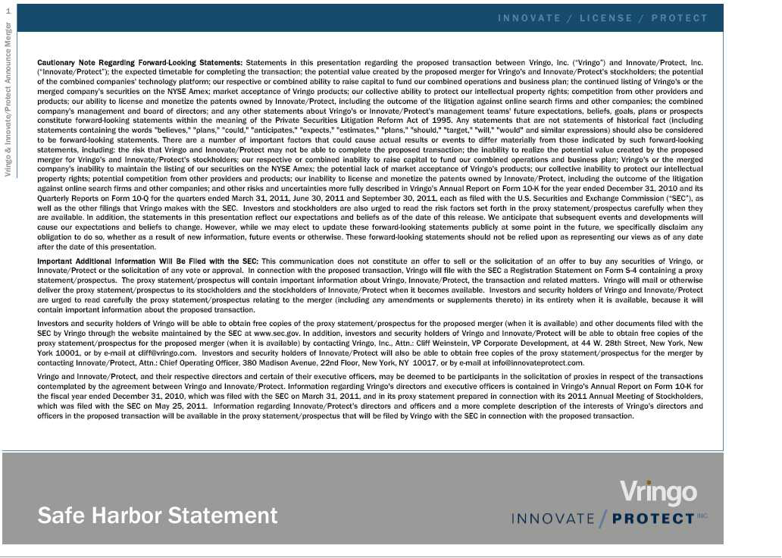

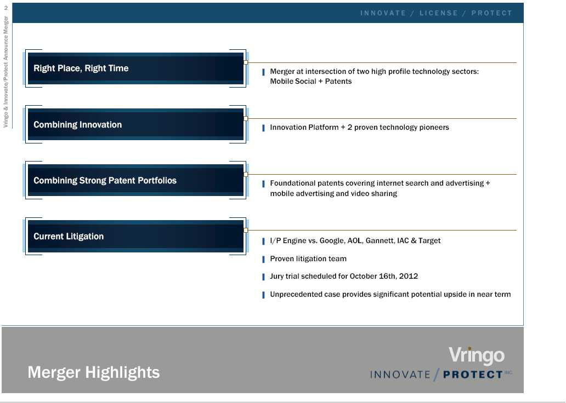

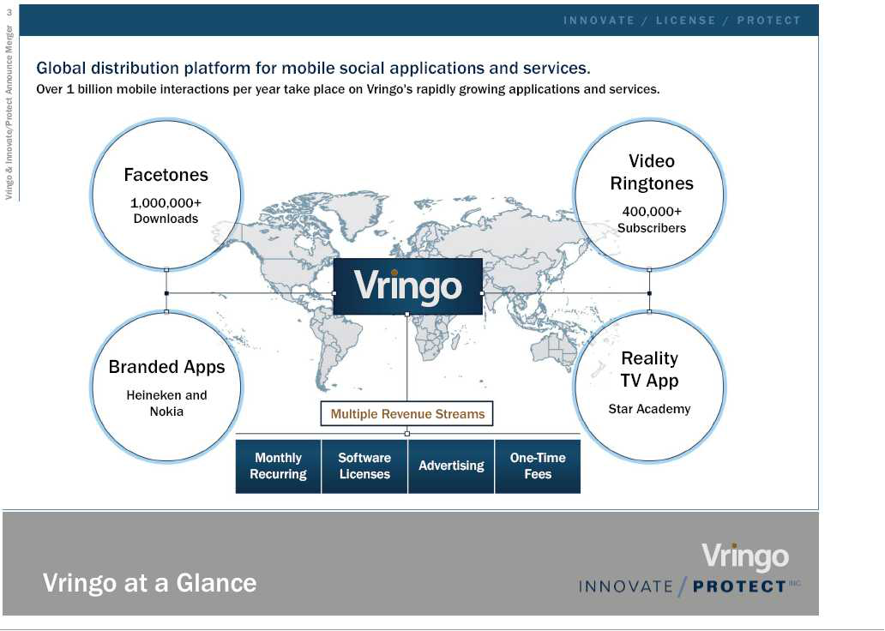

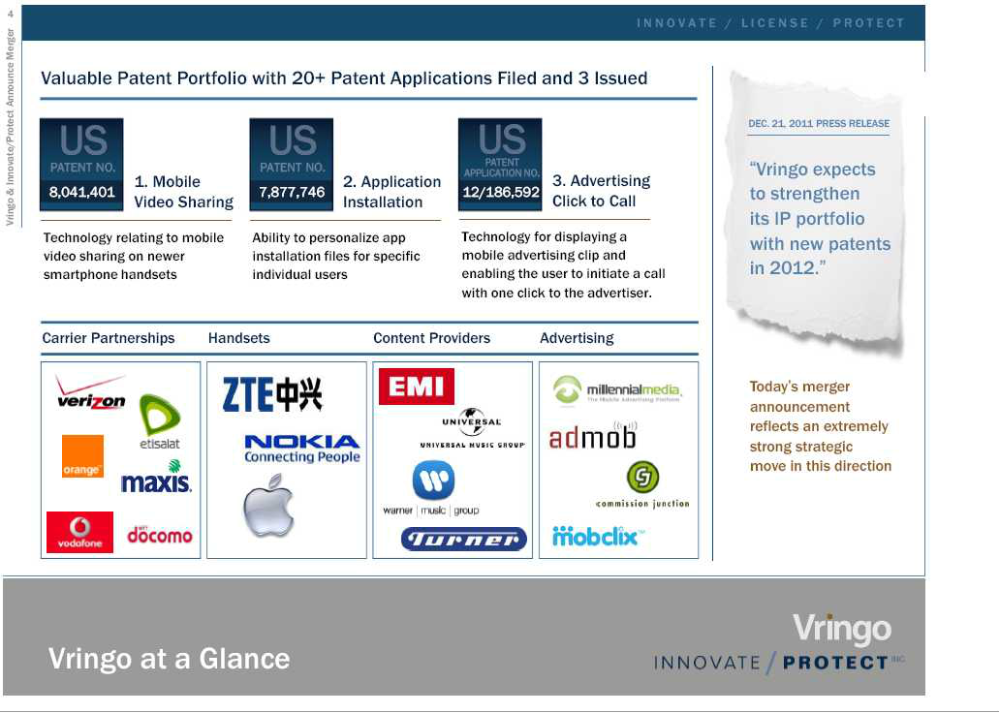

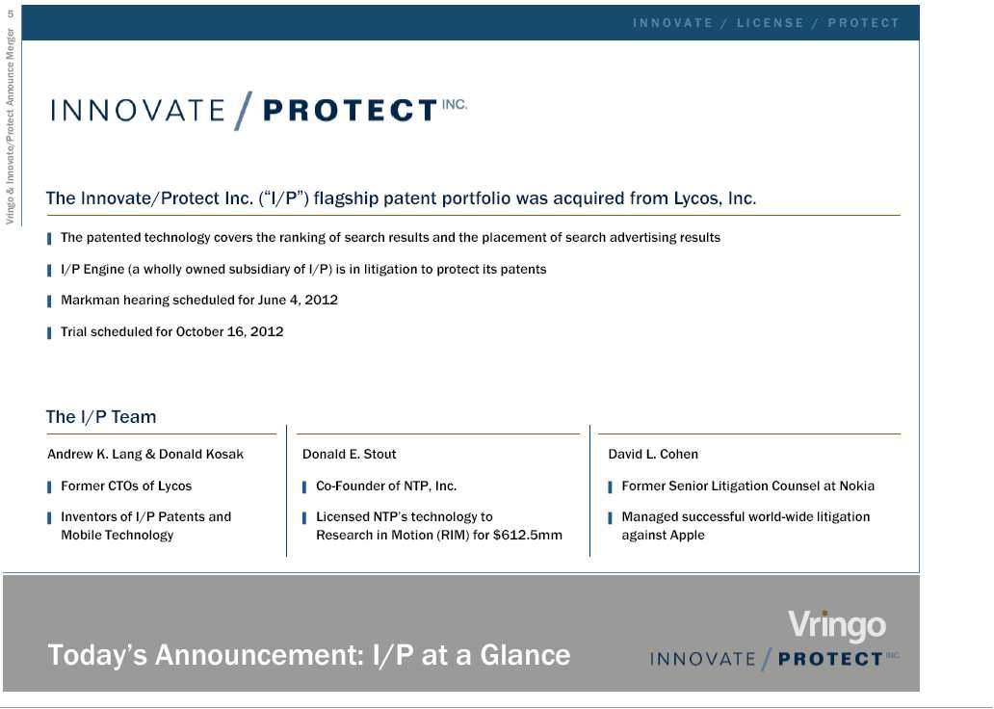

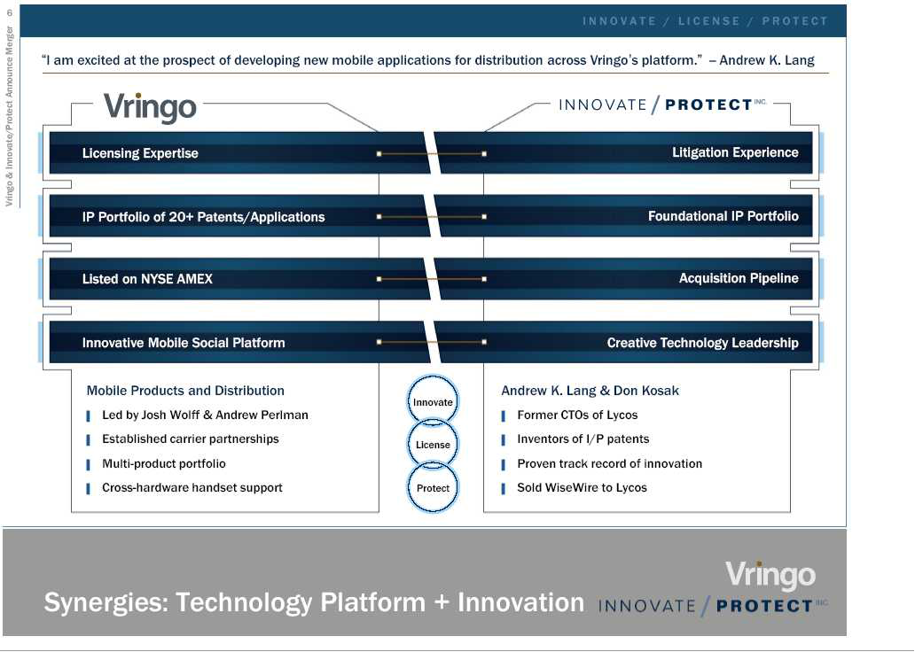

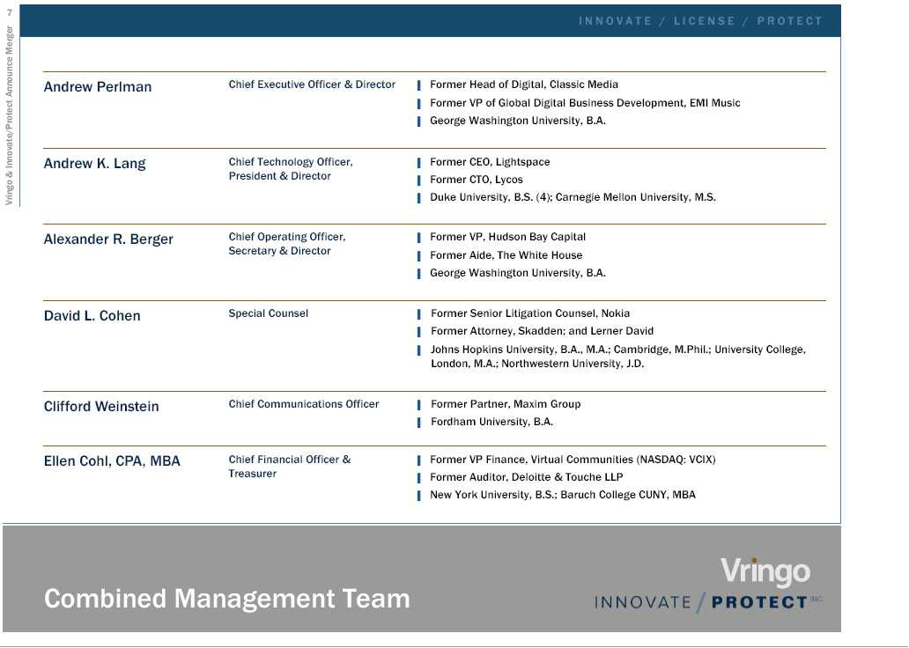

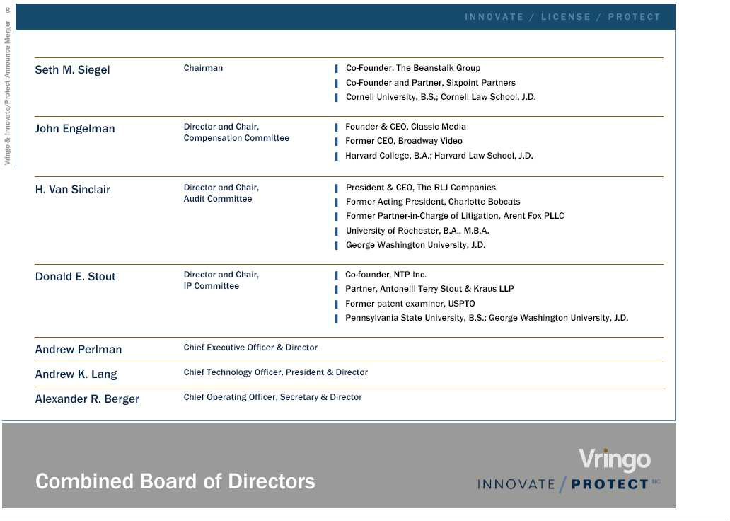

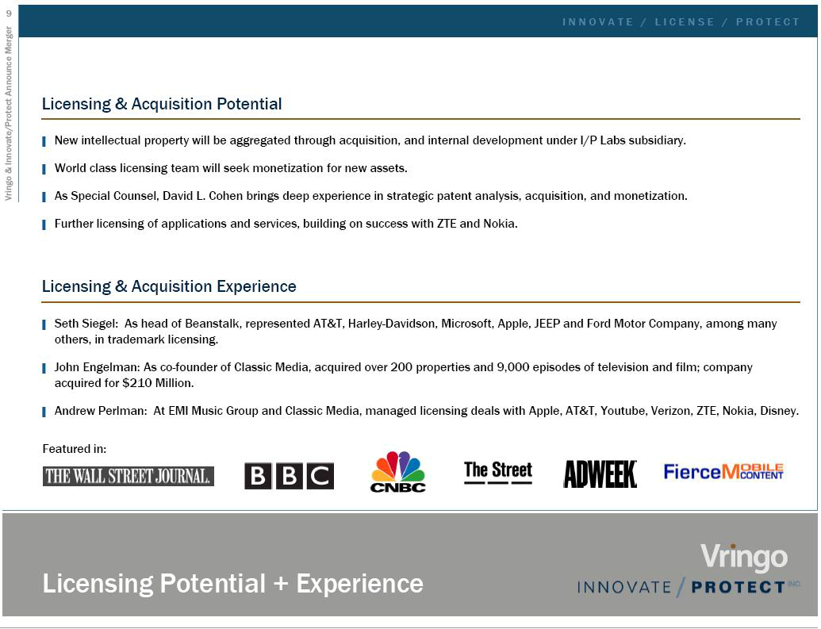

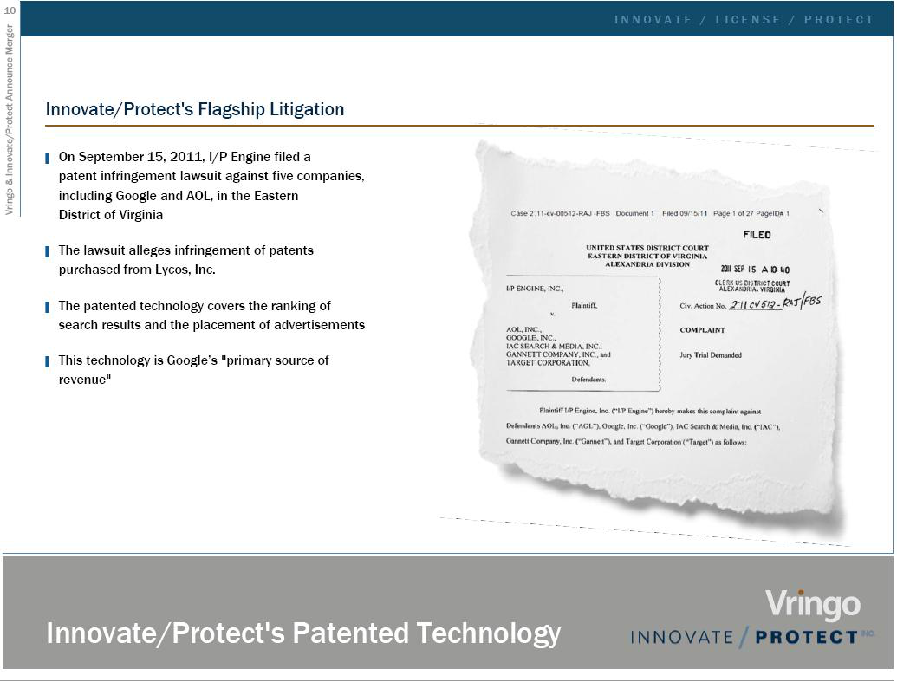

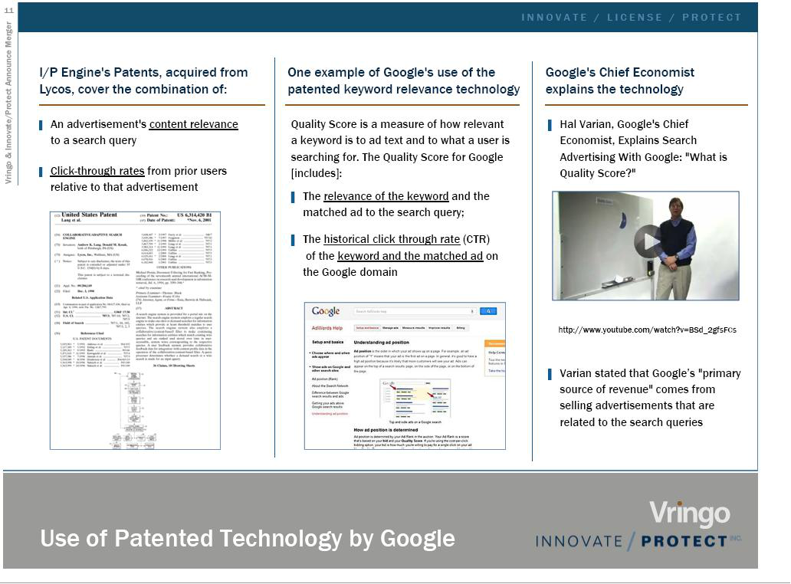

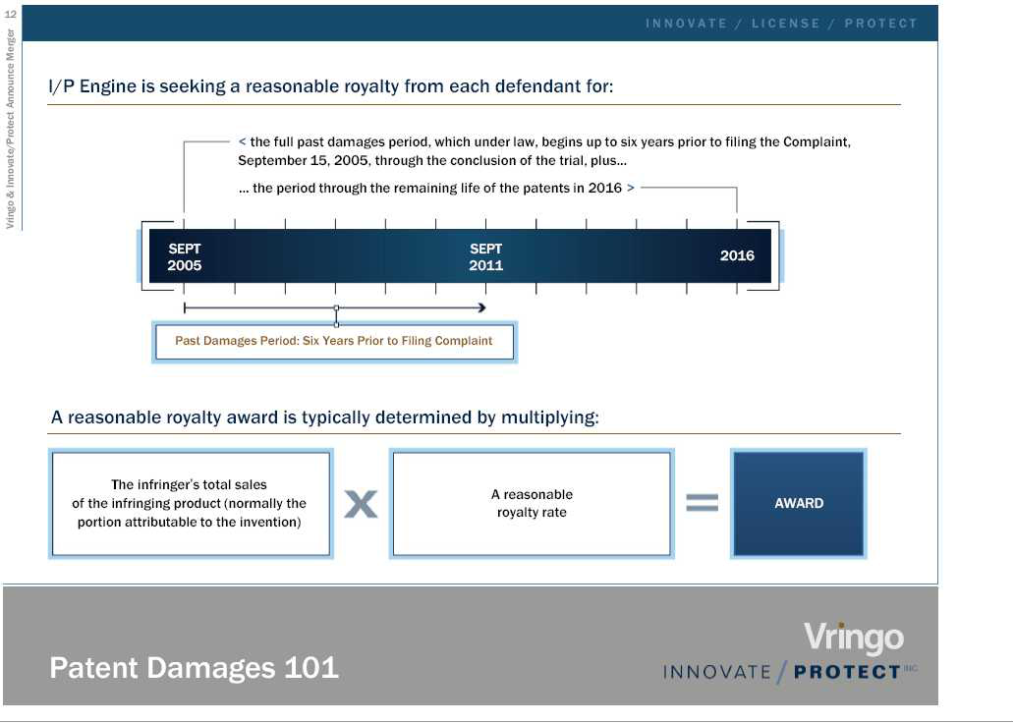

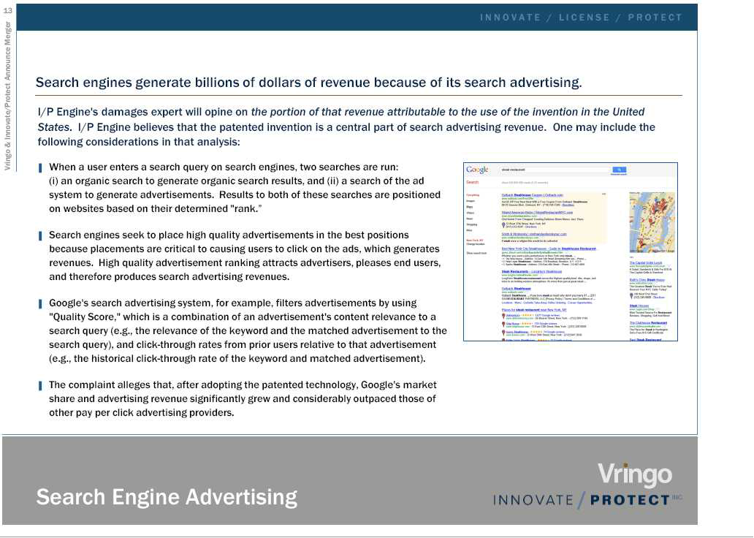

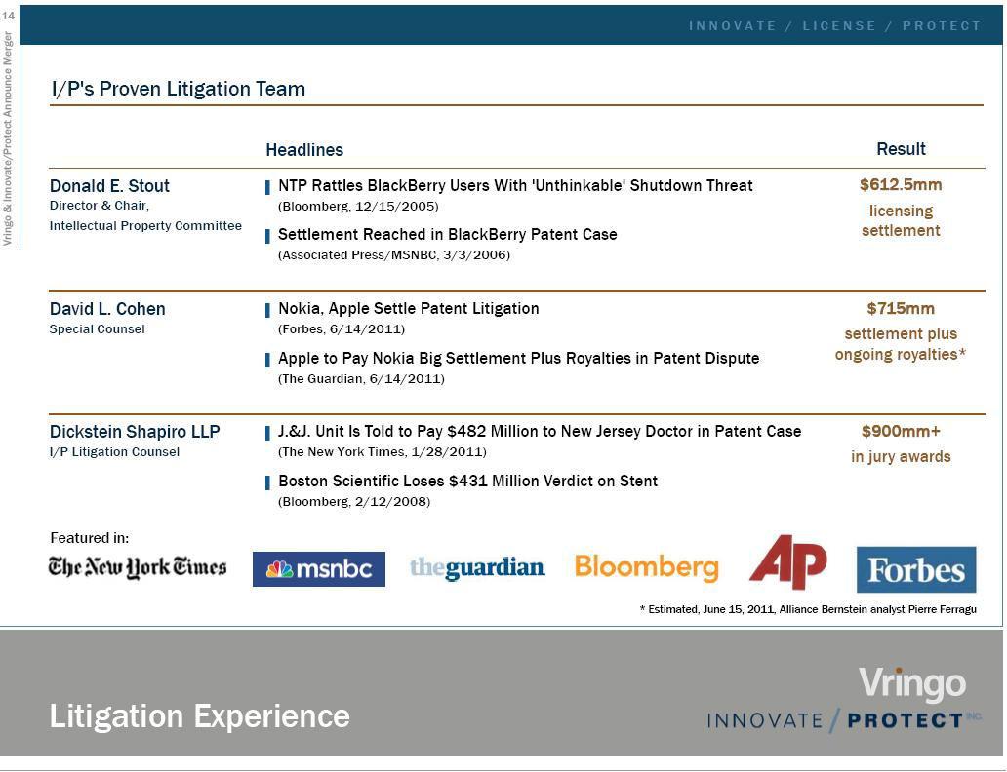

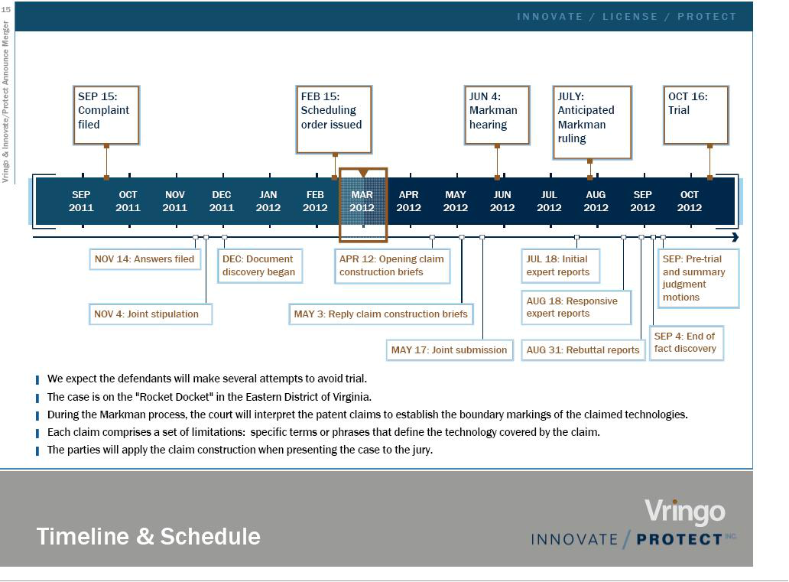

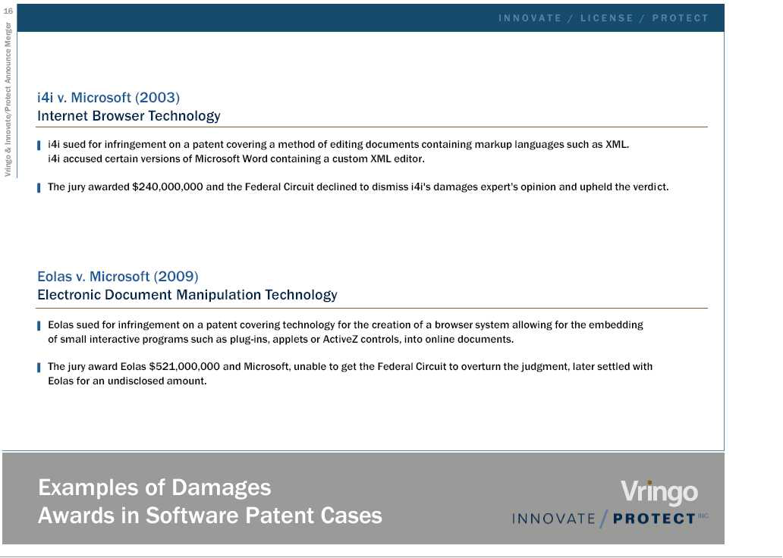

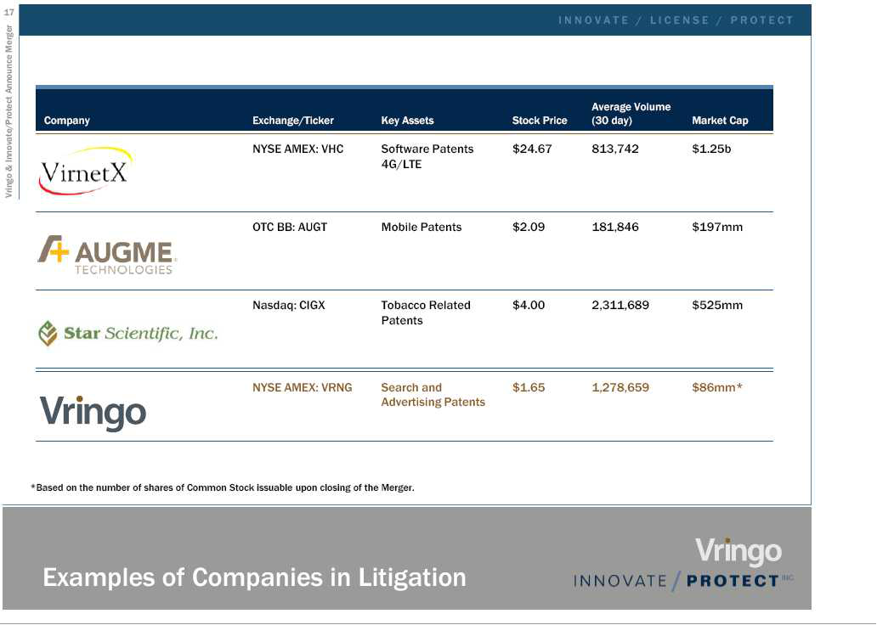

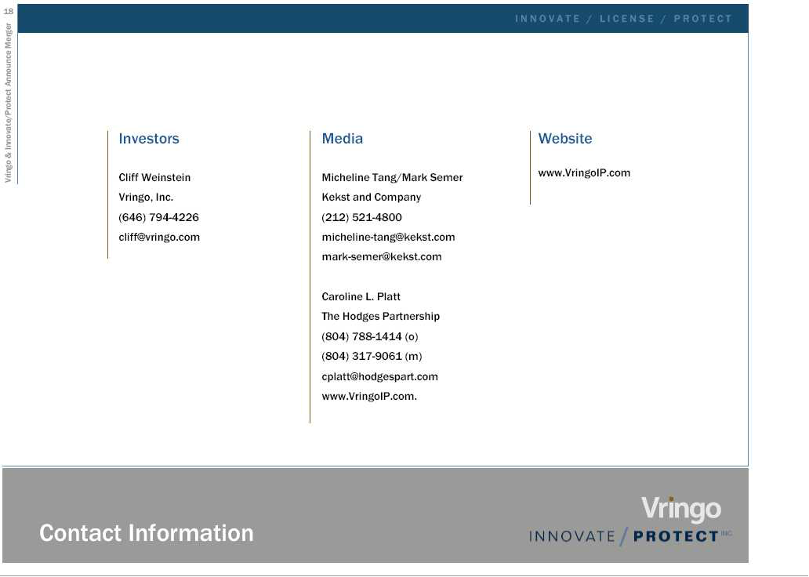

VRINGO AND INNOVATE/PROTECT TO HOLD TELECONFERENCE TO DISCUSS MERGER

NEW YORK, March 14, 2012 – Vringo, Inc. (NYSE Amex: VRNG) and Innovate/Protect Inc. will hold a teleconference today to discuss details of their merger agreement, announced this morning. Executives from both companies will participate in the teleconference, which will include a presentation regarding the merger and a question and answer session.

WHEN: | TODAY, Wednesday, March 14, 2012
 | 8:45 am EDT (please dial or log in ten minutes in advance to ensure access)
DETAILS: | Toll Free U.S. Call in: | 866-770-7051
 | International: | 617-213-8064
 | Passcode: | 62161274
 | Webcast: | Investors section of Vringo’s website at www.vringoinc.com or via the following link

http://www.media-server.com/m/acs/748729f15d3395743b29d00f5d843e1b

A recorded replay of the teleconference will be available from 10:45 am EDT until March 21, 2012. The replay may be accessed through the Investors section of Vringo’s website, www.vringoinc.com, or by dialing 888-286-8010 or 617-801-6888 and entering passcode 21675695.

Contact: | Investors: | Cliff Weinstein
 |  | Vringo, Inc
 |  | 646-794-4226
 |  | cliff@vringo.com
 | Media: | Micheline Tang/Mark Semer
 |  | Kekst and Company
 |  | 212-521-4800
 |  | Caroline L. Platt
 |  | The Hodges Partnership
 |  | 804-788-1414 (o)
 |  | 804-317-9061 (m)
 |  | cplatt@hodgespart.com

Important Additional Information Will Be Filed with the SEC

This communication does not constitute an offer to sell or the solicitation of an offer to buy any securities of Vringo, Inc. ("Vringo") or Innovate/Protect, Inc. ("Innovate/Protect") or the solicitation of any vote or approval. In connection with the proposed transaction, Vringo will file with the U.S. Securities and Exchange Commission ("SEC") a Registration Statement on Form S-4 containing a proxy statement/prospectus. The proxy statement/prospectus will contain important information about Vringo, Innovate/Protect, the transaction and related matters. Vringo will mail or otherwise deliver the proxy statement/prospectus to its stockholders and the stockholders of Innovate/Protect when it becomes available. Investors and security holders of Vringo and Innovate/Protect are urged to read carefully the proxy statement/prospectus relating to the merger (including any amendments or supplements thereto) in its entirety when it is available, because it will contain important information about the proposed transaction.

Investors and security holders of Vringo will be able to obtain free copies of the proxy statement/prospectus for the proposed merger (when it is available) and other documents filed with the SEC by Vringo through the website maintained by the SEC at www.sec.gov. In addition, investors and security holders of Vringo and Innovate/Protect will be able to obtain free copies of the
proxy statement/prospectus for the proposed merger (when it is available) by contacting Vringo, Inc., Attn.: Cliff Weinstein, VP Corporate Development, at 44 W. 28th Street, New York, New York 10001, or by e-mail at cliff@vringo.com. Investors and security holders of Innovate/Protect will also be able to obtain free copies of the proxy statement/prospectus for the merger by contacting Innovate/Protect, Attn.: Chief Operating Officer, 380 Madison Avenue, 22nd Floor, New York, NY 10017, or by e-mail at info@innovateprotect.com.

Vringo and Innovate/Protect, and their respective directors and certain of their executive officers, may be deemed to be participants in the solicitation of proxies in respect of the transactions contemplated by the agreement between Vringo and Innovate/Protect. Information regarding Vringo's directors and executive officers is contained in Vringo's Annual Report on Form 10-K for the fiscal year ended December 31, 2010, which was filed with the SEC on March 31, 2011, and in its proxy statement prepared in connection with its 2011 Annual Meeting of Stockholders, which was filed with the SEC on May 25, 2011. Information regarding Innovate/Protect's directors and officers and a more complete description of the interests of Vringo's directors and officers in the proposed transaction will be available in the proxy statement/prospectus that will be filed by Vringo with the SEC in connection with the proposed transaction.

Vringo, Inc. and Subsidiary

(a Development Stage Company)

CONSOLIDATED STATEMENT OF OPERATIONS

(in thousands except share and per share data)

Unaudited

 | For the Year
 | Ended
 | December
 | 31, 2011
 | U.S.$
Revenue | 718
Costs and Expenses
Cost of revenue | 155
Research and development | 2,017
Marketing | 2,193
General and administrative | 2,777
Total operating expenses | 7,142
Operating loss | (6,424)
Non-operating income | 13
Non-operating expenses | (14)
Interest and amortization of debt discount expense | (1,525)
Loss on revaluation of warrants | (402)
Gain on restructuring of venture loan | 963
Loss before taxes on income | (7,389)
Income tax expense | (90)
Net loss | (7,479)
Basic and diluted net loss per common share | (1.17)
Weighted average number of shares used in computing basic and dilutive net loss per common share | 6,372,659


March 8, 2012

Mr. Jon Medved

Zerubavel 6

Jerusalem 93511

Israel

Dear Jon:

As discussed between us we have mutually determined that you will cease providing services to Vringo (Israel) Ltd. (“Vringo” or the “Company”) as its Chief Executive Officer. This letter sets out the terms of such separation, including provisions set forth in your Employment Agreement with the Company dated as of July 29, 2007, as amended (the “Employment Agreement”), as well as several items which are now offered at the Company’s discretion in exchange for your agreement to the terms hereof. Unless indicated otherwise, capitalized terms contained in this Separation Letter Agreement are defined in the Employment Agreement.

This Separation Letter Agreement constitutes a notice of cessation of your Employment Agreement and your employment with the Company and sets forth the terms governing such separation.

- The Company agrees with you that you have ceased providing services to the Company as an employee as of the date of signing this Separation Letter Agreement and that the effective date of such cessation for the purposes described herein shall be May 6, 2012 (the “Effective Date”). The period from March 8, 2012 until the Effective Date shall be deemed sufficient prior notice for all purposes. Notwithstanding the aforementioned Effective Date, by your signature below, you are acknowledging that as of March 7, 2012 (the “Separation Date”), you are officially leaving your position as the Company’s CEO, as well as resigning from your directorships with the Company and with Vringo, Inc., the parent company of the Company (hereinafter referred to as the “Parent Company”). For the avoidance of doubt, as of the Separation Date, you will relinquish all titles, offices and authority and you will not act on behalf of or hold yourself out as being a representative of the Company or Parent Company following such date. The Parent Company shall provide you with a copy of a press release regarding your resignation prior to the announcement.
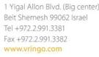

Within thirty (30) calendar days of the Effective Date, you shall transfer to the Company or the Company’s specific designee any relevant Company or Parent Company materials that are not already in the Company’s possession with other employees. This will include paper and electronic files related to Company or Parent Company matters and other items as defined in your Employment Agreement. Notwithstanding this transfer of Company or Parent Company tangible and electronic files, provided you are not in breach of any terms or provisions of this Separation Letter Agreement you are permitted to maintain your confidential Company email address (jon@vringo.com) and specify instructions for automatic forwarding to an address of your choice for a transition period of thirty-six (36) months following the Effective Date, with the stipulation that you immediately forward to the Company’s designee all emails involving Vringo business and maintain in confidence (per your Employment Agreement) the content of such emails.

- Under the terms of your Employment Agreement, since we agree that you are resigning as CEO of the Company for Good Reason, you are entitled to receive severance payments in an amount equal to your adjusted Salary of US $15,937.50 plus full benefits per month, for a period of nine (9) months following the Effective Date (that is, until February 6, 2013 (the “Termination Date”)), payable on a monthly basis in accordance with the Company’s normal payroll policies. The severance payments will be paid in NIS, according to a previously-agreed normalized exchange rate of 4.00 NIS/$. You will provide us at the Separation Date with an updated standard Form 101, and provide further updated forms during the period through the Termination Date to the extent that there are changes in your status, including if you will have additional employment income during such period. If at any time during the period through the Termination Date, you receive employment income from another employer, the Company will process payments to you at the maximum tax rates, as required by law, unless the Company is presented with a tax reconcilation document from the Tax Authorities (“Teum Mas”).

- In addition to the severance payments described in item 2 above, you will receive all the benefits associated with your Salary as the Company’s CEO, including the timely release shortly following the Termination Date, in full, of your Manager’s Insurance Fund/Bituach M’nahalim (including its severance, disability and pension components) for the entire period you will have been employed by the Company (April 1, 2006 through the Termination Date). You shall also receive through the Termination Date, continuing benefits from the Company to include: national insurance payments (Bituach Leumi); Further Education Fund contributions (Keren Hishtalmut); payments for Car expenses (maintenance, lease and other related expenses) up to US $1,000 per month; and your personal life insurance premiums up to NIS 5,500 per month. You agree that during the period from the Effective Date through the Termination Date, you will be deemed to be utilizing any vacation days that accrue during such period, and will not be entitled to any further payment with respect thereto.

- Your final Salary for the month immediately following the Termination Date shall also include payments for any unpaid vacation days and recuperation pay (D’may Havra’a) through the Effective Date, subject only to deduction of any amounts the Company may need to withhold to cover any amounts owed by you to the Company (and that such amount is estimated as of the date of this Separation Letter Agreement to be NIS 141,929 for vacation (representing 48.24 accrued and unused vacation days) and NIS 1,916 for “recuperation pay” (D’may Havra’a) representing 279 accrued and unpaid days).

- To the extent such policy is in effect, you will personally continue to be covered (for acts performed as CEO and Director of the Company and Parent Company prior to the Effective Date) by the Company’s and/or Parent Company’s D&O insurance policy, for a period of seven (7) years following the Effective Date, or for such other period considered customary in the industry and readily obtainable as D&O tail coverage.

- You have on several previous occasions been awarded options to purchase stock of the Parent Company. The numbers of such options, as well as their respective grant dates, vesting periods, and strike prices, are all set forth in Appendix 1 to this Separation Letter Agreement. Per our discussions and agreements, and notwithstanding that which is set forth in your option agreements or the original vesting schedules with the Company or Parent Company, we agree that, subject only to your good faith compliance with your obligations to the Company that survive the termination of your employment, (i) all unvested options set forth in Appendix 1 (other than the penny options, as described below) shall continue to vest according to the current vesting schedule despite the cessation of your employment with the Company, (ii) your right to exercise all options that have vested on or before June 21, 2013 shall remain available to you until September 21, 2013, and, if and to the extent that the Company shall in the future make available such a possibility to its Israeli employees under the relevant incentive plan, you may choose to engage in a cashless exercise of such vested options, and (iii) all options granted to you on March 17, 2010 at a strike price of $ 0.01 that remain unvested shall fully vest as of June 21, 2012. If you decide to exercise some or all of the aforesaid options before September 21, 2012, the Company, to the extent possible and upon written instructions from you, can deduct the relevant amounts from some of its continuing Salary and other payment obligations it has to you. Otherwise, as well as with respect to your potential exercise of other vested options after September 21, 2012, exercise will only be possible upon receipt of a check made payable to the Company in the amount set forth above (or the NIS equivalent converted at the representative rate on the date of receipt of the check). You represent and warrant that you will not dispose of any securities of the Parent Company in violation of any securities law or regulation.

- In addition to the options set forth in Appendix 1 hereto, the Company hereby grants to you an additional 100,000 options, vesting over three (3) years, subject only to your good faith compliance with your obligations to the Company that survive the termination of your employment. Vesting for such options shall commence as of the Separation Date, subject to the approval of this grant at the next regularly scheduled board meeting to take place not later than April 15, 2012, and the strike price shall be the closing market value price determined on such date.

- In the event that, at any time, the Parent Company files any registration statement with a public stock exchange to include options or shares of stock held or owned by its or the Company’s employees and/or service providers, it shall include within such registration statement all shares of Parent Company stock and options to purchase such stock held by you, including those options and shares referenced in paragraphs 6 and 7 above.

- In return for the Company and Parent Company's agreements to the terms set forth in this Separation Letter Agreement, and as a condition to such terms, you, for yourself, your heirs, privies, executors, administrators, assigns, successors-in-interest and predecessors-in-interest, hereby release and forever discharge the Company, the Parent Company, and each of their affiliates and subsidiaries, the present or former officers, directors, employees and agents of all of them (collectively, the “Company Releasees”) of and from any and all charges, complaints, actions, causes of action, grievances, suits, liabilities, obligations, promises, controversies, damages, losses, debts and expenses and claims in law or in equity of any nature whatsoever, known or unknown, suspected or unsuspected, you ever had, now have or shall have against any Company Releasees to the Effective Date, including those arising by reason of any and all matters connected with your past employment with, compensation during, and separation from the Company. The Company acknowledges that the release contained in this paragraph shall not preclude you from suing to enforce your rights (i) under this Separation Letter Agreement, or (ii) with respect to any future act or omission involving misconduct or gross negligence by the Company that directly causes you harm.

- In return for your execution of this Separation Letter Agreement, the Company, for itself and its affiliates (including the Parent Company), predecessor organizations, present or former partners, members, committees and officers hereby releases and forever discharges you, your heirs, privies, executors, administrators, assigns, successors-in-interest and predecessors-in-interest to the same extent you released the Company in paragraph 9 above.

- In return for the Company's agreement to the terms set forth in this Separation Letter Agreement, and as a condition to such terms, you agree to vote all voting securities of the Parent Company created (by grant or extended exercise period) or otherwise accelerated by the terms hereof consistent with the written recommendation of the Parent Company's Board of Directors. For the removal of any doubt, however, you are free to vote securities you hold in the Parent Company that are unrelated to the options granted, subject to extended exercise or accelerated by the provisions of this Separation Letter Agreement, in any manner you so choose.

- The Company and you hereby agree to refrain from making any written or oral statement or taking any action, directly or indirectly, which the parties know or reasonably should know to be disparaging or negative concerning the other, except as required by law. We each also hereby agree to refrain from suggesting to anyone that any written or oral statements be made which the parties know or reasonably should know to be disparaging or negative concerning the other party. This provision shall include, but not be limited to, the requirement that we each refrain from expressing any disparaging or negative opinions concerning one another, your separation from the Company, any of the Company's officers, directors, or employees, or other matters relative to the Company's reputation as an employer or any other matters relative to your reputation as an executive

- By February 6th , 2013, you are required to either return to the Company your Company Car and keys or personally assume the Car lease on your Company Car. This choice will be at your option. To avoid doubt, you will be solely responsible for any penalty fees incurred for early or late return of the Company Car, any damages to the Company Car and traffic and parking violations relating to the period of your use of the Company Car. An appropriate portion of your February 2013 entitlements will be withheld for up to 30 days to ensure payment of any outstanding matters relating to the use of the Company Car or other Company property. A single laptop computer and mobile phone / SIM card you have been using are yours to keep (and any additional items should be promptly returned within 30 days of the Separation Date).

- You agree that, as of the Termination Date, you will cease to incur expenses in the name of the Company or Parent Company, or for which the Company or Parent Company could be liable, including but not limited to your expense accounts. Neither the Company nor Parent Company will be responsible for reimbursing any expenses which have not been submitted prior to the execution and delivery of this Separation Letter Agreement.

- The terms contained in this Separation Letter Agreement are contingent upon your provision of the release contained in paragraph 9 hereof, your full co-operation in the transition arising from your departure from the Company, and your compliance with the terms of your Employment Agreement with the Company, including but not limited to provisions regarding confidentiality and noncompetition (see sections 10 and 12 thereof), which survive this departure from the Company. In furtherance of those confidentiality and noncompetition undertakings, we agree that (A) the terms of this Separation Letter Agreement are confidential and shall not be the subject of any disclosure to third parties other than to advisors or as required by law, regulation, or any NYSE Amex rule and (B) notwithstanding the Employment Agreement provision, you may provide professional services to Movius, Swagbucks and MEN, as well as any other companies brought by you to the Company and approved as a specific carveout to your non-compete obligations under the Employment Agreement on a case-by-case basis, provided that in each such instance you shall refrain from any use of or reliance upon trade secrets or other confidential, proprietary or non-public information of the Company and the Parent Company.

- This Separation Letter Agreement contains the entire understanding between the parties. This Separation Letter Agreement supersedes all prior understandings among the parties hereto with respect to the subject matter contained herein.

- By signing this Separation Letter Agreement, you acknowledge that you are not aware of having violated any material provision of your Employment Agreement or any other employment-related agreement entered into by you and the Company, which would have given the Company the right to terminate you for Cause (as defined thereunder).

- This Separation Letter Agreement may be signed in counterparts, each of which may be delivered by facsimile or other electronic transmission, and each of which, when taken together, shall constitute one and the same Separation Letter Agreement.

- Any notice to the Company or Parent Company shall be addressed to it in care of its Chief Financial Officer at its executive offices located at 1Yigal Allon Blvd. Beit Shemesh 99062 Israel, and any notice to you shall be addressed to the you at the address currently in the records of the Company. Any notice shall be deemed duly given if and when properly addressed and either (i) posted by registered or certified mail, postage prepaid or (ii) sent by reputable overnight courier or (iii) delivered in person.

/s/ Seth Siegel
Seth Siegel, Chairman

Vringo, Inc., on behalf of Vringo (Israel) Ltd.

Accepted and agreed by:

/s/ Jon Medved
Jon Medved

Date: March 8, 2012

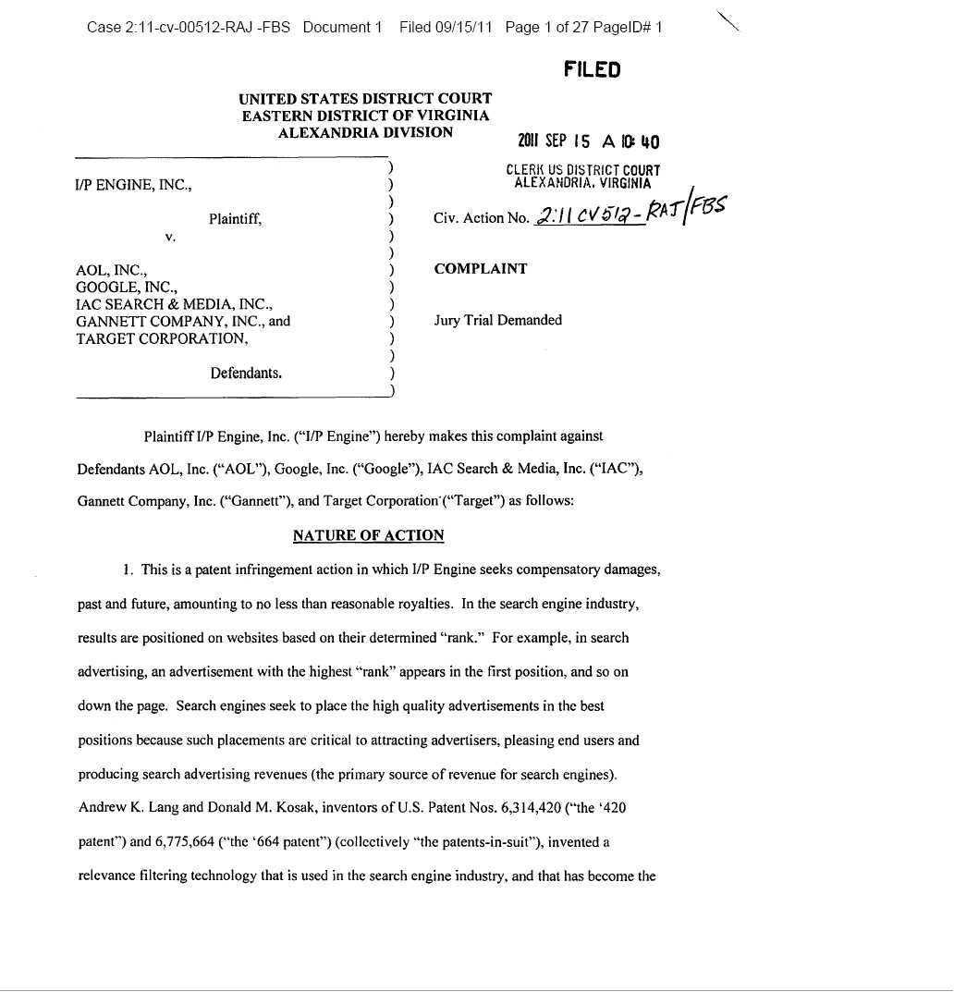

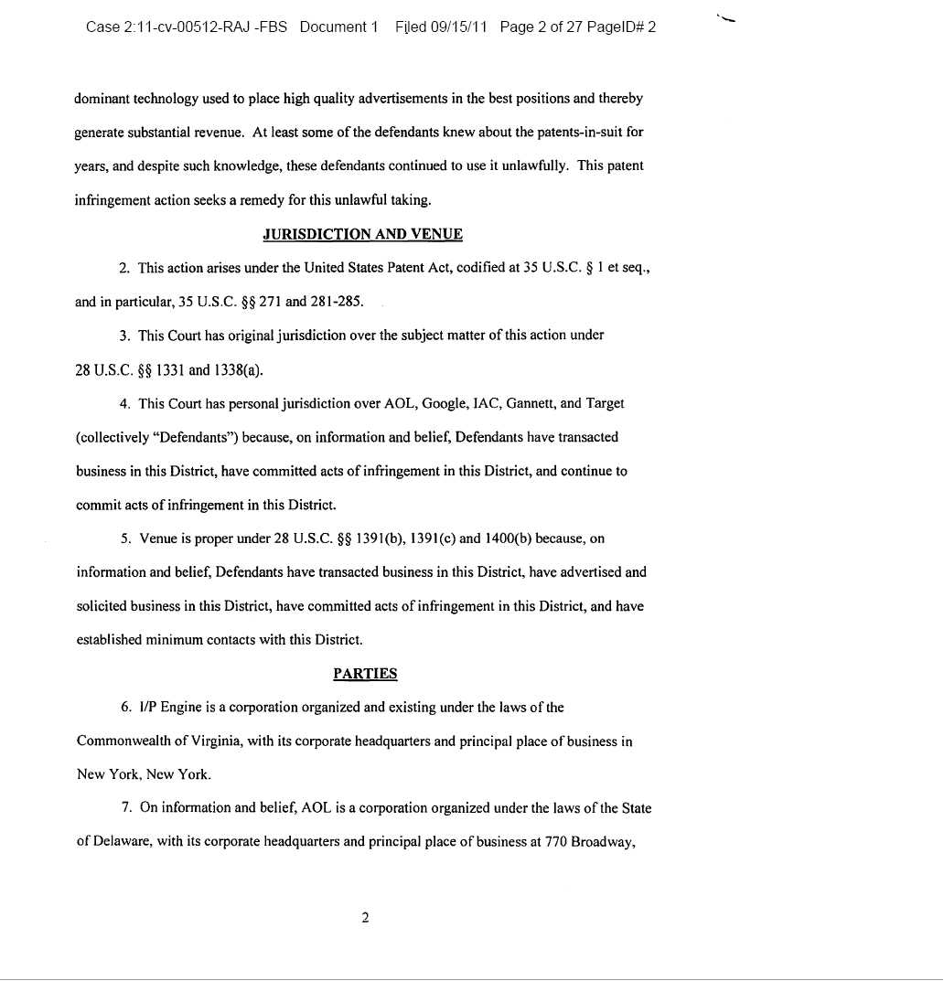

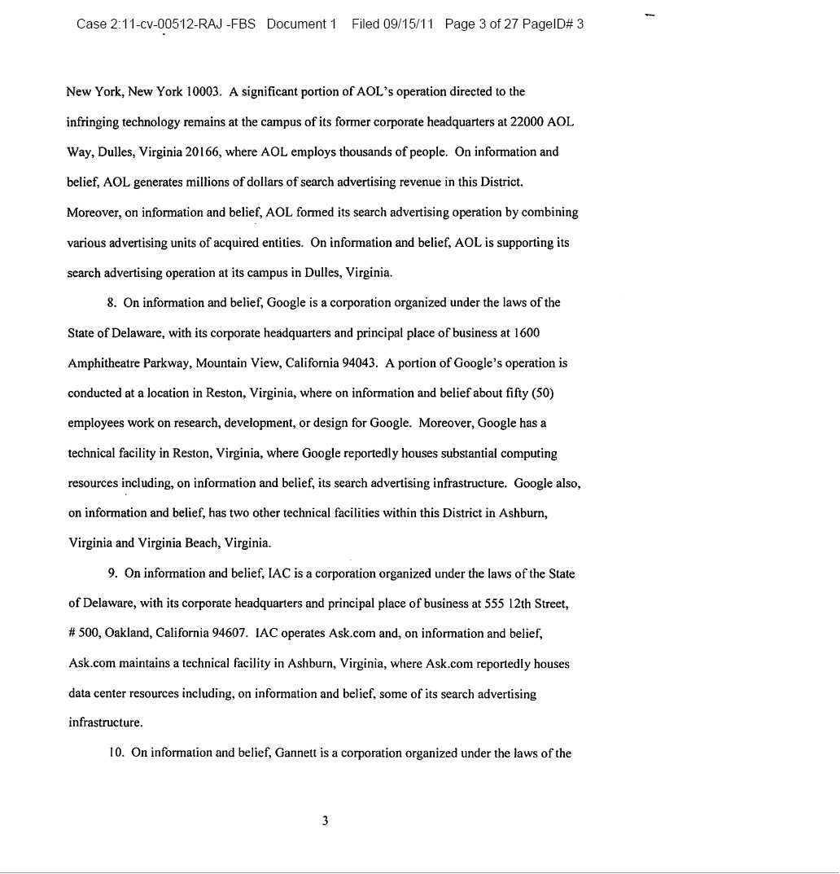

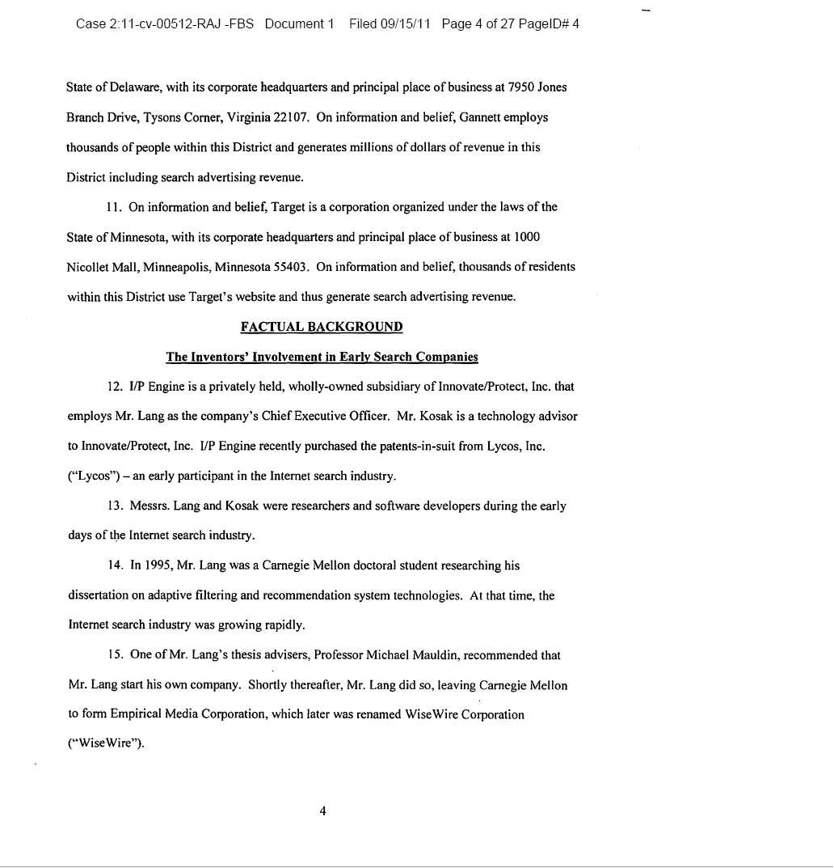

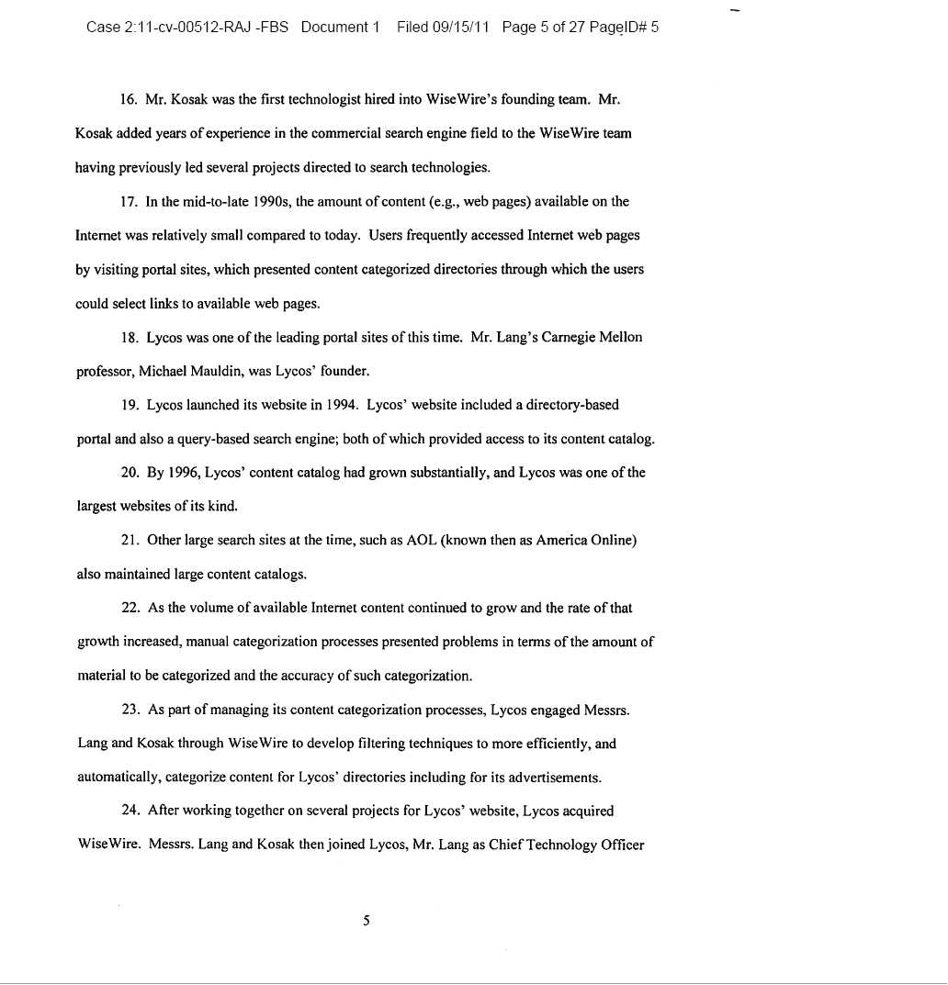

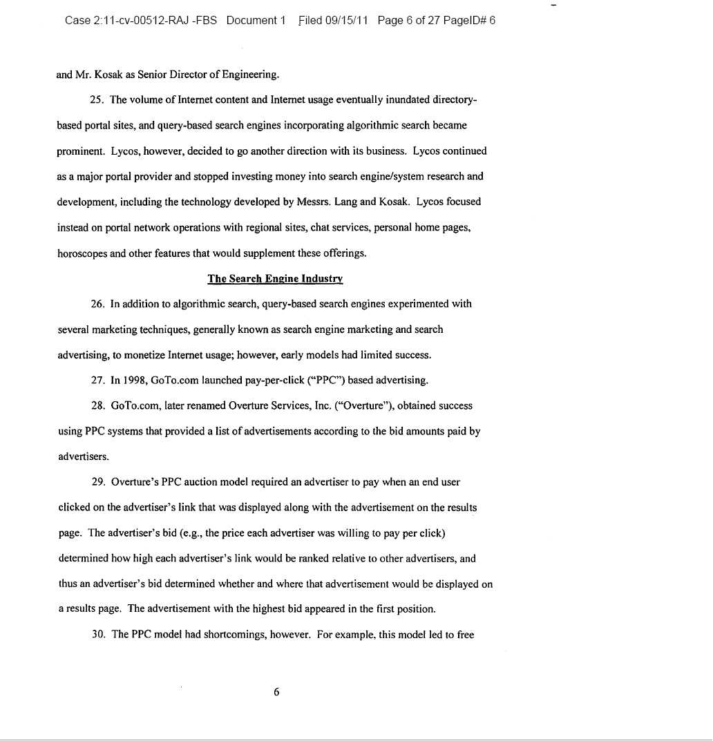

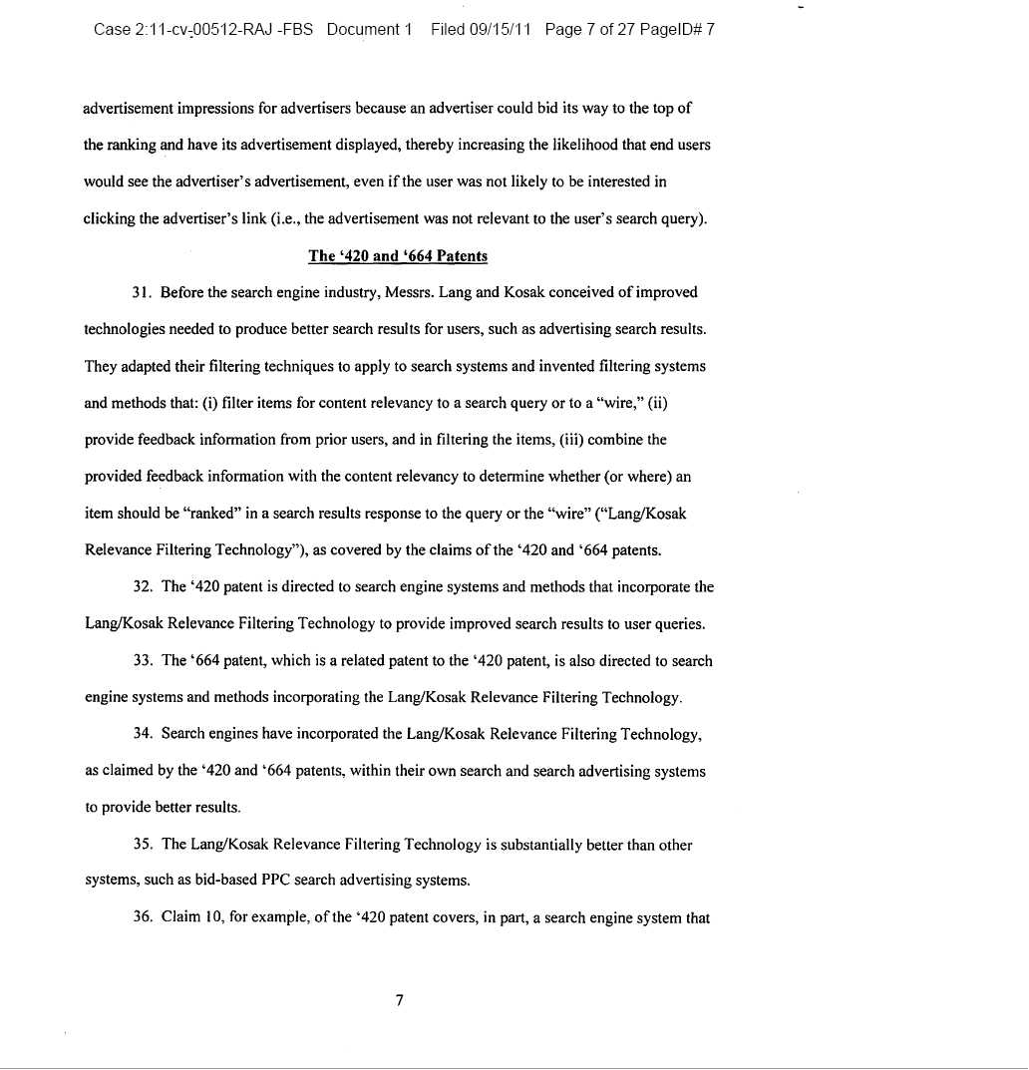

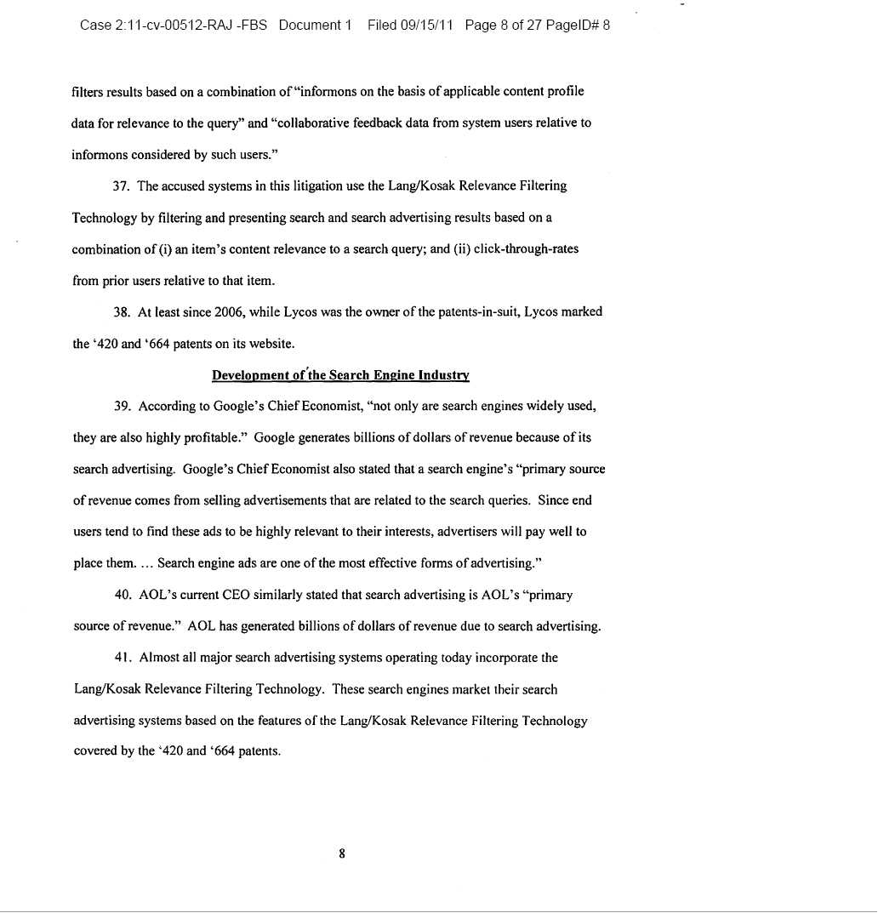

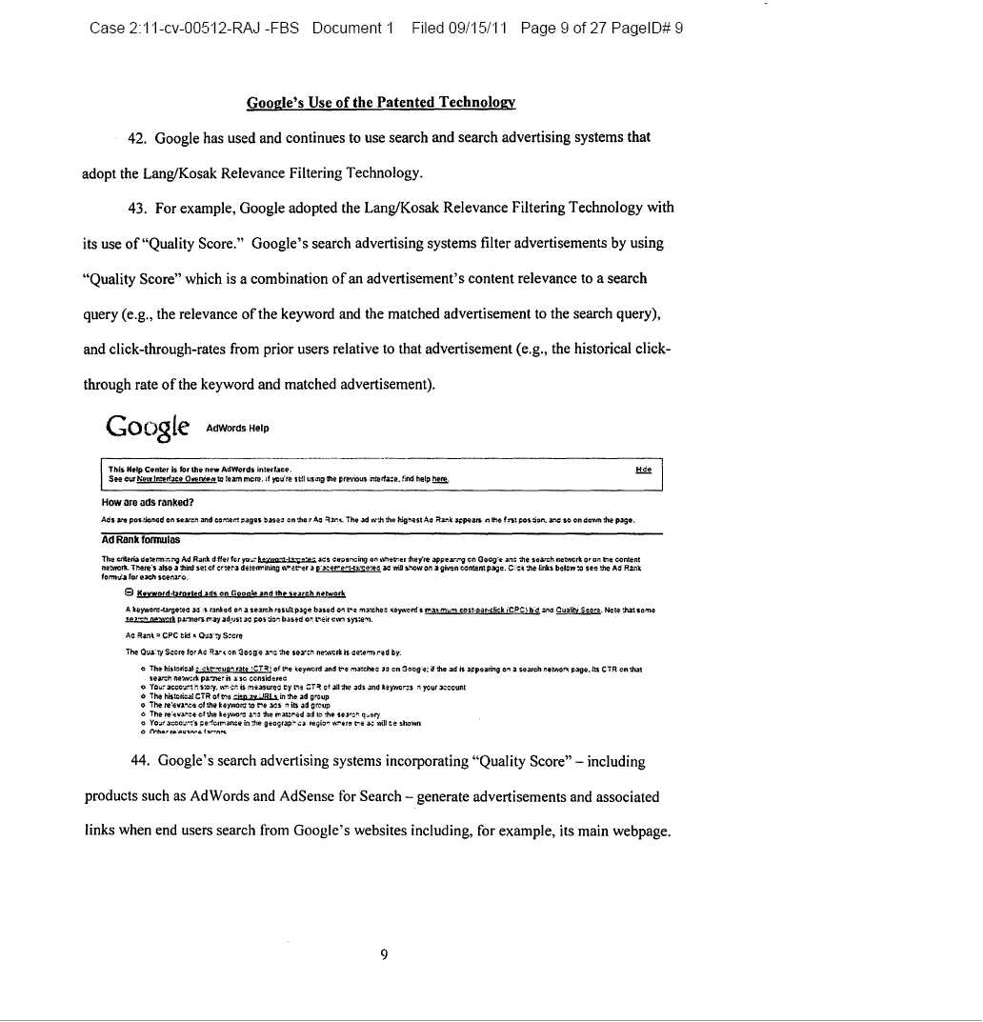

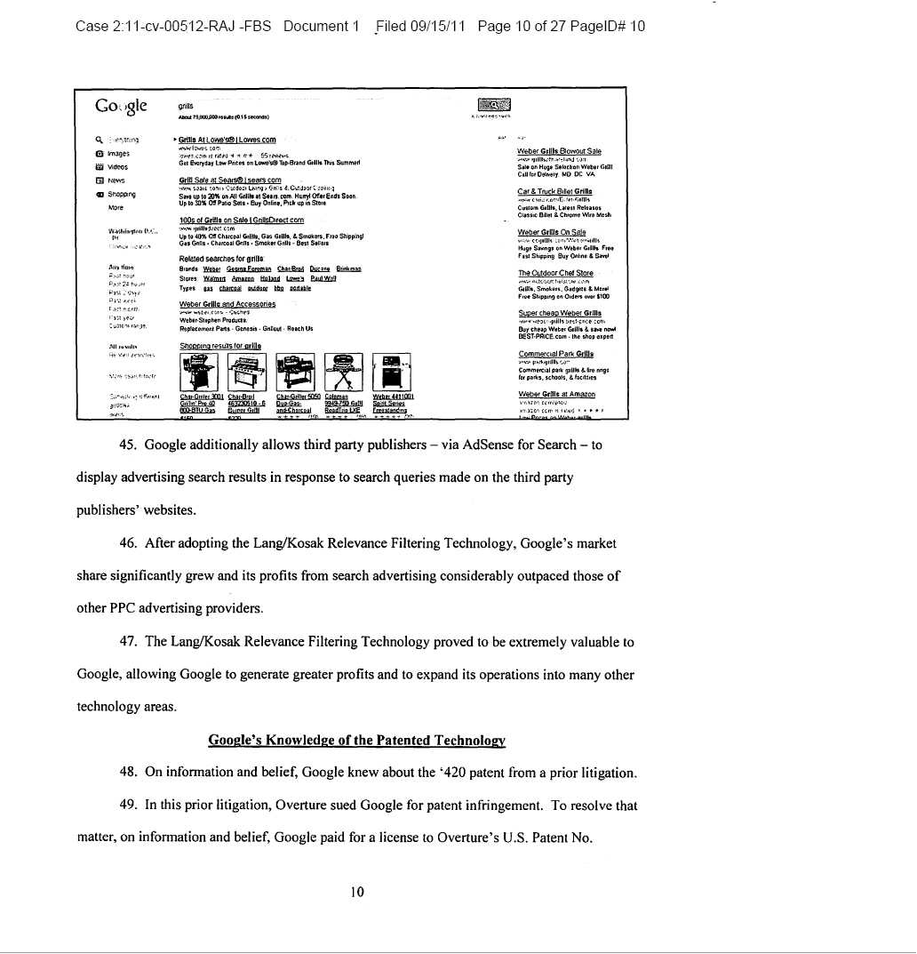

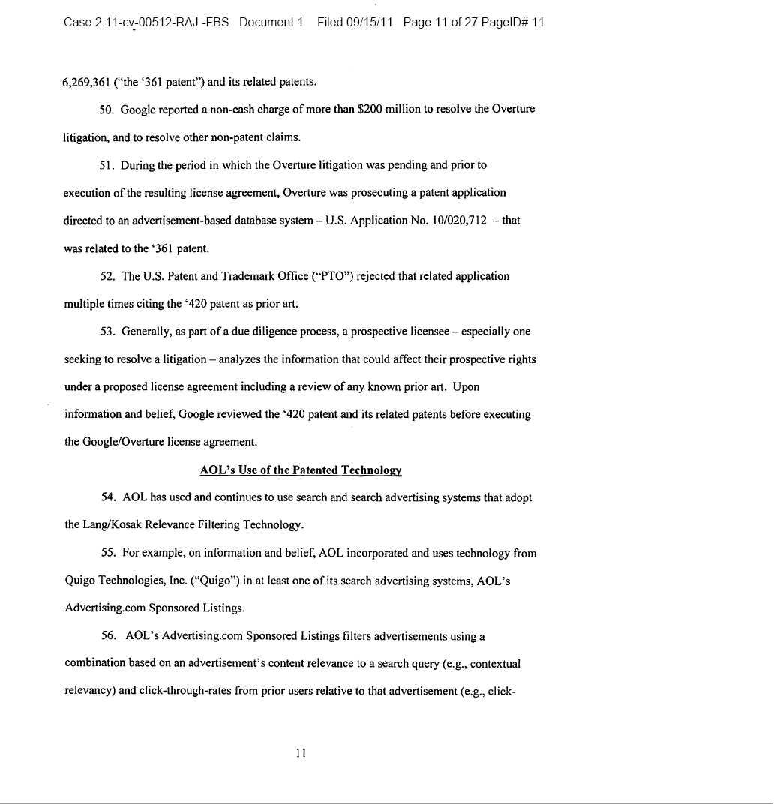

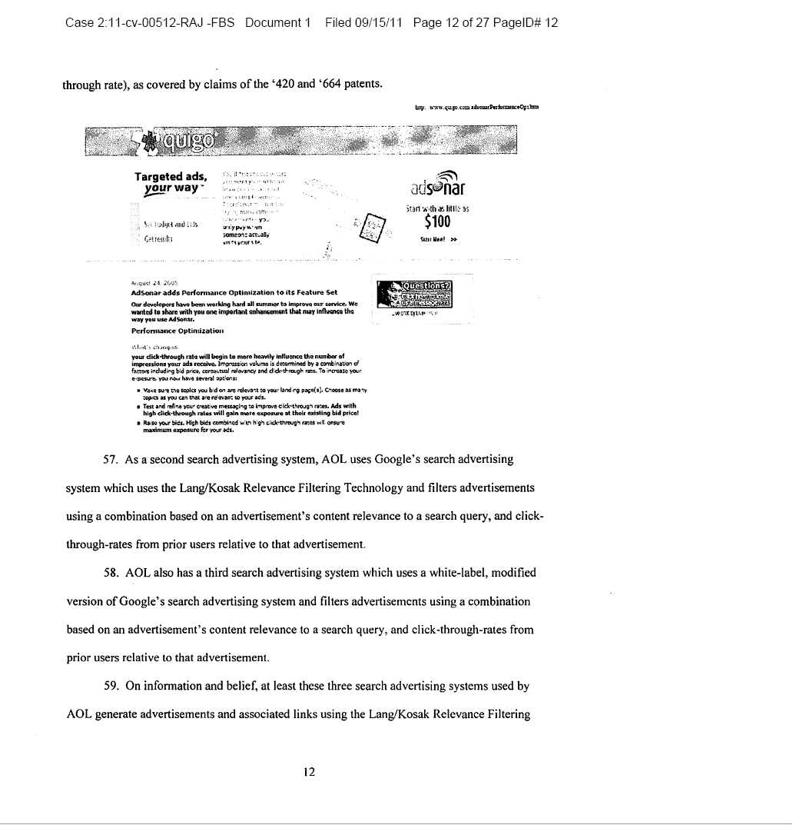

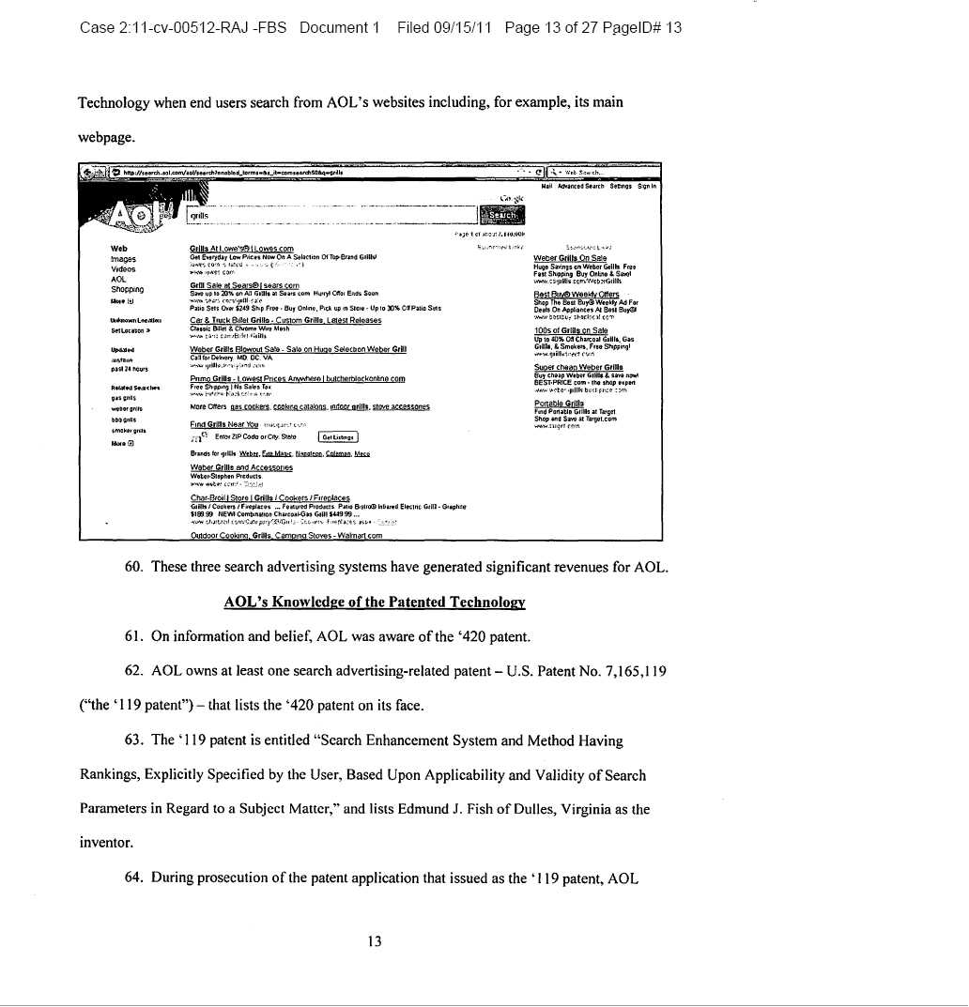

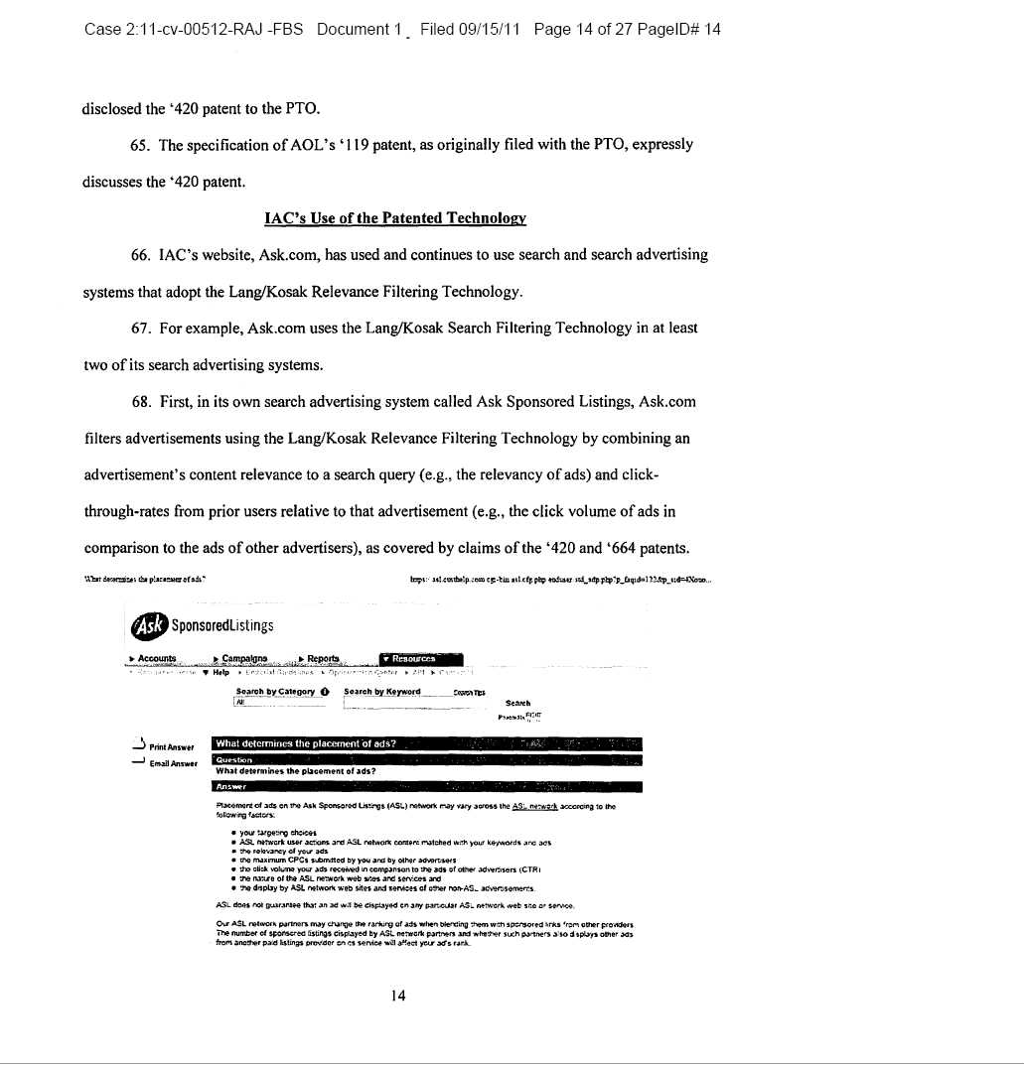

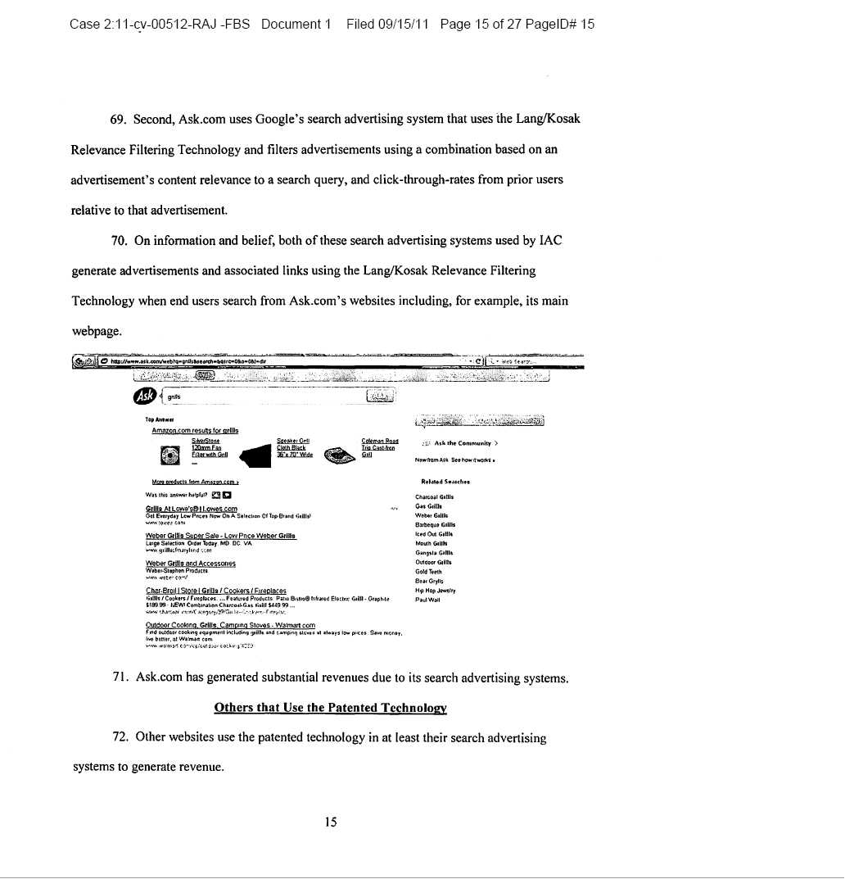

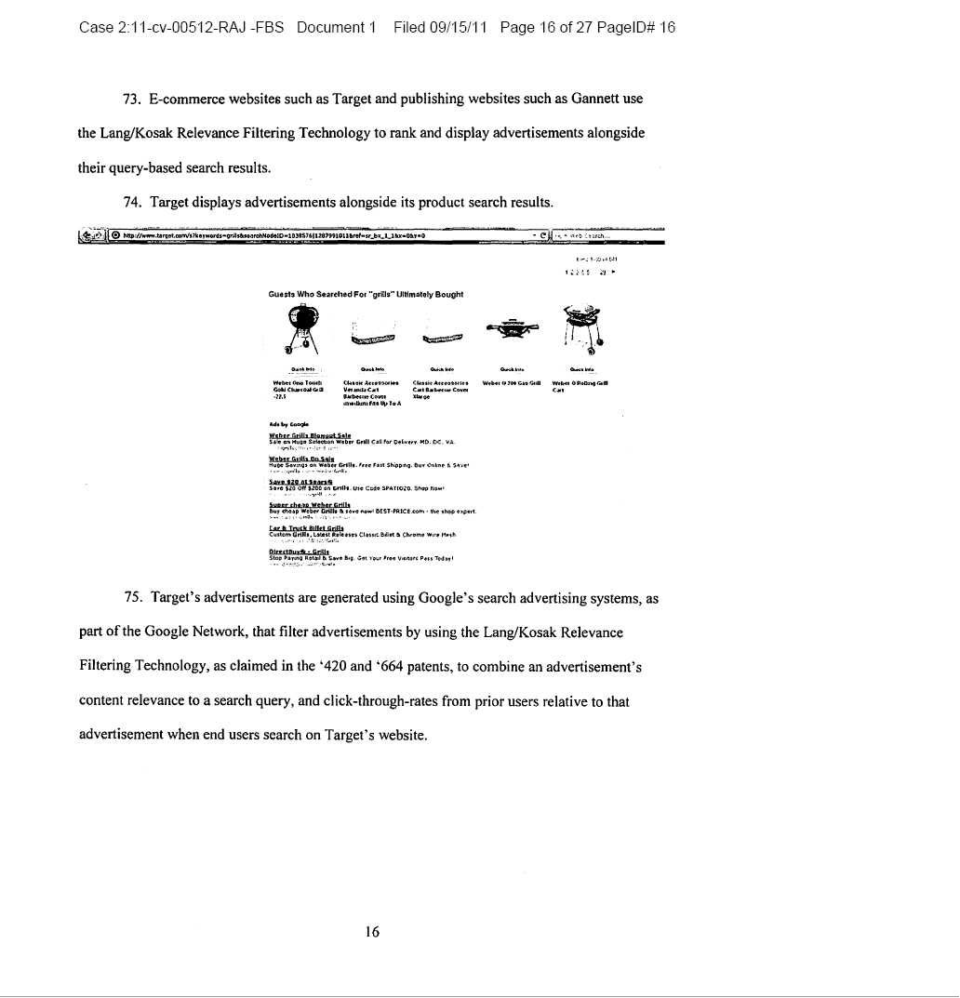

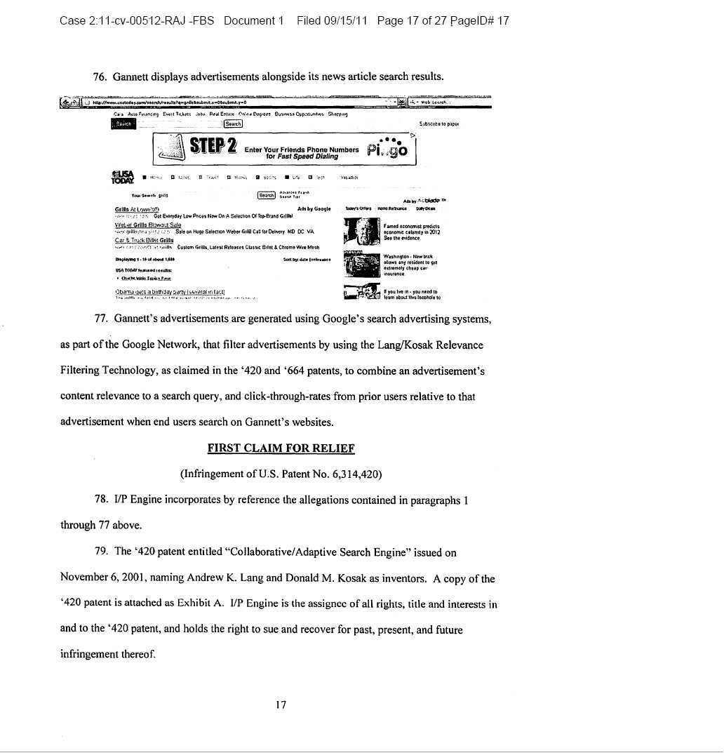

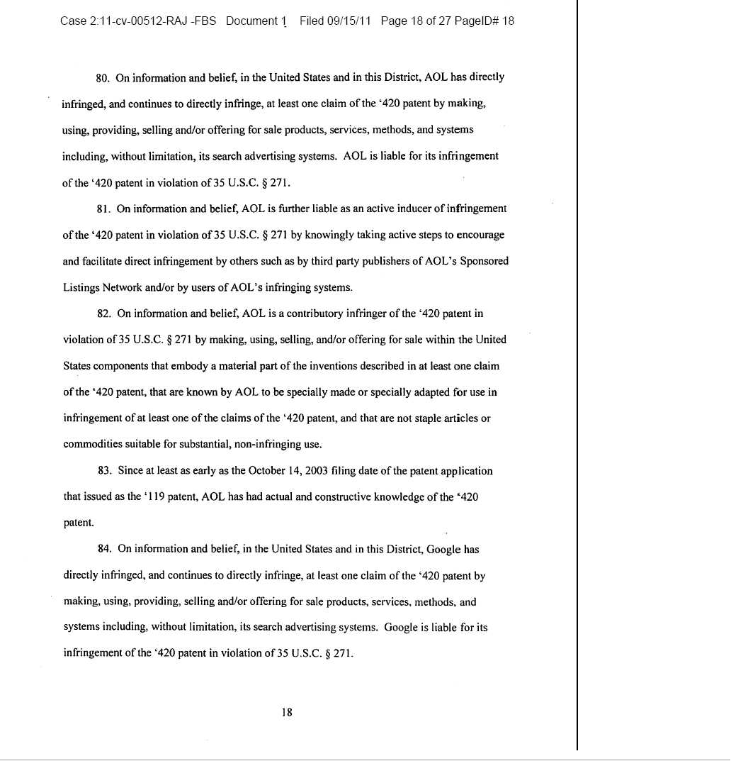

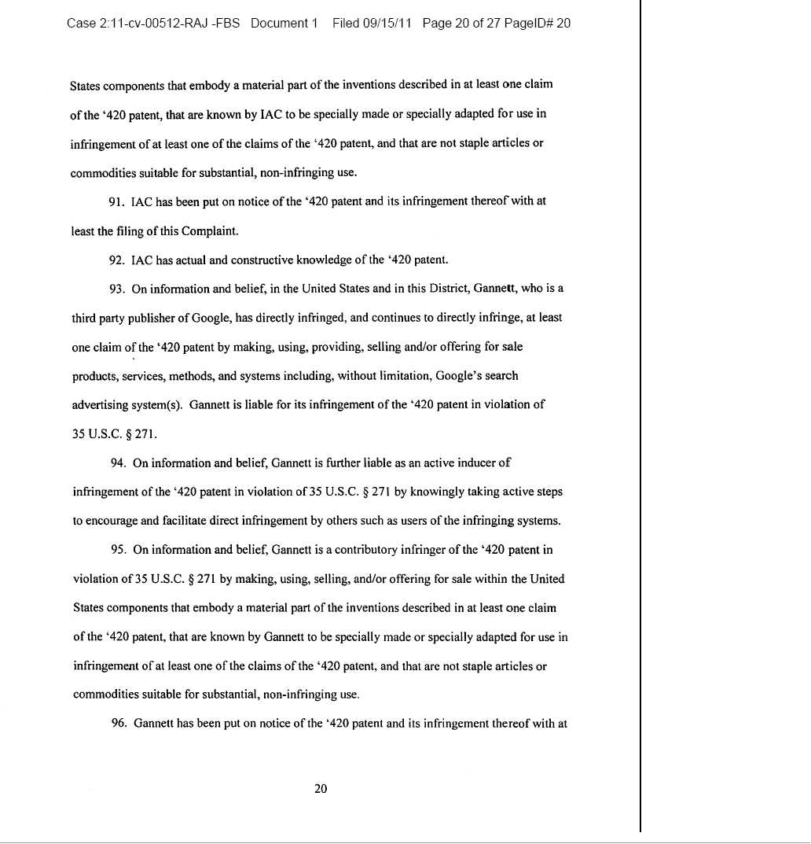

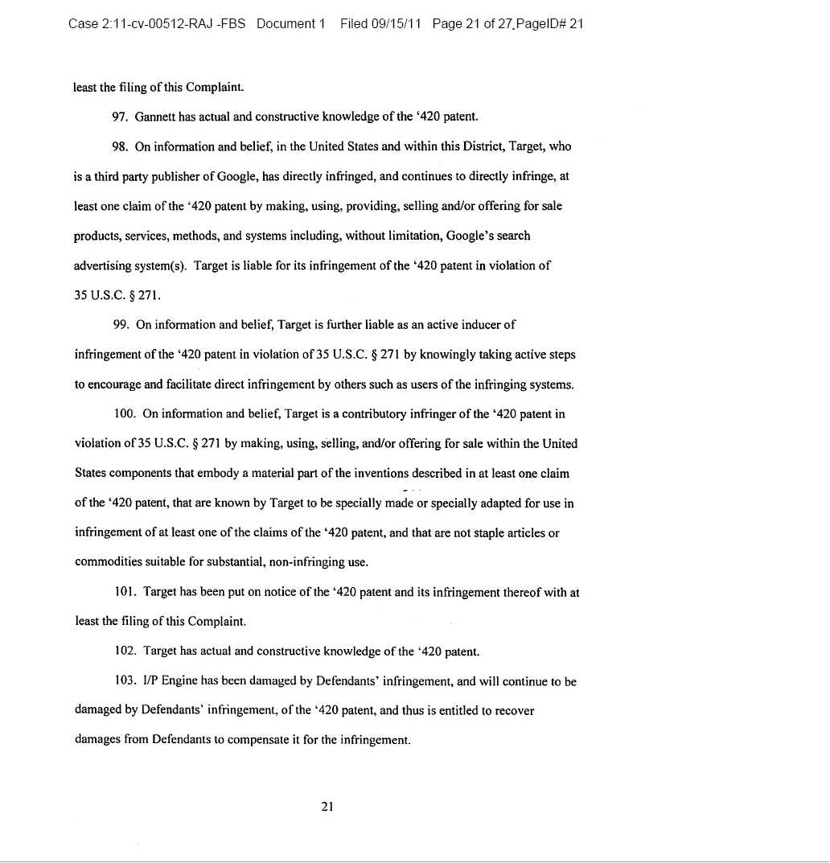

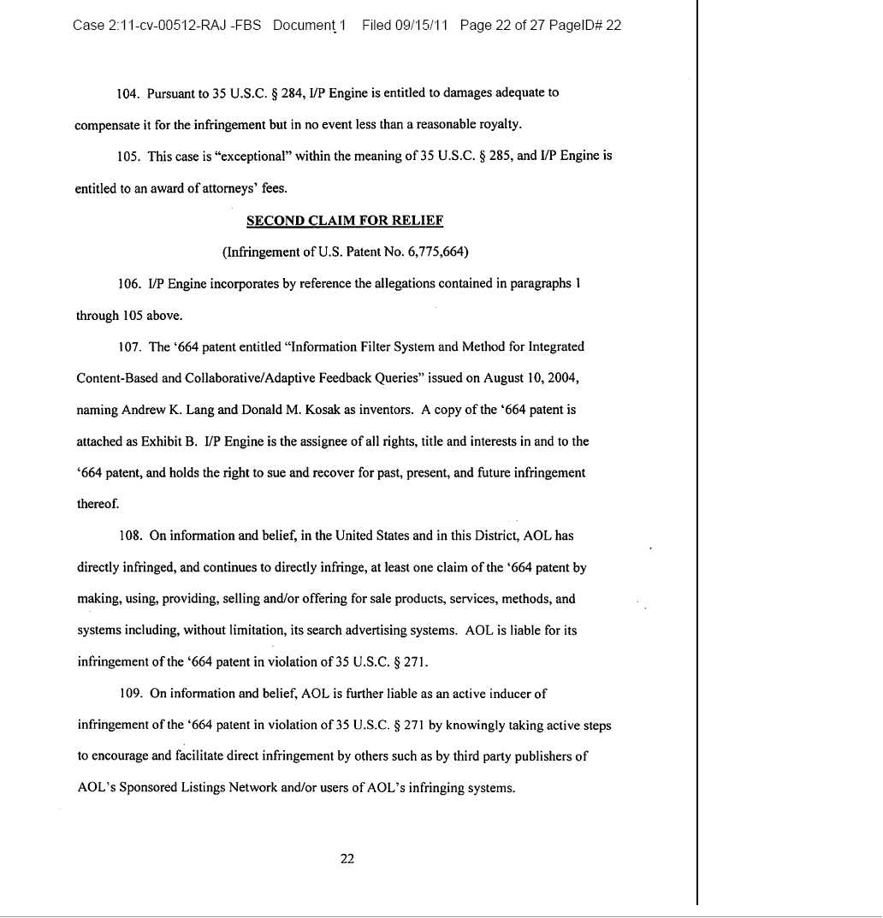

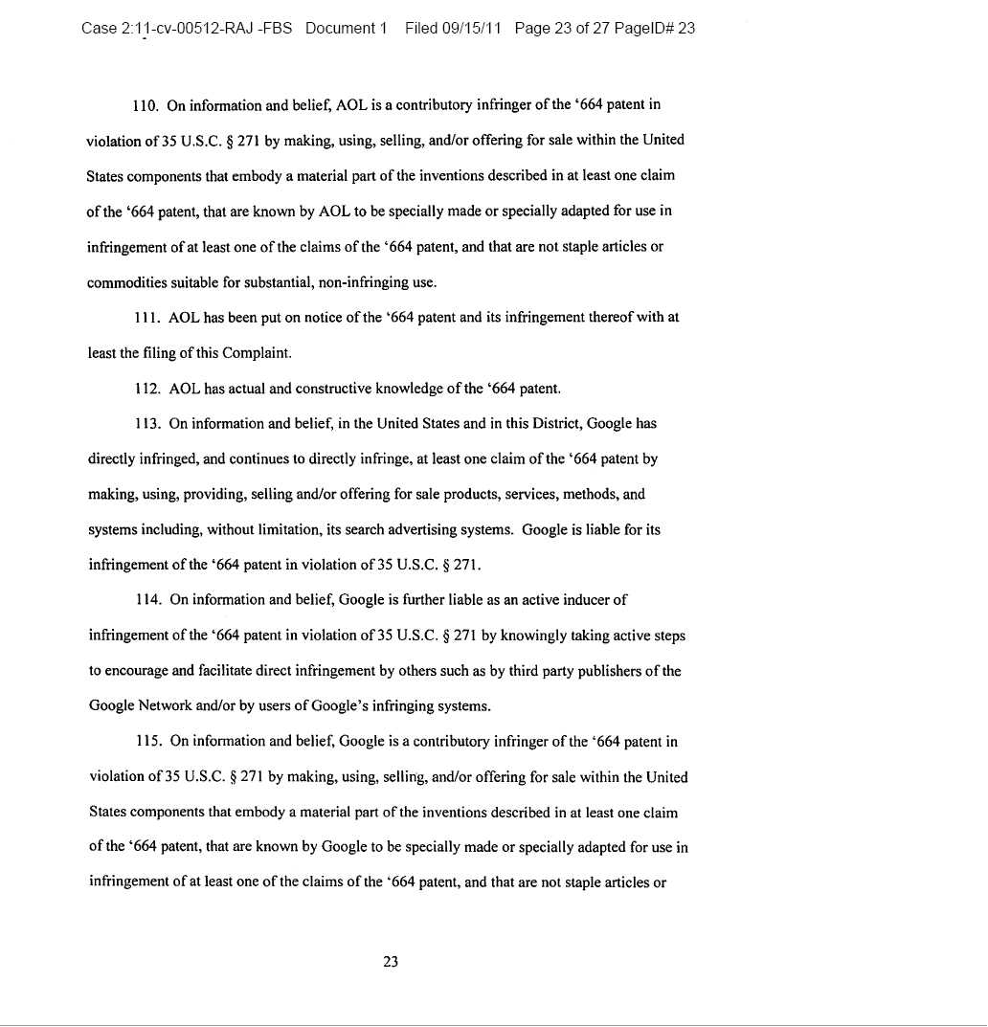

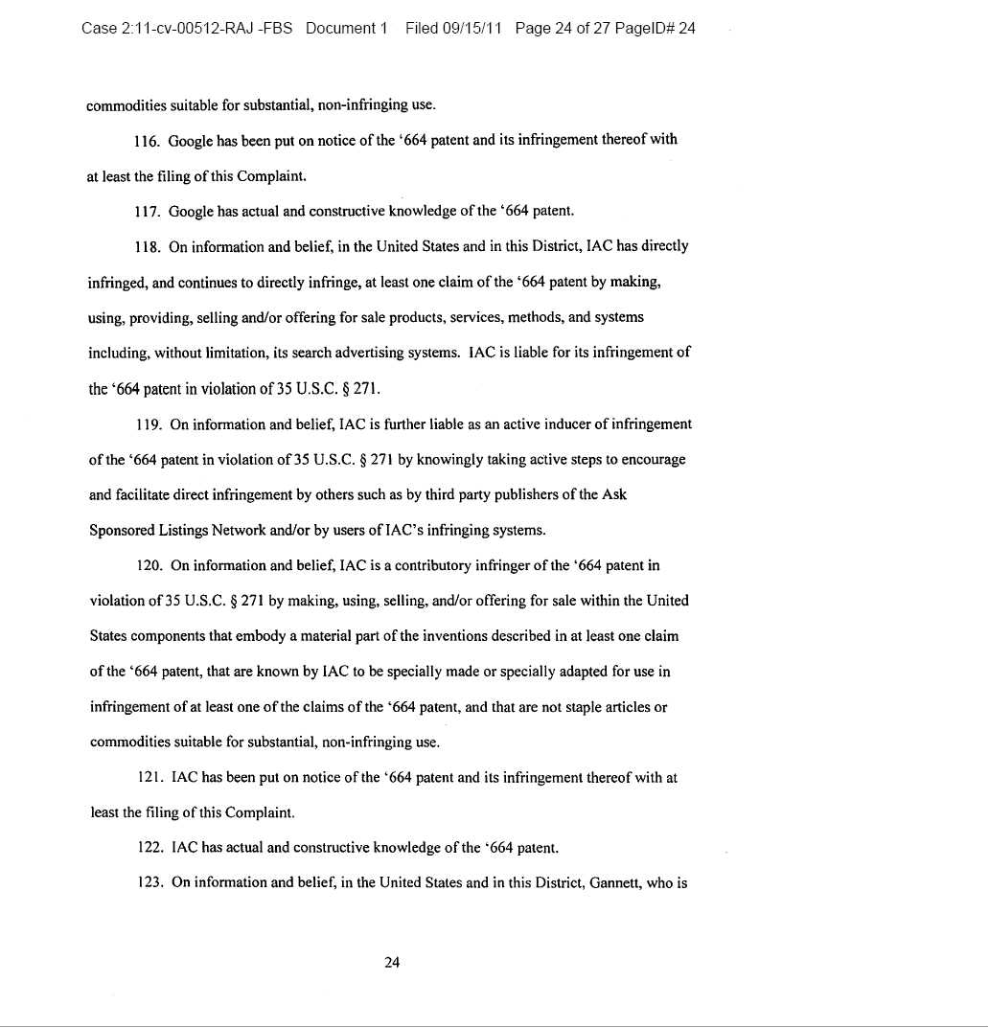

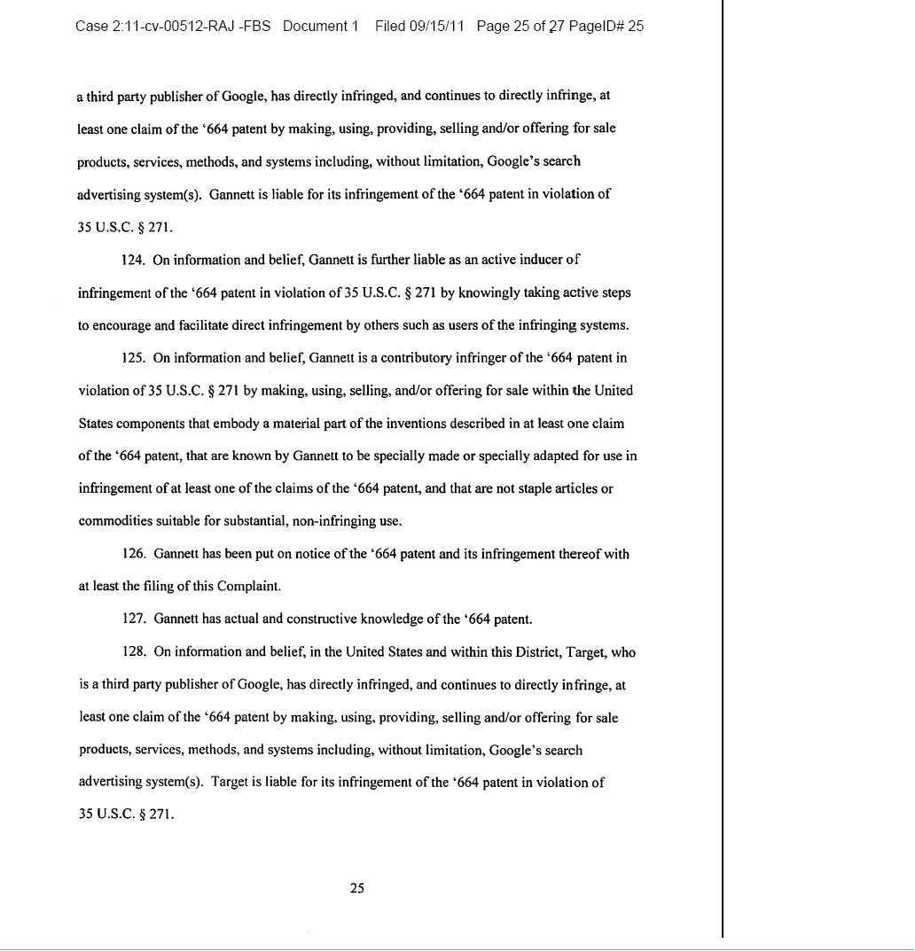

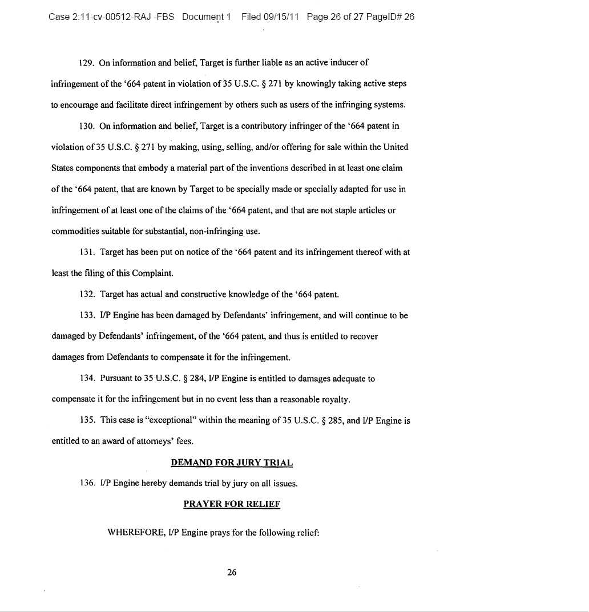

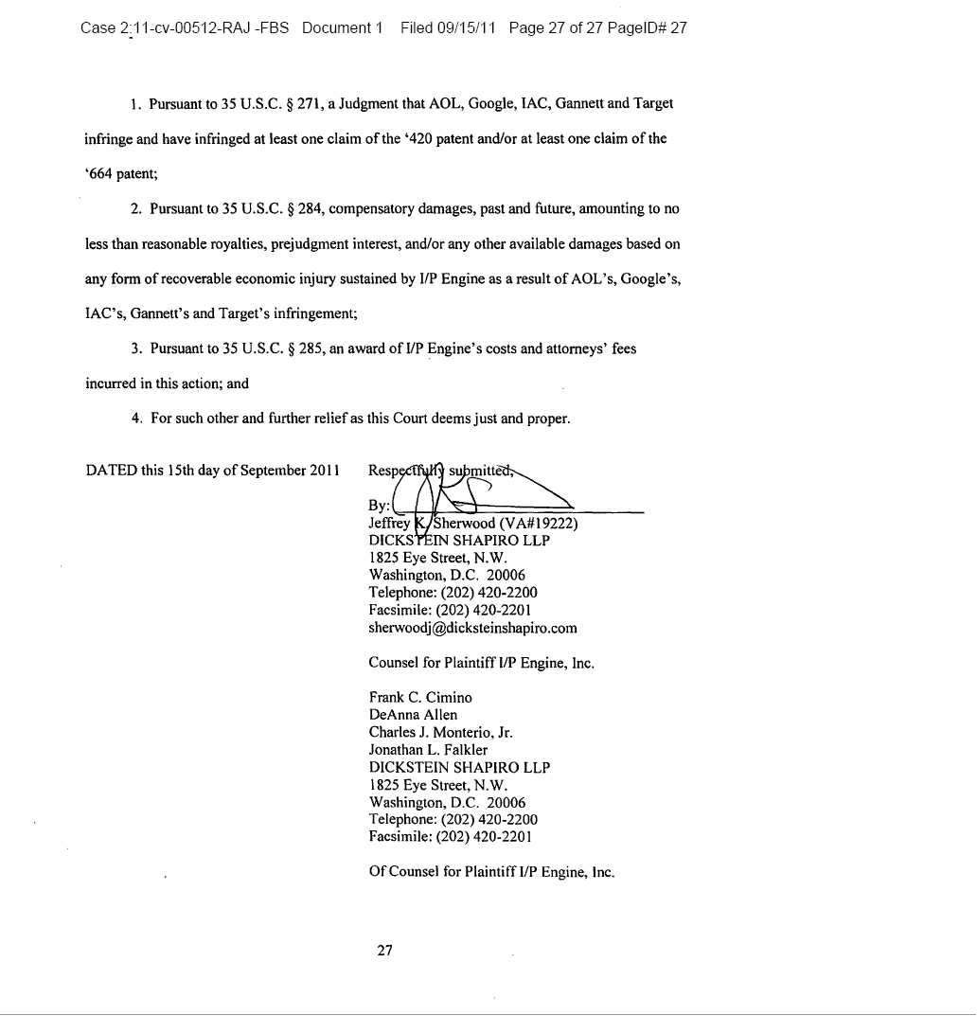

Exhibit 99.7

On September 15, 2011, I/P Engine, Inc. (“I/P Engine”) filed a patent infringement lawsuit in the United States District Court, Eastern District of Virginia, Alexandria Division against AOL, Inc., Google, Inc., IAC Search & Media, Inc., Gannett Company, Inc., and Target Corporation for patent infringement regarding two of the Lycos Patents (U.S. Patent Nos. 6,314,420 and 6,775,664). The case was assigned to the Norfolk Division.

The patents relate to relevance filtering technology used in the search engine industry to place high quality advertisements in the best positions on websites and thereby maximizing the potential for generating substantial advertising revenue to the website owner. In this lawsuit, I/P Engine alleges that the defendants have used, and continue to use, search and search advertising systems that infringe upon our relevant filtering patents. I/P Engine is seeking unspecified compensatory damages, past and future, amounting to no less than reasonable royalties and attorneys’ fees.

On November 4, 2011, I/P Engine entered into a stipulation with all of the defendants, which provided, among other things, that: (i) I/P Engine would provide the defendants with a preliminary identification of the asserted claims, and representative claim charts, and (ii) the defendants would not move or otherwise seek to transfer or sever any party from the action, or otherwise assert that the Eastern District of Virginia is inconvenient for any reason. The defendants filed their answers to the complaint on November 14, 2011, and also asserted declaratory judgment counterclaims of non-infringement and invalidity.

On November 28, 2011, all defendants (except AOL, which asserted no such allegation) amended their counterclaims to remove an allegation of unenforceability. On December 5, 2011, I/P Engine filed answers to AOL’s counterclaims.

On December 9, 2011, I/P Engine filed answers to the counterclaims of the remaining defendants.

On February 15, 2012, the Court entered a scheduling order in the case setting a Markman hearing for June 4, 2012 and trial for October 16, 2012.

After giving effect to the costs and expenses of the litigation, I/P Engine expects that it will retain approximately 80% of any recovery awarded or agreed to in settlement of this litigation.

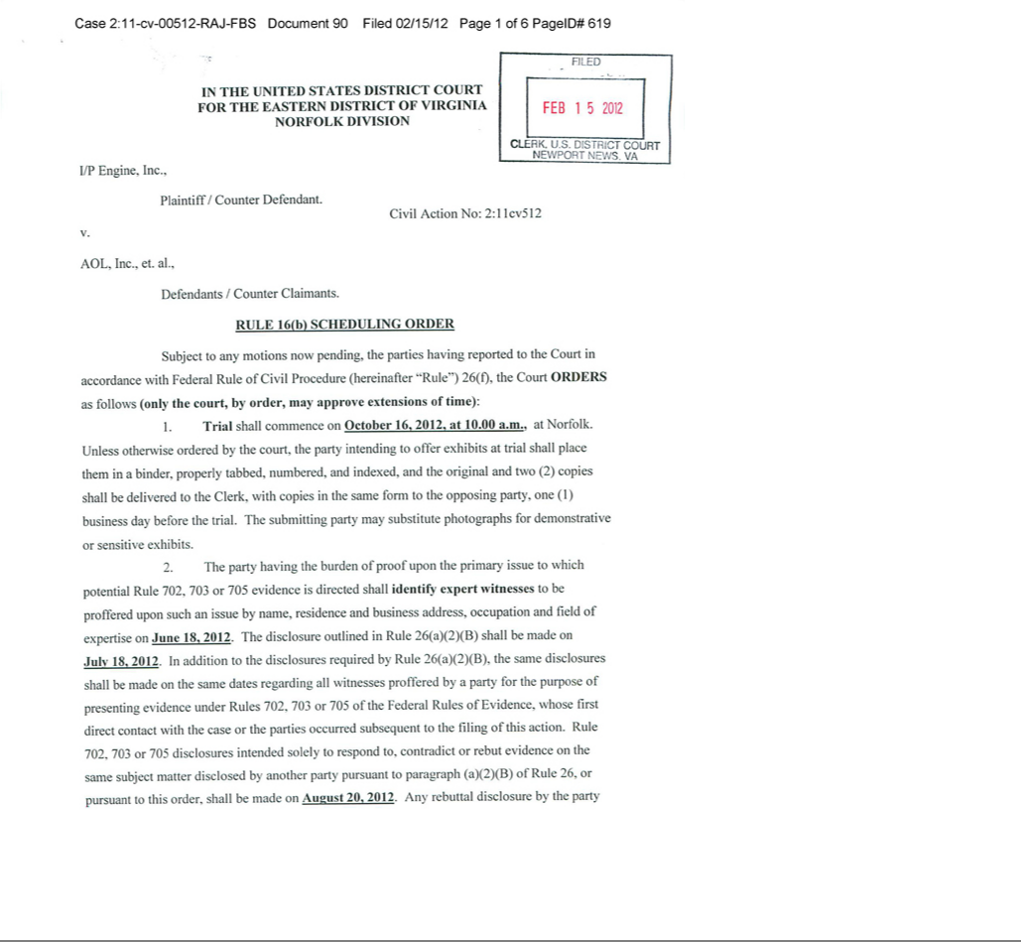

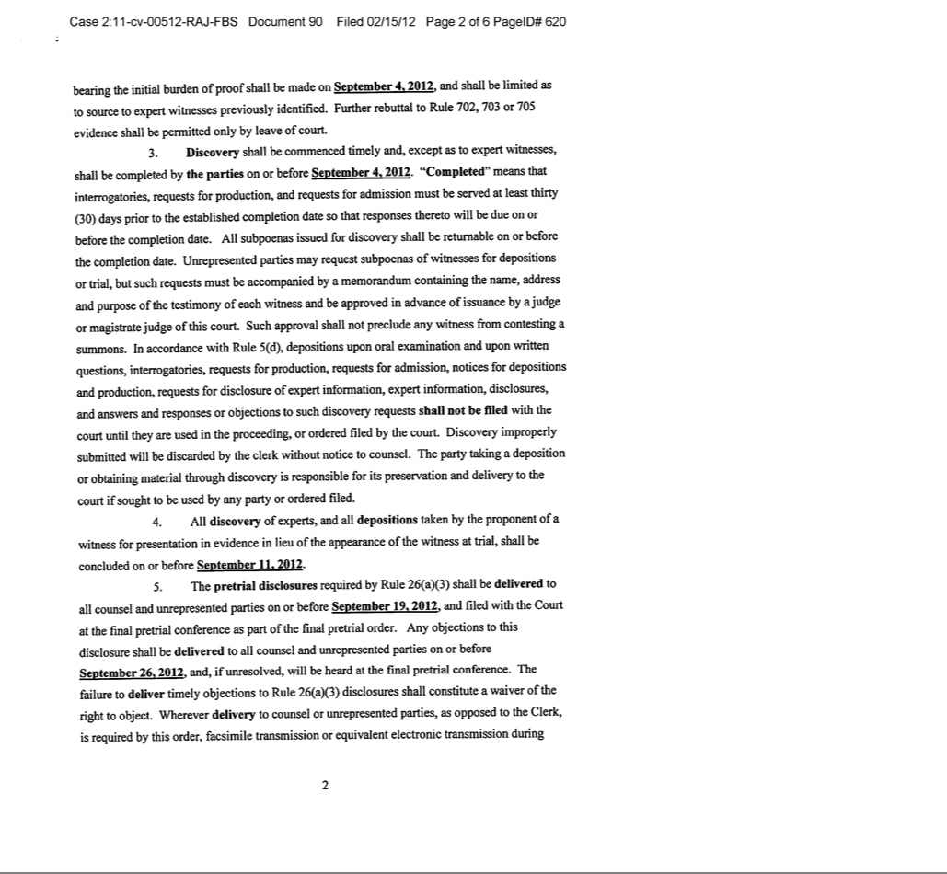

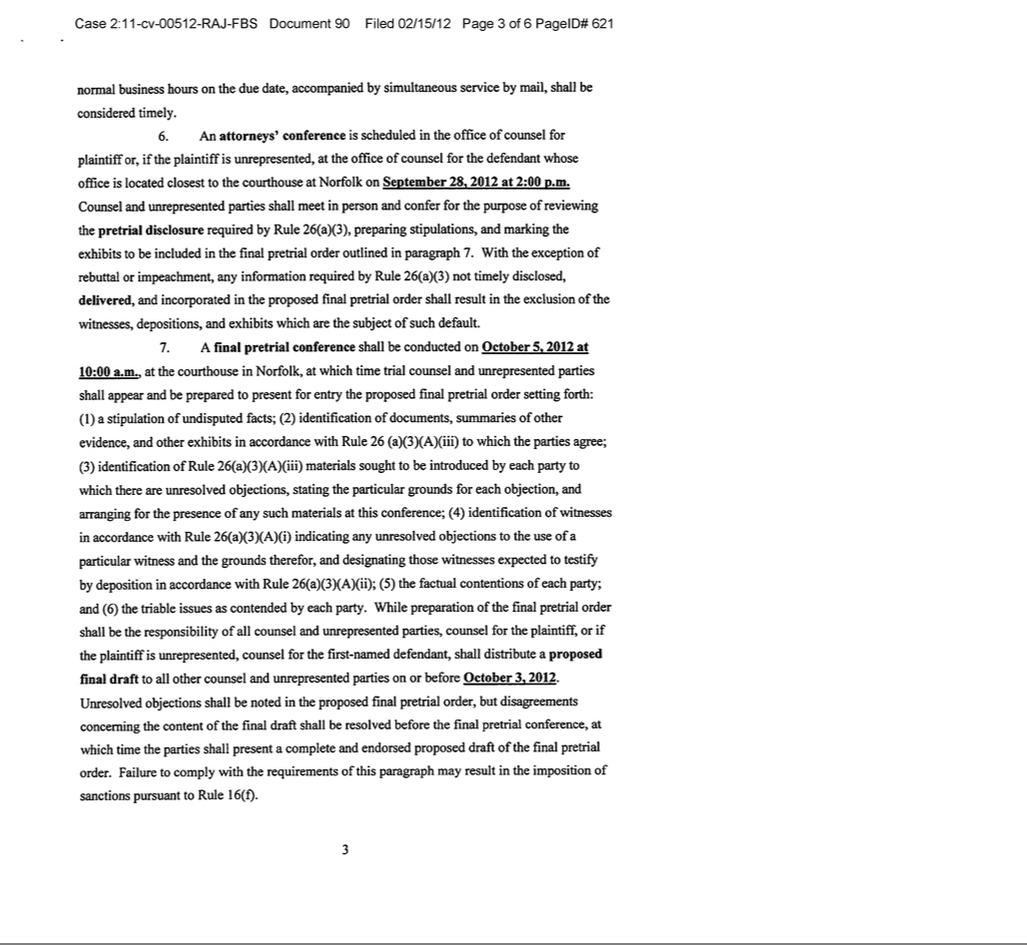

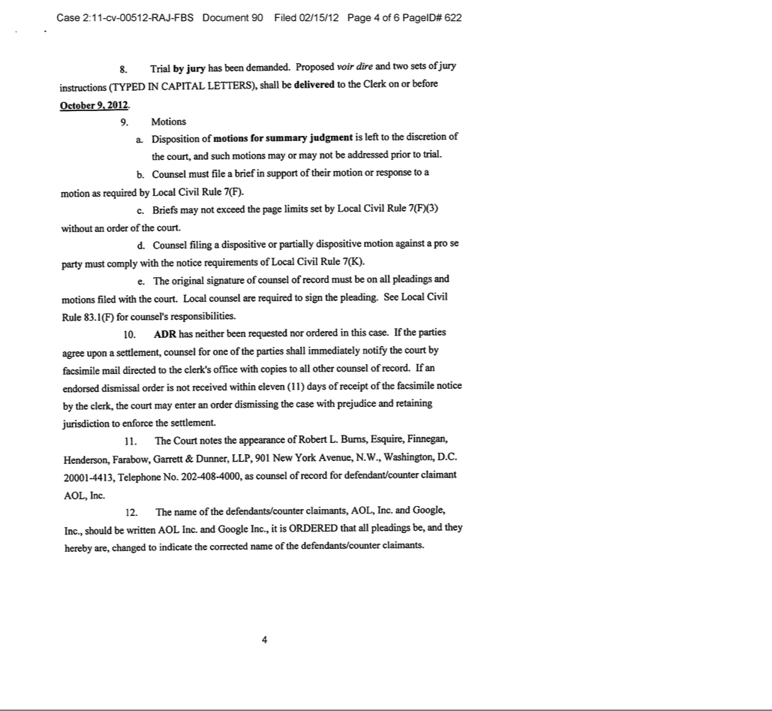

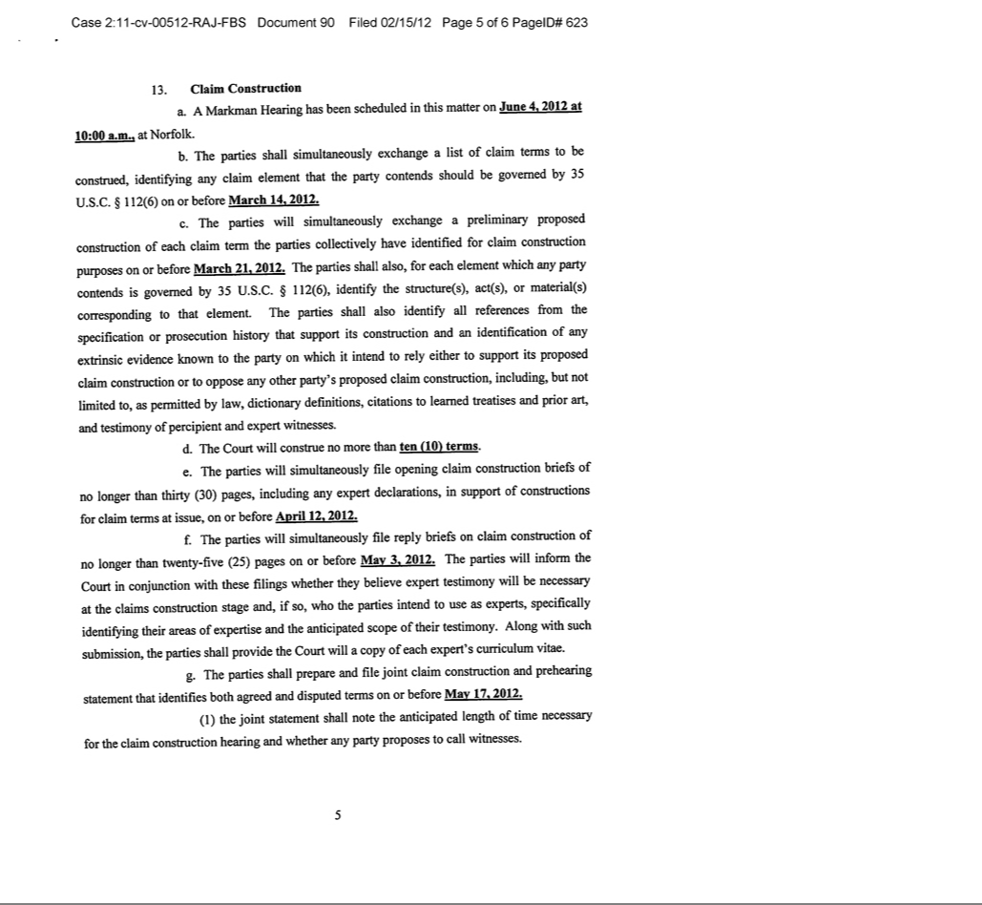

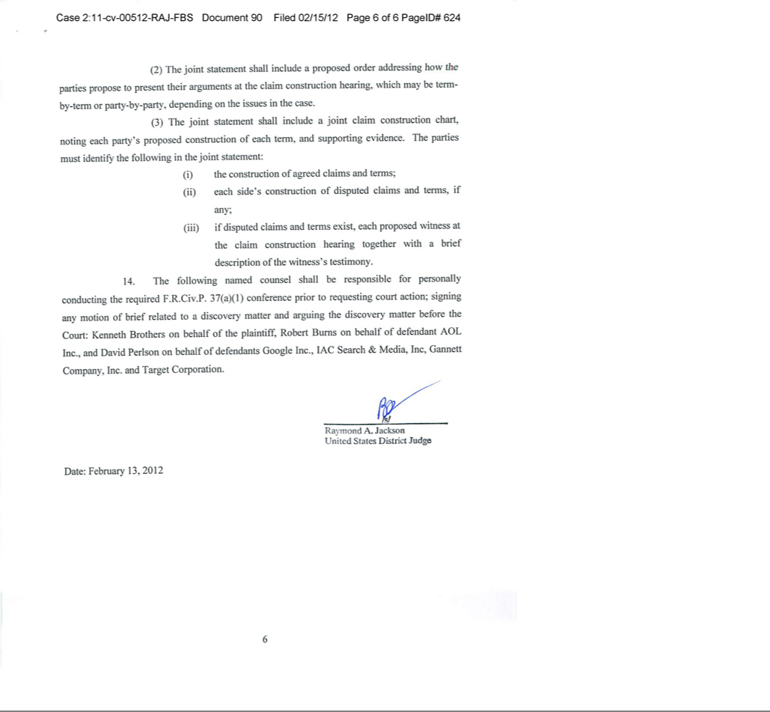

Exhibit 99.9

INNOVATE/PROTECT, INC.

BIOGRAPHIES OF

MEMBERS OF THE BOARD OF DIRECTORS, MANAGEMENT

AND SIGNIFICANT CONSULTANT

Yoav Roth, 35, has served as Chairman of the Board of directors of our company since June 22, 2011. Mr. Roth is a founding partner of Hudson Bay Capital Management LP, the investment manager of Hudson Bay, a multi-strategy investment fund with over $1 billion under management. Mr. Roth began his career at UBS Financial Services Inc. in 1999 as a research analyst on the convertibles desk, performing derivative modeling and credit analysis. In 2001, Mr. Roth joined Hudson Bay's predecessor fund, and has since led a team that makes direct investments in growth-stage companies. Mr. Roth holds a Bachelor's degree, with honors, in Economics from Union College.

Andrew Kennedy Lang, 45, has served as President, Chief Executive Officer, Chief Technology Officer and a Director of our company since June 22, 2011. Mr. Lang has been an inventor and entrepreneur for over two decades, innovating through a variety of companies and across numerous fields that include artificial intelligence, adaptive filtering/search/advertising, computer gaming, fitness management, and asset allocation modeling. Mr. Lang founded WiseWire Corporation in 1995 and sold it to Lycos in 1998 for $39.75 million. He served as the Chief Technology Officer of Lycos prior to its sale to Terra Networks in 2000 for $5.4 billion. Thereafter, Mr. Lang served as CEO of Lightspace Corporation, an active gaming technology company. Mr. Lang is a graduate of Duke University where he finished second in his class and holds Bachelor's degrees in Electrical Engineering, Computer Science, Mathematics, and Physics. Mr. Lang holds a Master's degree in Computer Science from Carnegie Mellon University.

Alexander R. Berger, 28, has served as our Chief Operating Officer, Chief Financial Officer, Secretary and Treasurer and a Director of our company since inception. Prior to joining our company, from February 2008 to August 2011, Mr. Berger was employed at Hudson Bay Capital Management LP, most recently as a Vice President. From 2005 to 2007, Mr. Berger was an aide to the President's energy and environmental policy adviser at the White House. Mr. Berger holds a Bachelor's degree in Accounting from The George Washington University.

Donald E. Stout, 65, is a Director of our company since August 15, 2011. In a career spanning over forty years, Mr. Stout has been involved in virtually all facets of intellectual property law. From 1968 to 1972, Mr. Stout was an assistant examiner at the United States Patent and Trademark Office ("USPTO"), where he focused on patent applications covering radio and television technologies. Thereafter, from 1971 to 1972 Mr. Stout worked as a law clerk for two members of the USPTO Board of Appeals. Mr. Stout has been a senior partner at the law firm of Antonelli, Terry, Stout and Kraus, LLP since 1982. As an attorney in private practice, Mr. Stout has focused on litigation, licensing and representation of clients before the USPTO in diverse technological areas. Mr. Stout has written and prosecuted hundreds of patent applications in diverse technologies, rendered opinions on patent infringement and validity, and has testified as an expert witness regarding obtaining and prosecuting patents. Mr. Stout is the co-founder of NTP Inc., which licensed Research in Motion (RIM), the maker of the Blackberry handheld devices, for $612.5 million to settle a patent infringement action. Mr. Stout is a member of the bars of the District of Columbia and Virginia, and is admitted to practice before the Supreme Court of the United States, the Court of Appeals for the Federal Circuit, and the USPTO. Mr. Stout holds a Bachelor's degree in Electrical Engineering, with distinction, from Pennsylvania State University, and a Juris Doctor degree, with honors, from The George Washington University.

H. Van Sinclair, 59, has been a Director of our company since November 7, 2011. Since 2003, Mr. Sinclair has served as President and Chief Executive Officer of The RLJ Companies, the investment company organized by Robert L. Johnson, the founder of Black Entertainment Television. The RLJ Companies owns or holds interests in diverse businesses, including private equity, financial services, asset management, insurance services, automobile dealerships, film production, sports and entertainment and video lottery terminal gaming. Mr. Sinclair currently serves as President and a Director of RLJ Acquisition, Inc., a publicly traded Special Purpose Acquisition Company, and sits on additional boards of RLJ portfolio investment companies, including RLJ Acquisition, Inc. (OTC BB: RLJAU), a special purpose acquisition company. Mr. Sinclair has also served as Vice President of Legal and Business Affairs for RLJ Urban Lodging Funds, a private equity fund which concentrated on limited and focused service hotels; for RLJ Development, the RLJ Companies' hotel and hospitality company; and as Acting President of the Charlotte Bobcats, the NBA franchise located in Charlotte, North Carolina. Mr. Sinclair has also served as a Director of Urban Trust Bank, a federal thrift headquartered in Orlando, Florida, where he chaired the Audit Committee. Prior to joining The RLJ Companies, Mr. Sinclair spent 28 years, from October 1978 to February 2003, with the Washington, DC based law firm Arent Fox, PLLC, where he specialized in complex commercial disputes and litigation. In the late 1990s, Mr. Sinclair became the partner in charge of litigation at Arent Fox, and today remains of counsel to the firm. Mr. Sinclair holds a Bachelor's degree and a Master's degree in business administration from the University of Rochester, and a Juris Doctor degree from The George Washington University.

David L. Cohen, 41, has been Special Counsel to our company since February 22, 2012. Prior to joining our company, Mr. Cohen was Senior Litigation Counsel for Nokia, where he was the global manager responsible for developing and running Nokia’s multi-jurisdictional litigation with Apple. Additionally, Mr. Cohen was responsible for managing the U.S. side of Nokia’s litigations with Qualcomm. Prior to Nokia, Mr. Cohen was an attorney in private practice at Lerner David Littenberg Krumholz & Mentlik LLP, where his practice focused on intellectual property litigation, and at Skadden Arps Slate Meagher & Flom LLP. Earlier in his career, Mr. Cohen clerked for Chief Judge Carman on the US Court of International Trade. Mr. Cohen holds Bachelor's and Master's degrees from the Johns Hopkins University in the History of Science and History, a Master's degree from Cambridge University in the History and Philosophy of Science, a Master's degree in Legal and Political Theory from University College London, and a Juris Doctor degree from the Northwestern University School of Law. Mr. Cohen is admitted to practice before the New York, New Jersey and District of Columbia bars as well as before the USPTO.

There are no family relationships among any of our directors and executive officers.

Significant Consultant

Donald Kosak, 48, is a consulting inventor for our wholly-owned subsidiary, I/P Engine. Since April 2009, Mr. Kosak has been a principal at Kosak & Associates, an executive consulting firm, where he assists businesses with scalability, intellectual property matters, virtualization and cloud computing deployments. From 2004 to 2009, Mr. Kosak served as Chief Technology Officer of Lycos, where he was responsible for software engineering, data centers, and technical operations. Mr. Kosak integrated the infrastructure of acquired companies including Wired.com, HotBot.com, Tripod.com, Angelfire.com, Matchmaker.com, Quote.com, RagingBull.com and Gamesville. Mr. Kosak led the globalization of Lycos Search in Japan and Korea and of Tripod throughout Europe, Latin America, Japan and Korea, and served as the Director of Lycos Labs, an Internet business incubator. Earlier in his career at Lycos, Mr. Kosak was Vice President of Engineering from October 2000 to October 2004, and Senior Director of Engineering an head of Core Technology from May 1998 to October 2000. Prior to joining Lycos, Mr. Kosak was among the core founding team at WiseWire Corporation. Mr. Kosak has created large-scale systems for Westinghouse, Alcoa, the U.S. Navy and the U.S. Senate. He has numerous patents in the fields of information retrieval, machine learning, video and internet technologies. Mr. Kosak studied Computer Science and Psychology at the University of Pittsburgh, and holds an Executive Certificate in Strategy and Technology from the Massachusetts Institute of Technology Sloan School of Business.

INNOVATE/PROTECT, INC. AND SUBSIDIARIES

(A Development Stage Company)

CONSOLIDATED FINANCIAL STATEMENTS

AS OF DECEMBER 31, 2011

AND FOR THE PERIOD

FROM JUNE 8, 2011(Inception) TO DECEMBER 31, 2011

TABLE OF CONTENTS

CONSOLIDATED FINANCIAL STATEMENTS
Report of Independent Registered Public Accounting Firm | 1
Consolidated Balance Sheet | 2
Consolidated Statement of Operations | 3
Consolidated Statement of Stockholders' Equity | 4
Consolidated Statement of Cash Flows | 5
Notes to Consolidated Financial Statements | 6 – 17

REPORT OF INDEPENDENT REGISTERED PUBLIC ACCOUNTING FIRM

Management and the Board of Directors

Innovate/Protect, Inc (f/k/a Labrador Search Company)

We have audited the accompanying consolidated balance sheets of Innovate/Protect Inc. (a Delaware corporation) and subsidiaries (the “Company”) as of December 31, 2011, and the related consolidated statements of operations, stockholders’ equity, and cash flows for the period from June 8, 2011 (inception) to December 31, 2011. These financial statements are the responsibility of the Company’s management. Our responsibility is to express an opinion on these financial statements based on our audit.

We conducted our audit in accordance with the standards of the Public Company Accounting Oversight Board (United States). Those standards require that we plan and perform the audit to obtain reasonable assurance about whether the financial statements are free of material misstatement. The Company is not required to have, nor were we engaged to perform an audit of its internal control over financial reporting. Our audit included consideration of internal control over financial reporting as a basis for designing audit procedures that are appropriate in the circumstances, but not for the purpose of expressing an opinion on the effectiveness of the Company’s internal control over financial reporting. Accordingly, we express no such opinion. An audit also includes examining, on a test basis, evidence supporting the amounts and disclosures in the financial statements, assessing the accounting principles used and significant estimates made by management, as well as evaluating the overall financial statement presentation. We believe that our audit provide a reasonable basis for our opinion.

In our opinion, the consolidated financial statements referred to above present fairly, in all material respects, the financial position of Innovate/Protect Inc. and subsidiaries as of December 31, 2011 and the results of their operations and their cash flows from June 8, 2011 (inception) to December 31, 2011, in conformity with accounting principles generally accepted in the United States of America.

The accompanying financial statements have been prepared assuming that the Company will continue as a going concern. As discussed in Note 2 to the financial statements, the Company incurred substantial losses from operations and used significant amount of cash to fund its operating activities. Additional capital is required to support the Company operations. These conditions raise substantial doubt about the Company ability to continue as a going concern. Management's plans in regard to these matters are also described in Note 2. The financial statements do not include any adjustments that might result from the outcome of this uncertainty.

/s/ GRANT THORNTON LLP

New York, New York

March 2, 2012

1

INNOVATE/PROTECT, INC. AND SUBSIDIARIES

(A Development Stage Company)

CONSOLIDATED BALANCE SHEET

As of December 31, 2011

ASSETS
Current Assets
Cash and cash equivalents | $ |  | 5,212,142
Prepaid assets |  |  | 25,886
Total current assets |  |  | 5,238,028
Property and Equipment, net |  |  | 8,006
Other Assets
Intangible assets, net |  |  | 3,067,592
Total assets | $ |  | 8,313,626
LIABILITIES AND STOCKHOLDERS' EQUITY
Current Liabilities
Accounts payable | $ |  | 201
Accrued liabilities |  |  | 448,264
Current portion, note payable-related party |  |  | 2,000,000
Total current liabilities |  |  | 2,448,465
Note Payable-related party |  |  | 1,200,000
Total liabilities |  |  | 3,648,465
Commitments and Contingencies (See note 11)
Preferred stock, Series A Convertible, $.0001 par value; |  |  | 1,800,000
liquidation value $1,250 per share; 6,968 shares authorized, issued and outstanding
Stockholders' Equity
Common stock, $.0001 par value; 100,000,000 shares authorized; |  |  | 563
5,624,661 shares issued and outstanding
Additional paid-in capital |  |  | 5,618,780
Deficit accumulated during the development stage |  |  | (2,754,182)
 |  |  | 2,865,161
Total liabilities and stockholders' equity | $ |  | 8,313,626
 | 2

INNOVATE/PROTECT, INC. AND SUBSIDIARIES

(A Development Stage Company)

CONSOLIDATED STATEMENT OF OPERATIONS

Period from June 8, 2011 (Inception) to December 31, 2011

Revenue | $ |  | -
Operating Expenses
Legal |  |  | 1,102,100
Compensation |  |  | 996,913
Amortization and depreciation |  |  | 328,278
General and administrative |  |  | 213,192
Startup and capital acquisition costs |  |  | 105,971
 |  |  | 2,746,454
Loss from operations |  |  | (2,746,454)
Other Expense
Interest expense |  |  | 7,728
Net loss | $ |  | (2,754,182)
Basic and diluted loss per share
Net Loss | $ |  | (2,754,182)
Weighted Average Common Shares Outstanding |  |  | 2,802,100
Basic and diluted loss per share | $ |  | (0.98)
 | 3

INNOVATE/PROTECT, INC. AND SUBSIDIARIES

(A Development Stage Company)

CONSOLIDATED STATEMENT OF STOCKHOLDERS' EQUITY

Period from June 8, 2011 (Inception) to December 31, 2011

 |  |  |  |  |  |  |  |  |  |  | Deficit
 |  |  |  |  |  |  | Additional |  |  |  | Accumulated
 |  | Common |  |  |  |  | Paid-in |  |  |  | During the
 |  | Stock |  |  |  |  | Capital |  |  | Development Stage |  |  |  |  | Total
Balance, June 8, 2011 (inception) | $ |  | - |  | $ |  | - |  | $ |  | - |  | $ |  | -
Issuance of common stock |  |  | 563 |  |  |  | 5,144,662 |  |  |  | - |  |  |  | 5,145,225
Stock-based compensation |  |  | - |  |  |  | 474,118 |  |  |  | - |  |  |  | 474,118
Net loss |  |  | - |  |  |  | - |  |  |  | (2,754,182) |  |  |  | (2,754,182)
Balance, December 31, 2011 |  | $ | 563 |  | $ |  | 5,618,780 |  | $ |  | (2,754,182) |  | $ |  | 2,865,161
 |  | 4

INNOVATE/PROTECT, INC. AND SUBSIDIARIES

(A Development Stage Company)

CONSOLIDATED STATEMENT OF CASH FLOWS

Period from June 8, 2011 (Inception) to December 31, 2011

Cash Flows From Operating Activities
Net loss

Adjustments to reconcile net loss to net cash used in operating activities:
Amortization and depreciation

Stock-based compensation expense
Increase in prepaid assets

Increase in accounts payable and accrued liabilities

Net cash used in operating activities

Cash Flows From Investing Activities
Purchase of intangible assets

Purchase of fixed assets

Net cash used in investing activities

Cash Flows From Financing Activities
Proceeds from note payable

Proceeds from issuance of preferred stock
Proceeds from issuance of common stock

Net cash provided by financing activities

Increase in cash

Cash Balance, beginning of period

Cash Balance, ending of period

Supplemental Disclosures of Cash Flow Information

Cash paid for interest

5

- (2,754,182)

328,277

474,118

(25,886)

448,465

(1,529,208)

(3,395,187)

(8,688)

(3,403,875)

3,200,000

1,800,000

5,145,225

10,145,225

5,212,142

-

- 5,212,142

- 7,728

INNOVATE/PROTECT, INC. AND SUBSIDIARIES

(A Development Stage Company

NOTES TO CONSOLIDATED FINANCIAL STATEMENTS

Note 1. Nature of Business and Significant Accounting Policies

Nature of business: Innovate/Protect, Inc. ("I/P") was incorporated under the laws of the state of Delaware on June 8, 2011 ("Inception"), as Labrador Search Corporation. On September 6, 2011, Labrador Search Corporation changed its name to Innovate/Protect, Inc. I/P is a holding company, which, at December 31, 2011, owned 100% of the issued and outstanding common stock of I/P Engine, Inc. ("I/P Engine") and I/P Labs, Inc. ("I/P Labs" and together with I/P Engine, the "Subsidiaries"). I/P Engine was incorporated in Virginia on June 14, 2011, as Smart Search Labs, Inc. Smart Search Labs Inc. changed its name to I/P Engine, Inc. on September 9, 2011. I/P Engine operates for the purpose of realizing economic benefits from a collection of patents related to search engine technology. I/P Labs was incorporated in Delaware on June 8, 2011 as Scottish Terrier Capital, Inc. and changed its name to I/P Labs, Inc. on September 9, 2011. I/P Labs, Inc. operates to acquire or develop other patented technologies or intellectual property. I/P's principal offices are located in New York City.

Principles of consolidation: The consolidated financial statements include the accounts of I/P and the Subsidiaries. Unless the context otherwise indicates, the terms "I/P" or the "Company" mean Innovate/Protect, Inc. and its consolidated subsidiaries. All intercompany balances and transactions have been eliminated in consolidation.

Estimates and assumptions: The preparation of financial statements in conformity with accounting principles generally accepted in the United States of America requires management to make estimates and assumptions that affect the reported amounts of assets and liabilities and disclosure of contingent assets and liabilities at the date of the financial statements and the reported amounts of revenues and expenses during the reporting period. Actual results could differ from those estimates.

Development stage: The Company is in the development stage and had not yet generated revenue for the period from inception to December 31, 2011.

Cash and cash equivalents: Cash and cash equivalents include cash and highly liquid investments with original maturities of three months or less. The Company maintains its cash in a non-interest bearing account at a commercial bank, which account balances at times may exceed federally insured limits. The Company has not experienced any losses in such accounts and believes it is not exposed to any significant credit risk on cash and cash equivalents.

Intangible assets: Intangible assets consist of patents that were purchased and the costs to acquire them. They are amortized over their legal lives, for periods that vary from five to ten years depending on the patents' expiration. The useful lives of intangible assets are periodically evaluated for reasonableness and the assets are tested for impairment whenever events or changes in circumstances indicate that the carrying amount may no longer be recoverable. Costs to investigate potential purchases of intangible assets are treated expense when incurred, until or unless purchase of the respective assets are deemed viable, after which time the costs to further investigate and acquire the assets are capitalized.

Property and equipment: Property and equipment purchases are recorded at cost. Depreciation is computed using the straight-line method over estimated useful lives of 5 years.

6

INNOVATE/PROTECT, INC. AND SUBSIDIARIES

(A Development Stage Company

NOTES TO CONSOLIDATED FINANCIAL STATEMENTS

Note 1. Nature of Business and Significant Accounting Policies (Continued)

Stock-based compensation: The Company has made the following types of stock-based awards, valued and reflected in the financial statements as follows:

Common Stock Grants: Common stock grants are valued at their fair market value at the date of the grant, multiplied by the number of shares granted. These grants are reflected as compensation expense in the period during which the respective awards vest, ranging from immediate to 36 months from the grant dates.

Sales of Common Stock at Less than Fair Market Value: Common stock sales at less than fair market value to executive officers are valued at their fair market value on the date of the sale, multiplied by the number of shares sold at less than fair market value. Common stock sales at less than fair market value to consultants are valued at their fair market value on the date the purchased shares vest (the "measurement date"), revalued as to the number of shares vesting at each subsequent measurement date, multiplied by the number of shares vesting at the measurement date. The difference between the purchase price and the fair market value of the shares vesting at each measurement date is reflected as compensation expense in the period during which the respective awards vest, over periods ranging from immediate to 36 months.

Common Stock Options: Common stock options are valued at their fair market value at the time the options are granted, using the Black-Scholes option pricing model for valuing stock-based compensation awards. Common stock options are reflected as compensation expense in the period during which they vest.

Fair value of common stock: At inception, the Company determined the fair value of each common share to be $.25832. Management determined the amount of capital it estimated would be required ($1,800,000) to carry the Company through its earliest stages of development. This amount was financed through the issuance of Series A convertible preferred stock (the "Series A Preferred Stock"). To arrive at the estimated fair value of a share of common stock, the $1,800,000 was divided by the number of common shares, 6,968,000, into which the Company's Series A Preferred Stock sold would convert upon demand, in accordance with the terms of the Series A Preferred Stock.

Subsequent to inception, the Company determined fair value per share based on multiple private sales of common stock to third parties including individuals and institutional investors. Three rounds of common stock sales occurred after inception, one round at $1 per share during late August and early September 2011, one round at $3 per share during mid-September and October 2011, and one round at $3.30 per share during November and December 2011.

7

INNOVATE/PROTECT, INC. AND SUBSIDIARIES

(A Development Stage Company

NOTES TO CONSOLIDATED FINANCIAL STATEMENTS

Note 1. Nature of Business and Significant Accounting Policies (Continued)

Fair value of financial instruments: Fair value of financial assets and liabilities is defined as the exchange price that would be received to sell an asset or paid to transfer a liability in an orderly transaction between market participants in the principal market at the measurement date (exit price). The Company is required to classify fair value measurements in one of the following categories:

Level 1 inputs which are defined as quoted prices (unadjusted) in active markets for identical assets or liabilities that the reporting entity has the ability to access at the measurement date.

Level 2 inputs which are defined as inputs other than quoted prices included within Level 1 that are observable for the assets or liabilities, either directly or indirectly.

Level 3 inputs are defined as unobservable inputs for the assets or liabilities. Financial assets and liabilities are classified based on the lowest level of input that is significant to the fair value measurement. The Company's assessment of the significance of a particular input to the fair value measurement requires judgment, and may affect the valuation of the fair value of assets and liabilities and their placement within the fair value hierarchy levels.

The Company determined the fair value of the embedded derivative liability to be level 3 inputs. These inputs require material subjectivity because value is derived through the use of probability weighted discounted cash flows. As further discussed in Note 5, the Company has determined that the probability of the holder exercising its options is remote and that any value allocated the embedded derivative at December 31, 2011 would be trivial.

Due to the Company being in its development stage, it is not practical to value our notes payable at December 31, 2011. The carrying amounts of cash and cash equivalents, accounts payable and accrued liabilities approximate fair value due to the short term maturity of the instruments.

Income taxes: Deferred income tax assets and liabilities are determined using the asset and liability method. Under this method, the net deferred tax asset or liability is determined based on the tax effects of permanent and temporary differences between the book and tax bases of the various balance sheet assets and liabilities and gives current recognition to changes in tax rates and laws.

A valuation allowance is recorded when it is more likely than not that some portion or all of the deferred tax assets will not be realized.

The Company recognizes tax positions taken or expected to be taken when it is more likely than not that the position would be sustained upon examination by tax authorities. A recognized tax position is then measured at the largest amount of benefit that is more likely than not to be realized upon ultimate settlement. It is the Company's policy to classify interest and penalties related to uncertain income tax matters as income tax expense.

Earnings Per Share: Basic loss per share is based on the weighted number of common shares issued and outstanding, and is calculated by dividing net loss attributable to common shareholders by the weighted average shares outstanding during the period. Diluted loss per share is calculated by dividing net loss

8

INNOVATE/PROTECT, INC. AND SUBSIDIARIES

(A Development Stage Company

NOTES TO CONSOLIDATED FINANCIAL STATEMENTS

Note 1. Nature of Business and Significant Accounting Policies (Continued)

attributable to common shareholders by the weighted average number of common shares used in the basic earnings per share calculation plus the number of common shares that would be issued assuming conversion of all potentially dilutive securities outstanding. Diluted loss per share is equal to the basic loss per share as all potentially dilutive securities are anti-dilutive in the period presented. For the year ended December 31, 2011 the Company incurred net losses and therefore no common stock equivalents were utilized in the calculation of earnings per share.

At December 31, 2011, the Company excluded the following potentially dilutive securities:

- Series A Preferred Stock convertible into 6,968,000 shares of common stock.

- Warrants to purchase 250,000 shares of common stock.

- Options to purchase 13,646 shares of common stock.

- 1,237,270 shares of common stock granted but not vested.

Recent Accounting Pronouncements:

In May 2011, the FASB issued new guidance amending the existing pronouncement related to fair value measurement. This new guidance primarily expands the existing disclosure requirements for fair value. Specifically, the new guidance mandates the following additional disclosures: (1) the amount of any transfers between Level 1 and Level 2 of the fair value hierarchy, (2) a quantitative disclosure of the unobservable inputs and assumptions used in the measurement of Level 3 instruments, (3) a qualitative discussion of the sensitivity of the fair value to changes in unobservable inputs and any inter-relationships between those inputs that magnify or mitigate the effect on the measurement of Level 3 instruments and (4) the level within the fair value hierarchy, of items that are not measured at fair value in the statement of financial condition but whose fair value must be disclosed. This new guidance is effective for us prospectively beginning January 1, 2012. We expect the adoption of this new guidance will result in an increase of certain of our financial statement disclosures, but the adoption will not have any impact on our financial position or results of operations.

In June 2011, the FASB issued new guidance amending the existing pronouncement regarding the presentation of comprehensive income. This new guidance reduces the alternatives for the presentation of the components of other comprehensive income. Specifically, it eliminates the alternative of presenting them as part of the Statement of Changes in Shareholders' Equity. This new guidance is effective for fiscal years and interim periods within those years, beginning after December 15, 2011; however, early adoption is permitted. We currently do not have any components of other comprehensive income within our consolidated financial statements thus adoption of this new guidance does not impact us.

9

INNOVATE/PROTECT, INC. AND SUBSIDIARIES

(A Development Stage Company

NOTES TO CONSOLIDATED FINANCIAL STATEMENTS

Note 2. Liquidity and Capital Resources, Going Concern

As a development stage company, the Company requires significant amounts of capital to support its operations during the period prior to the commencement of a revenue stream or other liquidity events.

As of December 31, 2011 the Company had cash of $5,212,142 and working capital of $2,789,563. During the period from inception through December 31, 2011, the Company funded operations from the proceeds of private sales of equity and the private issuance of debt. Because of the nature of the Company's business, capital is required to support the Company's substantial legal costs as well as its normal operating costs. The Company has developed a budget outlining its expected legal and operating costs, including contingencies for unforeseen costs and delays over the next twelve (12) months.

The Company plans to conduct future financings through the sale of debt of equity securities, which management believes will provide sufficient working capital to fund operations for at least the next twelve (12) months. Changes in operating plans, increased expenses, additional property acquisitions, other events or other strategic alternatives the Company may pursue, may cause additional equity or debt financing to be required in the future. There is no assurance that additional financing will be available upon future prevailing terms or at all.

For the period from inception through December 31, 2011, the Company used $4,933,083 of net cash to fund operating activities and to invest in tangible personal and intangible intellectual property. During the period, the Company borrowed $3,200,000 through the issuance of a promissory note and raised $5,145,225 and $1,800,000 through common and preferred stock issuances, respectively.

Despite the Company's capital raising activities to date, given the factors noted above, there is no assurance that the Company will continue to be able to raise the capital or generate revenue necessary to fund ongoing operations at the current level. As such, absent future capital raises or revenue generation by the Company, there remains substantial doubt about the Company's ability to continue as a going concern. The accompanying financial statements have been prepared on a going concern basis and as such do not include any adjustments that might result from the outcome of this uncertainty.

10

INNOVATE/PROTECT, INC. AND SUBSIDIARIES

(A Development Stage Company

NOTES TO CONSOLIDATED FINANCIAL STATEMENTS

Note 3. Property and Equipment
Property and equipment consisted of the following as of December 31, 2011:
 | Computer equipment | $ |  | 8,688
 | Less accumulated depreciation |  |  | (682)
 |  | $ |  | 8,006
Property and equipment are being depreciated over their expected useful lives.
Note 4. Intangible Assets
Intangible assets consisted of the following as of December 31, 2011:
 | Patents | $ |  | 3,395,188
 | Less accumulated amortization |  |  | (327,596)
 |  | $ |  | 3,067,592

The gross carrying amount of patents is comprised of the original purchase price of $3,200,000 and $195,188 of associated patent acquisition costs. Patents are being amortized over their individual legal lives which expire between 2016 and 2021. The weighted average amortization period for these patents is five years and eleven months.

Estimated amortization expense for each of the five succeeding years based upon intangible assets owned at December 31, 2011 is as follows:

 | Year |  |  |  | Amount
 | December 31, 2012 | $ |  |  | 622,775
 | December 31, 2013 |  |  |  | 622,775
 | December 31, 2014 |  |  |  | 622,775
 | December 31, 2015 |  |  |  | 622,775
 | December 31, 2016 and thereafter |  |  |  | 576,492
 |  | 11

INNOVATE/PROTECT, INC. AND SUBSIDIARIES

(A Development Stage Company

NOTES TO CONSOLIDATED FINANCIAL STATEMENTS

Note 5. Note Payable – Related Party

The Company is obligated under a note payable to Hudson Bay Master Fund Ltd. ("Hudson Bay") with an outstanding balance of $3,200,000 at December 31, 2011 (the "Hudson Bay Note"). At December 31, 2011, Hudson Bay owned all of the outstanding preferred stock of the Company, convertible upon demand to common stock sufficient to control the Company. The Hudson Bay Note accrues interest at 0.46% per annum and matures on June 22, 2014. The Company has granted Hudson Bay a security interest in all tangible and intangible personal property of the Company and its subsidiaries to secure its obligations under the Hudson Bay Note.

Hudson Bay has the option of requiring the Company to redeem up to $2,000,000 aggregate principal of the Hudson Bay Note beginning March 22, 2012. The Hudson Bay Note does not contain any financial statement covenants, however there are standard events of default. In the event of a default, which is not subsequently cured or waived, the interest rate would increase to a rate of 18% per annum. At the option of Hudson Bay and upon notice, the entire unpaid principal balance together with all accrued interest thereon would be immediately due and payable. Hudson Bay has the right to require the Company to redeem the Hudson Bay Note in the event of a change of control or in event of default at a redemption price, pursuant to a formula, of up to 125% of the sum of the portion of the principal amount and any accrued and unpaid interest.

As of December 31, 2011, there were no known conditions of default.

The Company determined there was an embedded derivative since certain redemption options were determined not to be clearly and closely related to the debt host. The Company also determined that the fair value of the embedded derivative was zero at December 31, 2011 since the probability of change in control or event of default in the near future is remote. The gross amount the Company would have to pay if this redemption option is exercised would be $800,000.

The Company will evaluate the fair value of the derivative each reporting period and report changes in the fair value as other income (expense), net.

12

INNOVATE/PROTECT, INC. AND SUBSIDIARIES

(A Development Stage Company

NOTES TO CONSOLIDATED FINANCIAL STATEMENTS

Note 6. Series A Convertible Preferred Stock

The Company is authorized to issue up to 10,000,000 shares of preferred stock, par value $0.0001, of which 6,968 shares of preferred stick have been designated as Series A Preferred Stock with such rights and preferences designated in the Company's Certificate of Designations (the "Series A Preferred Stock"). In June 2011, the Company issued 6,968 shares of Series A Preferred Stock to Hudson Bay for $1,800,000 ($258.32 per share). The Series A Preferred Stock has a liquidation preference of $1,250 per share and is otherwise convertible, at the option of the holder, into 6,968,000 shares of common stock at a conversion price of $1 per common share received, subject to adjustment for anti-dilution and other corporate events. The holder of Series A Preferred Stock is entitled to receive such dividends paid and distributions made to holders of common stock and to participate in voting matters on an as converted basis. Shares of Series A Preferred Stock are redeemable by the holder upon the occurrence of certain events as defined in the Series A Preferred Stock Certificate of Designations. The holder has the right to require the Company to redeem the Series A Preferred Stock in the event of a change of control or a

triggering event (including, without limitation, an event of default or change of control) at a redemption price, pursuant to a formula, of up to 125% of the stated value of $1,000 per share, subject to adjustment.

The Series A Preferred Stock is classified as mezzanine because certain Triggering Events may occur outside the control of the Company.

Note 7. Warrants

On August 30, 2011, the Company issued 250,000 warrants to Hudson Bay. Each warrant entitles Hudson Bay to purchase one (1) share of common stock in the Company at a price of $1. The warrants expire sixty (60) months after the issue date, and are subject to adjustment for certain corporate events under the terms and conditions contained in the Warrant Agreement between the Company and Hudson Bay dated August 30, 2011.

Note 8. Stock-Based Compensation

In June 2011, the Company sold 2,115,625 shares of common stock to an executive officer at par value. The excess of the fair value of the shares sold over the purchase price of the shares at the time of purchase is treated as compensation and is recognized at such times as the shares vest to the benefit of the executive officer. 1,178,125 shares vested immediately upon grant and 937,500 shares vest over a three (3) year period.

In June 2011, the Company sold 125,000 shares of common stock to a consultant at par value. The excess of the fair value of the shares sold over the purchase price of the shares is treated as compensation and is recognized at such times as the shares vest to the benefit of the consultant. 62,500 shares vested immediately upon purchase and 62,500 shares vest over a three (3) year period. Compensation related to unvested shares will be recognized in the period the shares vest and will be calculated using the fair value of the common stock at that time.

In August 2011, the Company granted 625,000 shares of common stock to an executive officer of the Company at no cost. The fair value of these shares at the time of grant is treated as compensation and is recognized at such times as the shares vest over an eighteen (18) month period.

13

INNOVATE/PROTECT, INC. AND SUBSIDIARIES

(A Development Stage Company

NOTES TO CONSOLIDATED FINANCIAL STATEMENTS

Note 8. Stock-Based Compensation (Continued)

In August 2011, the Company adopted its 2011 Equity and Performance Incentive Plan (the "Plan"). The Plan provides for the issuance of stock options and restricted stock to the Company's employees, consultants, directors and advisors. Terminated, expired or forfeited grants may be reissued under the Plan. The number of shares available under the Plan is subject to adjustment for certain changes in the Company's capital structure. As of December 31, 2011, 946,354 shares are available for future grant.

In November 2011, pursuant to the Plan, the Company granted 40,000 shares of common stock to an independent director of the Company at no cost. The fair value of these shares at the time of grant is treated as compensation and is recognized at such times as the shares vest over an eighteen (18) month period.

In November 2011, pursuant to the Plan, the Company issued stock options to an independent director of the Company at no cost. The options became fully vested and exercisable at the date of grant. The options allows the director to purchase up to 13,646 shares of common stock at an exercise price of $3.00 per share at any time prior to expiration of the options on November 6, 2016.

The table below illustrates the grants of common stock and the sales of common stock at less than fair value made during the period from inception through December 31 2011.

Grants Of Common Stock and Sales of Common Stock at Less Than Fair Market Value

 |  |  |  |  |  |  |  |  |  |  |  |  |  |  |  |  |  |  | Compensation
 |  | Grant, |  |  |  |  |  | Fair Value at |  |  |  |  |  |  |  |  |  |  | Recognized
 |  | Purchase or |  |  |  |  | Grant, Purchase or |  |  |  |  | Amount Paid for |  |  | Total Stock Based |  |  | Inception through |  |  |  | Compensation Not
Title |  | Vest Date |  | # Shares |  |  |  | Vest Date |  | Total Value |  |  | Shares |  | Compensation |  |  |  | 12/31/11 |  |  | Vested at 12/31/11
Consultant | 6/22/2011 |  | 125,000 |  |  | $ |  | 0.25832 |  | N/A |  | $ | 12 |  | N/A |  | $ |  | 49,070 |  |  |  | 170,346*
Exec. Officer | 6/22/2011 |  | 2,115,625 |  |  | $ |  | 0.25832 |  | 546,508 |  |  | 212 |  | 546,296 |  |  |  | 346,329 |  |  |  | 199,955
Exec. Officer | 8/10/2011 |  | 625,000 |  |  | $ |  | 0.25832 |  | 161,450 |  |  | - |  | 161,450 |  |  |  | 41,900 |  |  |  | 119,550
Director | 11/07/2011 |  | 40,000 |  |  | $ |  | 3.00 |  | 120,000 |  |  | - |  | 120,000 |  |  |  | 11,781 |  |  |  | 108,219
 |  |  |  |  |  |  |  |  |  |  |  |  |  |  |  |  |  | $ | 449,080 |  | $ |  | 598,070

*Based on the fair value of common stock of $3.30 per share, at December 31, 2011

Nonvested compensation of $598,070 will vest over approximately 2.5 years.

14

INNOVATE/PROTECT, INC. AND SUBSIDIARIES

(A Development Stage Company

NOTES TO CONSOLIDATED FINANCIAL STATEMENTS

Note 8. Stock-Based Compensation (Continued)

The table below illustrates the common stock options granted during the period from inception through December 31 2011.

Grants of Common Stock Options |  |  |  |  |  |  |  |  |  |  |  |  |  |  |  |  |  |  | Compensation
 |  |  |  |  |  |  |  |  |  |  |  |  |  |  |  |  |  |  | Recognized |  | Compensation
 |  |  |  |  |  |  |  |  |  |  |  |  |  |  |  |  |  |  | Inception through |  | Not Vested at
Title |  | Grant Date |  | # Shares |  |  | Exercise Price |  |  | FMV at Grant Date |  |  |  | Total Option Value |  |  |  |  | 12/31/11 |  | 12/31/11
Director | 11/6/2011 |  |  | 13,646 |  | $ | 3 |  | $ |  | 1.8341 |  |  | $ | 25,028 |  | $ |  | 25,028 |  | -0-

The fair value of options granted is estimated on the date of grant using the Black-Scholes option pricing model based on the assumptions in the table below for the years ended December 31, 2011:

Expected life (in years) | 5
Risk-free interest rate | 0.88%
Volatility | 75%
Dividend yield | -

Note 9. Income Taxes

The differences between income tax computed using the statutory federal (35%) and state (10% net of federal deduction) income tax rates and the income tax provision for the period from inception through December 31, 2011, are as follows:

 | Federal income tax benefit at statutory rate | $ |  | (957,000)
 | State tax benefit, net of federal income tax benefit |  |  | (274,000)
 | Increase in valuation allowance |  |  | 1,231,000
 | Income tax expense | $ |  | -
At December 31, 2011, the temporary differences resulted in net deferred tax assets consisting of the following:
 | Deferred tax assets resulting from:
 | Startup costs | $ |  | 46,000
 | Estimated net operating loss carryforwards |  |  | 1,185,000
 |  |  |  | 1,231,000
 | Less: valuation allowance |  |  | (1,231,000)
 | Net deferred tax | $ |  | -
15

INNOVATE/PROTECT, INC. AND SUBSIDIARIES

(A Development Stage Company

NOTES TO CONSOLIDATED FINANCIAL STATEMENTS

Note 9. Income Taxes (Continued)

The Company has determined that, based on objective evidence currently available, it is not likely that the deferred tax assets will be realized. Accordingly, the Company has provided a valuation allowance for the full amount of the deferred tax assets at December 31, 2011. There are no amounts of interest or penalties related to tax matters contained within the balance sheet at December 31, 2011. Under current tax law, net operating losses can be carried forward through the year to end December 31, 2031.

Management does not believe it is exposed to any uncertain tax positions as they are defined within accounting principles. Management does not believe there are tax positions for which it is reasonably possible that there will be a significant increase or decrease in the amounts of unrecognized tax benefits within 12 months of December 31, 2011. The Company will be required to file income tax returns with the United States federal jurisdiction and the State and City of New York beginning with the year ending December 31, 2011. Only tax returns for the tax year 2011 are open and, once filed, will be subject to examination by relevant tax jurisdictions.

Note 10. Lease Obligations

In July 2011, the Company entered into a license agreement with a non-affiliated third party to lease office space in New York City. The license is for a term of two years and five months and requires monthly payments in the amount of $2,152.

Estimated occupancy expense for the remaining lease term based upon lease obligations at December 31, 2011 is as follows:
 | Year |  |  | Amount
 | 2012 |  |  | 25,824
 | 2013 |  |  | 25,824
 | $ |  |  | 51,648
 | 16

INNOVATE/PROTECT, INC. AND SUBSIDIARIES

(A Development Stage Company

NOTES TO CONSOLIDATED FINANCIAL STATEMENTS

Note 11. Contingencies

The Company retains the services of law firms that specialize in intellectual property licensing and enforcement and patent law in connection with their licensing and enforcement activities. These law firms may be retained on an hourly fee, contingent fee, or blended fee basis. In a contingency fee arrangement, law firms are paid a scaled percentage of any negotiated fees, settlements or judgments awarded, based on how and when the fees, settlements or judgments are obtained.

On September 15, 2011, I/P Engine filed a patent infringement action in the Eastern District of Virginia. The matter involves two patents related to search systems having content and collaborative filters, and alleges that defendants AOL, Inc., Google, Inc., IAC Search & Media, Inc., Gannett Company, Inc. and Target Corporation each infringe both patents at issue. The defendants filed their answers to the complaint on November 14, 2011, and also asserted declaratory judgment counterclaims of non-infringement and invalidity. On November 28, 2011, all defendants (except AOL, Inc., which asserted no such allegation) amended their counterclaims to remove an allegation of unenforceability. On December 5, 2011, I/P Engine filed answers to AOL's counterclaims. On December 9, 2011, I/P Engine filed answers to the counterclaims of the remaining defendants. At this stage of the litigation, the Company cannot assess the duration, cost or outcome of the infringement action.

Note 12. Subsequent Events

Subsequent events have been evaluated through March 2, 2012, the date the financial statements were available to be issued.

17

