UNITED STATES
SECURITIES AND EXCHANGE COMMISSION
Washington, D.C. 20549

SCHEDULE 14A

PROXY STATEMENT PURSUANT TO SECTION 14(a) OF THE
SECURITIES EXCHANGE ACT OF 1934

Filed by the Registrant ☒
Filed by a Party other than the Registrant ☐

Check the appropriate box:

 | ☐ | Preliminary Proxy Statement
 | ☐ | Confidential, for Use of the Commission Only (as permitted by Rule 14a-6(e)(2))
 | ☐ | Definitive Proxy Statement
 | ☒ | Definitive Additional Materials
 | ☐ | Soliciting Materials under §240.14a-12

XWELL, Inc.
(Name of Registrant as Specified in its Charter)

N/A
(Names of Person(s) Filing Proxy Statement, if other than the Registrant)

Payment of Filing Fee (check the appropriate box):

 | ☒ | No fee required
 | ☐ | Fee paid previously with preliminary materials
 | ☐ | Fee computed on table in exhibit required by Item 25(b) per Exchange Act Rules 14a-6(i)(1) and 0-11

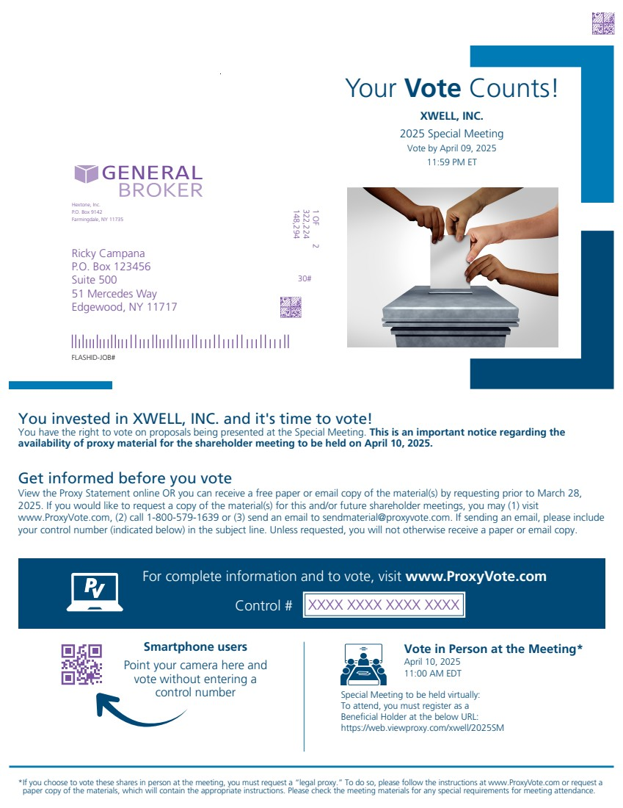 | Get informed before you vote *If you choose to vote these shares in person at the meeting, you must request a “legal proxy.” To do so, please follow the instructions at www.ProxyVote.com or request a paper copy of the materials, which will contain the appropriate instructions. Please check the meeting materials for any special requirements for meeting attendance. Smartphone users Point your camera here and vote without entering a control number Your Vote Counts! FLASHID-JOB# For complete information and to vote, visit www.ProxyVote.com Control # Ricky Campana P.O. Box 123456 Suite 500 51 Mercedes Way Edgewood, NY 11717 148,294 322,224 1 OF 2 30# Hextone, Inc. P.O. Box 9142 Farmingdale, NY 11735 XXXX XXXX XXXX XXXX XWELL, INC. 2025 Special Meeting Vote by April 09, 2025 11:59 PM ET You invested in XWELL, INC. and it's time to vote! You have the right to vote on proposals being presented at the Special Meeting. This is an important notice regarding the availability of proxy material for the shareholder meeting to be held on April 10, 2025. View the Proxy Statement online OR you can receive a free paper or email copy of the material(s) by requesting prior to March 28, 2025. If you would like to request a copy of the material(s) for this and/or future shareholder meetings, you may (1) visit www.ProxyVote.com, (2) call 1-800-579-1639 or (3) send an email to sendmaterial@proxyvote.com. If sending an email, please include your control number (indicated below) in the subject line. Unless requested, you will not otherwise receive a paper or email copy. Vote in Person at the Meeting* April 10, 2025 11:00 AM EDT Special Meeting to be held virtually: To attend, you must register as a Beneficial Holder at the below URL: https://web.viewproxy.com/xwell/2025SM
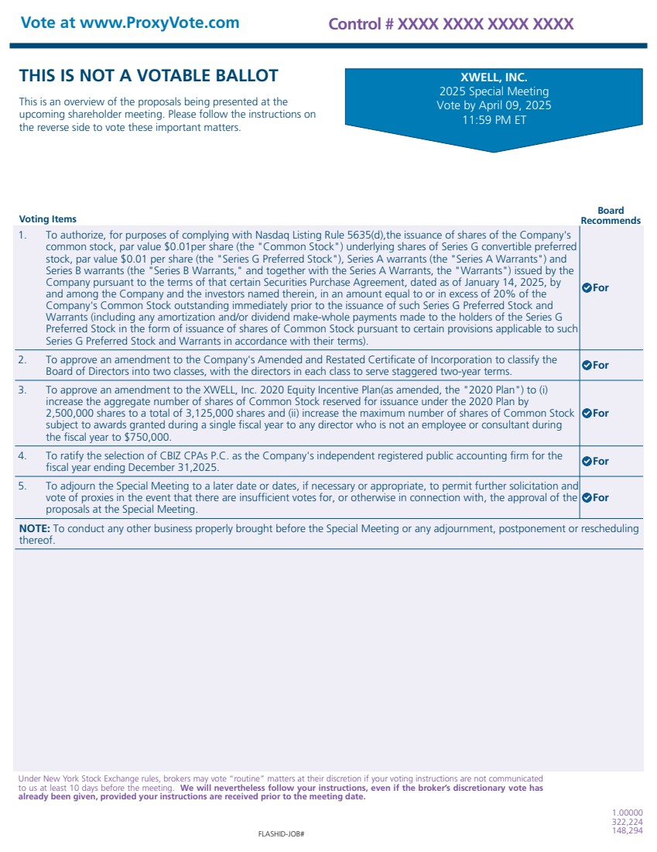 | Voting Items Board Recommends THIS IS NOT A VOTABLE BALLOT This is an overview of the proposals being presented at the upcoming shareholder meeting. Please follow the instructions on the reverse side to vote these important matters. Vote at www.ProxyVote.com FLASHID-JOB# Control # XXXX XXXX XXXX XXXX 1.00000 322,224 148,294 Under New York Stock Exchange rules, brokers may vote “routine” matters at their discretion if your voting instructions are not communicated to us at least 10 days before the meeting. We will nevertheless follow your instructions, even if the broker’s discretionary vote has already been given, provided your instructions are received prior to the meeting date. XWELL, INC. 2025 Special Meeting Vote by April 09, 2025 11:59 PM ET 1. To authorize, for purposes of complying with Nasdaq Listing Rule 5635(d),the issuance of shares of the Company's common stock, par value $0.01per share (the "Common Stock") underlying shares of Series G convertible preferred stock, par value $0.01 per share (the "Series G Preferred Stock"), Series A warrants (the "Series A Warrants") and Series B warrants (the "Series B Warrants," and together with the Series A Warrants, the "Warrants") issued by the Company pursuant to the terms of that certain Securities Purchase Agreement, dated as of January 14, 2025, by and among the Company and the investors named therein, in an amount equal to or in excess of 20% of the Company's Common Stock outstanding immediately prior to the issuance of such Series G Preferred Stock and Warrants (including any amortization and/or dividend make-whole payments made to the holders of the Series G Preferred Stock in the form of issuance of shares of Common Stock pursuant to certain provisions applicable to such Series G Preferred Stock and Warrants in accordance with their terms). For 2. To approve an amendment to the Company's Amended and Restated Certificate of Incorporation to classify the Board of Directors into two classes, with the directors in each class to serve staggered two-year terms. For 3. To approve an amendment to the XWELL, Inc. 2020 Equity Incentive Plan(as amended, the "2020 Plan") to (i) increase the aggregate number of shares of Common Stock reserved for issuance under the 2020 Plan by 2,500,000 shares to a total of 3,125,000 shares and (ii) increase the maximum number of shares of Common Stock subject to awards granted during a single fiscal year to any director who is not an employee or consultant during the fiscal year to $750,000. For 4. To ratify the selection of CBIZ CPAs P.C. as the Company's independent registered public accounting firm for the fiscal year ending December 31,2025. For 5. To adjourn the Special Meeting to a later date or dates, if necessary or appropriate, to permit further solicitation and vote of proxies in the event that there are insufficient votes for, or otherwise in connection with, the approval of the proposals at the Special Meeting. For NOTE: To conduct any other business properly brought before the Special Meeting or any adjournment, postponement or rescheduling thereof.

