UNITED STATES

SECURITIES AND EXCHANGE COMMISSION

Washington, D.C. 20549

FORM 8-K

Current Report

Pursuant to Section 13 or 15(d) of the

Securities Exchange Act of 1934

Date of Report (Date of earliest event reported): February 22, 2019

XPRESSPA GROUP, INC.

(Exact Name of Registrant as Specified in its Charter)

Delaware | 001-34785 | 20-4988129
(State or other jurisdiction | (Commission | (I.R.S. Employer
of incorporation) | File Number) | Identification No.)
 | 780 Third Avenue, 12th Floor
 | New York, New York 10017
 | (Address of Principal Executive Offices and Zip Code)

Registrant’s telephone number, including area code: (646) 525-4319

Check the appropriate box below if the Form 8-K filing is intended to simultaneously satisfy the filing obligation of the registrant under any of the following provisions:

- Written communications pursuant to Rule 425 under the Securities Act (17 CFR 230.425)

- Soliciting material pursuant to Rule 14a-12 under the Exchange Act (17 CFR 240.14a-12)

- Pre-commencement communications pursuant to Rule 14d-2(b) under the Exchange Act (17 CFR 240.14d-2(b))

- Pre-commencement communications pursuant to Rule 13e-4(c) under the Exchange Act (17 CFR 240.13e-4(c))

Indicate by check mark whether the registrant is an emerging growth company as defined in Rule 405 of the Securities Act of 1933 (§230.405 of this chapter) or Rule 12b-2 of the Securities Exchange Act of 1934 (§240.12b-2 of this chapter).

Emerging growth company ☐

If an emerging growth company, indicate by check mark if the registrant has elected not to use the extended transition period for complying with any new or revised financial accounting standards provided pursuant to Section 13(a) of the Exchange Act. ☐

Item 3.03 Material Modifications of Rights of Security Holders.

The information set forth in Item 5.03 is incorporated herein by reference.

Item 5.03 Amendments to Articles of Incorporation or Bylaws.

Amendment to Amended and Restated Certificate of Incorporation

On February 22, 2019, XpresSpa Group, Inc. (the “Company”) filed a certificate of amendment to its amended and restated certificate of incorporation with the Secretary of State of the State of Delaware to effect a 1-for-20 reverse stock split of the Company’s shares of common stock. Such amendment and ratio were previously approved by the Company’s stockholders and board of directors, respectively.

As a result of the reverse stock split, every twenty (20) shares of the Company’s pre-reverse split common stock will be combined and reclassified into one (1) share of common stock. Proportionate voting rights and other rights of common stock holders will not be affected by the reverse stock split. Stockholders who would otherwise hold a fractional share of common stock will receive payment in cash in lieu of any such resulting fractional shares of common stock as the post-reverse split amounts of common stock will be rounded down to the nearest full share. Such cash payment in lieu of a fractional share of common stock will be calculated by multiplying such fractional interest in one share of common stock by the closing trading price of the Company’s common stock on the trading day immediately preceding the effective date of the reverse stock split, and rounded to the nearest cent. No fractional shares will be issued in connection with the reverse stock split.

The reverse stock split will be effective at 5:00 p.m., Eastern Time, on February 22, 2019, and the Company’s common stock will trade on the Nasdaq Capital Market on a post-reverse split basis at the open of business on February 25, 2019. The Company’s post-reverse split common stock has a new CUSIP number (CUSIP No. 98420U604), but the par value and other terms of the common stock are not affected by the reverse stock split.

The Company’s transfer, American Stock Transfer & Trust Company, LLC, is acting as exchange agent for the reverse stock split.

On February 22, 2019, the Company issued a press release with respect to the reverse stock split, which is being filed as Exhibit 99.1 to this Current Report on Form 8-K. A copy of the certificate of amendment to the amended and restated certificate of incorporation is being filed as Exhibit 3.1 to this Current Report on Form 8-K and is incorporated herein by reference.

Item 9.01 Financial Statements and Exhibits.

- Exhibits.

Exhibit
Number |  |  |  |  |  | Description
 | 3.1 |  |  |  | Certificate of Amendment to the Amended and Restated Certificate of Incorporation of XpresSpa Group, Inc., filed with the Secretary of State
 |  |  |  |  | of the State of Delaware on February 22, 2019
99.1 |  |  |  |  | Press Release Issued by XpresSpa Group, Inc. on February 22, 2019

SIGNATURES

Pursuant to the requirements of the Securities Exchange Act of 1934, the registrant has duly caused this report to be signed on its behalf by the undersigned hereunto duly authorized.

 | XPRESSPA GROUP, INC.
Dated: February 22, 2019 | By: /s/ Douglas Satzman
 |  | Name: Douglas Satzman
 |  | Title: Chief Executive Officer

Exhibit 3.1
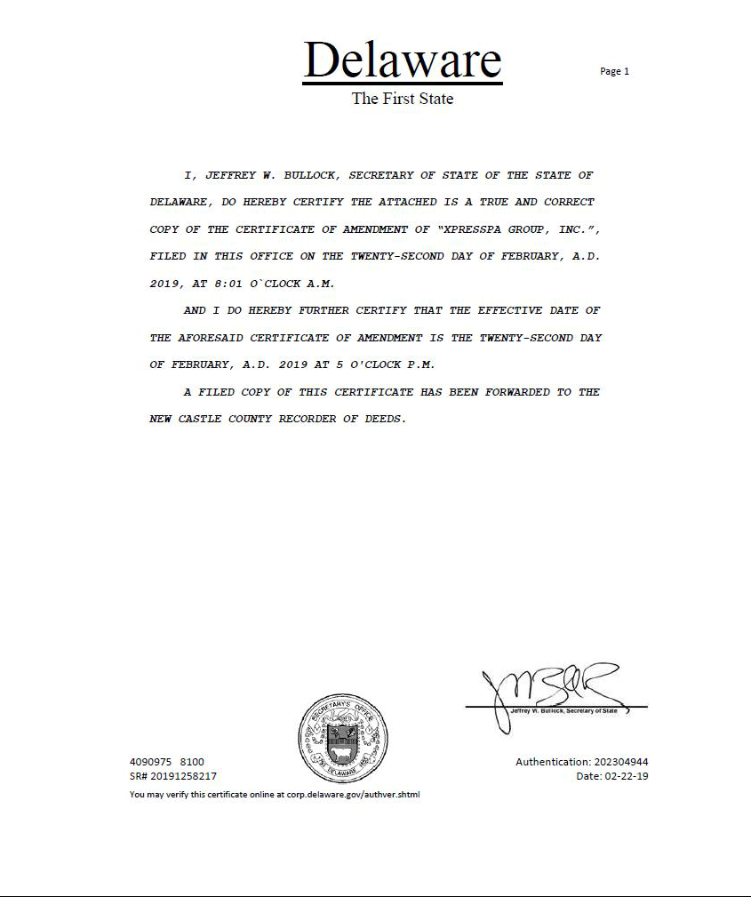

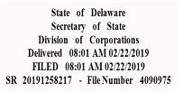

CERTIFICATE OF AMENDMENT

TO

AMENDED AND RESTATED CERTIFICATE OF INCORPORATION OF

XPRESSPA GROUP, INC.

Pursuant to Section 242 of the General Corporation Law of the State of Delaware, XpresSpa Group, Inc., a corporation organized and existing under the laws of the State of Delaware (the “Corporation”), does hereby certify as follows:

- The name of the Corporation is XpresSpa Group, Inc. The date of filing of its original Certificate of Incorporation with the Secretary of State of the State of Delaware was January 9, 2006, under the name of Vringo, Inc. The name of the Corporation was changed to FORM Holdings Corp. by filing a Certificate of Amendment to the Certificate of Incorporation with the Secretary of State of the State of Delaware on May 6, 2016. The name of the Corporation was changed to XpresSpa Group, Inc. by filing a Certificate of Amendment to the Certificate of Incorporation with the Secretary of State of the State of Delaware on January 5, 2018.

- The Board of Directors of the Corporation has duly adopted a resolution pursuant to Section 242 of the General Corporation Law of the State of Delaware setting forth a proposed amendment to the Amended and Restated Certificate of Incorporation of the Corporation and declaring said amendment to be advisable. The requisite stockholders of the Corporation have duly approved said proposed amendment in accordance with Section 242 of the General Corporation Law of the State of Delaware. The amendment amends the Amended and Restated Certificate of Incorporation of the Corporation as follows:

Sections (3) and (4) of Article Fourth are hereby amended and restated in their entirety as follows:

- Upon effectiveness of this Certificate of Amendment to the Amended and Restated Certificate of Incorporation of the Corporation (the “Effective Time”), the shares of Common Stock issued and outstanding immediately prior to the Effective Time and the shares of Common Stock issued and held in the treasury of the Corporation immediately prior to the Effective Time are reclassified into a smaller number of shares such that each twenty (20) shares of issued Common Stock immediately prior to the Effective Time is reclassified into one (1) share of Common Stock. Notwithstanding the immediately preceding sentence, no fractional shares shall be issued as a result of the reverse stock split. Instead, any stockholder who would otherwise be entitled to a fractional share of our Common Stock as a result of the reclassification shall be entitled to receive a cash payment equal to the product of such resulting fractional interest in one share of our Common Stock multiplied by the closing trading price of our Common Stock on the trading day immediately preceding the effective date of the reverse stock split. Notwithstanding the foregoing, the Corporation shall not be obliged to issue certificates evidencing the shares of Common Stock outstanding as a result of the reverse stock split or cash in lieu of fractional shares, if any, unless and until the certificates evidencing the shares held by a holder prior to the reverse stock split are either delivered to the Corporation or its transfer agent, or the holder notifies the Corporation or its transfer agent that such certificates have been lost, stolen or destroyed and executes an agreement satisfactory to the Corporation to indemnify the Corporation from any loss incurred by it in connection with such certificates.

- Each stock certificate that, immediately prior to the Effective Time, represented shares of Common Stock that were issued and outstanding immediately prior to the Effective Time shall, from and after the Effective Time, automatically and without the necessity of presenting the same for exchange, represent that the number of whole shares of Common Stock after the Effective Time into which the shares of Common Stock formerly represented by such certificate shall have been reclassified (as well as the right to receive a cash payment in lieu of a fractional share of Common Stock), provided, however, that each person of record holding a certificate that represented shares of Common Stock that were issued and outstanding immediately prior to the Effective Time shall receive, upon surrender of such certificate, a new certificate evidencing and representing the number of whole shares of Common Stock after the Effective Time into which the shares of Common Stock formerly represented by such certificate shall have been reclassified (including the right to receive a cash payment in lieu of a fractional share of Common Stock).”

This Certificate of Amendment shall be effective on February 22, 2019 at 5:00 p.m., Eastern Time.

IN WITNESS WHEREOF, the Corporation has caused this Certificate of Amendment to be signed by its Chief Executive Officer on this 22nd day of February, 2019.

XPRESSPA GROUP, INC.

By: /s/ Douglas Satzman

Name: Douglas Satzman

Title: Chief Executive Officer

Exhibit 99.1

XpresSpa Announces 1-for-20 Reverse Stock Split

NEW YORK, February 22, 2019 - XpresSpa Group, Inc. (Nasdaq: XSPA), a health and wellness company, today announced that it filed a certificate of amendment to its amended and restated certificate of incorporation with the Secretary of State of the State of Delaware to effect a 1-for-20 reverse stock split of shares of the company’s common stock, par value $0.01 per share. Such amendment and ratio were previously approved by the Company’s stockholders and board of directors, respectively. The reverse stock split is intended to enable the Company to regain full compliance with the Nasdaq Capital Market listing rules. The reverse stock split does not have any impact on the voting and other rights of stockholders and will have no impact on the Company’s business operations or any of its outstanding indebtedness.

The reverse stock split is scheduled to take effect after the market closes on February 22, 2019 (the "Effective Time"). Shares of the company’s common stock are expected to begin trading on a split-adjusted basis on February 25, 2019. As a result of the reverse stock split, every twenty (20) shares of the company’s pre-reverse split common stock will be combined and reclassified into one (1) share of common stock. Trading in the common stock will continue on the Nasdaq Capital Market under the ticker symbol "XSPA," but the security will be assigned a new CUSIP number (CUSIP No. 98420U604).

No fractional shares will be issued in connection with the reverse stock split. Stockholders who would otherwise hold a fractional share of the Company’s common stock will receive payment in cash in lieu of any such resulting fractional shares of common stock as the post-reverse split amounts of common stock will be rounded down to the nearest full share. Such cash payment in lieu of a fractional share of common stock will be calculated by multiplying such fractional interest in one share of common stock by the closing trading price of the company’s common stock on the trading day immediately preceding the effective date of the reverse stock split, and rounded to the nearest cent.

Stockholders of record will be receiving information from the company’s transfer agent, American Stock Transfer & Trust Company, regarding their share ownership following the reverse stock split and any payments in cash in lieu of fractional shares, if applicable.

About XpresSpa Group, Inc.

XpresSpa Group, Inc. (Nasdaq: XSPA) is a health and wellness company. XpresSpa Group’s core asset, XpresSpa, is the world’s largest airport spa company, with 57 locations in 23 airports globally, including one off-airport spa at Westfield World Trade Center in New York City. XpresSpa offers services that are tailored specifically to the busy customer. XpresSpa is committed to providing exceptional customer experiences with its innovative premium spa services, as well as exclusive luxury travel products and accessories. XpresSpa serves almost one million customers per year at its locations in the United States, Holland, and the United Arab Emirates. XpresSpa Group’s non-core assets include Infomedia and intellectual property assets. To learn more about XpresSpa Group, visit: www.XpresSpaGroup.com. To learn more about XpresSpa, visit www.XpresSpa.com

Investor Relations:

ICR

Raphael Gross

(203) 682-8253

