UNITED STATES

SECURITIES AND EXCHANGE COMMISSION

Washington, D.C. 20549

FORM 8-K

Current Report

Pursuant to Section 13 or 15(d) of the

Securities Exchange Act of 1934

Date of Report (Date of earliest event reported): August 9, 2012

VRINGO, INC.

(Exact Name of Registrant as Specified in its Charter)

Delaware | 001-34785 | 20-4988129
(State or other jurisdiction | (Commission | (I.R.S. Employer
of incorporation) | File Number) | Identification No.)
 | 780 Third Avenue, 15th Floor
 | New York, New York 10017
 | (Address of Principal Executive Offices and Zip Code)
 | Registrant’s telephone number, including area code: (212) 309-7549

Check the appropriate box below if the Form 8-K filing is intended to simultaneously satisfy the filing obligation of the registrant under any of the following provisions:

- Written communications pursuant to Rule 425 under the Securities Act (17 CFR 230.425)

- Soliciting material pursuant to Rule 14a-12 under the Exchange Act (17 CFR 240.14a-12)

- Pre-commencement communications pursuant to Rule 14d-2(b) under the Exchange Act (17 CFR 240.14d-2(b))

- Pre-commencement communications pursuant to Rule 13e-4(c) under the Exchange Act (17 CFR 240.13e-4(c))

Item 1.01 Entry into a Material Definitive Agreement

Patent Purchase Agreement

On August 9, 2012, Vringo, Inc. (the “Company”) entered into a Patent Purchase Agreement (the “Patent Purchase Agreement”) with Nokia Corporation (“Nokia”) pursuant to which Nokia agreed to sell to the Company a portfolio consisting of over 500 patents and patent applications worldwide, including 109 issued United States patents. The Company agreed to compensate Nokia with a cash payment and certain ongoing rights in revenues generated from the patent portfolio.

The portfolio encompasses a broad range of technologies relating to cellular infrastructure, including communication management, data and signal transmission, mobility management, radio resources management and services.

Thirty-one of the 124 patent families acquired have been declared essential by Nokia to wireless communications standards. Standards represented in the portfolio are commonly known as 2G, 2.5G, 3G and 4G and related technologies and include GSM, WCDMA, T63, T64, DECT, IETF, LTE, SAE, and OMA.

The purchase price for the portfolio is $22 million, plus to the extent that the gross revenue (as defined in the Patent Purchase Agreement) generated by such portfolio exceeds $22 million, a royalty of 35% of such excess. The $22 million payment shall be paid to Nokia on or before September 14, 2012. The Patent Purchase Agreement provides that Nokia and its affiliates will retain a non-exclusive, worldwide and fully paid-up license (without the right to grant sublicenses) to the portfolio for the sole purpose of supplying (as defined in the Patent Purchase Agreement) Nokia’s products. The Patent Purchase Agreement also provides that if the Company brings a proceeding against Nokia or its affiliates within seven years, Nokia shall have the right to re-acquire the patent portfolio for a nominal amount.

Further, if the Company either sells to a third party any assigned essential cellular patent, or more than a certain portion of the other assigned patents (other than in connection with a change of control of the Company), or files an action against a telecom provider to enforce any of the assigned patents (other than in response to any specified action filed by a telecom provider against the Company or its affiliate) which action is not withdrawn after notice from Nokia, then the Company will be obligated to pay to Nokia a substantial impairment payment. Because all of the foregoing actions are within the Company’s sole control, it does not expect to be obligated to pay any such impairment payment.

The list of assigned patents and essential cellular patents pursuant to the Patent Purchase Agreement is attached as Exhibit 99.1 hereto and is incorporated herein by reference.

The Company intends to file the Patent Purchase Agreement as an exhibit to its quarterly report on Form 10-Q for the period ending September 30, 2012 and plans to seek confidential treatment of certain terms in the Patent Purchase Agreement at such time.

Registered Direct Financing

On August 9, 2012, the Company entered into Subscription Agreements with several investors with respect to the registered direct offer and sale by the Company of an aggregate of 9,600,000 shares of the Company’s common stock, par value $0.01 per share (the “Shares”), at a purchase price of $3.25 per share in a privately negotiated transaction in which no party is acting as an underwriter or placement agent. The sale of the Shares is expected to settle on or about August 10, 2012. The net proceeds to the Company are expected to be approximately $30.5 million after deducting estimated offering expenses payable by the Company.

1

Of the approximately $30.5 million net proceeds from this offering, the Company intends to use $22 million as payment to Nokia in connection with the acquisition of patent assets pursuant to the Patent Purchase Agreement described above, $3.2 million as repayment in full of the Company’s outstanding debt to Hudson Bay Master Fund Ltd. and the remainder for general corporate purposes.

The sale and issuance of the Shares is being made pursuant to a prospectus supplement dated August 9, 2012 and an accompanying prospectus dated August 2, 2012, pursuant to the Company’s existing effective “shelf” registration statement on Form S-3 (File No. 333-182823), which was filed with the Securities and Exchange Commission (the “Commission”) on July 24, 2012 and declared effective by the Commission on August 2, 2012.

A copy of the opinion of Mintz, Levin, Cohn, Ferris, Glovsky and Popeo, P.C. relating to the legality of the issuance and sale of the Shares is attached as Exhibit 5.1 hereto. A copy of the form of Subscription Agreement is filed herewith as Exhibit 10.1 and is incorporated herein by reference. The foregoing description of the sale and issuance of the Shares by the Company and the documentation related thereto does not purport to be complete and is qualified in its entirety by reference to such Exhibits.

2

Item 7.01 Regulation FD Disclosure

The Company will host a conference call on August 9, 2012 at 10:00 a.m. Eastern Time to discuss certain information regarding the entry into the Patent Purchase Agreement with Nokia. A copy of the investor presentation prepared by the Company for use during the call is attached hereto as Exhibit 99.2.

The information furnished by the Company pursuant to this Item 7.01, including Exhibit 99.2, shall not be deemed “filed” for purposes of Section 18 of the Exchange Act, or otherwise subject to the liability of that section, and shall not be deemed to be incorporated by reference into any filing under the Securities Act of 1933, as amended, or the Securities Exchange Act of 1934, as amended.

Item 8.01 Other Events

In connection with the entry into the Patent Purchase Agreement with Nokia and the sale and issuance of the Shares as described in Item 1.01 of this Current Report on Form 8-K, the Company issued press releases. Copies of the press releases are filed as Exhibit 99.2 and Exhibit 99.3, respectively, to this Current Report on Form 8-K and are incorporated by reference herein.

Item 9.01 Financial Statements and Exhibits

(d) Exhibits.
Exhibit
Number |  | Description
5.1 |  | Opinion of Mintz, Levin, Cohn, Ferris, Glovsky and Popeo, P.C.
10.1 |  | Form of Subscription Agreement, dated August 9, 2012, by and between Vringo, Inc. and each of the investors
23.1 |  | Consent of Mintz, Levin, Cohn, Ferris, Glovsky and Popeo, P.C. (included in the opinion filed as Exhibit 5.1)
99.1 |  | List of Assigned Patents and Essential Cellular Patents
99.2 |  | Investor Presentation of Vringo, Inc.
99.3 |  | Press release, dated August 9, 2012, announcing the entry into the Patent Purchase Agreement with Nokia Corporation
99.4 |  | Press release, dated August 9, 2012, announcing the sale and issuance of shares of common stock by the company in a registered direct offering
 |  | 3

SIGNATURES

Pursuant to the requirements of the Securities Exchange Act of 1934, the registrant has duly caused this report to be signed on its behalf by the undersigned hereunto duly authorized.

 | VRINGO, INC.
Dated: August 9, 2012 | By: | /s/ Andrew D. Perlman
 |  | Name: Andrew D. Perlman
 |  | Title: Chief Executive Officer
 | 4

666 Third Avenue


New York, New York 10017

Mintz, Levin, Cohn, Ferris, Glovsky and Popeo, P.C. 212-935-3000

212-983-3115 fax

www.mintz.com

August 9, 2012

Vringo, Inc.
780 Third Avenue, 15th Floor

New York, New York 10017

Ladies and Gentlemen:

We have acted as legal counsel to Vringo, Inc., a Delaware corporation (the “Company”), in connection with the preparation and filing with the Securities and Exchange Commission (the “Commission”) of a Prospectus Supplement, dated August 9, 2012 (the “Prospectus Supplement”), to a Registration Statement (No.
333-182823) on Form S-3 (the “Registration Statement”), filed by the Company with the Commission under the Securities Act of 1933, as amended (the “Securities Act”). The Prospectus Supplement relates to the sale of an aggregate of 9,600,000 shares (the “Shares”) of the Company’s common stock, $0.01 par value per share (the “Common Stock”), pursuant to Subscription Agreements, dated August 9, 2012, by and among the Company and the purchasers set forth on the signature pages thereto (the “Subscription Agreements”). The form of Subscription Agreement will be filed as an exhibit to a Current Report on Form 8-K and incorporated by reference into the Registration Statement. This opinion is being rendered in connection with the filing of the Prospectus Supplement with the Commission. All capitalized terms used herein and not otherwise defined shall have the respective meanings given to them in the Registration Statement.

In connection with this opinion, we have examined the Company’s Certificate of Incorporation and Bylaws, each as currently in effect, the Registration Statement and the exhibits thereto, the Prospectus Supplement and the Subscription Agreements and such other records of the corporate proceedings of the Company and certificates of the Company’s officers as we have deemed relevant.

In our examination, we have assumed the genuineness of all signatures, the legal capacity of natural persons, the authenticity of all documents submitted to us as originals, the conformity to original documents of all documents submitted to us as certified or photostatic copies and the authenticity of the originals of such copies.

Our opinion is limited to the General Corporation Law of the State of Delaware and we express no opinion with respect to the laws of any other jurisdiction. No opinion is expressed herein with respect to the qualification of the Shares under the securities or blue sky laws of any state or any foreign jurisdiction.

Please note that we are opining only as to the matters expressly set forth herein, and no opinion should be inferred as to any other matters. This opinion is based upon currently existing statutes, rules, regulations and judicial decisions, and we disclaim any obligation to advise you of any change in any of these sources of law or subsequent legal or factual developments which might affect any matters or opinions set forth herein.

Mintz, Levin, Cohn, Ferris, Glovsky and Popeo, P.C.

BOSTON | WASHINGTON | NEW YORK | STAMFORD | LOS ANGELES | SAN DIEGO | LONDON | SAN FRANCISCO

Mintz, Levin, Cohn, Ferris, Glovsky and Popeo, P.C.

August 9, 2012

Page 2

Based upon the foregoing, we are of the opinion that the Shares, when issued and sold in accordance with the Subscription Agreements and the Prospectus Supplement, will be validly issued, fully paid and non-assessable.

We understand that you wish to file this opinion with the Commission as an exhibit to a Current Report on Form 8-K and the Registration Statement in accordance with the requirements of Item 601(b)(5) of Regulation S-K promulgated under the Securities Act and to reference the firm’s name under the caption “Legal Matters” in the Prospectus Supplement, and we hereby consent thereto. In giving this consent, we do not admit that we are within the category of persons whose consent is required under Section 7 of the Securities Act or the rules and regulations of the Commission promulgated thereunder.

Very truly yours,

/s/ Mintz, Levin, Cohn, Ferris, Glovsky and Popeo, P.C.

Mintz, Levin, Cohn, Ferris, Glovsky and Popeo, P.C.

SUBSCRIPTION AGREEMENT

This SUBSCRIPTION AGREEMENT (this “Agreement”) is dated as of August 9, 2012, between Vringo, Inc., a Delaware corporation (the “Company”), and the purchaser identified on the signature page hereto (the “Purchaser”).

WHEREAS, the Purchaser desires to subscribe for, and the Company desires to issue, shares of the Company’s common stock, $0.01 par value per share (the “Common Stock”), to the Purchaser pursuant to the terms and conditions of this Agreement;

NOW, THEREFORE, upon the execution and delivery of this Agreement, the Company and the Purchaser agree as follows:

- Subscription. The Purchaser, intending to be legally bound, hereby irrevocably subscribes for and agrees to purchase the number of shares of Common Stock (the “Shares”) at the per share purchase price and aggregate purchase price (the “Purchase Price”) as set forth on the signature page hereto, and the Company, intending to be legally bound, hereby agrees to issue and sell the Shares to the Purchaser, provided, however, that the Company reserves the right to accept or reject this subscription for Shares, in whole or in part. If the Company elects to accept this subscription for Shares in part, it shall promptly notify such Purchaser by delivery to the Purchaser by email of the signature page countersigned by the Company and reflecting the amount of the subscription accepted.

- Registration of Shares. The offering and sale of the Shares (the “Offering”) are being made pursuant to (a) an effective Registration Statement on Form S-3 (File No. 333-182823) (the “Registration Statement”) filed by the Company with the Securities and Exchange Commission (the “Commission”) under the Securities Act of 1933, as amended (the “Securities Act”), including the prospectus contained therein (the “Base Prospectus”), which relates, among other things, to the Shares and the sale thereof from time to time in accordance with Rule 415 under the Securities Act, and (b) a prospectus supplement (the “Prospectus Supplement” and, together with the Base Prospectus, the “Prospectus”) containing certain supplemental information regarding the Shares and terms of the Offering that will be filed with the Commission and delivered to the Purchaser (or made available to the Purchaser by the filing by the Company of an electronic version thereof with the Commission) no later than the second business day following the date of this Agreement.

- Purchase and Sale of Shares. The Company agrees to issue and sell to the Purchaser and the Purchaser agrees to purchase the Shares at a closing to take place at the offices of the Company, or such other place as the Purchaser and the Company shall mutually agree, including by way of the exchange of facsimile or “pdf” copies of signatures (the “Closing”), no later than the first Trading Day (as such term is defined below) following the date hereof (the “Closing Date”). At the Closing, the Company shall deliver instructions to the Company’s transfer agent to issue the Shares as of the Closing Date and deliver via the Depository Trust Company Deposit Withdrawal Agent Commission System (“DWAC”) the Shares, registered in the name of the Purchaser, against delivery of the Purchase Price, which shall be paid by the Purchaser at the Closing by wire transfer of immediately available funds to the account set forth on Schedule I hereto. The term “Trading Day” means a day on which the principal NYSE MKT is open for trading.

Prior to Closing, the Purchaser shall direct the broker-dealer at which the account or accounts to be credited with the Shares being purchased by such Purchaser are maintained, which broker/dealer shall be a DTC participant, to set up a DWAC instructing the Company’s transfer agent, to credit such account or accounts with the Shares by means of an electronic book-entry delivery. Simultaneously with the delivery to the Company by the Purchaser of the Purchase Price at Closing, the Company shall direct its transfer agent to credit the Purchaser’s account or accounts with the Shares pursuant to the information contained in the DWAC (as specified by such Purchaser on the Investor Questionnaire annexed hereto as Exhibit A).

- Closing Conditions.

- The obligations of the Company hereunder are subject to the following conditions being met:

- the accuracy in all material respects as of the date hereof of the representations and warranties by the Purchaser contained herein; and

- the delivery by the Purchaser of the Purchase Price to the Company for the Shares as set forth herein on the Closing Date.

- The obligations of the Purchaser hereunder are subject to the following conditions being met:

- the accuracy in all material respects as of the date hereof of the representations and warranties by the Company contained herein;

- the delivery by the Company to the Purchaser of the Prospectus and Prospectus Supplement (which may be delivered in accordance with Rule 172 under the Securities Act); and

- the delivery by the Company to the Purchaser of a copy of the irrevocable instructions to the Company’s transfer agent instructing the transfer agent to deliver on an expedited basis via DWAC the number of Shares subscribed for that was accepted by the Company, registered in the name of such Purchaser.

- Representations and Warranties of the Company. As of the date hereof, the Company hereby represents and warrants to the Purchaser that:

- Organization. The Company is a corporation, duly organized, validly existing and in good standing under the laws of the State of Delaware.

- Authority and Validity. The Company has all requisite corporate power and authority to execute, deliver and perform its obligations under this Agreement and to consummate the transactions contemplated hereby. The execution, delivery and performance by the Company of this Agreement and the consummation of the transactions contemplated hereby have been duly and validly authorized by all necessary action required on the part of the Company, and no other proceedings on the part of the Company are necessary to authorize this Agreement or for the Company to perform its obligations under this Agreement. This Agreement constitutes the lawful, valid and legally binding obligation of the Company, enforceable in accordance with its terms, except as the same may be limited by applicable bankruptcy, insolvency, reorganization, moratorium or similar laws affecting the enforcement of creditors’ rights generally and general equitable principles regardless of whether such enforceability is considered in a proceeding at law or in equity.

- Valid Issuance of Common Stock. The Shares, when issued, sold and delivered in accordance with the terms hereof for the Purchase Price, will be duly and validly authorized and issued, fully paid and nonassessable and free of restrictions on transfer other than the applicable state and federal securities laws.

- Registration Statement. The Registration Statement is in full force and effect and no cease and desist order or other suspension of the Registration Statement exists, has been imposed or, to the knowledge of the Company is threatened by the Commission.

- No Violation or Conflict. The execution, delivery and performance of this Agreement and the transactions contemplated hereby do not (i) violate, conflict with or result in the breach of any provision of the Company’s Certificate of Incorporation or Bylaws, (ii) conflict with or violate any law, rule, regulation, order, judgment or decree applicable the Company or any of its assets, properties or businesses, or (iii) conflict with, result in any breach of, constitute a default (or event that with the giving of notice or lapse of time, or both, would become a default) under, require any consent under, or give to others any rights of termination, amendment, acceleration, suspension, revocation or cancellation of, or result in the creation of any encumbrance on any of the assets or properties of the Company, pursuant to any note, bond, mortgage or indenture, contract, agreement, lease, sublease, license, permit, franchise or other instrument or arrangement to which the Company is a party except, in the case of clauses (ii) and (iii), to the extent that such conflicts, breaches, defaults or other matters would not, individually or in the aggregate, reasonably be expected to have a material adverse effect on the Company.

- Governmental/Regulatory Consents and Approvals. Except for filings under federal securities laws and, if required, NYSE MKT rules and regulations, the execution, delivery and performance of this Agreement by the Company do not, and the consummation of the transactions contemplated hereby do not and will not, require any permits, consents, approvals, orders, authorizations of, or declarations to or filings with any federal, state, local or foreign government or regulatory authority, which has not already been obtained, effected or provided.

- Representations, Warranties and Covenants of the Purchaser. As of the date hereof, the Purchaser hereby represents and warrants to the Company

that:

- The Purchaser has received (or otherwise had made available to him by the filing by the Company of an electronic version thereof with the Commission) the Base Prospectus which is a part of the Registration Statement, and the documents incorporated by reference therein (collectively, the “Disclosure Package”), prior to or in connection with the execution of this Agreement. The Purchaser acknowledges that, prior to the delivery of this Agreement to the Company, the Purchaser will receive certain additional information regarding the Offering, including pricing information (the “Offering Information”). Such information may be provided to the Purchaser by any means permitted under the Act, including the Prospectus Supplement, a free writing prospectus and oral communications.

- The Purchaser (a) is knowledgeable, sophisticated and experienced in making, and is qualified to make decisions with respect to, investments in shares presenting an investment decision like that involved in the purchase of the Shares, including investments in securities issued by the Company and investments in comparable companies and has reviewed such information and made such inquiries regarding the Company and the purchase of the Shares as he has deemed appropriate and (b) in connection with his decision to purchase the Shares, has received (or had full access to) and is relying only upon the Disclosure Package and the documents incorporated by reference therein.

- The Purchaser understands that nothing in this Agreement, the Disclosure Package or any other materials presented to the Purchaser in connection with the purchase and sale of the Shares constitutes legal, tax or investment advice. The Purchaser has consulted such legal, tax and investment advisors and made such investigations as he, it his sole discretion, has deemed necessary or appropriate in connection with his purchase of the Shares.

- No person or entity acting on behalf of, or under the authority of, the Purchaser is or will be entitled to any broker’s, finder’s, or similar fees or commission payable by the Company.

- Since the date that the Purchaser became aware of the proposed Offering, the Purchaser has not disclosed any information regarding the Offering to any third parties (other than its legal, accounting and other advisors) and has not engaged in any purchases or sales of the securities of the Company (including, without limitation, any Short Sales (as defined herein) involving the Company’s securities). The Purchaser agrees that it will not use any of the Shares acquired pursuant to this Agreement to cover any short position in the Common Stock if doing so would be in violation of applicable securities laws. For purposes hereof, “Short Sales” include, without limitation, all “short sales” as defined in Rule 200 promulgated under Regulation SHO under the Exchange Act, whether or not against the box, and all types of direct and indirect stock pledges, forward sales contracts, options, puts, calls, short sales, swaps, ”put equivalent positions” (as defined in Rule 16a-1(h) under the Exchange Act) and similar arrangements (including on a total return basis), and sales and other transactions through non-U.S. broker dealers or foreign regulated brokers.

- No offer by the Purchaser to buy the Shares will be accepted and no part of the Purchase Price will be delivered to the Company until the Purchaser has received the Offering Information and the Company has accepted such offer by countersigning a copy of this Agreement, and any such offer may be withdrawn or revoked, without obligation or commitment of any kind, at any time prior to the Company sending (orally, in writing or by electronic mail) notice of its acceptance of such offer. An indication of interest will involve no obligation or commitment of any kind until the Purchaser has been delivered the Offering Information and this Agreement is accepted and countersigned by or on behalf of the Company. The Purchaser understands and agrees that the Company, in its sole discretion, reserves the right to accept or reject this subscription for Shares, in whole or in part.

- Public Announcement. The Company and the Purchaser agree that the Company shall, prior to the opening of the financial markets in New York City on the business day immediately after the date hereof: (a) issue a press release announcing the Offering and disclosing all material information regarding the Offering and (b) file a Current Report on Form 8-K with the Securities and Exchange Commission, including a form of this Agreement as an exhibit thereto, which discloses all material non-public information disclosed to the Purchaser.

- Governing Law. This Agreement shall be governed by, and construed in accordance with, the laws of the State of Delaware, without regard to its conflicts of laws principles.

- Entire Agreement. This Agreement constitutes the entire agreement between the Company and the Purchaser with respect to the matters covered hereby and supersedes all prior agreements and understanding with respect to such matters between the Company and the Purchaser.

- Severability. In case any provision contained in this Agreement should be invalid, illegal or unenforceable in any respect, the validity, legality and enforceability of the remaining provisions contained herein will not in any way be affected or impaired thereby.

- Counterparts; Facsimile or “pdf” Copies. This Agreement may be executed in counterparts, each of which, when executed, shall be deemed an original but all of which, taken together, shall constitute one and the same Agreement. Delivery of an executed copy of a signature page to this Agreement by facsimile or “pdf” transmission shall be as effective as delivery of a manually executed copy of this Agreement and shall be as effective and enforceable as the original.

[SIGNATURES FOLLOW ON NEXT PAGE]

IN WITNESS WHEREOF, the undersigned has caused this Agreement to be duly executed by its authorized signatory as of the date first indicated above.

 | PURCHASER:
 | [Name of Purchaser]
 | By:
 | Name:
Subscription Amount: $_________________ | Title:
Purchase Price per Share: $______________
No. of Shares: ________________________
 | VRINGO, INC.
Agreed and Accepted this ___
day of August, 2012:
 | By:
 | Name:
 | Title:
 | Address for Notice:
 | 780 Third Avenue, 15th Floor
Subscription Amount Accepted: | New York, NY 10017
$__________________ | Telephone: (646) 525-4319
 | Facsimile: (509) 271-5246
No. of Shares Accepted: | E-mail: andrew.perlman@vringo.com
___________________ | Attention: Chief Executive Officer
 | With a copy to:
 | Mintz, Levin, Cohn, Ferris, Glovsky and Popeo, P.C.
 | Chrysler Center
 | 666 Third Avenue
 | New York, NY 10017
 | Telephone: (212) 935-3000
 | Facsimile: (212) 983-3115
 | E-mail: KRKoch@mintz.com
 | Attention: Kenneth R. Koch, Esq.

EXHIBIT A

INVESTOR QUESTIONNAIRE

  - The exact name that your Shares are to be registered in. You may use a nominee name if appropriate:

_____________________________________________________________________

- The relationship between the Purchaser and the registered holder listed in response to item 1 above:

_____________________________________________________________________

- The mailing address of the registered holder listed in response to item 1 above:

____________________________________________________

____________________________________________________

____________________________________________________

____________________________________________________

Fax: ________________________________________________

- The Social Security Number or Tax Identification Number of the registered holder listed in the response to item 1 above:

_____________________________________________________________

- Name of DTC Participant (broker-dealer at which the account or accounts to be credited with the Shares are maintained):

______________________________________________________________

- DTC Participant Number: _______________________________________________________________________

- Name of Account at DTC Participant being credited with the Shares: ______________________________________

- Account Number at DTC Participant being credited with the Shares: ______________________________________

Patent/

Exhibit 99.1

ASSIGNED PATENTS

Publication

DE69330097.3

EP660992

FI109064

FR660992

GB660992

US5682600

DE69331152.5

EP720805

US5722074

US5600705

CNZL96190165.9

US5805301

CN97192428.7 EP885540 IN200572 PH1-1997-55589 SG55627

Title
MENETELMÄ SMS-SANOMIEN LÄHETTÄMISEKSI ALERTIA VIIVÄSTÄMÄLLÄ

MENETELMÄ SMS-SANOMIEN LÄHETTÄMISEKSI ALERTIA VIIVÄSTÄMÄLLÄ

MENETELMÄ SMS-SANOMIEN LÄHETTÄMISEKSI ALERTIA VIIVÄSTÄMÄLLÄ

MENETELMÄ SMS-SANOMIEN LÄHETTÄMISEKSI ALERTIA VIIVÄSTÄMÄLLÄ

MENETELMÄ SMS-SANOMIEN LÄHETTÄMISEKSI ALERTIA VIIVÄSTÄMÄLLÄ

A METHOD FOR STARTING A SHORT MESSAGE TRANSMISSION

METHOD AND APPARATUS FOR SYNCHRONIZING SPEECH FRAMES BETWEENBASE STATIONS

METHOD AND APPARATUS FOR SYNCHRONIZING SPEECH FRAMES BETWEENBASE STATIONS

SOFT HANDOFF IN A CELLULAR TELECOMMUNICATIONS SYSTEM METHOD FOR CALL ESTABLISHMENT
A METHOD FOR SPLITTING AND COMBINING FAX GROUP 3 DATA IN TRANSPARENT HSCSD

FACSIMILE TRANSMISSION IN A MOBILE COMMUNICATION SYSTEM

FAST MOVING MOBILE STATION HANDLING IN A MACRO CELL FAST MOVING MOBILE STATION HANDLING IN A MACRO CELL FAST MOVING MOBILE STATION HANDLING IN A MACRO CELL FAST MOVING MOBILE STATION HANDLING IN A MACRO CELL FAST MOVING MOBILE STATION HANDLING IN A MACRO CELL

Status |  | Family |  | County |  | Filing Date |  | Filing No.
Grant |  | 2089 |  | DE |  | 17.09.1993 |  | 93919376.9
Grant |  | 2089 |  | EP |  | 17.09.1993 |  | 93919376.9
Grant |  | 2089 |  | FI |  | 18.09.1992 |  | 924198
Grant |  | 2089 |  | FR |  | 17.09.1993 |  | 93919376.9
Grant |  | 2089 |  | GB |  | 17.09.1993 |  | 93919376.9
Grant |  | 2089 |  | US |  | 17.09.1993 |  | 08/403901
Grant |  | 2314 |  | DE |  | 24.09.1993 |  | 93920866.6
Grant |  | 2314 |  | EP |  | 24.09.1993 |  | 93920866.6
Grant |  | 2314 |  | US |  | 24.09.1993 |  | 08/619701
Grant |  | 2336 |  | US |  | 20.09.1993 |  | 08/387926
Grant |  | 2390 |  | CN |  | 06.03.1996 |  | 96190165.9
Grant |  | 2390 |  | US |  | 06.03.1996 |  | 08/732467
Grant |  | 2398 |  | CN |  | 18.02.1997 |  | 97192428.7
Abandoned |  | 2398 |  | EP |  | 18.02.1997 |  | 97903403
Grant |  | 2398 |  | IN |  | 14.02.1997 |  | 304/MAS/97
Grant |  | 2398 |  | PH |  | 17.02.1997 |  | I-55589
Grant |  | 2398 |  | SG |  | 18.02.1997 |  | 9804369.8

Patent/
Publication
US6285884

DE69326903

EP788698

GB788698

US5638359

DE69328565.6

EP673573

FR673573

GB673573

JP3273790

US6064648

AU696034

CA2181333

CNZL95191251.8

DE69528819.9

EP740875

ES2186710

Title
FAST MOVING MOBILE STATION HANDLING IN A MACRO CELL

Method for congestion management in a frame relay network and a node in a frame relay network

Method for congestion management in a frame relay network and a node in a frame relay network

Method for congestion management in a frame relay network and a node in a frame relay network

Method for congestion management in a frame relay network and a node in a frame relay network

A METHOD FOR CONGESTION MANAGEMENT IN A FRAME RELAY NETWORK AND A NODE IN A FRAME RELAY NETWORK

A METHOD FOR CONGESTION MANAGEMENT IN A FRAME RELAY NETWORK AND A NODE IN A FRAME RELAY NETWORK

A METHOD FOR CONGESTION MANAGEMENT IN A FRAME RELAY NETWORK AND A NODE IN A FRAME RELAY NETWORK

A METHOD FOR CONGESTION MANAGEMENT IN A FRAME RELAY NETWORK AND A NODE IN A FRAME RELAY NETWORK

A METHOD FOR CONGESTION MANAGEMENT IN A FRAME RELAY NETWORK AND A NODE IN A FRAME RELAY NETWORK

METHOD FOR NOTIFYING A FRAME RELAY NETWORK OF TRAFFIC CONGESTION IN AN ATM

METHOD AND SYSTEM FOR CONTROLLING STATISTICALLY MULTIPLEXEDATM BUS

METHOD AND SYSTEM FOR CONTROLLING STATISTICALLY MULTIPLEXEDATM BUS

METHOD AND SYSTEM FOR CONTROLLING STATISTICALLY MULTIPLEXEDATM BUS

METHOD AND SYSTEM FOR CONTROLLING STATISTICALLY MULTIPLEXEDATM BUS

METHOD AND SYSTEM FOR CONTROLLING STATISTICALLY MULTIPLEXEDATM BUS

METHOD AND SYSTEM FOR CONTROLLING STATISTICALLY MULTIPLEXEDATM BUS

Status |  | Family |  | County |  | Filing Date |  | Filing No.
Grant |  | 2398 |  | US |  | 30.11.2000 |  | 09/117486
Grant |  | 2651 |  | DE |  | 14.12.1993 |  | 94901974.9
Grant |  | 2651 |  | EP |  | 14.12.1993 |  | 94901974.9
Grant |  | 2651 |  | GB |  | 14.12.1993 |  | 94901974.9
Grant |  | 2651 |  | US |  | 14.12.1993 |  | 08/454233
Grant |  | 2652 |  | DE |  | 14.12.1993 |  | 94901973.1
Grant |  | 2652 |  | EP |  | 14.12.1993 |  | 94901973.1
Grant |  | 2652 |  | FR |  | 14.12.1993 |  | 94901973
Grant |  | 2652 |  | GB |  | 14.12.1993 |  | 94901973
Grant |  | 2652 |  | JP |  | 14.12.1993 |  | 6513838
Grant |  | 2702 |  | US |  | 21.12.1995 |  | 08/875582
Grant |  | 2704 |  | AU |  | 13.1.1995 |  | 14180/95
Grant |  | 2704 |  | CA |  | 13.1.1995 |  | 2181333
Grant |  | 2704 |  | CN |  | 13.1.1995 |  | 95191251.8
Grant |  | 2704 |  | DE |  | 13.1.1995 |  | 95905653.2
Grant |  | 2704 |  | EP |  | 13.1.1995 |  | 95905653.2
Grant |  | 2704 |  | ES |  | 13.1.1995 |  | 95905653.2

Patent/
Publication

FI94816

FR740875

GB740875

IT740875

JP2927553

NZ278086

US5841774

US20050240981 US6961953 US6577721 US6029065

CNZL95197341.X

NL1001744

US6295286

CNZL96195981.9

DE69633315.5

EP748136

JP3842335

NL748136

RU2153238

US6081534

Title
METHOD AND SYSTEM FOR CONTROLLING STATISTICALLY MULTIPLEXEDATM BUS

METHOD AND SYSTEM FOR CONTROLLING STATISTICALLY MULTIPLEXEDATM BUS

METHOD AND SYSTEM FOR CONTROLLING STATISTICALLY MULTIPLEXEDATM BUS

METHOD AND SYSTEM FOR CONTROLLING STATISTICALLY MULTIPLEXEDATM BUS

METHOD AND SYSTEM FOR CONTROLLING STATISTICALLY MULTIPLEXEDATM BUS

METHOD AND SYSTEM FOR CONTROLLING STATISTICALLY MULTIPLEXEDATM BUS

METHOD AND SYSTEM FOR CONTROLLING STATISTICALLY MULTIPLEXEDATM BUS

SPLIT ADVERTISEMENT

SPLIT ADVERTISEMENT

CONFERENCE CALL MACRO

REMOTE FEATURE CODE PROGRAMMING FOR MOBILE STATIONS

A METHOD FOR INDICATING A MULTI-SLOT CHANNEL IN A TDMA RADIOSYSTEM

A METHOD FOR INDICATING A MULTI-SLOT CHANNEL IN A TDMA RADIOSYSTEM

A METHOD FOR INDICATING A MULTI-SLOT CHANNEL IN A TDMA RADIOSYSTEM

IMPLEMENTATION OF MUTUAL RATE ADAPTATIONS IN DATA SERVICES BETWEEN GSM AND

IMPLEMENTATION OF MUTUAL RATE ADAPTATIONS IN DATA SERVICES BETWEEN GSM AND

IMPLEMENTATION OF MUTUAL RATE ADAPTATIONS IN DATA SERVICES BETWEEN GSM AND

IMPLEMENTATION OF MUTUAL RATE ADAPTATIONS IN DATA SERVICES BETWEEN GSM AND

IMPLEMENTATION OF MUTUAL RATE ADAPTATIONS IN DATA SERVICES BETWEEN GSM AND

IMPLEMENTATION OF MUTUAL RATE ADAPTATIONS IN DATA SERVICES BETWEEN GSM AND

IMPLEMENTATION OF MUTUAL RATE ADAPTATIONS IN DATA SERVICES BETWEEN GSM AND

Status |  | Family |  | County |  | Filing Date |  | Filing No.
Grant |  | 2704 |  | FI |  | 17.1.1994 |  | 940220
Grant |  | 2704 |  | FR |  | 13.1.1995 |  | 95905653.2
Grant |  | 2704 |  | GB |  | 13.1.1995 |  | 95905653.2
Grant |  | 2704 |  | IT |  | 13.1.1995 |  | 95905653.2
Grant |  | 2704 |  | JP |  | 13.1.1995 |  | 7-518860
Grant |  | 2704 |  | NZ |  | 13.1.1995 |  | 278086
Grant |  | 2704 |  | US |  | 13.1.1995 |  | 08/676202
Pending |  | 4561 |  | US |  | 24.06.2005 |  | 11/165994
Grant |  | 4561 |  | US |  | 29.12.2000 |  | 09/752127
Grant |  | 6390 |  | US |  | 30.04.1999 |  | 09/302811
Grant |  | 6815 |  | US |  | 05.05.1997 |  | 08/841850
Grant |  | 7158 |  | CN |  | 24.11.1995 |  | 95197341.X
Grant |  | 7158 |  | NL |  | 24.11.1995 |  | 1001744
Grant |  | 7158 |  | US |  | 24.11.1995 |  | 08/836969
Grant |  | 7164 |  | CN |  | 29.05.1996 |  | 96195981.9
Grant |  | 7164 |  | DE |  | 05.06.1996 |  | 96304138.9
Grant |  | 7164 |  | EP |  | 05.06.1996 |  | 96304138.9
Grant |  | 7164 |  | JP |  | 30.05.1996 |  | 8-136887
Grant |  | 7164 |  | NL |  | 05.06.1996 |  | 96304138.9
Grant |  | 7164 |  | RU |  | 29.05.1996 |  | 97119934
Grant |  | 7164 |  | US |  | 06.06.1996 |  | 08/659590

Patent/
Publication
AU716158

US7420948

US6173187

US6366602

US6349099

US6859447

AT1068762

AU755890

CH1068762

CNZL99804679.5

DE69927492.3

EP1068762

JP4059626

NL1068762

NO325596

US6456237

GB2370183

US6249816

DE69935006.9

EP1135962

Title
NEW 14.4 KBIT/S SERVICE FOR GSM

NEW 14.4 KBIT/S SERVICE FOR GSM

ADAPTIIVINEN MENETELMÄ OPTIMAALISEN SIR-TAVOITTEEN ASETTAMISEKSI

BCCH-CARRIER CHANGE FOR GSM

Connection identification in transmission system of wireless telecommunication network over ATM protocol stack

A BASESTATION CONTROLLER (BSC) BASED ON AN ATM SWITCH

TRACKING OF REAL TIME AND OBSERVED TIME DIFFERENCE VALUES INTIME

TRACKING OF REAL TIME AND OBSERVED TIME DIFFERENCE VALUES INTIME

TRACKING OF REAL TIME AND OBSERVED TIME DIFFERENCE VALUES INTIME

TRACKING OF REAL TIME AND OBSERVED TIME DIFFERENCE VALUES INTIME

TRACKING OF REAL TIME AND OBSERVED TIME DIFFERENCE VALUES INTIME

TRACKING OF REAL TIME AND OBSERVED TIME DIFFERENCE VALUES INTIME

TRACKING OF REAL TIME AND OBSERVED TIME DIFFERENCE VALUES INTIME

TRACKING OF REAL TIME AND OBSERVED TIME DIFFERENCE VALUES INTIME

TRACKING OF REAL TIME AND OBSERVED TIME DIFFERENCE VALUES INTIME

TRACKING OF REAL TIME AND OBSERVED TIME DIFFERENCE VALUES INTIME

NBR POOL FOR SIMA NETWORK

NBR POOL FOR SIMA NETWORK

System and method for prioritizing multicast packets in a network service class utilizing a priority-based quality of service

System and method for prioritizing multicast packets in a network service class utilizing a priority-based quality of service

Status |  | Family |  | County |  | Filing Date |  | Filing No.
Grant |  | 7272 |  | AU |  | 31.10.1996 |  | 73003/96
Grant |  | 7272 |  | US |  | 09.09.2005 |  | 11/221797
Grant |  | 7300 |  | US |  | 25.11.1997 |  | 09/117274
Grant |  | 7485 |  | US |  | 03.12.1997 |  | 09/117700
Grant |  | 7776 |  | US |  | 11.6.1998 |  | 09/460158
Grant |  | 7794 |  | US |  | 30.12.1997 |  | 09/607065
Grant |  | 7882 |  | AT |  | 30.03.1999 |  | 99945702.1
Grant |  | 7882 |  | AU |  | 30.03.1999 |  | 59468/99
Grant |  | 7882 |  | CH |  | 30.03.1999 |  | 99945702.1
Grant |  | 7882 |  | CN |  | 30.03.1999 |  | 99804679.5
Grant |  | 7882 |  | DE |  | 30.03.1999 |  | 99945702.1
Grant |  | 7882 |  | EP |  | 30.03.1999 |  | 99945702.1
Grant |  | 7882 |  | JP |  | 30.03.1999 |  | 2000-544146
Grant |  | 7882 |  | NL |  | 30.03.1999 |  | 99945702.1
Grant |  | 7882 |  | NO |  | 30.03.1999 |  | 20004893
Grant |  | 7882 |  | US |  | 30.03.1999 |  | 09/677114
Grant |  | 7959 |  | GB |  | 20.7.1999 |  | 30514.4
Grant |  | 7959 |  | US |  | 22.7.1998 |  | 09/120607
Grant |  | 7960 |  | DE |  | 9.12.1999 |  | 99966074.9
Grant |  | 7960 |  | EP |  | 9.12.1999 |  | 99966074.9

Patent/ |  | Title
Publication |  | Title
FR1135962 |  | System and method for prioritizing multicast packets in a network service
FR1135962 | class utilizing a priority-based quality of service
GB1135962 | System and method for prioritizing multicast packets in a network service
GB1135962 | class utilizing a priority-based quality of service
IT1135962 | System and method for prioritizing multicast packets in a network service
IT1135962 | class utilizing a priority-based quality of service
SE1135962 | System and method for prioritizing multicast packets in a network service
SE1135962 | class utilizing a priority-based quality of service
US6549938 | System and method for prioritizing multicast packets in a network service
US6549938 | class utilizing a priority-based quality of service
US6466794 | CHANNEL ALLOCATION
CNZL97192088.5 | MT SMS QUEUING AT THE VISITED MSC
FI102346 | MT SMS QUEUING AT THE VISITED MSC
US6463291 | MT SMS QUEUING AT THE VISITED MSC
CA2250037 | SPEECH TRANSMISSION IN A PACKET NETWORK
CNZL97194117.3 | SPEECH TRANSMISSION IN A PACKET NETWORK
DE69738106.4 | SPEECH TRANSMISSION IN A PACKET NETWORK
EP894383 | SPEECH TRANSMISSION IN A PACKET NETWORK
ES894383 | SPEECH TRANSMISSION IN A PACKET NETWORK
FI103456 | SPEECH TRANSMISSION IN A PACKET NETWORK
FR894383 | SPEECH TRANSMISSION IN A PACKET NETWORK
GB894383 | SPEECH TRANSMISSION IN A PACKET NETWORK
HK1017189 | SPEECH TRANSMISSION IN A PACKET NETWORK
IN206503 | SPEECH TRANSMISSION IN A PACKET NETWORK
IT894383 | SPEECH TRANSMISSION IN A PACKET NETWORK
PH1-1997-55861 | SPEECH TRANSMISSION IN A PACKET NETWORK
US6738374 | SPEECH TRANSMISSION IN A PACKET NETWORK
US6085100 | METHOD OF ROUTING REPLY SHORT MESSAGES
CNZL98807025.1 | ROUTING SHORT MESSAGES
DE69834402.2 | ROUTING SHORT MESSAGES
EP992164 | ROUTING SHORT MESSAGES
ES992164 | ROUTING SHORT MESSAGES
FI109511 | ROUTING OF MOBILE ORIGINATED SHORT MESSAGES (MO-SM)
FI109511 | FORM SMSC TO THE RIGHT
FR992164 | ROUTING SHORT MESSAGES

Status |  | Family |  | County |  | Filing Date |  | Filing No.
Grant |  | 7960 |  | FR |  | 9.12.1999 |  | 99966074.9
Grant |  | 7960 |  | GB |  | 9.12.1999 |  | 99966074.9
Grant |  | 7960 |  | IT |  | 9.12.1999 |  | 99966074.9
Grant |  | 7960 |  | SE |  | 9.12.1999 |  | 99966074.9
Grant |  | 7960 |  | US |  | 10.12.1998 |  | 09/209182
Grant |  | 10215 |  | US |  | 21.01.1998 |  | 09/357180
Grant |  | 10609 |  | CN |  | 04.02.1997 |  | 97192088.5
Grant |  | 10609 |  | FI |  | 05.02.1996 |  | FI 960523
Grant |  | 10609 |  | US |  | 04.02.1997 |  | 09/117701
Grant |  | 10732 |  | CA |  | 27.3.1997 |  | 2250037
Grant |  | 10732 |  | CN |  | 27.3.1997 |  | 97194117.3
Grant |  | 10732 |  | DE |  | 27.3.1997 |  | 97908301.1
Grant |  | 10732 |  | EP |  | 27.3.1997 |  | 97908301.1
Grant |  | 10732 |  | ES |  | 27.3.1997 |  | 97908301.1
Grant |  | 10732 |  | FI |  | 29.3.1996 |  | 961442
Grant |  | 10732 |  | FR |  | 27.3.1997 |  | 97908301.1
Grant |  | 10732 |  | GB |  | 27.3.1997 |  | 97908301.1
Grant |  | 10732 |  | HK |  | 27.4.1999 |  | 99101866.1
Grant |  | 10732 |  | IN |  | 20.3.1997 |  | IN 588/MAS/97
Grant |  | 10732 |  | IT |  | 27.3.1997 |  | 97908301.1
Grant |  | 10732 |  | PH |  | 17.3.1997 |  | I-55861
Grant |  | 10732 |  | US |  | 27.3.1997 |  | 09/155426
Grant |  | 10762 |  | US |  | 02.01.1998 |  | 09/125752
Grant |  | 10765 |  | CN |  | 02.06.1998 |  | 98807025.1
Grant |  | 10765 |  | DE |  | 02.06.1998 |  | 98924342.3
Grant |  | 10765 |  | EP |  | 02.06.1998 |  | 98924342.3
Grant |  | 10765 |  | ES |  | 02.06.1998 |  | 98924342.3
Grant |  | 10765 |  | FI |  | 03.06.1997 |  | FI 972357
Grant |  | 10765 |  | FR |  | 02.06.1998 |  | 98924342.3

Patent/ |  | Title |  | Status |  | Family |  | County |  | Filing Date |  | Filing No.
Publication
GB992164 |  | ROUTING SHORT MESSAGES |  | Grant |  | 10765 |  | GB |  | 02.06.1998 |  | 98924342.3
IT992164 | ROUTING SHORT MESSAGES |  |  | Grant |  | 10765 |  | IT |  | 02.06.1998 |  | 98924342.3
JP3988836 | ROUTING SHORT MESSAGES |  |  | Grant |  | 10765 |  | JP |  | 02.06.1998 |  | 11-501673
NL992164 | ROUTING SHORT MESSAGES |  |  | Grant |  | 10765 |  | NL |  | 02.06.1998 |  | 98924342.3
SE992164 | ROUTING SHORT MESSAGES |  |  | Grant |  | 10765 |  | SE |  | 02.06.1998 |  | 98924342.3
US6292669 | ROUTING SHORT MESSAGES |  |  | Grant |  | 10765 |  | US |  | 02.06.1998 |  | 09/454946
US6571284 | RADIOTOISTINTEN AUTOMAATTINEN VIRITYS |  |  | Grant |  | 10780 |  | US |  | 02.01.1998 |  | 09/331764
CNZL00816538.6 | CALL ROUTING IN A TELECOMMUNICATION SYSTEM |  |  | Grant |  | 10906 |  | CN |  | 29.11.2000 |  | 816538.6
EP1234418 | CALL ROUTING IN A TELECOMMUNICATION SYSTEM |  |  | Grant |  | 10906 |  | EP |  | 29.11.2000 |  | 985284.9
GB1234418 | CALL ROUTING IN A TELECOMMUNICATION SYSTEM |  |  | Grant |  | 10906 |  | GB |  | 29.11.2000 |  | 985284.9
US7606261 | CALL ROUTING IN A TELECOMMUNICATION SYSTEM |  |  | Grant |  | 10906 |  | US |  | 29.11.2000 |  | 10/153180
CNZL01810732.X | MANAGEMENT OF SUBSCRIBER DATA IN MOBILE SYSTEM |  |  | Grant |  | 10919 |  | CN |  | 04.06.2001 |  | 01810732.X
DE60115454.1 | MANAGEMENT OF SUBSCRIBER DATA IN MOBILE SYSTEM |  |  | Grant |  | 10919 |  | DE |  | 04.06.2001 |  | 1938289.4
EP1303942 | MANAGEMENT OF SUBSCRIBER DATA IN MOBILE SYSTEM |  |  | Grant |  | 10919 |  | EP |  | 04.06.2001 |  | 1938289.4
ES1303942 | MANAGEMENT OF SUBSCRIBER DATA IN MOBILE SYSTEM |  |  | Grant |  | 10919 |  | ES |  | 04.06.2001 |  | 1938289.4
FI111594 | IP-TEKNIIKAN JA WEB-SIVUJEN HYÖDYNTÄMINEN |  |  | Grant |  | 10919 |  | FI |  | 05.06.2000 |  | 20001339
FI111594 | MATKAPUHELINVERKONTILAAJATIETOJEN |  |  |  |  | 10919 |  |  |  | 05.06.2000 |  | 20001339
FR1303942 | MANAGEMENT OF SUBSCRIBER DATA IN MOBILE SYSTEM |  |  | Grant |  | 10919 |  | FR |  | 04.06.2001 |  | 1938289.4
GB1303942 | MANAGEMENT OF SUBSCRIBER DATA IN MOBILE SYSTEM |  |  | Grant |  | 10919 |  | GB |  | 04.06.2001 |  | 1938289.4
IT1303942 | MANAGEMENT OF SUBSCRIBER DATA IN MOBILE SYSTEM |  |  | Grant |  | 10919 |  | IT |  | 04.06.2001 |  | 1938289.4
US20040038679 | MANAGEMENT OF SUBSCRIBER DATA IN MOBILE SYSTEM |  |  | Pending |  | 10919 |  | US |  | 04.06.2001 |  | 10/297333
US7012924 | Process and unit for configuring or monitoring ATM devices comprising |  |  | Grant |  | 10969 |  | US |  | 11.1.2000 |  | 09/889522
US7012924 | registers |  |  |  |  | 10969 |  |  |  | 11.1.2000 |  | 09/889522
CA2287227 | Method to combine the radio and fixed network transmission channels |  |  | Grant |  | 11159 |  | CA |  | 09.04.1998 |  | 2287227
CA2287227 | effectively in the fixed |  |  |  |  | 11159 |  |  |  | 09.04.1998 |  | 2287227
CNZL98804385.8 | DATA TRANSMISSION IN A MOBILE NETWORK |  |  | Grant |  | 11159 |  | CN |  | 09.04.1998 |  | 98804385.8
DE69834917.2 | Method to combine the radio and fixed network transmission channels |  |  | Grant |  | 11159 |  | DE |  | 09.04.1998 |  | 98913785.6
DE69834917.2 | effectively in the fixed |  |  |  |  | 11159 |  |  |  | 09.04.1998 |  | 98913785.6
EP985288 | Method to combine the radio and fixed network transmission channels |  |  | Grant |  | 11159 |  | EP |  | 09.04.1998 |  | 98913785.6
EP985288 | effectively in the fixed |  |  |  |  | 11159 |  |  |  | 09.04.1998 |  | 98913785.6

Patent/
Publication

FR985288

GB985288

IT985288

US6353605

DE69733613.1 EP941592 FR941592 GB941592 IT941592 US6870839 CNZL98812499.8 DE69829118.2 EP1053626 GB1053626 US6678368

US6345091

EP1013132 GB1013132 US6735203 DE69838103.3 EP1031253 FR1031253 US6549541 US6954426

CA2276374

CN98802213.3

Title
Method to combine the radio and fixed network transmission channels effectively in the fixed

Method to combine the radio and fixed network transmission channels effectively in the fixed

Method to combine the radio and fixed network transmission channels effectively in the fixed

Method to combine the radio and fixed network transmission channels effectively in the fixed

ROUTING OF PACKETS IN A TELECOMMUNICATIONS SYSTEM ROUTING OF PACKETS IN A TELECOMMUNICATIONS SYSTEM ROUTING OF PACKETS IN A TELECOMMUNICATIONS SYSTEM ROUTING OF PACKETS IN A TELECOMMUNICATIONS SYSTEM ROUTING OF PACKETS IN A TELECOMMUNICATIONS SYSTEM CROSS-CONNECTING SUB-TIMESLOT DATA RATES CALLING SUBSCRIBER VALIDATION CALLING SUBSCRIBER VALIDATION

CALLING SUBSCRIBER VALIDATION

CALLING SUBSCRIBER VALIDATION

CALLING SUBSCRIBER VALIDATION

Telecommunication system and method for implementing an ISDN PBX interface

SWITCH ARRANGEMENT

SWITCH ARRANGEMENT

SWITCH ARRANGEMENT

BUFFER MANAGEMENT

BUFFER MANAGEMENT

BUFFER MANAGEMENT

BUFFER MANAGEMENT

METHOD AND SYSTEM FOR ROUTING IN AN ATM NETWORK

SCP.N OHJAAMAN LISÄVALINNAN KERÄÄMISEN MONIPUOLISTAMINEN

SCP.N OHJAAMAN LISÄVALINNAN KERÄÄMISEN MONIPUOLISTAMINEN

Status |  | Family |  | County |  | Filing Date |  | Filing No.
Grant |  | 11159 |  | FR |  | 09.04.1998 |  | 98913785.6
Grant |  | 11159 |  | GB |  | 09.04.1998 |  | 98913785.6
Grant |  | 11159 |  | IT |  | 09.04.1998 |  | 98913785.6
Grant |  | 11159 |  | US |  | 09.04.1998 |  | 09/418660
Grant |  | 11162 |  | DE |  | 27.10.1997 |  | 97910478.3
Grant |  | 11162 |  | EP |  | 27.10.1997 |  | 97910478.3
Grant |  | 11162 |  | FR |  | 27.10.1997 |  | 97910478.3
Grant |  | 11162 |  | GB |  | 27.10.1997 |  | 97910478.3
Grant |  | 11162 |  | IT |  | 27.10.1997 |  | 97910478.3
Grant |  | 11338 |  | US |  | 21.9.1999 |  | 09/400645
Grant |  | 11399 |  | CN |  | 23.12.1998 |  | 98812499.8
Grant |  | 11399 |  | DE |  | 23.12.1998 |  | 98962457.2
Grant |  | 11399 |  | EP |  | 23.12.1998 |  | 98962457.2
Grant |  | 11399 |  | GB |  | 23.12.1998 |  | 98962457.2
Grant |  | 11399 |  | US |  | 23.12.1998 |  | 09/594334
Grant |  | 11406 |  | US |  | 16.2.1999 |  | 09/641381
Grant |  | 11590 |  | EP |  | 14.7.1998 |  | 98935047.5
Grant |  | 11590 |  | GB |  | 14.7.1998 |  | 98935047.5
Grant |  | 11590 |  | US |  | 14.7.1998 |  | 09/480235
Grant |  | 11602 |  | DE |  | 27.10.1998 |  | 98950138.2
Grant |  | 11602 |  | EP |  | 27.10.1998 |  | 98950138.2
Grant |  | 11602 |  | FR |  | 27.10.1998 |  | 98950138.2
Grant |  | 11602 |  | US |  | 27.10.1998 |  | 09/557467
Grant |  | 11674 |  | US |  | 31.5.1999 |  | 09/728615
Grant |  | 14028 |  | CA |  | 26.10.1998 |  | 2276374
Grant |  | 14028 |  | CN |  | 26.10.1998 |  | 98802213.3

Patent/
Publication

DE69828151.9

EP956714

ES956714

FI105981

FR956714

GB956714

IT956714

JP4317271

US6393121

EP1232646

US6980791

EP1142236 JP4477240 US7792092 US6466790 US7031318 US7050403 BR9917334 CA2374847 CNZL99816695.2 JP3782348 KR700080 US7072358

Title
SCP.N OHJAAMAN LISÄVALINNAN KERÄÄMISEN MONIPUOLISTAMINEN

SCP.N OHJAAMAN LISÄVALINNAN KERÄÄMISEN MONIPUOLISTAMINEN

SCP.N OHJAAMAN LISÄVALINNAN KERÄÄMISEN MONIPUOLISTAMINEN

SCP.N OHJAAMAN LISÄVALINNAN KERÄÄMISEN MONIPUOLISTAMINEN

SCP.N OHJAAMAN LISÄVALINNAN KERÄÄMISEN MONIPUOLISTAMINEN

SCP.N OHJAAMAN LISÄVALINNAN KERÄÄMISEN MONIPUOLISTAMINEN

SCP.N OHJAAMAN LISÄVALINNAN KERÄÄMISEN MONIPUOLISTAMINEN

SCP.N OHJAAMAN LISÄVALINNAN KERÄÄMISEN MONIPUOLISTAMINEN

SCP.N OHJAAMAN LISÄVALINNAN KERÄÄMISEN MONIPUOLISTAMINEN

MENETELMÄ GSM-TILAAJAN LASKUTUKSEN OHJAAMISEKSI KESKITETYN SSP-KESKUKSEN

MENETELMÄ GSM-TILAAJAN LASKUTUKSEN OHJAAMISEKSI KESKITETYN SSP-KESKUKSEN

Data transmission method and a network element

Data transmission method and a network element

Data transmission method and a network element

SOLSA AND GPRS

Selection of a virtual path or channel in a communications network

PACKET LENGTH CLASSIFICATION

TRANSMISSION AND INTERCONNECTION METHOD

TRANSMISSION AND INTERCONNECTION METHOD

TRANSMISSION AND INTERCONNECTION METHOD

TRANSMISSION AND INTERCONNECTION METHOD

TRANSMISSION AND INTERCONNECTION METHOD

TRANSMISSION AND INTERCONNECTION METHOD

Status |  | Family |  | County |  | Filing Date |  | Filing No.
Grant |  | 14028 |  | DE |  | 26.10.1998 |  | 98950132.5
Grant |  | 14028 |  | EP |  | 26.10.1998 |  | 98950132.5
Grant |  | 14028 |  | ES |  | 26.10.1998 |  | 98950132.5
Grant |  | 14028 |  | FI |  | 30.10.1997 |  | 974100
Grant |  | 14028 |  | FR |  | 26.10.1998 |  | 98950132.5
Grant |  | 14028 |  | GB |  | 26.10.1998 |  | 98950132.5
Grant |  | 14028 |  | IT |  | 26.10.1998 |  | 98950132.5
Grant |  | 14028 |  | JP |  | 26.10.1998 |  | 11-530114
Grant |  | 14028 |  | US |  | 26.10.1998 |  | 09/331874
Publication |  | 14208 |  | EP |  | 23.11.2000 |  | 981400.5
Grant |  | 14208 |  | US |  | 23.11.2000 |  | 10/152353
Publication |  | 14268 |  | EP |  | 23.12.1999 |  | 99967599.4
Grant |  | 14268 |  | JP |  | 23.12.1999 |  | 2000-591759
Grant |  | 14268 |  | US |  | 23.12.1999 |  | 09/868819
Grant |  | 14541 |  | US |  | 17.01.2000 |  | 09/903865
Grant |  | 14633 |  | US |  | 20.4.2000 |  | 10/013634
Grant |  | 14670 |  | US |  | 12.04.1999 |  | 09/970754
Publication |  | 14734 |  | BR |  | 31.05.1999 |  | PI9917334.4
Grant |  | 14734 |  | CA |  | 31.05.1999 |  | 2374847
Grant |  | 14734 |  | CN |  | 31.05.1999 |  | 99816695.2
Grant |  | 14734 |  | JP |  | 31.05.1999 |  | 2001-500582
Grant |  | 14734 |  | KR |  | 31.05.1999 |  | 7015377/2001
Grant |  | 14734 |  | US |  | 31.05.1999 |  | 09/997200

Patent/
Publication

DE69940526.2

EP1179266

FR1179266

GB1179266

US 11/448132

US7075923

DE69917686.7

EP1245130

US7467209

CA2375995

CN811870.1

US7502339

BR13975 CA2384290 CNZL00812876.6 DE60044939.4 EP1212919 ES1212919 GB1212919 JP3602501 KR531144 US7242933 AU773182 BE1221212

Title
IP TELEPHONY GATEWAY FOR SOLUTION FOR TELECOM SWITCHES

IP TELEPHONY GATEWAY FOR SOLUTION FOR TELECOM SWITCHES

IP TELEPHONY GATEWAY FOR SOLUTION FOR TELECOM SWITCHES

IP TELEPHONY GATEWAY FOR SOLUTION FOR TELECOM SWITCHES

IP TELEPHONY GATEWAY FOR SOLUTION FOR TELECOM SWITCHES

IP TELEPHONY GATEWAY FOR SOLUTION FOR TELECOM SWITCHES

Connection management in ATM based network and in ATM network elements

Connection management in ATM based network and in ATM network elements

Connection management in ATM based network and in ATM network elements

ARCHITECTURE FOR IP TEPELHONY NETWORK WITH MOBILITY SUPPORT

ARCHITECTURE FOR IP TEPELHONY NETWORK WITH MOBILITY SUPPORT

ARCHITECTURE FOR IP TEPELHONY NETWORK WITH MOBILITY SUPPORT

RELOCATION OF RRC PROTOCOL IN SRNS RELOCATION RELOCATION OF RRC PROTOCOL IN SRNS RELOCATION RELOCATION OF RRC PROTOCOL IN SRNS RELOCATION RELOCATION OF RRC PROTOCOL IN SRNS RELOCATION RELOCATION OF RRC PROTOCOL IN SRNS RELOCATION RELOCATION OF RRC PROTOCOL IN SRNS RELOCATION RELOCATION OF RRC PROTOCOL IN SRNS RELOCATION RELOCATION OF RRC PROTOCOL IN SRNS RELOCATION RELOCATION OF RRC PROTOCOL IN SRNS RELOCATION RELOCATION OF RRC PROTOCOL IN SRNS RELOCATION SYNCHRONIZATION OF PROTOCOL REMAPPING SYNCHRONIZATION OF PROTOCOL REMAPPING

Status |  | Family |  | County |  | Filing Date |  | Filing No.
Grant |  | 14777 |  | DE |  | 14.5.1999 |  | 99973857.8
Grant |  | 14777 |  | EP |  | 14.5.1999 |  | 99973857.8
Grant |  | 14777 |  | FR |  | 14.5.1999 |  | 99973857.8
Grant |  | 14777 |  | GB |  | 14.5.1999 |  | 99973857.8
N/A |  | 14777 |  | US |  | 7.6.2006 |  | 11/448132
Grant |  | 14777 |  | US |  | 14.5.1999 |  | 10/002242
Grant |  | 14786 |  | DE |  | 23.12.1999 |  | 99968379
Grant |  | 14786 |  | EP |  | 23.12.1999 |  | 99968379
Grant |  | 14786 |  | US |  | 23.12.1999 |  | 10/149734
Grant |  | 14926 |  | CA |  | 12.06.2000 |  | 2375995
Grant |  | 14926 |  | CN |  | 12.06.2000 |  | 811870.1
Grant |  | 14926 |  | US |  | 21.06.1999 |  | 09/337330
Publication |  | 15038 |  | BR |  | 13.09.2000 |  | PI0013975.0
Grant |  | 15038 |  | CA |  | 13.09.2000 |  | 2384290
Grant |  | 15038 |  | CN |  | 13.09.2000 |  | 812876.6
Grant |  | 15038 |  | DE |  | 13.09.2000 |  | 966045.7
Grant |  | 15038 |  | EP |  | 13.09.2000 |  | 966045.7
Grant |  | 15038 |  | ES |  | 13.09.2000 |  | 966045.7
Grant |  | 15038 |  | GB |  | 13.09.2000 |  | 966045.7
Grant |  | 15038 |  | JP |  | 13.09.2000 |  | 524385/2001
Grant |  | 15038 |  | KR |  | 13.09.2000 |  | 7003438/2002
Grant |  | 15038 |  | US |  | 13.09.2000 |  | 10/088452
Grant |  | 15081 |  | AU |  | 11.10.1999 |  | 63372/99
Grant |  | 15081 |  | BE |  | 11.10.1999 |  | 99950691.8

Patent/ |  | Title |  | Status |  | Family |  | County |  | Filing Date |  | Filing No.
Publication
CA2385914 |  | SYNCHRONIZATION OF PROTOCOL REMAPPING |  | Grant |  | 15081 |  | CA |  | 11.10.1999 |  | 2385914
CH1221212 | SYNCHRONIZATION OF PROTOCOL REMAPPING |  |  | Grant |  | 15081 |  | CH |  | 11.10.1999 |  | 99950691.8
CNZL99816942.0 | SYNCHRONIZATION OF PROTOCOL REMAPPING |  |  | Grant |  | 15081 |  | CN |  | 11.10.1999 |  | 99816942
DE69923611.8 | SYNCHRONIZATION OF PROTOCOL REMAPPING |  |  | Grant |  | 15081 |  | DE |  | 11.10.1999 |  | 99950691.8
EP1221212 | SYNCHRONIZATION OF PROTOCOL REMAPPING |  |  | Grant |  | 15081 |  | EP |  | 11.10.1999 |  | 99950691.8
ES1221212 | SYNCHRONIZATION OF PROTOCOL REMAPPING |  |  | Grant |  | 15081 |  | ES |  | 11.10.1999 |  | 99950691.8
FR1221212 | SYNCHRONIZATION OF PROTOCOL REMAPPING |  |  | Grant |  | 15081 |  | FR |  | 11.10.1999 |  | 99950691.8
GB1221212 | SYNCHRONIZATION OF PROTOCOL REMAPPING |  |  | Grant |  | 15081 |  | GB |  | 11.10.1999 |  | 99950691.8
IT1221212 | SYNCHRONIZATION OF PROTOCOL REMAPPING |  |  | Grant |  | 15081 |  | IT |  | 11.10.1999 |  | 99950691.8
JP3694266 | SYNCHRONIZATION OF PROTOCOL REMAPPING |  |  | Grant |  | 15081 |  | JP |  | 11.10.1999 |  | 2001-530235
KR621232 | SYNCHRONIZATION OF PROTOCOL REMAPPING |  |  | Grant |  | 15081 |  | KR |  | 11.10.1999 |  | 7004651/2002
NL1221212 | SYNCHRONIZATION OF PROTOCOL REMAPPING |  |  | Grant |  | 15081 |  | NL |  | 11.10.1999 |  | 99950691.8
SE1221212 | SYNCHRONIZATION OF PROTOCOL REMAPPING |  |  | Grant |  | 15081 |  | SE |  | 11.10.1999 |  | 99950691.8
US7720048 | Channel allocation in a network element between at least two networks |  |  | Grant |  | 15251 |  | US |  | 11.4.2001 |  | 10/297764
JP4357835 | PROVIDING MT SERVICES FOR UNREGISTERED SUBSCRIBERS IN |  |  | Grant |  | 15483 |  | JP |  | 04.01.2002 |  | 2002-555050
JP4357835 | R2000IM NETWORKS |  |  |  |  | 15483 |  |  |  | 04.01.2002 |  | 2002-555050
JP4929248 | PROVIDING MT SERVICES FOR UNREGISTERED SUBSCRIBERS IN |  |  | Grant |  | 15483 |  | JP |  | 06.08.2008 |  | 2008-202743
JP4929248 | R2000IM NETWORKS |  |  |  |  | 15483 |  |  |  | 06.08.2008 |  | 2008-202743
US7043246 | PROVIDING MT SERVICES FOR UNREGISTERED SUBSCRIBERS IN |  |  | Grant |  | 15483 |  | US |  | 04.01.2002 |  | 10/035339
US7043246 | R2000IM NETWORKS |  |  |  |  | 15483 |  |  |  | 04.01.2002 |  | 10/035339
CNZL00819649.4 | MULTIMEDIA MESSAGING DIGITAL PRINT DESIGNATION FORMAT |  |  | Grant |  | 15513 |  | CN |  | 16.06.2000 |  | 819649.4
DE60010529.6 | MULTIMEDIA MESSAGING DIGITAL PRINT DESIGNATION FORMAT |  |  | Grant |  | 15513 |  | DE |  | 16.06.2000 |  | 942088.6
EP1295465 | MULTIMEDIA MESSAGING DIGITAL PRINT DESIGNATION FORMAT |  |  | Grant |  | 15513 |  | EP |  | 16.06.2000 |  | 942088.6
FR1295465 | MULTIMEDIA MESSAGING DIGITAL PRINT DESIGNATION FORMAT |  |  | Grant |  | 15513 |  | FR |  | 16.06.2000 |  | 942088.6
GB1295465 | MULTIMEDIA MESSAGING DIGITAL PRINT DESIGNATION FORMAT |  |  | Grant |  | 15513 |  | GB |  | 16.06.2000 |  | 942088.6
US7986422 | MULTIMEDIA MESSAGING DIGITAL PRINT DESIGNATION FORMAT |  |  | Grant |  | 15513 |  | US |  | 16.06.2000 |  | 10/296891
US6934280 | Multiple services emulation over a single network service |  |  | Grant |  | 16675 |  | US |  | 4.5.2000 |  | 09/565675
US7353278 | SUBSCRIPTION OF EVENTS IN IMS FROM AN EXTERNAL |  |  | Grant |  | 16712 |  | US |  | 04.06.2003 |  | 10/517532
US7353278 | NETWORK |  |  |  |  | 16712 |  |  |  | 04.06.2003 |  | 10/517532
CN200480014430 | TRANSMITTING KEY LOAD/THROUGHPUT FIGURES FOR CLUSTER |  |  | Grant |  | 16875 |  | CN |  | 24.05.2004 |  | 200480014430
CN200480014430 | NODES IN HEARTBEAT |  |  |  |  | 16875 |  |  |  | 24.05.2004 |  | 200480014430

Patent/
Publication

EP1627316

JP4129473

US7546366

DE69727641.4

EP841770

FR841770

GB841770

US5909491

US6996195

CN2806506.9

DE60243027.5

EP1378064

IN223183

RU2273091

US7155173

US7693492

DE60331071

EP1523840

FR1523840

GB1523840

US7218618

Title
TRANSMITTING KEY LOAD/THROUGHPUT FIGURES FOR CLUSTER NODES IN HEARTBEAT

TRANSMITTING KEY LOAD/THROUGHPUT FIGURES FOR CLUSTER NODES IN HEARTBEAT

TRANSMITTING KEY LOAD/THROUGHPUT FIGURES FOR CLUSTER NODES IN HEARTBEAT

METHOD FOR SENDING A SECURE MESSAGE IN A TELECOMMUNICATION SYSTEM

METHOD FOR SENDING A SECURE MESSAGE IN A TELECOMMUNICATION SYSTEM

METHOD FOR SENDING A SECURE MESSAGE IN A TELECOMMUNICATION SYSTEM

METHOD FOR SENDING A SECURE MESSAGE IN A TELECOMMUNICATION SYSTEM

METHOD FOR SENDING A SECURE MESSAGE IN A TELECOMMUNICATIONSSYSTEM

MMSE INTERPOLATION TECHNIQUES FOR THE LEAST SQUARES CHANNELESTIMATE IN STC

CROSS SESSION DICTIONARY FOR COMPRESSION OF TEXT-BASED MESSAGES

CROSS SESSION DICTIONARY FOR COMPRESSION OF TEXT-BASED MESSAGES

CROSS SESSION DICTIONARY FOR COMPRESSION OF TEXT-BASED MESSAGES

CROSS SESSION DICTIONARY FOR COMPRESSION OF TEXT-BASED MESSAGES

CROSS SESSION DICTIONARY FOR COMPRESSION OF TEXT-BASED MESSAGES

CROSS SESSION DICTIONARY FOR COMPRESSION OF TEXT-BASED MESSAGES

CROSS SESSION DICTIONARY FOR COMPRESSION OF TEXT-BASED MESSAGES

GPRS/UMTS GGSN/IGSN ACTING AS MOBILE IP PROXY

GPRS/UMTS GGSN/IGSN ACTING AS MOBILE IP PROXY

GPRS/UMTS GGSN/IGSN ACTING AS MOBILE IP PROXY

GPRS/UMTS GGSN/IGSN ACTING AS MOBILE IP PROXY

GPRS/UMTS GGSN/IGSN ACTING AS MOBILE IP PROXY

Status |  | Family |  | County
Publication |  | 16875 |  | EP
Grant |  | 16875 |  | JP
Grant |  | 16875 |  | US
Grant |  | 17007 |  | DE
Grant |  | 17007 |  | EP
Grant |  | 17007 |  | FR
Grant |  | 17007 |  | GB
Grant |  | 17007 |  | US
Grant |  | 17122 |  | US
Grant |  | 17233 |  | CN
Grant |  | 17233 |  | DE
Allowance |  | 17233 |  | EP
Grant |  | 17233 |  | IN
Grant |  | 17233 |  | RU
Grant |  | 17233 |  | US
Grant |  | 17233 |  | US
Grant |  | 17242 |  | DE
Grant |  | 17242 |  | EP
Grant |  | 17242 |  | FR
Grant |  | 17242 |  | GB
Grant |  | 17242 |  | US

Filing Date Filing No.

24.05.2004 4734532.7

24.05.2004 2006-508328

31.07.2003 10/630972

04.11.1997 97308890.9

04.11.1997 97308890.9

04.11.1997 97308890.9

04.11.1997 97308890.9

06.11.1996 08/744682

21.12.2000 09/746376

11.03.2002 2806506.9

11.03.2002 02707033.3

11.03.2002 2707033.3

11.03.2002 1420/CHENP/2

11.03.2002 2003130270

17.12.2001 10/024412

12.09.2005 11/225263

17.07.2003 3765225.2

17.07.2003 3765225.2

17.07.2003 3765225.2

17.07.2003 3765225.2

19.07.2002 10/198599

Patent/
Publication

US6128659

DE69901031.4

EP1080601

US6449276

US6717948

CNZL00804632.8

US6331978

DE60039288

EP1157506

FR1157506

GB1157506

IT29517 BE/2008

US6366961

DE60234466.2 EP1451705 US7420943

CN200580013835

EP1776644

IN243980

Title
Method and apparatus for resolving dynamic channel assignment conflict in AAL2 negotiation procedure

Method and apparatus for efficient switching of partial minicells in ATM adaptation layer 2

Method and apparatus for efficient switching of partial minicells in ATM adaptation layer 2

Method and apparatus for efficient switching of partial minicells in ATM adaptation layer 2

Knowledge-based connection admission method and apparatus for providing efficient multiplexing of data and speech over AAL2

GENERIC LABEL ENCAPSULATION PROTOCOL FOR CARRYING LABEL SWITCHED PACKETS

GENERIC LABEL ENCAPSULATION PROTOCOL FOR CARRYING LABEL SWITCHED PACKETS

MINI PACKET SWITCHING IN IP BASED CELLULAR ACCESS NETWORKS

MINI PACKET SWITCHING IN IP BASED CELLULAR ACCESS NETWORKS

MINI PACKET SWITCHING IN IP BASED CELLULAR ACCESS NETWORKS

MINI PACKET SWITCHING IN IP BASED CELLULAR ACCESS NETWORKS

MINI PACKET SWITCHING IN IP BASED CELLULAR ACCESS NETWORKS

METHOD AND APPARATUS FOR PROVIDING MINI PACKET SWITCHING INIP BASED

Mechanism to create pinhole for existing session in middlebox

Mechanism to create pinhole for existing session in middlebox

Mechanism to create pinhole for existing session in middlebox

CORRELATION OF SERVICE INSTANCE, R-P CONNECTION AND RADIO CONNECTION IN

CORRELATION OF SERVICE INSTANCE, R-P CONNECTION AND RADIO CONNECTION IN

CORRELATION OF SERVICE INSTANCE, R-P CONNECTION AND RADIO CONNECTION IN

Status |  | Family |  | County |  | Filing Date |  | Filing No.
Grant |  | 17304 |  | US |  | 24.2.1998 |  | 09/028804
Grant |  | 17307 |  | DE |  | 19.5.1999 |  | 99924367.8
Grant |  | 17307 |  | EP |  | 19.5.1999 |  | 99924367.8
Grant |  | 17307 |  | US |  | 20.5.1998 |  | 09/082031
Grant |  | 17309 |  | US |  | 30.7.1998 |  | 09/126835
Grant |  | 17315 |  | CN |  | 09.03.2000 |  | 804632.8
Grant |  | 17315 |  | US |  | 09.03.1999 |  | 09/264758
Grant |  | 17326 |  | DE |  | 03.03.2000 |  | 917722.1
Grant |  | 17326 |  | EP |  | 03.03.2000 |  | 917722.1
Grant |  | 17326 |  | FR |  | 03.03.2000 |  | 917722.1
Grant |  | 17326 |  | GB |  | 03.03.2000 |  | 917722.1
Grant |  | 17326 |  | IT |  | 03.03.2000 |  | 917722.1
Grant |  | 17326 |  | US |  | 03.03.1999 |  | 09/262148
Grant |  | 17439 |  | DE |  | 6.12.2002 |  | 2788297.6
Grant |  | 17439 |  | EP |  | 6.12.2002 |  | 2788297.6
Grant |  | 17439 |  | US |  | 6.12.2002 |  | 10/314494
Grant |  | 17746 |  | CN |  | 10.03.2005 |  | 200580013835
Publication |  | 17746 |  | EP |  | 10.03.2005 |  | 5725368.4
Grant |  | 17746 |  | IN |  | 10.03.2005 |  | 5366/DELNP/2

Patent/
Publication

JP4672002

US7558283

ZA2006/8432

CN200580026870 EP1767009 TW94121076 US7289807

US6408063

CNZL00806049.5 DE60039231.7 EP1166589 FR1166589 GB1166589 IT1166589 NL1166589 US6973060

AT1330933

BE1330933

BRPI0114863-

CA2426082

CH1330933

CNZL01817866.9

DE60115947

EP1330933

Title
CORRELATION OF SERVICE INSTANCE, R-P CONNECTION AND RADIO CONNECTION IN

CORRELATION OF SERVICE INSTANCE, R-P CONNECTION AND RADIO CONNECTION IN

CORRELATION OF SERVICE INSTANCE, R-P CONNECTION AND RADIO CONNECTION IN CDMA2000 NETWORK

CELLULAR ENABLED WLAN OPERATION CONFIGURATION

CELLULAR ENABLED WLAN OPERATION CONFIGURATION

CELLULAR ENABLED WLAN OPERATION CONFIGURATION

CELLULAR ENABLED WLAN OPERATION CONFIGURATION

A SUBSCRIBER RELATED INFO TO B-SUBSCRIBER BEFORE CALL IS ANSWERED

ROTATING SCH TRANSMISSION

ROTATING SCH TRANSMISSION

ROTATING SCH TRANSMISSION

ROTATING SCH TRANSMISSION

ROTATING SCH TRANSMISSION

ROTATING SCH TRANSMISSION

ROTATING SCH TRANSMISSION

ROTATING SCH TRANSMISSION

ASSOCIATION OF TLLI AND SCCP CONNECTION TO ENABLE FAST DEPLOYMENT OF LCS IN

ASSOCIATION OF TLLI AND SCCP CONNECTION TO ENABLE FAST DEPLOYMENT OF LCS IN

ASSOCIATION OF TLLI AND SCCP CONNECTION TO ENABLE FAST DEPLOYMENT OF LCS IN

ASSOCIATION OF TLLI AND SCCP CONNECTION TO ENABLE FAST DEPLOYMENT OF LCS IN

ASSOCIATION OF TLLI AND SCCP CONNECTION TO ENABLE FAST DEPLOYMENT OF LCS IN

ASSOCIATION OF TLLI AND SCCP CONNECTION TO ENABLE FAST DEPLOYMENT OF LCS IN

ASSOCIATION OF TLLI AND SCCP CONNECTION TO ENABLE FAST DEPLOYMENT OF LCS IN

ASSOCIATION OF TLLI AND SCCP CONNECTION TO ENABLE FAST DEPLOYMENT OF LCS IN

Status |  | Family |  | County |  | Filing Date |  | Filing No.
Grant |  | 17746 |  | JP |  | 10.03.2005 |  | 2007-503048
Grant |  | 17746 |  | US |  | 02.03.2005 |  | 11/071492
Grant |  | 17746 |  | ZA |  | 10.03.2005 |  | 2006/8432
Grant |  | 17918 |  | CN |  | 23.06.2005 |  | 200580026870
Local filing |  | 17918 |  | EP |  | 23.06.2005 |  | 5754686.3
Allowance |  | 17918 |  | TW |  | 24.06.2005 |  | 94121076
Grant |  | 17918 |  | US |  | 23.06.2005 |  | 11/159700
Grant |  | 18052 |  | US |  | 05.10.1999 |  | 09/412926
Grant |  | 18319 |  | CN |  | 07.04.2000 |  | 806049.5
Grant |  | 18319 |  | DE |  | 07.04.2000 |  | 920976.8
Grant |  | 18319 |  | EP |  | 07.04.2000 |  | 920976.8
Grant |  | 18319 |  | FR |  | 07.04.2000 |  | 920976.8
Grant |  | 18319 |  | GB |  | 07.04.2000 |  | 920976.8
Grant |  | 18319 |  | IT |  | 07.04.2000 |  | 920976.8
Grant |  | 18319 |  | NL |  | 07.04.2000 |  | 920976.8
Grant |  | 18319 |  | US |  | 03.01.2000 |  | 09/476500
Grant |  | 18965 |  | AT |  | 18.10.2001 |  | 1980558.9
Grant |  | 18965 |  | BE |  | 18.10.2001 |  | 1980558.9
Publication |  | 18965 |  | BR |  | 18.10.2001 |  | PI0114863.0
Grant |  | 18965 |  | CA |  | 18.10.2001 |  | 2426082
Grant |  | 18965 |  | CH |  | 18.10.2001 |  | 1980558.9
Grant |  | 18965 |  | CN |  | 18.10.2001 |  | 1817866.9
Grant |  | 18965 |  | DE |  | 18.10.2001 |  | 1980558.9
Grant |  | 18965 |  | EP |  | 18.10.2001 |  | 1980558.9

Patent/
Publication

ES1330933

FI111044

FR1330933

GB1330933

IT1330933

JP4638470

KR509575

NL1330933

SE1330933

SG95367

US7126940

ZA2003/3108

US7647374

CN1701329

EP1500012

US7860806

EP1451994

US7782777

DE60307707.2

EP1347603

Title
ASSOCIATION OF TLLI AND SCCP CONNECTION TO ENABLE FAST DEPLOYMENT OF LCS IN

ASSOCIATION OF TLLI AND SCCP CONNECTION TO ENABLE FAST DEPLOYMENT OF LCS IN

ASSOCIATION OF TLLI AND SCCP CONNECTION TO ENABLE FAST DEPLOYMENT OF LCS IN

ASSOCIATION OF TLLI AND SCCP CONNECTION TO ENABLE FAST DEPLOYMENT OF LCS IN

ASSOCIATION OF TLLI AND SCCP CONNECTION TO ENABLE FAST DEPLOYMENT OF LCS IN

ASSOCIATION OF TLLI AND SCCP CONNECTION TO ENABLE FAST DEPLOYMENT OF LCS IN

ASSOCIATION OF TLLI AND SCCP CONNECTION TO ENABLE FAST DEPLOYMENT OF LCS IN

ASSOCIATION OF TLLI AND SCCP CONNECTION TO ENABLE FAST DEPLOYMENT OF LCS IN

ASSOCIATION OF TLLI AND SCCP CONNECTION TO ENABLE FAST DEPLOYMENT OF LCS IN

ASSOCIATION OF TLLI AND SCCP CONNECTION TO ENABLE FAST DEPLOYMENT OF LCS IN

ASSOCIATION OF TLLI AND SCCP CONNECTION TO ENABLE FAST DEPLOYMENT OF LCS IN

ASSOCIATION OF TLLI AND SCCP CONNECTION TO ENABLE FAST DEPLOYMENT OF LCS IN GERAN, SDOMAIN

OPTIMIZED SIP SIGNALING FOR MULTIPLE SIMULTANEOUS SIP SESSIONS

A METHOD FOR COLLECTING USAGE BASED INFORMATION FOR CHARGING

A METHOD FOR COLLECTING USAGE BASED INFORMATION FOR CHARGING

A METHOD FOR COLLECTING USAGE BASED INFORMATION FOR CHARGING

Method and system for handling network congestion

Method and system for handling network congestion

SIMPLE ADMISSION CONTROL FOR IP BASED RADIO ACCESS NETWORKS

SIMPLE ADMISSION CONTROL FOR IP BASED RADIO ACCESS NETWORKS

Status |  | Family |  | County |  | Filing Date |  | Filing No.
Grant |  | 18965 |  | ES |  | 18.10.2001 |  | 1980558.9
Grant |  | 18965 |  | FI |  | 24.10.2000 |  | 20002337
Grant |  | 18965 |  | FR |  | 18.10.2001 |  | 1980558.9
Grant |  | 18965 |  | GB |  | 18.10.2001 |  | 1980558.9
Grant |  | 18965 |  | IT |  | 18.10.2001 |  | 1980558.9
Grant |  | 18965 |  | JP |  | 05.09.2007 |  | 2007-230678
Grant |  | 18965 |  | KR |  | 18.10.2001 |  | 20037005573
Grant |  | 18965 |  | NL |  | 18.10.2001 |  | 1980558.9
Grant |  | 18965 |  | SE |  | 18.10.2001 |  | 1980558.9
Grant |  | 18965 |  | SG |  | 18.10.2001 |  | 200301203.6
Grant |  | 18965 |  | US |  | 23.10.2001 |  | 10/004084
Grant |  | 18965 |  | ZA |  | 18.10.2001 |  | 2003/3108
Grant |  | 19120 |  | US |  | 03.07.2001 |  | 10/483006
Allowance |  | 19264 |  | CN |  | 11.03.2003 |  | 3806589.4
Publication |  | 19264 |  | EP |  | 11.03.2003 |  | 3706810.3
Grant |  | 19264 |  | US |  | 12.03.2002 |  | 10/096712
Abandoned |  | 19277 |  | EP |  | 23.11.2001 |  | 1274740.8
Grant |  | 19277 |  | US |  | 23.11.2001 |  | 10/495011
Grant |  | 19437 |  | DE |  | 20.03.2003 |  | 3251763.3
Grant |  | 19437 |  | EP |  | 20.03.2003 |  | 3251763.3

Patent/ |  | Title |  | Status |  | Family |  | County |  | Filing Date |  | Filing No.
Publication
FR1347603 |  | SIMPLE ADMISSION CONTROL FOR IP BASED RADIO ACCESS |  | Grant |  | 19437 |  | FR |  | 20.03.2003 |  | 3251763.3
FR1347603 | NETWORKS |  |  |  |  | 19437 |  |  |  | 20.03.2003 |  | 3251763.3
US7489632 | SIMPLE ADMISSION CONTROL FOR IP BASED RADIO ACCESS |  |  | Grant |  | 19437 |  | US |  | 22.03.2002 |  | 10/105067
US7489632 | NETWORKS |  |  |  |  | 19437 |  |  |  | 22.03.2002 |  | 10/105067
EP1500209 | NEW CLIPPING METHOD |  |  | Grant |  | 23720 |  | EP |  | 29.04.2003 |  | 3722635.4
GB1500209 | NEW CLIPPING METHOD |  |  | Grant |  | 23720 |  | GB |  | 29.04.2003 |  | 3722635.4
US7940857 | NEW CLIPPING METHOD |  |  | Grant |  | 23720 |  | US |  | 29.04.2003 |  | 10/511759
EP1579640 | PRIORITIZED RLC RETRANSMISSIONS, WITH MAC BUFFERING |  |  | Publication |  | 23857 |  | EP |  | 01.12.2003 |  | 3775703.6
US7489691 | PRIORITIZED RLC RETRANSMISSIONS, WITH MAC BUFFERING |  |  | Grant |  | 23857 |  | US |  | 23.12.2002 |  | 10/325736
BE1186119 | METHOD FOR TRANSMITTING A SEQUENCE OF SYMBOLS |  |  | Grant |  | 24835 |  | BE |  | 06.07.2000 |  | 9944091.8
CH1186119 | METHOD FOR TRANSMITTING A SEQUENCE OF SYMBOLS |  |  | Grant |  | 24835 |  | CH |  | 06.07.2000 |  | 9944091.8
CN101969326 | METHOD FOR TRANSMITTING A SEQUENCE OF SYMBOLS |  |  | Publication |  | 24835 |  | CN |  | 28.10.2010 |  | 201010526581
CN1360764 | METHOD FOR TRANSMITTING A SEQUENCE OF SYMBOLS |  |  | Publication |  | 24835 |  | CN |  | 06.07.2000 |  | 810081
DE60010882.1 | METHOD FOR TRANSMITTING A SEQUENCE OF SYMBOLS |  |  | Grant |  | 24835 |  | DE |  | 06.07.2000 |  | 944091.8
EP1186119 | METHOD FOR TRANSMITTING A SEQUENCE OF SYMBOLS |  |  | Opposition |  | 24835 |  | EP |  | 06.07.2000 |  | 944091.8
ES1186119 | METHOD FOR TRANSMITTING A SEQUENCE OF SYMBOLS |  |  | Grant |  | 24835 |  | ES |  | 06.07.2000 |  | 944091.8
FI111438 | METHOD FOR TRANSMITTING A SEQUENCE OF SYMBOLS |  |  | Grant |  | 24835 |  | FI |  | 09.07.1999 |  | 991589
FR1186119 | METHOD FOR TRANSMITTING A SEQUENCE OF SYMBOLS |  |  | Grant |  | 24835 |  | FR |  | 06.07.2000 |  | 944091.8
GB1186119 | METHOD FOR TRANSMITTING A SEQUENCE OF SYMBOLS |  |  | Grant |  | 24835 |  | GB |  | 06.07.2000 |  | 944091.8
IT1186119 | METHOD FOR TRANSMITTING A SEQUENCE OF SYMBOLS |  |  | Grant |  | 24835 |  | IT |  | 06.07.2000 |  | 944091.8
JP3977640 | METHOD FOR TRANSMITTING A SEQUENCE OF SYMBOLS |  |  | Grant |  | 24835 |  | JP |  | 06.07.2000 |  | 2001-509178
KR449817 | METHOD FOR TRANSMITTING A SEQUENCE OF SYMBOLS |  |  | Grant |  | 24835 |  | KR |  | 06.07.2000 |  | 2001-7016957
NL1186119 | METHOD FOR TRANSMITTING A SEQUENCE OF SYMBOLS |  |  | Grant |  | 24835 |  | NL |  | 06.07.2000 |  | 944091.8

Patent/
Publication
SE1186119

US7724720

US20080144570

US6901046

US7561509

US6665309

US7050406

US7085257

US6965562

EP1073295

US7171209

DE60002904.2

EP1221149

FI1221149

FR1221149

GB1221149

SE1221149

US6288641

DE1197036

EP1197036

FI111583

FR1197036

GB1197036

Title
METHOD FOR TRANSMITTING A SEQUENCE OF SYMBOLS

METHOD FOR TRANSMITTING A SEQUENCE OF SYMBOLS

METHOD AND APPARRATUS OF SCHEDULING AND MODULATION/CODING SELECTION FOR

METHOD AND APPARRATUS OF SCHEDULING AND MODULATION/CODING SELECTION FOR

METHOD AND APPARRATUS OF SCHEDULING AND MODULATION/CODING SELECTION FOR

METHODS AND APPARATUS OF CHANNEL ALLOCATION WITH CODE DIVISION MULTIPLEXING

METHODS AND APPARATUS OF CHANNEL ALLOCATION WITH CODE DIVISION MULTIPLEXING

Network phonebook

POOLING H.323 GATEWAYS TO RESTRICT WAN-LINK OVERLOADING

LOCATION UPDATE PROCEDURE IN INTERNATIONAL (OR INTER OPERATIONAL) WIRELESS

LOCATION UPDATE PROCEDURE IN INTERNATIONAL (OR INTER OPERATIONAL) WIRELESS

ASSEMBLY AND ASSOCIATED METHOD, FOR REMOTELY MONITORING A SURVEILLANCE

ASSEMBLY AND ASSOCIATED METHOD, FOR REMOTELY MONITORING A SURVEILLANCE

ASSEMBLY AND ASSOCIATED METHOD, FOR REMOTELY MONITORING A SURVEILLANCE

ASSEMBLY AND ASSOCIATED METHOD, FOR REMOTELY MONITORING A SURVEILLANCE

ASSEMBLY AND ASSOCIATED METHOD, FOR REMOTELY MONITORING A SURVEILLANCE

ASSEMBLY AND ASSOCIATED METHOD, FOR REMOTELY MONITORING A SURVEILLANCE

REMOTE AUDIO-SURVEILLANCE WITH A MOBILE PHONE LICENSE CONTROL AT A GATEWAY SERVER LICENSE CONTROL AT A GATEWAY SERVER LICENSE CONTROL AT A GATEWAY SERVER LICENSE CONTROL AT A GATEWAY SERVER LICENSE CONTROL AT A GATEWAY SERVER

Status |  | Family |  | County |  | Filing Date |  | Filing No.
Grant |  | 24835 |  | SE |  | 06.07.2000 |  | 944091.8
Grant |  | 24835 |  | US |  | 17.07.2006 |  | 11/457879
Pending |  | 25862 |  | US |  | 21.02.2008 |  | 12/035133
Grant |  | 25862 |  | US |  | 26.12.2001 |  | 10/025609
Grant |  | 25862 |  | US |  | 26.07.2004 |  | 10/898354
Grant |  | 25975 |  | US |  | 28.06.2002 |  | 10/185402
Grant |  | 25975 |  | US |  | 12.12.2003 |  | 10/735266
Grant |  | 26053 |  | US |  | 06.04.2000 |  | 09/544141
Grant |  | 26126 |  | US |  | 14.12.2000 |  | 09/735516
Publication |  | 26505 |  | EP |  | 28.07.2000 |  | 306448.2
Grant |  | 26505 |  | US |  | 30.03.2004 |  | 10/812171
Grant |  | 27006 |  | DE |  | 14.09.2000 |  | 958915.1
Grant |  | 27006 |  | EP |  | 14.09.2000 |  | 958915.1
Grant |  | 27006 |  | FI |  | 14.09.2000 |  | 958915.1
Grant |  | 27006 |  | FR |  | 14.09.2000 |  | 958915.1
Grant |  | 27006 |  | GB |  | 14.09.2000 |  | 958915.1
Grant |  | 27006 |  | SE |  | 14.09.2000 |  | 958915.1
Grant |  | 27006 |  | US |  | 15.09.1999 |  | 09/396692
Grant |  | 27008 |  | DE |  | 07.06.2000 |  | 935241
Grant |  | 27008 |  | EP |  | 07.06.2000 |  | 935241
Grant |  | 27008 |  | FI |  | 30.06.1999 |  | 991493
Grant |  | 27008 |  | FR |  | 07.06.2000 |  | 935241
Grant |  | 27008 |  | GB |  | 07.06.2000 |  | 935241

Patent/
Publication
NL1197036

US7193995

US7333946

FI111899

US7590225

US6930988

DE60331848.7

EP1559242

GB1559242

KR745206

US7035940

US6741555

CNZL02122854.X

DE60208990.5

EP1265420

ES1265420

FR1265420

GB1265420

IT1265420

US7085808

US7103681

EP1680879

Title
LICENSE CONTROL AT A GATEWAY SERVER

LICENSE CONTROL AT A GATEWAY SERVER

TICKETING WITH PRINTING OPTION

A BILLING SOLUTION FOR MULTIMEDIA MESSAGING

A BILLING SOLUTION FOR MULTIMEDIA MESSAGING

Method and system for fast IP connectivity in a mobile network

MOBILE ROUTER COST METRIC FOR ROUTING PROTOCOL UPDATES IN MOBILE ROUTER

MOBILE ROUTER COST METRIC FOR ROUTING PROTOCOL UPDATES IN MOBILE ROUTER

MOBILE ROUTER COST METRIC FOR ROUTING PROTOCOL UPDATES IN MOBILE ROUTER

MOBILE ROUTER COST METRIC FOR ROUTING PROTOCOL UPDATES IN MOBILE ROUTER

MOBILE ROUTER COST METRIC FOR ROUTING PROTOCOL UPDATES IN MOBILE ROUTER

ENHANCEMENT OF EXPLICIT CONGESTION FOR NOTIFICATION (ECN) FOR WIRELESS NETWORK

METHOD OF TELLING A WIRELESS CLIENT FROM A LOCAL SERVER

METHOD OF TELLING A WIRELESS CLIENT FROM A LOCAL SERVER

METHOD OF TELLING A WIRELESS CLIENT FROM A LOCAL SERVER

METHOD OF TELLING A WIRELESS CLIENT FROM A LOCAL SERVER

METHOD OF TELLING A WIRELESS CLIENT FROM A LOCAL SERVER

METHOD OF TELLING A WIRELESS CLIENT FROM A LOCAL SERVER

METHOD OF TELLING A WIRELESS CLIENT FROM A LOCAL SERVER

METHOD OF TELLING A WIRELESS CLIENT FROM A LOCAL SERVER

ADAPTATION SYSTEM PROVIDING TERMINAL-SPECIFIC URLS OF DOWNLOADABLE

METHOD OF INFORMING TERMINAL CAPABILITY TO NETWORK AFTER START-UP OR ON

Status |  | Family |  | County |  | Filing Date |  | Filing No.
Grant |  | 27008 |  | NL |  | 07.06.2000 |  | 935241
Grant |  | 27008 |  | US |  | 07.06.2000 |  | 10/019893
Grant |  | 27014 |  | US |  | 30.04.2001 |  | 09/843718
Grant |  | 29648 |  | FI |  | 16.06.2000 |  | 20001437
Grant |  | 29648 |  | US |  | 15.06.2001 |  | 09/882756
Grant |  | 30602 |  | US |  | 28.10.2002 |  | 10/282926
Grant |  | 30625 |  | DE |  | 08.10.2003 |  | 3751094.8
Grant |  | 30625 |  | EP |  | 08.10.2003 |  | 3751094.8
Grant |  | 30625 |  | GB |  | 08.10.2003 |  | 3751094.8
Grant |  | 30625 |  | KR |  | 08.10.2003 |  | 7008153/2005
Grant |  | 30625 |  | US |  | 07.11.2002 |  | 10/290031
Grant |  | 31502 |  | US |  | 14.6.2000 |  | 09/594463
Grant |  | 33025 |  | CN |  | 07.06.2002 |  | 02122854.X
Grant |  | 33025 |  | DE |  | 28.05.2002 |  | 2396076.8
Grant |  | 33025 |  | EP |  | 28.05.2002 |  | 2396076.8
Grant |  | 33025 |  | ES |  | 28.05.2002 |  | 2396076.8
Grant |  | 33025 |  | FR |  | 28.05.2002 |  | 2396076.8
Grant |  | 33025 |  | GB |  | 28.05.2002 |  | 2396076.8
Grant |  | 33025 |  | IT |  | 28.05.2002 |  | 2396076.8
Grant |  | 33025 |  | US |  | 07.06.2001 |  | 09/876480
Grant |  | 36688 |  | US |  | 19.06.2003 |  | 10/601278
Publication |  | 36740 |  | EP |  | 28.10.2004 |  | 4791765.3

Patent/
Publication

US7478146

US7627692

CN200480020637

DE602004033083

EP1645157

GB1645157

PL1645157

RO1645157

SE1645157

US7917152

AT1700419 AU2004309946 CH1700419 CN200480041579 CN200910126587 DE1700419 EP1700419 ES1700419 FR1700419 GB1700419 HU1700419 IN3722/DELNP/2 IT1700419 JP4078381 KR761805 NL1700419 RO1700419 SE1700419 TR1700419 US7920499

Title
METHOD OF INFORMING TERMINAL CAPABILITY TO NETWORK AFTER START-UP OR ON

MULTIPLEXING OF COMPRESSED CONTROL AND USER-PLANE MESSAGES

A MECHANISM FOR ENABLING A MOBILE NODE TO ENGAGE IN IP SIGNALING WITH ITS OFF-

A MECHANISM FOR ENABLING A MOBILE NODE TO ENGAGE IN IP SIGNALING WITH ITS OFF-

A MECHANISM FOR ENABLING A MOBILE NODE TO ENGAGE IN IP SIGNALING WITH ITS OFF-

A MECHANISM FOR ENABLING A MOBILE NODE TO ENGAGE IN IP SIGNALING WITH ITS OFF-

A MECHANISM FOR ENABLING A MOBILE NODE TO ENGAGE IN IP SIGNALING WITH ITS OFF-

A MECHANISM FOR ENABLING A MOBILE NODE TO ENGAGE IN IP SIGNALING WITH ITS OFF-

A MECHANISM FOR ENABLING A MOBILE NODE TO ENGAGE IN IP SIGNALING WITH ITS OFF-

A MECHANISM FOR ENABLING A MOBILE NODE TO ENGAGE IN IP SIGNALING WITH ITS OFF-

INDICATING INITIAL FLOOR STATE IN SDP

INDICATING INITIAL FLOOR STATE IN SDP

INDICATING INITIAL FLOOR STATE IN SDP

INDICATING INITIAL FLOOR STATE IN SDP

INDICATING INITIAL FLOOR STATE IN SDP

INDICATING INITIAL FLOOR STATE IN SDP

INDICATING INITIAL FLOOR STATE IN SDP

INDICATING INITIAL FLOOR STATE IN SDP

INDICATING INITIAL FLOOR STATE IN SDP

INDICATING INITIAL FLOOR STATE IN SDP

INDICATING INITIAL FLOOR STATE IN SDP

INDICATING INITIAL FLOOR STATE IN SDP

INDICATING INITIAL FLOOR STATE IN SDP

INDICATING INITIAL FLOOR STATE IN SDP

INDICATING INITIAL FLOOR STATE IN SDP

INDICATING INITIAL FLOOR STATE IN SDP

INDICATING INITIAL FLOOR STATE IN SDP

INDICATING INITIAL FLOOR STATE IN SDP

INDICATING INITIAL FLOOR STATE IN SDP

INDICATING INITIAL FLOOR STATE IN SDP

Status |  | Family |  | County |  | Filing Date |  | Filing No.
Grant |  | 36740 |  | US |  | 03.11.2003 |  | 10/700346
Grant |  | 37366 |  | US |  | 30.01.2004 |  | 10/768343
Grant |  | 39894 |  | CN |  | 23.06.2004 |  | 200480020637
Grant |  | 39894 |  | DE |  | 23.06.2004 |  | 4743792.6
Grant |  | 39894 |  | EP |  | 23.06.2004 |  | 4743792.6
Grant |  | 39894 |  | GB |  | 23.06.2004 |  | 4743792.6
Grant |  | 39894 |  | PL |  | 23.06.2004 |  | 4743792.6
Grant |  | 39894 |  | RO |  | 23.06.2004 |  | 4743792.6
Grant |  | 39894 |  | SE |  | 23.06.2004 |  | 4743792.6
Grant |  | 39894 |  | US |  | 12.02.2004 |  | 10/776502
Grant |  | 40217 |  | AT |  | 16.12.2004 |  | 4806376.2
Grant |  | 40217 |  | AU |  | 16.12.2004 |  | 2004309946
Grant |  | 40217 |  | CH |  | 16.12.2004 |  | 4806376.2
Grant |  | 40217 |  | CN |  | 16.12.2004 |  | 200480041579
Grant |  | 40217 |  | CN |  | 16.03.2009 |  | 200910126587
Grant |  | 40217 |  | DE |  | 16.12.2004 |  | 4806376.2
Grant |  | 40217 |  | EP |  | 16.12.2004 |  | 4806376.2
Grant |  | 40217 |  | ES |  | 16.12.2004 |  | 4806376.2
Grant |  | 40217 |  | FR |  | 16.12.2004 |  | 4806376.2
Grant |  | 40217 |  | GB |  | 16.12.2004 |  | 4806376.2
Grant |  | 40217 |  | HU |  | 16.12.2004 |  | 4806376.2
Filing |  | 40217 |  | IN |  | 16.12.2004 |  | 3722/DELNP/2
Grant |  | 40217 |  | IT |  | 16.12.2004 |  | 4806376.2
Grant |  | 40217 |  | JP |  | 16.12.2004 |  | 2006-546370
Grant |  | 40217 |  | KR |  | 16.12.2004 |  | 2006-7014663
Grant |  | 40217 |  | NL |  | 16.12.2004 |  | 4806376.2
Grant |  | 40217 |  | RO |  | 16.12.2004 |  | 4806376.2
Grant |  | 40217 |  | SE |  | 16.12.2004 |  | 4806376.2
Grant |  | 40217 |  | TR |  | 16.12.2004 |  | 4806376.2
Grant |  | 40217 |  | US |  | 26.03.2004 |  | 10/809710

Patent/ |  | Title |  | Status |  | Family |  | County |  | Filing Date |  | Filing No.
Publication
DE602005020445 |  | DISCOVERY OF V4-V6 INTERWORKING ROUTER |  | Grant |  | 40233 |  | DE |  | 08.06.2005 |  | 5748845.4
EP1759519 |  | DISCOVERY OF V4-V6 INTERWORKING ROUTER |  | Grant |  | 40233 |  | EP |  | 08.06.2005 |  | 5748845.4
IN388/DELNP/20 |  | DISCOVERY OF V4-V6 INTERWORKING ROUTER |  | Filing |  | 40233 |  | IN |  | 08.06.2005 |  | 388/DELNP/20
US7710964 |  | DISCOVERY OF V4-V6 INTERWORKING ROUTER |  | Grant |  | 40233 |  | US |  | 20.08.2004 |  | 10/921849
EA10335 |  | PS HANDOVER MECHANISM - LLC SYCHRONISATION |  | Grant |  | 40284 |  | EA |  | 18.02.2005 |  | EA200601344/
EP1719352 |  | PS HANDOVER MECHANISM - LLC SYCHRONISATION |  | Publication |  | 40284 |  | EP |  | 18.02.2005 |  | 5717234.8
RU10335 |  | PS HANDOVER MECHANISM - LLC SYCHRONISATION |  | Grant |  | 40284 |  | RU |  | 18.02.2005 |  | 200601344
US20080062930 |  | PS HANDOVER MECHANISM - LLC SYCHRONISATION |  | Pending |  | 40284 |  | US |  | 14.09.2007 |  | 11/898773
US7333793 |  | PS HANDOVER MECHANISM - LLC SYCHRONISATION |  | Grant |  | 40284 |  | US |  | 05.04.2004 |  | 10/816931
AU2005212893 |  | HSDPA HS-DPCCH DUTY CYCLE |  | Grant |  | 40312 |  | AU |  | 14.02.2005 |  | 2005212893
CN200580010576 |  | HSDPA HS-DPCCH DUTY CYCLE |  | Grant |  | 40312 |  | CN |  | 14.02.2005 |  | 200580010576
IN4685/DELNP/2 |  | HSDPA HS-DPCCH DUTY CYCLE |  | Filing |  | 40312 |  | IN |  | 14.02.2005 |  | 4685/DELNP/2
JP4551902 |  | HSDPA HS-DPCCH DUTY CYCLE |  | Grant |  | 40312 |  | JP |  | 14.02.2005 |  | 2006-553605
US20050278420 |  | METHOD TO GET SUBCRIBER'S IDENTITIES FROM IMS BASED ON |  | Allowance |  | 40322 |  | US |  | 26.04.2005 |  | 11/114216
 |  | IMSI.METHOD TO CHECK |  |  |  | 40322 |  |  |  | 26.04.2005 |  | 11/114216
EP1797693 |  | REQUEST RATE LIMITER |  | Publication |  | 40333 |  | EP |  | 26.08.2005 |  | 5784113.2
US7583647 |  | REQUEST RATE LIMITER |  | Grant |  | 40333 |  | US |  | 24.02.2005 |  | 11/063967
EP1779697 |  | SCHEDULING NODE B CHANGE DURING SHO |  | Publication |  | 40609 |  | EP |  | 12.08.2005 |  | 5772926.1
IN1569/DELNP/2 |  | SCHEDULING NODE B CHANGE DURING SHO |  | Local filing |  | 40609 |  | IN |  | 12.08.2005 |  | 1569/DELNP/2
JP4954073 |  | SCHEDULING NODE B CHANGE DURING SHO |  | Grant |  | 40609 |  | JP |  | 12.08.2005 |  | 2007-526603
KR927525 |  | SCHEDULING NODE B CHANGE DURING SHO |  | Grant |  | 40609 |  | KR |  | 12.08.2005 |  | 2007-7006069
CN101044771 |  | LACK OF CHANNEL CODINGS IMPLIES A HANDOVER |  | Publication |  | 40773 |  | CN |  | 03.11.2004 |  | 200480044232
DE602004021646 |  | LACK OF CHANNEL CODINGS IMPLIES A HANDOVER |  | Grant |  | 40773 |  | DE |  | 03.11.2004 |  | 4798766.4
DK1808029 |  | LACK OF CHANNEL CODINGS IMPLIES A HANDOVER |  | Grant |  | 40773 |  | DK |  | 03.11.2004 |  | 4798766.4
EP1808029 |  | LACK OF CHANNEL CODINGS IMPLIES A HANDOVER |  | Grant |  | 40773 |  | EP |  | 03.11.2004 |  | 4798766.4
GB1808029 |  | LACK OF CHANNEL CODINGS IMPLIES A HANDOVER |  | Grant |  | 40773 |  | GB |  | 03.11.2004 |  | 4798766.4
IN2238/DELNP/2 |  | LACK OF CHANNEL CODINGS IMPLIES A HANDOVER |  | Local filing |  | 40773 |  | IN |  | 03.11.2004 |  | 2238/DELNP/2
JP4612050 |  | LACK OF CHANNEL CODINGS IMPLIES A HANDOVER |  | Grant |  | 40773 |  | JP |  | 03.11.2004 |  | 2007-539641
KR912629 |  | LACK OF CHANNEL CODINGS IMPLIES A HANDOVER |  | Grant |  | 40773 |  | KR |  | 03.11.2004 |  | 2007-7010154
MYMY-142706-A |  | LACK OF CHANNEL CODINGS IMPLIES A HANDOVER |  | Grant |  | 40773 |  | MY |  | 03.11.2004 |  | PI20055102
PK783/2005 |  | LACK OF CHANNEL CODINGS IMPLIES A HANDOVER |  | Filing |  | 40773 |  | PK |  | 24.08.2005 |  | 783/2005
RO1808029 |  | LACK OF CHANNEL CODINGS IMPLIES A HANDOVER |  | Grant |  | 40773 |  | RO |  | 03.11.2004 |  | 4798766.4
TW94137753 |  | LACK OF CHANNEL CODINGS IMPLIES A HANDOVER |  | Filing |  | 40773 |  | TW |  | 28.10.2005 |  | 94137753

Patent/
Publication
US20090156215 US7283092 EP1842386 HR39569 RU2405285 UA93039 US7817622 EP1964357 US20070143502

AU2005268547

BRPI0514400

CA2575106

CN200580032286

EP1779684

HK8102265.6

IDW00200700292

IN856/DELNP/20

JP4750114

KR899132

MX277338

RU2407236

SG200700603.4

Title
LACK OF CHANNEL CODINGS IMPLIES A HANDOVER ENHANCED SWITCHED BEAM SMART ANTENNAS FOR TD-SCDMA DOWNLINK DATA OPTIMIZATION FOR PS HANDOVER DOWNLINK DATA OPTIMIZATION FOR PS HANDOVER DOWNLINK DATA OPTIMIZATION FOR PS HANDOVER DOWNLINK DATA OPTIMIZATION FOR PS HANDOVER

UMA WITH OPTIMISED USER PLANE SUBSCRIPTION TO RSS/ATOM FEEDS WITH SIP SUBSCRIPTION TO RSS/ATOM FEEDS WITH SIP

FORBIDDING OF CONTENT ADAPTATION WHEN SENDING A MESSAGE

FORBIDDING OF CONTENT ADAPTATION WHEN SENDING A MESSAGE

FORBIDDING OF CONTENT ADAPTATION WHEN SENDING A MESSAGE

FORBIDDING OF CONTENT ADAPTATION WHEN SENDING A MESSAGE

FORBIDDING OF CONTENT ADAPTATION WHEN SENDING A MESSAGE

FORBIDDING OF CONTENT ADAPTATION WHEN SENDING A MESSAGE

FORBIDDING OF CONTENT ADAPTATION WHEN SENDING A MESSAGE

FORBIDDING OF CONTENT ADAPTATION WHEN SENDING A MESSAGE

FORBIDDING OF CONTENT ADAPTATION WHEN SENDING A MESSAGE

FORBIDDING OF CONTENT ADAPTATION WHEN SENDING A MESSAGE

FORBIDDING OF CONTENT ADAPTATION WHEN SENDING A MESSAGE

FORBIDDING OF CONTENT ADAPTATION WHEN SENDING A MESSAGE

FORBIDDING OF CONTENT ADAPTATION WHEN SENDING A MESSAGE

Status |  | Family |  | County |  | Filing Date |  | Filing No.
Pending |  | 40773 |  | US |  | 27.04.2007 |  | 11/666578
Grant |  | 40837 |  | US |  | 20.05.2005 |  | 11/133277
Publication |  | 40985 |  | EP |  | 08.12.2005 |  | 5824117.5
Publication |  | 40985 |  | HR |  | 08.12.2005 |  | P200703056A
Grant |  | 40985 |  | RU |  | 08.12.2005 |  | 2007132872
Grant |  | 40985 |  | UA |  | 08.12.2005 |  | 2007 09534
Grant |  | 41305 |  | US |  | 12.12.2005 |  | 11/298622
Local filing |  | 41410 |  | EP |  | 26.10.2006 |  | 6809713.8
Pending |  | 41410 |  | US |  | 27.03.2006 |  | 11/389026
Grant |  | 43895 |  | AU |  | 25.07.2005 |  | 2005268547
Publication |  | 43895 |  | BR |  | 25.07.2005 |  | PI0514400.0
Filing |  | 43895 |  | CA |  | 25.07.2005 |  | 2575106
Grant |  | 43895 |  | CN |  | 25.07.2005 |  | 200580032286
Publication |  | 43895 |  | EP |  | 25.07.2005 |  | 5772981.6
Publication |  | 43895 |  | HK |  | 28.02.2008 |  | 8102265.6
Filing |  | 43895 |  | ID |  | 25.07.2005 |  | W00200700292
Local filing |  | 43895 |  | IN |  | 25.07.2005 |  | 856/DELNP/20
Grant |  | 43895 |  | JP |  | 25.07.2005 |  | 2007-523168
Grant |  | 43895 |  | KR |  | 25.07.2005 |  | 2007-7003351
Grant |  | 43895 |  | MX |  | 25.07.2005 |  | MX/a/2007/001
Grant |  | 43895 |  | RU |  | 25.07.2005 |  | 2007105981
Allowance |  | 43895 |  | SG |  | 26.01.2007 |  | 200700603.4

Patent/
Publication

SG200905097.2

US20060020669

ZA2007/1602

US20060015520

CN101112048 EP1829292 KR899331 US7366511

CN200580023268

EP1769377

JP4657294

US7730294

CN101053201

EP1807970

US7729385

CN200580044792 EP1810445 IN3635/DELNP/2 KR895028 US8150920

EP1869929

US7630338

APAP/P/08/00440

CN101278589

Title |  | Status |  | Family |  | County
FORBIDDING OF CONTENT ADAPTATION WHEN SENDING A |  | Publication |  | 43895 |  | SG
MESSAGE |  |  |  | 43895 |  | SG
FORBIDDING OF CONTENT ADAPTATION WHEN SENDING A |  | Pending |  | 43895 |  | US
MESSAGE |  |  |  | 43895 |  | US
FORBIDDING OF CONTENT ADAPTATION WHEN SENDING A |  | Grant |  | 43895 |  | ZA
MESSAGE |  |  |  | 43895 |  | ZA
METHOD TO ENHANCE APPLICATION CONTENT PURCHASE |  | Pending |  | 44802 |  | US
PROCEDURE |  |  |  | 44802 |  | US
SMART WLAN NETWORK SCANNING |  | Allowance |  | 44839 |  | CN
SMART WLAN NETWORK SCANNING |  | Local filing |  | 44839 |  | EP
SMART WLAN NETWORK SCANNING |  | Grant |  | 44839 |  | KR
SMART WLAN NETWORK SCANNING |  | Grant |  | 44839 |  | US
A SYSTEM AND ARCHITECTURE FOR VIRTUAL PRIVATE |  | Grant |  | 45193 |  | CN
NETWORKING |  |  |  | 45193 |  | CN
A SYSTEM AND ARCHITECTURE FOR VIRTUAL PRIVATE |  | Publication |  | 45193 |  | EP
NETWORKING |  |  |  | 45193 |  | EP
A SYSTEM AND ARCHITECTURE FOR VIRTUAL PRIVATE |  | Grant |  | 45193 |  | JP
NETWORKING |  |  |  | 45193 |  | JP
A SYSTEM AND ARCHITECTURE FOR VIRTUAL PRIVATE |  | Grant |  | 45193 |  | US
NETWORKING |  |  |  | 45193 |  | US
IP CAROUSELS FOR BANDWIDTH USAGE OPTIMIZATION IN DVB-H |  | Publication |  | 45236 |  | CN
IP ENCAPSULATORS
IP CAROUSELS FOR BANDWIDTH USAGE OPTIMIZATION IN DVB-H |  | Publication |  | 45236 |  | EP
IP ENCAPSULATORS
IP CAROUSELS FOR BANDWIDTH USAGE OPTIMIZATION IN DVB-H |  | Grant |  | 45236 |  | US
IP ENCAPSULATORS |  |  |  | 45236 |  | US
MOBILE CONFERENCING |  | Grant |  | 45410 |  | CN
MOBILE CONFERENCING |  | Publication |  | 45410 |  | EP
MOBILE CONFERENCING |  | Local filing |  | 45410 |  | IN
MOBILE CONFERENCING |  | Grant |  | 45410 |  | KR
MOBILE CONFERENCING |  | Grant |  | 45410 |  | US
A METHOD FOR PACKET TRAFFIC OPTIMIZED RADIO RESOURCE |  | Local filing |  | 46645 |  | EP
MANAGEMENT |  |  |  | 46645 |  | EP
A METHOD FOR PACKET TRAFFIC OPTIMIZED RADIO RESOURCE |  | Grant |  | 46645 |  | US
MANAGEMENT |  |  |  | 46645 |  | US
PSI/SI INDICATOR AND TRANSFERING PSI/SI BLOCKS IN THE |  | Allowance |  | 46841 |  | AP
TRANSPARENT CONTAINER FOR |  |  |  | 46841 |  | AP
PSI/SI INDICATOR AND TRANSFERING PSI/SI BLOCKS IN THE |  | Publication |  | 46841 |  | CN
TRANSPARENT CONTAINER FOR |  |  |  | 46841 |  | CN

Filing Date |  | Filing No.
27.07.2009 |  | 200905097.2
26.07.2004 |  | 10/899322
25.07.2005 |  | 2007/1602
14.06.2004 |  | 10/868499
20.12.2005 |  | 200580047549
20.12.2005 |  | 5850701.3
20.12.2005 |  | 2007-7016572
20.12.2004 |  | 11/017426
31.05.2005 |  | 200580023268
31.05.2005 |  | 5751741.9
31.05.2005 |  | 2007-514186
04.06.2004 |  | 10/861226
27.10.2005 |  | 200580037510
27.10.2005 |  | 5809969.8
01.11.2004 |  | 10/976851
26.10.2005 |  | 200580044792
26.10.2005 |  | 5819781.5
26.10.2005 |  | 3635/DELNP/2
26.10.2005 |  | 2007-7012367
01.11.2004 |  | 10/978861
12.04.2006 |  | 6727470.4
12.04.2006 |  | 11/403695
29.09.2006 |  | AP/P/08/00440
29.09.2006 |  | 200680036107

Patent/
Publication

EP1938648

IN1917/DELNP/2

JP2009-

KR992075

PK1286/2006

TW95136469

US20070070949

US20070238525

EP2011311

US20070240189

US7869837

US8112075

EP1873998

US20080002829

US20080153510 CN101653023 EP2132915 IN5874/CHENP/2 US7907969 US20080256627

Title
PSI/SI INDICATOR AND TRANSFERING PSI/SI BLOCKS IN THE TRANSPARENT CONTAINER FOR

PSI/SI INDICATOR AND TRANSFERING PSI/SI BLOCKS IN THE TRANSPARENT CONTAINER FOR

PSI/SI INDICATOR AND TRANSFERING PSI/SI BLOCKS IN THE TRANSPARENT CONTAINER FOR

PSI/SI INDICATOR AND TRANSFERING PSI/SI BLOCKS IN THE TRANSPARENT CONTAINER FOR

PSI/SI INDICATOR AND TRANSFERING PSI/SI BLOCKS IN THE TRANSPARENT CONTAINER FOR

PSI/SI INDICATOR AND TRANSFERING PSI/SI BLOCKS IN THE TRANSPARENT CONTAINER FOR

PSI/SI INDICATOR AND TRANSFERING PSI/SI BLOCKS IN THE TRANSPARENT CONTAINER FOR

EVENT TRIGGERED MICRO AND MINIGAMES

UTILIZING PRESENCE SERVICE FOR SERVICE DISCOVERY IN MOBILE BROADCAST

UTILIZING PRESENCE SERVICE FOR SERVICE DISCOVERY IN MOBILE BROADCAST

MOBILE IP NODE LOSSLESS TRANSITION FROM IDLE TO AWAKE STATE

HARQ-AWARE CQI REPORTING

USER PRIVACY: PROTECTING IMSI FROM ACTIVE ATTACKERS IN 3GPPLTE (REL 8)

USER PRIVACY: PROTECTING IMSI FROM ACTIVE ATTACKERS IN 3GPPLTE (REL 8)

UPDATING SERVER WHEN NO TAG EXISTING

I-HSPA ADAPTER IDENTIFICATION IN SGSN

I-HSPA ADAPTER IDENTIFICATION IN SGSN

I-HSPA ADAPTER IDENTIFICATION IN SGSN

I-HSPA ADAPTER IDENTIFICATION IN SGSN

COPYRIGHTS WITH POST-PAYMENTS FOR P2P FILE SHARING

Status |  | Family |  | County |  | Filing Date |  | Filing No.
Publication |  | 46841 |  | EP |  | 29.09.2006 |  | 6808913.5
Local filing |  | 46841 |  | IN |  | 29.09.2006 |  | 1917/DELNP/2
Publication |  | 46841 |  | JP |  | 29.09.2006 |  | 2008-531818
Grant |  | 46841 |  | KR |  | 29.09.2006 |  | 2008-7007485
Filing |  | 46841 |  | PK |  | 29.09.2006 |  | 1286/2006
Filing |  | 46841 |  | TW |  | 29.09.2006 |  | 95136469
Pending |  | 46841 |  | US |  | 28.09.2006 |  | 11/540940
Pending |  | 51553 |  | US |  | 30.03.2006 |  | 11/393588
Abandoned |  | 52014 |  | EP |  | 05.04.2007 |  | 7754821.2
Abandoned |  | 52014 |  | US |  | 06.04.2006 |  | 11/398757
Grant |  | 52069 |  | US |  | 13.12.2006 |  | 11/610436
Grant |  | 52716 |  | US |  | 23.03.2007 |  | 11/728265
Publication |  | 53394 |  | EP |  | 22.06.2007 |  | 7252548.8
Pending |  | 53394 |  | US |  | 27.06.2007 |  | 11/769621
Pending |  | 54228 |  | US |  | 22.12.2006 |  | 11/615327
Publication |  | 56536 |  | CN |  | 31.03.2008 |  | 200880010870
Local filing |  | 56536 |  | EP |  | 31.03.2008 |  | 8736805.6
Publication |  | 56536 |  | IN |  | 31.03.2008 |  | 5874/CHENP/2
Grant |  | 56536 |  | US |  | 30.03.2007 |  | 11/731127
Pending |  | 56542 |  | US |  | 13.04.2007 |  | 11/734863

ESSENTIAL CELLULAR PATENTS

Patent/
Publication

US5722074

US5805301

EP740875

US6295286

US6081534

US7420948

US6859447

US6456237

US6393121

US7792092

US7072358

US7242933

EP1221212

US7043246

US7155173

STD |  | Standard |  | Title
Org. |  |  |  | Title
ETSI |  | WC DMA |  | SOFT HANDOFF IN A CELLULAR
ARIB |  | T63 |  | TELECOMMUNICATIONS SYSTEM
ETSI |  | GSM |  | FACSIMILE TRANSMISSION IN A MOBILE
 |  |  |  | COMMUNICATION SYSTEM
 |  |  |  | METHOD AND SYSTEM FOR
ATM |  | ATM |  | CONTROLLING STATISTICALLY
 |  |  |  | MULTIPLEXEDATM BUS
 |  |  |  | A METHOD FOR INDICATING A MULTI-
ETSI |  | GSM |  | SLOT CHANNEL IN A TDMA
 |  |  |  | RADIOSYSTEM
 |  |  |  | IMPLEMENTATION OF MUTUAL RATE
ETSI |  | GSM, DECT |  | ADAPTATIONS IN DATA SERVICES
 |  |  |  | BETWEEN GSM AND
ETSI |  | GSM |  | NEW 14.4 KBIT/S SERVICE FOR GSM
ETSI |  | WC DMA |  | A BASESTATION CONTROLLER (BSC)
ARIB |  | T63 |  | BASED ON AN ATM SWITCH
ETSI |  | GSM, WC DMA |  | TRACKING OF REAL TIME AND
ARIB |  | T63 |  | OBSERVED TIME DIFFERENCE VALUES
 |  |  |  | INTIME
ETSI |  | GSM |  | SCP.N OHJAAMAN LISÄVALINNAN
ITU |  | Q1238.2 |  | KERÄÄMISEN MONIPUOLISTAMINEN
IETF |  | IETF |  | Data transmission method and a network element
ETSI |  | GSM, WC DMA |  | TRANSMISSION AND INTERCONNECTION
ARIB |  | T63 |  | METHOD
ETSI |  | LTE, WC DMA |  | RELOCATION OF RRC PROTOCOL IN SRNS
ARIB |  | T63 |  | RELOCATION
ETSI |  | GSM, WC DMA |  | SYNCHRONIZATION OF PROTOCOL
ARIB |  | T63 |  | REMAPPING
ETSI |  | GSM, WC DMA, SAE |  | PROVIDING MT SERVICES FOR
ARIB |  | T63 |  | UNREGISTERED SUBSCRIBERS IN
 |  |  |  | R2000IM NETWORKS
 |  |  |  | CROSS SESSION DICTIONARY FOR
IETF |  | IETF |  | COMPRESSION OF TEXT-BASED
 |  |  |  | MESSAGES

Status |  | Family |  | County |  | Filing Date |  | Filing No.
Grant |  | 2314 |  | US |  | 24.09.1993 |  | 08/619701
Grant |  | 2390 |  | US |  | 06.03.1996 |  | 08/732467
Grant |  | 2704 |  | EP |  | 13.1.1995 |  | 95905653.2
Grant |  | 7158 |  | US |  | 24.11.1995 |  | 08/836969
Grant |  | 7164 |  | US |  | 06.06.1996 |  | 08/659590
Grant |  | 7272 |  | US |  | 09.09.2005 |  | 11/221797
Grant |  | 7794 |  | US |  | 30.12.1997 |  | 09/607065
Grant |  | 7882 |  | US |  | 30.03.1999 |  | 09/677114
Grant |  | 14028 |  | US |  | 26.10.1998 |  | 09/331874
Grant |  | 14268 |  | US |  | 23.12.1999 |  | 09/868819
Grant |  | 14734 |  | US |  | 31.05.1999 |  | 09/997200
Grant |  | 15038 |  | US |  | 13.09.2000 |  | 10/088452
Grant |  | 15081 |  | EP |  | 11.10.1999 |  | 99950691.8
Grant |  | 15483 |  | US |  | 04.01.2002 |  | 10/035339
Grant |  | 17233 |  | US |  | 17.12.2001 |  | 10/024412

Patent/
Publication

US7218618

US6331978

US7558283

US6408063

US6973060

US7126940

US7724720

US6901046

US7050406

US7920499

US7333793

AU2005212893

EP1779697

US20090156215

EP1842386

STD |  | Standard
Org. |  | Standard
IETF |  | IETF
ITU-T |  | G.7041/Y.1303
ARIB |  | T64(cdma2000)
ETSI |  | GSM, WC DMA
ARIB |  | T63, T64
ETSI |  | GSM
ETSI |  | GSM
ETSI |  | WC DMA
ARIB |  | T63
ETSI |  | WC DMA
ARIB |  | T63, T64
ETSI |  | WC DMA
ARIB |  | T63, T64
OMA |  | OMA
ETSI |  | GSM
ETSI |  | WC DMA
ARIB |  | T63
ETSI |  | WC DMA
ARIB |  | T63
ETSI |  | GSM, WC DMA
ARIB |  | T63
ETSI |  | GSM

Title
GPRS/UMTS GGSN/IGSN ACTING AS MOBILE IP PROXY

GENERIC LABEL ENCAPSULATION PROTOCOL FOR CARRYING LABEL SWITCHED PACKETS

CORRELATION OF SERVICE INSTANCE, R-P CONNECTION AND RADIO CONNECTION IN

A SUBSCRIBER RELATED INFO TO B-SUBSCRIBER BEFORE CALL IS ANSWERED

ROTATING SCH TRANSMISSION

ASSOCIATION OF TLLI AND SCCP CONNECTION TO ENABLE FAST DEPLOYMENT OF LCS IN

METHOD FOR TRANSMITTING A SEQUENCE OF SYMBOLS

METHOD AND APPARRATUS OF SCHEDULING AND MODULATION/CODING SELECTION FOR

METHODS AND APPARATUS OF CHANNEL ALLOCATION WITH CODE DIVISION MULTIPLEXING

INDICATING INITIAL FLOOR STATE IN SDP

PS HANDOVER MECHANISM - LLC SYCHRONISATION

HSDPA HS-DPCCH DUTY CYCLE

SCHEDULING NODE B CHANGE DURING SHO

LACK OF CHANNEL CODINGS IMPLIES A HANDOVER

DOWNLINK DATA OPTIMIZATION FOR PS HANDOVER

Status |  | Family |  | County |  | Filing Date |  | Filing No.
Grant |  | 17242 |  | US |  | 19.07.2002 |  | 10/198599
Grant |  | 17315 |  | US |  | 09.03.1999 |  | 09/264758
Grant |  | 17746 |  | US |  | 02.03.2005 |  | 11/071492
Grant |  | 18052 |  | US |  | 05.10.1999 |  | 09/412926
Grant |  | 18319 |  | US |  | 03.01.2000 |  | 09/476500
Grant |  | 18965 |  | US |  | 23.10.2001 |  | 10/004084
Grant |  | 24835 |  | US |  | 17.07.2006 |  | 11/457879
Grant |  | 25862 |  | US |  | 26.12.2001 |  | 10/025609
Grant |  | 25975 |  | US |  | 12.12.2003 |  | 10/735266
Grant |  | 40217 |  | US |  | 26.03.2004 |  | 10/809710
Grant |  | 40284 |  | US |  | 05.04.2004 |  | 10/816931
Grant |  | 40312 |  | AU |  | 14.02.2005 |  | 2005212893
Publication |  | 40609 |  | EP |  | 12.08.2005 |  | 5772926.1
Pending |  | 40773 |  | US |  | 27.04.2007 |  | 11/666578
Publication |  | 40985 |  | EP |  | 08.12.2005 |  | 5824117.5

Patent/ |  | STD |  | Standard
Publication |  | Org. |  | Standard
US20070070949 |  | ETSI |  | WC DMA
 |  | ARIB |  | T63

Title |  | Status |  | Family |  | County |  | Filing Date |  | Filing No.
PSI/SI INDICATOR AND TRANSFERING
PSI/SI BLOCKS IN THE TRANSPARENT |  | Pending |  | 46841 |  | US |  | 28.09.2006 |  | 11/540940
CONTAINER FOR



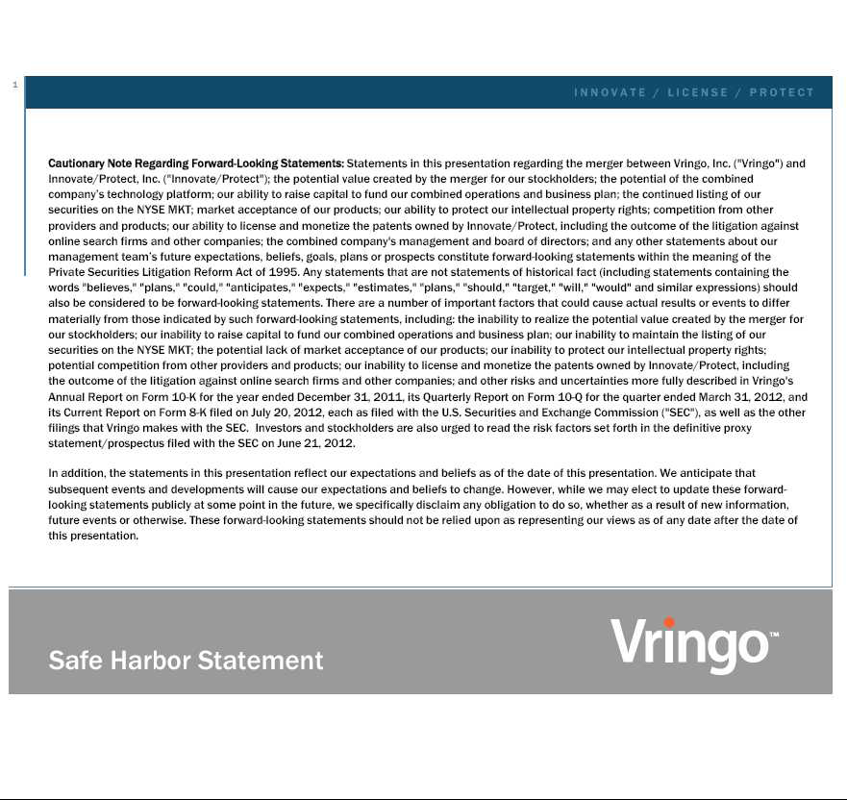











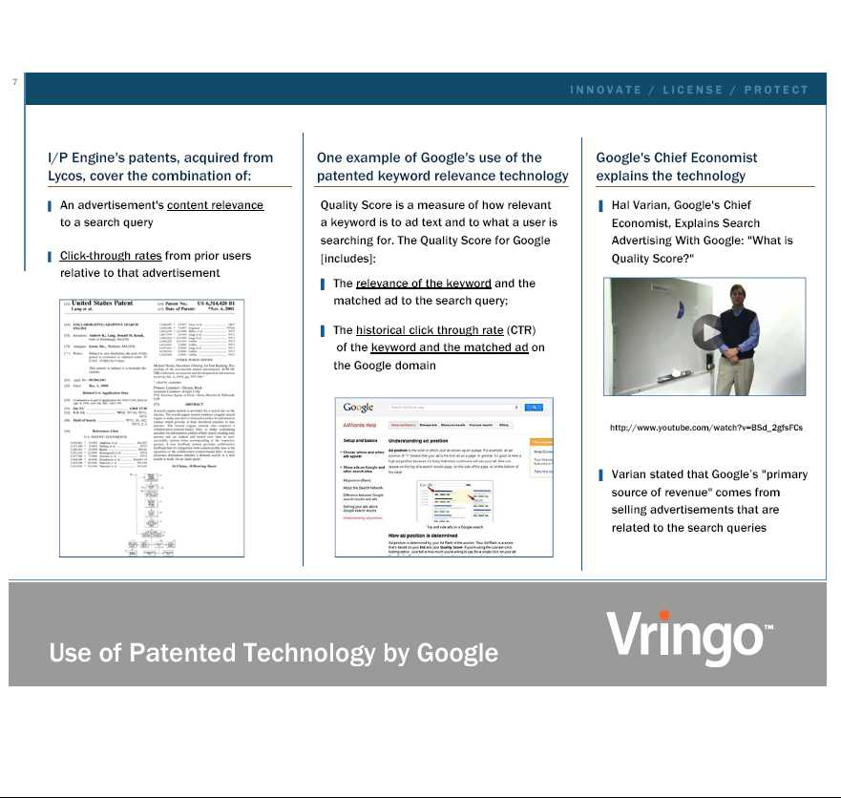

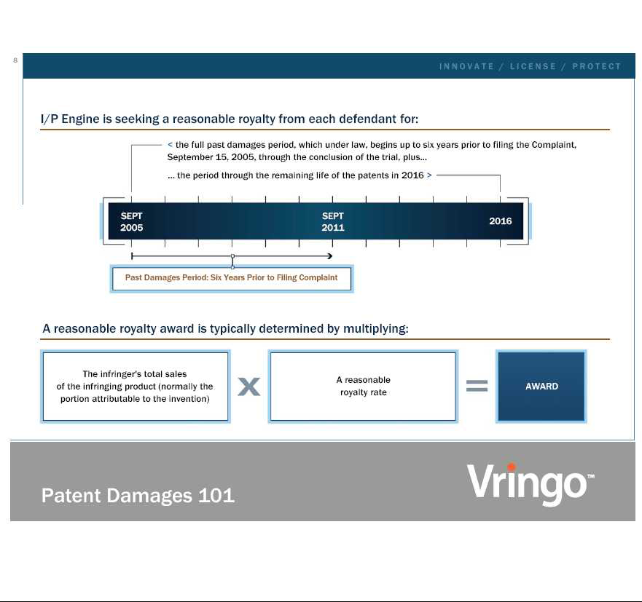

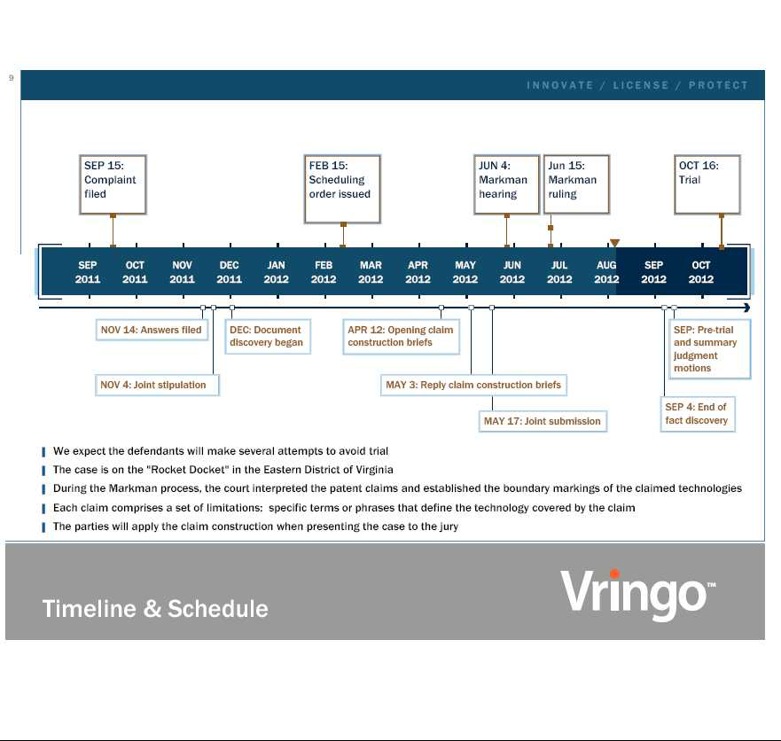





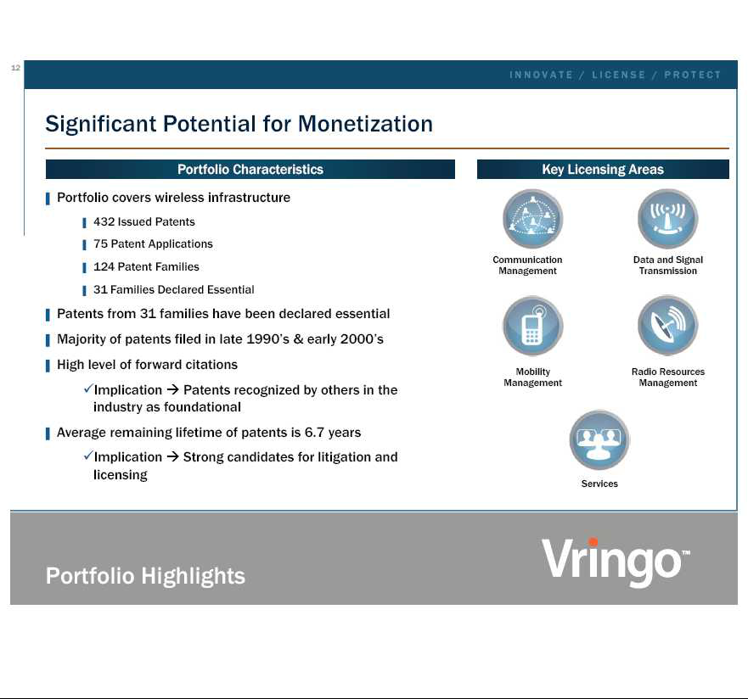

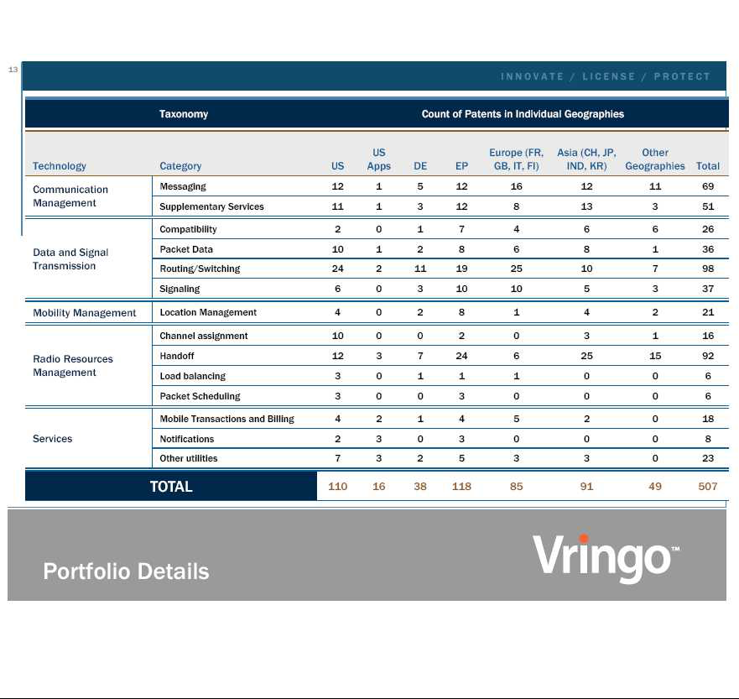

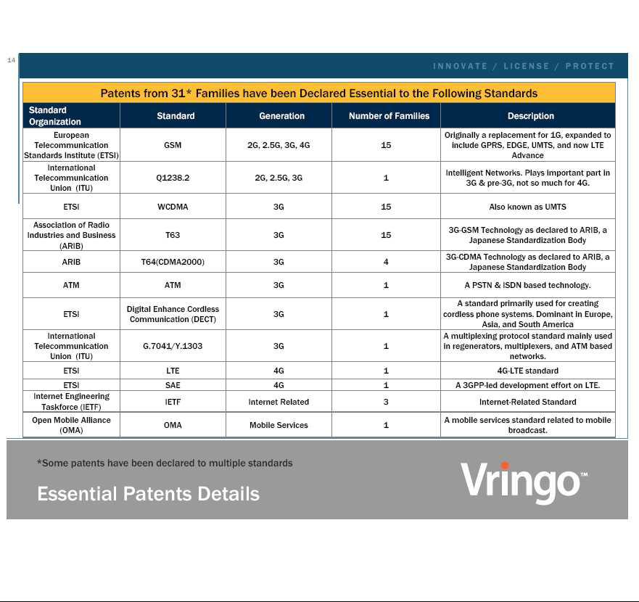

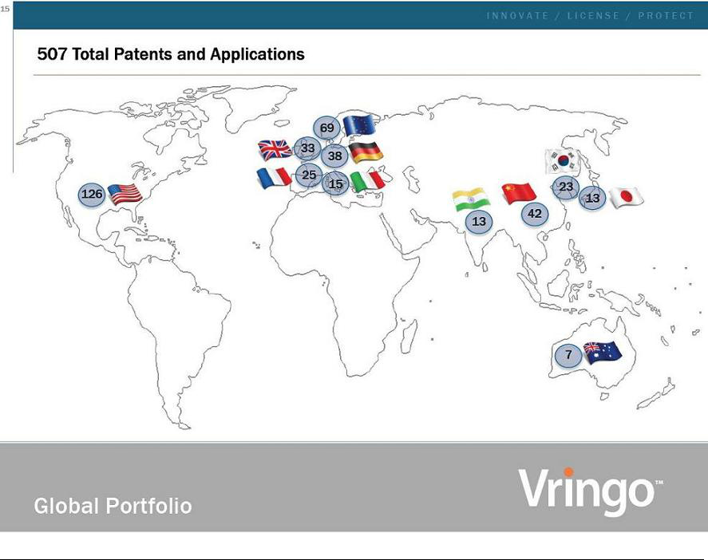

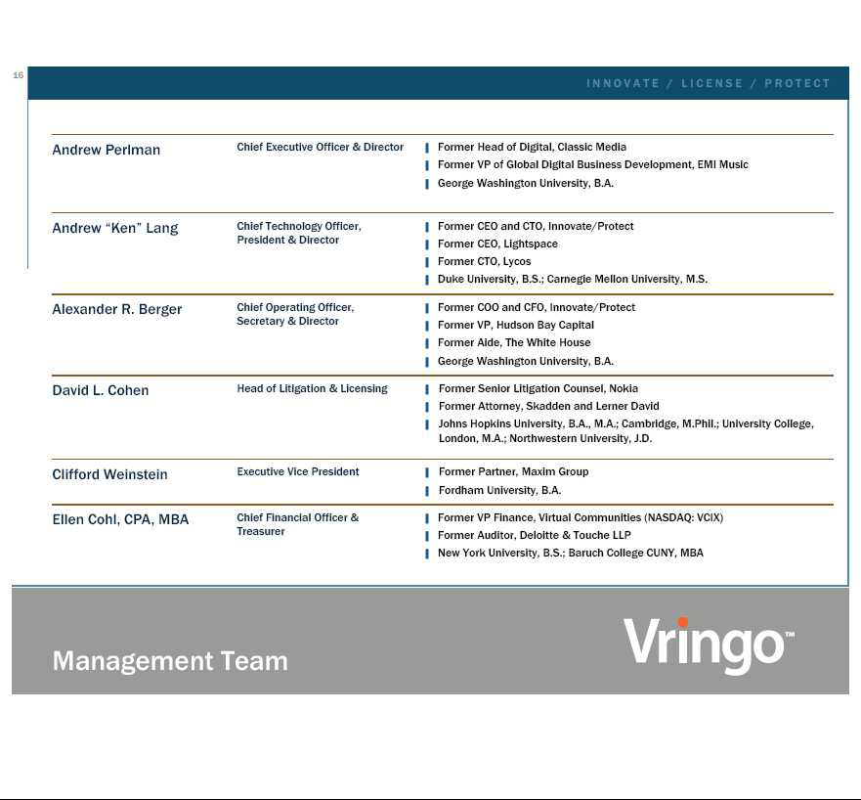

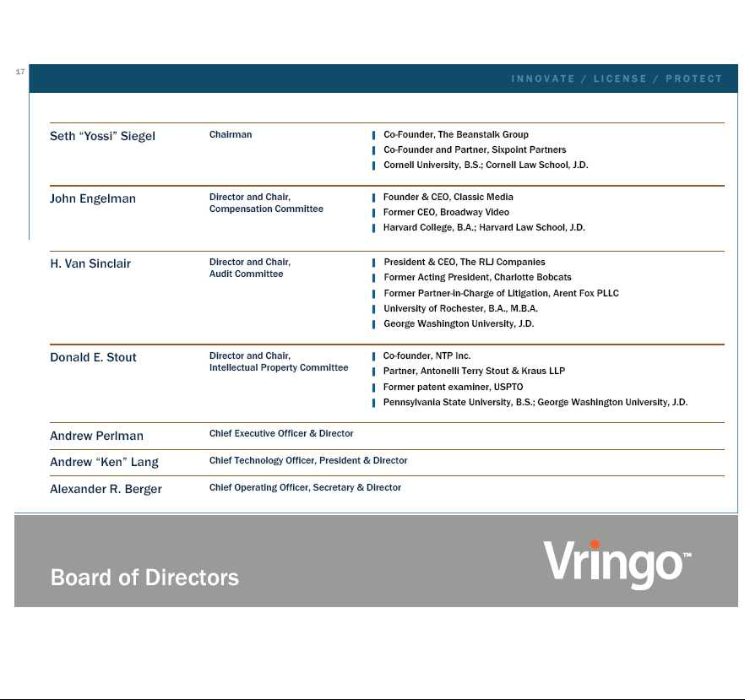

Exhibit 99.3

Vringo and Nokia Execute Patent Purchase Agreement

Vringo to Acquire Over 500 Patents and Applications from Nokia

NEW YORK — August 9, 2012 — Vringo, Inc. (NYSE MKT: VRNG), a company engaged in the innovation, development and monetization of mobile technologies and intellectual property, today announced that it had entered into a Patent Purchase Agreement with Nokia Corporation pursuant to which Nokia agreed to sell Vringo a portfolio consisting of over 500 patents and patent applications worldwide, including 109 issued United States patents. Vringo agreed to compensate Nokia with a cash payment and certain ongoing rights in revenues generated from the patent portfolio.

The portfolio encompasses a broad range of technologies relating to cellular infrastructure, including communication management, data and signal transmission, mobility management, radio resources management and services.

Thirty one of the 124 patent families acquired have been declared essential by Nokia to wireless communications standards. Standards represented in the portfolio are commonly known as 2G, 2.5G, 3G and 4G and related technologies and include GSM, WCDMA, T63, T64, DECT, IETF, LTE, SAE, and OMA.

Further details are included in a Form 8-K to be filed by Vringo with the United States Securities and Exchange Commission.

For more information, visit: www.vringoIP.com.

About Vringo, Inc.

Vringo, Inc. is engaged in the innovation, development and monetization of mobile technologies and intellectual property. Vringo's intellectual property portfolio consists of eleven patents, eight of which were acquired from Lycos, Inc., as well as over twenty patent applications. Vringo operates a global platform for the distribution of mobile social applications and services including Facetones® and Video Ringtones which transforms the basic act of making and receiving mobile phone calls into a highly visual, social experience.

Forward-Looking Statements

This press release includes forward-looking statements, which may be identified by words such as "believes," "expects," "anticipates," "estimates," "projects," "intends," "should," "seeks," "future," "continue," or the negative of such terms, or other comparable terminology. Forward-looking statements are statements that are not historical facts. Such forward-looking statements are subject to risks and uncertainties, which could cause actual results to differ materially from the forward-looking statements contained herein. Factors that could cause actual results to differ materially include, but are not limited to: the inability to realize the potential value created by the merger with Innovate/Protect for our stockholders; our inability to raise additional capital to fund our combined operations and business plan; our inability to monetize and recoup our investment with respect to patent assets that we acquire; our inability to maintain the listing of our securities on the NYSE MKT; the potential lack of market acceptance of our products; our inability to protect our intellectual property rights; potential competition from other providers and products; our inability to license and monetize the patents owned by Innovate/Protect, including the outcome of the litigation against online search firms and other companies; our inability to monetize and recoup our investment with respect to patent assets that we acquire; and other risks and uncertainties and other factors discussed from time to time in our filings with the Securities and Exchange Commission ("SEC"). Investors and stockholders are also urged to read the risk factors set forth in the definitive proxy statement/prospectus filed with the SEC on June 21, 2012. Vringo expressly disclaims any obligation to publicly update any forward-looking statements contained herein, whether as a result of new information, future events or otherwise, except as required by law.

Contacts:

Investors:

Cliff Weinstein

Executive Vice President

Vringo, Inc.

646-532-6777 (o)

cliff@vringo.com

Media:

Caroline L. Platt

The Hodges Partnership

804-788-1414 (o)

804-317-9061 (m)

cplatt@hodgespart.com

Exhibit 99.4

Vringo Announces $31.2 Million Registered Direct Offering of Common Stock

NEW YORK — August 9, 2012 — Vringo, Inc. (NYSE MKT: VRNG), a company engaged in the innovation, development and monetization of mobile technologies and intellectual property, today announced that it has entered into subscription agreements for the sale of 9.6 million shares of its common stock in a registered direct offering at a price of $3.25 per share, for gross proceeds of approximately $31.2 million. Approximately 90% of the shares in the offering were placed with three institutional investors. The shares were offered directly to the investors without a placement agent or underwriter. The sale and issuance of the shares is expected to close on or about August 10, 2012.

Vringo intends to use the proceeds of the offering to acquire a portfolio of intellectual property from Nokia Corporation, to repay all outstanding indebtedness, and for general corporate purposes.

The sale and issuance of the shares is being made pursuant to a prospectus supplement dated August 9, 2012 and an accompanying prospectus dated August 2, 2012, pursuant to Vringo's effective "shelf" registration statement on Form S-3 (File No. 333-182823), which was filed with the Securities and Exchange Commission on July 24, 2012 and was declared effective on August 2, 2012.

This press release shall not constitute an offer to sell or the solicitation of an offer to buy any securities of Vringo, Inc. nor shall there be any sale of securities in any state or jurisdiction in which such an offer, solicitation or sale would be unlawful prior to registration or qualification under the securities laws of any such state or jurisdiction.

About Vringo, Inc.

Vringo, Inc. is engaged in the innovation, development and monetization of mobile technologies and intellectual property. Vringo's intellectual property portfolio consists of eleven patents, eight of which were acquired from Lycos, Inc., as well as over twenty patent applications. Vringo operates a global platform for the distribution of mobile social applications and services including Facetones® and Video Ringtones which transforms the basic act of making and receiving mobile phone calls into a highly visual, social experience. For more information, visit: www.vringoIP.com.

Forward-Looking Statements

This press release includes forward-looking statements, which may be identified by words such as "believes," "expects," "anticipates," "estimates," "projects," "intends," "should," "seeks," "future," "continue," or the negative of such terms, or other comparable terminology. Forward-looking statements are statements that are not historical facts. Such forward-looking statements are subject to risks and uncertainties, which could cause actual results to differ materially from the forward-looking statements contained herein. Factors that could cause actual results to differ materially include, but are not limited to: the inability to realize the potential value created by the merger with Innovate/Protect for our stockholders; our inability to raise additional capital to fund our combined operations and business plan; our inability to monetize and recoup our investment with respect to patent assets that we acquire; our inability to maintain the listing of our securities on the NYSE MKT; the potential lack of market acceptance of our products; our inability to protect our intellectual property rights; potential competition from other providers and products; our inability to license and monetize the patents owned by Innovate/Protect, including the outcome of the litigation against online search firms and other companies; our inability to monetize and recoup our investment with respect to patent assets that we acquire; and other risks and uncertainties and other factors discussed from time to time in our filings with the Securities and Exchange Commission ("SEC"). Investors and stockholders are also urged to read the risk factors set forth in the definitive proxy statement/prospectus filed with the SEC on June 21, 2012. Vringo expressly disclaims any obligation to publicly update any forward-looking statements contained herein, whether as a result of new information, future events or otherwise, except as required by law.

Contacts:

Investors:

Cliff Weinstein

Executive Vice President

Vringo, Inc.

646-532-6777 (o)

cliff@vringo.com

Media:

Caroline L. Platt

The Hodges Partnership

804-788-1414 (o)

804-317-9061 (m)

cplatt@hodgespart.com

