UNITED STATES

SECURITIES AND EXCHANGE COMMISSION

Washington, D.C. 20549

FORM 8-K

Current Report

Pursuant to Section 13 or 15(d) of the

Securities Exchange Act of 1934

Date of Report (Date of earliest event reported): October 5, 2012

VRINGO, INC.

(Exact Name of Registrant as Specified in its Charter)

Delaware | 001-34785 | 20-4988129
(State or other jurisdiction | (Commission | (I.R.S. Employer
of incorporation) | File Number) | Identification No.)
 | 780 Third Avenue, 15th Floor, New York, NY 10017
 | (Address of Principal Executive Offices and Zip Code)
 | Registrant’s telephone number, including area code: (212) 309-7549

Check the appropriate box below if the Form 8-K filing is intended to simultaneously satisfy the filing obligation of the registrant under any of the following provisions:

- Written communications pursuant to Rule 425 under the Securities Act (17 CFR 230.425)

- Soliciting material pursuant to Rule 14a-12 under the Exchange Act (17 CFR 240.14a-12)

- Pre-commencement communications pursuant to Rule 14d-2(b) under the Exchange Act (17 CFR 240.14d-2(b))

- Pre-commencement communications pursuant to Rule 13e-4(c) under the Exchange Act (17 CFR 240.13e-4(c))

Item 8.01 Other Events.

On October 5, 2012, Vringo Infrastructure, Inc., a wholly-owned subsidiary of Vringo, Inc. (“Vringo”), filed a patent infringement lawsuit against ZTE (UK) Limited (“ZTE”), a United Kingdom subsidiary of ZTE Corporation, in the United Kingdom High Court of Justice, Chancery Division, Patents Court. Vringo Infrastructure is seeking a declaration that its European Patents (UK) 1,212,919; 1,166,589; and 1,808,029 have been infringed by ZTE’s activities and that the court use its full legal, equitable and injunctive power to stop ZTE’s activities as may be appropriate in the circumstances.

A copy of the patent infringement claim against ZTE is attached hereto as Exhibit 99.1 and is incorporated herein by reference.

On October 8, 2012, Vringo issued a press release regarding Vringo Infrastructure’s filing of its patent infringement lawsuit against ZTE. A copy of the press release is attached hereto as Exhibit 99.2 and is incorporated herein by reference.

Item 9.01 Financial Statements and Exhibits.

(d) Exhibits.
Exhibit Number |  |  | Description of Exhibits
 | 99.1 |  | Vringo Infrastructure, Inc. Patent Infringement Claim against ZTE (UK) Limited
99.2 |  | Press Release, dated October 8, 2012

SIGNATURES

Pursuant to the requirements of the Securities Exchange Act of 1934, the registrant has duly caused this report to be signed on its behalf by the undersigned hereunto duly authorized.

 | VRINGO, INC.
Dated: October 10, 2012 | By: | /s/ Andrew D. Perlman
 |  | Name: | Andrew D. Perlman
 |  | Title: | Chief Executive Officer

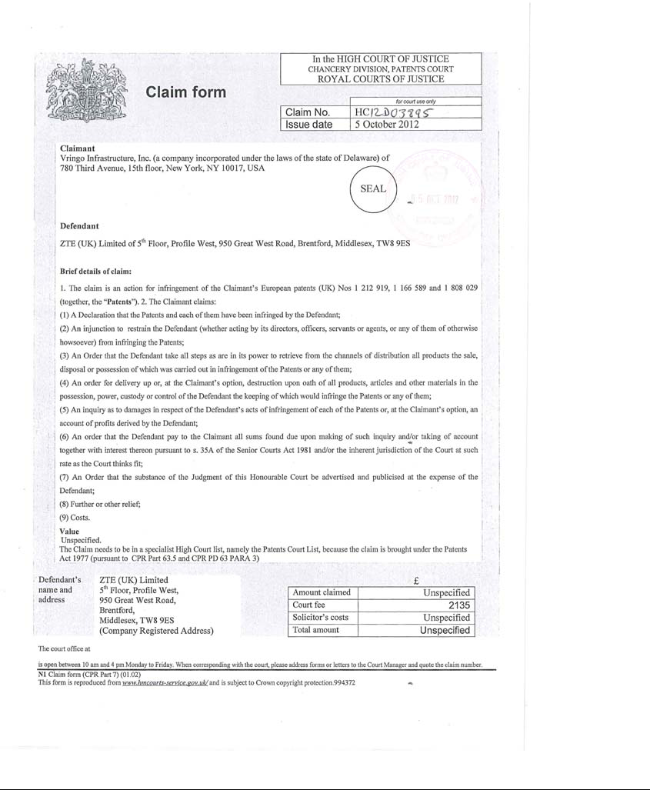

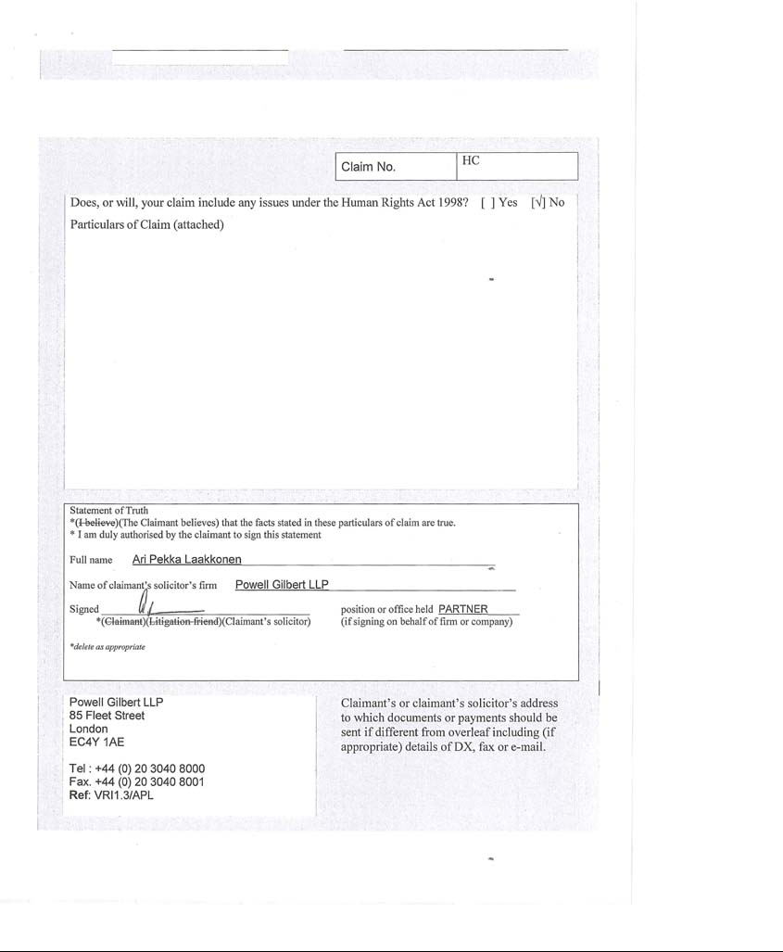

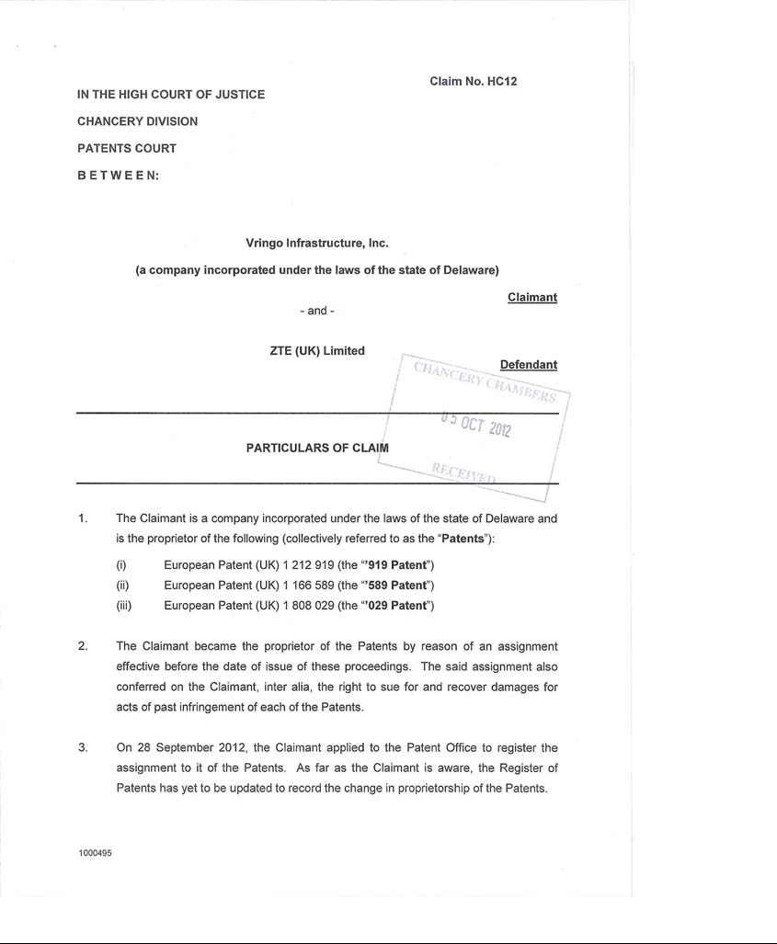

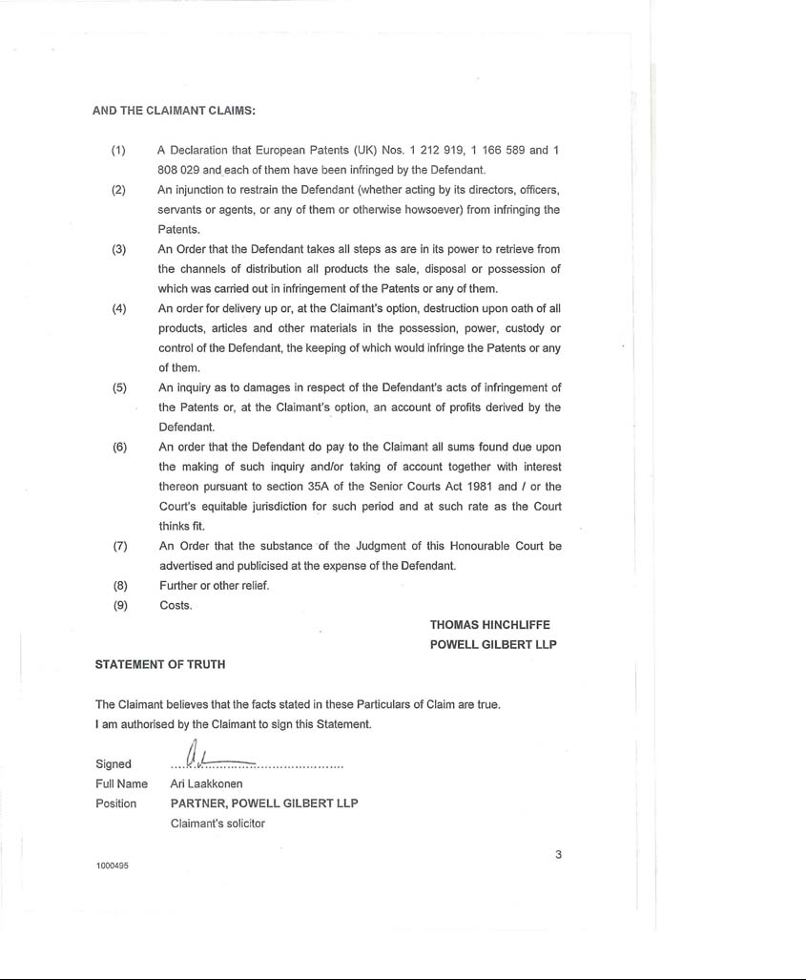

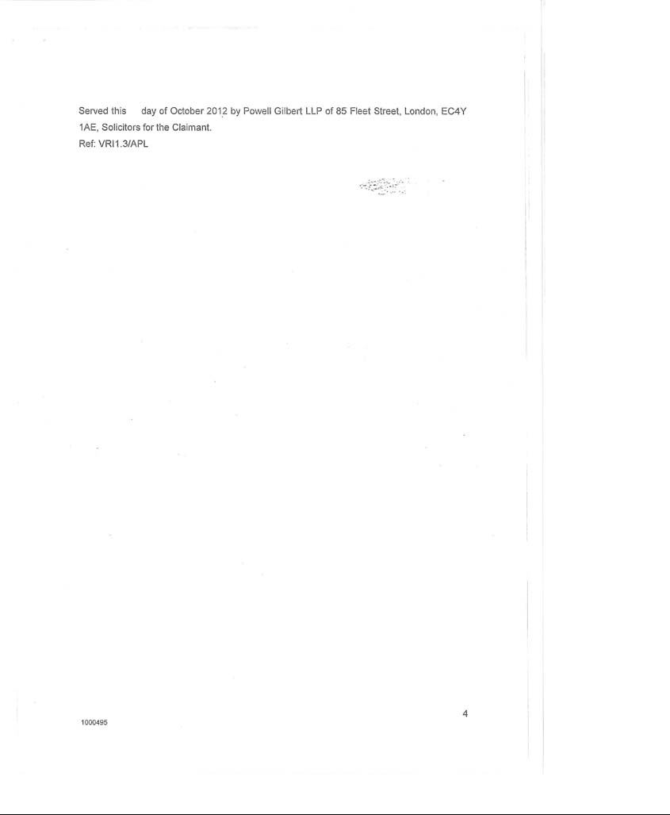

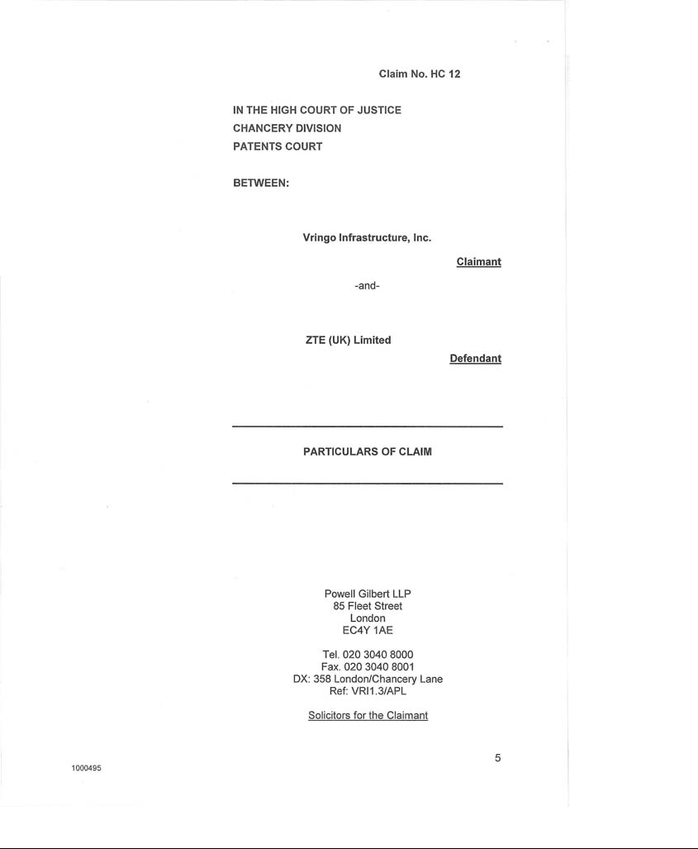

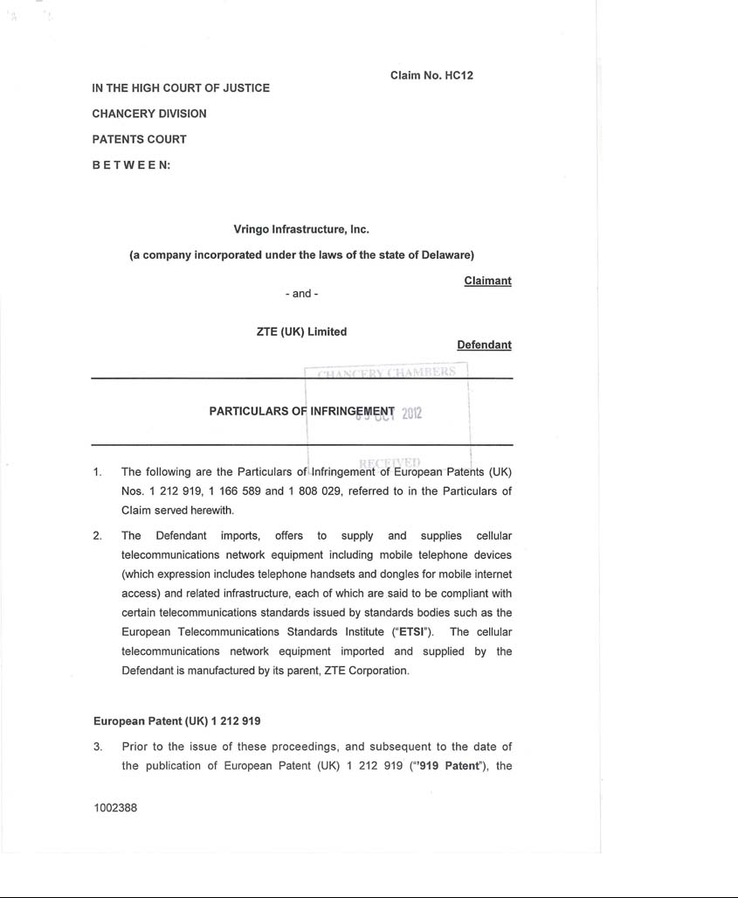

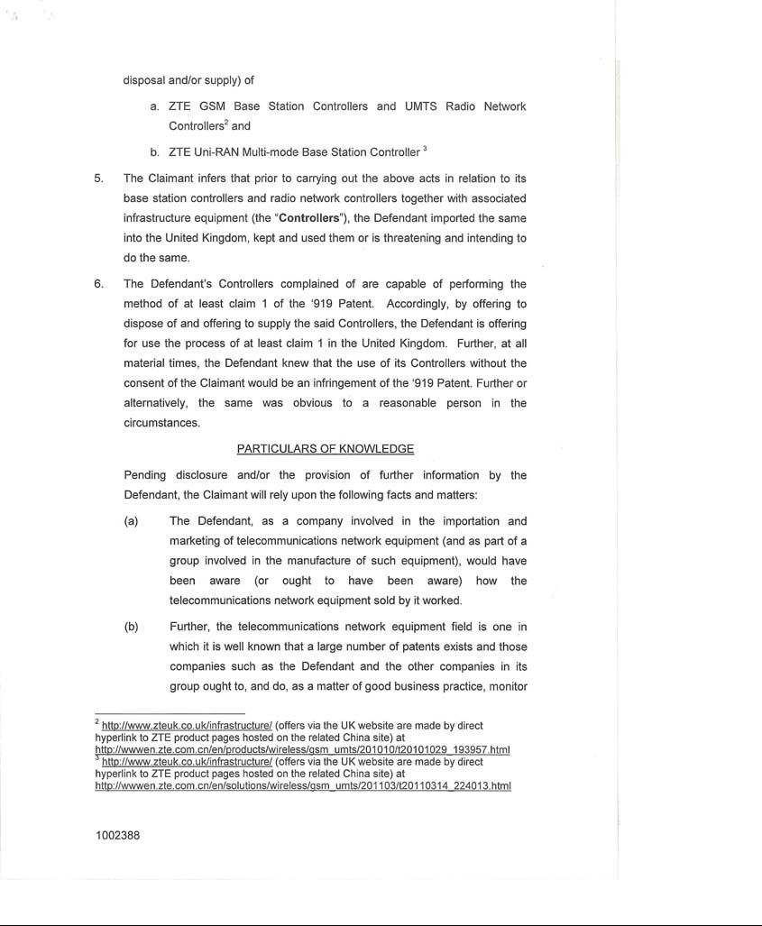

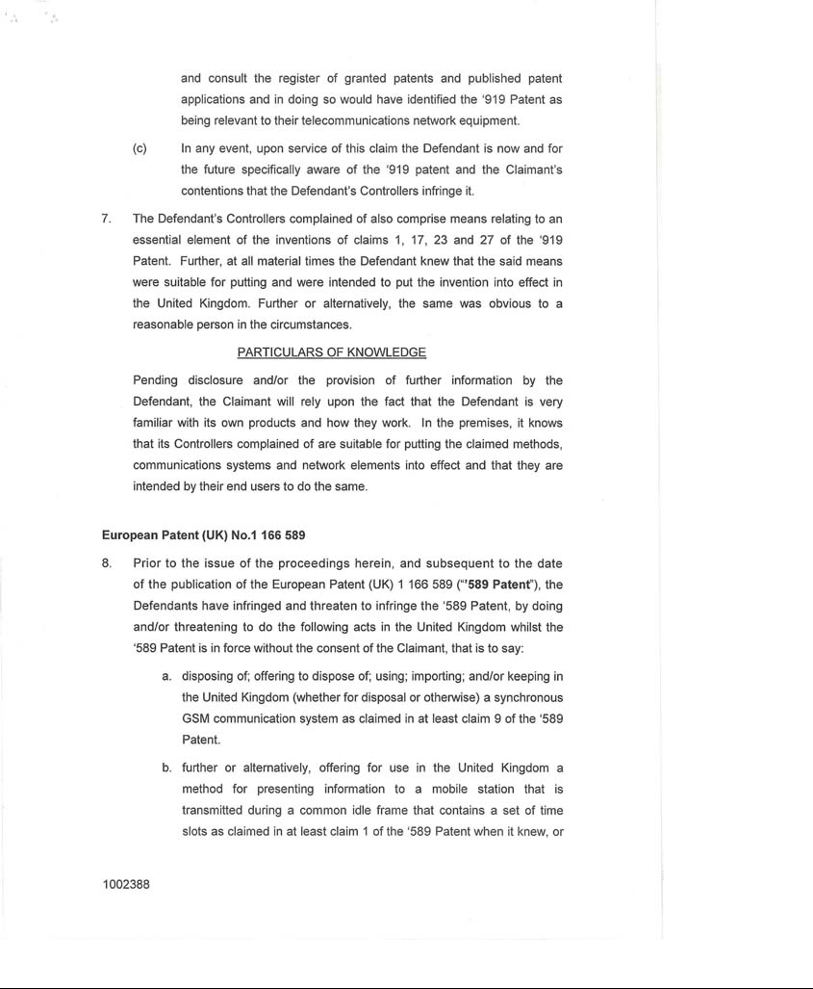

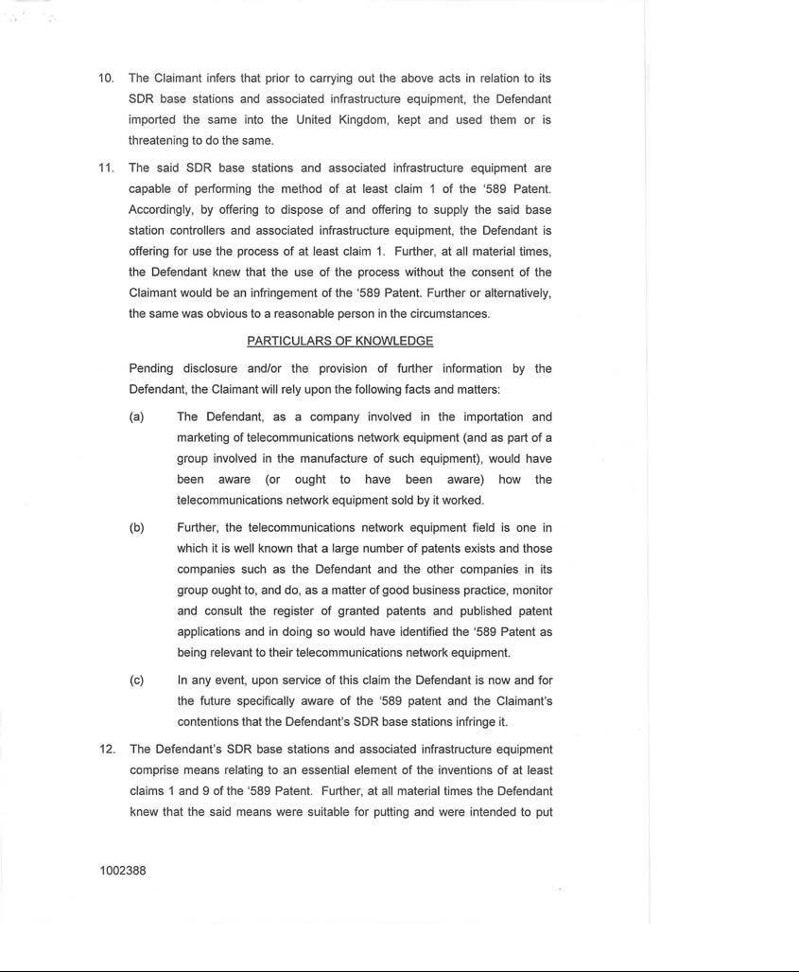

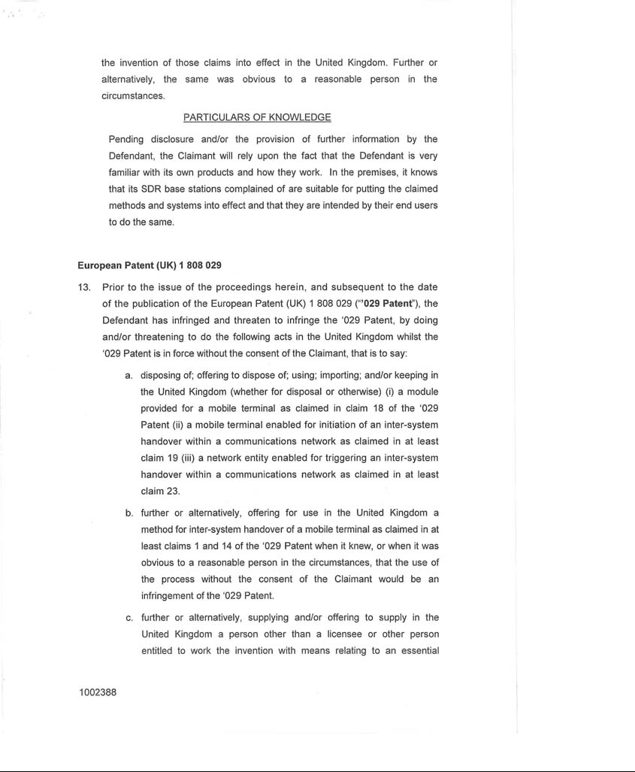

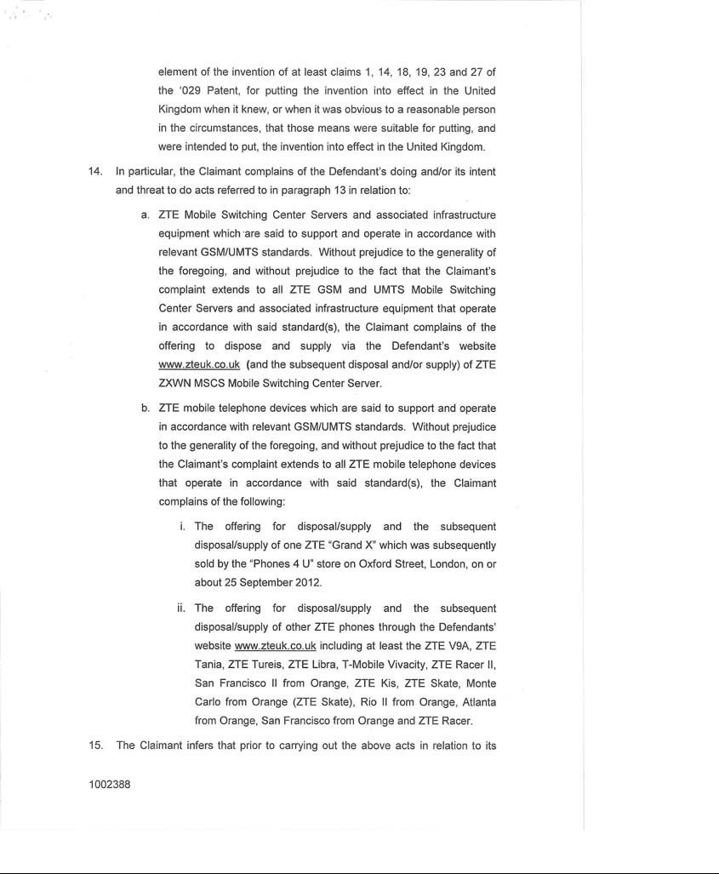

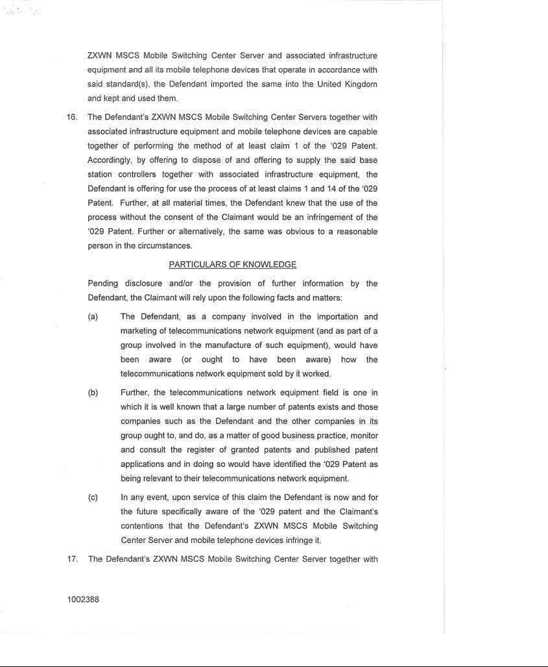

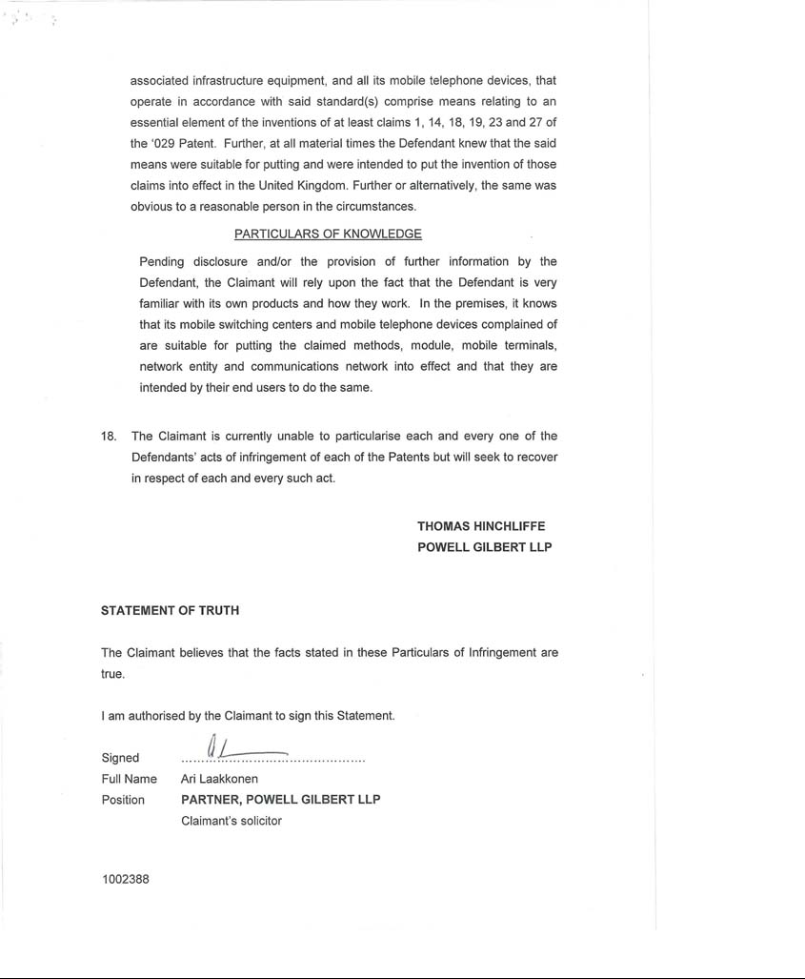

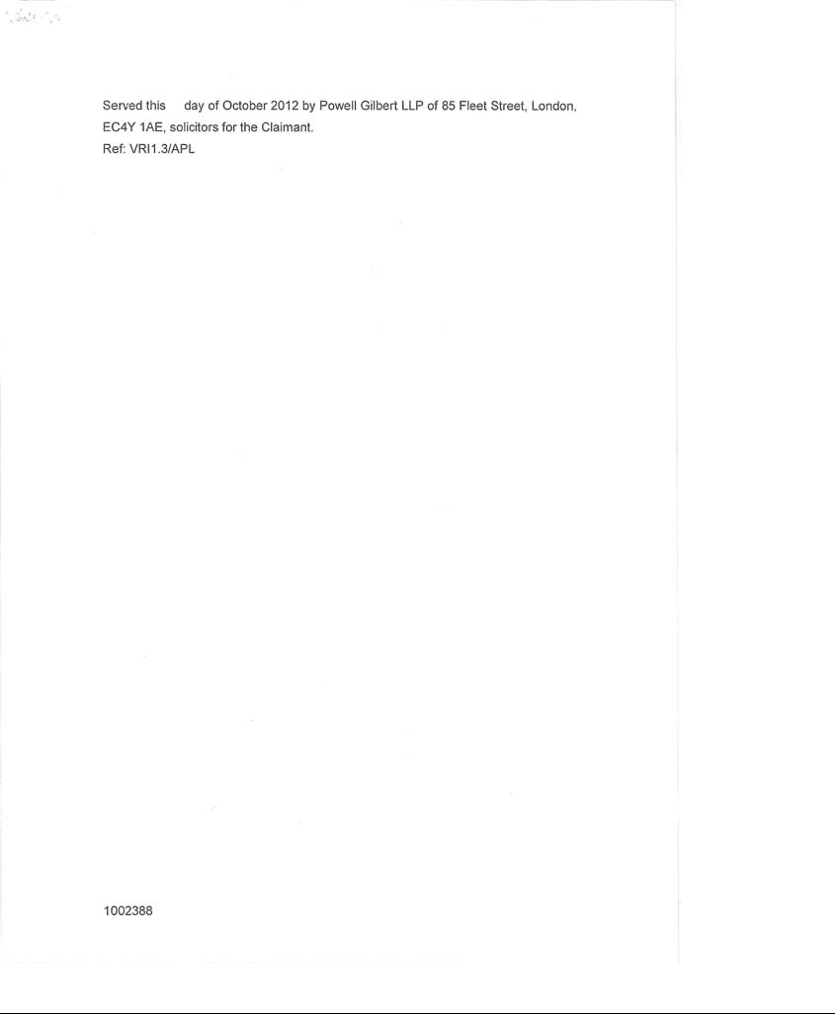

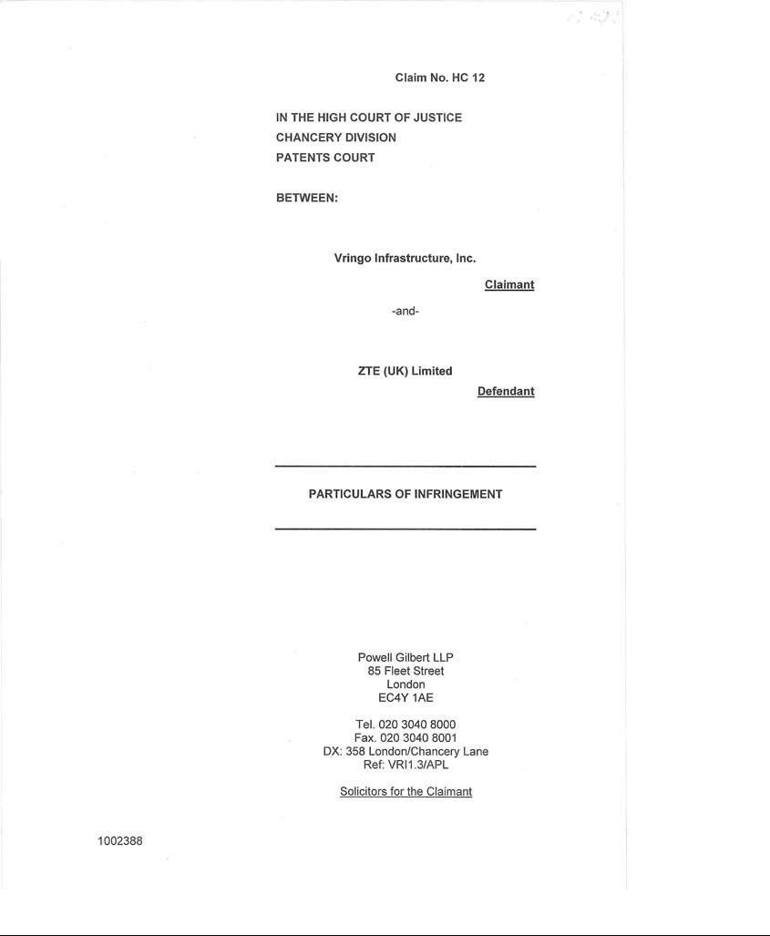


News Release

Vringo Files Lawsuit against ZTE

Vringo Alleges Infringement over Handsets, Base Stations and Base Station Controllers

NEW YORK—(BUSINESS WIRE)—Oct. 8, 2012— Vringo, Inc. (NYSE MKT: VRNG), a company engaged in the innovation, development and monetization of mobile technologies and intellectual property, today announced that its wholly-owned subsidiary, Vringo Infrastructure, Inc., filed a patent infringement lawsuit against the UK subsidiary of ZTE Corporation (ZTE). ZTE describes itself as "a leading global provider of telecommunications equipment and network solutions," with recently reported annual revenue of US $13.7 billion (RMB 86.254 billion), according to filings with the Hong Kong Stock Exchange. According to ZTE's public filings, the company generates its revenue primarily from the sale of telecommunications equipment and handsets.

"The filing of this action in the United Kingdom is an initial step in Vringo's global licensing and enforcement program in the telecommunications sector. ZTE has elected not to take a license to patents in Vringo's portfolio relevant to certain international standards, despite manufacturing and selling devices and equipment for a number of years that are said by ZTE to be compliant with those standards," said David L. Cohen, Head of Licensing, Litigation, and Intellectual Property at Vringo. "We believe that ZTE is aware that it requires licenses to all patents that are essential to relevant standards. Further, we believe that ZTE is familiar with systems for declaring patents to standards-setting organizations and the relevant intellectual property rights policies for those organizations, having itself declared hundreds of patents to international standards."

The lawsuit, filed in the UK High Court of Justice, Chancery Division, Patents Court, alleges infringement of European Patents (UK) 1,212,919; 1,166,589; and 1,808,029. Declarations have been filed at the European Telecommunications and Standards Institute (ETSI) that cover the patents. ZTE's cellular network elements fall within the scope of all three patents, and ZTE's GSM/UMTS multi-mode wireless handsets also fall within the scope of the '029 patent.

According to the complaint, Vringo is seeking a declaration that its patents have been infringed by ZTE's activities and that the court use its full legal, equitable and injunctive power to stop ZTE's activities as may be appropriate in the circumstances.

"ZTE's liability will continue to increase as long as the issue remains unresolved. We hope that ZTE will work with us to resolve this matter in a positive and productive manner," said Alexander R. Berger, Chief Operating Officer at Vringo.

A copy of Vringo's complaint is available at www.vringoinc.com, and Vringo's earlier correspondence to ZTE is available at http://1.usa.gov/OLWhDT.

About Vringo, Inc.

Vringo, Inc. is engaged in the innovation, development and monetization of mobile technologies and intellectual property. Vringo's intellectual property portfolio consists of over 500 patents and patent applications covering telecom infrastructure, internet search, and mobile technologies. The patents and patent applications have been developed internally, and acquired from third parties. Vringo operates a global platform for the distribution of mobile social applications and services including Facetones® and Video Ringtones which transform the basic act of making and receiving mobile phone calls into a highly visual, social experience. For more information, visit: www.vringoIP.com.

Forward-Looking Statements

This press release includes forward-looking statements, which may be identified by words such as "believes," "expects," "anticipates," "estimates," "projects," "intends," "should," "seeks," "future," "continue," or the negative of such terms, or other comparable terminology. Forward-looking statements are statements that are not historical facts. Such forward-looking statements are subject to risks and uncertainties, which could cause actual results to differ materially from the forward-looking statements contained herein. Factors that could cause actual results to differ materially include, but are not limited to: the inability to realize the potential value created by the merger with Innovate/Protect for our stockholders; our inability to raise additional capital to fund our combined operations and business plan; our inability to monetize and recoup our investment with respect to patent assets that we acquire; our inability to maintain the listing of our securities on the NYSE MKT; the potential lack of market acceptance of our products; our inability to protect our intellectual property rights; potential competition from other providers and products; our inability to license and monetize the patents owned by Innovate/Protect, including the outcome of the litigation against online search firms and other companies; our inability to monetize and recoup our investment with respect to patent assets that we acquire; and other risks and uncertainties and other factors discussed from time to time in our filings with the Securities and Exchange Commission ("SEC"), including our quarterly report on Form 10-Q filed with the SEC on August 14, 2012. Vringo expressly disclaims any obligation to publicly update any forward-looking statements contained herein, whether as a result of new information, future events or otherwise, except as required by law.

Source: Vringo, Inc.

Investors:

Vringo, Inc.

Cliff Weinstein

Executive Vice President

646-532-6777 (o)

cliff@vringo.com

or

Media:

The Hodges Partnership

Caroline L. Platt

804-788-1414 (o)

804-317-9061 (m)

cplatt@hodgespart.com

