UNITED STATES

SECURITIES AND EXCHANGE COMMISSION

Washington, D.C. 20549

FORM 8-K

CURRENT REPORT

Pursuant to Section 13 or Section 15(d) of the Securities Exchange Act of 1934

Date of Report (Date of earliest event reported): September 12, 2011 (September 7, 2011)

VRINGO, INC.

(Exact name of registrant as specified in its charter)

Delaware

(State or other jurisdiction

of incorporation)

1-34785

(Commission

File Number)

20-4988129

(IRS Employer

Identification No.)

44 W. 28th Street

New York, New York

(Address of principal executive offices)

10001

(Zip Code)

Registrant’s telephone number, including area code: (646) 525-4319

18 East 16th Street, 7th Floor

New York, New York 10003

(Former name or former address, if changed since last report)

Check the appropriate box below if the Form 8-K filing is intended to simultaneously satisfy the filing obligation to the registrant under any of the following provisions:

- Written communications pursuant to Rule 425 under the Securities Act (17 CFR 230.425)

- Soliciting material pursuant to Rule 14a-12 under the Exchange Act (17 CFR 240.14a-12)

- Pre-commencement communications pursuant to Rule 14d-2(b) under the Exchange Act (17 CFR 240.14d-2(b))

- Pre-commencement communications pursuant to Rule 13e-4(c) under the Exchange Act (17 CFR 240.13e-4(c))

Item 7.01 Regulation FD Disclosure.

On September 7, 2011, Vringo, Inc. (the “Company”) issued a press release announcing that it will be presenting at the Rodman & Renshaw Annual Global Investment Conference in New York City on September 13, 2011. The presentation to be used at the conference is furnished herewith as Exhibit 99.1 and a copy of the press release is furnished herewith as Exhibit 99.2, both of which are incorporated herein by reference.

The information contained in this Current Report on Form 8-K, including the exhibits hereto, shall not be deemed “filed” for purposes of Section 18 of the Securities Exchange Act of 1934, as amended, and shall not be incorporated by reference into any filings under the Securities Act of 1933, as amended, or the Securities Exchange Act of 1934, as amended, except to the extent the Company specifically incorporates the information by reference.

Item 9.01. Financial Statements and Exhibits.

- Exhibits

99.1 Presentation Materials for the Rodman & Renshaw Annual Global Investment Conference

99.2 Press Release, dated September 7, 2011

SIGNATURE

Pursuant to the requirements of the Securities Exchange Act of 1934, the registrant has duly caused this report to be signed on its behalf by the undersigned hereunto duly authorized.

Dated: September 12, 2011

VRINGO, INC.

By: /s/ Ellen Cohl

Name: Ellen Cohl

Title: Chief Financial Officer

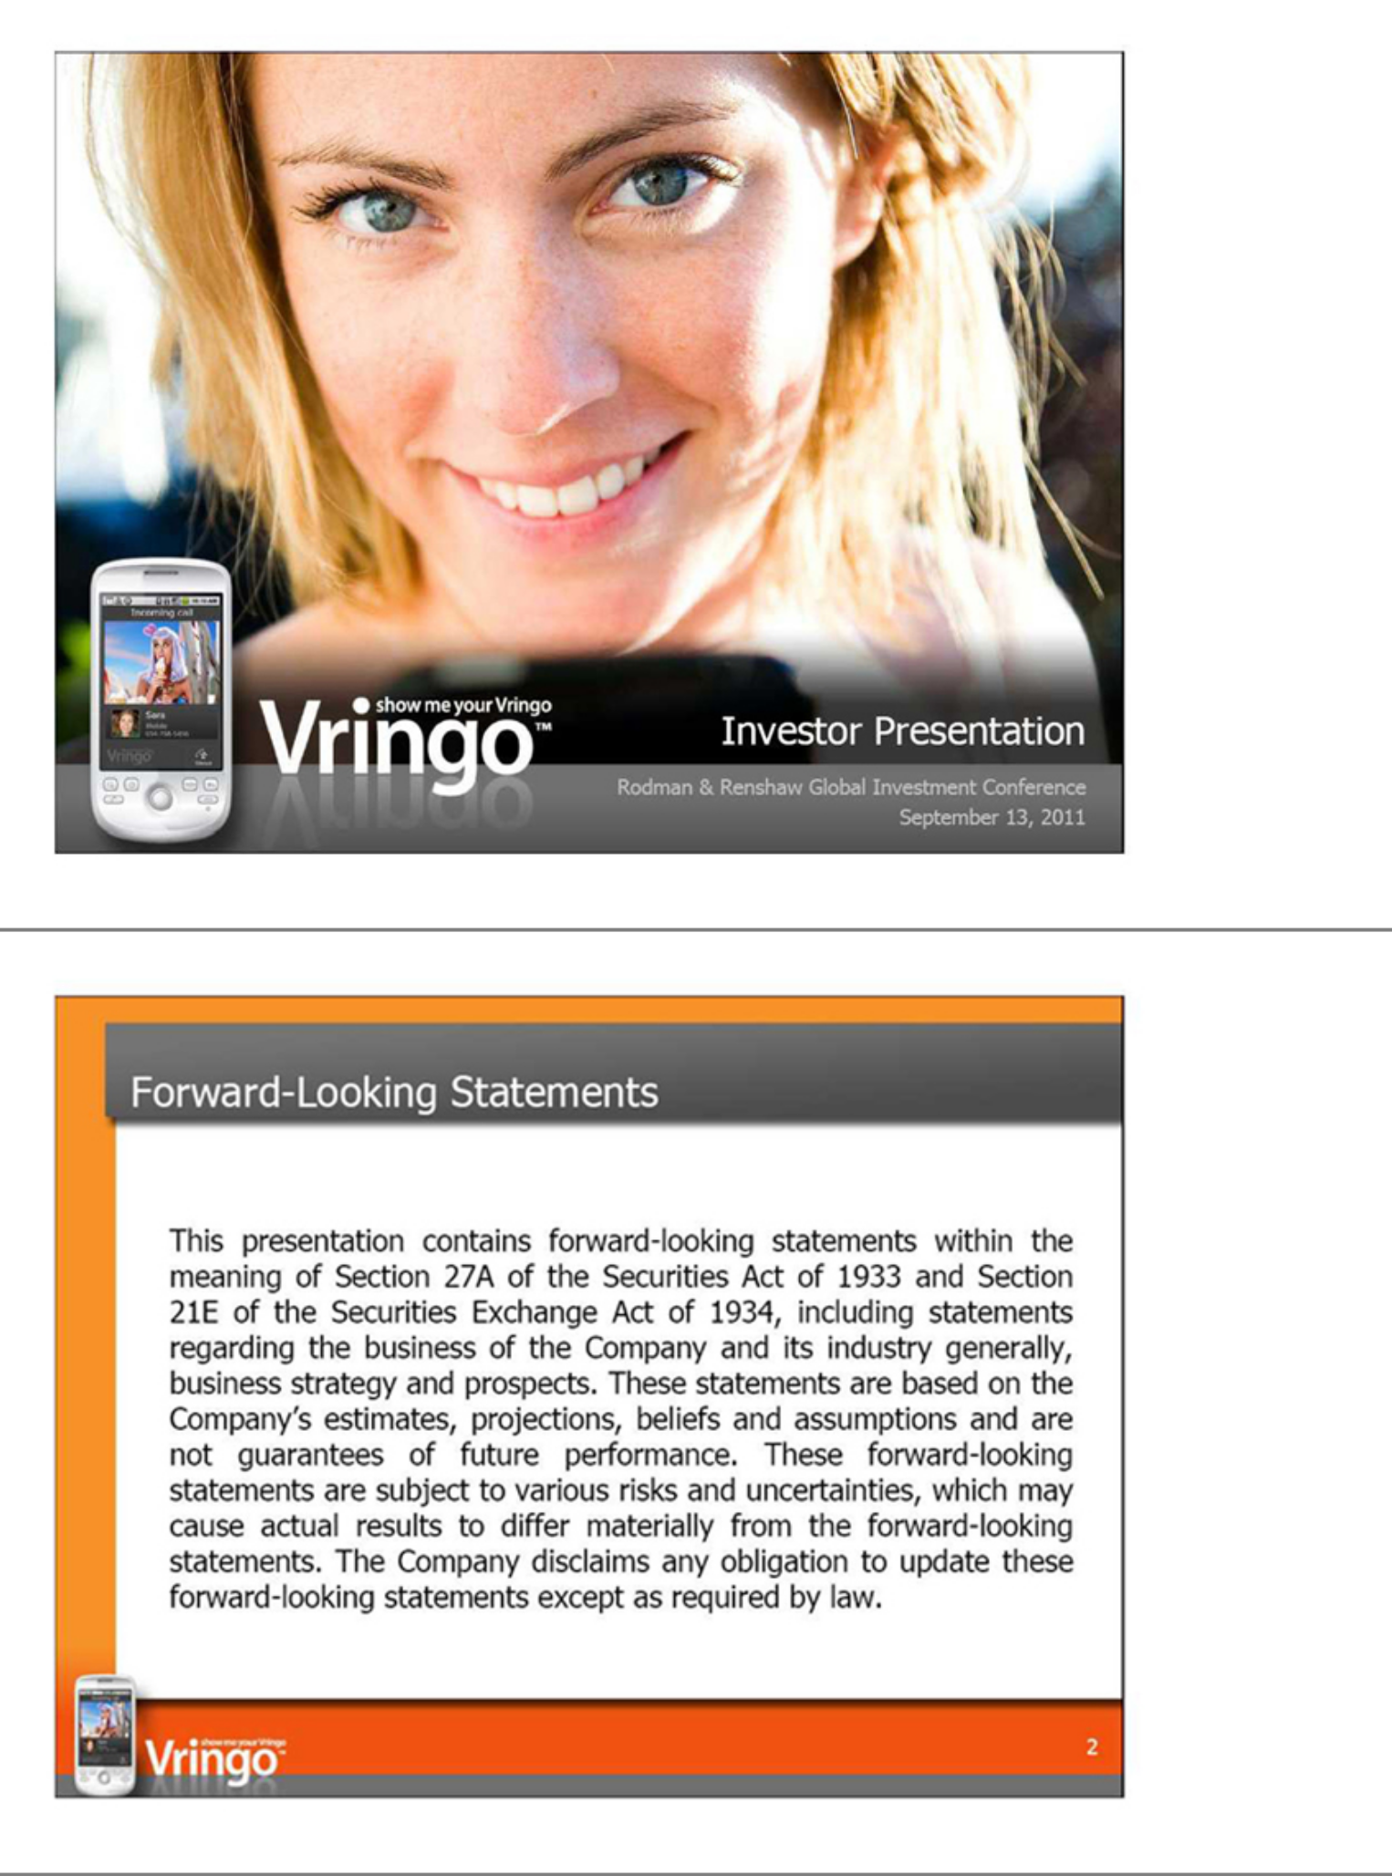

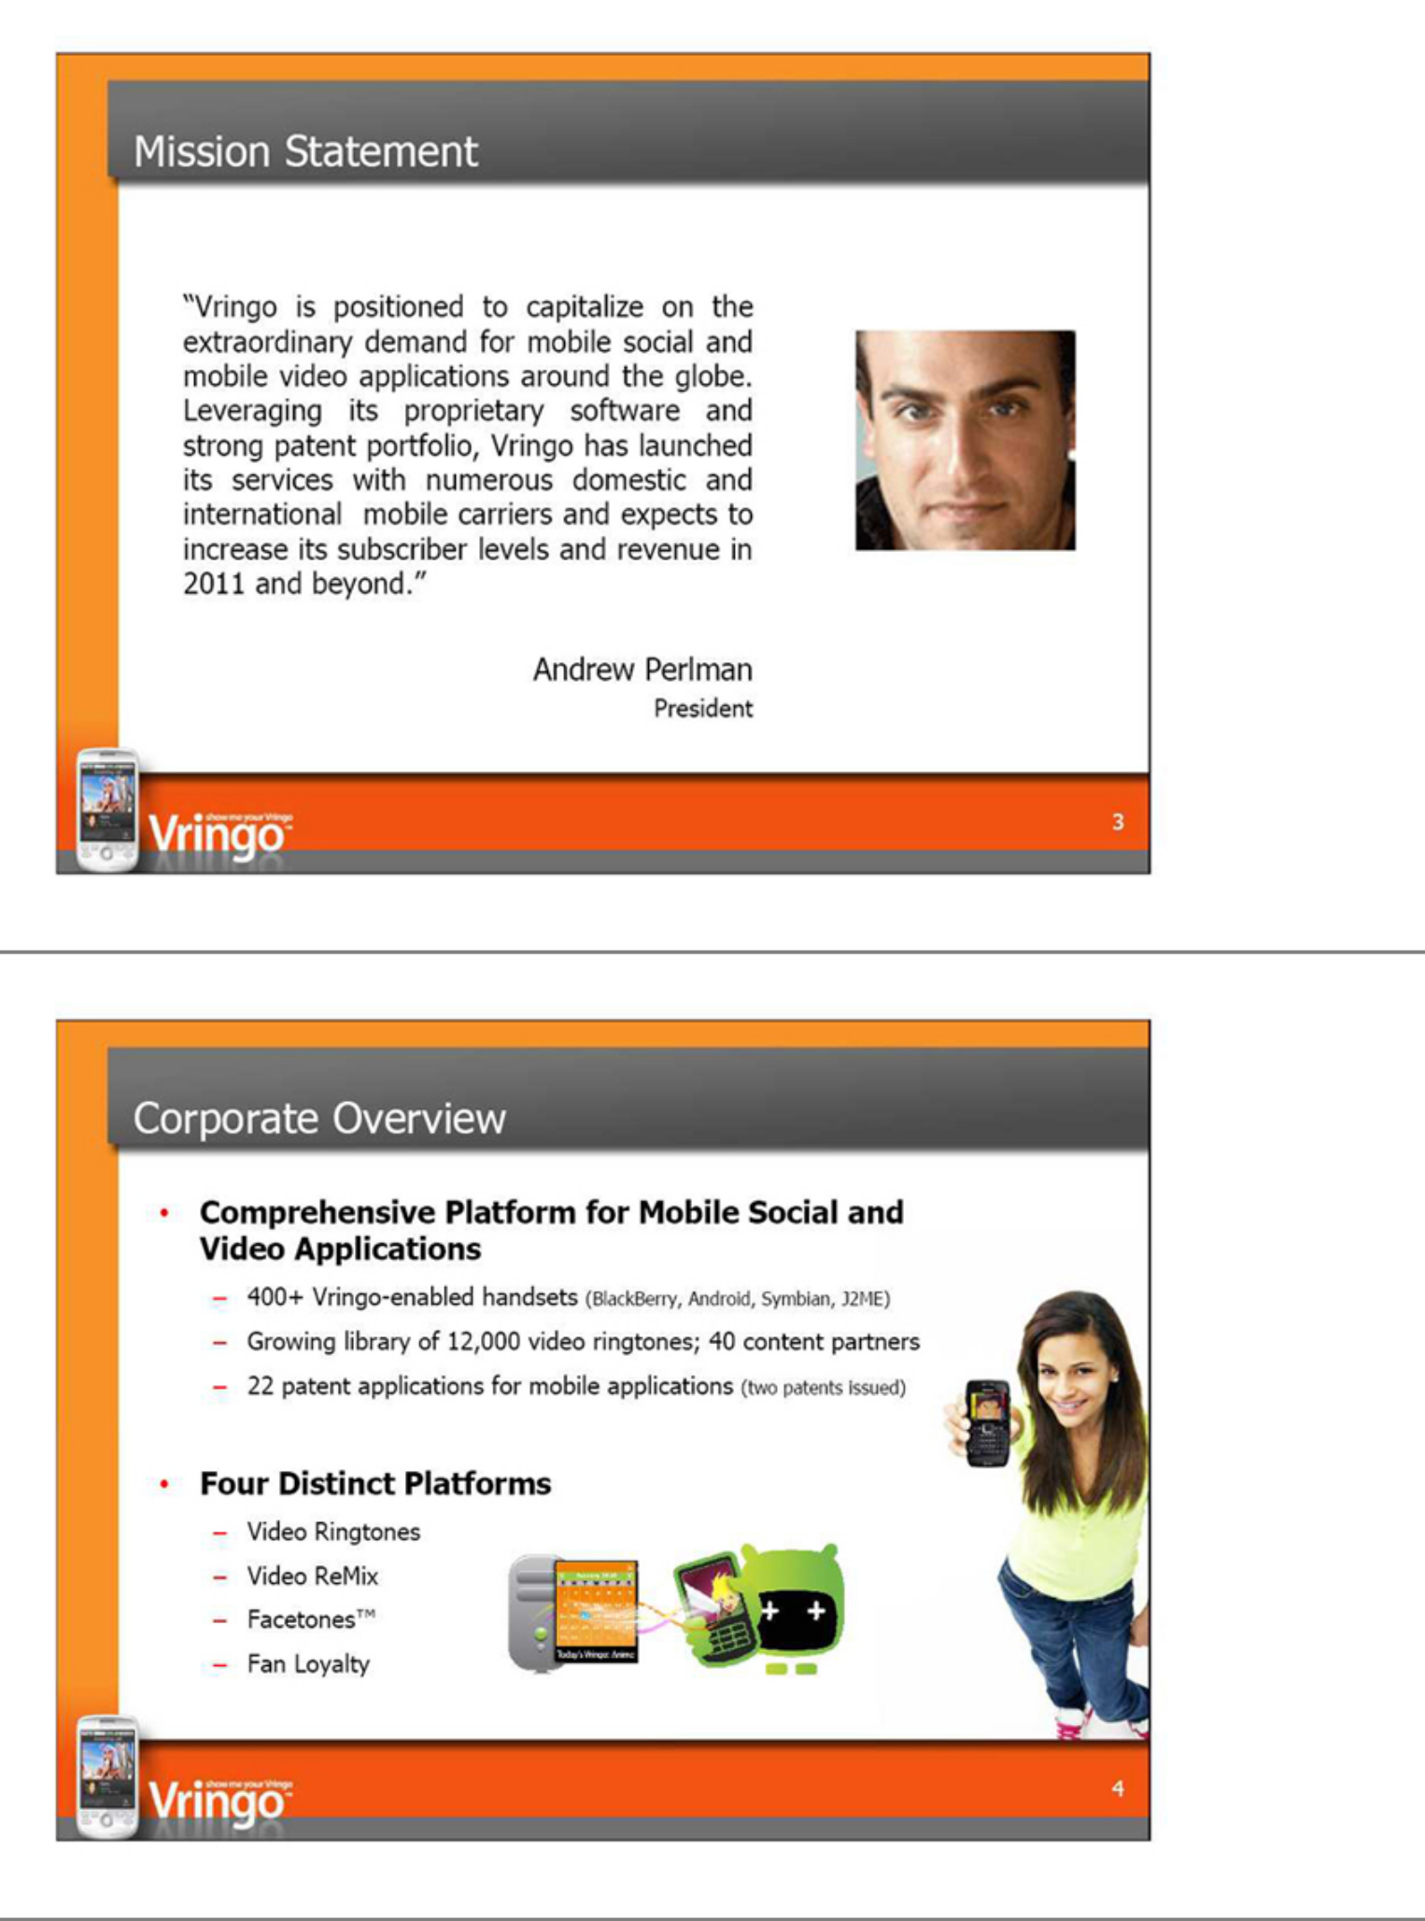

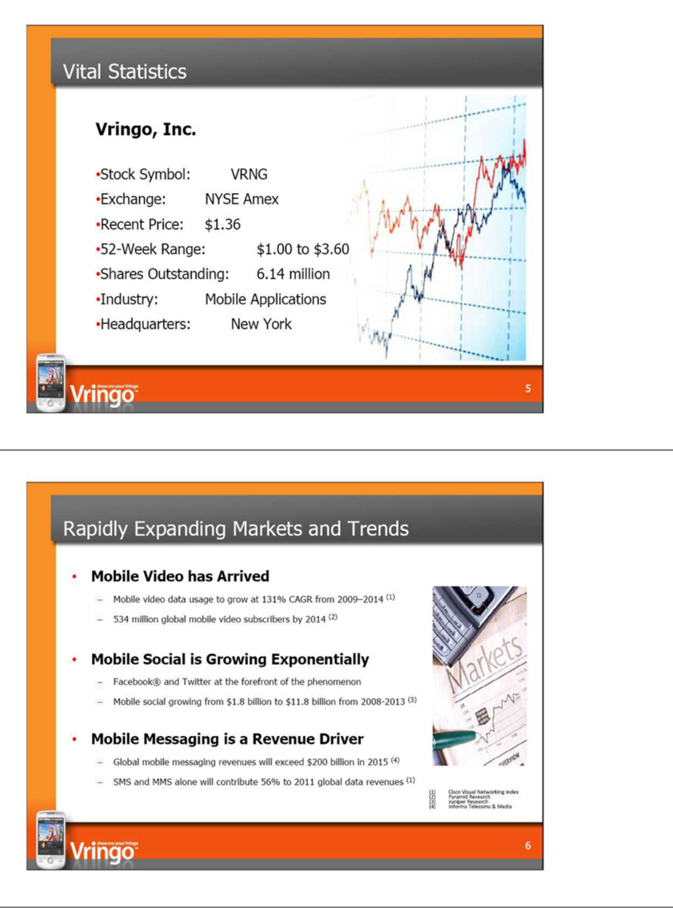

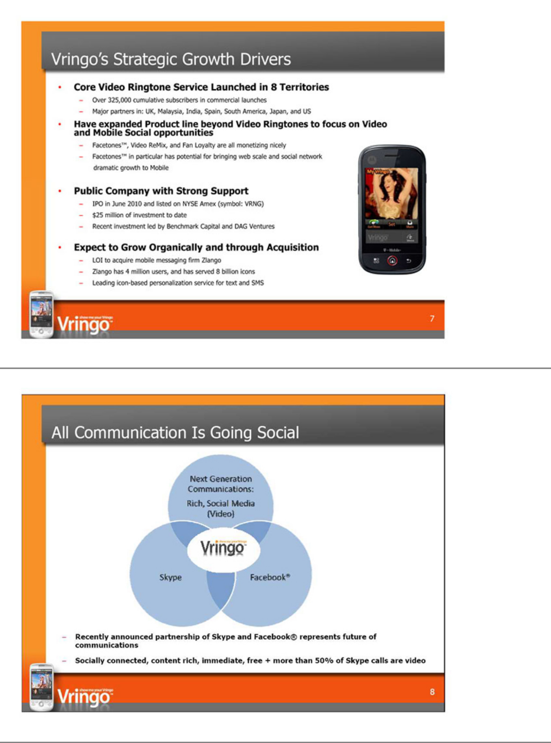

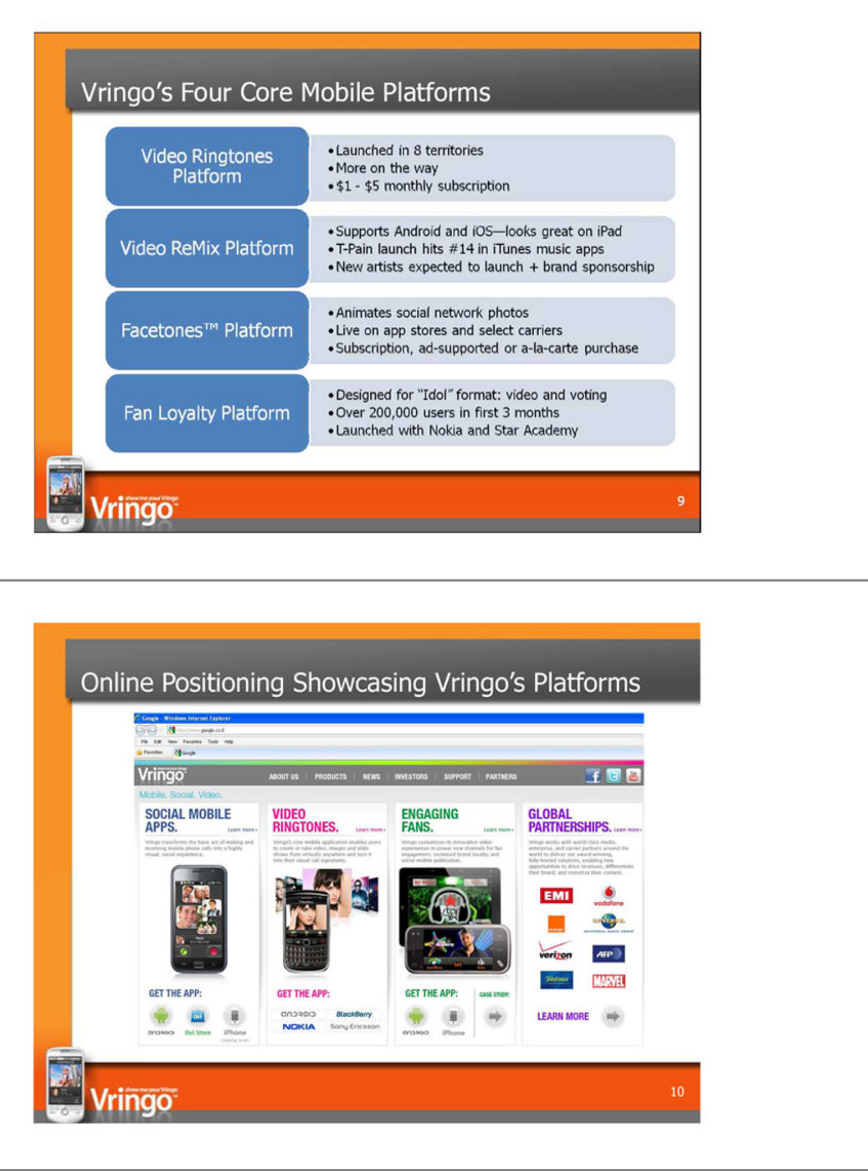

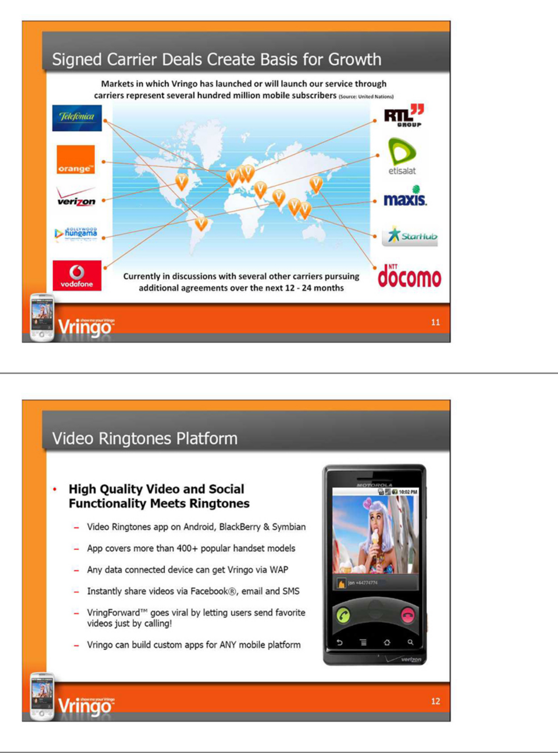

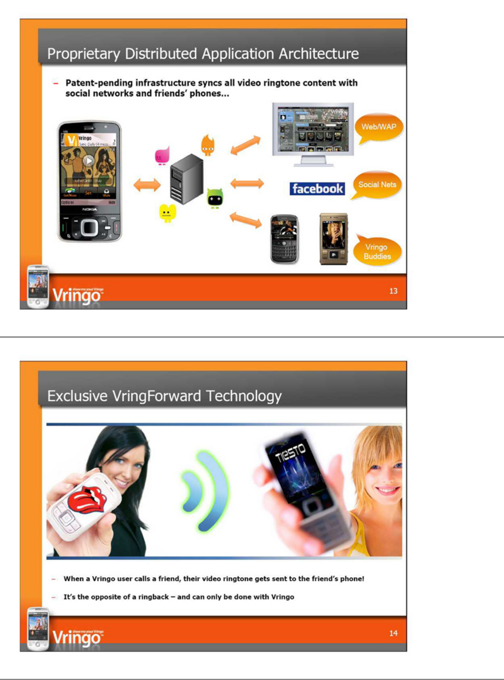

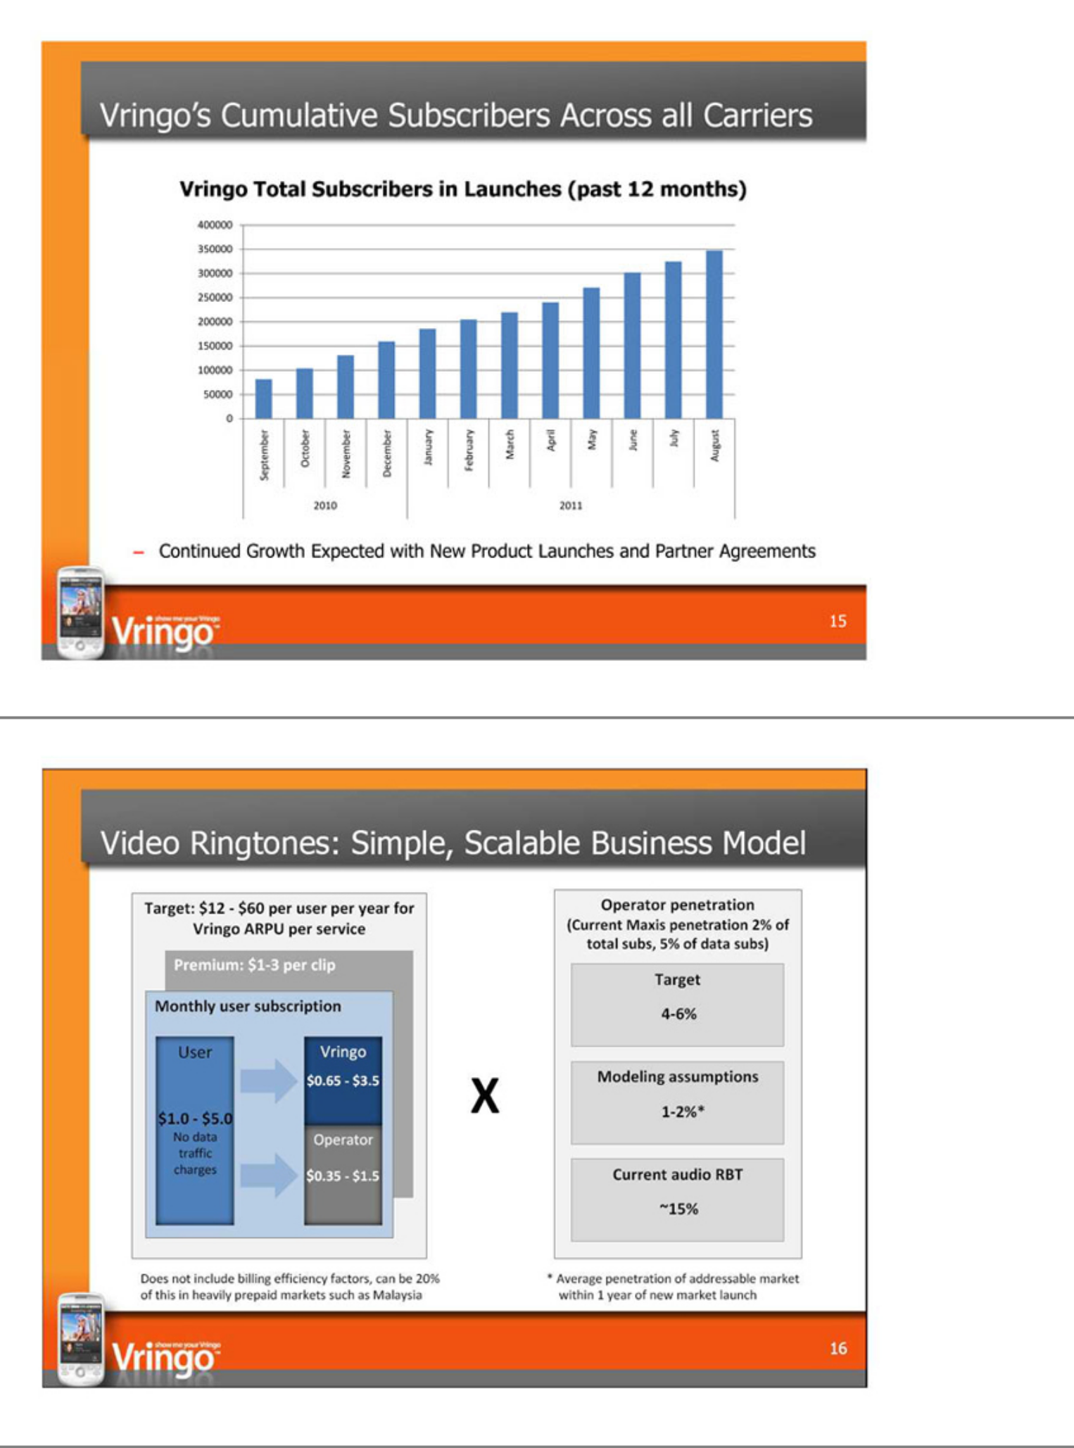

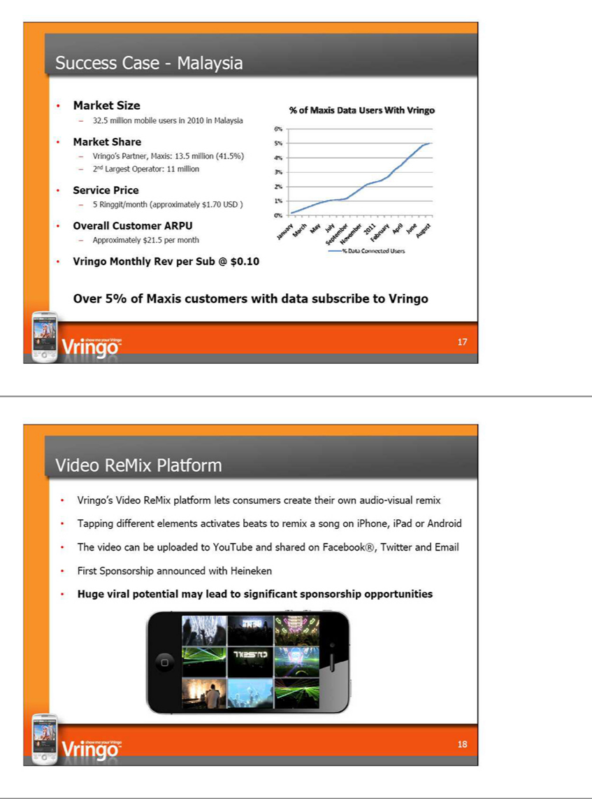

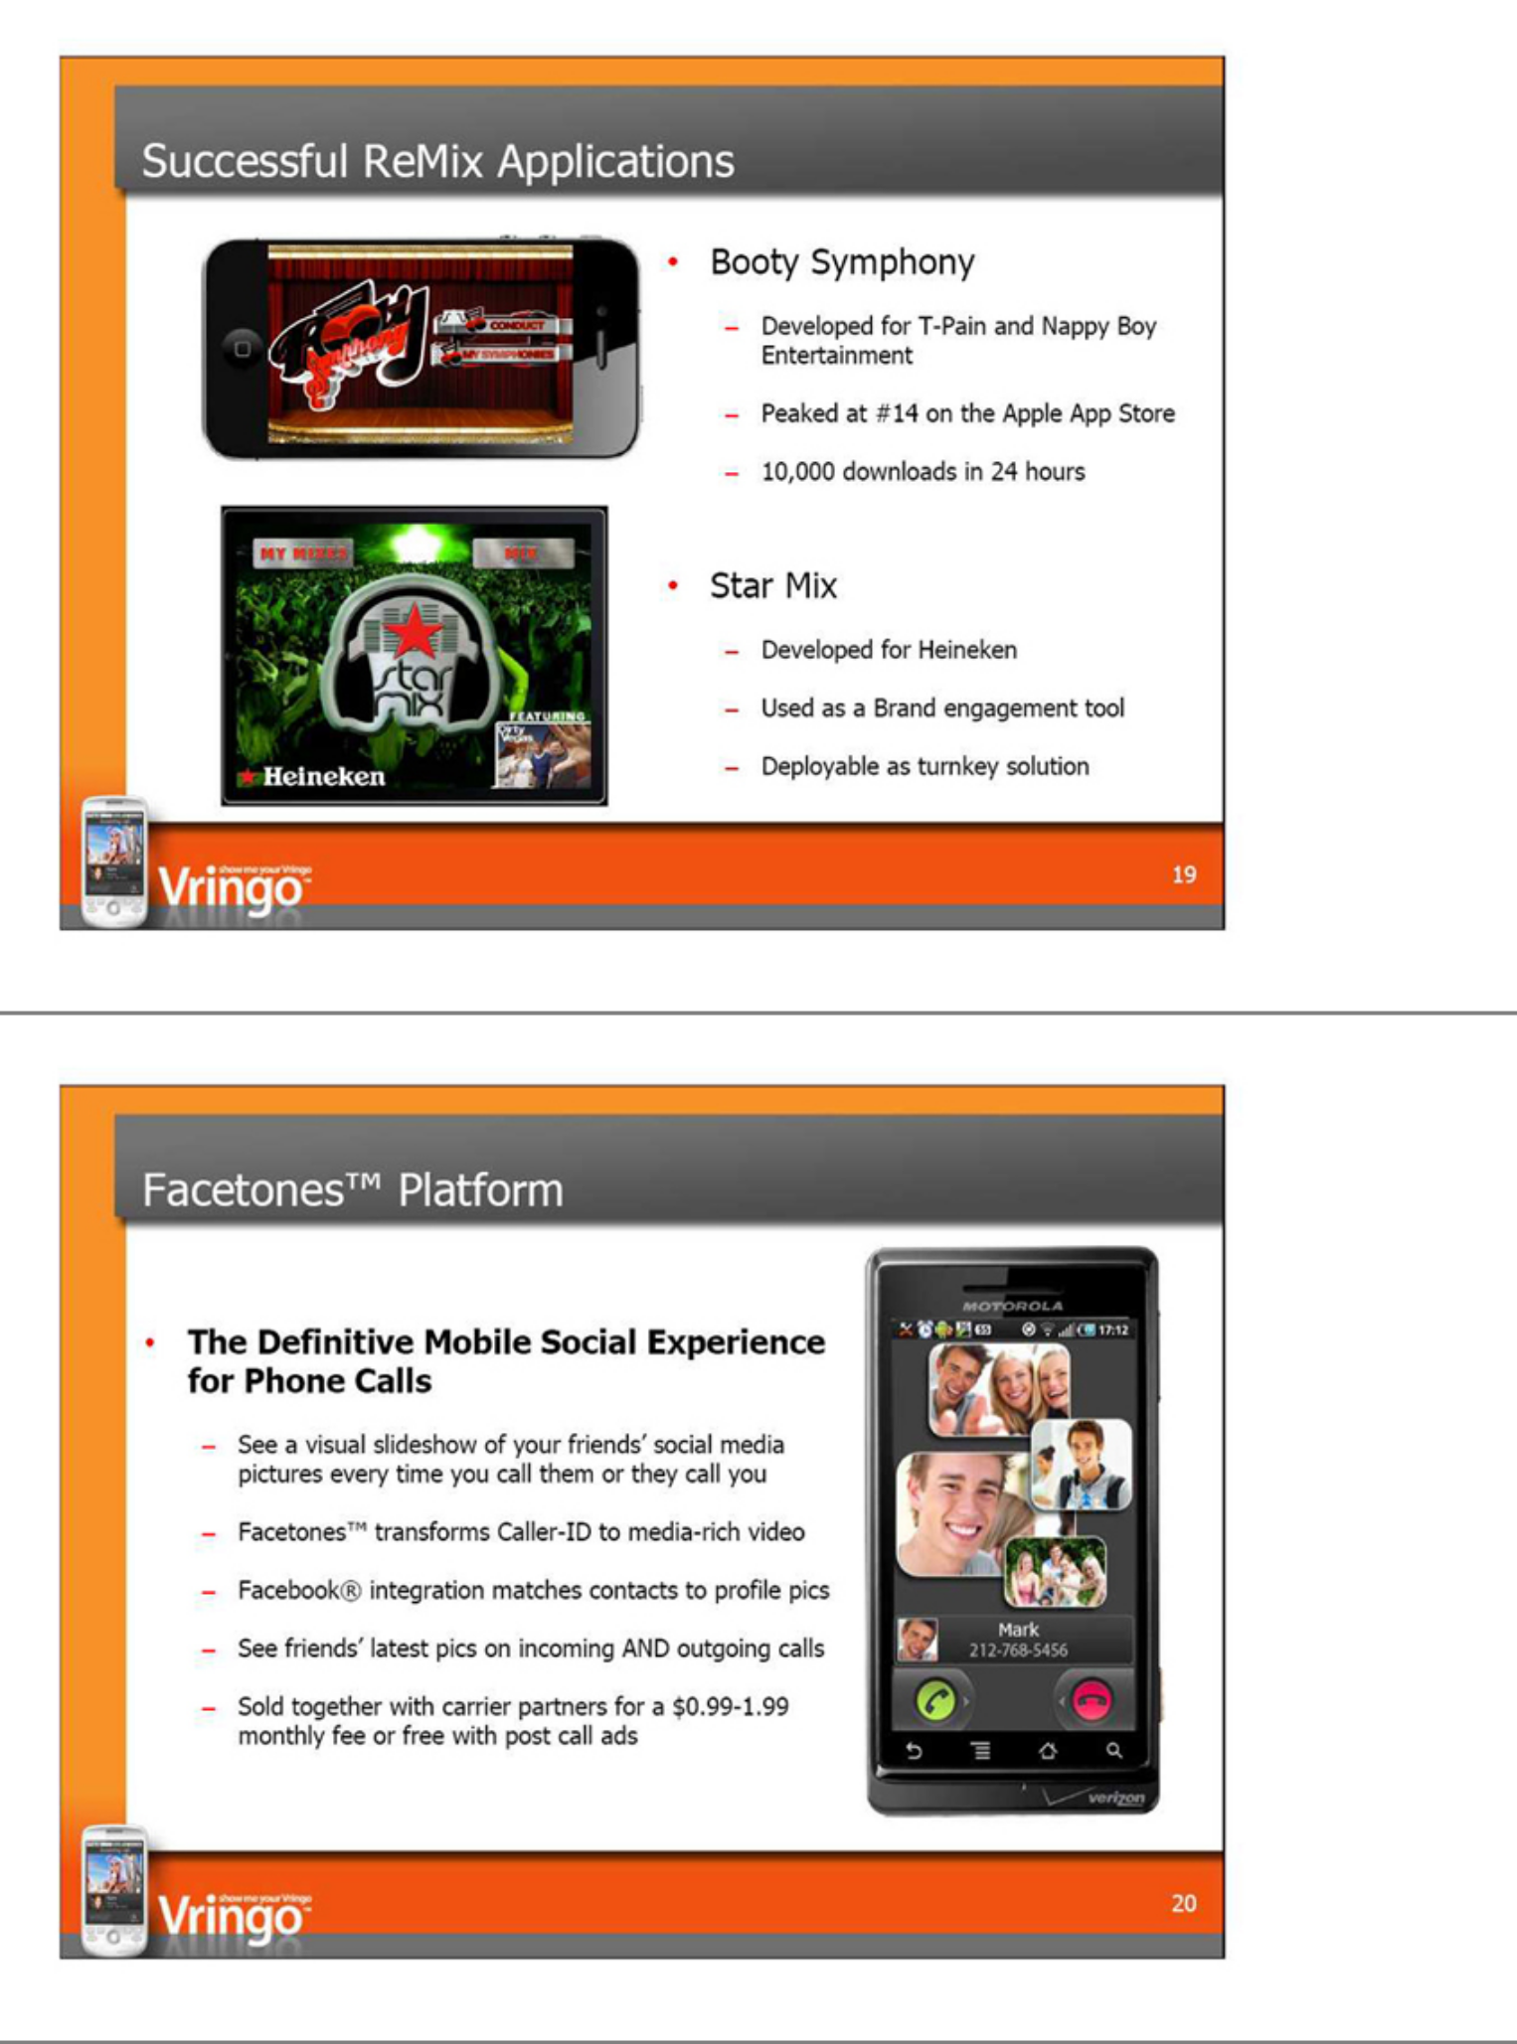

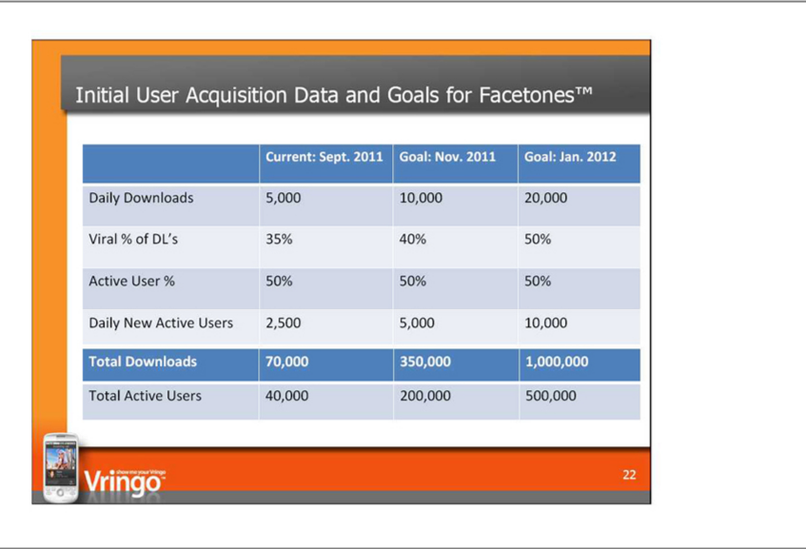

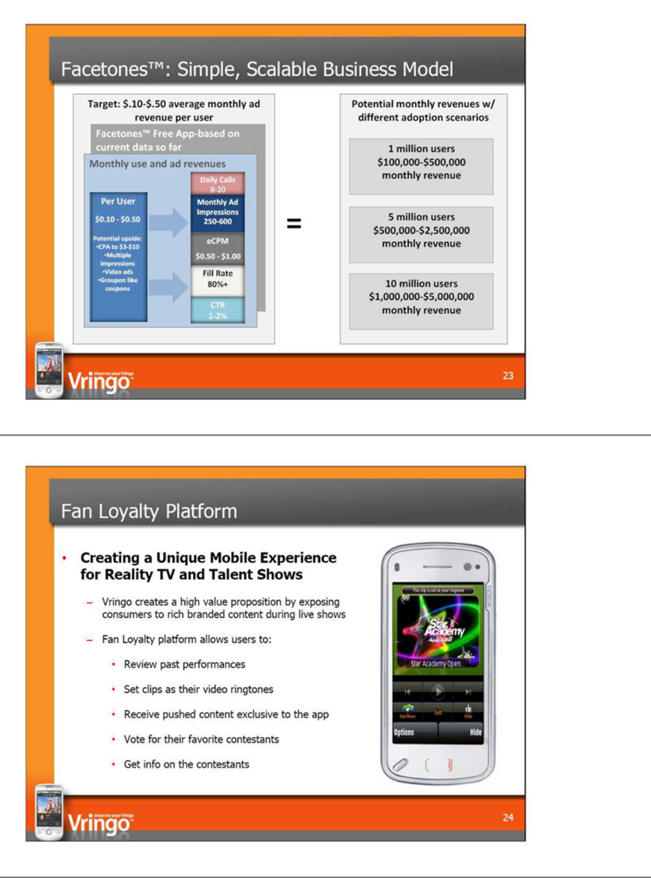

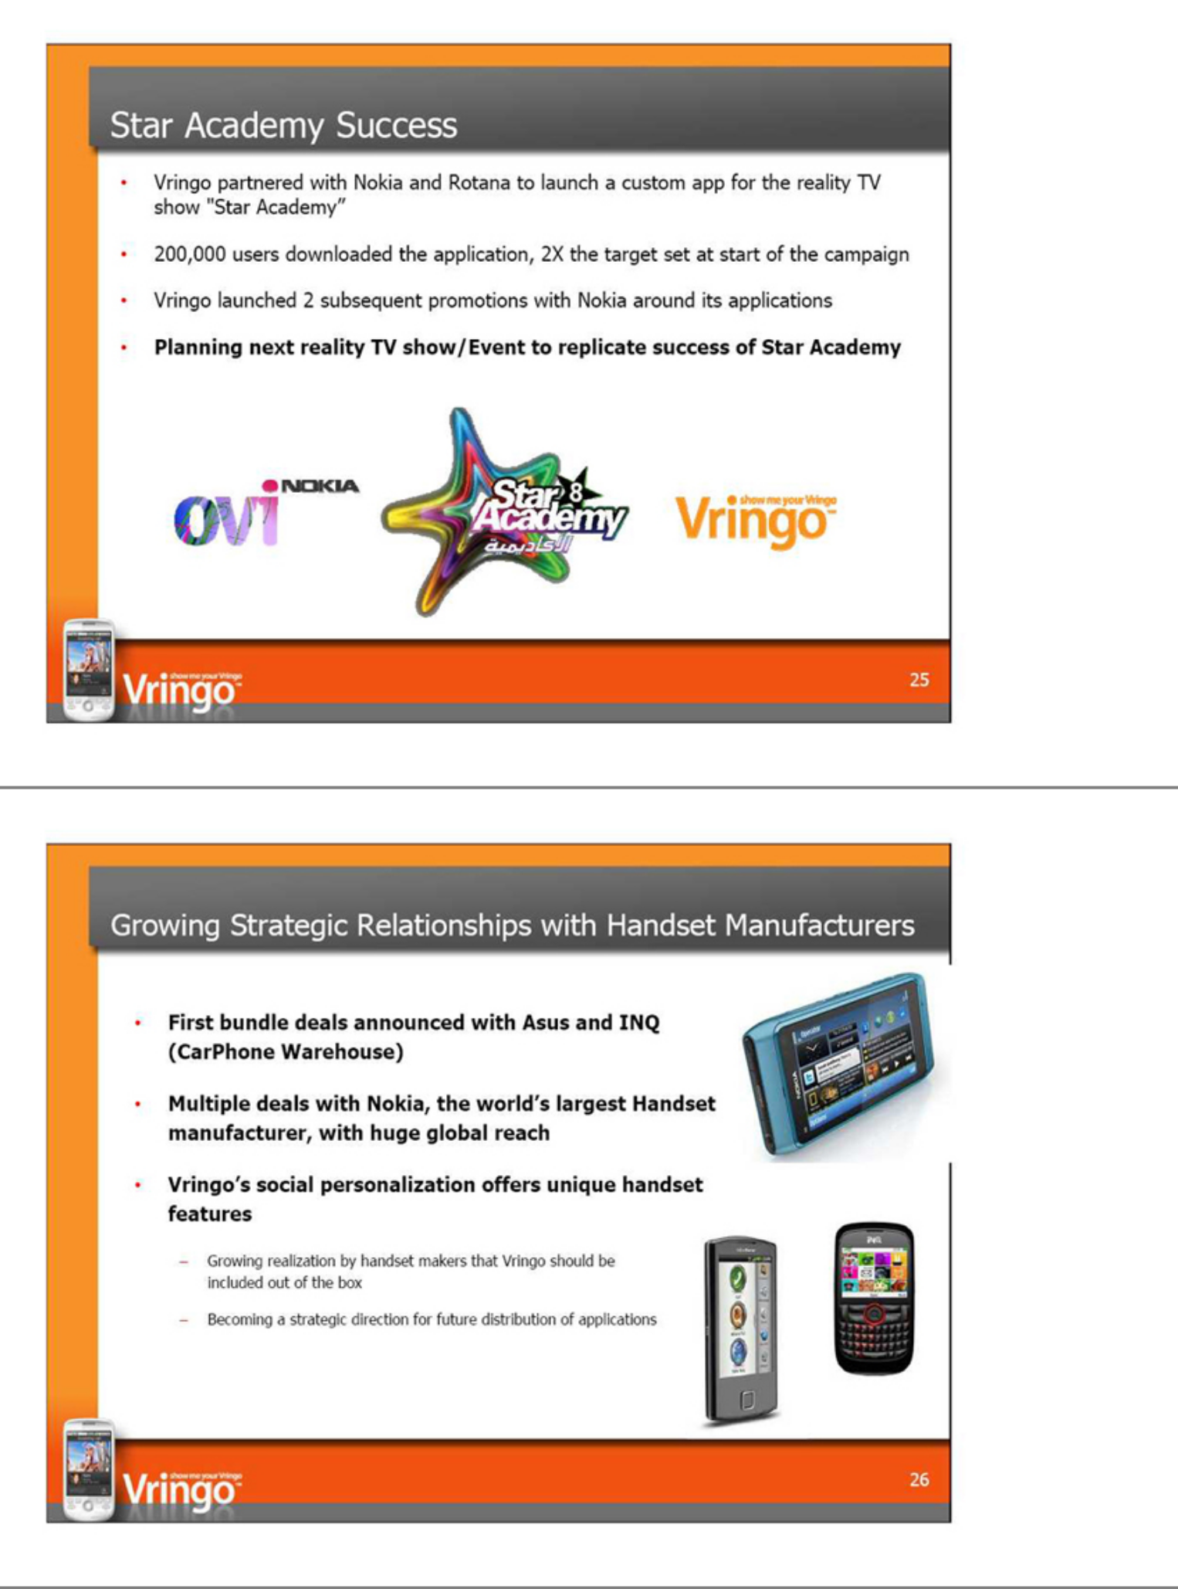

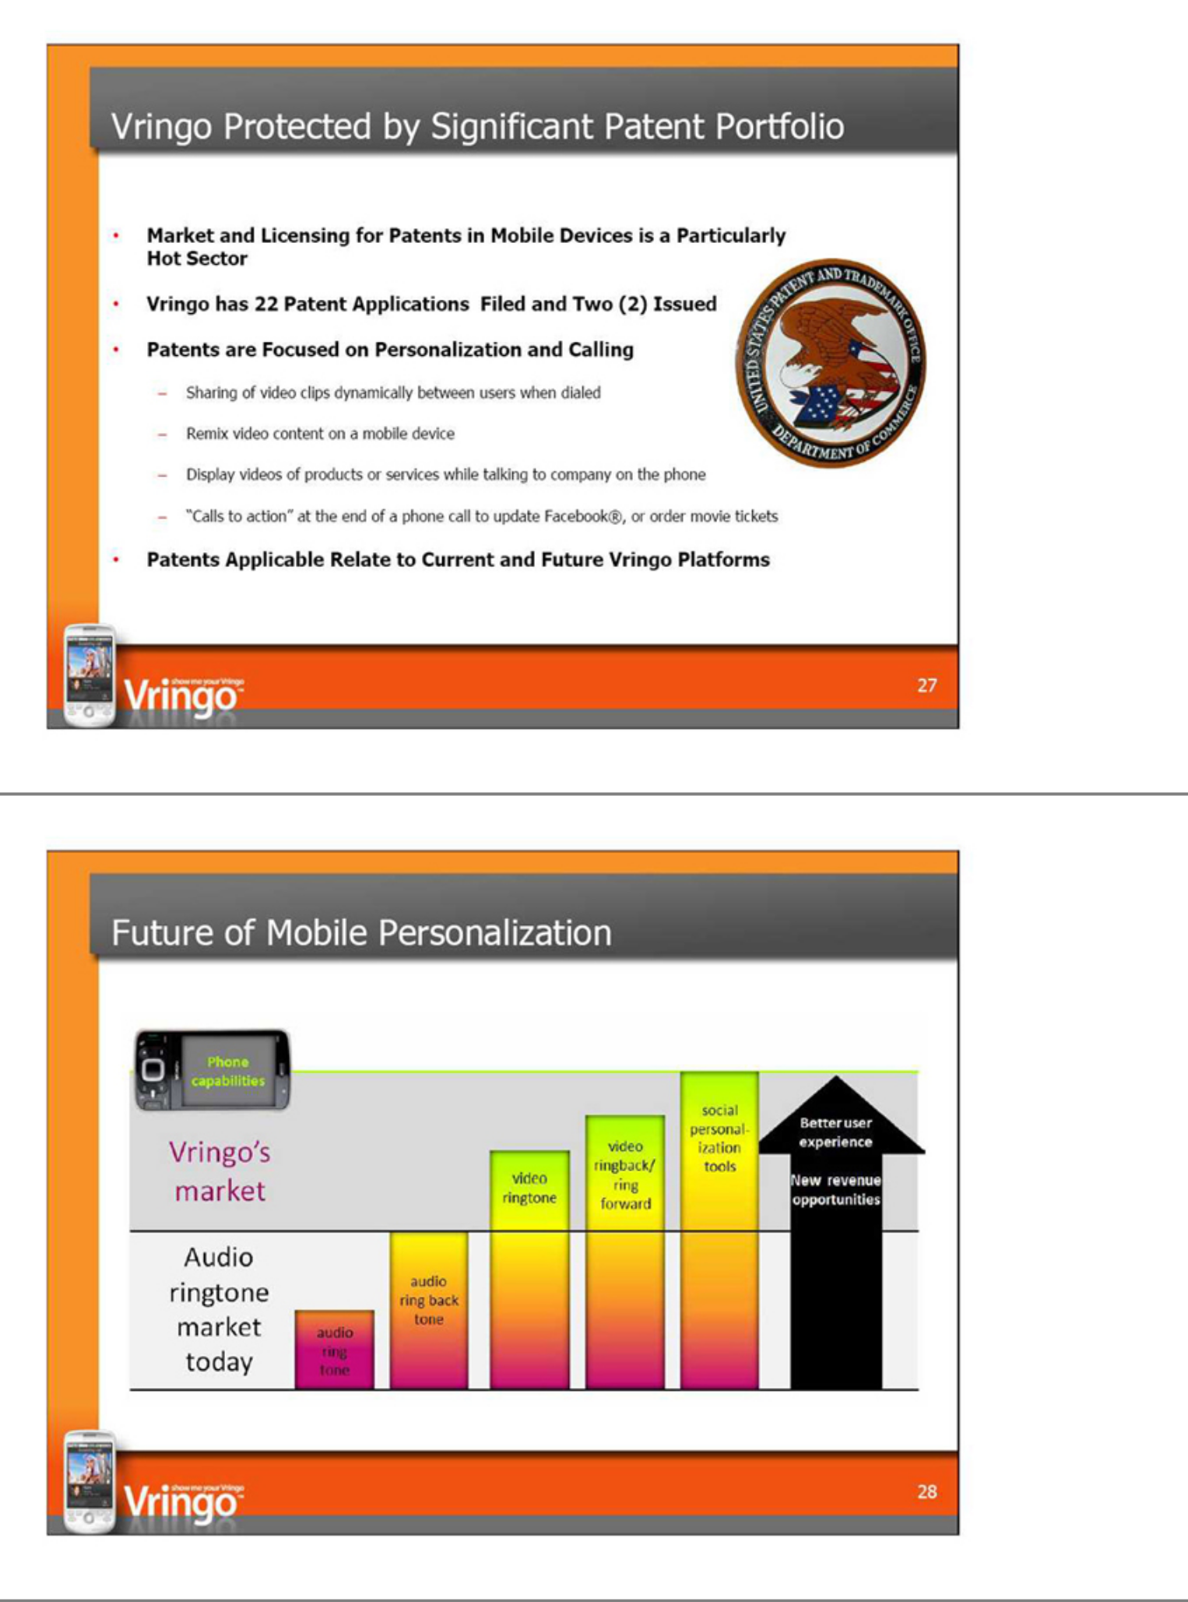

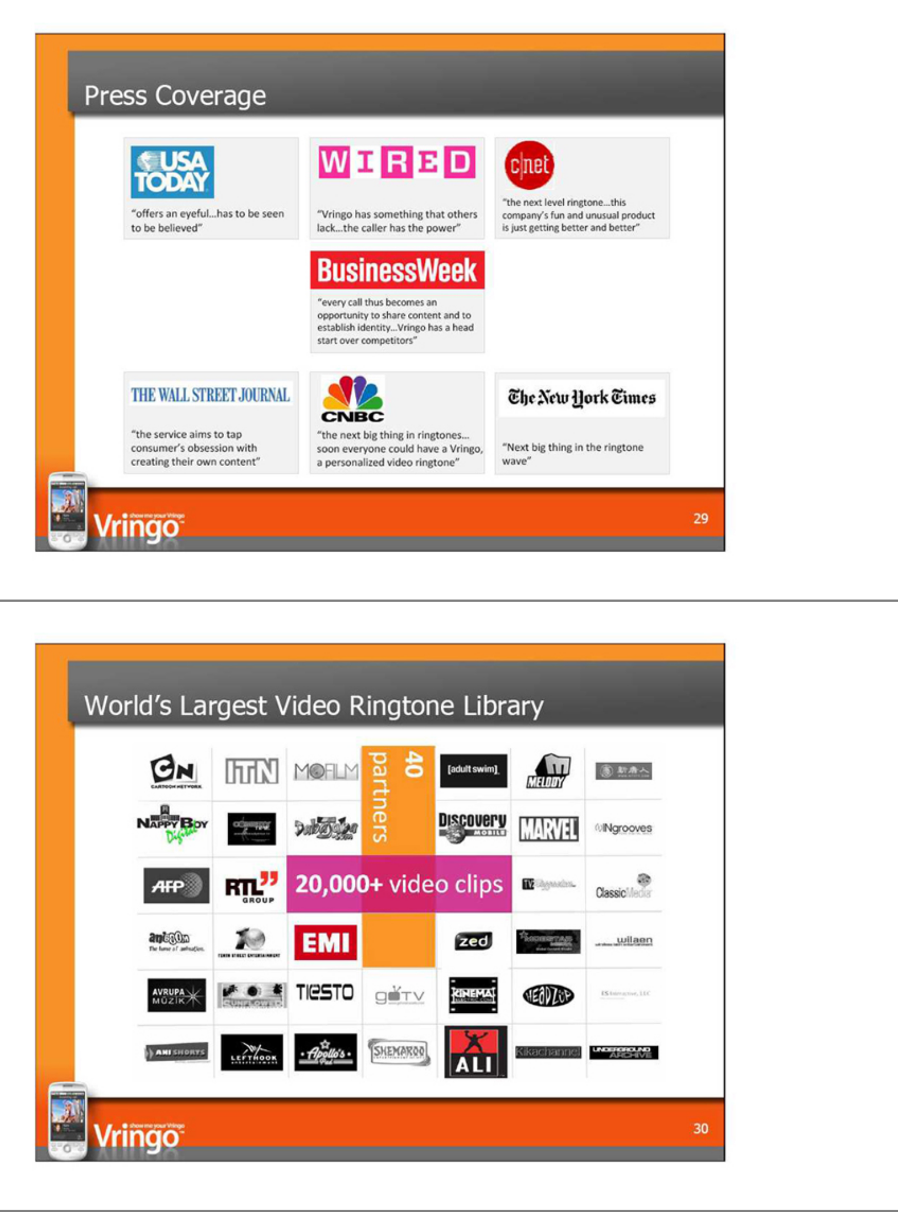

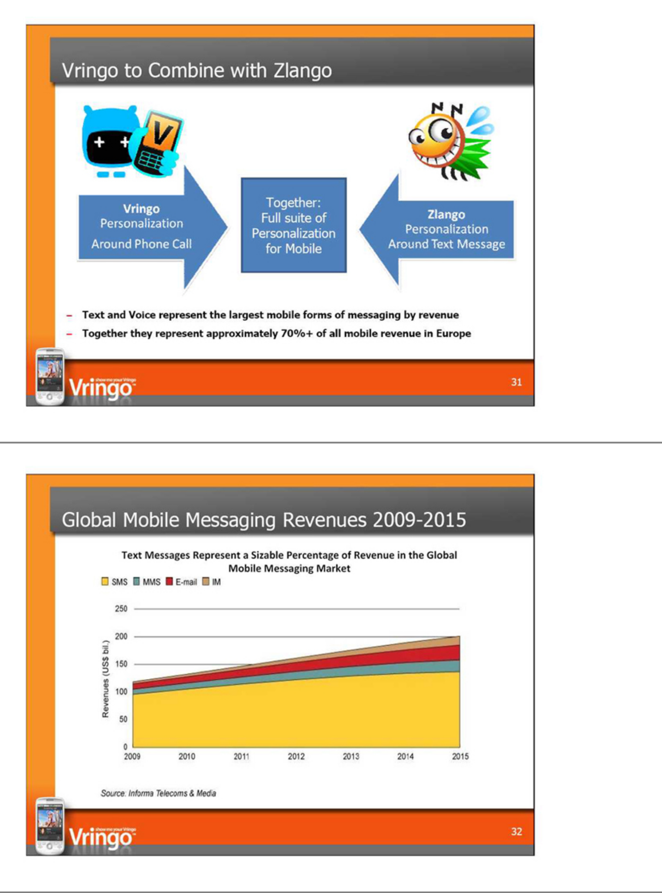

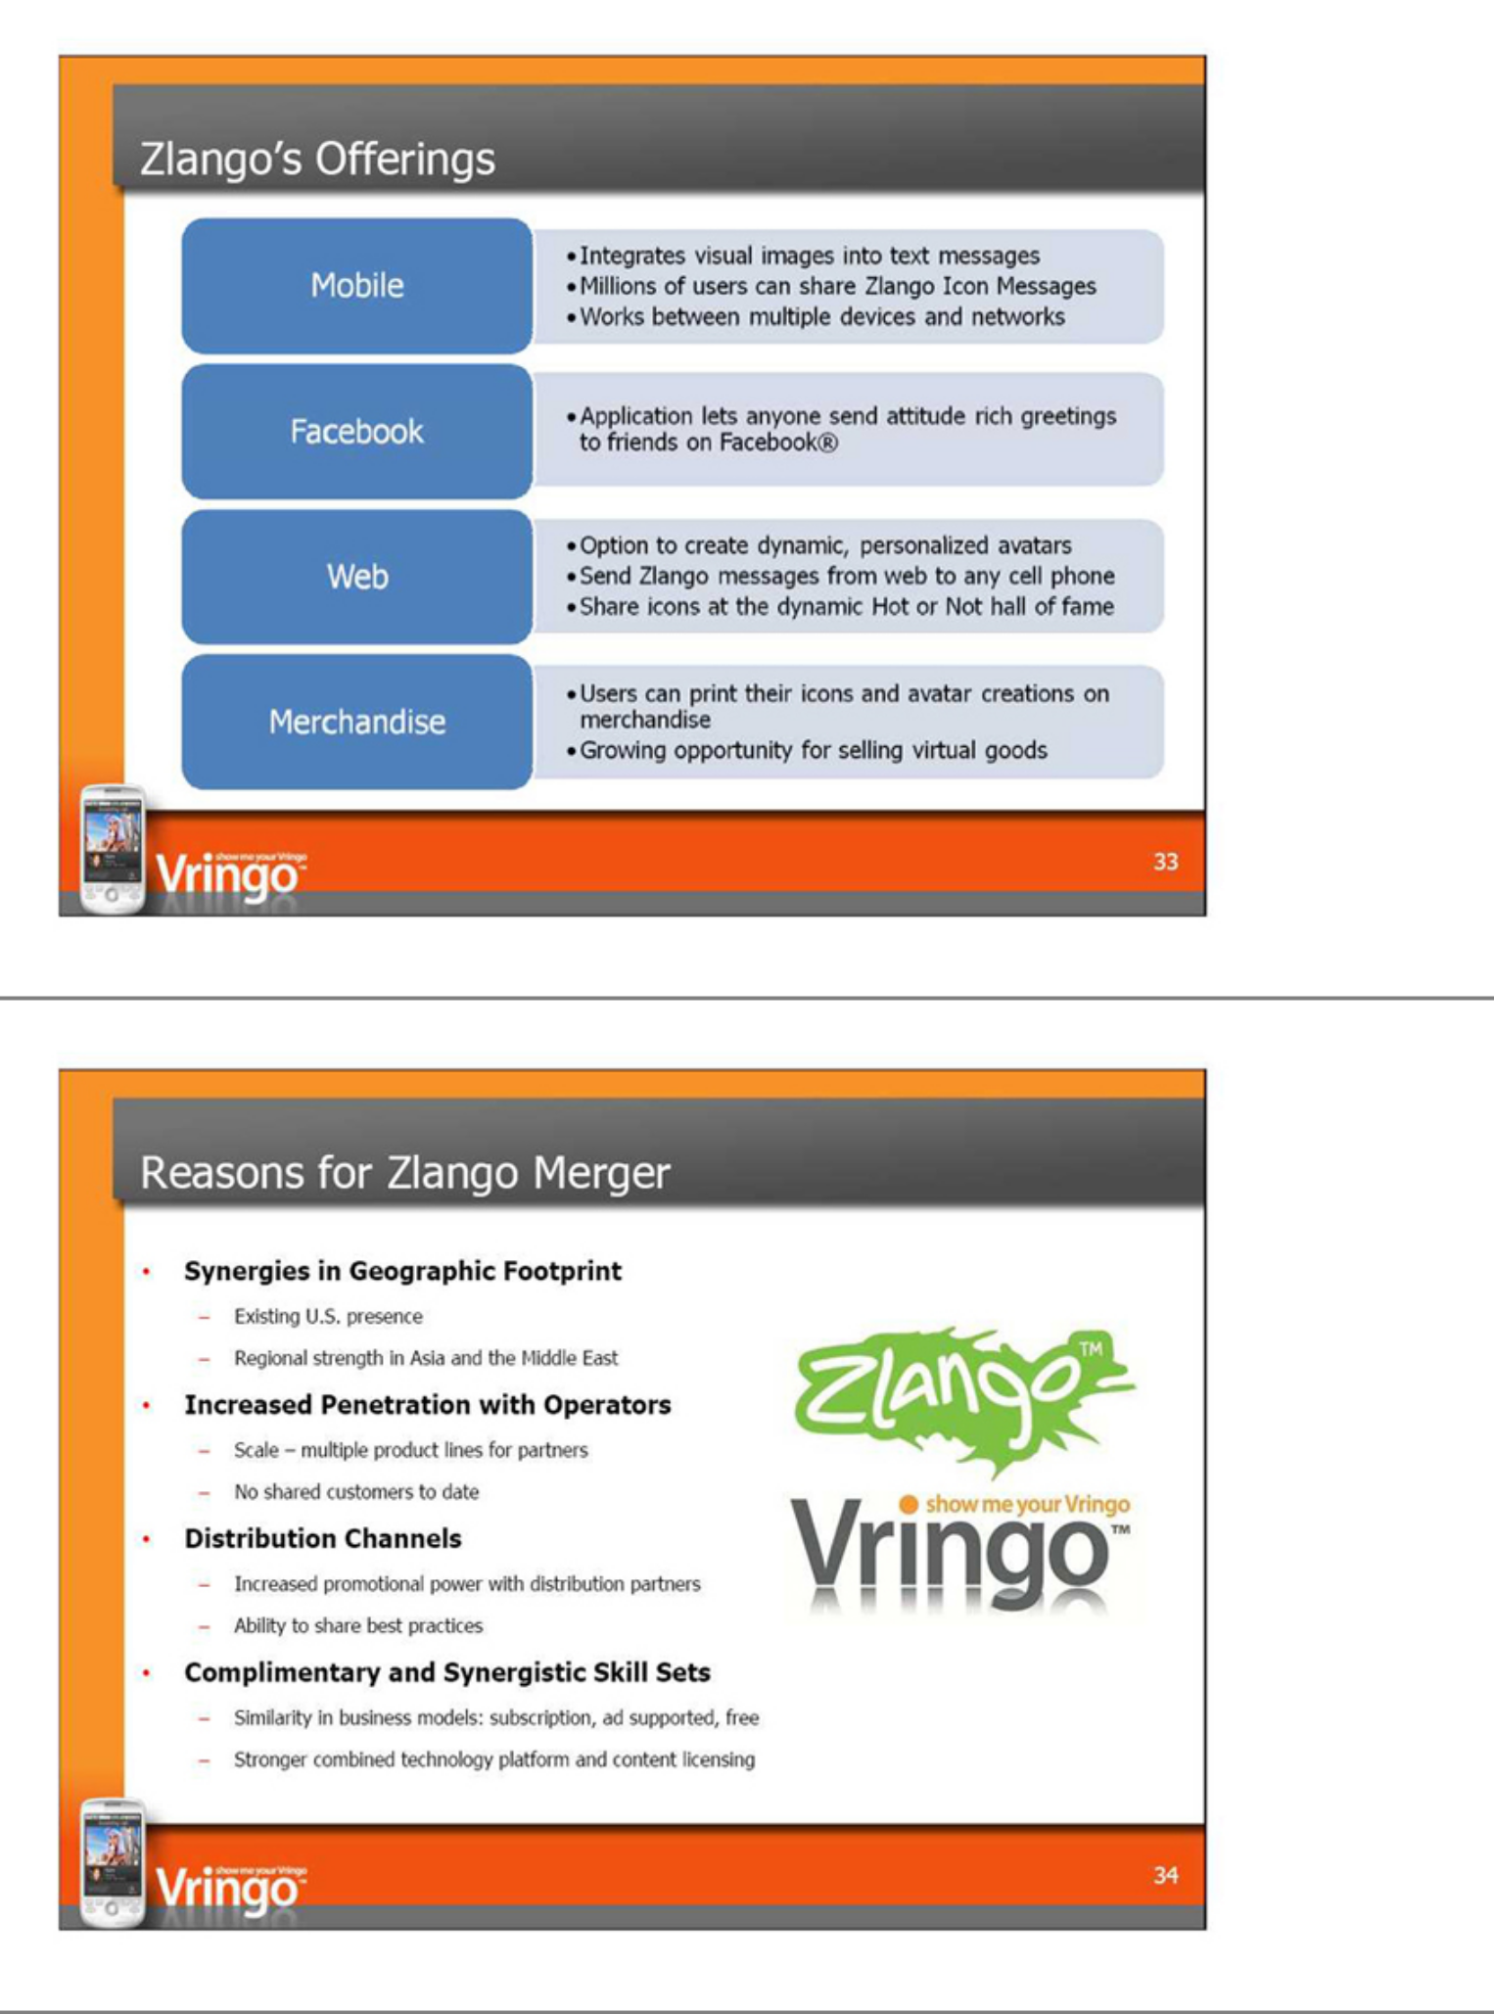

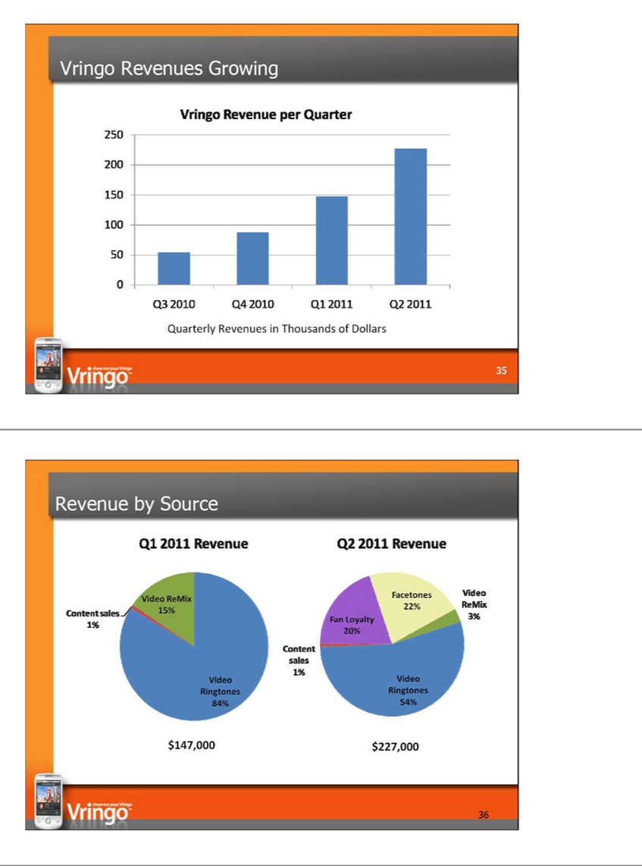

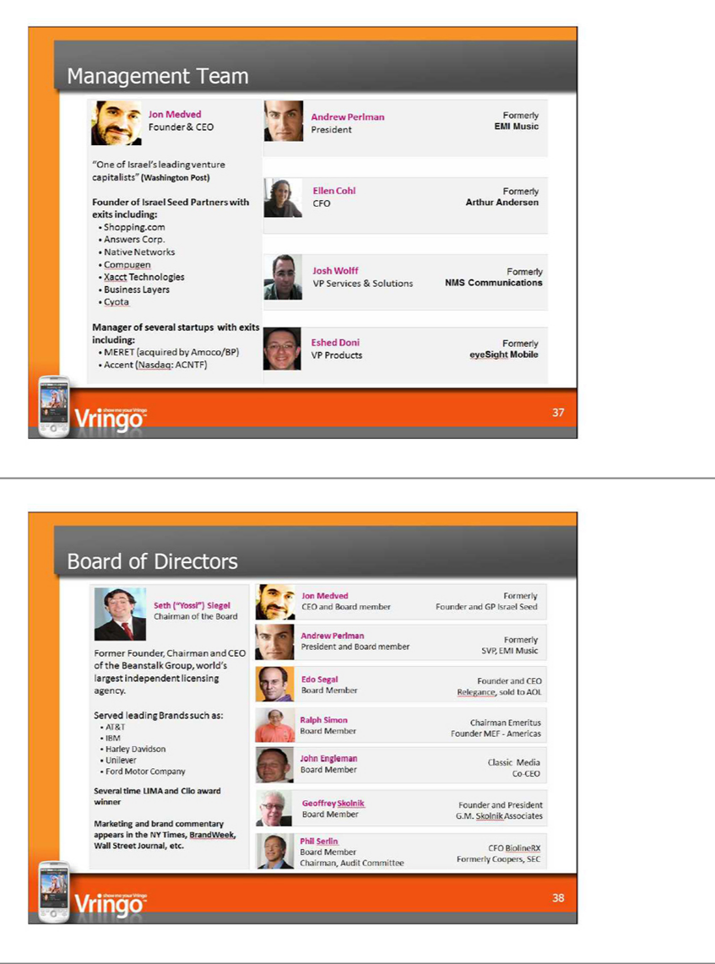

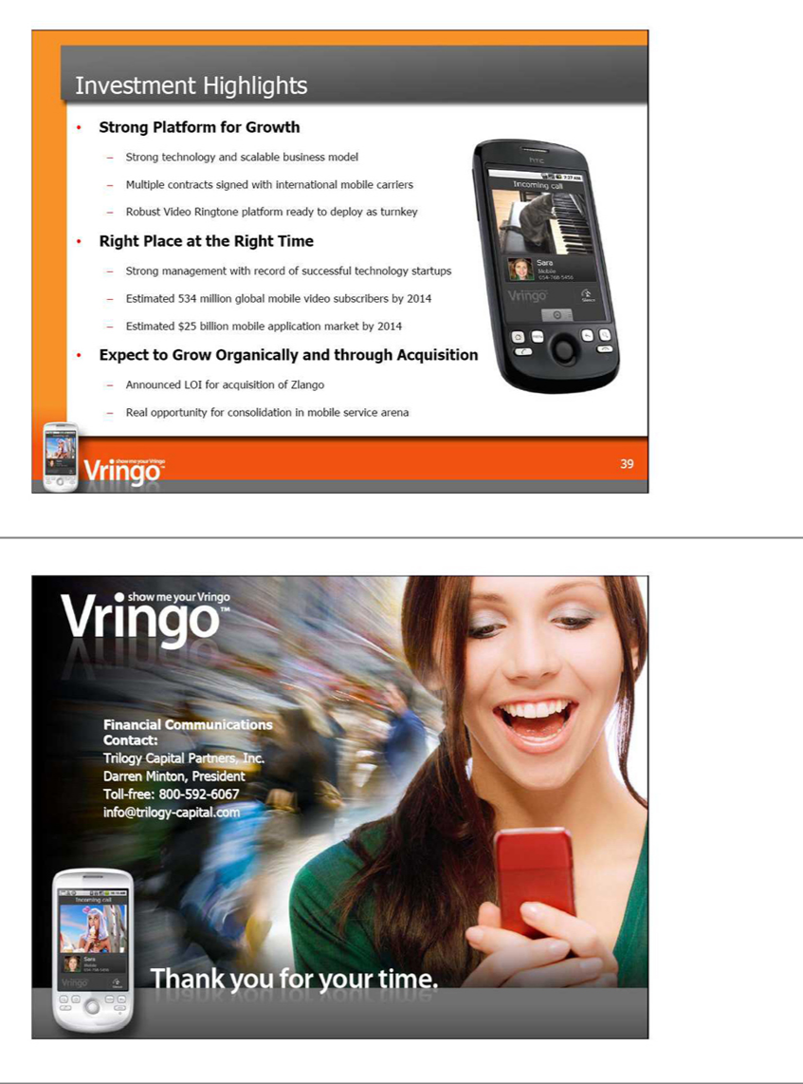



Vringo to Present at the Rodman & Renshaw Annual Global Investment Conference on September 13th

Vringo to Discuss Growth Strategy, Business Model, and Increasing Popularity of Mobile Social and Video Applications Around the Globe

NEW YORK, Sep 07, 2011

Vringo, Inc. (NYSE Amex: VRNG), a provider of software platforms for mobile social and video applications, announced today that the Company will participate in the Rodman & Renshaw Annual Global Investment Conference, to be held September 11-13, 2011 at the Waldorf=Astoria Hotel in New York City. The Company's presentation at the conference will take place in the Sutton Suite at 10:00 a.m. Eastern on Tuesday, September 13th.

The Company's President, Andrew Perlman, will also participate in one-on-one meetings with conference attendees and discuss the Company's growth strategy, business model, and the increasing popularity of mobile social and mobile video applications around the globe. A live webcast of the presentation will be available to investors and interested parties at http://www.wsw.com/webcast/rrshq20/vrng.

Registration is mandatory. For more information regarding the conference, visit http://www.rodmanandrenshaw.com.

To schedule one-on-one meetings with the Company at this event or in the New York area, please contact a Rodman & Renshaw representative directly or call Darren Minton at 212-521-4405, or email info@trilogy-capital.com.

About Vringo

Vringo (NYSE Amex: VRNG) is a leading provider of software platforms for mobile social and mobile video services. With its award-winning video ringtone application and other mobile software platforms - including Facetones, Video Remix and Fan Loyalty - Vringo transforms the basic act of making and receiving mobile phone calls into a highly visual, social experience. Vringo's video ringtone service enables users to create or take video, images and slideshows from virtually anywhere and turn it into their visual call signatures. In a first for the mobile industry, Vringo has introduced its patented VringForward technology, which allows users to share video clips with friends with a simple call. Vringo's Facetones(TM) product creates an automated video slideshow using friends' photos from social media web sites and photo sites, which is played each time a user makes or receives a mobile call. Vringo's Video ReMix application, in partnership with music artists and brands, allows users to create their own music video by tapping on a Smartphone or tablet. Lastly, Fan Loyalty is a platform that lets users interact, vote and communicate with contestants in reality TV series, as well as downloading and setting clips from such shows as video ringtones. Vringo's video ringtone application has been heralded by The New York Times as "the next big thing in ringtones" and USA Today said it has "to be seen to be believed." For more information, visit: www.vringo.com.

For comprehensive investor relations material, including fact sheets, white papers, conference calls and video regarding Vringo and its applications, please follow the appropriate link: Investor Portal, White Paper,Overview Video and Facetones Video.

Forward-Looking Statements

This press release includes forward-looking statements that involve risks and uncertainties. Forward-looking statements are statements that are not historical facts. Such forward-looking statements are subject to risks and uncertainties, which could cause actual results to differ from the forward-looking statements. Vringo expressly disclaims any obligation to publicly update any forward-looking statements contained herein, whether as a result of new information, future events or otherwise, except as required by law.

SOURCE: Vringo, Inc.

Company Contact:

Vringo, Inc.

Aaron Godfrey, Director of Communications

646-525-4319 x 2547

agodfrey@vringo.com

Skype: agodfrey_vringo

Twitter: @vringo

or

Financial Communications:

Trilogy Capital Partners, Inc.

Darren Minton, President

Toll-free: 800-592-6067

info@trilogy-capital.com

