UNITED STATES

SECURITIES AND EXCHANGE COMMISSION

WASHINGTON, D.C. 20549

SCHEDULE 14A

Proxy Statement Pursuant to Section 14(a) of the Securities Exchange Act of 1934

(Amendment No. )

Filed by the Registrant

Filed by a Party other than the Registrant

x

☐

Check the appropriate box:

- Preliminary Proxy Statement

- Confidential, for Use of the Commission Only (as permitted by Rule 14a-6(e)(2))

- Definitive Proxy Statement

- Definitive Additional Materials

- Soliciting Material Under Rule 14a-12

XpresSpa Group, Inc.

(Name of Registrant as Specified In Its Charter)

(Name of Person(s) Filing Proxy Statement, if other than the Registrant)

Payment of Filing Fee (Check the appropriate box):

- No fee required.

- Fee computed on table below per Exchange Act Rules 14a-6(i)(1) and 0-11.

  - Title of each class of securities to which transaction applies:

  - Aggregate number of securities to which transaction applies:

  - Per unit price or other underlying value of transaction computed pursuant to Exchange Act Rule 0-11 (set forth the amount on which the filing fee is calculated and state how it was determined):

  - Proposed maximum aggregate value of transaction:

  - Total fee paid:

- Fee paid previously with preliminary materials.

- Check box if any part of the fee is offset as provided by Exchange Act Rule 0-11(a)(2) and identify the filing for which the offsetting fee was paid previously. Identify the previous filing by registration statement number, or the Form or Schedule and the date of its filing:

  - Amount previously paid:

  - Form, Schedule or Registration Statement No:

  - Filing party:

  - Date Filed:

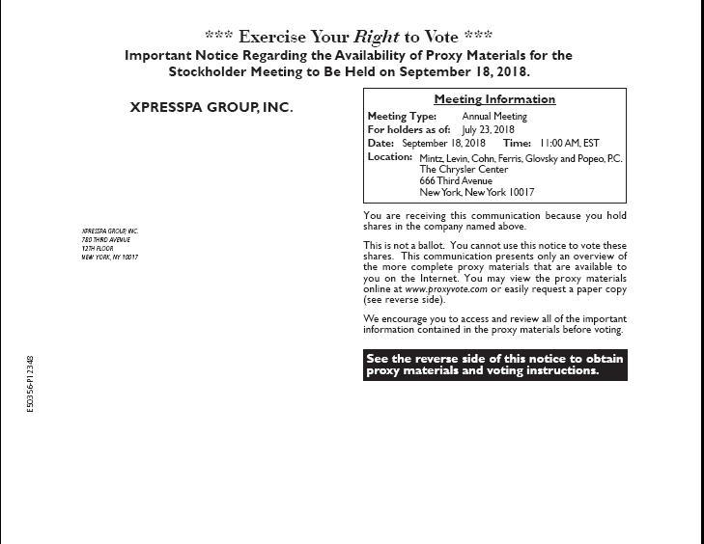

XPRESSPA GROUP, INC.*** Exercise Your Right to Vote ***Important Notice Regarding the Availability of Proxy Materials for theStockholder Meeting to Be Held on September 18, 2018.XPRESSPA GROUP, INC.780 THIRD AVENUE12TH FLOORNEW YORK, NY 10017See the reverse side of this notice to obtain proxy materials and voting instructions.E50356-P12348You are receiving this communication because you hold shares in the company named above.This is not a ballot. You cannot use this notice to vote these shares. This communication presents only an overview of the more complete proxy materials that are available to you on the Internet. You may view the proxy materials online at www.proxyvote.com or easily request a paper copy (see reverse side).We encourage you to access and review all of the important information contained in the proxy materials before voting.Meeting InformationMeeting Type: Annual MeetingFor holders as of: July 23, 2018Date: September 18, 2018 Time: 11:00 AM, ESTLocation:Mintz, Levin, Cohn, Ferris, Glovsky and Popeo, P.C.The Chrysler Center666 Third AvenueNew York, New York 10017

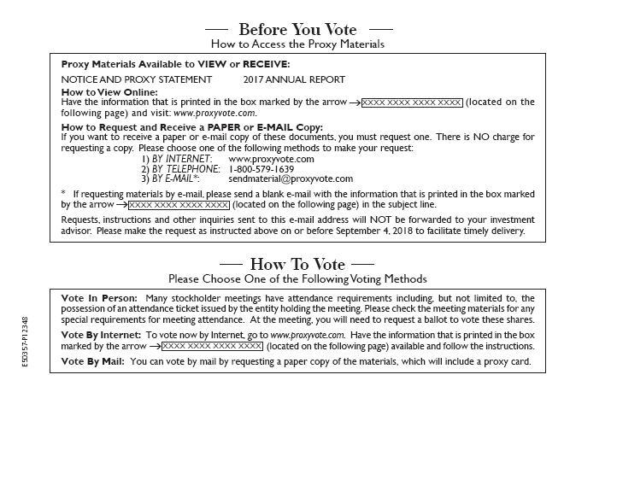

E50357-P12348Vote In Person: Many stockholder meetings have attendance requirements including, but not limited to, the possession of an attendance ticket issued by the entity holding the meeting. Please check the meeting materials for any special requirements for meeting attendance. At the meeting, you will need to request a ballot to vote these shares.Vote By Internet: To vote now by Internet, go to www.proxyvote.com. Have the information that is printed in the boxmarked by the arrow (located on the following page) available and follow the instructions.Vote By Mail: You can vote by mail by requesting a paper copy of the materials, which will include a proxy card.Requests, instructions and other inquiries sent to this e-mail address will NOT be forwarded to your investment advisor. Please make the request as instructed above on or before September 4, 2018 to facilitate timely delivery.How to View Online:Have the information that is printed in the box marked by the arrow (located on the following page) and visit: www.proxyvote.com.How to Request and Receive a PAPER or E-MAIL Copy:If you want to receive a paper or e-mail copy of these documents, you must request one. There is NO charge for requesting a copy. Please choose one of the following methods to make your request:1) BY INTERNET: www.proxyvote.com2) BY TELEPHONE: 1-800-579-16393) BY E-MAIL*: sendmaterial@proxyvote.com* If requesting materials by e-mail, please send a blank e-mail with the information that is printed in the box marked by the arrow (located on the following page) in the subject line.NOTICE AND PROXY STATEMENT 2017 ANNUAL REPORTProxy Materials Available to VIEW or RECEIVE:XXXX XXXX XXXX XXXXXXXX XXXX XXXX XXXXXXXX XXXX XXXX XXXXBefore You VoteHow to Access the Proxy MaterialsHow To VotePlease Choose One of the Following Voting Methods

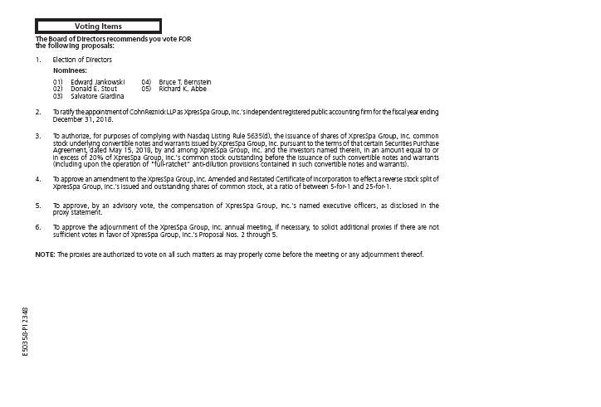

Voting ItemsNOTE: The proxies are authorized to vote on all such matters as may properly come before the meeting or any adjournment thereof.Nominees:01) Edward Jankowski02) Donald E. Stout03) Salvatore Giardina04) Bruce T. Bernstein05) Richard K. Abbe2. To ratify the appointment of CohnReznick LLP as XpresSpa Group, Inc.'s independent registered public accounting firm for the fiscal year endingDecember 31, 2018.3. To authorize, for purposes of complying with Nasdaq Listing Rule 5635(d), the issuance of shares of XpresSpa Group, Inc. commonstock underlying convertible notes and warrants issued by XpresSpa Group, Inc. pursuant to the terms of that certain Securities PurchaseAgreement, dated May 15, 2018, by and among XpresSpa Group, Inc. and the investors named therein, in an amount equal to orin excess of 20% of XpresSpa Group, Inc.'s common stock outstanding before the issuance of such convertible notes and warrants(including upon the operation of "full-ratchet" anti-dilution provisions contained in such convertible notes and warrants).4. To approve an amendment to the XpresSpa Group, Inc. Amended and Restated Certificate of Incorporation to effect a reverse stock split ofXpresSpa Group, Inc.'s issued and outstanding shares of common stock, at a ratio of between 5-for-1 and 25-for-1.5. To approve, by an advisory vote, the compensation of XpresSpa Group, Inc.'s named executive officers, as disclosed in theproxy statement.6. To approve the adjournment of the XpresSpa Group, Inc. annual meeting, if necessary, to solicit additional proxies if there are notsufficient votes in favor of XpresSpa Group, Inc.'s Proposal Nos. 2 through 5.1. Election of DirectorsThe Board of Directors recommends you vote FORthe following proposals:E50358-P12348

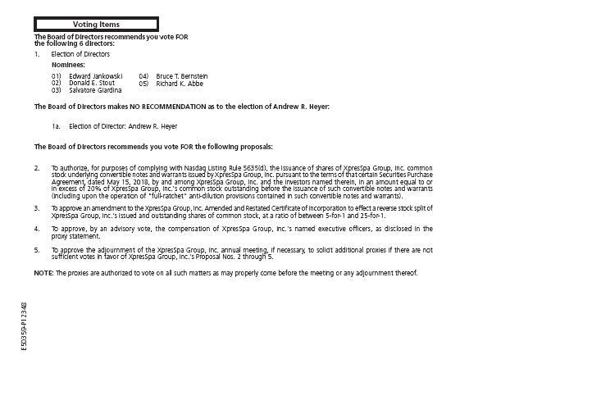

Voting ItemsNOTE: The proxies are authorized to vote on all such matters as may properly come before the meeting or any adjournment thereof.Nominees:01) Edward Jankowski02) Donald E. Stout03) Salvatore Giardina04) Bruce T. Bernstein05) Richard K. Abbe2. To authorize, for purposes of complying with Nasdaq Listing Rule 5635(d), the issuance of shares of XpresSpa Group, Inc. commonstock underlying convertible notes and warrants issued by XpresSpa Group, Inc. pursuant to the terms of that certain Securities PurchaseAgreement, dated May 15, 2018, by and among XpresSpa Group, Inc. and the investors named therein, in an amount equal to orin excess of 20% of XpresSpa Group, Inc.'s common stock outstanding before the issuance of such convertible notes and warrants(including upon the operation of "full-ratchet" anti-dilution provisions contained in such convertible notes and warrants).3. To approve an amendment to the XpresSpa Group, Inc. Amended and Restated Certificate of Incorporation to effect a reverse stock split ofXpresSpa Group, Inc.'s issued and outstanding shares of common stock, at a ratio of between 5-for-1 and 25-for-1.4. To approve, by an advisory vote, the compensation of XpresSpa Group, Inc.'s named executive officers, as disclosed in theproxy statement.5. To approve the adjournment of the XpresSpa Group, Inc. annual meeting, if necessary, to solicit additional proxies if there are notsufficient votes in favor of XpresSpa Group, Inc.'s Proposal Nos. 2 through 5.1. Election of Directors1a. Election of Director: Andrew R. HeyerThe Board of Directors recommends you vote FORthe following 6 directors:The Board of Directors makes NO RECOMMENDATION as to the election of Andrew R. Heyer:The Board of Directors recommends you vote FOR the following proposals:E50359-P12348



E50360-P12348

