UNITED STATES

SECURITIES AND EXCHANGE COMMISSION
WASHINGTON, DC 20549

FORM 8-K

CURRENT REPORT

Pursuant to Section 13 OR 15(D) of the Securities Exchange Act Of 1934

Date of report (Date of earliest event reported): January 9, 2022

XpresSpa Group, Inc.

(Exact Name of Registrant as Specified in Its Charter)

Delaware

(State or Other Jurisdiction of Incorporation)

001-34785 |  | 20-4988129
(Commission File Number) |  | (IRS Employer Identification No.)
254 West 31st Street, 11th Floor, New York, New York |  | 10001
(Address of Principal Executive Offices) |  |  |  | (Zip Code)

(212) 309-7549

(Registrant’s Telephone Number, Including Area Code)

(Former Name or Former Address, if Changed Since Last Report)

Check the appropriate box below if the Form 8-K filing is intended to simultaneously satisfy the filing obligation of the registrant under any of the following provisions:

- Written communications pursuant to Rule 425 under the Securities Act (17 CFR 230.425)

- Soliciting material pursuant to Rule 14a-12 under the Exchange Act (17 CFR 240.14a-12)

- Pre-commencement communications pursuant to Rule 14d-2(b) under the Exchange Act (17 CFR 240.14d-2(b))

- Pre-commencement communications pursuant to Rule 13e-4(c) under the Exchange Act (17 CFR 240.13e-4(c))

Securities registered pursuant to Section 12(b) of the Act: ☐
 | Title of each class |  | Trading Symbol(s) |  | Name of each exchange on which registered
 | Common Stock, par value $0.01 per share |  | XSPA |  | The Nasdaq Stock Market

Indicate by check mark whether the registrant is an emerging growth company as defined in Rule 405 of the Securities Act of 1933 (§230.405 of this chapter) or Rule 12b-2 of the Securities Exchange Act of 1934 (§240.12b-2 of this chapter).

Emerging growth company ☐

If an emerging growth company, indicate by check mark if the registrant has elected not to use the extended transition period for complying with any new or revised financial accounting standards provided pursuant to Section 13(a) of the Exchange Act. ☐

Item 2.02. Results of Operations and Financial Condition

On January 10, 2022, XpresSpa Group, Inc. (“XpresSpa Group” or the “Company”) issued a press release (the “Selected Preliminary Results Press Release”) setting forth the Company’s preliminary expectations regarding selected financial results for the fourth quarter and full 2021 fiscal year. A copy of the Selected Preliminary Results Press Release is being furnished as Exhibit 99.1 and incorporated herein by reference.

The financial results in the Selected Preliminary Results Press Release are preliminary and subject to change pending the Company’s filing of its Form 10-K for fiscal year 2021, scheduled for March 2022. The preliminary financial results presented in the Selected Preliminary Results Press Release are based solely upon information available to the Company as of the date thereof, are not a comprehensive statement of the Company’s financial results or positions as of or for the three months or 12 months ended December 31, 2021, and are subject to change pending the Company’s announcement of definitive financial results.

Item 3.02. Unregistered Sales of Equity Securities.

On January 9, 2022, XpresSpa Group entered into an acquisition agreement to acquire all of the equity interests in gcg Connect, LLC, d/b/a HyperPointe, a New Jersey limited liability company (“HyperPointe”), for an aggregate purchase price of approximately $6.5 million, plus a potential earnout described below of up to $7.5 million (the “Acquisition”). As a portion of the initial consideration for the Acquisition, XpresSpa Group has agreed to issue 552,486 shares of XpresSpa Group’s common stock, $0.01 par value (“Common Stock”), valued at the closing reference price of $1.81, which is equal to the volume weighted average trading price of the Common Stock on the Nasdaq Global Select Market for the 30 consecutive trading day period ended December 31, 2021, to the equityholders of HyperPointe upon consummation of the transactions contemplated by the acquisition agreement, subject to certain closing conditions.

XpresSpa Group also agreed pursuant to an earnout provision to issue up to an additional $7.5 million in cash or stock if certain earnout performance targets are met during an earnout period ending on the third anniversary of the date of the acquisition agreement. For purposes of the earnout, the Common Stock will also be valued based on per share. The earnout payments may be satisfied in (i) cash, (i) shares of Common Stock (also priced at $1.81, which is equal to the volume weighted average trading price of the Common Stock on the Nasdaq Global Select Market for the 30 consecutive trading day period ended December 31, 2021, or (iii) any combination thereof, at the election of the equity owners of HyperPointe, provided that in the event (and to the extent) XpresSpa Group does not have sufficient authorized shares of Common Stock that are unissued and not duly reserved for issuance upon options, warrants or other convertible securities), then XpresSpa Group shall be permitted to settle any earnout payments in cash. As a result, XpresSpa Group may issue up to an additional 4,143,647 shares of Common Stock; however, the actual number of shares that will be issued under the earnout, if any, will depend on (i) the extent of fulfillment of the earnout performance targets at the time of calculation of the earnout and (ii) the elections and conditions described in the previous sentence. The parties expect the Acquisition, which is subject to customary closing conditions, will close in the first quarter of 2022.

Effective upon and subject to the closing of the Acquisition, the Company has agreed to issue options to Ezra Ernst to purchase up to an aggregate of 1,000,000 shares of Common Stock, which award was granted as an employment inducement award pursuant to NASDAQ Listing Rule 5635(c)(4) (the “Inducement Award”).

The issuance of shares of Common Stock in connection with the Acquisition, as well as the Inducement Award and the shares of common stock issuable upon exercise thereof, will be made in accordance with the terms and subject to the conditions set forth in the acquisition agreement and in reliance on the private offering exemption of Section 4(a)(2) of the Securities Act of 1933, as amended, and/or the private offering safe harbor provision of Rule 506 of Regulation D promulgated thereunder. The issuance and sale is not being conducted in connection with a public offering, and no public solicitation or advertisement will be made or relied upon in connection with the issuance of the shares.

Item 7.01. Regulation FD Disclosure.

The Company will be presenting at the 24th Annual ICR Conference on Tuesday, January 11th, 2022 at 11:00 a.m. Eastern Time. The investor presentation is attached hereto as Exhibit 99.2 and is incorporated herein by reference. The presentation will be available on the Company’s website http://xpresspagroup.com. Visitors to the website should select the “Investors” tab and navigate to the “Events” link to access the webcast.

Item 8.01. Other Events

On January 10, 2022, the Company issued a press release (the “HyperPointe Press Release” and together with the Selected Preliminary Results Press Release, the “Press Releases”) regarding the Acquisition and announcing that Ezra Ernst, CEO of HyperPointe, as the Chief Executive Officer of the Company’s subsidiary, XpresTest, Inc., running that subsidiary’s XpresCheck business and reporting to Doug Satzman, XpresSpa Group Chief Executive Officer. A copy of the HyperPointe Press Release is attached hereto as Exhibit 99.3 and is incorporated herein by reference.

On January 10, 2022, we issued a press release entitled “XpresSpa Group Announces Inducement Grant Under Nasdaq Listing Rule 5635(c)(4),” a copy of which is included as Exhibit 99.4 to this report.

Forward-Looking Statements

The Press Releases and the Investor Presentation include forward-looking statements, which may be identified by words such as “believes,” “expects,” “anticipates,” “estimates,” “projects,” “intends,” “should,” “seeks,” “future,” “continue,” or the negative of such terms, or other comparable terminology. Forward-looking statements are statements that are not historical facts. Such forward-looking statements are subject to risks and uncertainties, which could cause actual results to differ materially from the forward-looking statements contained herein. The forward looking statements in the Press Releases and the Investor Presentation constitute forward-looking statements within the meaning of the Private Securities Litigation Reform Act of 1995. There are a number of important factors that could cause actual results or events to differ materially from those indicated by such forward-looking statements, including, but not limited to, the risks and uncertainties and other factors discussed from time to time in the Company’s filings with the Securities and Exchange Commission (“SEC”), including the Company’s Annual Report on Form 10-K for the year ended December 31, 2020 filed on March 31, 2021, and the Company’s subsequently filed Quarterly Reports on Form 10-Q, including the Form 10-Q for the quarter ended September 30, 2021 to be filed substantially concurrently with this Form 8-K. The Company expressly disclaims any obligation to publicly update any forward-looking statements contained herein, whether as a result of new information, future events or otherwise, except as required by law.

Item 9.01. Financial Statements and Exhibits

- Exhibits

99.1 Selected Preliminary Results Press Release, dated January 10, 2022

99.2 Investor Presentation – January 10, 2022

99.3 HyperPointe Press Release, dated January 10, 2022

99.4 Press Release, dated January 10, 2022 entitled “XpresSpa Group Announces Inducement Grant Under Nasdaq Listing Rule 5635(c)(4)”

104 Cover Page Interactive Data File (formatted as Inline XBRL and contained in Exhibit 101)

SIGNATURES

Pursuant to the requirements of the Securities Exchange Act of 1934, the registrant has duly caused this report to be signed on its behalf by the undersigned hereunto duly authorized.

 | XpresSpa Group, Inc.
Date: January 10, 2022 | By: | /s/ Douglas Satzman
 | Name:
 | Name: | Douglas Satzman
 | Title: | Chief Executive Officer

Exhibit 99.1

XpresSpa Group Reports Preliminary Fourth Quarter and Full Year 2021 Revenue

Participating in the Virtual H.C. Wainwright BioConnect Conference on January 10th – 13th

Presenting at the 24th Annual ICR Conference on January 11th at 11:00 a.m. ET

NEW YORK, January 10, 2022 - XpresSpa Group, Inc. (Nasdaq: XSPA), a travel health and wellness company, today reported preliminary revenue for the fourth quarter and full year ended December 31, 2021.

Doug Satzman, XpresSpa Group CEO, stated, “We are extremely pleased with our record revenue results and sincerely thank our entire team for our performance. For the fourth quarter, we generated our highest ever quarterly revenue of at least $27 million, while for the full year, we generated our highest ever annual revenue of at least $71 million.”

Mr. Satzman continued, “XpresCheck experienced extremely robust testing volumes throughout the peak holiday travel season despite staffing challenges related to the Omicron variant. As we believe pre-travel COVID testing will remain mandatory before boarding an airplane to many international destinations, we are looking to expand XpresCheck to some existing and new airports in 2022 in order to capitalize on the ongoing and growing need for this critical service.”

Mr. Satzman added, “In mid-December, we opened our first Treat location in JFK Terminal 4 which is off to an encouraging start. We will be following this up with Treat Phoenix Sky Harbor, which is now expected to open during the spring, while other additional locations are planned for later this year. We envision Treat becoming a leader in the emerging category of travel health and wellness by providing 24/7, on-demand access to healthcare through our app, content and retail through treat.com, and a new level of wellness services in airports.”

Business Update

XpresCheck® Wellness Centers

XpresCheck has entered into management services agreements (“MSAs”) with Professional Corporations (“PCs”) that in turn contract with physicians and other professional providers to offer healthcare services. Under the terms of the MSAs, which may be modified according to market conditions, XpresTest provides office space, equipment, supplies, non-licensed staff, and management services to support and facilitate the PC’s provision of COVID-19, including a Polymerase Chain Reaction (PCR) test and a rapid PCR test, and other medical diagnostic testing in return for a management fee. There are currently 14 operating XpresCheck locations in 12 airports.

During the fourth quarter of 2021, XpresCheck initiated a $2 million, eight-week pilot program with the CDC in collaboration with Concentric by Ginkgo. Under this program, XpresCheck conducted biosurveillance monitoring at three major U.S. airports (JFK International Airport, Newark Liberty International Airport and San Francisco International Airport) aimed at identifying existing and new SARS-CoV-2 variants. With the emergence of the Omicron variant, this pilot transitioned into a program targeting travelers arriving from additional countries and expended to Hartsfield-Jackson Atlanta International Airport. Revenue recognition for this program is based on certain milestones specified in the contract and approximately 75% of the revenue was recorded during the fourth quarter of 2021.

XpresSpa® Services

By the end of the fourth quarter of 2021, there were 14 operating XpresSpa domestic locations. A majority of the domestic XpresSpa locations are operating approximately eight hours per day during the busiest hours (compared to up to 16 hours per day pre-pandemic) thereby improving labor productivity. XpresSpa also implemented a price increase in mid-October.

During the fourth quarter of 2021, we began testing new touchless massage services and selling additional retail products. We evaluate each airport on a month by month basis as well as review continued learnings as the portfolio is re-activated.

There are also six international locations operating during the fourth quarter of 2021, including three XpresSpa locations in Dubai International Airport in the United Arab Emirates and three XpresSpa locations in Schiphol Amsterdam Airport in the Netherlands.

Treat™: A New Travel Health and Wellness Brand

Treat provides access to integrated care services that can seamlessly fit into a health and wellness lifestyle. Empowering travelers to take a health-first approach to the journey ahead, Treat acts as a wellness concierge, providing medical care and wellness services to consumers as they return to travel.

Treat In-airport Wellness Centers offer services such as anxiety care, emergency prescriptions, rapid PCR testing, vitamin IV therapies, as well as private virtual wellness services including fitness, yoga and guided meditation sessions. Treat In-airport Wellness Centers include a highly curated assortment of premium health and wellness travel items in their onsite retail collection.

The first Treat In-Airport Wellness Center launched at JFK International Airport Terminal 4 on December 16, 2021 and we are encouraged by the early results. Our second location at Phoenix Sky Harbor International Airport is expected to open in Spring 2022. We are also in negotiations for several additional locations, including some XpresSpa conversions, at major airports across the U.S. for 2022 and 2023.

The Treat website (www.treat.com) features original content, access to resources about global COVID-19 requirements, and curated e-commerce. The Treat mobile app provides access to on-demand virtual care to board-certified physicians, including chat care and video care. The app also has a “travel wallet” providing access to a person’s medical records, vaccinations and test results. Eventually, we expect to expand the app and benefits to include in-app premium wellness content including meditations and workouts as well a Smart Health Card online shopping and prescription discounts.

Over the long-term, we envision that digital channels will provide growth opportunities beyond the airport locations, which would be achieved through subscription-based services that offer care and tools supporting travel health and wellness. We also anticipate offering upstream content that can be monetized through affiliate revenue as well as curated ecommerce retail through www.treat.com.

Share Repurchase Program

During the fourth quarter of 2021, we continued to execute on our share repurchase program. Management will continue to exercise discretion in determining the conditions under which shares may be purchased from time to time, if at all.

Preliminary Fourth Quarter and Full Year 2021 Revenue Results

Total preliminary revenue during the three months ended December 31, 2021 was at least $27 million compared to $0.3 million in the same period in 2020. Total preliminary revenue during the twelve months ended December 31, 2021 was at least $71 million compared to $8.4 million in 2020.

Long-Term Revenue Target of $500 Million by 2025

Our long-term revenue target is $500 million by 2025 which was first introduced at the HC Wainwright 23rd Annual Global Investment Conference in September 2021.

ICR Conference and H.C. Wainwright BioConnect Conference Participation

We be presenting and hosting virtual meetings with institutional investors at the H.C. Wainwright BioConnect Conference January 10th – 13th, 2022.

We will be presenting at the 24th Annual ICR Conference on Tuesday, January 11th, 2022 at 11:00 a.m. Eastern Time. The presentation will be available on our website http://xpresspagroup.com. Visitors to the website should select the “Investors” tab and navigate to the “Events” link to access the webcast. We will be hosting virtual meetings with institutional investors during this conference as well.

About XpresSpa Group, Inc.

XpresSpa Group, Inc. (Nasdaq: XSPA) is a leading global health and wellness holding company operating three distinct brands: XpresCheck®, XpresSpa®, Treat™. XpresCheck is a leading on-site airport provider of COVID-19 screening and testing with 14 locations in 12 domestic airports. XpresSpa is a leading airport retailer of spa services and related health and wellness products, with 43 locations in 21 airports globally. Treat is a travel health and wellness brand that will be providing on-demand access to healthcare through technology and personalized services.

To learn more about XpresSpa Group, visit: www.XpresSpaGroup.com.

To learn more about XpresCheck, visit: www.XpresCheck.com.

To learn more about XpresSpa, visit www.XpresSpa.com.

To learn more about Treat, visit: www.Treat.com.

Twitter: @xprescheck and Instagram: @realxprescheck

Twitter: @XpresSpa and Instagram: @XpresSpa

Twitter: @Treat_Care and Instagram: @treat_care

Forward-Looking Statements

This press release may contain "forward-looking" statements within the meaning of Section 27A of the Securities Act of 1933, and Section 21E of the Securities Exchange Act of 1934. These include statements preceded by, followed by or that otherwise include the words "believes," "expects," "anticipates," "estimates," "projects," "intends," "should," "seeks," "future," "continue," or the negative of such terms, or other comparable terminology. Forward-looking statements relating to expectations about future results or events are based upon information available to XpresSpa Group as of today's date and are not guarantees of the future performance of the Company, and actual results may vary materially from the results and expectations discussed. Additional information concerning these and other risks is contained in XpresSpa Group’s most recently filed Annual Report on Form 10-K, Quarterly Reports on Form 10-Q and Current Reports on Form 8-K, and other Securities and Exchange Commission filings. All subsequent written and oral forward-looking statements concerning XpresSpa Group, or other matters and attributable to XpresSpa Group or any person acting on its behalf are expressly qualified in their entirety by the cautionary statements above. XpresSpa Group does not undertake any obligation to publicly update any of these forward-looking statements to reflect events or circumstances that may arise after the date hereof.

This preliminary unaudited financial information for the quarter and year ended December 31, 2021 continued in this press release is derived from the Company’s preliminary internal financial reports and is subject to revision based on the completion of our quarter-end and year-end accounting and financial reporting processes necessary to finalize financial statements as of and for the quarter and year ended December 31, 2021. There can be no assurance that final fourth quarter and year-end results will not differ materially from these estimated results when we report the final results for the quarter and year.

Investor Relations

ICR

Raphael Gross

ir@xpresspagroup.com

(203) 682-8253

Media

Julie Ferguson

Julie@jfprmedia.com

(312) 385-0098

Exhibit 99.2
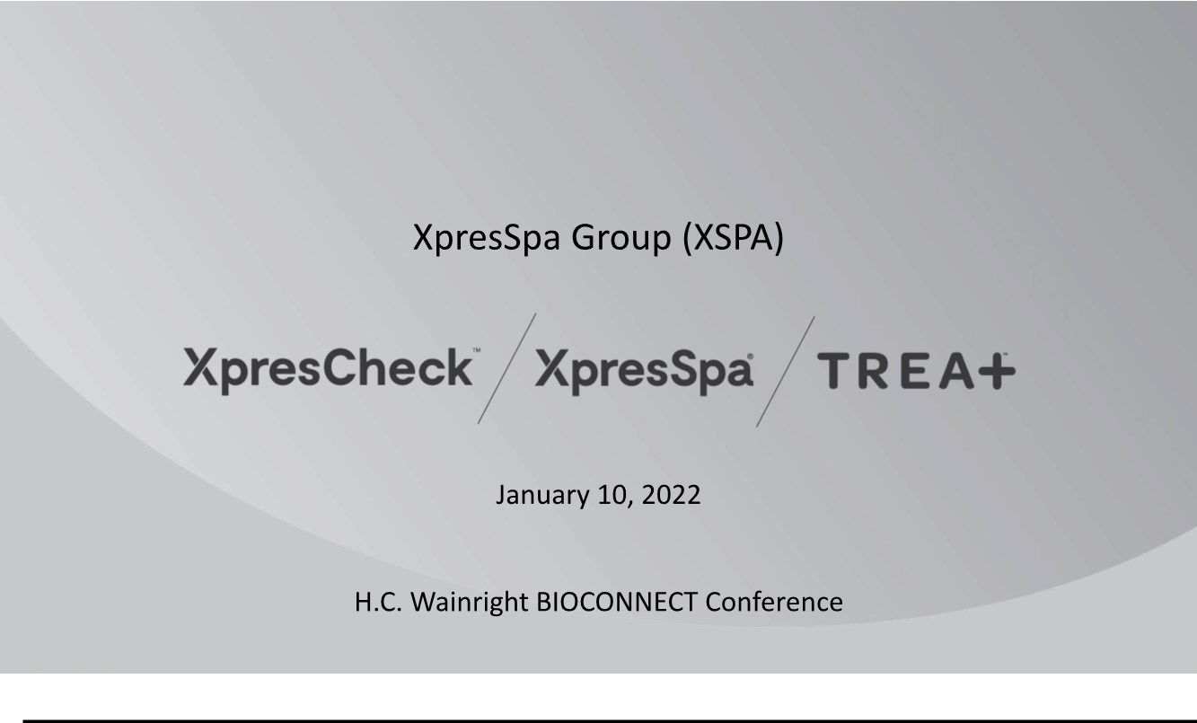

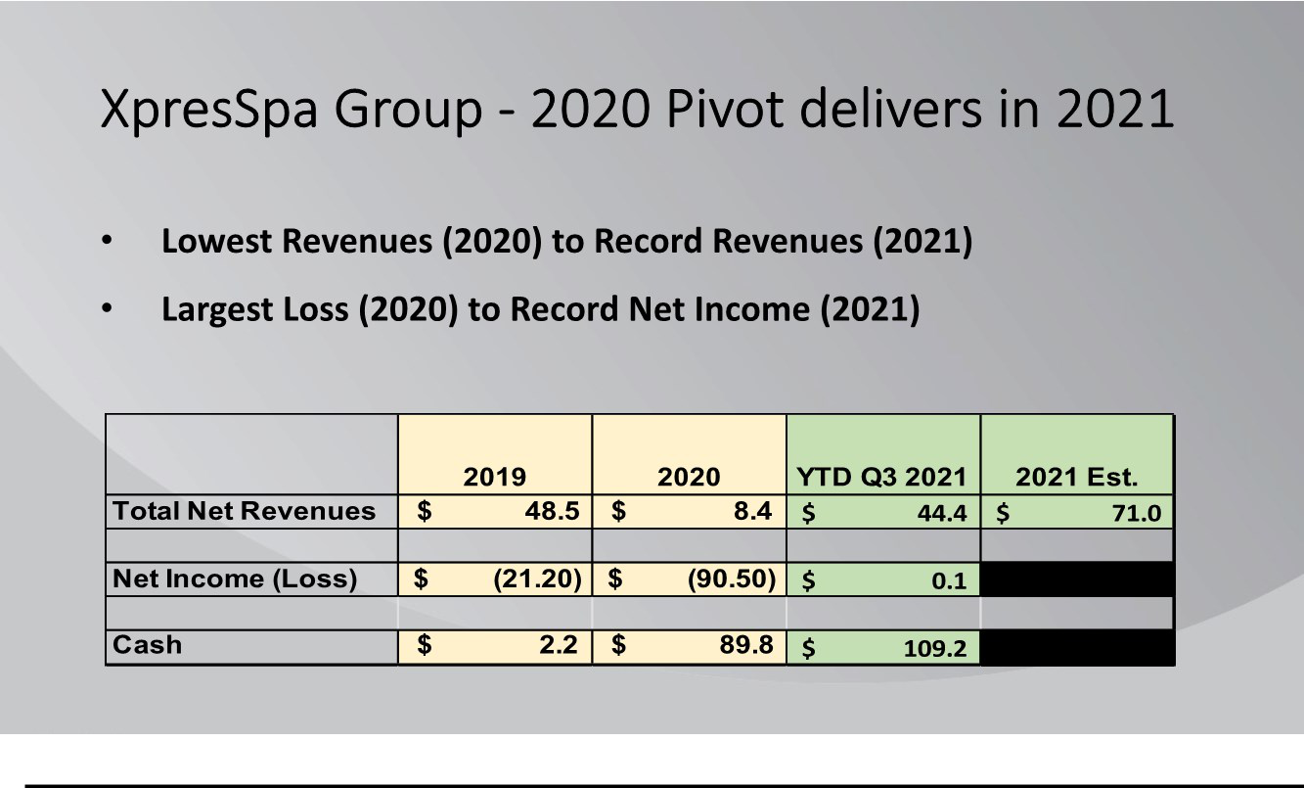

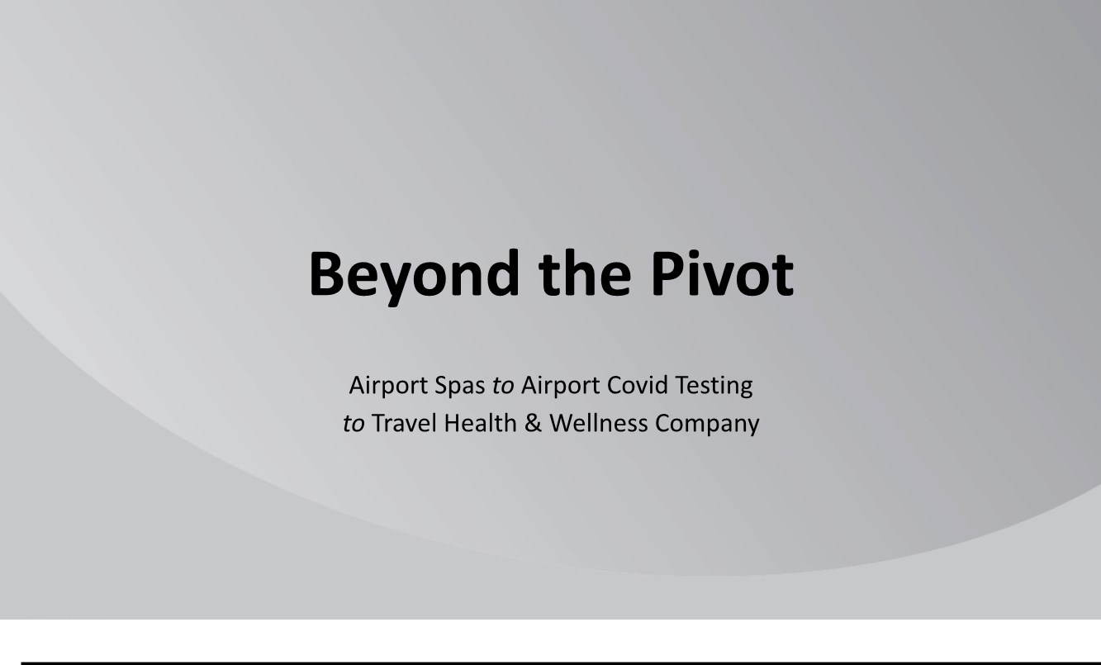

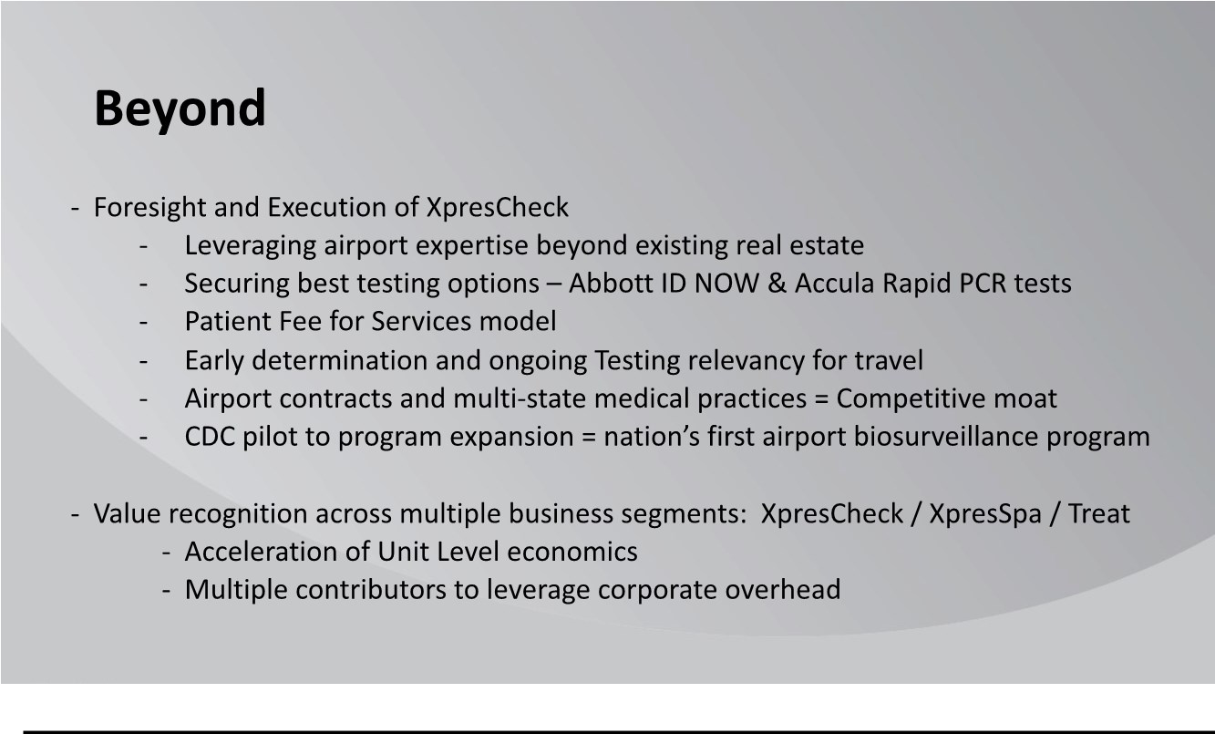

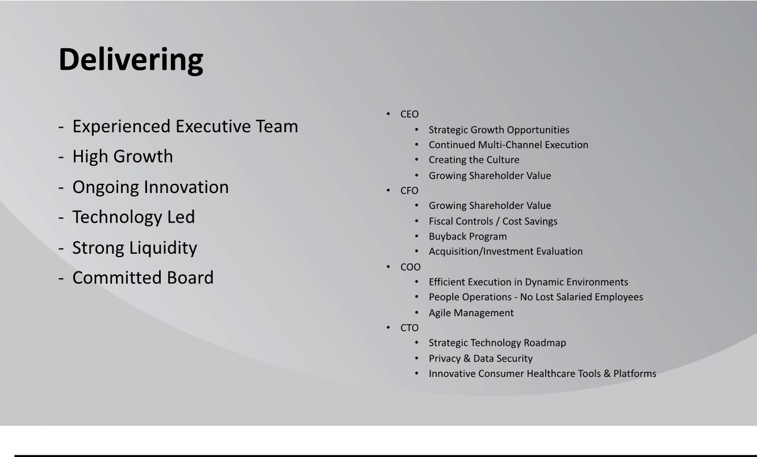

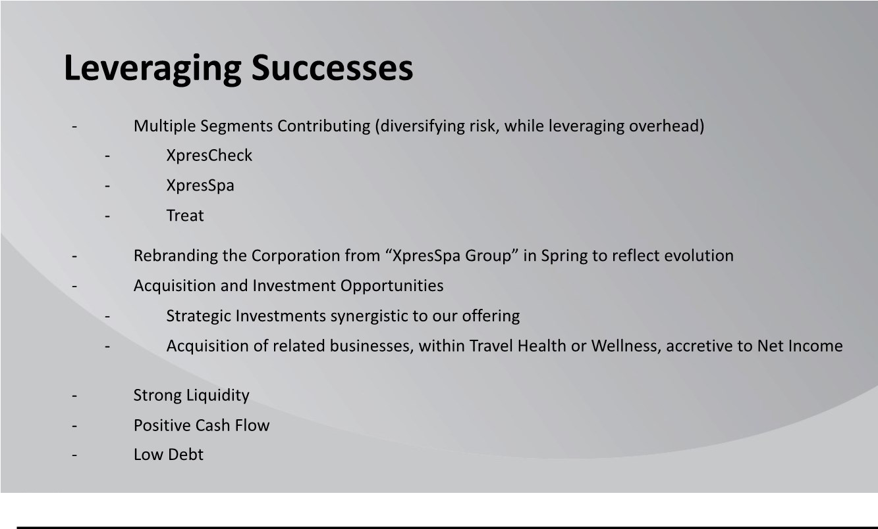

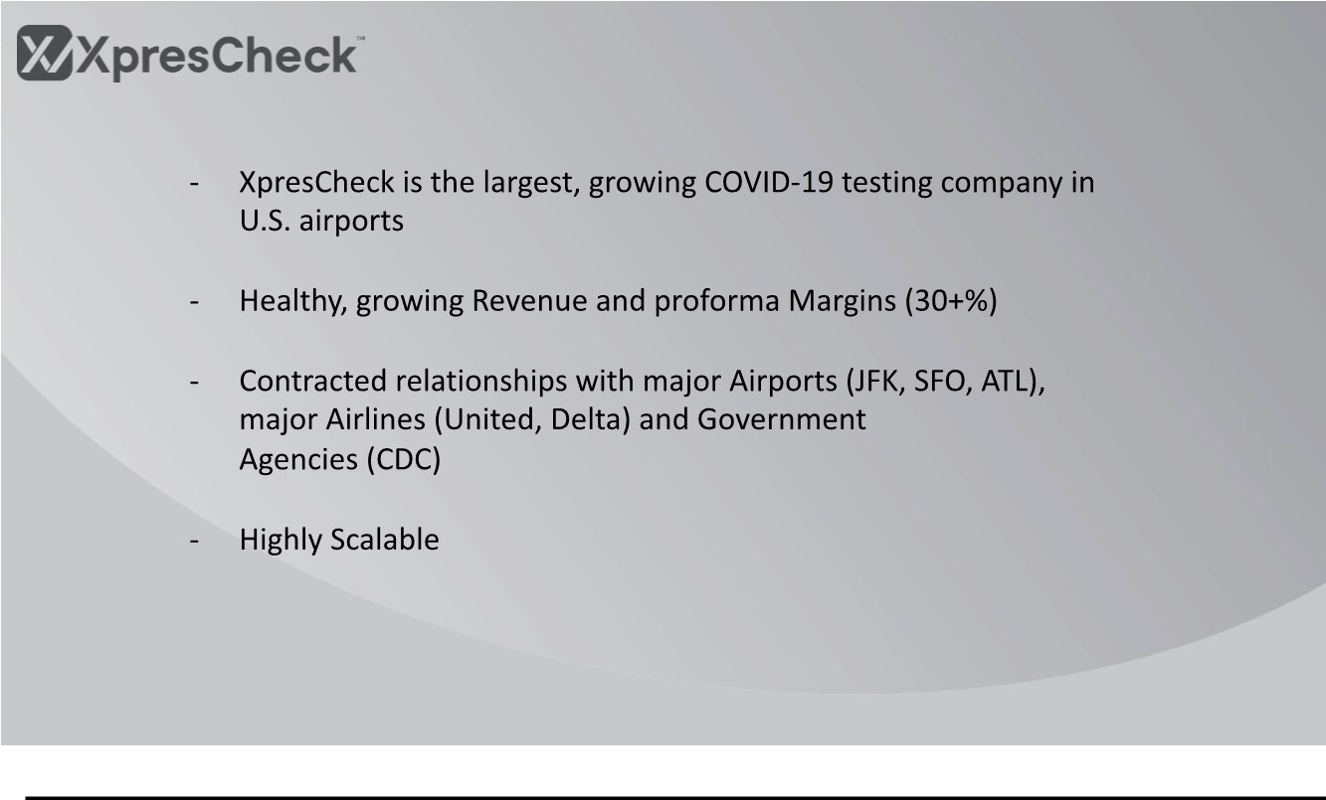

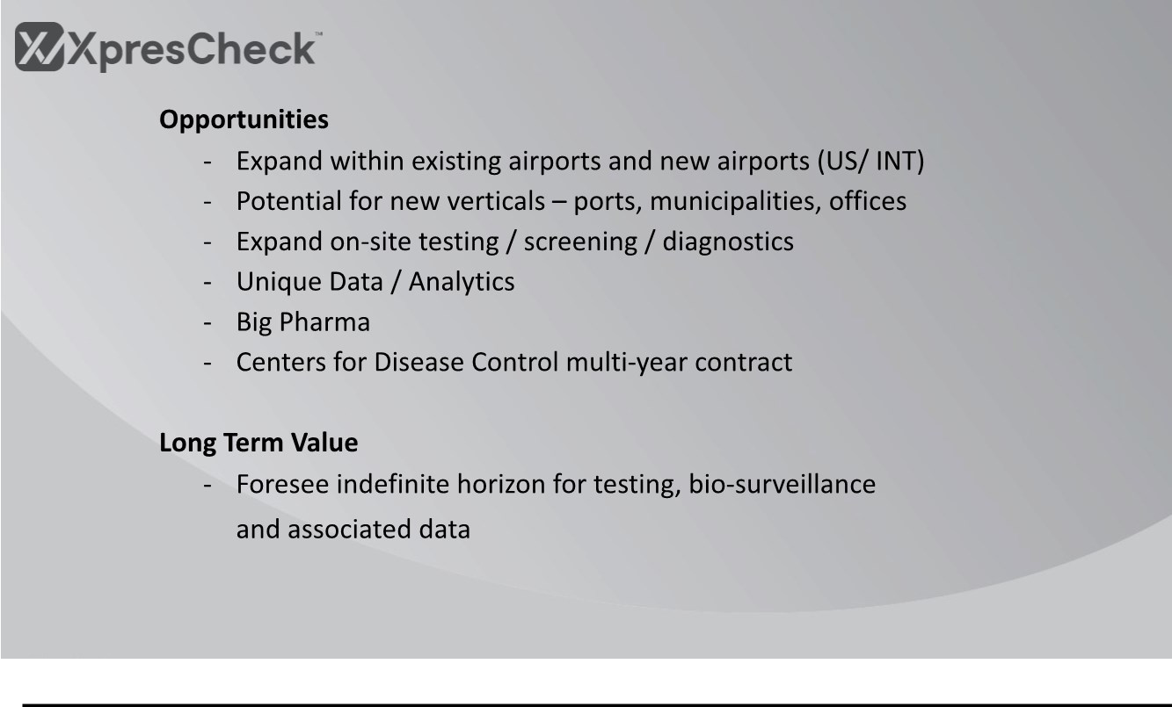

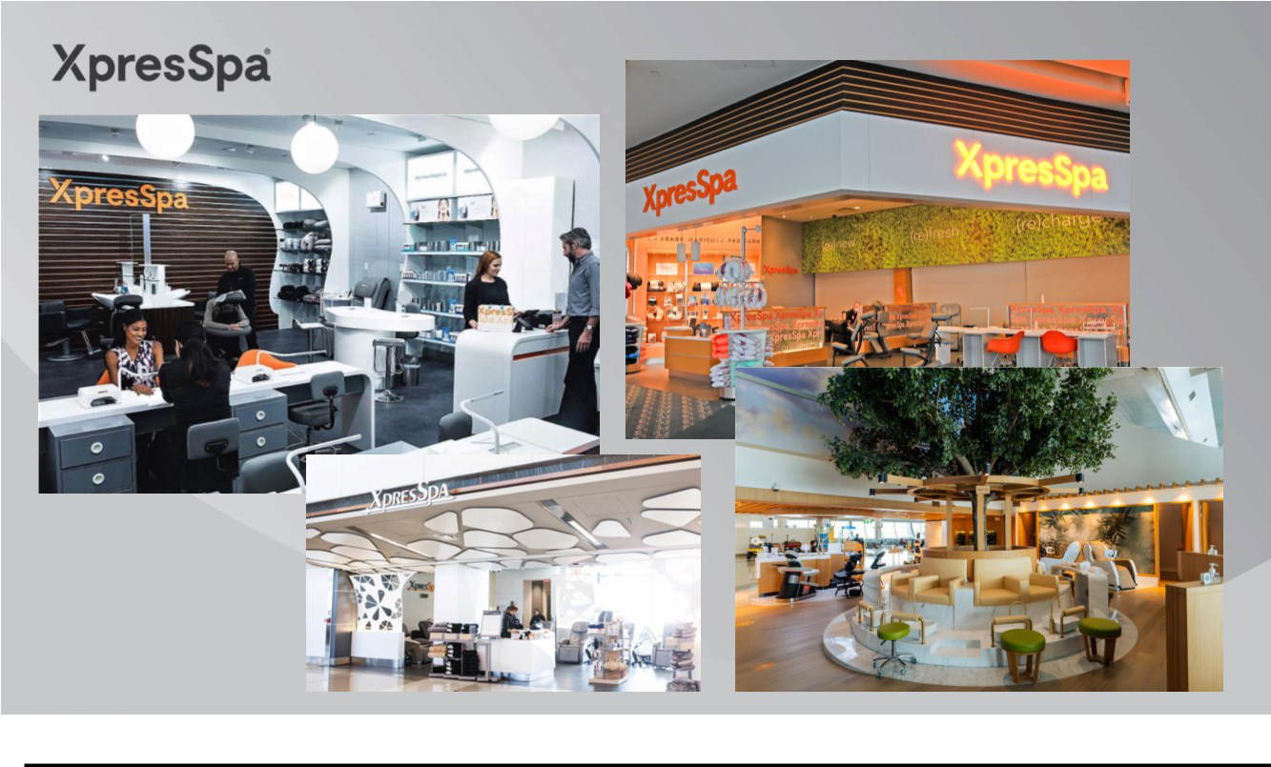

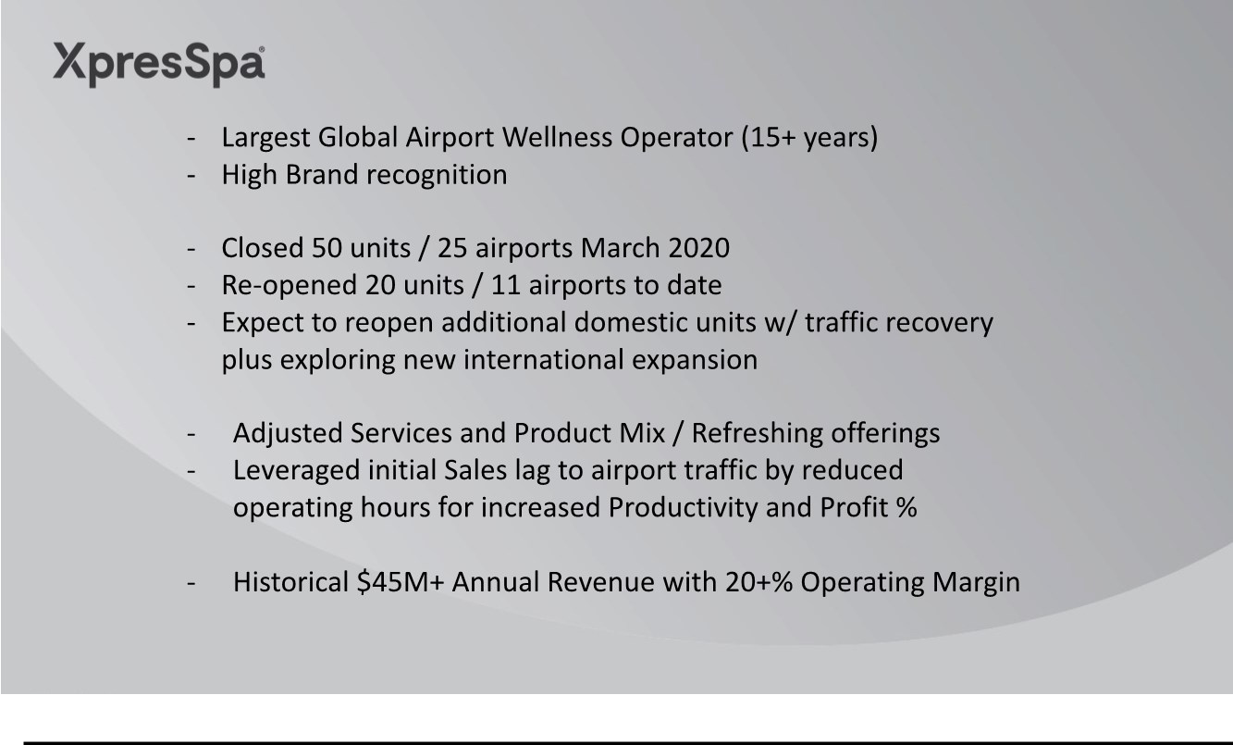

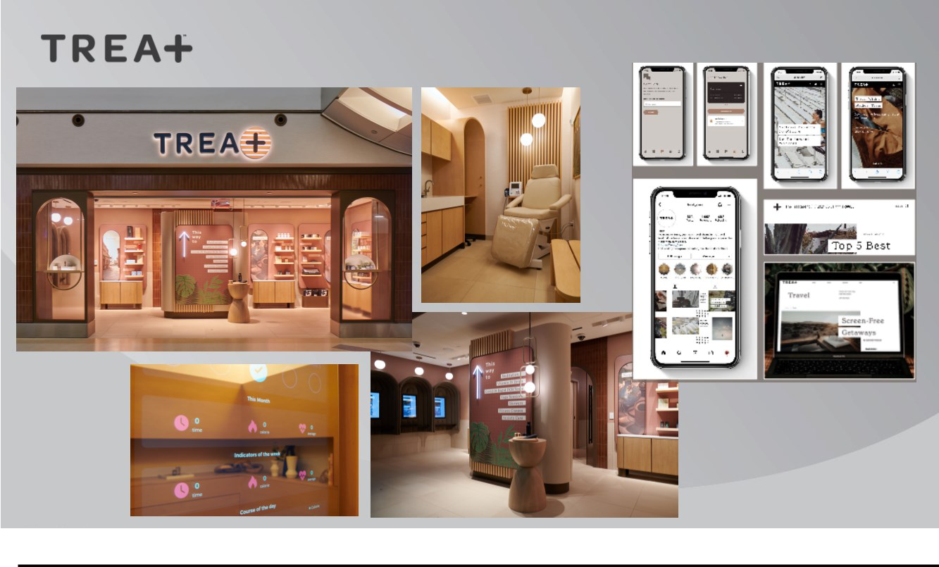

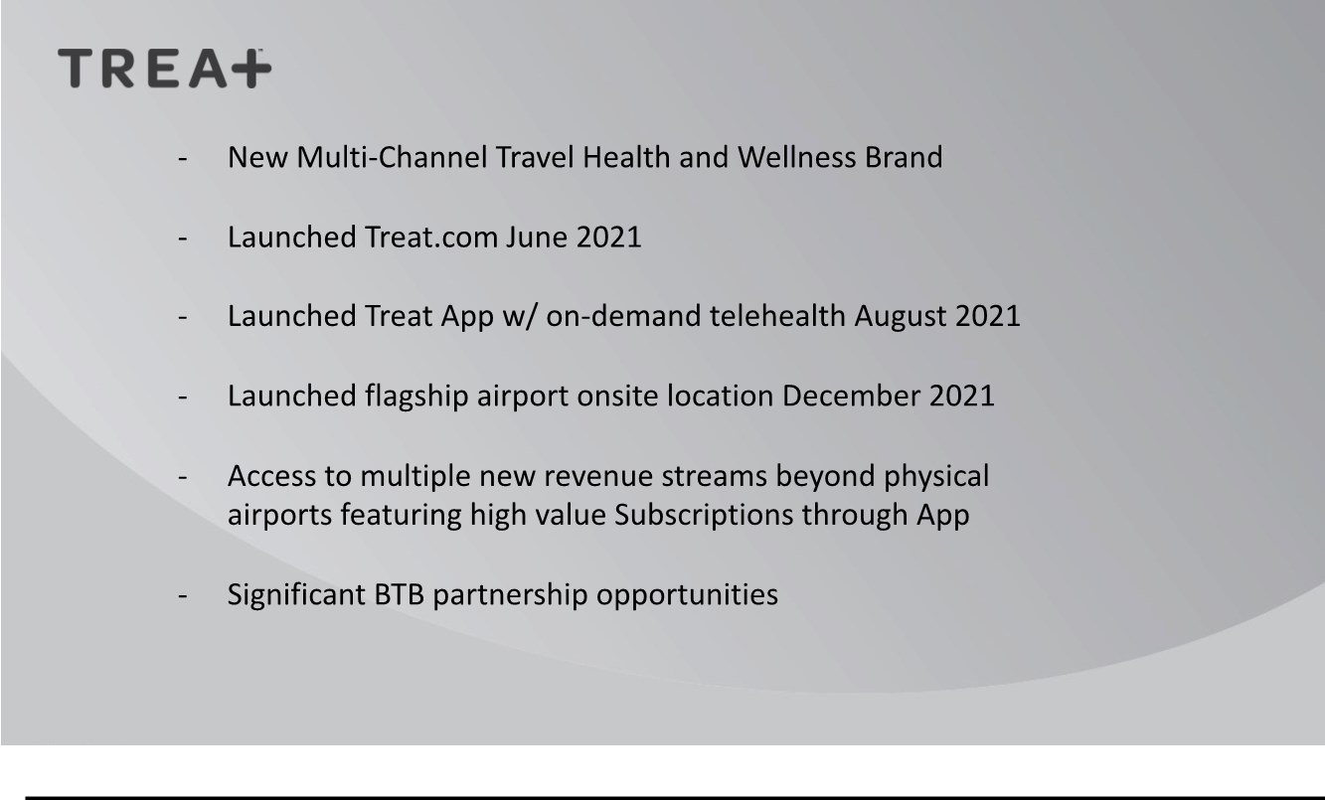

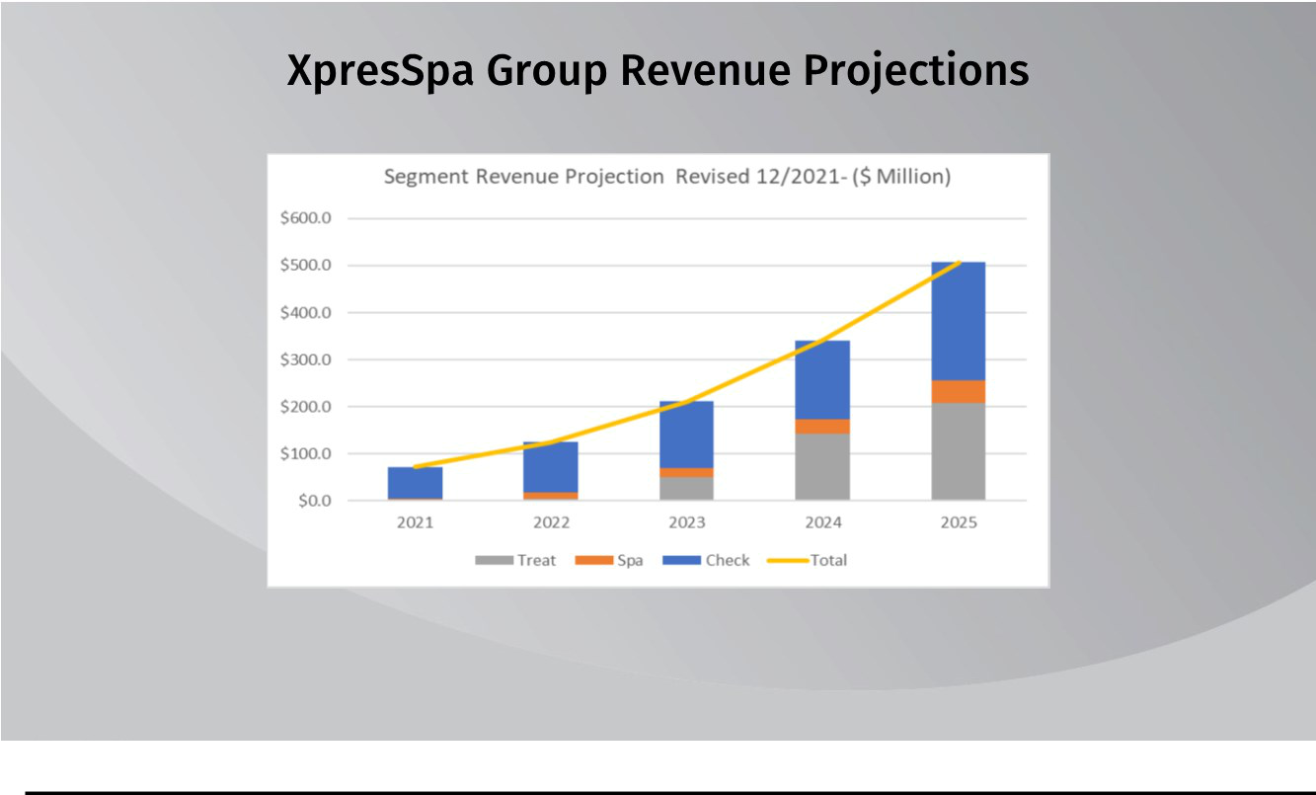

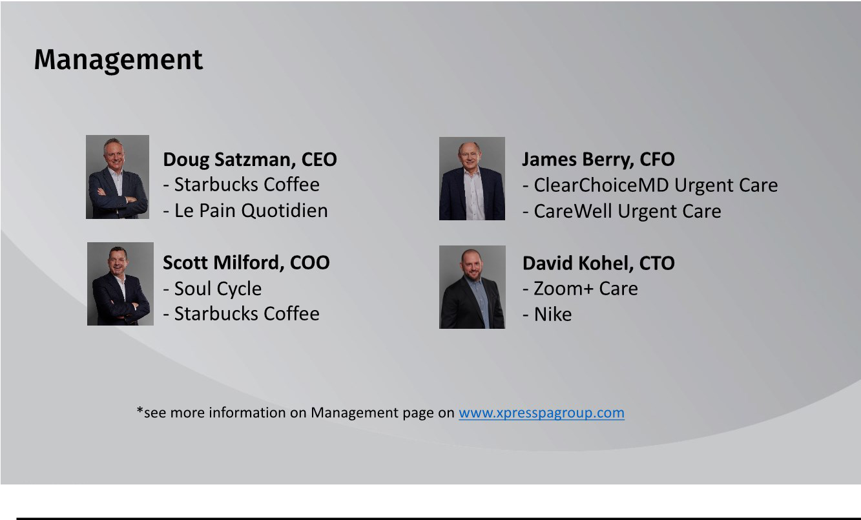

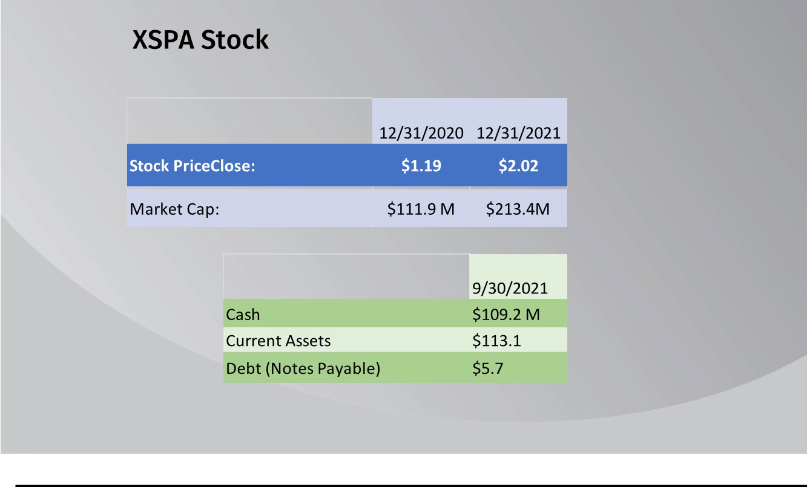

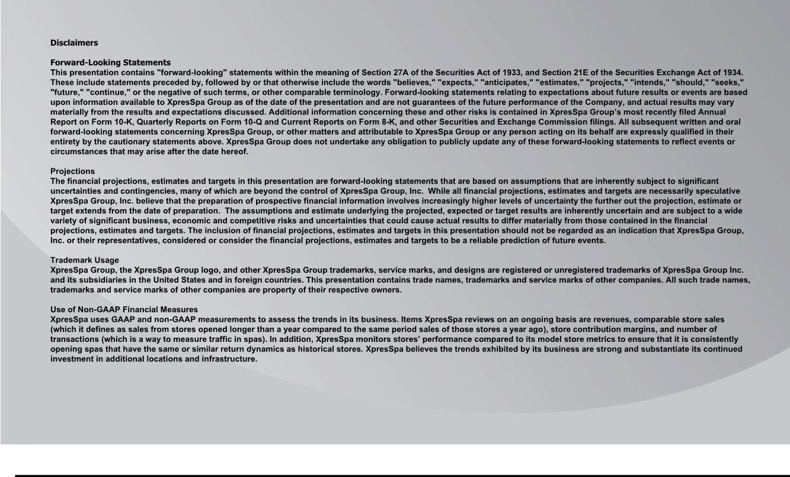

Exhibit 99.3


XpresSpa Group Announces Strategic Acquisition of HyperPointe

XpresCheck® Expanding Digital Health Capabilities & Data Analytics Services

NEW YORK, January 10, 2022 - XpresSpa Group, Inc. (Nasdaq: XSPA), a travel health and wellness company (the “Company”), today announced it had entered into an agreement to acquire all of the equity interests of GCG Connect, LLC d/b/a HyperPointe for $5.5 million in cash, $1 million in common stock, along with potential additional earn-out payments of up to $7.5 million over a three-year timeframe based upon future performance, which may be satisfied in cash or Company common stock or a combination subject to various terms and conditions. Based upon preliminary and unaudited results, HyperPointe generated $5.5 million in revenue and $1.2 million in EBITDA during 2021. The transaction is subject to customary closing conditions and is expected to close during the first quarter of 2022.

HyperPointe is a leading digital healthcare and data analytics relationship marketing agency servicing the global healthcare and pharmaceutical industry. HyperPointe has significant experience in patient and healthcare professional marketing and deep technological experience with CXM (customer experience management) and data analytics. Since June 2020 HyperPointe’s personnel and suite of services and technology have been used to develop and deploy the technological infrastructure for XpresCheck®. This partnership has proven to be trusted, strategic, and focused in launching COVID-19 screening and testing in U.S. airports through XpresCheck.

Doug Satzman, XpresSpa Group CEO, stated, “Expanding our digital health and data footprints is vital to expanding our business and developing additional routes to revenue. We view this as the next step in the journey we have been on since we first laid the groundwork for XpresCheck in the spring of 2020. HyperPointe was instrumental in helping to secure the CDC partnership, has been intimately involved in expanding that relationship, and has extensive healthcare knowledge and relationships with the pharmaceutical industry.

Ezra Ernst, HyperPointe CEO, added, “We have worked closely with the XpresSpa Group for more than 18 months and are excited to be joining their family of brands. We believe there is great opportunity for us to work collaboratively across multiple business lines, including data integration and analytics, which will allow us to bring proactive, personalized healthcare experiences, clinical intelligence, and biosecurity services to our many constituents from patients, health care professionals, governments, and pharmaceutical companies.

The HyperPointe team will join the Company as part of this transaction. HyperPointe will operate as a stand-alone entity and join the Company’s family of brands along with XpresCheck®, XpresSpa®, and Treat™. Mr. Ernst will also take on the role as Chief Executive Officer of XpresCheck, reporting to Doug Satzman, XpresSpa Group Chief Executive Officer. Mr. Ernst will spearhead efforts to rapidly expand and integrate XpresCheck’s COVID-19 screening and testing business with HyperPointe’s customer experience management technology, data management know how in furthering product and service offerings to additional airports and business customers in the healthcare and pharmaceutical verticals.

Mr. Ernst has spent 25 years in the healthcare sector revitalizing and accelerating revenue growth with innovation and agility to better serve clients, leverage technology, develop new products, leverage key industry partnerships, working with multiple presidential administrations and gaining access to new markets. His prior roles have included President - OptumHealth Education at UnitedHealth Group, General Manager at WebMD, and CEO at Physician’s Weekly.

Bruce Bernstein, XpresSpa Group Chairman of the Board, stated, “The extension of the CDC program underscores the importance of proactive bio-surveillance testing across our nation's airports and the leading role that XpresCheck is playing in monitoring the potential risks that may be entering our borders. Today’s modern consumers desire digital connections, services and safety when they travel. With HyperPointe joining our organization, I see them as an additional catalysts to further expand our relationship with the CDC and new revenue streams by moving XpresCheck into the digital health and biosecurity ecosystems.”

About XpresSpa Group, Inc.

XpresSpa Group, Inc. (Nasdaq: XSPA) is a leading global health and wellness holding company operating three distinct brands: XpresCheck®, XpresSpa®, Treat™. XpresCheck is a leading on-site airport provider of COVID-19 screening and testing with 14 locations in 12 domestic airports. XpresSpa is a leading airport retailer of spa services and related health and wellness products, with 43 locations in 21 airports globally. Treat is a travel health and wellness brand that is providing on-demand access to healthcare through technology and personalized services.

To learn more about XpresSpa Group, visit: www.XpresSpaGroup.com.

To learn more about XpresCheck, visit: www.XpresCheck.com.

To learn more about XpresSpa, visit www.XpresSpa.com.

To learn more about Treat, visit: www.Treat.com.

Twitter: @xprescheck and Instagram: @realxprescheck

Twitter: @XpresSpa and Instagram: @XpresSpa

Twitter: @Treat_Care and Instagram: @treat_care

About HyperPointe™

HyperPointe is a leading digital healthcare and data analytics relationship marketing agency servicing the global healthcare and pharmaceutical industry located in Teaneck, NJ. Throughout its history of 35+ years, HyperPointe has served as a valuable partner to a diverse array of global and domestic health brands by building deep, personal connections to the patients, caregivers, and healthcare providers they serve. To learn more, visit www.Hyperpointe.com

Forward-Looking Statements

This press release may contain "forward-looking" statements within the meaning of Section 27A of the Securities Act of 1933, and Section 21E of the Securities Exchange Act of 1934. These include statements preceded by, followed by or that otherwise include the words "believes," "expects," "anticipates," "estimates," "projects," "intends," "should," "seeks," "future," "continue," or the negative of such terms, or other comparable terminology. Forward-looking statements relating to expectations about future results or events are based upon information available to XpresSpa Group as of today's date and are not guarantees of the future performance of the Company, and actual results may vary materially from the results and expectations discussed. Additional information concerning these and other risks is contained in XpresSpa Group’s most recently filed Annual Report on Form 10-K, Quarterly Reports on Form 10-Q and Current Reports on Form 8-K, and other Securities and Exchange Commission filings. All subsequent written and oral forward-looking statements concerning XpresSpa Group, or other matters and attributable to XpresSpa Group or any person acting on its behalf are expressly qualified in their entirety by the cautionary statements above. XpresSpa Group does not undertake any obligation to publicly update any of these forward-looking statements to reflect events or circumstances that may arise after the date hereof.

Investor Relations

ICR

Raphael Gross

ir@xpresspagroup.com

(203) 682-8253

Media

Julie Ferguson

Julie@jfprmedia.com

(312) 385-0098

Exhibit 99.4

XpresSpa Group Announces Inducement Grant Under Nasdaq Listing Rule 5635(c)(4)

NEW YORK, January 10, 2022 - XpresSpa Group, Inc. (Nasdaq: XSPA), a travel health and wellness company, today announced that a majority of the independent members of its Board of Directors granted an equity award to Ezra T. Ernst, who was previously affiliated with GCG Connect LLC d/b/a HyperPointe (“HyperPointe”) and who was offered employment with the Company in connection with XpresSpa’s acquisition of the equity interests of HyperPointe, as an inducement material to such new employee entering into employment with the Company. The equity award was approved on January 7, 2022, in accordance with Nasdaq Listing Rule 5635(c)(4).

The employee will receive stock options to purchase 1,000,000 shares of XpresSpa common stock. The stock options will be issued upon the closing of the acquisition of HyperPointe and employee’s hire date in connection therewith (the "Grant Date"), and all stock options included within the equity inducement award will have an exercise price equal to the closing price of XpresSpa common stock on the Grant Date. One-third of the options will vest on each of the first three anniversaries of the Grant Date, subject to the employee's continued employment with XpresSpa or its subsidiaries on such vesting dates. The stock options have a ten-year term.

About XpresSpa Group, Inc.

XpresSpa Group, Inc. (Nasdaq: XSPA) is a leading global travel health and wellness holding company operating three distinct brands: XpresCheck®, XpresSpa® and Treat™. XpresCheck is a leading on-site airport provider of COVID-19 screening and testing with 14 locations in 12 domestic airports. XpresSpa is a leading airport retailer of spa services and related health and wellness products, with 43 locations in 21 airports globally. Treat is a travel health and wellness brand that will be providing on-demand access to healthcare through technology and personalized services with one flagship location at JFK Terminal 4.

To learn more about XpresSpa Group, visit: www.XpresSpaGroup.com.

To learn more about XpresCheck, visit: www.XpresCheck.com.

To learn more about XpresSpa, visit www.XpresSpa.com.

To learn more about Treat, visit: www.Treat.com.

Twitter: @xprescheck and Instagram: @realxprescheck

Twitter: @XpresSpa and Instagram: @XpresSpa

Twitter: @Treat_Care and Instagram: @treat_care

