UNITED STATES

SECURITIES AND EXCHANGE COMMISSION

Washington, D.C. 20549

SCHEDULE 13D

Under the Securities Exchange Act of 1934

(Amendment No. 1)*

XWELL, Inc.

(Name of Issuer)

Common Stock, $0.01 par value per share

(Title of Class of Securities)

98420U703

(CUSIP Number)

Wayne Mack

Richard Waldo

CPC Pain & Wellness SPV, LLC

301 Edgewater Place, Suite 100

Wakefield, MA 01880

(617) 531-9767

Ben A. Stacke

Faegre Drinker Biddle & Reath LLP

2200 Wells Fargo Center

90 S. Seventh Street

Minneapolis, Minnesota 55402

(612) 776-7000

(Name, Address and Telephone Number of Person Authorized to Receive Notices and Communications)

July 19, 2024

(Date of Event which Requires Filing of this Statement)

If the filing person has previously filed a statement on Schedule 13G to report the acquisition that is the subject of this Schedule 13D, and is filing this schedule because of Rule 13d-1(e), 13d-1(f) or 13d-1(g), check the following box ☐.

*The remainder of this cover page shall be filled out for a reporting person’s initial filing on this form with respect to the subject class of securities, and for any subsequent amendment containing information which would alter disclosures provided in a prior cover page.

The information required on the remainder of this cover page shall not be deemed to be “filed” for the purpose of Section 18 of the Securities Exchange Act of 1934 (“Act”) or otherwise subject to the liabilities of that section of the Act but shall be subject to all other provisions of the Act (however, see the Notes).

SCHEDULE 13D
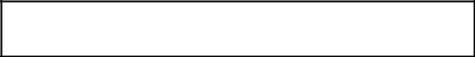
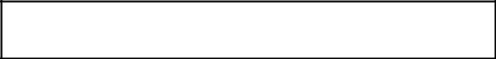

CUSIP No. 98420U703

1 |  | NAME OF REPORTING PERSON
1 |  | CPC Pain & Wellness SPV, LLC
2 |  | CHECK THE APPROPRIATE BOX IF A MEMBER OF A GROUP |  |  |  | (a) ☐
 |  | (See Instructions) |  |  |  | (b) ☐
3 |  | SEC USE ONLY
4 |  | SOURCE OF FUNDS (See Instructions)
4 |  | WC
5 |  | CHECK IF DISCLOSURE OF LEGAL PROCEEDINGS IS REQUIRED |  |  |  | ☐
 |  | PURSUANT TO ITEM 2(d) or 2(e)
6 |  | CITIZENSHIP OR PLACE OF ORGANIZATION
6 |  | Delaware
 |  |  | 7 |  | SOLE VOTING POWER
 |  |  | 7 |  | 0
 |  | NUMBER OF |  |  | 0
 |  | SHARES | 8 |  | SHARED VOTING POWER
 | BENEFICIALLY |  | 8 |  | SHARED VOTING POWER
 |  |  | 8 |  | 394,200
 |  | OWNED BY |  |  | 394,200
 |  | EACH
 |  | EACH | 9 |  | SOLE DISPOSITIVE POWER
 |  | REPORTING | 9 |  | SOLE DISPOSITIVE POWER
 |  | REPORTING | 9 |  | 0
 |  | PERSON |  |  | 0
 |  | WITH
 |  | WITH | 10 |  | SHARED DISPOSITIVE POWER
 |  |  | 10 |  | 394,200
11 |  | AGGREGATE AMOUNT BENEFICIALLY OWNED BY EACH REPORTING PERSON
11 |  | 394,200
12 |  | CHECK IF THE AGGREGATE AMOUNT IN ROW (11) EXCLUDES CERTAIN SHARES |  |  |  | ☐
 |  | (See Instructions)
13 |  | PERCENT OF CLASS REPRESENTED BY AMOUNT IN ROW (11)
13 |  | 9.42%¹
14 |  | TYPE OF REPORTING PERSON (See Instructions)
14 |  | OO

- Based on 4,183,435 shares of Common Stock outstanding as of May 14, 2024 as reported in the Issuer’s quarterly report on Form 10-Q for the quarter ended March 31, 2024.

2 of 11

1 |  | NAME OF REPORTING PERSON
1 |  | ACM-CPC, LLC
2 |  | CHECK THE APPROPRIATE BOX IF A MEMBER OF A GROUP |  |  |  | (a) ☐
 |  | (See Instructions) |  |  |  | (b) ☐
3 |  | SEC USE ONLY
4 |  | SOURCE OF FUNDS (See Instructions)
4 |  | AF
5 |  | CHECK IF DISCLOSURE OF LEGAL PROCEEDINGS IS REQUIRED
5 |  | PURSUANT TO ITEM 2(d) or 2(e)
6 |  | CITIZENSHIP OR PLACE OF ORGANIZATION |  |  |  | ☐
 |  | Delaware
 |  |  | 7 |  | SOLE VOTING POWER
 |  |  | 7 |  | 0
 |  | NUMBER OF |  |  | 0
 |  | SHARES | 8 |  | SHARED VOTING POWER
 | BENEFICIALLY |  | 8 |  | 394,200
 |  | OWNED BY
 |  | EACH | 9 |  | SOLE DISPOSITIVE POWER
 |  | REPORTING | 9 |  | 0
 |  | PERSON
 |  | WITH | 10 |  | SHARED DISPOSITIVE POWER
 |  |  |  |  | 394,200
11 |  | AGGREGATE AMOUNT BENEFICIALLY OWNED BY EACH REPORTING PERSON
11 |  | 394,200
12 |  | CHECK IF THE AGGREGATE AMOUNT IN ROW (11) EXCLUDES CERTAIN SHARES |  |  |  | ☐
 |  | (See Instructions)
13 |  | PERCENT OF CLASS REPRESENTED BY AMOUNT IN ROW (11)
13 |  | 9.42%²
14 |  | TYPE OF REPORTING PERSON (See Instructions)
14 |  | OO

- Based on 4,183,435 shares of Common Stock outstanding as of May 14, 2024 as reported in the Issuer’s quarterly report on Form 10-Q for the quarter ended March 31, 2024.

3 of 15

1 |  | NAME OF REPORTING PERSON
1 |  | Wayne Mack
2 |  | CHECK THE APPROPRIATE BOX IF A MEMBER OF A GROUP |  |  |  |  | (a) ☐
 |  | (See Instructions) |  |  |  |  | (b) ☐
3 |  | SEC USE ONLY
4 |  | SOURCE OF FUNDS (See Instructions)
4 |  | AF
5 |  | CHECK IF DISCLOSURE OF LEGAL PROCEEDINGS IS REQUIRED |  |  |  |  | ☐
5 |  | PURSUANT TO ITEM 2(d) or 2(e) |  |  |  |  | ☐
6 |  | CITIZENSHIP OR PLACE OF ORGANIZATION
6 |  | United States of America
 |  |  |  | 7 |  | SOLE VOTING POWER
 |  |  |  | 7 |  | 0
 |  | NUMBER OF |  |  |  | 0
 |  | SHARES |  | 8 |  | SHARED VOTING POWER
 | BENEFICIALLY |  |  | 8 |  | SHARED VOTING POWER
 |  |  |  | 8 |  | 394,200
 |  | OWNED BY |  |  |  | 394,200
 |  | EACH
 |  | EACH |  | 9 |  | SOLE DISPOSITIVE POWER
 |  | REPORTING |  | 9 |  | SOLE DISPOSITIVE POWER
 |  | REPORTING |  | 9 |  | 0
 |  | PERSON |  |  |  | 0
 |  | WITH
 |  | WITH |  | 10 |  | SHARED DISPOSITIVE POWER
 |  |  |  | 10 |  | 394,200
11 |  | AGGREGATE AMOUNT BENEFICIALLY OWNED BY EACH REPORTING PERSON
11 |  | 394,200
12 |  | CHECK IF THE AGGREGATE AMOUNT IN ROW (11) EXCLUDES CERTAIN SHARES |  |  |  |  | ☐
 |  | (See Instructions)
13 |  | PERCENT OF CLASS REPRESENTED BY AMOUNT IN ROW (11)
13 |  | 9.42%³
14 |  | TYPE OF REPORTING PERSON (See Instructions)
14 |  | IN

- Based on 4,183,435 shares of Common Stock outstanding as of May 14, 2024 as reported in the Issuer’s quarterly report on Form 10-Q for the quarter ended March 31, 2024.

4 of 15

1 |  | NAME OF REPORTING PERSON
1 |  | Richard Waldo
2 |  | CHECK THE APPROPRIATE BOX IF A MEMBER OF A GROUP |  |  |  |  | (a) ☐
 |  | (See Instructions) |  |  |  |  | (b) ☐
3 |  | SEC USE ONLY
4 |  | SOURCE OF FUNDS (See Instructions)
4 |  | AF
5 |  | CHECK IF DISCLOSURE OF LEGAL PROCEEDINGS IS REQUIRED |  |  |  |  | ☐
5 |  | PURSUANT TO ITEM 2(d) or 2(e) |  |  |  |  | ☐
6 |  | CITIZENSHIP OR PLACE OF ORGANIZATION
6 |  | United States of America
 |  |  |  | 7 |  | SOLE VOTING POWER
 |  |  |  | 7 |  | 0
 |  | NUMBER OF |  |  |  | 0
 |  | SHARES |  | 8 |  | SHARED VOTING POWER
 | BENEFICIALLY |  |  | 8 |  | SHARED VOTING POWER
 |  |  |  | 8 |  | 394,200
 |  | OWNED BY |  |  |  | 394,200
 |  | EACH
 |  | EACH |  | 9 |  | SOLE DISPOSITIVE POWER
 |  | REPORTING |  | 9 |  | SOLE DISPOSITIVE POWER
 |  | REPORTING |  | 9 |  | 0
 |  | PERSON |  |  |  | 0
 |  | WITH
 |  | WITH |  | 10 |  | SHARED DISPOSITIVE POWER
 |  |  |  | 10 |  | 394,200
11 |  | AGGREGATE AMOUNT BENEFICIALLY OWNED BY EACH REPORTING PERSON
11 |  | 394,200
12 |  | CHECK IF THE AGGREGATE AMOUNT IN ROW (11) EXCLUDES CERTAIN SHARES |  |  |  |  | ☐
 |  | (See Instructions)
13 |  | PERCENT OF CLASS REPRESENTED BY AMOUNT IN ROW (11)
13 |  | 9.42%⁴
14 |  | TYPE OF REPORTING PERSON (See Instructions)
14 |  | IN

- Based on 4,183,435 shares of Common Stock outstanding as of May 14, 2024 as reported in the Issuer’s quarterly report on Form 10-Q for the quarter ended March 31, 2024.

5 of 15

The following constitutes Amendment No. 1 (this "Amendment No. 1") to the Schedule 13D filed by the Reporting Persons on June 17, 2024 with the Securities and Exchange Commission (the "June 17, 2024 Schedule 13D"). Information reported in the June 17, 2024 Schedule 13D remains in effect except to the extent that it is amended, restated or superseded by information contained in this Amendment No. 1. Capitalized terms used but not defined herein shall have the meanings set forth in the June 17, 2024 Schedule 13D.

Item 4. Purpose of Transaction.

Item 4 is hereby amended and supplemented as follows:

As originally disclosed in the June 17, 2024 Schedule 13D, the Reporting Persons purchased the Shares based on their belief that the Shares, when purchased, were undervalued and represented an attractive investment opportunity. Depending upon overall market conditions, other investment opportunities available to the Reporting Persons, and the availability of Common Stock at prices that would make the purchase or sale of Common Stock desirable, the Reporting Persons may endeavor to increase or decrease their position in the Issuer through, among other things, the purchase or sale of Common Stock on the open market or in private transactions or otherwise, on such terms and at such times as the Reporting Persons may deem advisable.

Also as originally disclosed in the June 17, 2024 Schedule 13D, the Reporting Persons are concerned with the Issuer’s long-term underperformance and believe shareholder representation on the Board of Directors of the Issuer (the “Board”) and a change in the composition of the Board is necessary to drive significant improvements to the Issuer’s governance, capital allocation and operations, and to explore strategic alternatives. The Reporting Persons believe there are significant growth opportunities at the Issuer and remains available and ready to engage directly with the Board and management to discuss such opportunities.

6 of 11

As further originally disclosed in the June 17, 2024 Schedule 13D, depending on various factors including, without limitation, the Issuer’s financial position and investment strategy, the price levels of the Common Stock, conditions in the securities markets and general economic and industry conditions, the Reporting Persons may in the future take such actions with respect to their investment in the Issuer as they deem appropriate including, without limitation, engaging in communications with management and the Board, engaging in discussions with shareholders of the Issuer or third parties, including potential acquirers and service providers about the Issuer and the Reporting Persons’ investment, making proposals to the Issuer concerning changes to the capital allocation strategy, capitalization, ownership structure, Board structure (including Board composition), certain strategic alternatives or the operations of the Issuer, purchasing additional Common Stock, selling some or all of its Shares, engaging in short selling of or any hedging or similar transaction with respect to the Shares, or changing its intention with respect to any and all matters referred to in Item 4.

On June 17, 2024, the Reporting Persons sent by email a letter to the Issuer (the “Initial Notice”) providing notice of intent to nominate Daniel Serpico, Chad J. Cooper, Matthew Thelen and Jerry J. Rosenstock (together, the “Nominees”) for election to the Board at the Issuer’s upcoming annual meeting of stockholders (the “Annual Meeting”). A copy of the Initial Notice was delivered to the Issuer’s principal office on June 17, 2024.

On June 21, 2024, the Issuer, through its counsel, delivered a letter to CPC (the “First Rejection”) rejecting CPC’s nomination of the Nominees at the Annual Meeting.

On June 23, 2024, the Reporting Persons sent by email a letter to the Issuer (the “Second Notice”) responding to the First Rejection and amending and revising the Initial Notice. A copy of the Second Notice was delivered to the Issuer’s principal office on June 23, 2024.

On June 29, 2024, the Issuer, through its counsel, delivered a letter to CPC (the “Second Rejection”) rejecting the Second Notice and declaring that the deadline for a timely and proper notice of intention to nominate candidates for election as directors at the Annual Meeting was the close of business on June 23, 2024, and therefore the Reporting Persons do not have the right to nominate any candidates for election as directors at the Annual Meeting.

On July 8, 2024, following the entry into a mutual non-disclosure agreement between the Issuer and the Reporting Persons, the parties entered into settlement negotiations, which, ultimately, proved unsuccessful.

On July 19, 2024, CPC filed a Verified Complaint in the Delaware Court of Chancery (the “Delaware Action”) against the Issuer and Bruce T. Bernstein, Michael Lebowitz, Robert Weinstein, Gaëlle Wizenberg and Scott R. Milford (together, the “Entrenched Directors” and collectively with the Issuer, the “Defendants”). The Delaware Action alleges, among other things, claims for breach of fiduciary duties by the Entrenched Directors and unlawful, unenforceable and/or inequitable application of the Issuer’s Bylaws by the Defendants to reject the Initial Notice and Second Notice. The Delaware Action requests, among other things, that the Delaware Court of Chancery (i) declare that the Nominees have been properly nominated for election to the Board at the Annual Meeting, (ii) declare that the Nominees can stand for election notwithstanding the rejection of the Initial Notice and Second Notice, (iii) order the Defendants to accept the Second Notice as valid and include the Nominees on the Issuer’s universal proxy card that the Issuer will issue in connection with the Annual Meeting, and (iv) if necessary, preliminarily enjoin the Annual Meeting so that it occurs after the Reporting Persons have the opportunity to file their own Schedule 14A and to distribute it to the Issuer’s stockholders for their consideration. The foregoing description of the Delaware Action does not purport to be complete and is qualified in its entirety by reference to the Delaware Action, which is attached as Exhibit 99.2 hereto and is incorporated herein by reference.

Item 5. Interest in Securities of the Issuer.

The aggregate number of shares of Common Stock to which this Amendment No. 1 relates is 394,200 shares of Common Stock beneficially owned by the Reporting Persons, representing 9.42% of the 4,183,435 shares of Common Stock reported as outstanding in the Issuer’s Form 10-Q filed on May 15, 2024.

A. CPC

- As of the date hereof, CPC directly owned 394,200 Shares.

- 1. Sole power to vote or direct vote: 0

  - Shared power to vote or direct vote: 394,200

  - Sole power to dispose or direct the disposition: 0

  - Shared power to dispose or direct the disposition: 394,200

7 of 11

- Schedule A annexed hereto lists all transactions in securities of the Issuer by CPC during the past 60 days. All of such transactions were effected in the open market unless otherwise noted therein.

B. ACM-CPC

- ACM-CPC, as the managing member of CPC, may be deemed the beneficial owner of the 394,200 Shares owned directly by CPC.

- 1. Sole power to vote or direct vote: 0

  - Shared power to vote or direct vote: 394,200

  - Sole power to dispose or direct the disposition: 0

  - Shared power to dispose or direct the disposition: 394,200

- ACM-CPC has not entered into any transactions in securities of the Issuer during the past 60 days.

C. Wayne Mack

- Mr. Mack, as the co-managing member of ACM-CPC, may be deemed the beneficial owner of the 394,200 Shares owned directly by CPC.

- 1. Sole power to vote or direct vote: 0

  - Shared power to vote or direct vote: 394,200

  - Sole power to dispose or direct the disposition: 0

  - Shared power to dispose or direct the disposition: 394,200

- Mr. Mack has not entered into any transactions in securities of the Issuer during the past 60 days.

D. Richard Waldo

- Mr. Waldo, as the co-managing member of ACM-CPC, may be deemed the beneficial owner of the 394,200 Shares owned directly by CPC.

- 1. Sole power to vote or direct vote: 0

  - Shared power to vote or direct vote: 394,200

  - Sole power to dispose or direct the disposition: 0

  - Shared power to dispose or direct the disposition: 394,200

- Mr. Waldo has not entered into any transactions in securities of the Issuer during the past 60 days.

- No person other than the Reporting Persons is known to have the right to receive, or the power to direct the receipt of dividends from, or proceeds from the sale of, the Shares.

- Not applicable.

Item 6. Contracts, Arrangements, Understandings or Relationships with Respect to Securities of the Issuer.

Item 6 is hereby amended to add the following:

On July 22, 2024, the Reporting Persons entered into a Joint Filing Agreement in which the Reporting Persons agreed to the joint filing on behalf of each of them of statements on Amendment No. 1 with respect to the securities of the Issuer to the extent as required by applicable law. A copy of this agreement is attached hereto as Exhibit 99.1 and is incorporated herein by reference.

Item 7. Material to Be Filed as Exhibits.

99.1 Joint Filing Agreement, by and among CPC Pain & Wellness SPV, LLC, ACM-CPC, LLC, Wayne Mack and Richard Waldo, dated July 22, 2024.

99.2 Complaint filed in the Delaware Court of Chancery on July 19, 2024.

8 of 11

Signature

After reasonable inquiry and to the best of my knowledge and belief, I certify that the information set forth in this statement is true, complete and correct.

Dated: July 22, 2024

CPC PAIN & WELLNESS SPV, LLC

By: ACM-CPC, LLC

By: /s/ Wayne Mack

Name: Wayne Mack

Title: Managing Member

By: /s/ Richard Waldo

Name: Richard Waldo

Title: Managing Member

ACM-CPC, LLC

By: /s/ Wayne Mack

Name: Wayne Mack

Title: Managing Member

By: /s/ Richard Waldo

Name: Richard Waldo

Title: Managing Member

/s/ Wayne Mack

Wayne Mack

/s/ Richard Waldo

Richard Waldo

9 of 11

 |  | Schedule A
Nature of Transacton | Amount of Securites Purchased |  |  | Price ($) | Date of Purchase
Purchase of Common Stock | 3,000 |  |  | $1.6403 | 6/5/2024
Purchase of Common Stock | 3,000 |  |  | $1.6574 | 6/6/2024
Purchase of Common Stock | 3,000 |  |  | $1.6026 | 6/7/2024
Purchase of Common Stock | 41,068 |  |  | $1.6799 | 6/10/2024
Purchase of Common Stock | 20,310 |  |  | $1.9073 | 6/11/2024
Purchase of Common Stock | 48,921 |  |  | $2.0691 | 6/12/2024
Purchase of Common Stock | 46,255 |  |  | $2.3456 | 6/13/2024
Purchase of Common Stock | 24,320 |  |  | $2.4972 | 6/14/2024
Purchase of Common Stock | 4,326 |  |  | $2.4950 | 6/17/2024

10 of 11

Exhibit 99.1

JOINT FILING AGREEMENT

In accordance with Rule 13d-1(k)(1)(iii) under the Securities Exchange Act of 1934, as amended, the persons named below agree to the joint filing on behalf of each of them of this amendment to Schedule 13D (including additional amendments thereto) with respect to the Common Stock, par value $0.01 per share, of XWELL, Inc., a Delaware corporation. This Joint Filing Agreement shall be filed as an Exhibit to such Statement.

Dated: July 22, 2024

CPC PAIN & WELLNESS SPV, LLC

By: ACM-CPC, LLC

By: /s/ Wayne Mack

Name: Wayne Mack

Title: Managing Member

By: /s/ Richard Waldo

Name: Richard Waldo

Title: Managing Member

ACM-CPC, LLC

By: /s/ Wayne Mack

Name: Wayne Mack

Title: Managing Member

By: /s/ Richard Waldo

Name: Richard Waldo

Title: Managing Member

/s/ Wayne Mack

Wayne Mack

/s/ Richard Waldo

Richard Waldo

11 of 11

Exhibit 99.2

IN THE COURT OF CHANCERY OF THE STATE OF DELAWARE
 | )
CPC PAIN & WELLNESS SPV, LLC, | )
 | )
Plaintiff, | )
 | ) C.A. No. 2024-______
v. | )
 | )
XWELL, INC., BRUCE T. BERNSTEIN, | )
MICHAEL LEBOWITZ, ROBERT | )
WEINSTEIN, GAËLLE WIZENBERG | )
and SCOTT R. MILFORD, | )
 | )
Defendants. | )

VERIFIED COMPLAINT

Plaintiff CPC Pain and Wellness SPV, LLC (“CPC”), by and through its undersigned counsel, alleges as follows:

INTRODUCTION

- Stockholders of XWELL, Inc. (“XWELL”) want to have a choice regarding who to elect when they vote to elect directors to XWELL’s board of directors (the “Board”) at the annual meeting of stockholders later this year (the “2024 Annual Meeting”).

- Defendants XWELL and the current members of the Board—Bruce T. Bernstein (“Bernstein”), Michael Lebowitz (“Lebowitz”), Robert Weinstein (“Weinstein”), Gaëlle Wizenberg (“Wizenberg”) and Scott R. Milford (“Milford”) (Bernstein, Lebowitz, Weinstein, Wizenberg and Milford, together, are the “Entrenched Directors”)—are denying XWELL’s stockholders this choice by improperly rejecting candidates CPC has nominated for service on XWELL’s Board.

- This action challenges the Entrenched Directors’ inequitable reliance on a recently adopted, and unclear advance notice bylaw as an improper effort to entrench themselves in office and prevent CPC from nominating a competing slate of director candidates. The recently adopted advance notice bylaw imposes ambiguous demands that seek near useless information from CPC and its candidates, and is being enforced inequitably based on defendants’ subjective interpretation of its imprecise terms.

- In March 2024, a representative of CPC asked XWELL’s General Counsel, Cara Soffer (“Soffer”), if there was a deadline by which stockholder proposals for director nominees must be received as XWELL’s Schedule 14A filed with the United States Securities and Exchange Commission (the “SEC”) on July 14, 2023 stated that the March 26, 2024 deadline for stockholder proposals to be included in the proxy statement relating to XWELL’s 2024 Annual Meeting did not apply to director nominations. In a subsequent conversation between Soffer and the CPC representative in April 2024, Soffer stated that XWELL’s certificate of incorporation and bylaws did not establish a deadline by which stockholder proposals for director nominees must be submitted or received.

2

- Following that conversation with Soffer, in May 2024 the Entrenched Directors amended Section 1.2 of XWELL’s bylaws (the “Bylaw Amendment”) to include a new provision that requires: (i) stockholders to provide written notice not less than sixty (60) days and not more than ninety (90) days prior to the anniversary date of the immediately preceding annual meeting of stockholders; and (ii) that the notice include information concerning the candidates and the nominating stockholders.¹

- Among other things, the Bylaw Amendment requires the disclosure of information that “is required to be disclosed in a proxy statement or other filings required to be made in connection with the solicitation of proxies for election of directors” pursuant to Section 14 and Regulation 14A of the Securities Exchange Act of 1934, as amended (the “Securities Law Provisions”), and “a description of all arrangements or understandings between” the nominating stockholder “and each proposed nominee and any other person or persons … pursuant to which the nomination(s) are to be made by such stockholder” (the “AAU Provision”).

- A true and correct copy of the full Third Amended and Restated Bylaws is attached as Exhibit A. Exhibit B is a redline of those bylaws showing the changes made to Section 1.2 as a result of the Bylaw Amendment.

3

- The Entrenched Directors have never explained why they adopted the Bylaw Amendment, but its impact is clear: it creates vague and manipulable disclosure obligations the satisfaction of which is policed by the Entrenched Directors themselves. Those same Entrenched Directors are now relying on those manipulable disclosure obligations and their police powers related thereto to pretextually and improperly reject the nominations of Daniel Serpico, Chad J. Cooper, Matthew Thelen and Jerry J. Rosenstock (together, the “CPC Nominees”), the individuals CPC has nominated to replace Bernstein, Lebowitz, Weinstein, and Wizenberg.²

- XWELL’s stockholders clearly are dissatisfied with the current Board. A majority of XWELL’s stockholders did not vote “For” the reelection of any of the Entrenched Directors at the 2023 annual meeting, with less than 6.4% of the eligible voting shares voting to re-elect Bernstein and Weinstein (Board members since 2016 and 2020, respectively) and less than 14.5% of the eligible voting shares voting to re-elect Lebowitz and Milford (Board members since 2020 and 2022, respectively).³

- CPC does not seek to replace Milford, XWELL’s CEO, as an XWELL director.

- The Board filled a director vacancy when it appointed Wizenberg as a director of XWELL in January 2024. 4

- The stockholders’ lack of support for the Entrenched Directors is well-founded. Under the watch of Chairman Bernstein, who sits on every XWELL Board committee, XWELL’s stock price has declined by approximately 99%. Since Weinstein joined the Board, XWELL’s stock price has declined by approximately 95%. From 2018 through 2023, XWELL has reported a combined net loss of $207.3 million. XWELL is also burning through

its cash, going from cash and cash equivalents of over $109.1 million in the third quarter of 2021 to approximately $19.1 million⁴ in the first quarter of 2024. During this same period, XWELL has failed to articulate and execute a cohesive strategy or pursue strategic alternatives and has publicly stated no plans to change course.

- Despite these financial straits, the Entrenched Directors have approved excessive compensation packages for themselves, with compensation for non-employee directors totaling $6.8 million since 2016. Bernstein alone has received 42% of the $6.8 million, including $1,605,554 million for the fiscal year ending December 31, 2021.

- This is a consistent strategy for Bernstein, who serves as a director of multiple public companies. On average, the stock price of the entities on which Bernstein serves as a director has dropped 79.9% since Bernstein joined their boards. During that time, Bernstein earned compensation in
excess of $2.3 million from those other public companies.⁵ Destroying stockholder value while reaping large personal rewards is normal operating procedure for Chairman Bernstein.

- Includes approximately $14.7 million of marketable securities.

- Bernstein has earned aggregate compensation amounts of (a) $1,202,489 from Synaptogenix, Inc. (Nasdaq: SNPX) since joining its board of directors on June 7, 2021; (b) $674,549 from Petros Pharmaceuticals, Inc. (Nasdaq: PTPI) since joining its board of directors on December 2, 2020; and (c) $468,413 from Neurotrope, Inc. while serving on its board of directors for the fiscal years 2016 to 2019.

5

- The Entrenched Directors adopted the Bylaw Amendment to limit when and how XWELL’s stockholders can nominate candidates for service on XWELL’s Board, and thereby entrench themselves in office.

- These entrenchment efforts continued when the Board rejected the CPC Nominees. On June 17, 2024, CPC delivered its nomination notice (the “Initial Notice”), which nominates the CPC Nominees for election to the Board at the 2024 Annual Meeting, to XWELL. A true and correct copy of the Initial Notice is attached hereto as Exhibit C. The detailed Initial Notice complies with the Bylaw Amendment and gives XWELL’s stockholders the choice of voting for four highly successful businessmen with experience serving on boards of directors of publicly traded companies and with proven track records in helping companies, like XWELL, reach their potential.

- But Defendants do not want XWELL’s stockholders to have this choice. On, June 21, 2024, they predictably used the Bylaw Amendment as a sword to unlawfully and inequitably reject the Initial Notice (the “First Rejection”). A true and correct copy of the First Rejection is attached hereto as Exhibit D. The First Rejection was delivered after 9:00 p.m. (EDT) on Friday, June 21, and demanded a response by the “close of business” on Sunday, June 23.

- The purported deficiencies identified in the First Rejection provide no basis to prevent CPC from exercising its right to nominate the CPC Nominees for election at the 2024 Annual Meeting. Nevertheless, in an effort to address and resolve any issues regarding the Initial Notice, on June 23, 2024, CPC delivered a revised nomination notice (the “Revised Notice”), which addressed all of the concerns raised in the First Rejection and again nominated the CPC Nominees for election to XWELL’s Board at the 2024 Annual Meeting. A true and correct copy of the Revised Notice is attached hereto as Exhibit E.

6

- Contemporaneous with the delivery of the Revised Notice, counsel for CPC sent XWELL a letter (the “June 23 Letter”) explaining why the Initial Notice complied with the Bylaw Amendment and noting additional information that had been included in the Revised Notice. A true and correct copy of the June 23 Letter is attached hereto as Exhibit F.

- On June 29, 2024, Defendants again used the Bylaw Amendment as a sword to unlawfully and inequitably reject the Revised Notice (the “Second Rejection”). A true and correct copy of the Second Rejection is attached hereto as Exhibit G. The Second Rejection raised purported disclosure deficiencies that could have been, but were not, identified in the First Rejection. It also sought the disclosure of information that will not be disclosed in XWELL’s Schedule 14A and/or is neither relevant nor material to the issue of the CPC Nominees’ credentials to serve as XWELL directors. Finally, it asserted that the Revised Notice was deficient because it did not state that numerous circumstances do not exist. The hyper-technical, laundry list of alleged deficiencies identified in the Second Rejection demonstrates that the Entrenched Directors’ intent is not to collect relevant information regarding director candidates or enfranchise XWELL’s stockholders and allow them to have a choice as to who will lead this failing public company, but to bar XWELL’s stockholders from nominating a competing slate of directors and entrench themselves at all costs.

7

- To remedy Defendants’ wrongful conduct, CPC requests that the Court hold an expedited trial prior to the 2024 Annual Meeting and at the conclusion of that trial (a) declare that (i) the Bylaw Amendment is vague and unenforceable, (ii) Defendants acted unreasonably and inequitably when applying the Bylaw Amendment to reject the Initial Notice and the Revised Notice, and (iii) the Entrenched Directors breached their fiduciary duties by adopting the Bylaw Amendment and rejecting the Initial Notice and the Revised Notice, (b) order Defendants to include the CPC Nominees on the universal proxy card that XWELL will file with the SEC relating to the 2024 Annual Meeting and (c) if necessary, postpone the 2024 Annual Meeting until such time as CPC has the opportunity to distribute its Schedule 14A materials to XWELL’s stockholders.

PARTIES AND NON-PARTIES

- The principal business of CPC is investing in securities.

8

- CPC beneficially owns 394,200 shares of XWELL common stock (or approximately 9.42% of XWELL’s outstanding shares as of June 17, 2024, the date that CPC filed a Schedule 13D with the SEC).

- On June 17, 2024, CPC delivered the Initial Notice to the Secretary of XWELL, thereby expressing its intent to nominate the four CPC Nominees for election to the Board at the 2024 Annual Meeting.

- On June 23, 2024, CPC delivered the Second Notice to XWELL, thereby reiterating its intent to nominate the four CPC Nominees for election to the Board at the 2024 Annual Meeting.

- Defendant XWELL is a Delaware corporation with its principal place of business at 254 West 31st Street, 11th Floor, New York, NY 10001. XWELL is a wellness company operating multiple brands and focused on bringing restorative, regenerative and reinvigorating products and services to travelers. Through its subsidiaries, XWELL (i) operates spas located at airports, offering travelers spa services, such as massage and nail care, and selling spa and travel products, (ii) offers COVID-19 and other medical diagnostic testing services to the travelling public, (iii) provides marketing support to third parties, (iv) operates traveler-focused wellness center at JFK and the Salt Lake City airports, and (v) owns a group of hair removal boutiques in Florida.

9

- Defendant Bernstein has at all relevant times been a member of the Board and has served as Chairman of XWELL since 2018. Since Bernstein joined the Board, XWELL’s stock price has declined by approximately 99%. Bernstein has never worked in the healthcare, medical, pharmaceutical or wellness industries and has no experience operating spas or wellness centers. He has no degrees in business or the natural sciences. Bernstein serves as a director of other public companies, but on average those entities have lost 79.9% of their value since he joined their boards. During that time, Bernstein earned compensation in excess of $2.3 million from those other public companies.

- Bernstein serves on every committee of the Board and chairs every committee except the Audit Committee. Bernstein received cash and stock valued at $1,605,554 million for his services to XWELL and its affiliates in 2021 and $424,022 and $338,450 for his services in 2022 and 2023, respectively. He owns or has options to purchase 1.9% of the issued and outstanding shares of XWELL’s common stock.

- Defendant Weinstein has at all relevant times been a member of the Board. Since Weinstein joined the Board, XWELL’s stock price has declined by approximately 95%. Since 2013, Weinstein has served as the Chief Financial Officer of Synaptogenix, Inc. and he also is the current Chief Financial Officer of Petros Pharmaceuticals, Inc., two entities for which Bernstein serves as a director. He has no experience operating spas or wellness centers or serving as a director of a publicly traded company.

10

- Weinstein serves on every committee of the Board and chairs the Audit Committee. Weinstein received cash and stock valued $131,100 for his services to XWELL and its affiliates in 2023. He owns or has options to purchase less than 1% of the issued and outstanding shares of XWELL’s common stock.

- Defendant Lebowitz has at all relevant times been a member of the Board. Lebowitz has never worked in the healthcare, medical, pharmaceutical or wellness industries and has no experience operating spas or wellness centers. He has spent his career focused on creative branding. Since Lebowitz joined the Board, XWELL’s stock price has declined by approximately 95%.

- Lebowitz has a bachelor’s degree in film. He has no degrees in business or the natural sciences. He has no experience operating spas or wellness centers or serving as a director of a publicly traded company. Lebowitz received cash and stock valued $104,850 for his services to XWELL and its affiliates in 2023. He owns or has options to purchase less than 1% of the issued and outstanding shares of XWELL’s common stock.

- Defendant Wizenberg has at all relevant times been a member of the Board. Wizenberg has never worked in the healthcare, medical, or pharmaceutical industries and has no experience operating spas. She has no degrees in business or the natural sciences. She claims to be an expert in luxury consumer goods. She has no experience operating spas or serving as a director of a publicly traded company. She has spent the majority of her career founding and operating manufacturers of diapers and baby-food products. She was elected to the XWELL board of directors by the Board, effective January 1, 2024. Wizenberg does not own any XWELL stock.

11

- Defendant Milford has at all relevant times been a member of the Board. He joined XWELL in 2019 as Chief People Officer and was promoted to Chief Executive Officer in 2022. Milford owns less than 1% of the issued and outstanding shares of XWELL’s common stock, but earned $516,529 and $1,246,956 for his services to XWELL in 2023 and 2022, respectively.

- Non-party Daniel Serpico is one of CPC’s director nominees. Mr. Serpico has 30 years of experience as a finance and growth-oriented C-suite leader. He currently serves as Senior Managing Director at Briggs Management Partners (2023 to present), an advisory firm primarily focused on corporate restructuring and turnaround. He has navigated complex situations including industry and/or company downturns, financing and lending issues, company or debt restructuring, mergers/acquisitions/divestitures, and significant economic headwinds. Mr. Serpico has dual expertise as a CEO and CFO, including as CEO of codeMantra (from 2019 to 2023) and CEO and CFO of FusionStorm (from 2001 to 2019). Mr. Serpico currently serves on the Board of Directors of Halls Creek Preservation Fund Inc.

12

- Non-party Chad J. Cooper is one of CPC’s director nominees. Mr. Cooper has over 25 years of experience in small, micro-cap and special situation investing. He has served in various financial services roles, including investment management, investment banking, capital markets and investor relations. From June 2022 to December 2023, Mr. Cooper was Senior Vice President of Investor Relations at LivePerson (Nasdaq: LPSN), a leading conversational AI engagement platform. From 2002 to 2011, Mr. Cooper was an institutional salesperson at Roth Capital and was ultimately promoted to Partner and Managing Director of Institutional Sales at Roth Capital. He served on the Board of Directors at Research Solutions (Nasdaq: RSSS) from 2016 to 2021 and on the Board of Directors at ARI Networks (Nasdaq: ARIS) from 2014 to 2017 through its acquisition by True Wind Capital. From November 2018 to December 2021, he was the President of California Electronics. Mr. Cooper currently serves on the Board of Directors of YouMail, Inc. Mr. Cooper has a B.A. in International Relations from the University of Southern California and an M.B.A. from Georgetown University.

13

- Non-party Matthew Thelen is one of CPC’s director nominees. Mr. Thelen is the Founder and Chief Executive Officer at Attorney Share, LLC (from 2023 to present), a marketplace facilitating referrals for attorneys overseeing all aspects of corporate operations. He also acts as an advisor and board member to public and private corporations across a variety of consumer categories and has more than a decade in legal, finance and operational leadership roles. His primary focus is helping organizations achieve operational efficiencies and unlocking strategic value through corporate financing events. Previously, he served as Operating Officer and General Counsel at Venus Et Fleur, LLC (from October 2022 to November 2023), a luxury home-decor company, and General Counsel and Chief Strategy Officer at Winc Inc. (from October 2014 to September 2022), an alcohol company previously listed on the New York Stock Exchange. He has also functioned as an advisor on multiple public offerings on major domestic and Canadian exchanges. Mr. Thelen received a Juris Doctor and Master of Business Administration with a Corporate Finance concentration from the University of Notre Dame and a Bachelor of Economics from the University of San Diego.

- Non-party Jerry J. Rosenstock is one of CPC’s director nominees. Mr. Rosenstock has over 36 years of experience as a CPA. Most recently, he was a Partner at EY US LLP, where he worked from 1987 to 2023. At EY, Mr. Rosenstock had a leadership role within EY’s SEC Global Independence Center in which he was responsible for the development, drafting and consistent global implementation of firm guidance relating to the SEC, AICPA, and IESBA independence rules. Mr. Rosenstock was consulted on a regular basis with EY’s largest clients on SEC and PCAOB regulatory independence matters including permissibility of non-audit services, business relationships, employment matters, new public company and IPO acceptance, and represented EY with matters before the SEC. In addition, he frequently advised public company boards and audit committees on various accounting, independence, and risk management matters. Mr. Rosenstock currently serves as a Director in the Audit Committee of the Board of Directors of the Jewish Community Foundation of Greater Hartford. Mr. Rosenstock currently has an active CPA license in Connecticut. Mr. Rosenstock earned a Juris Doctor from Cleveland-Marshall College of Law and a B.S. in Business Administration from Ohio State University.

14

JURISDICTION

- This Court has jurisdiction over this action pursuant to 8 Del. C. § 111 and 10 Del. C. § 341.

- This Court has jurisdiction over XWELL pursuant to 10 Del. C. § 3111.

- As directors of a Delaware corporation, the Entrenched Directors have consented to the jurisdiction of this Court under 10 Del. C. §

3114.

FACTUAL BACKGROUND

- XWELL is publicly traded on the Nasdaq exchange under the trading symbol “XWEL”. 15

- XWELL is a wellness company that operates multiple brands and focuses on bringing restorative, regenerative and reinvigorating products and services to travelers.

- XWELL has gone through several name changes/re-brandings and changed the focus of its business multiple times. Its current principal business is XpresSpa, a provider of salon spa services at locations in the United States and internationally. Historically, XpresSpa serviced travelers and leased salon space at airports. XWELL’s other business lines generate little revenue. XWELL’s business operates at a loss and has for many years.

The Entrenched Directors Control XWELL and Run Unopposed

- The Entrenched Directors have controlled the Board for several years. Bernstein joined the Board in 2016 and became chairman in 2018. Weinstein and Lebowitz joined in 2020. Milford and Wizenberg joined in 2022 and 2024, respectively.

- At every annual stockholder meeting since 2016, the stockholders of XWELL’s common stock have not had an opportunity to elect any individual to the Board other than candidates nominated by the Board because those candidates have run unopposed.

16

XWELL Stockholder Value Has Plummeted under the

Reign of the Entrenched Directors

- The Entrenched Directors have overseen an astounding decline in XWELL stockholder value and substantial net losses.

- According to XWELL’s website, on February 8, 2016, the day Bernstein joined the Board, the closing price of XWELL’s common stock was $1,788 per share (accounting for subsequent reverse stock splits) on the Nasdaq exchange.

- Since February 2016, XWELL’s common stock has declined in value by approximately 99%. As of June 26, 2024, XWELL’s stock closed at approximately $1.74. This decline in value is illustrated in the below graph.
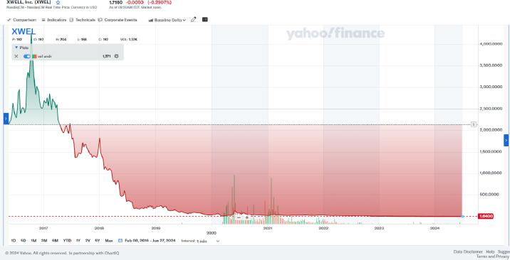

17

- The decline in XWELL stockholder value during the Entrenched Directors’ reign is unique to XWELL and not a trend as illustrated in

the below graphs.
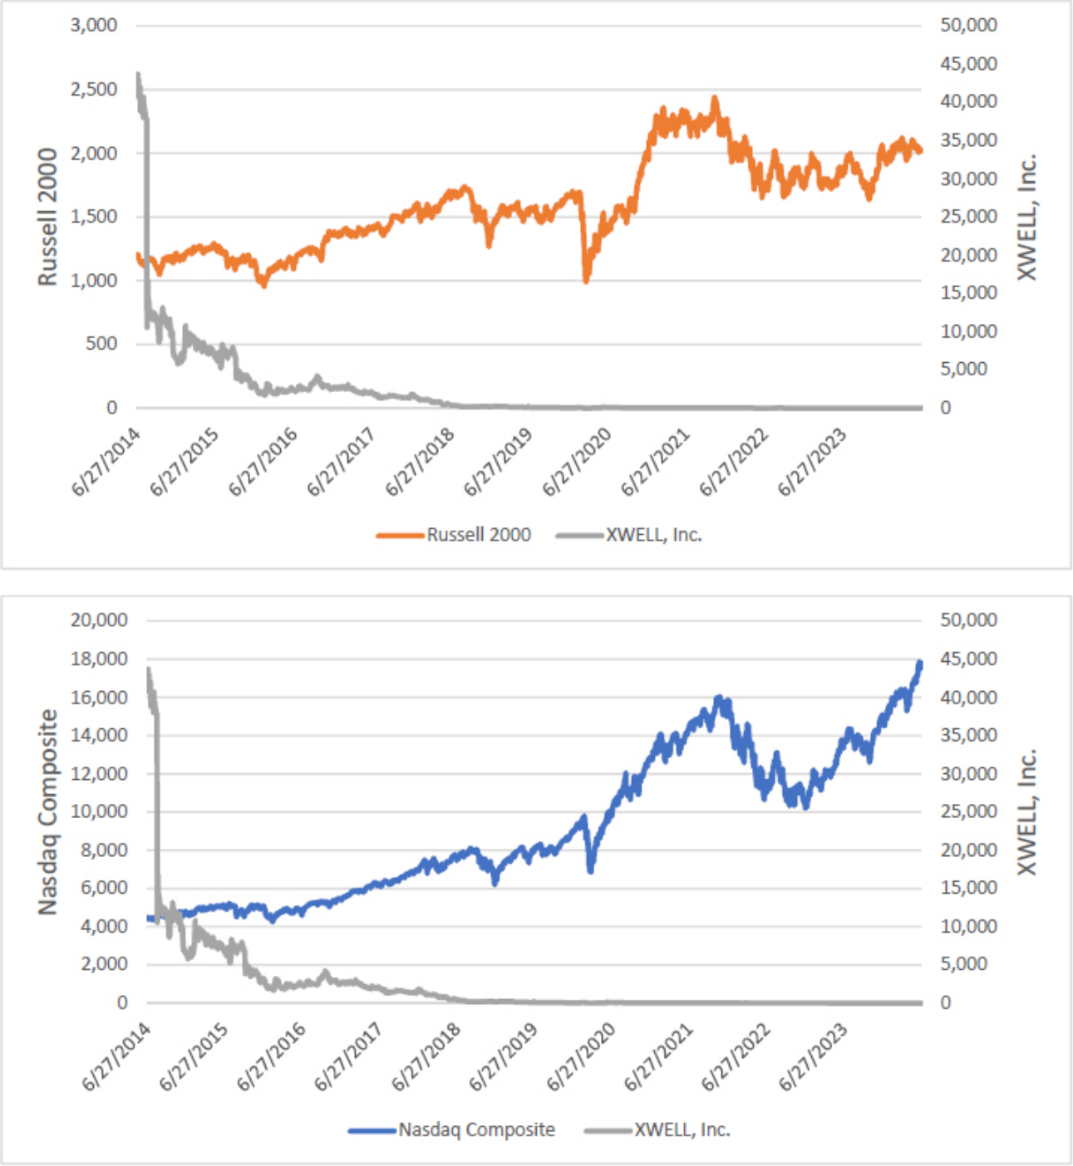

18

- Along with its staggering loss in market value, XWELL has reported a combined net operating loss of $207.3 million from 2018 through

2023.

- XWELL’s Annual Report on Form 10-K for the fiscal year ended December 31, 2023, discloses that XWELL’s revenue decreased from $55.9 million in 2022 to $30.1 million in 2023 and its shareholder equity dropped from $39.9 million to $13 million in the same period.

- XWELL is also burning through its cash, going from cash and cash equivalents of over $109.1 million in the third quarter of 2021 to

approximately $19.1 million⁶ in the first quarter of 2024. XWELL has failed to generate revenue that will slow its cash depletion or return the company to profitability.

- The Entrenched Directors have not done anything meaningful to reverse the near complete loss of value. For example, in this period, the Entrenched Directors have: (i) failed to increase XWELL’s revenue streams or decrease its costs such that the company returns to profitability; (ii) failed to explain to XWELL’s stockholders their plan, if any, to improve XWELL’s financial condition; (iii) struggled to expand the company from an airport based studio model to both an airport and off-airport based service model; and (iv) awarded and paid themselves large compensation packages.

- Includes approximately $14.7 million of marketable securities.

19

- The Entrenched Directors’ underperformance has not gone unnoticed by XWELL’s stockholders. Below are some recent examples of message board posts from XWELL’s stockholders.
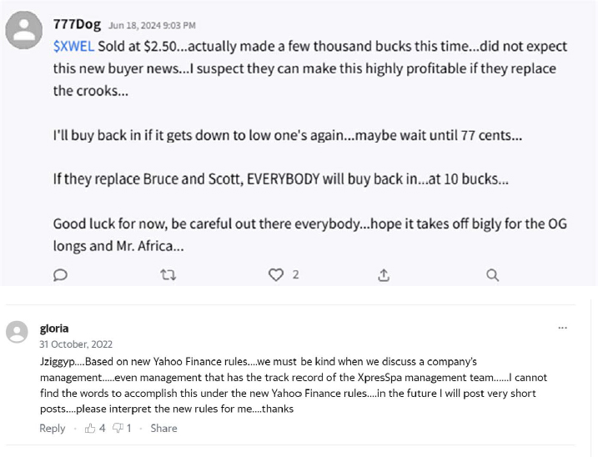

20

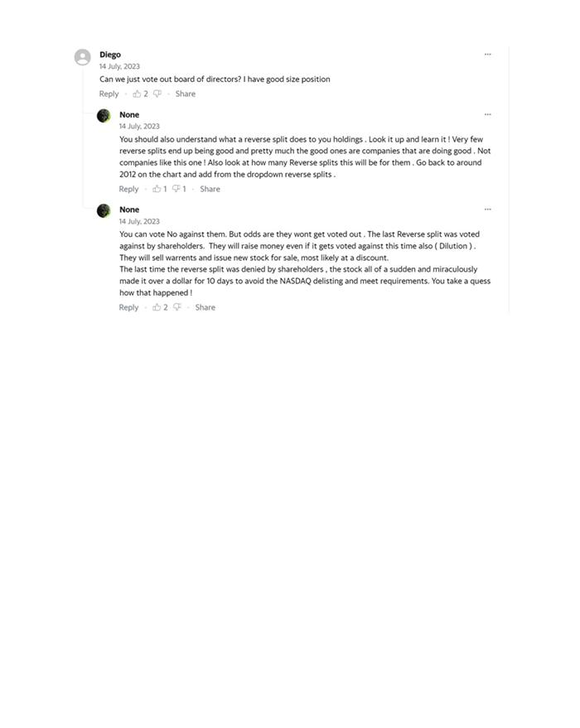

21

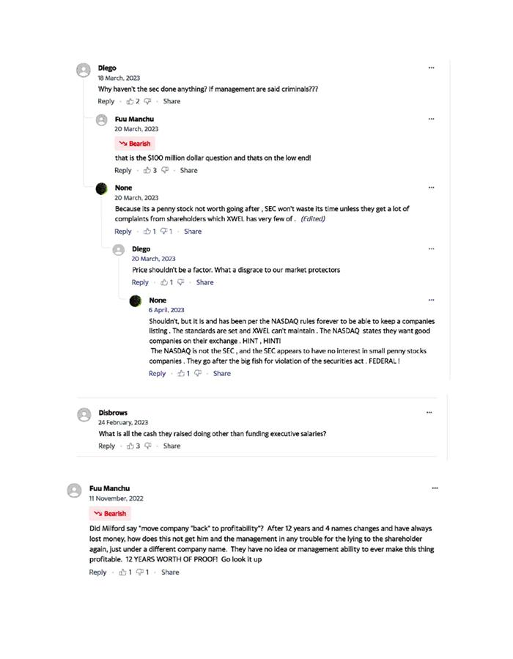

22

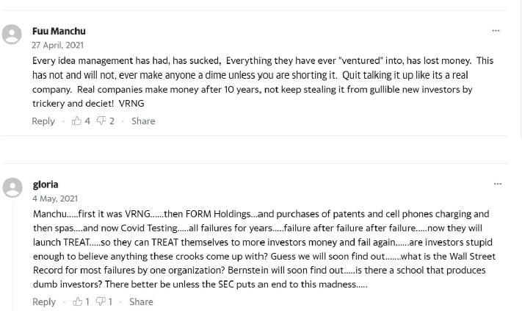

Despite XWELL’s Poor Financial Performance, the Entrenched Directors Have Paid Themselves Handsomely at the Expense of Stockholders

- Though XWELL’s stock price has fallen up to 99% during their reign, the Entrenched Directors have taken excessive compensation at the expense of XWELL’s stockholders.

- In 2016, Bernstein received $93,756 in compensation from XWELL. His compensation for service as an outside director of a start-up enterprise jumped to $125,862 the next year and was $1,605,554 million in 2021. In 2023, it was $338,450.

- Weinstein and Lebowitz have received similar largesse. Since joining the Board, they have been compensated as follows:

23

 | 2020 | 2021 | 2022 | 2023
Weinstein | $125,447 | $522,615 | $177,011 | $131,100
Lebowitz | $94,293 | $502,615 | $147,011 | $104,850

- XWELL is a small company, consisting of about 266 full-time employees. It has not been profitable and has not generated significant yearly revenue in any year during the Entrenched Directors’ reign. Still, the Entrenched Directors approved their own excessive compensation while the XWELL stock price plummeted.

Stockholders Withhold Their Votes from the

Unopposed Entrenched Directors at the 2023 Annual Meeting

- Section 1.8 of XWELL’s bylaws provides that “directors shall be elected by a plurality of the voting power of the shares” entitled to vote in an election. As a result, an XWELL director candidate need not receive “for” votes from the holders of a majority of shares in order to be elected and a candidate who is running unopposed need only receive a single vote to be elected.

- Because XWELL has rejected majority voting and adopted plurality voting with respect to the election of directors and because stockholders could not vote for anyone else, the Entrenched Directors were re-elected at XWELL’s August 22, 2023 annual stockholder meeting. But the tally confirms that the stockholders are not satisfied with and want to replace the Entrenched Directors.

24

- As reported in XWELL’s Current Report on Form 8-K filed on August 25, 2023, stockholders were unwilling to vote for the Entrenched Directors and would have appreciated being permitted to have other candidates on the ballot. Bernstein and Weinstein, the individuals who chair the Board and every one of its committees, received more than three times as many “Withhold” votes than “For” votes. Of the 83.4 million shares of XWELL’s outstanding common stock that was entitled to vote at that time, less than 5.3 million shares were voted “For” Bernstein and Weinstein. Milford and Lebowitz received more “For” votes than “Withheld” votes, but still far less than a majority with less than 12.1 million of the 83.4 million shares of XWELL’s outstanding common stock that was entitled to vote voting for Milford and less than 11.5 million of those shares voting for Lebowitz. In other words, 85 percent of the shares refused to vote for any of the Entrenched Directors.⁷

- The following chart from XWELL’s Current Report on Form 8-K filed on August 25, 2023, makes clear the Entrenched Directors’ lack of support among the XWELL stockholders.

Name |  | For |  | Withheld |  | Broker Non-Votes
Scott R. Milford |  | 12,042,587 |  | 9,790,979 |  | 23,149,514
Bruce T. Bernstein |  | 5,268,455 |  | 16,565,111 |  | 23,149,514
Robert Weinstein |  | 5,111,712 |  | 16,721,854 |  | 23,149,514
Donald E. Stout |  | 5,281,946 |  | 16,551,620 |  | 23,149,514
Michael Lebowitz |  | 11,466,064 |  | 10,367,502 |  | 23,149,514

- Following the 2023 annual meeting, XWELL implemented a 1-for-20 reverse stock split that greatly reduced the number of its outstanding shares of common stock.

25

The Entrenched Directors Amend XWELL’s Bylaws

to Further Entrench Themselves

- Beginning in March 2024, a CPC representative asked Soffer, XWELL’s General Counsel, if there was a deadline for stockholders to nominate directors for inclusion in the proxy statement relating to XWELL’s 2024 Annual Meeting. XWELL’s certificate of incorporation and bylaws were silent on this issue, and the CPC representative sought guidance from Soffer on the deadline. In a conversation between Soffer and the CPC representative in April 2024, Soffer stated that there was no deadline by which stockholder proposals for director nominees must be received.

- On or about May 17, 2024, the Entrenched Directors amended Section 1.2 of XWELL’s bylaws to include new advance notice provisions that make it harder for XWELL’s stockholders to nominate candidates for election to the Board.

- The Bylaw Amendment provides that a stockholder who wishes to nominate a candidate for election to the Board must submit a written nominating notice to XWELL’s Secretary not less than 60 and not more than 90 days prior to the anniversary date of the immediately preceding annual meeting of stockholders. The notice must also include:

  - as to each person nominated for election or re-election as a director:

    - the name, age, business address and residence address of the person;

26

  - the principal occupation or employment of the person;

  - the class and number of shares of capital stock of the Company which are beneficially owned by the person; and

  - any other information relating to the person that is required to be disclosed in solicitations for proxies for election of directors pursuant to Regulation 14A under the Securities Exchange Act of 1934, as amended; and

- as to the stockholder giving the notice:

  - the name and record address of the stockholder;

  - the class and number of shares of capital stock of the Company which are beneficially owned by the stockholder;

  - a description of all arrangements or understandings between such stockholder and each proposed nominee and any other person or persons (including their names) pursuant to which the nomination(s) are to be made by such stockholder;

  - a representation that such stockholder intends to appear in person or by proxy at the meeting to nominate the persons named in its notice;

  - a statement by the stockholder giving notice that such stockholder, its qualified representatives and/or any affiliates or associates of such person intend to solicit proxies or votes in accordance with Rule 14a-9 promulgated under the Exchange Act; and

  - any other information relating to such stockholder that would be required to be disclosed in a proxy statement or other filings required to be made in connection with solicitations of proxies for election of directors pursuant to Section 14 of the Securities Exchange Act of 1934, as amended, and the rules and regulations promulgated thereunder.

27

- A demonstrative showing the changes to Section 1.2 arising from the Bylaw Amendment is attached as Exhibit B.

- The Bylaw Amendment erects barriers to nominating directors and the shareholder franchise where none previously existed and gives the Entrenched Directors the authority to declare a nomination defective and disregarded. In pertinent part, the amendment states:

  - “No person shall be eligible for election as a director of the Company unless nominated in accordance with the procedures set forth herein.”

  - “The Chairperson of the meeting shall, if the facts warrant, determine and declare to the meeting that a nomination was not made in accordance with the foregoing procedure, and if he should so determine, he or she shall so declare to the meeting and the defective nomination shall be disregarded.”

- Pursuant to Section 1.7 of the bylaws, the default “Chairperson of the meeting” is Bernstein, XWELL’s chairman. Thus, in addition to creating impediments for stockholders to nominate candidates, the Board gave Bernstein, the most conflicted and entrenched director of the lot, the power to determine whether a stockholder complied with the nomination process and to declare that a stockholder’s nominee and the votes he or she received must be disregarded.

28

CPC Nominates Four Qualified Directors for Election to

XWELL’s Board at the 2024 Annual Meeting

- In an effort to provide XWELL’s stockholders with new representation, on June 17, 2024, CPC delivered to XWELL the Initial Notice, which nominates four individuals—the CPC Nominees—for election to the Board at this year’s not-yet-scheduled stockholder annual meeting.

- The Initial Notice was timely because it was submitted not less than 60 days and not more than 90 days prior to the anniversary of the 2023 annual meeting (i.e., August 22, 2024). The Initial Notice was also submitted six calendar days prior to the close of business on June 23, 2024, which is the date identified in XWELL’s Current Report on Form 8-K filed on May 21, 2024, as the date by which stockholders must provide written notice of director nominations or other proposals intended to be brought before the 2024 Annual Meeting. The Initial Notice was delivered to the Secretary of XWELL via email and it was also couriered to XWELL’s principal executive office in an effort to ensure timely receipt.

- The Initial Notice also contained all the information required to be disclosed by the Bylaw Amendment and attached written consents whereby each CPC Nominee consented to stand for election if nominated, to serve if elected, to be included in XWELL’s proxy statement and, if elected, to comply with all corporate policies. See Exhibit C.

29

Defendants Reject the Initial Notice

- After 9:00 p.m. (EDT) on Friday, June 21, 2024, XWELL’s counsel responded to the Initial Notice. See Exhibit D. The First Rejection stated the Initial Notice “fails to comply with the Company’s Third Amended and Restated Bylaws,” i.e., the Bylaw Amendment, and “includes disclosure that requires clarification in order to allow the Company to determine if such disclosure complies with” the Bylaw Amendment.

- The sole basis for the rejection was the alleged non-compliance with the Bylaw Amendment, and in particular the Securities Law Provisions and the AAU Provision. The First Rejection is unnecessarily drawn out and full of citations to federal law; yet, once its style is pierced, it becomes clear that the First Rejection raises a series of near-meaningless, pedantic points that could easily be resolved prior to the filing of the Schedule 14A for the 2024 Annual Meeting. For example, the First Rejection asserts that the Initial Notice was deficient because the consents that each CPC Nominee executed stated that each nominee consents to being “included in” XWELL’s proxy statement while the Entrenched Directors contend that applicable federal securities laws require each nominee to consent to being “named in” XWELL’s proxy statement.

- The First Rejection required a response in less than 48 hours and during the weekend (by the “close of business” on Sunday, June 23, 2024), based upon XWELL’s contention that the deadline to submit nominations would expire on June 23, 2024.

30

- The First Rejection did not include a director questionnaire or otherwise identify with any specificity what information XWELL believed CPC and its nominees had to submit to satisfy the Securities Law Provisions, amorphous provisions that imprecisely require the disclosure of all information required to be disclosed under federal securities laws.

The Revised Notice

- Although the issues raised in the First Rejection were pretextual and designed to create speedbumps to CPC’s effort to nominate a slate of directors for election, CPC chose not to leave those issues unanswered and submitted via email and courier the Revised Notice at approximately 3:30 p.m. (EDT) on June 23, 2024. The Revised Notice was not materially different than the First Notice—it nominated the CPC Nominees for election to the XWELL Board, included all information required by the Bylaw Amendment and attached the required written consents. See Exhibit E. It also addressed all of the issues raised in the First Rejection, mostly through minor wordsmithing.

- The Revised Notice complied fully with the Bylaw Amendment, and in particular the Bylaw Amendment’s terms regarding the notice stockholders must provide to nominate candidates for service as directors of XWELL.

31

- In addition, CPC’s counsel sent XWELL the June 23 Letter, which is attached hereto as Exhibit F. The June 23 Letter explains why the Initial Notice complied with the Bylaw Amendment, clarifies any statement identified in the First Rejection, and points out why the issues raised in the First Rejection are incorrect or non-issues. The letter also highlights the additional information or minor changes included within the Revised Notice that are designed to address the concerns raised in the First Rejection.

- The June 23 Letter also asked XWELL for a copy of its new director questionnaire. Completion of this questionnaire by the CPC Nominees would remove any doubt that XWELL had all the information it needed regarding these individuals. XWELL ignored this request.

The Second Rejection

- On June 29, 2024, XWELL’s counsel responded to the Revised Notice. See Exhibit G. The Second Rejection contends that the Revised Notice “fails to comply” with the Bylaw Amendment “due to numerous material omissions and deficiencies” and that it “fails to adequately correct certain disclosures” in the Initial Notice. The Second Rejection states that “the deadline for a timely and proper notice of intention to nominate candidates for election as directors” at the 2024 Annual Meeting “was the close of business on June 23, 2024,” and, therefore, CPC “does not have the right to nominate any candidates for election as directors” at the 2024 Annual Meeting.

32

- Like the First Rejection, the Second Rejection raises a series of hyper-technical issues that are not material to the CPC Nominees’ qualifications or credentials to stand for election to the Board and/or seeks to confirm facts that do not exist. For example, it incorrectly contends that CPC, a beneficial owner of XWELL stock, had to disclose the “record address” of the bank, broker or other nominee through which it holds its XWELL stock.

- The Second Rejection also includes a seven-page attachment of single-spaced text that purports to identify twenty-five ways (not including subparts) that the Revised Notice does not comply with the Securities Law Provisions. Although they could have been, none of these alleged deficiencies were identified in the First Rejection. This information also could have been obtained if XWELL had provided CPC and its nominees with a director questionnaire. XWELL never provided a questionnaire or asked for the details—many of which would not be included in XWELL’s Schedule 14A proxy materials and have no bearing on the CPC Nominees’ credentials—that it now contends is missing from the Revised Notice.

- The timing and substance of Defendants’ response to the Revised Notice demonstrates that Defendants are weaponizing the Bylaw Amendment, and in particular the Securities Law Provisions and the AAU Provision, in order to reject candidates nominated by stockholders and thereby ensure the Entrenched Director run unopposed, continuing to entrench themselves in office.

33

- Defendants’ reading and implementation of the Bylaw Amendment with respect to the Initial Notice and the Revised Notice is inequitable and irrational. It bears no relation to any proper corporate purpose or objective related to the election of directors. It merely serves to bar stockholders from nominating a competing director slate and entrenching the Entrenched Directors in office.

Urgent Court Intervention Is Needed to Protect CPC’s Rights

- The window under the Bylaw Amendment for nominating director candidates for consideration in the 2024 Annual Meeting closed on June 23, 2024 pursuant to the Current Report on Form 8-K filed with the SEC on May 21, 2024. XWELL will soon file a Schedule 14A with the SEC that will state that the Entrenched Directors are running unopposed in the upcoming 2024 Annual Meeting.

- Urgent Court intervention is needed to resolve the parties’ dispute about the validity of the Initial Notice and the Revised Notice in advance of this year’s not-yet-scheduled 2024 Annual Meeting. Mandatory injunctive relief is required to ensure that the CPC Nominees are permitted to stand for election at the 2024 Annual Meeting. Urgent Court intervention is also needed because XWELL likely will make misrepresentations about the notices in its proxy materials (or fail to discuss the notices or the CPC Nominees at all).

34

- Absent a prompt determination by this Court at trial, CPC, and the other stockholders of XWELL, will be denied their voting and

governance rights.

COUNT I

Declaration that Bylaw Amendment Is Unenforceable

- CPC repeats and realleges each and every allegation set forth in the foregoing paragraphs as if fully set forth herein.

- The Delaware Declaratory Judgment Act gives courts the “power to declare rights, status and other legal relations whether or not further relief is or could be claimed.” 10 Del. C. § 6501.

- XWELL’s stockholders have a fundamental right to vote for the directors whom they want to oversee the company. That fundamental right extends to the right to nominate the candidates whom they wish to have validly stand for election to the Board.

- There is a justiciable controversy regarding the enforceability of the recent and extensive amendments to Section 1.2 of the bylaws.

- The Bylaw Amendment is unenforceable given, among other things, that it (i) unnecessarily and unreasonably infringes upon the ability of stockholders to exercise their fundamental right as owners of XWELL, particularly given that the bylaws were amended by an interested Board without the approval of stockholders; (ii) was approved for the improper purpose of entrenching the Board; (iii) was approved for the purpose of improperly preventing XWELL’s stockholders from nominating candidates for the Board; (iv) was approved for inequitable purposes, including, but not limited to, targeting specific groups and/or individuals and further entrenching the Board; and (v) is unreasonably vague, unclear, and ambiguous and is being enforced inequitably based on defendants’ subjective interpretation of its imprecise terms.

35

- Enhanced scrutiny is the appropriate standard of review to apply to Defendants’ conduct given the inherent conflicts of interest that arise when a board of directors acts to prevent shareholders from effectively exercising their right to vote either contrary to the will of the incumbent board members generally or to replace the incumbent board members in a contested election.

- The enhanced scrutiny standard of review requires a context-specific application of the directors’ duties of loyalty, good faith, and care. In adopting the Bylaw Amendment, Defendants must identify the proper corporate objectives served by their actions and justify their actions as reasonable in relation to those objectives. They cannot justify their adoption, since the Bylaw Amendment was designed to obstruct stockholders from nominating director candidates.

- Defendants to date have failed to proffer a business reason for adopting the Bylaw Amendment.

36

- The timing, nature, context, and manner of the Bylaw Amendment’s adoption as well as its scope and ambiguity confirm that it was implemented for the improper purpose of entrenching the Company’s longstanding directors and disenfranchising the Company’s largest stockholders.

- CPC has no adequate remedy at law.

COUNT II

Declaration that Defendants’ Application of the Bylaw

Amendment to Reject the Notices Is Unenforceable and/or Inequitable

- CPC repeats and realleges each and every allegation set forth in the foregoing paragraphs as if fully set forth herein.

- This Court should find that Defendants’ application of the Bylaw Amendment to reject CPC’s Initial Notice and Revised Notice to be unenforceable and inequitable.

- The Delaware Declaratory Judgment Act gives courts the “power to declare rights, status and other legal relations whether or not further relief is or could be claimed.” 10 Del. C. § 6501.

- XWELL’s stockholders have a fundamental right to vote for the directors whom they want to oversee the company. That fundamental right extends to the right to nominate the candidates whom they wish to have validly stand for election to the Board. XWELL and the Entrenched Directors must accept a nomination for election as a director when that nomination is made in accordance with the procedures and conditions as set forth in the Bylaw Amendment.

37

- There is a justiciable controversy regarding Defendants’ inequitable conduct in applying the Bylaw Amendment to reject the Initial Notice and the Revised Notice.

- Defendants’ application of the Bylaw Amendment to reject the Initial Notice and the Revised Notice is unlawful, unenforceable and inequitable and cannot stand. Defendants applied the Bylaw Amendment to block CPC’s Initial Notice and Revised Notice despite the fact that CPC’s notices provide more than sufficient detail for every category and comply with all procedures and conditions set forth in the Bylaw Amendment.

- Defendants adopted the Bylaw Amendment after stockholders inquired about the deadline for nominating director candidates for the 2024 Annual Meeting. Enhanced scrutiny applies to Defendants’ adoption and implementation of the Bylaw Amendment given the inherent conflicts of interest that arise when a board of directors acts to prevent shareholders from effectively exercising their right to vote either contrary to the will of the incumbent board members generally or to replace the incumbent board members in a contested election. Defendants cannot meet their burden to identify a proper corporate objective served by their actions or justify their actions as reasonable in relation to those objectives.

38

- Defendants’ pretextual and non-explained rejections of the notices reveals the Board’s true purpose: to further entrench the Entrenched Directors and to block any nominations that CPC, or any discontented stockholder, may submit, regardless of whether or not the terms of the Bylaw Amendment have been satisfied.

- Defendants are thus disenfranchising CPC’s inviolable right to nominate directors for stockholder consideration and entrenching its conflicted leadership, in violation of Delaware law.

- As applied by Defendants, the Bylaw Amendment is also unreasonably vague, unclear, and ambiguous, making its notice requirement subject to abuse as a restraint on the stockholder franchise that lacks a proper business purpose, and thus unenforceable.

- As applied by Defendants, the Bylaw Amendment unnecessarily and overly expansively threatens CPC’s fundamental right as an XWELL stockholder to nominate any candidate to the Board. Defendants’ application of the Bylaw Amendment to deny CPC’s notices violated the rule of construction in favor of stockholder rights.

- CPC has no adequate remedy at law.

39

COUNT III

Declaration that the Entrenched Directors Breached their Fiduciary Duties

- CPC repeats and realleges each and every allegation set forth in the foregoing paragraphs as if fully set forth herein.

- As Board members, the Entrenched Directors owe XWELL’s stockholders (including CPC) the highest duties of care, loyalty, and good

faith.

- The Entrenched Directors breached their fiduciary duties of care and loyalty by adopting a vague and imprecise Bylaw Amendment that can be applied in an inequitable and unlawful manner to unduly infringe upon the stockholder franchise and improperly entrench the sitting directors.

- Further, all the Entrenched Directors breached their fiduciary duties to XWELL’s stockholders by improperly employing the Bylaw Amendment to reject the Initial Notice and the Revised Notice as set forth above.

- CPC has no adequate remedy at law.

PRAYER FOR RELIEF

WHEREFORE, CPC requests that this Court enter an order of judgment in CPC’s favor against Defendants as follows:

- Declaring that XWELL and the Entrenched Directors’ adoption and application of the Bylaw Amendment to reject the Initial Notice and the Revised Notice is unenforceable and/or inequitable;

40

- Declaring that the Entrenched Directors breached their fiduciary duties by rejecting the Initial Notice and the Revised Notice based on their interpretation and review of the Bylaw Amendment;

- Declaring that the CPC Nominees have been properly nominated for election to the Board at the 2024 Annual Meeting and that the CPC Nominees can stand for election notwithstanding the rejection of the Initial Notice and the Revised Notice;

- Ordering Defendants to accept CPC’s Revised Notice as valid and include the CPC Nominees on XWELL’s universal proxy card that XWELL will issue in connection with the SEC for the 2024 Annual Meeting;

- If necessary, preliminarily enjoining the 2024 Annual Meeting so that it occurs after CPC has the opportunity to file its own Schedule 14A and to distribute it to stockholders for their consideration;

- Awarding CPC the costs and disbursements of this action, including attorneys’, accountants’, and experts’ fees; and

- Granting such other, further, and different relief as the Court may deem just and proper.

41

FAEGRE DRINKER

BIDDLE & REATH LLP

/s/ Todd C. Schiltz

Todd C. Schiltz (#3253)

Joseph C. Schoell (#3133)

Oderah C. Nwaeze (#5697)

Angela Lam (#6431)

222 Delaware Avenue, Suite 1410

Wilmington, Delaware 19801

(302) 467-4200

todd.schiltz@faegredrinker.com

joseph.schoell@faegredrinker.com

oderah.nwaeze@faegredrinker.com

angela.lam@faegredrinker.com

Attorneys for Plaintiff

CPC Pain & Wellness SPV, LLC

Dated: July 19, 2024

42

