Filed by Vringo, Inc.

Pursuant to Rule 425 under the

Securities Act of 1933 (the "Securities Act") and

deemed filed pursuant to Rule 14a-12 under the

Securities Exchange Act of 1934 (the "Exchange Act")

Securities Act File Number: 333-180609

Subject Company: Vringo, Inc.

Exchange Act File Number: 001-34785

Set forth below is the presentation made by counsel to I/P Engine, Inc., a wholly-owned subsidiary of Innovate/Protect, Inc., at the Markman hearing on June 4, 2012 in connection with the lawsuit captioned I/P Engine, Inc. v. AOL Inc. et al., Civ. Action No. 2:11-cv-512, filed in United States District Court for the Eastern District of Virginia, Norfolk Division on September 15, 2011.

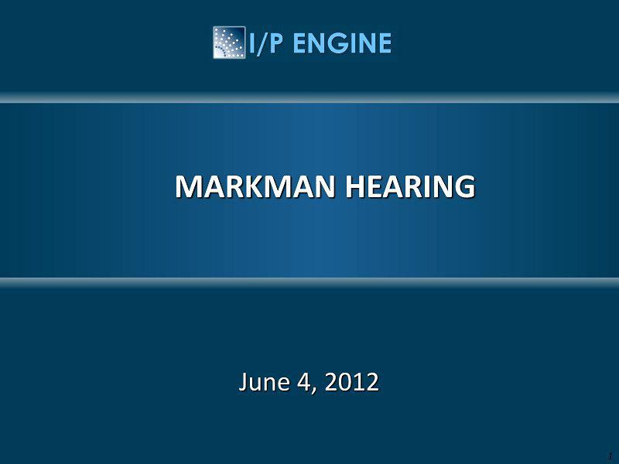

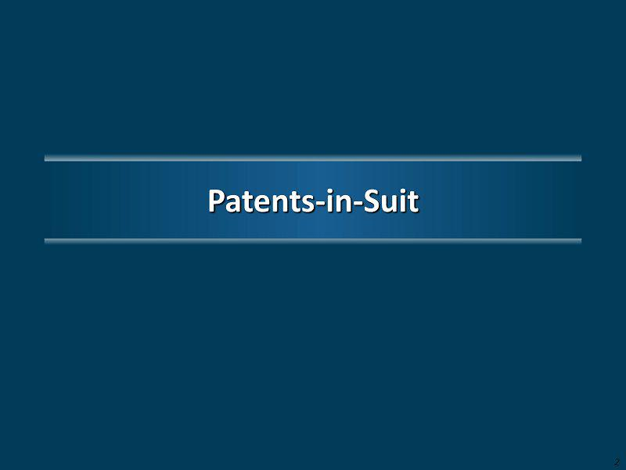

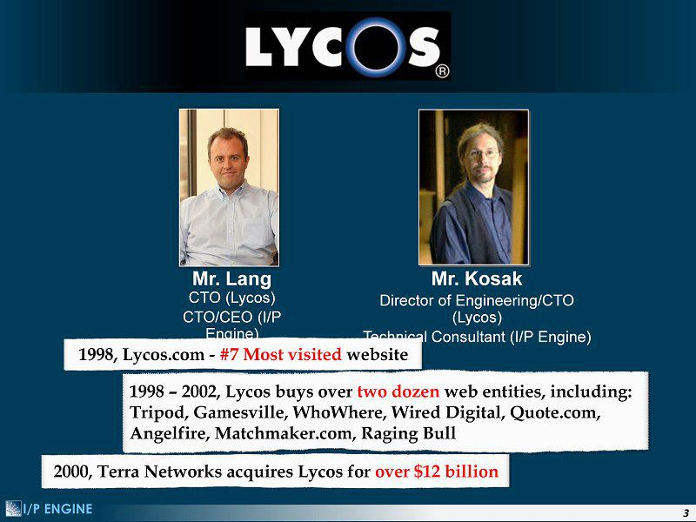

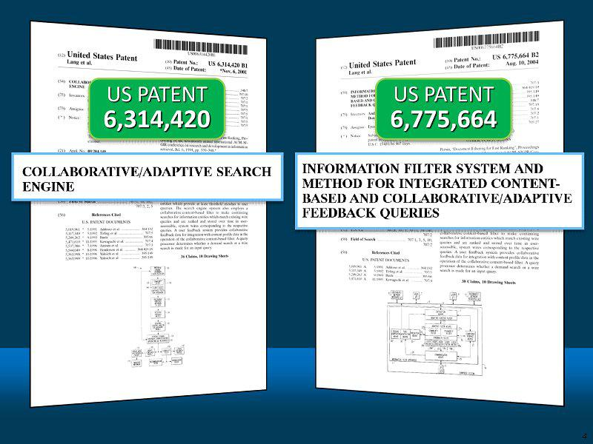

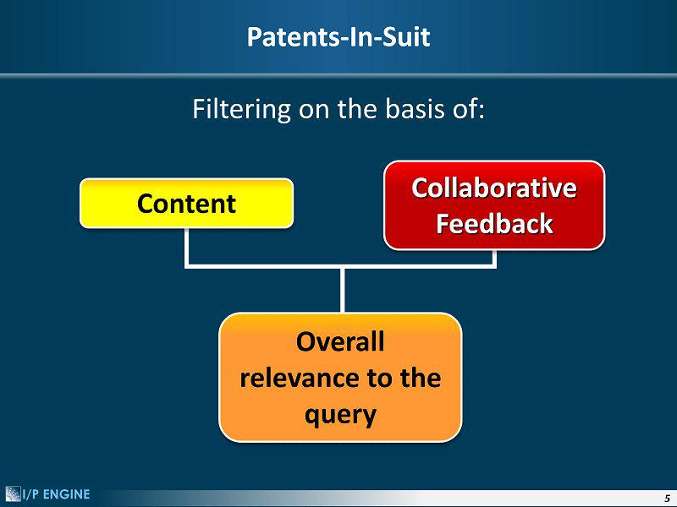

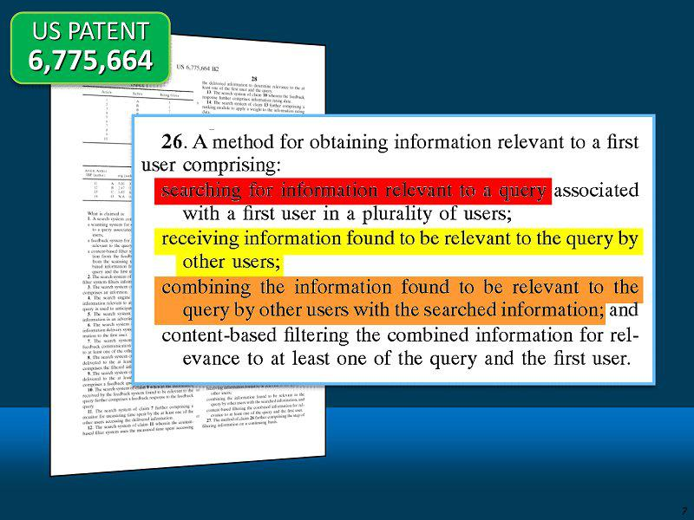

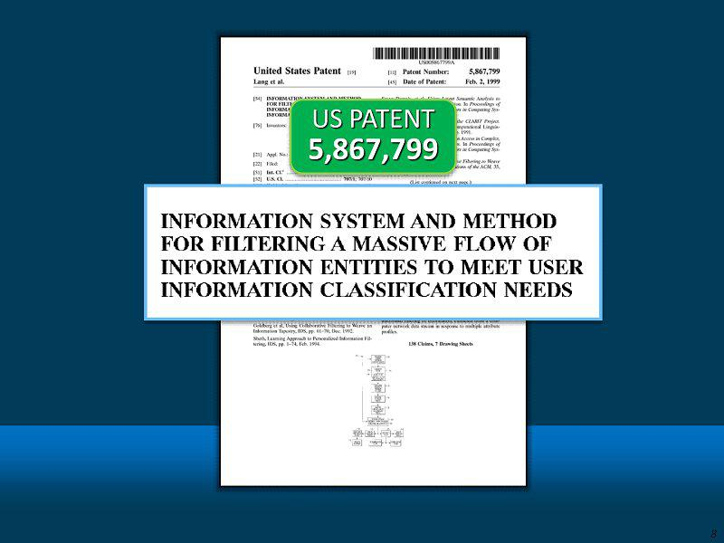

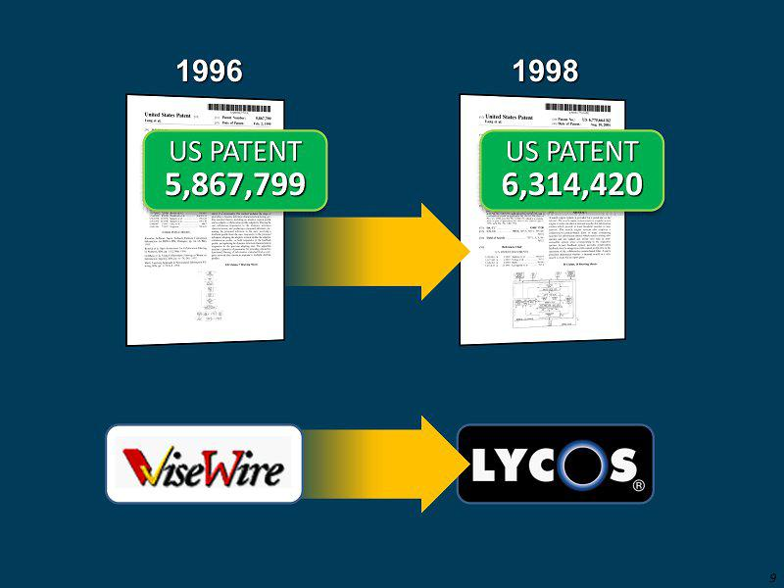

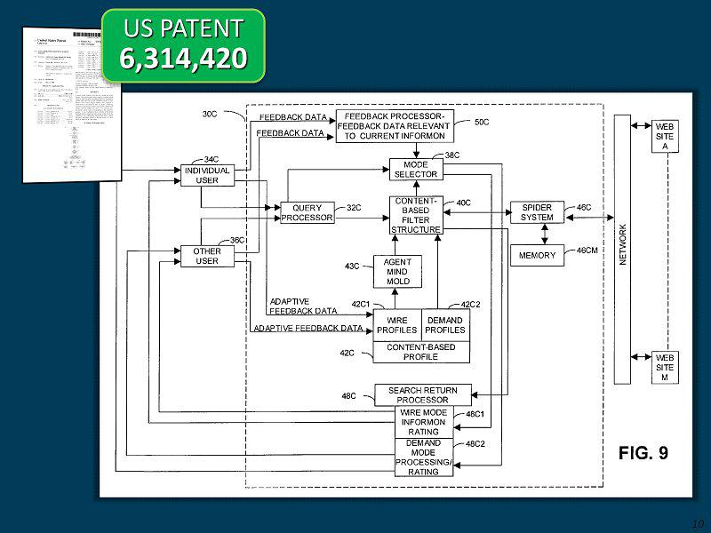

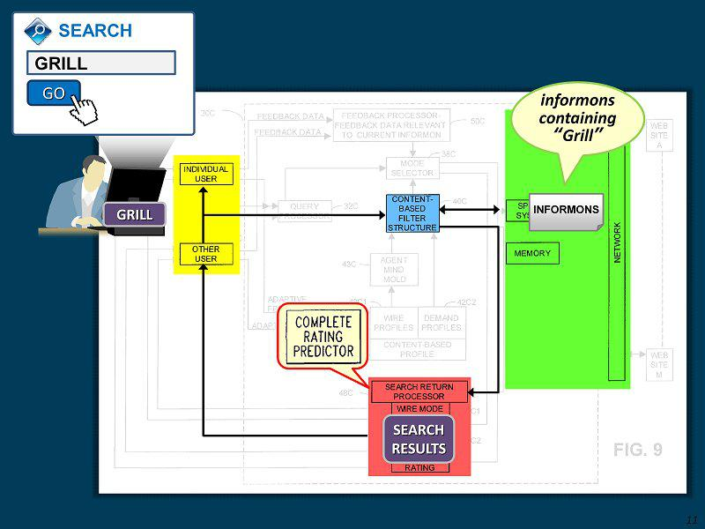

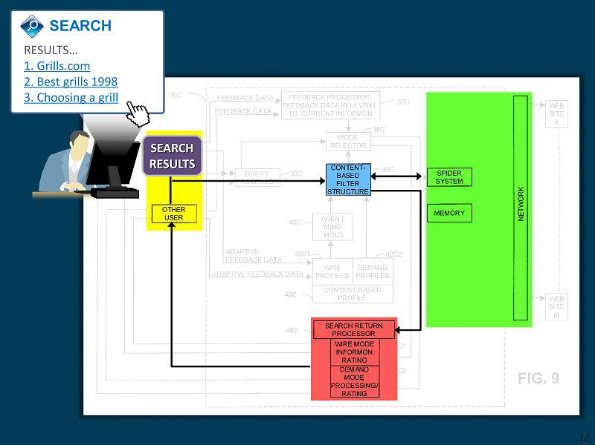

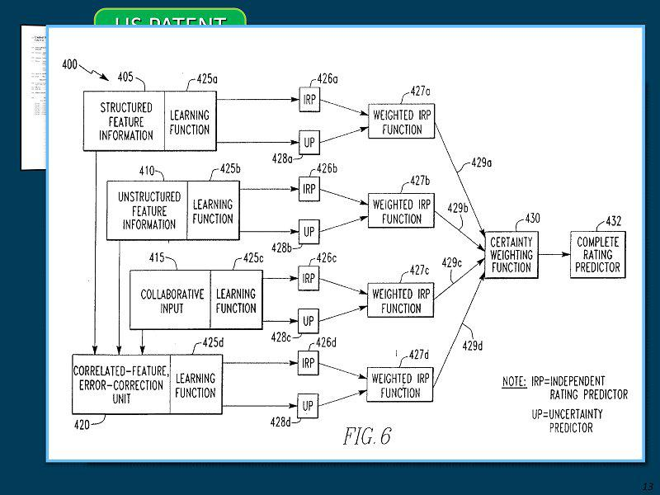

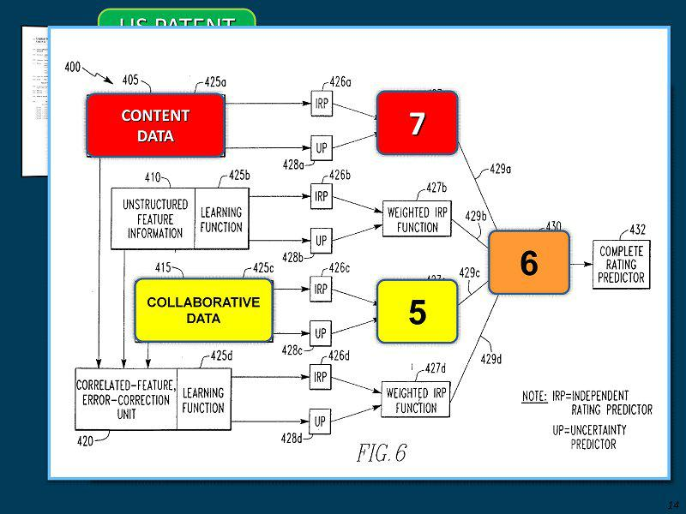

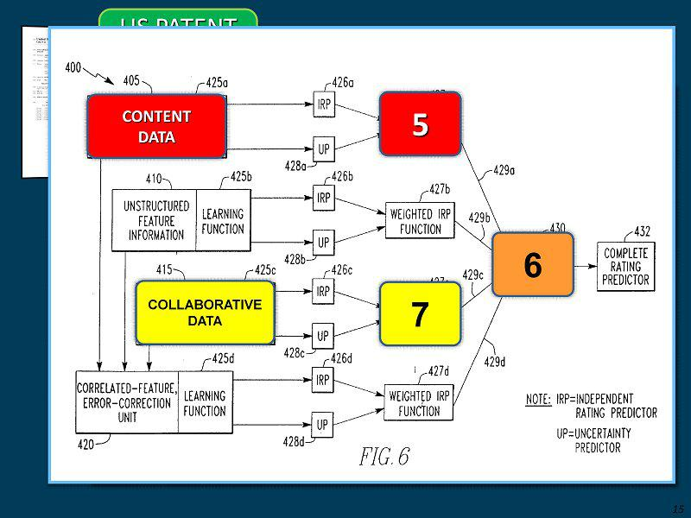

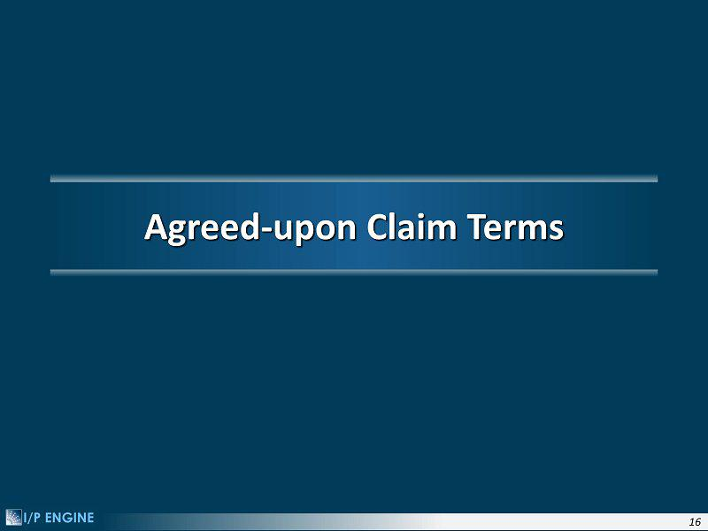

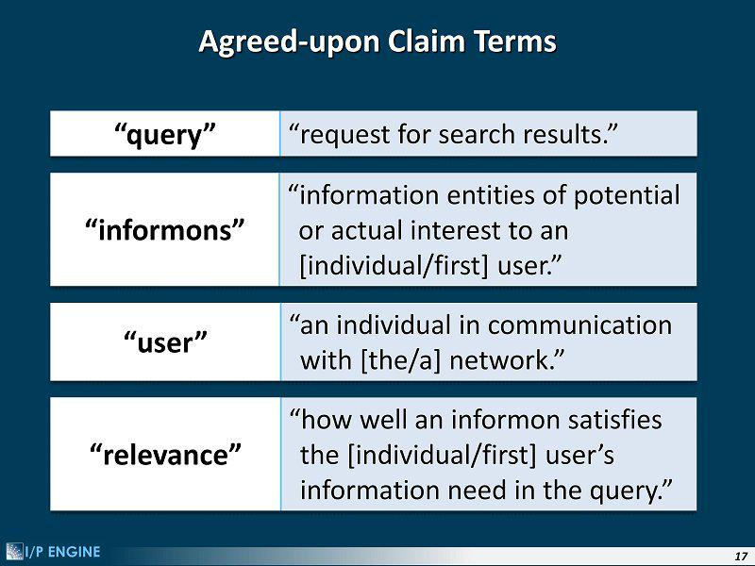

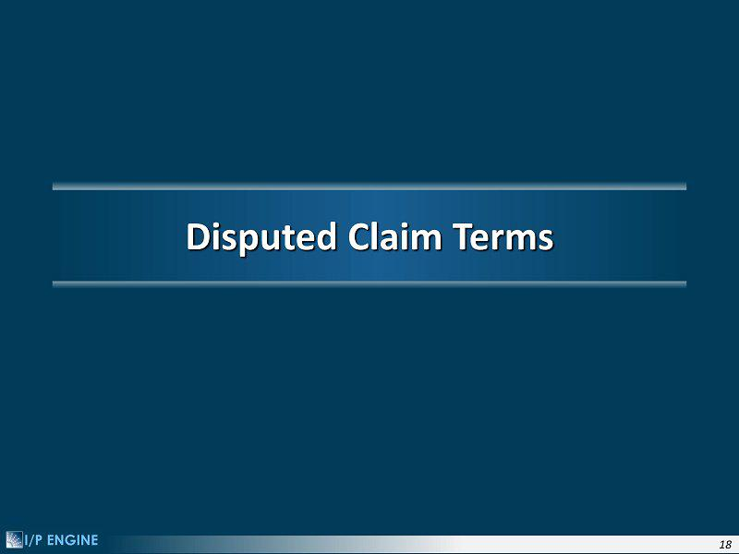

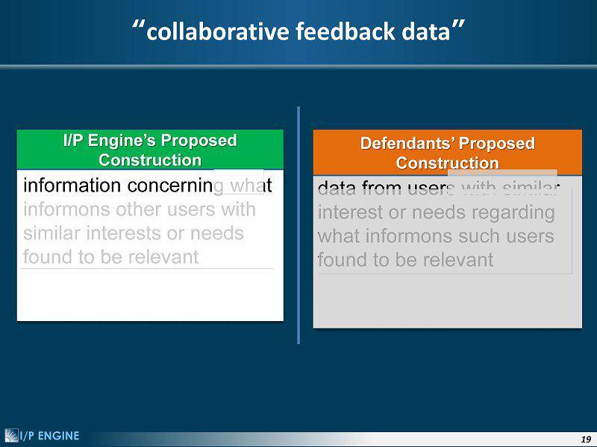

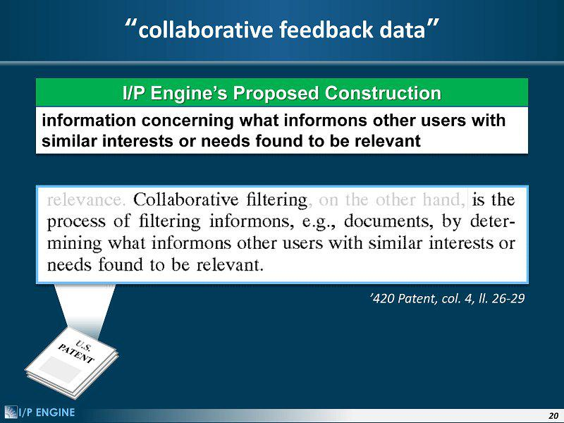

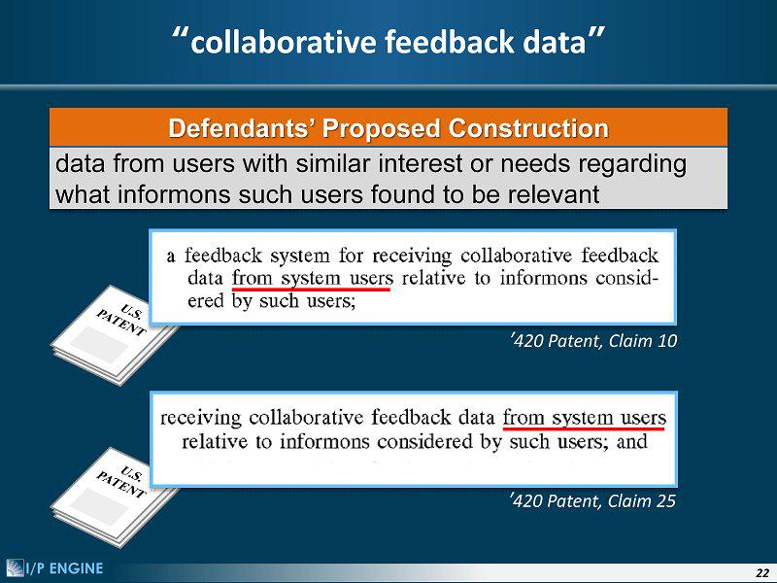

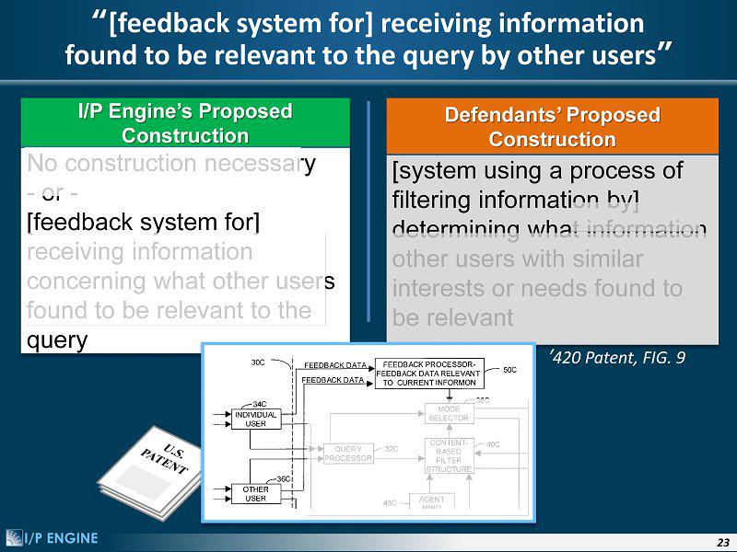

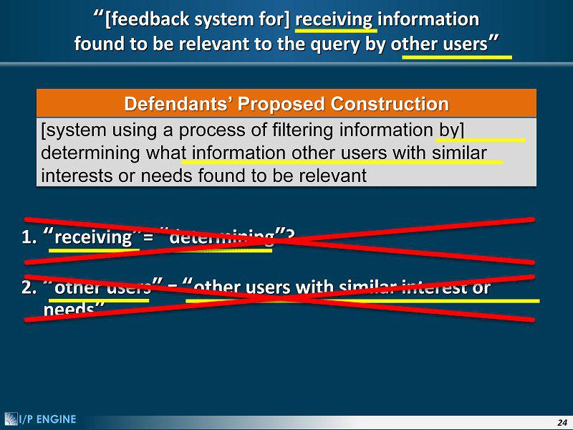

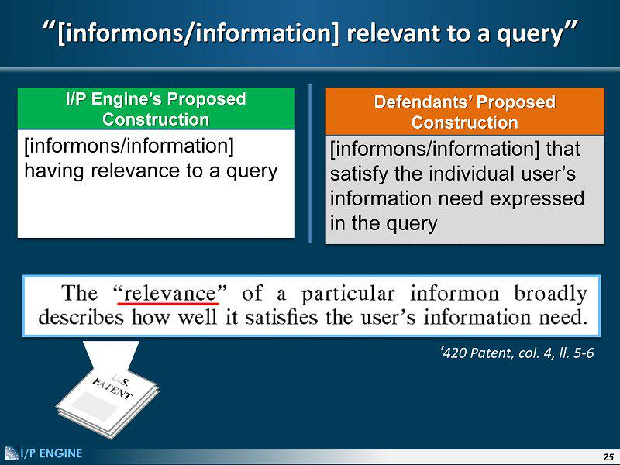

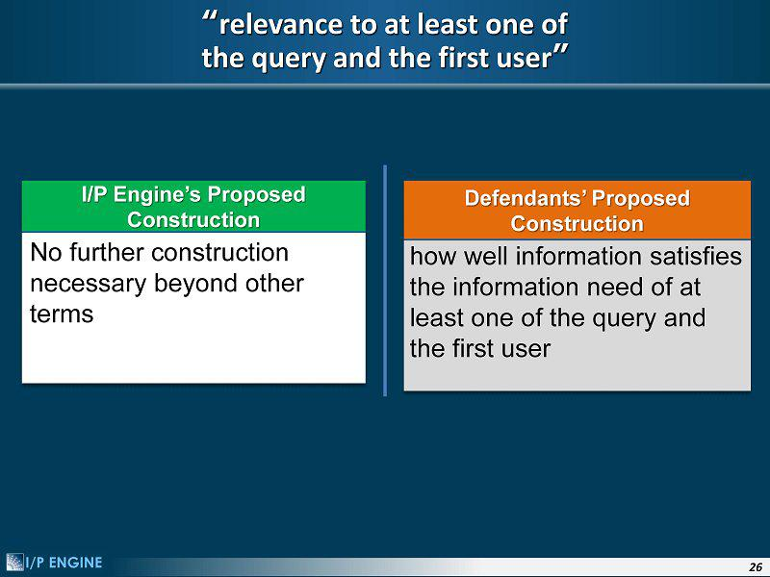

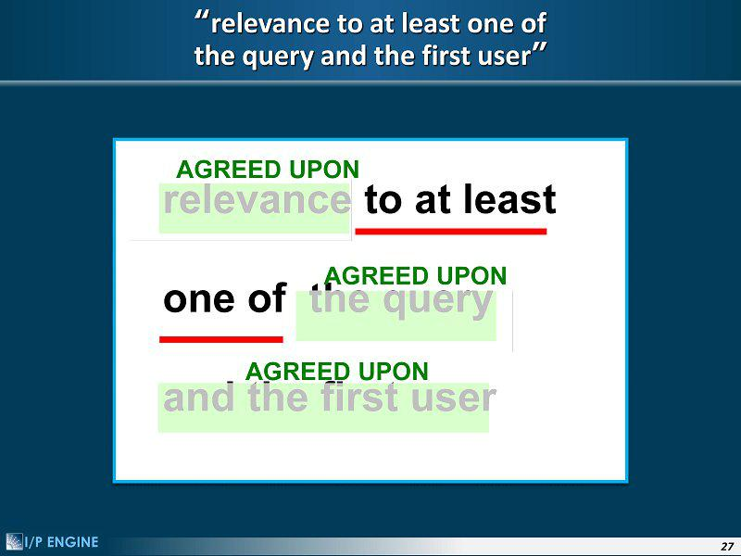

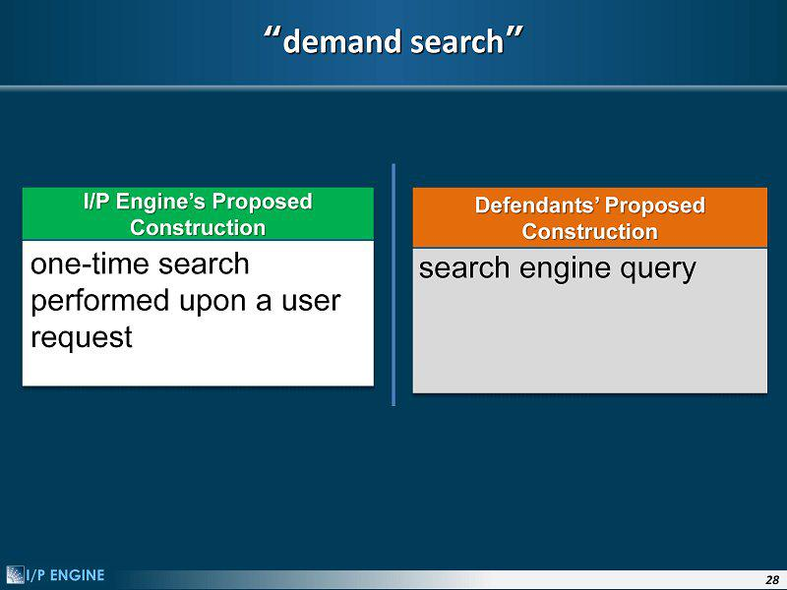

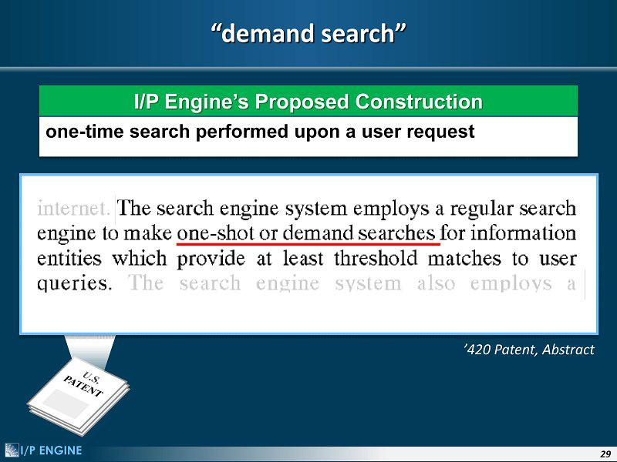

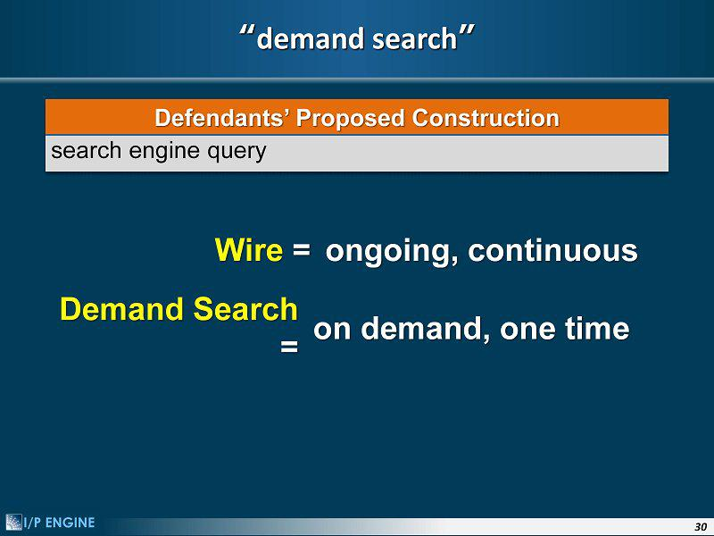

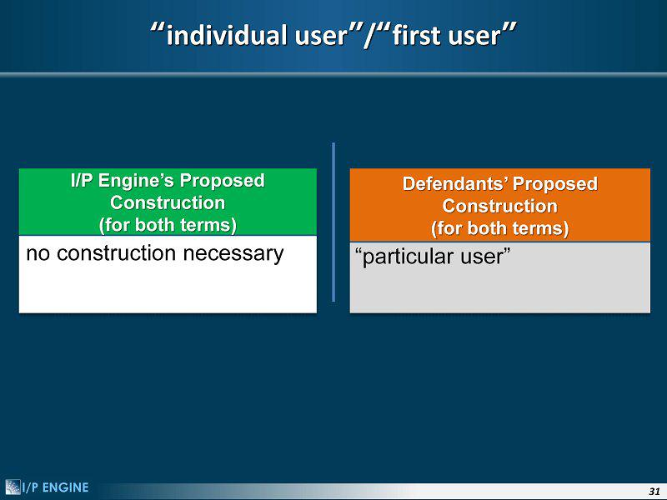

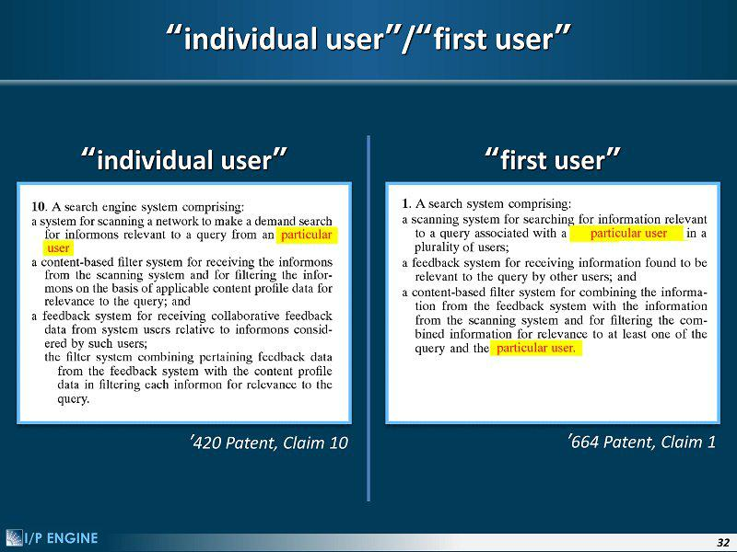

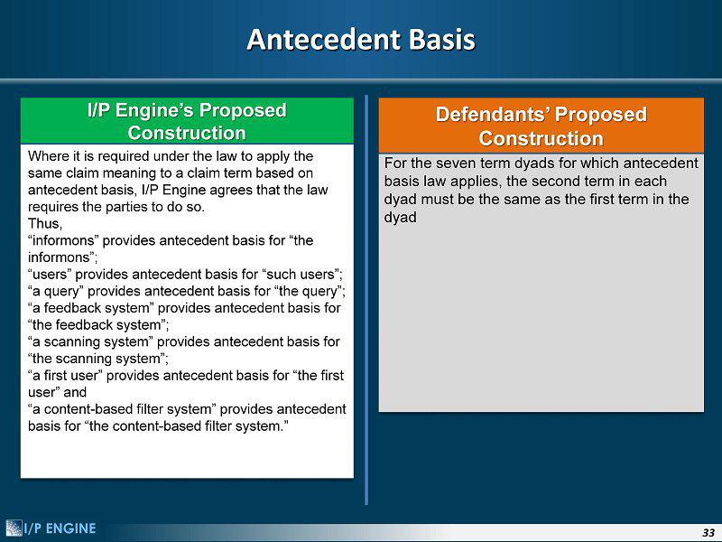

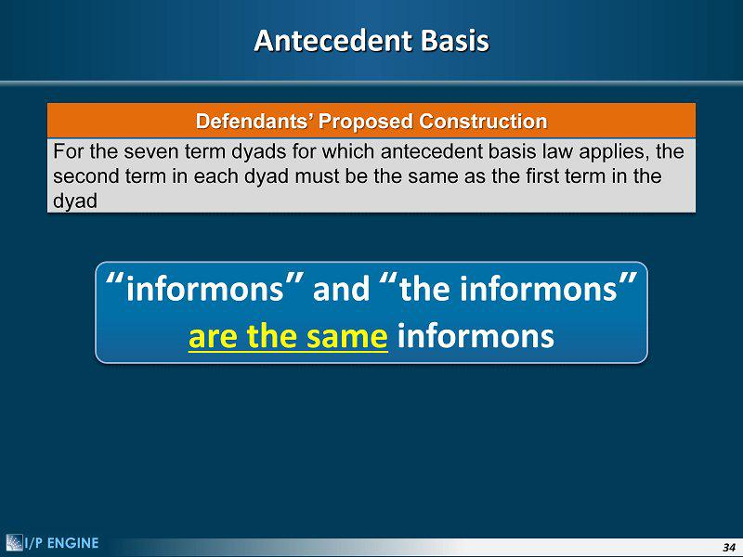

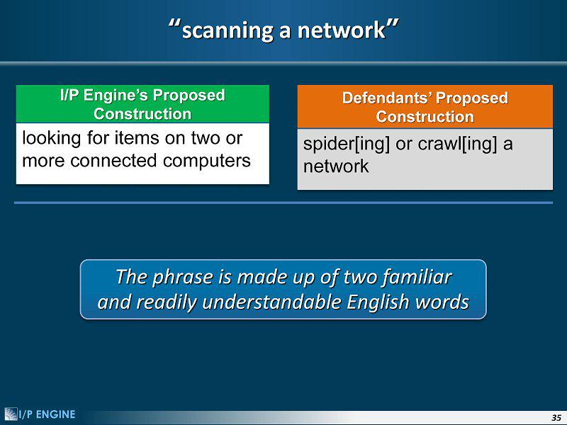

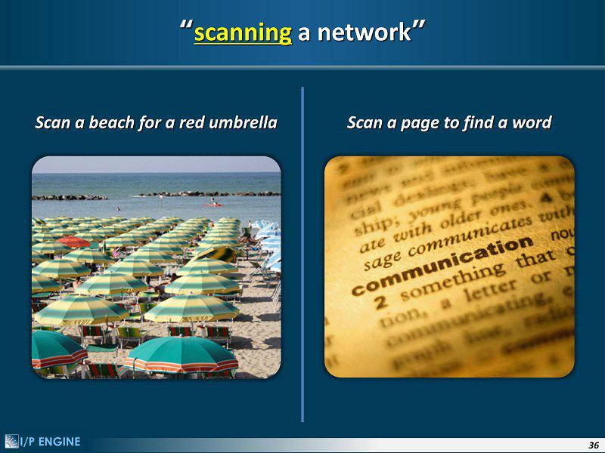

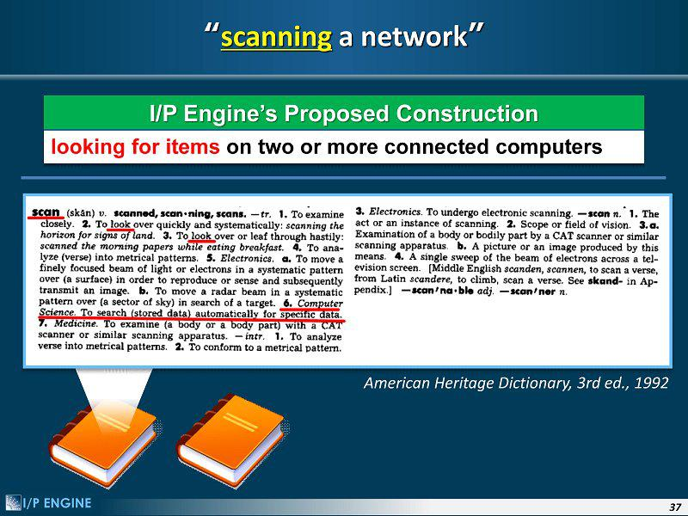

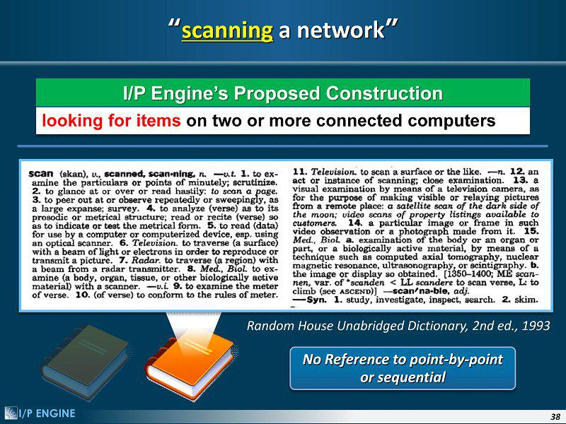

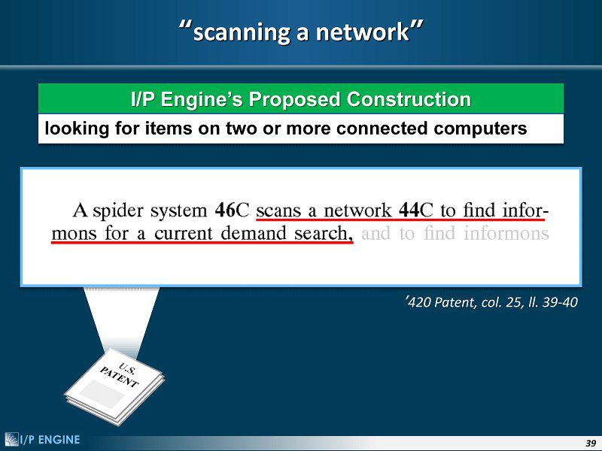

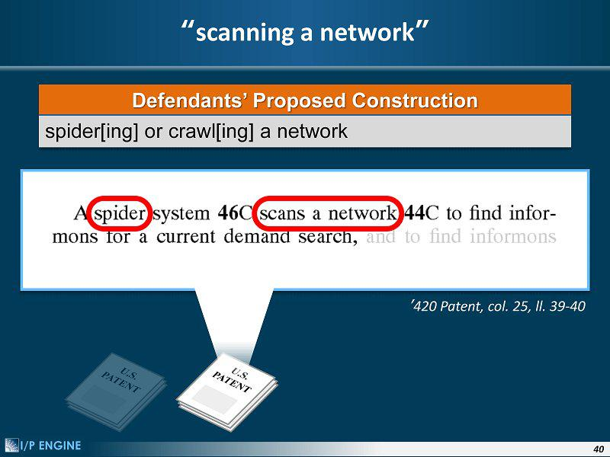

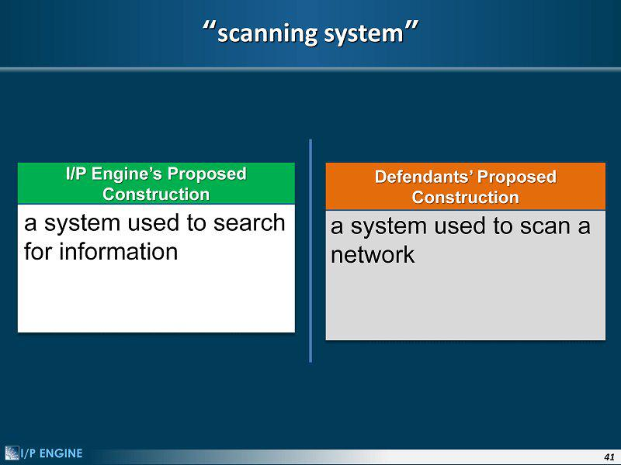

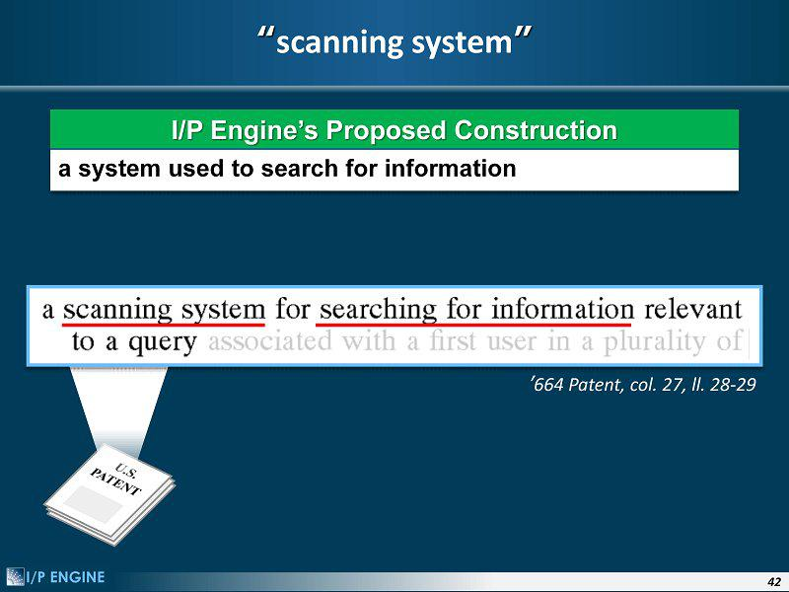

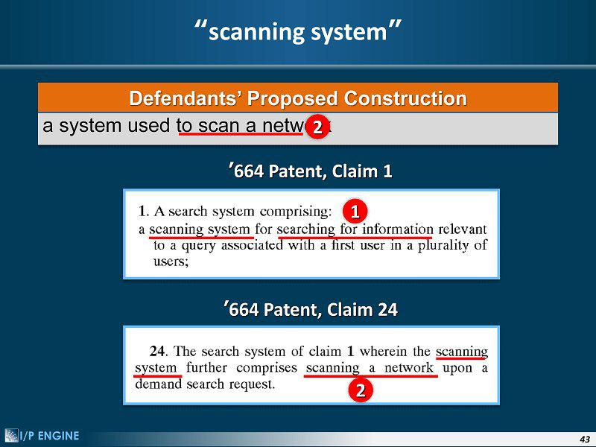

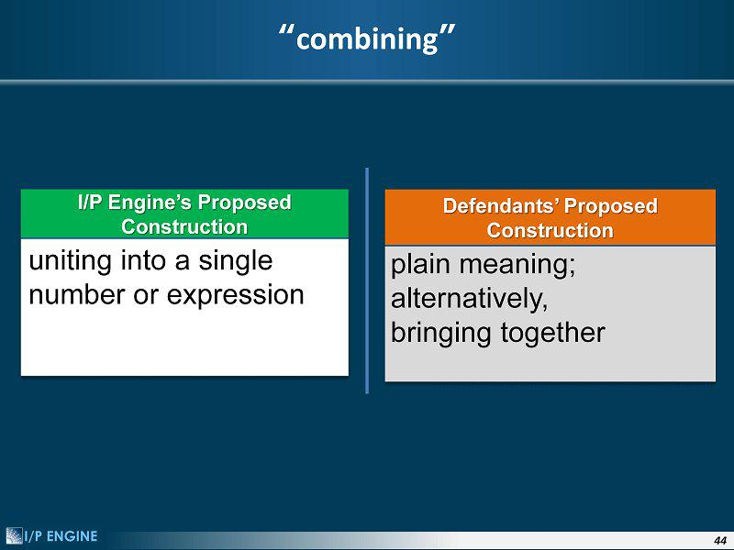

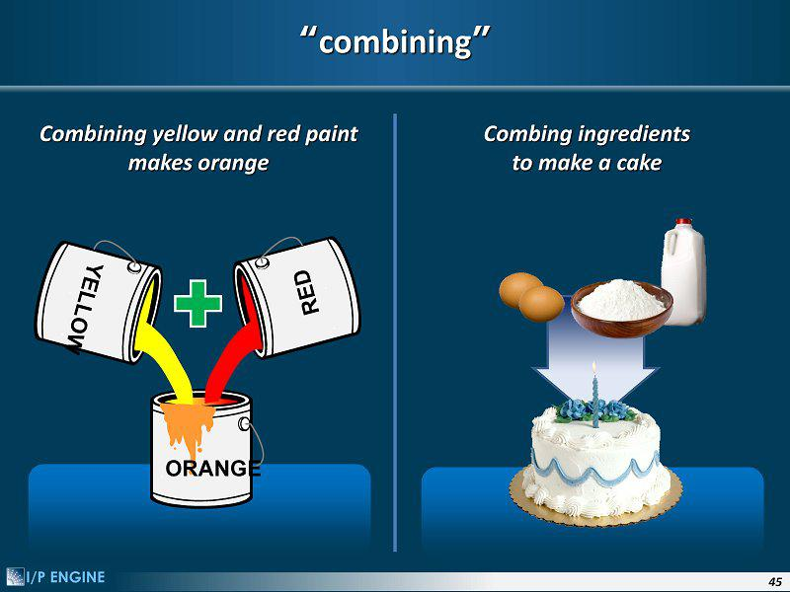

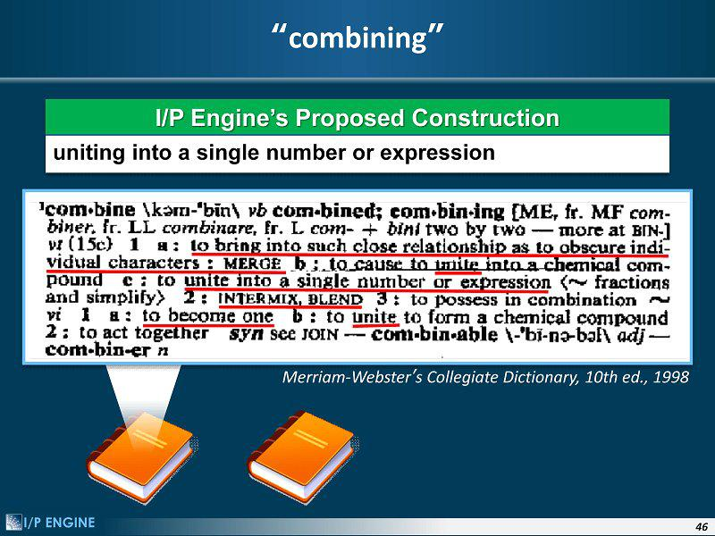

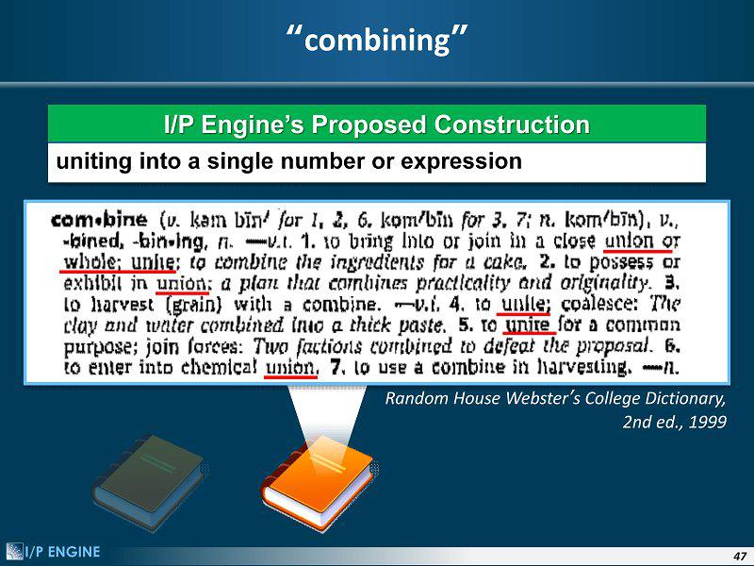

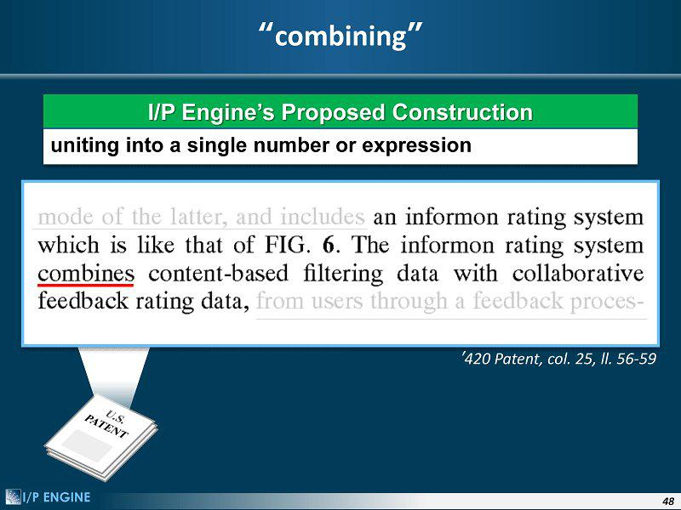

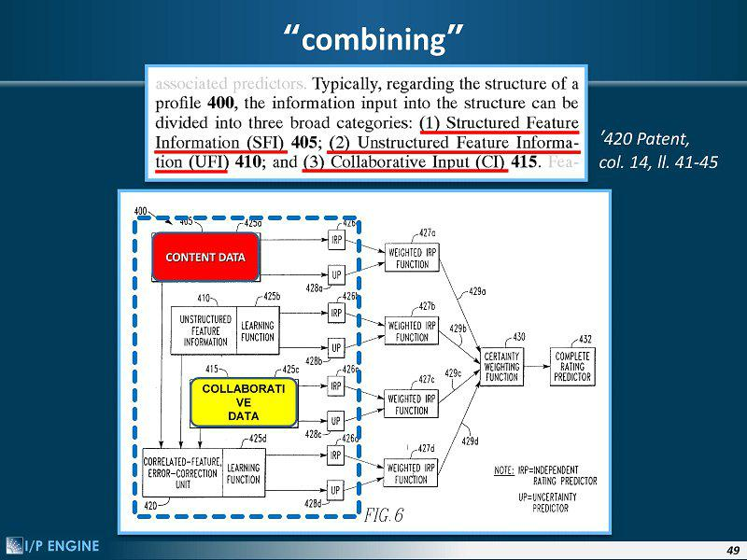

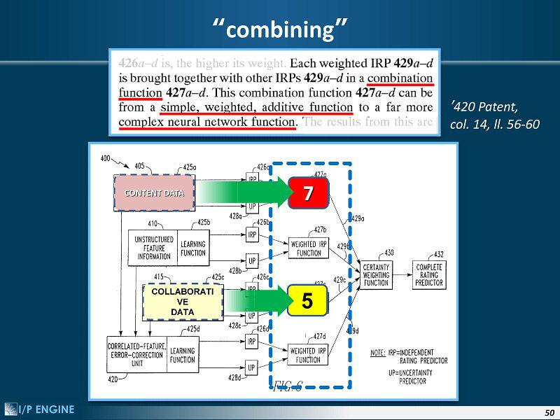

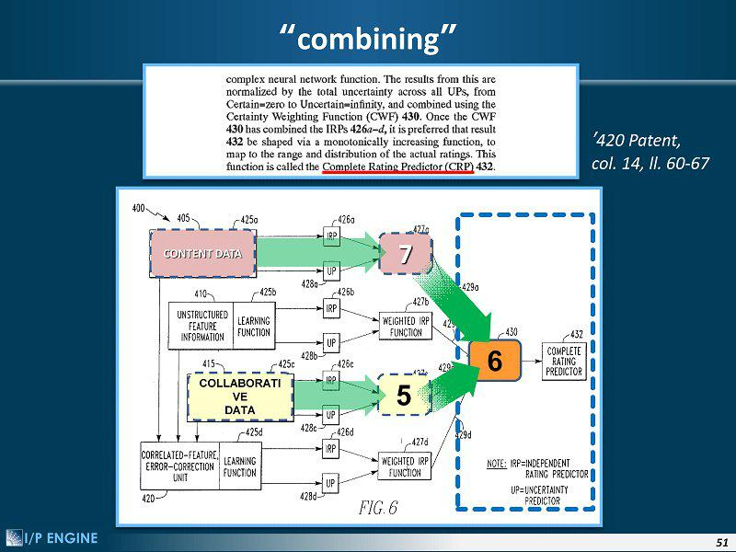

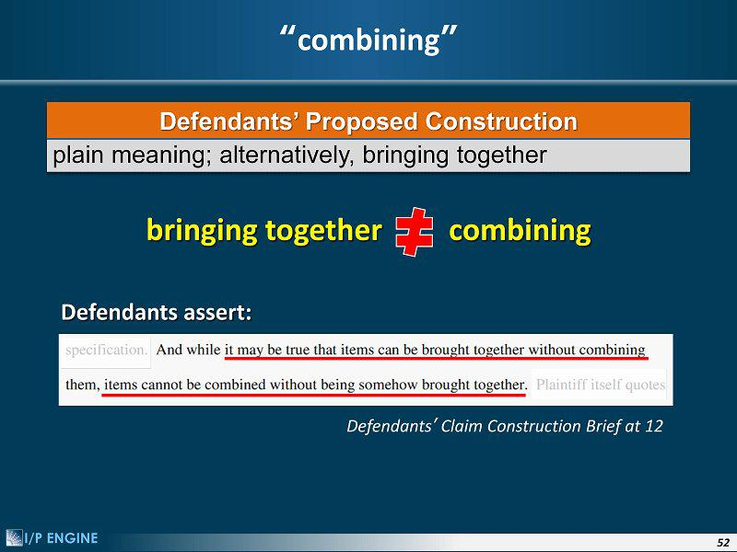

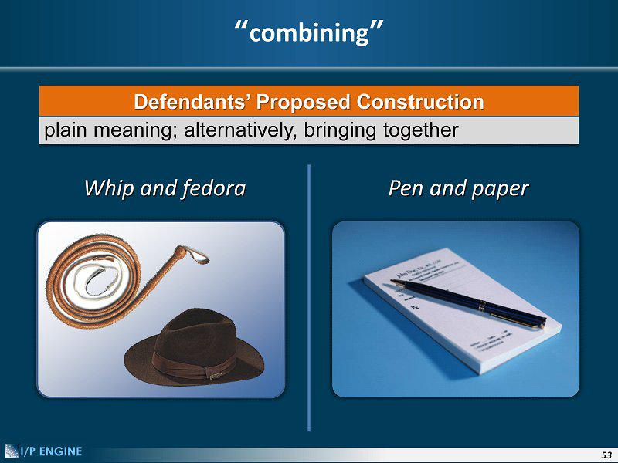

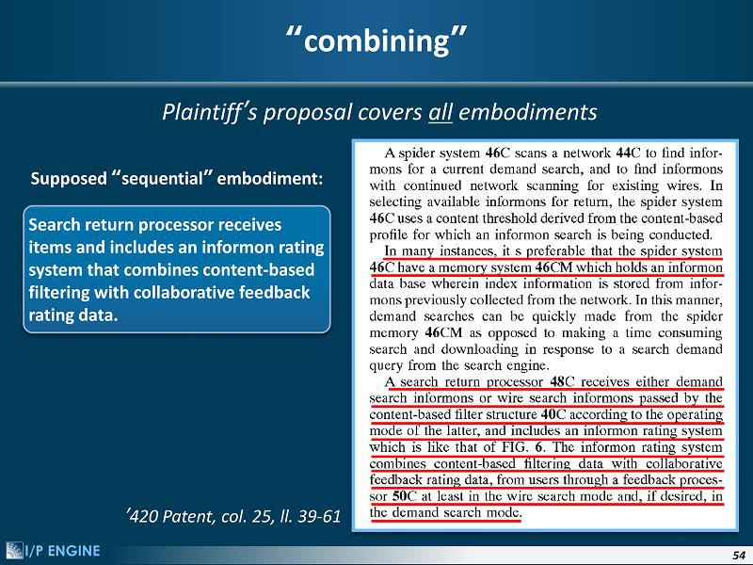

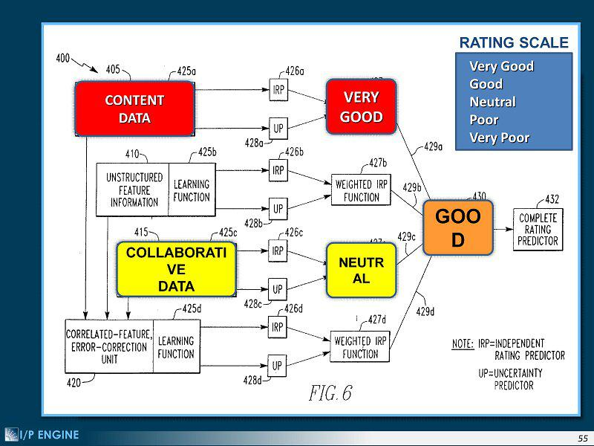

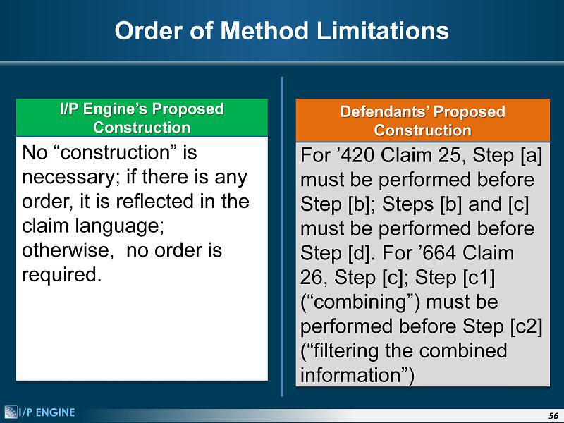

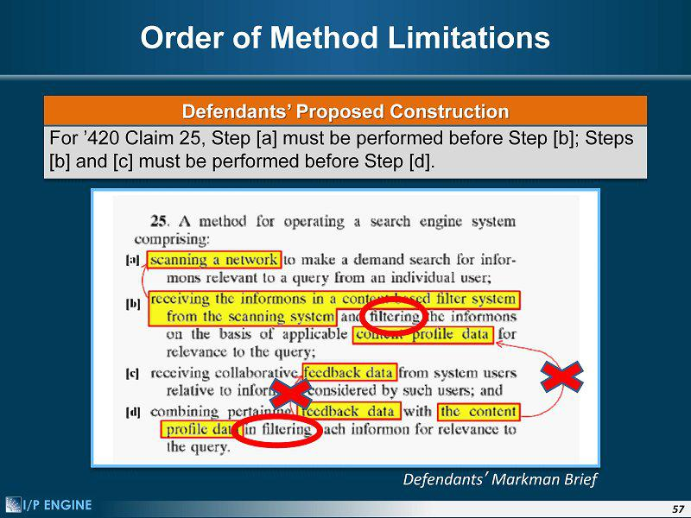

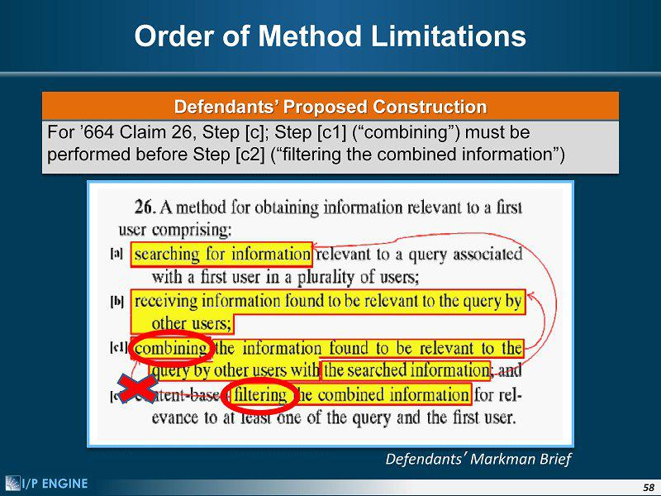

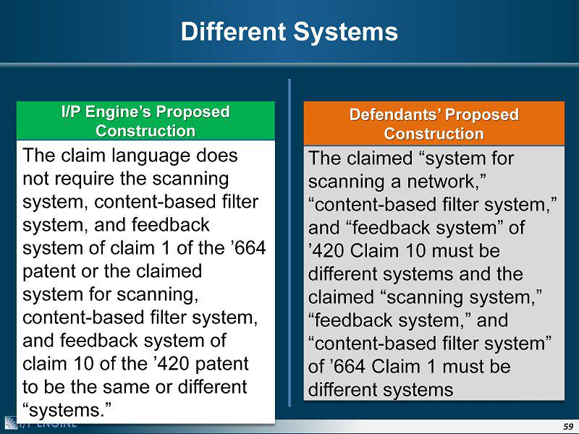

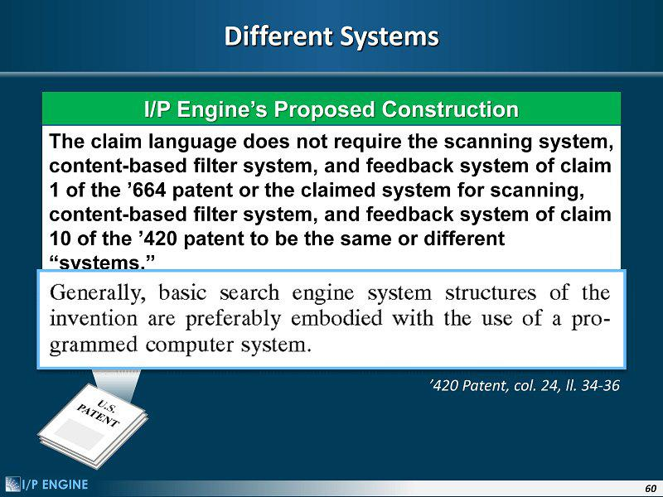

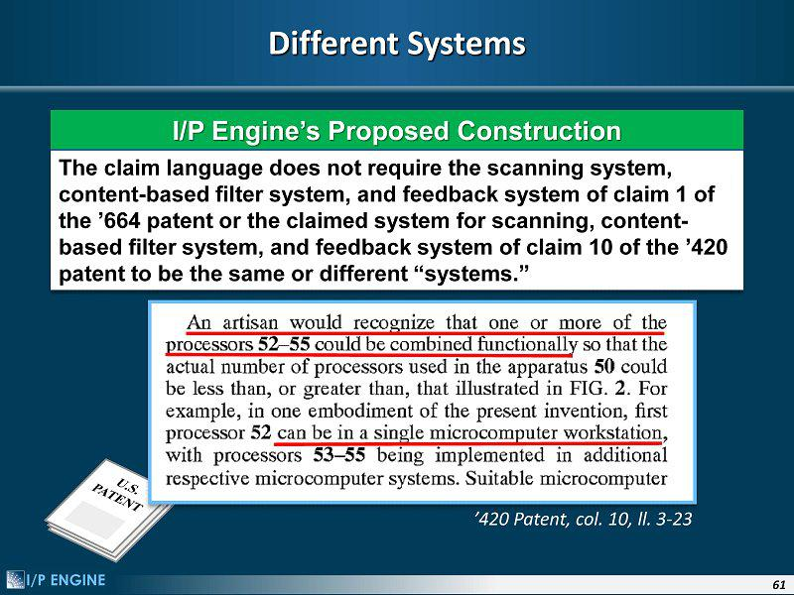

Important Additional Information Will Be Filed with the SEC

This communication does not constitute an offer to sell or the solicitation of an offer to buy any securities of Vringo, or Innovate/Protect or the solicitation of any vote or approval. In connection with the proposed transaction, Vringo filed a Registration Statement on Form S-4 with the SEC on April 6, 2012, subsequently amended on May 17, 2012 and June 1, 2012, which includes a preliminary proxy statement/prospectus of Vringo. These materials are not yet final and will be further amended. The proxy statement/prospectus contains important information about Vringo, Innovate/Protect, the transaction and related matters. Vringo will mail or otherwise deliver the proxy statement/prospectus to its stockholders and the stockholders of Innovate/Protect once it is final.

Investors and security holders of Vringo and Innovate/Protect are urged to read carefully the proxy statement/prospectus relating to the merger (including any amendments or supplements thereto) in its entirety when it is available, because it will contain important information about Vringo, Innovate/Protect and the proposed transaction.

Investors and security holders of Vringo will be able to obtain free copies of the proxy statement/prospectus for the proposed merger (when it is available) and other documents filed with the SEC by Vringo through the website maintained by the SEC at www.sec.gov. In addition, investors and security holders of Vringo and Innovate/Protect will be able to obtain free copies of the proxy statement/prospectus for the proposed merger (when it is available) by contacting Vringo, Inc., Attn.: Cliff Weinstein, VP Corporate Development, at 44 W. 28th Street, New York, New York 10001, or by e-mail at cliff@vringo.com.

Investors and security holders of Innovate/Protect will also be able to obtain free copies of the proxy statement/prospectus for the merger by contacting

Innovate/Protect, Attn.: Chief Operating Officer, 380 Madison Avenue, 22nd Floor, New York, NY 10017, or by e-mail at info@innovateprotect.com.

