UNITED STATES

SECURITIES AND EXCHANGE COMMISSION

Washington, D.C. 20549

FORM 8-K

Current Report

Pursuant to Section 13 or 15(d) of the

Securities Exchange Act of 1934

Date of Report (Date of earliest event reported): November 6, 2012

VRINGO, INC.

(Exact Name of Registrant as Specified in its Charter)

Delaware | 001-34785 | 20-4988129
(State or other jurisdiction | (Commission | (I.R.S. Employer
of incorporation) | File Number) | Identification No.)
 | 780 Third Avenue, 15th Floor, New York, NY 10017
 | (Address of Principal Executive Offices and Zip Code)
 | Registrant’s telephone number, including area code: (212) 309-7549

Check the appropriate box below if the Form 8-K filing is intended to simultaneously satisfy the filing obligation of the registrant under any of the following provisions:

- Written communications pursuant to Rule 425 under the Securities Act (17 CFR 230.425)

- Soliciting material pursuant to Rule 14a-12 under the Exchange Act (17 CFR 240.14a-12)

- Pre-commencement communications pursuant to Rule 14d-2(b) under the Exchange Act (17 CFR 240.14d-2(b))

- Pre-commencement communications pursuant to Rule 13e-4(c) under the Exchange Act (17 CFR 240.13e-4(c))

Item 8.01 Other Events.

On November 6, 2012, Vringo, Inc. (the “Company”) issued a press release regarding a verdict in the Company’s wholly-owned subsidiary, I/P Engine, Inc.’s case against AOL, Inc., Google, Inc., IAC Search & Media, Inc., Gannett Company, Inc. and Target Corporation (collectively, the “Defendants”) with respect to the Defendants’ infringement of the asserted claims of U.S. Patent Nos. 6,314,420, and 6,775,664 (the “Verdict”).

A copy of the press release announcing the Verdict is attached hereto as Exhibit 99.1 and is incorporated herein by reference. A copy of the executed Verdict Form is attached hereto as Exhibit 99.2 and is incorporated herein by reference.

On November 7, 2012, the Company issued a press release providing an update to the Company’s stockholders with respect to the Verdict against the Defendants.

A copy of the press release providing an update to the stockholders of the Company is attached hereto as Exhibit 99.3 and is incorporated herein by reference.

Item 9.01 Financial Statements and Exhibits.

(d) Exhibits.

Exhibit Number |  | Description of Exhibits
99.1 |  | Press Release, dated November 6, 2012, announcing the Verdict in the case against AOL, Inc., Google, Inc., IAC Search & Media,
 | Inc., Gannett Company, Inc. and Target Corporation
99.2 | A copy of the Verdict Form
99.3 | Press Release, dated November 7, 2012, providing an update to the stockholders of the Company with respect to the Verdict

SIGNATURES

Pursuant to the requirements of the Securities Exchange Act of 1934, the registrant has duly caused this report to be signed on its behalf by the undersigned hereunto duly authorized.

 | VRINGO, INC.
Date: November 8, 2012 | By: | /s/ Andrew D. Perlman
 |  | Name: Andrew D. Perlman
 |  | Title: Chief Executive Officer


News Release

Vringo Announces Verdict in I/P Engine Vs. AOL, Google et al.

Jury Finds Asserted Claims of Patents Infringed

Jury Confirms Validity of Patents

Jury Finds Damages Should be Based on a Running Royalty

NORFOLK, Va.--(BUSINESS WIRE)--Nov. 6, 2012-- Vringo, Inc. (NYSE MKT: VRNG), a company engaged in the innovation, development and monetization of mobile technologies and intellectual property, today announced a verdict in its wholly-owned subsidiary I/P Engine, Inc.'s case against AOL, Inc. ("AOL"), Google, Inc.("Google"), IAC Search & Media, Inc. ("IAC"), Gannett Company, Inc. ("Gannett"), and Target Corporation ("Target") (collectively, "Defendants") with respect to the Defendants' infringement of the asserted claims of U.S. Patent Nos. 6,314,420 (the "'420 Patent") and 6,775,664 (the "'664 Patent") (collectively, the "Patents").

The jury unanimously returned a verdict as follows:

- I/P Engine had proven by a preponderance of the evidence that the Defendants infringed the asserted claims of the Patents.

- Defendants had not proven by clear and convincing evidence that the asserted claims the Patents are invalid by anticipation.

The Court stated that it will decide the ultimate legal conclusion on whether the patents are invalid for obviousness. The jury answered the Court's factual questions with respect to obviousness as follows:

- Question for the Patents: What was the scope and content of the prior art at the time of the claimed invention?

Answer: No prior art applies because (1) the Bowman and Culliss references identified by Defendants lack any content analysis and filtering for relevance to the query and (2) other references identified by Defendants relate to profile system that do not disclose a tightly integrated search systems and could not filter information relevant to the query.

- Question for the '420 Patent: What difference, if any, existed between the claimed invention and the prior art at the time of the claimed invention?

Answer: The Bowman and Culliss references did not disclose either limitation (b) (a content-based filter and could not filter information relevant to the query) or (d) (combining feedback data with profile data) of independent claims 10 and 25. The other asserted references – Rose, Lashkari, and Fab, were profile systems that did not disclose a tightly integrated search system, and could not filter information relevant to the query.

- Question for the '664 Patent: What difference, if any, existed between the claimed invention and the prior art at the time of the claimed invention?

Answer: The Bowman and Culliss references do not disclose limitation (c) of the independent claims 1 and 26, because those references do not have a content-based filter that could not filter information relevant to a query, or combine information from a feedback system with content profile data. The other asserted references – Rose, Lashkari, and Fab, were profile systems that did not disclose a tightly integrated search system, and could not filter information relevant to the query.

- Question for the '420 Patent: Which of the following factors has been established by the evidence with respect to the claimed invention? ("[X]" means the jury indicated the factor did apply, and "[ ]" means the jury indicated the factor did not apply.)

- Commercial success of a product due to the merits of the claimed invention.

- A long felt need for the solution that is provided by the claimed invention.

- Unsuccessful attempts by others to find the solution that is provided by the claimed invention.

- Copying of the claimed invention by others.

- Unexpected and superior results from the claimed invention.

- Acceptance by others of the claimed invention as shown by praise from others in the field or from the licensing of the claimed invention. [ ] Independent invention of the claimed invention by others before or at about the same time the named inventor thought of it.

[ ] Other factor(s) indicating obviousness or nonobviousness — describe the factor(s).

· Question for the '664 Patent: Which of the following factors has been established by the evidence with respect to the claimed invention?

- Commercial success of a product due to the merits of the claimed invention.

- A long felt need for the solution that is provided by the claimed invention.

[ ] Unsuccessful attempts by others to find the solution that is provided by the claimed invention.

- Copying of the claimed invention by others.

- Unexpected and superior results from the claimed invention.

- Acceptance by others of the claimed invention as shown by praise from others in the field or from the licensing of the claimed invention.

- Independent invention of the claimed invention by others before or at about the same time the named inventor thought of it. [ ] Other factor(s) indicating obviousness or nonobviousness — describe the factor(s).
After finding that the asserted claims of the Patents were both valid and infringed by Google, the jury found that reasonable royalty damages should be based on a "running royalty", and that the running royalty rate should be 3.5%.

After finding that the asserted claims of the Patents were both valid and infringed by the Defendants, the jury found that the following sums of money, if paid now in cash, would reasonably compensate I/P Engine for the Defendants past infringement as follows:

- Google: $15,800,000

- AOL: $7,943,000

- IAC: $6,650,000

- Gannett: $4,322

- Target: $98,833

Vringo intends to file a copy of the executed Verdict Form with the U.S. Securities and Exchange Commission on Form 8-K when available.

I/P Engine and Defendants are allowed to file post-trial motions with the Court.

The case is styled I/P Engine, Inc. vs. AOL Inc. et al., and is pending in U.S. District Court for the Eastern District of Virginia, Norfolk Division. The case number is 2:11cv512RAJ. The court docket for the case is publicly available on the Public Access to Court Electronic Records website, www.pacer.gov, which is operated by the Administrative Office of the U.S. Courts.

About Vringo, Inc.

Vringo, Inc. is engaged in the innovation, development and monetization of mobile technologies and intellectual property. Vringo's intellectual property portfolio consists of over 500 patents and patent applications covering telecom infrastructure, internet search, and mobile technologies. The patents and patent applications have been developed internally, and acquired from third parties. Vringo operates a global platform for the distribution of mobile social applications and services including Facetones® and Video Ringtones which transform the basic act of making and receiving mobile phone calls into a highly visual, social experience. For more information, visit: www.vringoIP.com.

Forward-Looking Statements

This press release includes forward-looking statements, which may be identified by words such as "believes," "expects," "anticipates," "estimates," "projects," "intends," "should," "seeks," "future," "continue," or the negative of such terms, or other comparable terminology. Forward-looking statements are statements that are not historical facts. Such forward-looking statements are subject to risks and uncertainties, which could cause actual results to differ materially from the forward-looking statements contained herein. Factors that could cause actual results to differ materially include, but are not limited to: the inability to realize the potential value created by the merger with Innovate/Protect for our stockholders; our inability to raise additional capital to fund our combined operations and business plan; our inability to monetize and recoup our investment with respect to patent assets that we acquire; our inability to maintain the listing of our securities on the NYSE MKT; the potential lack of market acceptance of our products; our inability to protect our intellectual property rights; potential competition from other providers and products; our inability to license and monetize the patents owned by Innovate/Protect, including the outcome of the litigation against online search firms and other companies; our inability to monetize and recoup our investment with respect to patent assets that we acquire; and other risks and uncertainties and other factors discussed from time to time in our filings with the Securities and Exchange Commission ("SEC"), including our quarterly report on Form 10-Q filed with the SEC on August 14, 2012. Vringo expressly disclaims any obligation to publicly update any forward-looking statements contained herein, whether as a result of new information, future events or otherwise, except as required by law.

Source: Vringo, Inc.

Investors:

Vringo, Inc.

Cliff Weinstein, 646-532-6777

Executive Vice President

cliff@vringo.com

or

Media:

The Hodges Partnership

Caroline L. Platt, 804-788-1414

Mobile: 804-317-9061

cplatt@hodgespart.com

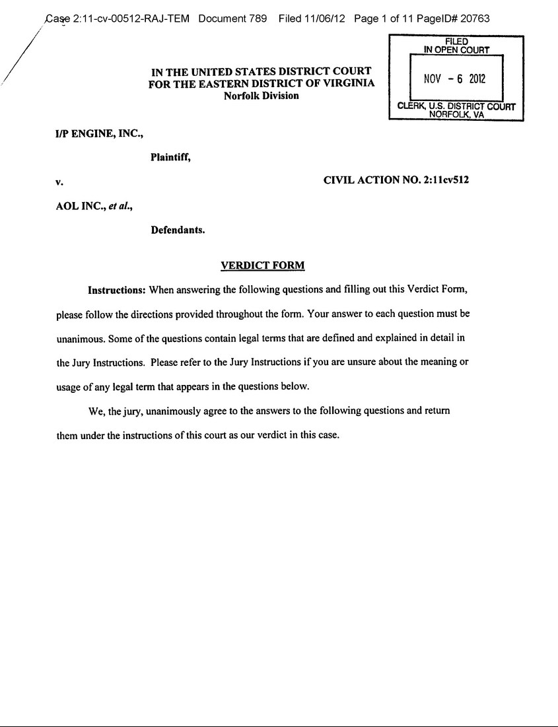

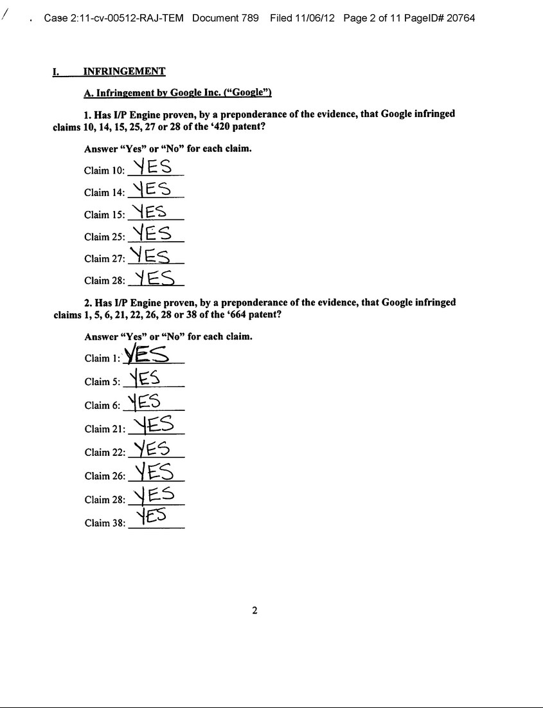

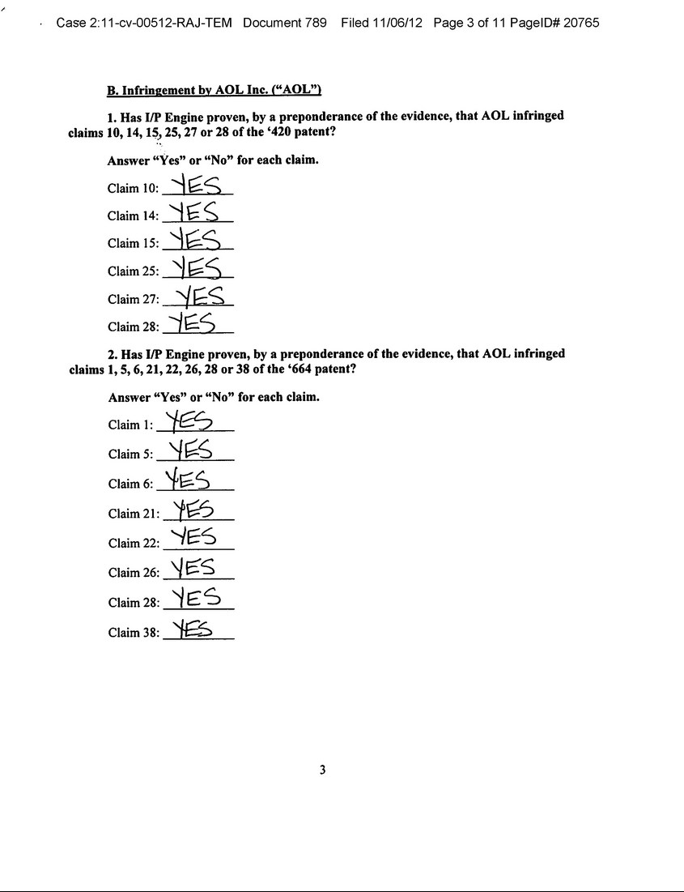

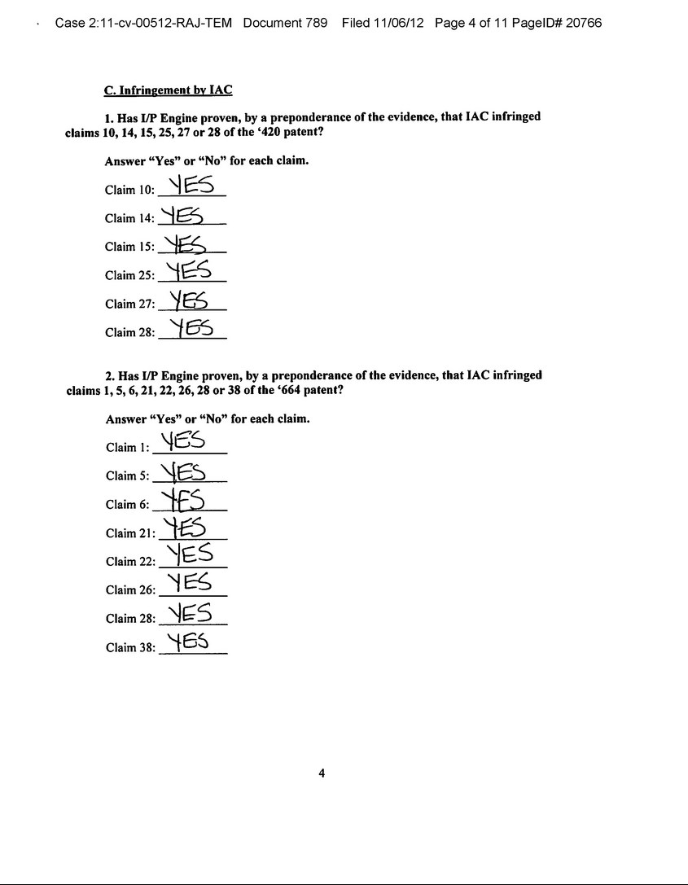

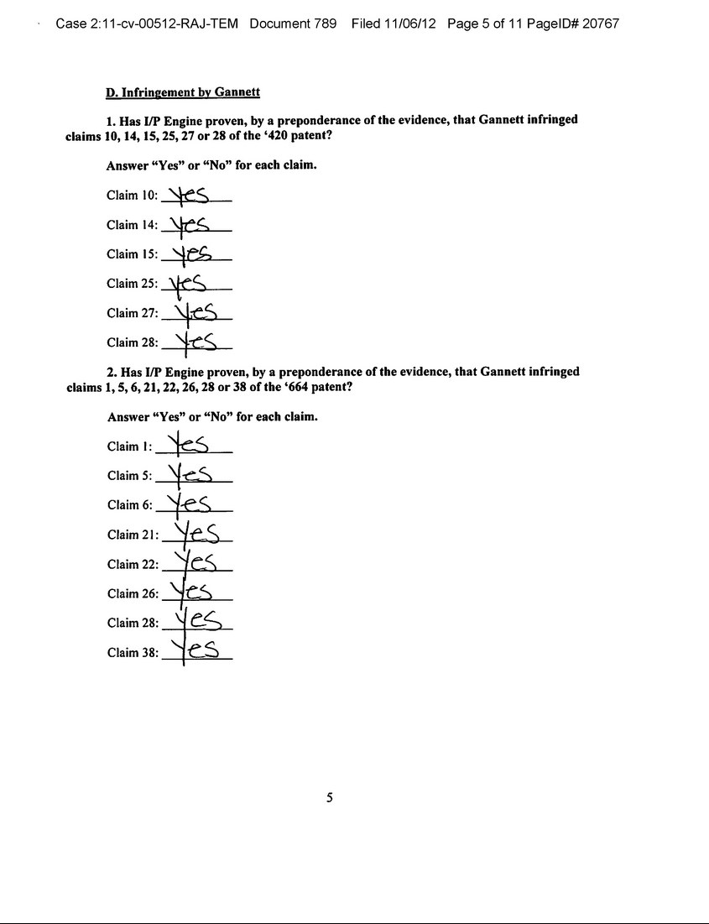

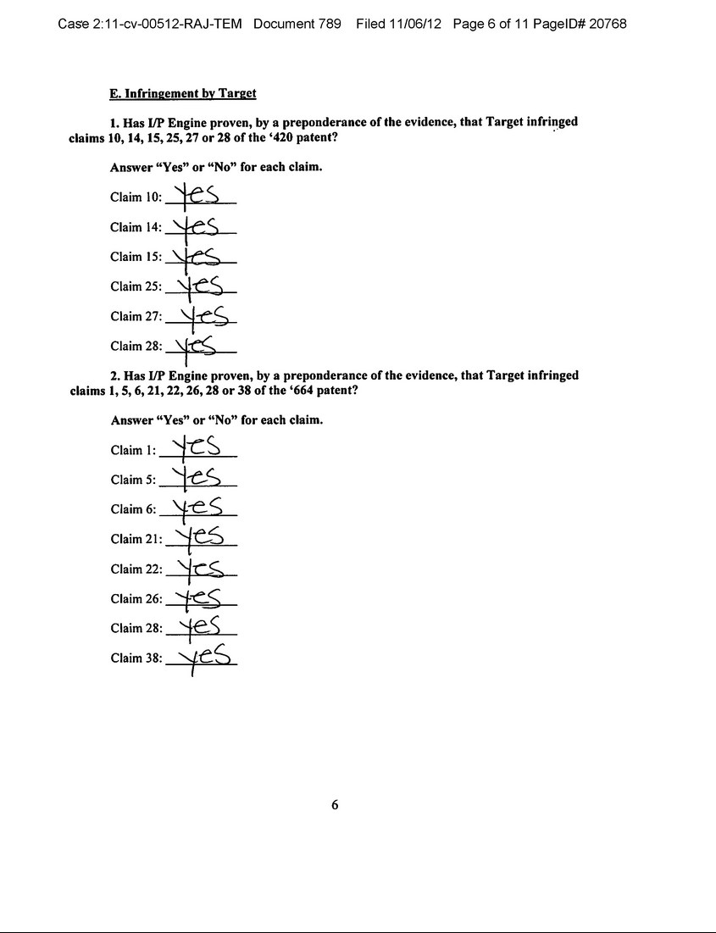

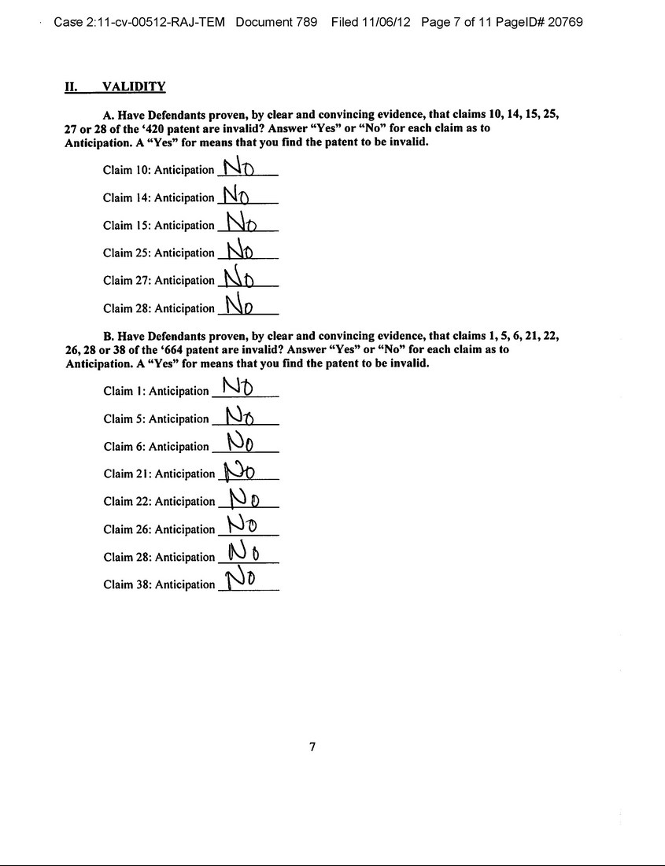

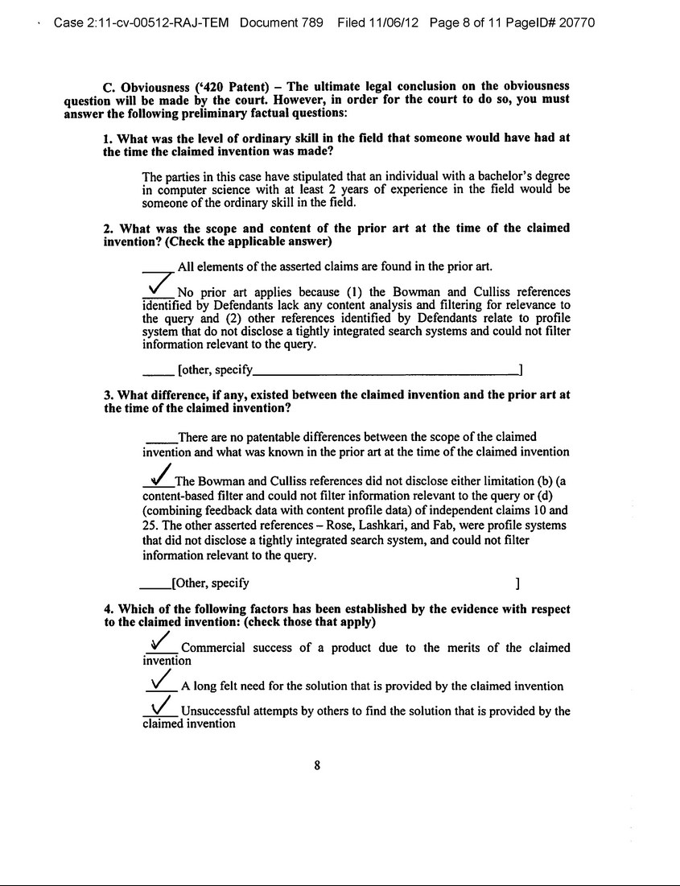

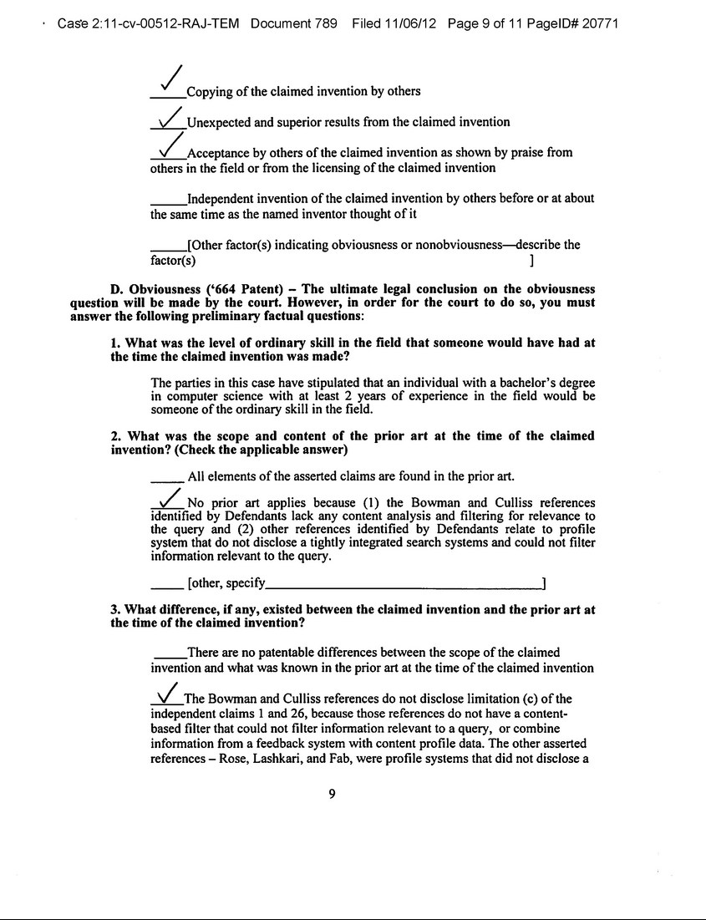

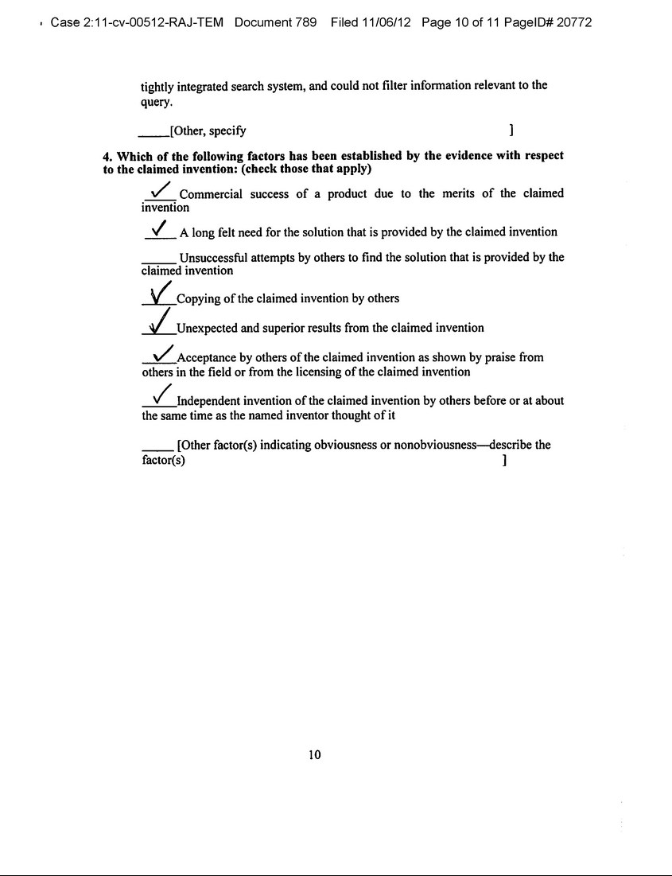

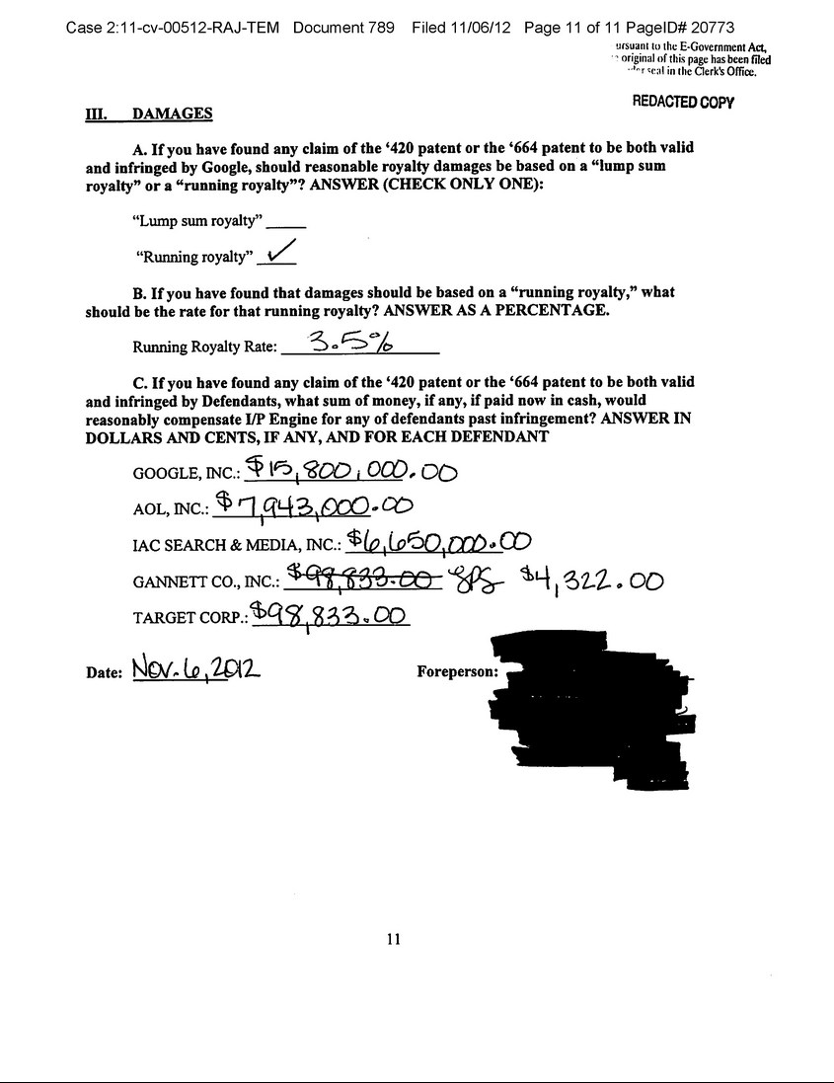

News Release

Vringo Provides Shareholder Update

NEW YORK--(BUSINESS WIRE)--Nov. 7, 2012-- Vringo, Inc. (NYSE MKT: VRNG), a company engaged in the innovation, development and monetization of mobile technologies and intellectual property, today provided an update to shareholders.

Yesterday, a jury in U.S. District Court in Norfolk, Virginia ruled in favor of Vringo, Inc.'s wholly-owned subsidiary, I/P Engine, Inc. in its litigation

against AOL, Inc. ("AOL"), Google, Inc. ("Google"), IAC Search & Media, Inc. ("IAC"), Gannett Company, Inc. ("Gannett"), and Target

Corporation ("Target") (collectively, "Defendants") with respect to the Defendants' infringement of the asserted claims of U.S. Patent Nos. 6,314,420 and

6,775,664. After finding that the asserted claims of the patents-in-suit were both valid, and infringed by Google, the jury found that reasonable royalty

damages should be based on a "running royalty," and that the running royalty rate should be 3.5%.

I/P Engine presented evidence at trial that the appropriate way to determine the incremental royalty base attributable to Google's infringement was to calculate 20.9% of Google's U.S. AdWords revenue, then apply a 3.5% running royalty rate to that base.

The jury also found that a total of $30,496,155 from Google, AOL, IAC, Gannett and Target, if paid now in cash, would reasonably compensate I/P Engine for the Defendants’ past infringement commencing on September 15, 2011.

The company has received numerous inquiries about the jury's calculation of past damages. Vringo's legal team is reviewing the verdict and plans to address all post-trial matters with the Court.

"We are very pleased with the jury’s conclusions with respect to validity and infringement,” said Jeffrey Sherwood, co-leader of Dickstein Shapiro’s Intellectual Property Practice and lead counsel for Vringo. "It is a very significant win."

Andrew Perlman, Chief Executive Officer of Vringo, said, "I would like to take this opportunity to thank our shareholders for their continued support. We are pleased with the fact that the jury found our patents valid and infringed, and that the defendants should pay a running royalty rate of 3.5%. Yesterday's verdict was an important milestone in demonstrating the value of our intellectual property portfolio. We look forward to continue to build shareholder value through the monetization of our assets."

The case is styled I/P Engine, Inc. vs. AOL Inc. et al., and is pending in U.S. District Court for the Eastern District of Virginia, Norfolk Division. The case number is 2:11cv512RAJ. The court docket for the case is publicly available on the Public Access to Court Electronic Records website, www.pacer.gov, which is operated by theAdministrative Office of the U.S. Courts.

About Vringo, Inc.

Vringo, Inc. is engaged in the innovation, development and monetization of mobile technologies and intellectual property. Vringo's intellectual property portfolio consists of over 500 patents and patent applications covering telecom infrastructure, internet search, and mobile technologies. The patents and patent applications have been developed internally, and acquired from third parties. Vringo operates a global platform for the distribution of mobile social applications and services including Facetones® and Video Ringtones which transform the basic act of making and receiving mobile phone calls into a highly visual, social experience. For more information, visit: www.vringoIP.com.

Forward-Looking Statements

This press release includes forward-looking statements, which may be identified by words such as "believes," "expects," "anticipates," "estimates," "projects," "intends," "should," "seeks," "future," "continue," or the negative of such terms, or other comparable terminology. Forward-looking statements are statements that are not historical facts. Such forward-looking statements are subject to risks and uncertainties, which could cause actual results to differ materially from the forward-looking statements contained herein. Factors that could cause actual results to differ materially include, but are not limited to: the inability to realize the potential value created by the merger with Innovate/Protect for our stockholders; our inability to raise additional capital to fund our combined operations and business plan; our inability to monetize and recoup our investment with respect to patent assets that we acquire; our inability to maintain the listing of our securities on the NYSE MKT; the potential lack of market acceptance of our products; our inability to protect our intellectual property rights; potential competition from other providers and products; our inability to license and monetize the patents owned by Innovate/Protect, including the outcome of the litigation against online search firms and other companies; our inability to monetize and recoup our investment with respect to patent assets that we acquire; and other risks and uncertainties and other factors discussed from time to time in our filings with the Securities and Exchange Commission ("SEC"), including our quarterly report on Form 10-Q filed with the SEC onAugust 14, 2012. Vringo expressly disclaims any obligation to publicly update any forward-looking statements contained herein, whether as a result of new information, future events or otherwise, except as required by law.

Source: Vringo, Inc.

Vringo, Inc.

Investors:

Cliff Weinstein, 646-532-6777

Executive Vice President

cliff@vringo.com

or

The Hodges Partnership

Media:

Caroline L. Platt, 804-788-1414 or 804-317-9061 (m)

cplatt@hodgespart.com

