UNITED STATES

SECURITIES AND EXCHANGE COMMISSION

Washington, D.C. 20549

FORM 8-K

Current Report

Pursuant to Section 13 or 15(d) of the

Securities Exchange Act of 1934

Date of Report (Date of earliest event reported): March 10, 2014

VRINGO, INC.

(Exact Name of Registrant as Specified in its Charter)

Delaware | 001-34785 | 20-4988129
(State or other jurisdiction | (Commission | (I.R.S. Employer
of incorporation) | File Number) | Identification No.)
 | 780 Third Avenue, 15th Floor, New York, NY 10017
 | (Address of Principal Executive Offices and Zip Code)
 | Registrant’s telephone number, including area code: (212) 309-7549

Check the appropriate box below if the Form 8-K filing is intended to simultaneously satisfy the filing obligation of the registrant under any of the following provisions:

- Written communications pursuant to Rule 425 under the Securities Act (17 CFR 230.425)

- Soliciting material pursuant to Rule 14a-12 under the Exchange Act (17 CFR 240.14a-12)

- Pre-commencement communications pursuant to Rule 14d-2(b) under the Exchange Act (17 CFR 240.14d-2(b))

- Pre-commencement communications pursuant to Rule 13e-4(c) under the Exchange Act (17 CFR 240.13e-4(c))

Item 2.02 Results of Operations and Financial Condition.

Attached hereto as Exhibit 99.1 is a copy of a press release of Vringo, Inc., dated March 10, 2014, announcing certain financial results for the fiscal year ended December 31, 2013.

The information set forth under this “Item 2.02. Results of Operations and Financial Condition,” including the exhibit attached hereto, shall not be deemed “filed” for purposes of Section 18 of the Securities Exchange Act of 1934, as amended, nor shall it be deemed incorporated by reference into any filing under the Securities Act of 1933, as amended, except as shall be expressly set forth by specific reference in such filing.

Item 7.01 Regulation FD Disclosure.

Attached hereto as Exhibit 99.2 and incorporated by reference herein is an updated investor presentation of the Company. A copy of the investor presentation is available on the Company’s website at www.vringoinc.com.

Also attached hereto as Exhibit 99.3 and incorporated by reference herein is the transcript of the investor update conference call held by the Company on February 12, 2014.

The information set forth under this “Item 7.01. Regulation FD Disclosure,” including the exhibit attached hereto, shall not be deemed “filed” for purposes of Section 18 of the Securities Exchange Act of 1934, as amended, nor shall it be deemed incorporated by reference into any filing under the Securities Act of 1933, as amended, except as shall be expressly set forth by specific reference in such filing.

Item 9.01 Financial Statements and Exhibits.

(d) Exhibits.
Exhibit Number |  | Description of Exhibits
99.1 |  | Press release announcing certain financial results for the fiscal year ended December 31, 2013.
99.2 |  | Updated Investor Presentation of Vringo, Inc. dated March 10, 2014
99.3 |  | Conference call transcript, held on February 12, 2014.

SIGNATURES

Pursuant to the requirements of the Securities Exchange Act of 1934, the registrant has duly caused this report to be signed on its behalf by the undersigned hereunto duly authorized.

 | VRINGO, INC.
Date: March 10, 2014 | By: | /s/ Andrew D. Perlman
 |  | Name: | Andrew D. Perlman
 |  | Title: | Chief Executive Officer

Exhibit 99.1

VRINGO ANNOUNCES YEAR END RESULTS FOR 2013

NEW YORK — March 10, 2014 — Vringo, Inc. (NASDAQ: VRNG), a company engaged in the innovation, development and monetization of intellectual property, today announced operating results for the year ended December 31, 2013. Vringo also released a new investor presentation, which is available online at http://bit.ly/1oFniVe. The transcript from Vringo's recent investor update call, held February 12, 2014, is available online at http://bit.ly/1cOScW7.

Operating Results for the Year Ended December 31, 2013

- As of December 31, 2013, we had approximately $33.6 million of cash and cash equivalents. We expect these funds will be sufficient to support our current operations and allow timely execution of our current business plans.

- Our average monthly use of cash in operations for the year ended December 31, 2013 was approximately $2.0 million per month. We expect this figure to decrease in 2014 and believe that our cash balance is sufficient for Vringo to operate through 2014 and 2015, conservatively without budgeting for a significant revenue event.

- During 2013, we recorded revenues of $1.1 million.

- Our net loss from continuing operations was approximately $41.7 million for the year ended December 31, 2013, mainly attributable to the following:

  - Operating legal costs of $20.0 million, mainly in connection with ongoing litigations against ZTE Corporation, Google, Inc., ASUSTeK Computer, Inc., and certain of their affiliates and customers, and other planned enforcements of our intellectual property.

  - General and administrative and other expenses of $6.3 million.

  - Non-cash expense of approximately $12.0 million related to equity-based compensation.

  - Non-cash expense of approximately $3.4 million related to the amortization of our patents.

- On December 31, 2013, we entered into a purchase agreement with Infomedia Services Ltd. (“Infomedia”) for the sale of our mobile social application business. The transaction closed on February 18, 2014 upon which we received an equity stake of approximately 8% of Infomedia.

- Our net loss from discontinued operations was approximately $10.7 million mostly driven by a one-time non-cash impairment charge of approximately $7.3 million in connection with the sale of our mobile social application business.

- On a per share basis, our total net loss (from both continuing and discontinuing operations) increased by 19% to $0.63 per basic share, compared to a net loss of $0.53 per basic share reported by the Company for the year ended December 31, 2012. The increase in basic loss per share was mostly driven by increases in operating legal costs and the one-time impairment charge related to the sale of our mobile social application business.

About Vringo, Inc.

Vringo, Inc. is engaged in the innovation, development and monetization of intellectual property and mobile technologies. Vringo`s intellectual property portfolio consists of over 500 patents and patent applications covering telecom infrastructure, internet search, and mobile technologies. The patents and patent applications have been developed internally, and acquired from third parties. For more information, visit: www.vringo.com.

Forward-Looking Statements

This press release includes forward-looking statements, which may be identified by words such as "believes," "expects," "anticipates," "estimates," "projects," "intends," "should," "seeks," "future," "continue," or the negative of such terms, or other comparable terminology. Forward-looking statements are statements that are not historical facts. Such forward-looking statements are subject to risks and uncertainties, which could cause actual results to differ materially from the forward-looking statements contained herein. Factors that could cause actual results to differ materially include, but are not limited to: our inability to license and monetize our patents, including the outcome of the litigation against online search firms and other companies; our inability to monetize and recoup our investment with respect to patent assets that we acquire; our inability to develop and introduce new products and/or develop new intellectual property; new legislation, regulations or court rulings related to enforcing patents, that could harm our business and operating results; unexpected trends in the mobile phone and telecom infrastructure industries; our inability to raise additional capital to fund our combined operations and business plan; our inability to maintain the listing of our securities on a major securities exchange; the potential lack of market acceptance of our products; potential competition from other providers and products; our inability to retain key members of our management team; the future success of Infomedia and our ability to receive value from its stock; and other risks and uncertainties and other factors discussed from time to time in our filings with the Securities and Exchange Commission ("SEC"), including our annual report on Form 10-K filed with the SEC on March 10, 2014. Vringo expressly disclaims any obligation to publicly update any forward-looking statements contained herein, whether as a result of new information, future events or otherwise, except as required by law.

Contacts

Investors and Media:

Cliff Weinstein

Executive Vice President

Vringo, Inc.

646-532-6777

cweinstein@vringoinc.com

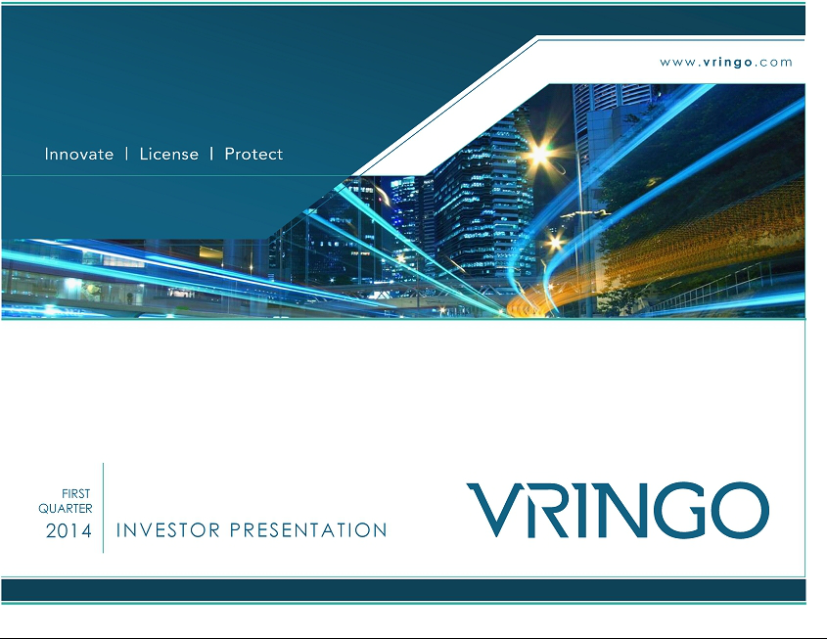

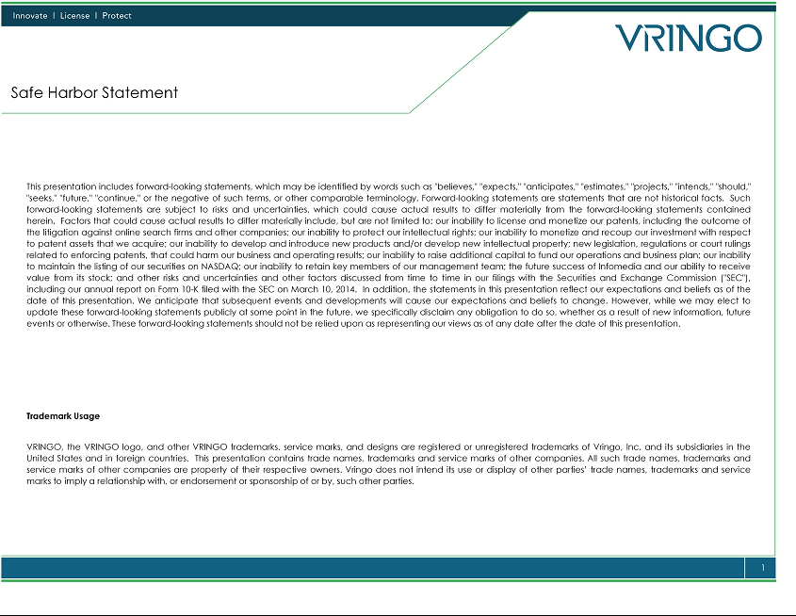

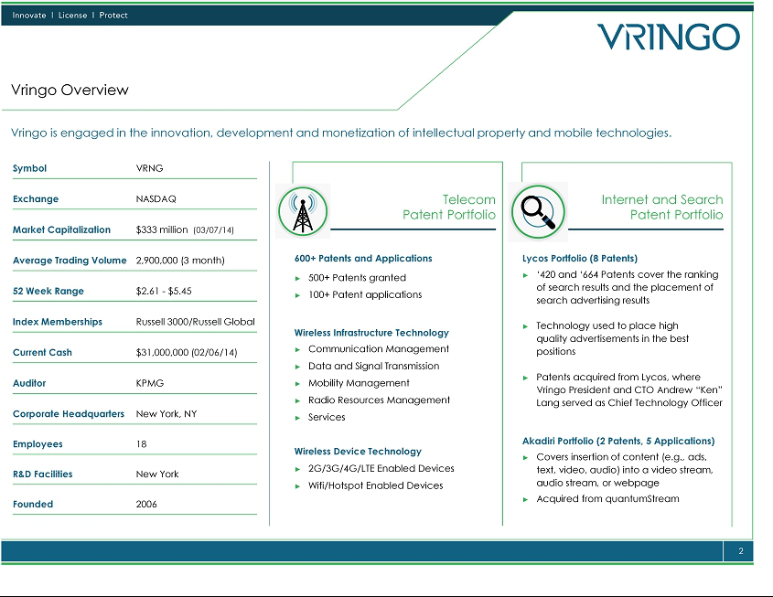

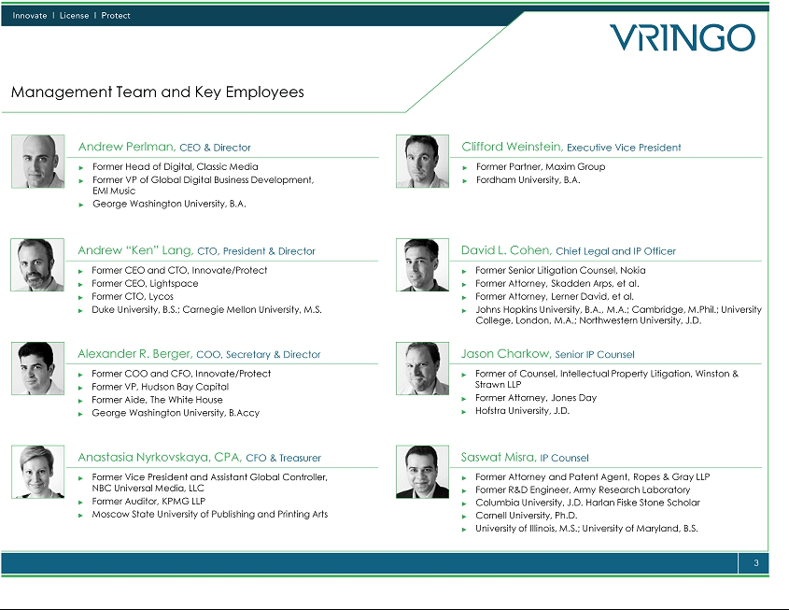

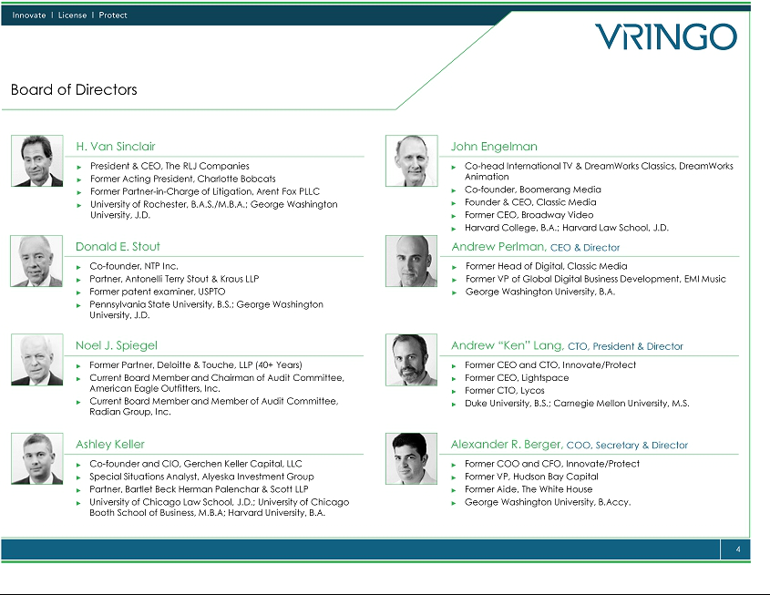

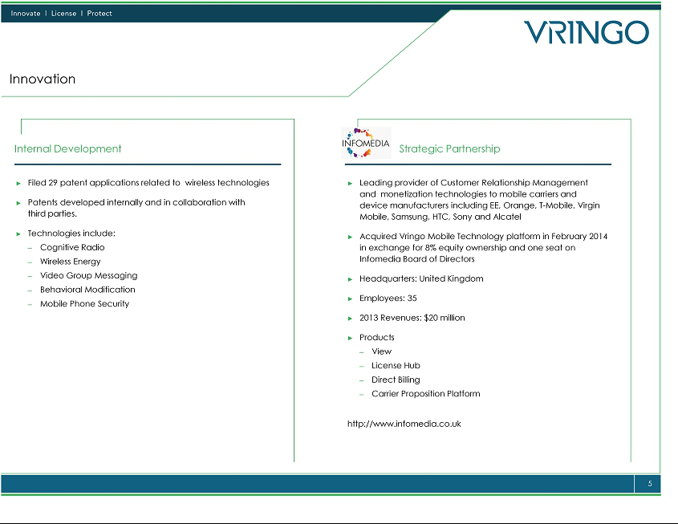

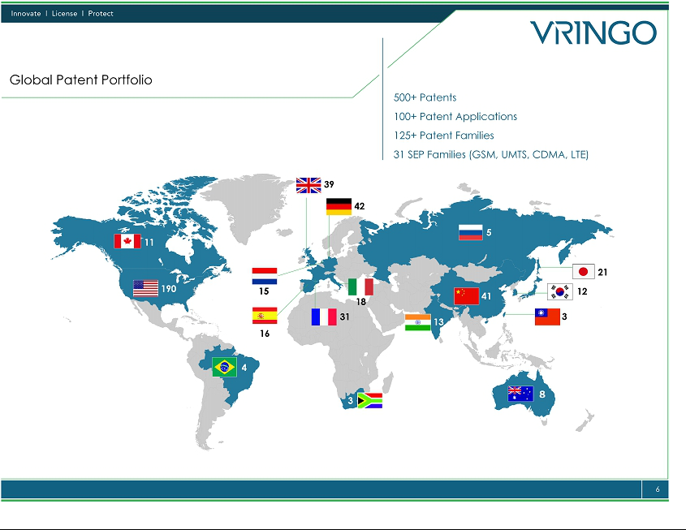



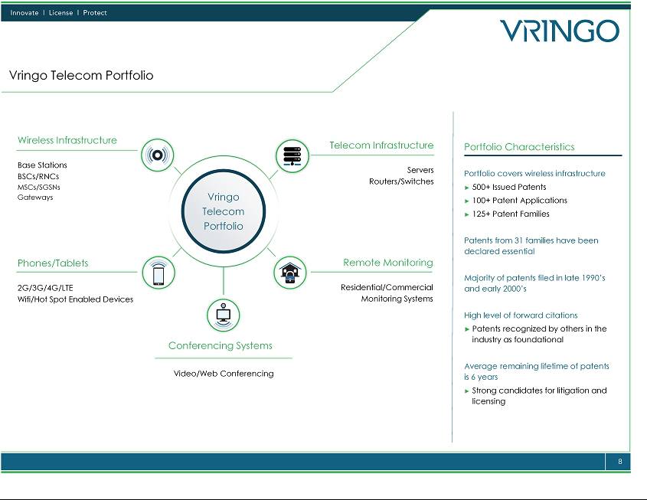

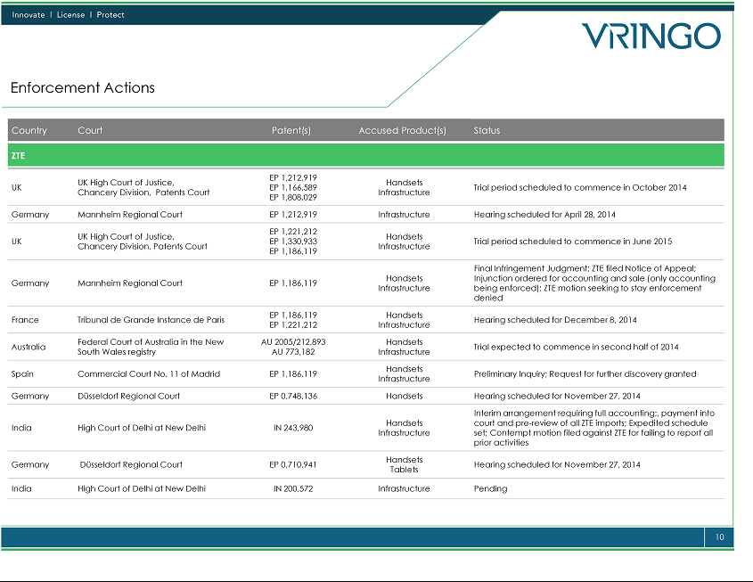

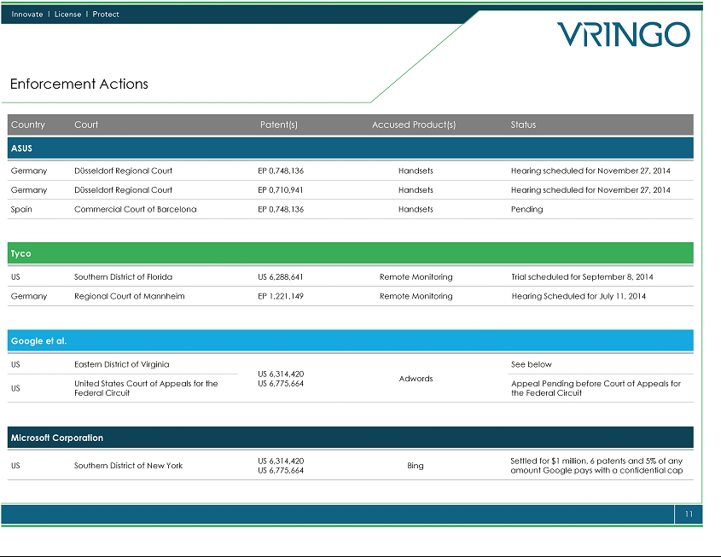

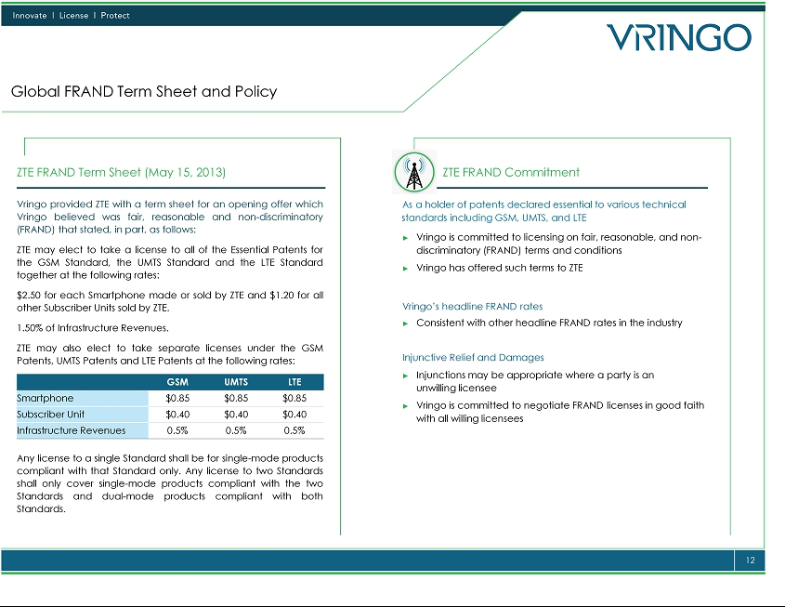



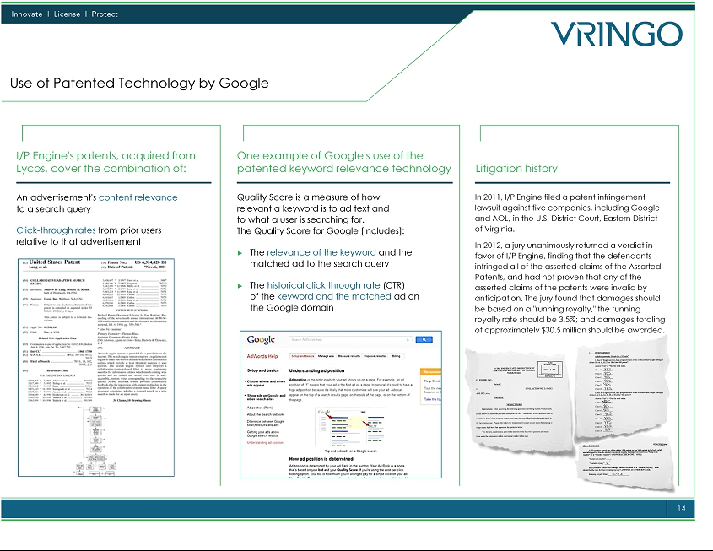

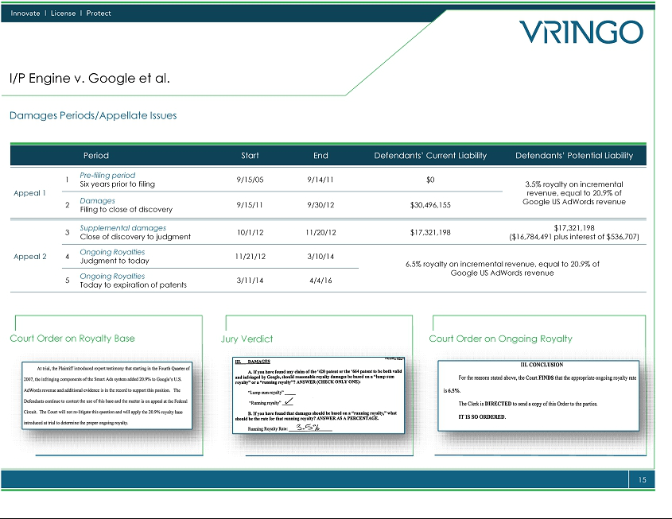

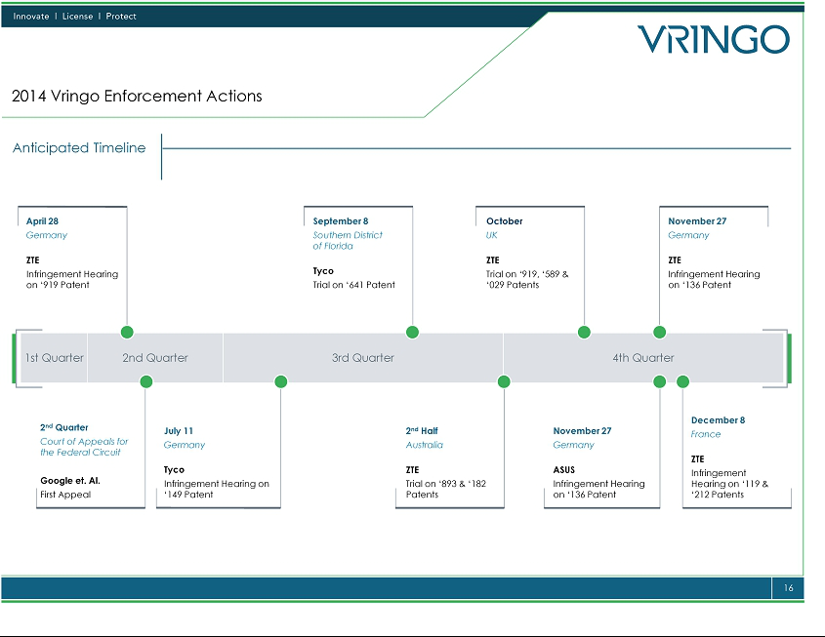

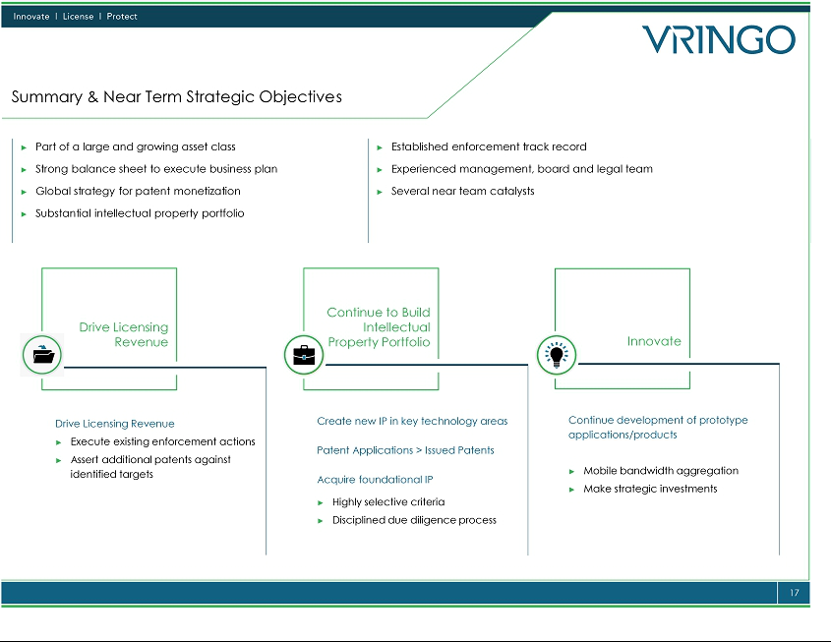

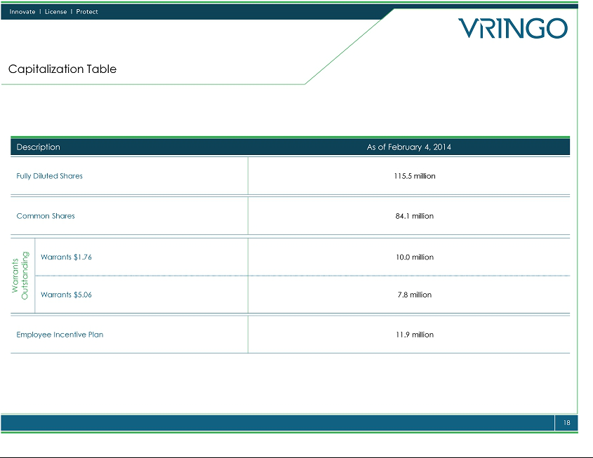

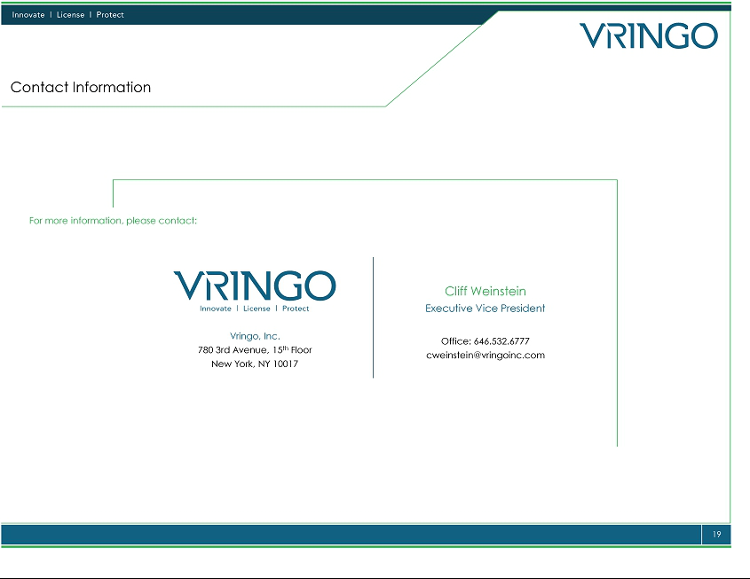

Exhibit 99.3

VRINGO, INC.

Investor Update Conference Call

February 12, 2014, 4:30 p.m. Eastern Time

Unofficial Transcript – Prepared by Infinite Conferencing, Inc.

This transcript of the investor update conference call includes forward-looking statements, which may be identified by words such as "believes," "expects," "anticipates," "estimates," "projects," "intends," "should," "seeks," "future," "continue," or the negative of such terms, or other comparable terminology. Forward-looking statements are statements that are not historical facts. Such forward-looking statements are subject to risks and uncertainties, which could cause actual results to differ materially from the forward-looking statements contained herein. Factors that could cause actual results to differ materially include, but are not limited to: our inability to license and monetize our patents, including the outcome of the litigation against online search firms and other companies; our inability to protect our intellectual rights; our inability to monetize and recoup our investment with respect to patent assets that we acquire; our inability to develop and introduce new products and/or develop new intellectual property; new legislation, regulations or court rulings related to enforcing patents, that could harm our business and operating results; our inability to raise additional capital to fund our operations and business plan; our inability to maintain the listing of our securities on NASDAQ; our inability to retain key members of our management team; the future success of Infomedia and our ability to receive value from its stock; and other risks and uncertainties and other factors discussed from time to time in our filings with the Securities and Exchange Commission ("SEC"), including our annual report on Form 10-K filed with the SEC on March 10, 2014. In addition, the statements in this transcript reflect our expectations and beliefs as of the date of this presentation. We anticipate that subsequent events and developments will cause our expectations and beliefs to change. However, while we may elect to update these forward-looking statements publicly at some point in the future, we specifically disclaim any obligation to do so, whether as a result of new information, future events or otherwise. These forward-looking statements should not be relied upon as representing our views as of any date after the date of this investor update conference call.

Vringo, Inc.

Investor Update Conference Call

February 12, 2014, 4:30 p.m. Eastern Time

Unofficial Transcript – Prepared by Infinite Conferencing, Inc.

OPERATOR: Thank you for joining us for today’s investor update conference call. Before I turn the call over to the company, we need to advise you of the following. Comments made on today’s call may contain forward-looking statements within the meaning of the Private Securities Litigation Reform Act of 1995. These forward-looking statements are based on current assumptions and opinions and involve a variety of known and unknown risks and uncertainties.

Actual results may differ materially from those contained in or suggested by such forward-looking statements. Important factors that might cause such differences include those set forth from time to time in the company’s SEC filing, including the company’s report on Form 10-K for the year ended December 31, 2012 and other current and periodic reports the company files with the SEC.

At this time I’d like to introduce Andrew Perlman, the Chief Executive Officer of Vringo.

ANDREW PERLMAN: Good afternoon and thank you all for taking the time to join us for investor update call. Joining me today on the call are Alex Berger, Chief Operating Officer; Ken Lang, President and Chief Technology Officer; Anastasia Nyrkovskaya, Chief Financial Officer, David Cohen, Chief Legal and Intellectual Property Officer and Cliff Weinstein, Executive Vice President.

We are taking this opportunity to offer our shareholders an update on recent activities in our domestic and global enforcement actions. At the end of the call we are going to have a brief question and answer session. In a few moments our chief operating officer Alex Berger will provide details about our subsidiary I/P engine litigation against Google and several of its customers. In short proceedings U.S. District Court, the Trial Court are substantially resolved. The parties appeal of the issues raised in the trial is completely briefed and pending docketing for oral argument at the Court of Appeal for the Federal Circuit.

The Federal Circuit is the only court sitting between the district court and the U.S. Supreme Court. At this time we do not believe defendants have raised presidential issues that would want review by the Supreme Courts. As it stands today we believe oral argument before the Federal Circuit for this appeal should be in April or May of this year. Google has appealed the more recent rulings by the District Court. Based on the typical Federal Circuit’s schedule oral arguments for the second appeal should be in August or September of this year. The two oral arguments maybe consolidated.

2

Vringo, Inc.

Investor Update Conference Call

February 12, 2014, 4:30 p.m. Eastern Time

Unofficial Transcript – Prepared by Infinite Conferencing, Inc.

Today I am announcing that Vringo has taken new actions relating to our telecommunications portfolio and our enforcement action against ZTE Corporation and ASUSTeK Computer, Inc. These new actions combined with our existing actions have resulted in seven trial dates currently scheduled to occur in 2014. With respect to ZTE first, last week on February 3rd Vringo filed a motion to hold the ZTE and its chief executive officer of its Indian subsidiary in contempt of court for non compliance with the court order to render accounts of products accused of infringing a patent that covers cellular infrastructure equipment and mobile devices.

The court had ordered ZTE Indian CEO to file an affidavit detailing ZTE’s import of relevant telecommunications equipments to India. ZTE’s India CEO failed to file the required document prompting the judge to threaten to block all of ZTE’s imports of CDMA 2000 products into India if the affidavit is not filed within three weeks. This (steps) from a lawsuit Vringo filed against ZTE in November. Second, on January 31st Vringo Infrastructure filed a new lawsuit against ZTE in India alleging infringement of an Indian patent covering cellular infrastructure equipment. The case is title Vringo Infrastructure versus IndiaMart. IndiaMart is a distributor of ZTE products.

ZTE is also a named defendant in this case. Importantly on February 3rd the court granted an (internment junction) against ZTE. This (internment junction) restrained ZTE and its officers, directors, agents, distributors and customers from importing, selling, offering for sale, advertising, installing, or operating any infringing products. It also gives Vringo the right to inspect any infringing goods arriving in India, which are detained by customs authorities and appointed commissioners to incept ZTE’s premises. The judge granted this (internment junction) after having made an initial determination that ZTE infringes (inaudible).

This action together, taken together with Vringo’s previous actions against ZTE now covers both CDMA 2000 and GSM infrastructure equipment as well as CDMA 2000 mobile devices. Third on February 10, 2014 in our second suit filed in India court appointed commissioners accompanied by counsel for Vringo executed a raid at a ZTE factory and a surprise inspection of ZTE’s headquarters in India for the purposes of collecting evidence of infringement and reviewing ZTE’s accounting records and sales data. Fourth on January 28th Vringo, Germany filed suit against both ZTE and ASUS in Germany alleging infringement of a European patent covering navigation systems found in mobile devices such as handsets and tablets.

3

Vringo, Inc.

Investor Update Conference Call

February 12, 2014, 4:30 p.m. Eastern Time

Unofficial Transcript – Prepared by Infinite Conferencing, Inc.

I’ll now provide some context around the royalty payment we believe is due from ZTE. According to ZTE they accepted to ship between 45 and 50 million smartphones in 2013. In the term sheet we provided to ZTE we’ve offered a license at a rate of $2.50 per smartphone. If this ultimately became our rate in our license to ZTE it would equate to over $100 million of royalties due for smartphones in 2013/11. We are also seeking additional royalties on non smartphones and infrastructure equipment. We are seeking six years of past royalties and future royalties until the expiration of the patent in our telecom portfolio. On average patents in our telecom portfolio have over five years of life (for meaning).

In addition we are in active dialog with some of the world’s largest corporations to acquire more partner in an effort to monetize intellectual property assets. A result of these efforts is a recent purchase of patents from Alcatel-Lucent, which we have already started to (ascertain). These patents are global in scope covering navigation system, social media and other technology. To summarize Vringo takes on license views of its technology seriously and has commenced these actions to enforce its right. My colleague David Cohen will provide a more comprehensive overview of the global enforcement actions against ZTE and ASUS in a few moments.

As you all know there’s been a number of other developments that have occurred in January and earlier February, which we will review. I would now like to offer managements view on our business today. We are focused on protecting a license fees and our rates including collecting past and future royalties we believe are due from companies that offer products that infringe our technology. When companies do not take licenses we work to secure successful enforcement actions. We are also focused on diversifying our asset base and broadening the scope of our technological focus areas.

Businesses with a risk (inaudible) profile line Vringo seek to offer superior returns for investors when management executes its business plan successfully and it’s supported by well informed investors. From the announcement of our merger with Innovate/Protect through today our team is executed on our business plan and produced favorable outcomes. These are the victories in 2013 and early 2014 (at the least) that they will lead to Vringo collecting the licensing royalties (that to do though). When we examine the performance of our stock price over the same period of time we feel that perhaps many of these milestones are not truly appreciated were properly valued.

4

Vringo, Inc.

Investor Update Conference Call

February 12, 2014, 4:30 p.m. Eastern Time

Unofficial Transcript – Prepared by Infinite Conferencing, Inc.

Several of our investors have inquired about what our plans are if and when we generate significant revenue that results in a large cash position on our balance sheet. At this point we cannot give investors a definitive answer and would be premature to adopt a dividend or share buyback policy. We will allocate capital in the best interest of the company shareholders. Examples of the ways to deploy capital include reinvestment in to additional I/P or I/P related assets, a shareholder dividend or share buyback. We want our investors to know that if after reviewing the current landscape with their board management decided that a dividend is in the best of the company we will be pleased to distribute the cash to our shareholders.

I would like to explain what we believe differentiates Vringo from other companies that own patents. As David will explain shortly Vringo standard for patent quality and in forcibility is already in a very high level. Vringo operates comfortably in countries that have strict patent laws and demands royalties on high quality patents after robust internal due diligence process. Our patent portfolio is global in scope and the major of enforcement activities occur outside of the United States. Of our over 500 patents roughly 75 percent are enforceable in jurisdictions outside of the U.S. We’ve been closely monitoring patent reform legislation in the U.S. as emerged is a major issue in the press and at the forefront of the legislative agenda in Washington.

Well no one is sure exactly what changes will be made or when they will be enacted we believe the change is inevitable. Those proposals advocate promoting higher quality patents and higher filing requirements. Some proposals seek to reduce discover cost and others allow winning parties to recover their fees and expenses from losing parties. This is already in effect in many of the counties where we have active litigation. For example we petitioned the District Court in Mannheim, Germany to require ZTE as the losing party to reimburse our fees and expenses because we were the (inaudible) party. Several companies including Google have lobbied for fee shifting legislation, which would bring the quote, unquote loser payroll to U.S. patent litigation.

We know that if it weren’t effect Vringo Subsidiary I/P Engine would have been able to seek recovery of its fees and cost from Google after a judge and jury in Federal Court, a Judge Google to infringe Vringo Subsidiary I/P Engine valid patents. Because of the exceeding high standards that we have set for ourselves, we believe that we are well positioned to continue to pursue royalties for products that use our technology both in the U.S. and overseas. Over the course of the past year we’ve built an extraordinary team composed of talented technical and legal minds and a management team that has demonstrated a stability to execute. We have an involved board of directors within valuable insight and a global consortium with external law firms each recognized as being a premiere advocate in its respective jurisdiction.

5

Vringo, Inc.

Investor Update Conference Call

February 12, 2014, 4:30 p.m. Eastern Time

Unofficial Transcript – Prepared by Infinite Conferencing, Inc.

Under the leadership of David Cohen we now have a very talented in house legal team consisting of six attorneys. As many of you know David began his career at Skadden, Arps and joined us from Nokia, where he was senior litigation counsel and (inaudible) global litigation against Apple. The Nokia-Apple litigations reportedly resulted in over $1 billion in license fees for Nokia. David has reunited with many of the international law firms that were part of that successful case. They are now part of the team that worked with him to conceive and execute the sophisticated plan in Vringo’s cases. Vringo began the licensing process in October of 2012 with our first (inaudible) for ZTE to take a license.

Before transitioning to an update on our ongoing enforcement actions, I would like to mention our current cash positions. As of February 12th, our cash position was over $31 million. Based on our internal budget and the cost of our anticipated licensing efforts we believe that this cash is sufficient for Vringo to operate through 2014 and 2015 conservatively without budget improve significant revenue for them. With regards to our ongoing litigations with Google, ZTE and others we have made great process over the course of the past year and a half. I will now turn the call over to Alex Berger, Vringo’s chief operating officer, Ken Lang, Vringo’s president and chief technology officer and David Cohen, our chief legal and intellectual property officer, who will go into further detail on what has happened in each of these campaigns respectively.

BERGER: Thanks Andrew. For our long term investors the next minute or two will serve as a review. On November 6, 2012 Vringo Subsidiary I/P Engine won the key victory against Google and several of its customers when a jury in U.S. District Court in Easter District of Virginia determined that Google’s search advertising system known as AdWords have breached two of our patents that relates to search and advertising technology. The judge and jury rejected Google’s defense of (inaudible) of the assorted patents awarded $30.5 million for past damages and a running royalty rate of 3.5 percent.

6

Vringo, Inc.

Investor Update Conference Call

February 12, 2014, 4:30 p.m. Eastern Time

Unofficial Transcript – Prepared by Infinite Conferencing, Inc.

On January 3rd of this year the District Court orders I/P Engine recover an additional (award) of $16.78 million from the defendants for supplemental damages during the 51 day period between the close of discovery and when the court formally entered judgment and $500,000 of prejudgment interest. And arriving at this sum the court appealed a 20.9 percent apportionment factor and then a 3.5 percent royalty rate to Google’s U.S. AdWords revenue. On January 21st of this year the District Court rejected Google’s alleged post verdict design around. The District Court found that the alleged design around was quote nothing more than a coverable variation of the system adjudged to infringe. And accordingly I/P Engines is entitled to ongoing royalties as long as defendant continue to use the modified system.

Most recently on January 28th the District Court issued an order stating that the appropriate ongoing royalty rate for the defendant’s ongoing infringement is 6.5 percent. An enhancement from the 3.5 percent rate previously set by the jury. To put that in context I/P Engine requested seven percent, while Google argued that 0.5 was an appropriate rate. We believe it is very important for our investors to understand that there are five distinct damages periods relating to Google’s infringement of I/P Engine’s patents. I will now walk through these periods.

The first period is the six year period prior to the filling of the lawsuit from September 15, 2005 through September 15, 2011. A trial that District Court ruled that the equitable doctrine of laches is appealed and damages of approximately $375 million for Google and the co-defendants in the case should not be awarded for this period. I/P Engine has appealed this ruling. The second period begins when the lawsuit is filed on September 15, 2011 and ends with September 30, 2012, which comprises the period for which revenue was produced during discovery. That trial the jury awarded $30.5 million of damages for this period.

We believe this award is the result of confusion by the jury over the appropriate calculations because that number is not based on the product of Google’s infringing search advertising revenue of the United States multiplied by the 20.9 percent of portion in factor and then a 3.5 percent royalty rates. I/P Engine believes the evidence support $118 million of damages for this period for Google and the co-defendants in the case because of that we have appealed for jury’s damages award. The third period begins with the end of the data produced during discovery and runs through the date. The District Court entered final judgment, November 20, 2012.

7

Vringo, Inc.

Investor Update Conference Call

February 12, 2014, 4:30 p.m. Eastern Time

Unofficial Transcript – Prepared by Infinite Conferencing, Inc.

The District Court awarded I/P Engine $16.78 million for this period plus about $500,000 in interest for a total award of $17.3 million dollars. The fourth and fifth damages periods comprised damages after the District Court entered judgment. The fourth period begins on the date of final judgment and remains ongoing through at least today. For purposes of discussion we will end this fourth period today because we believe damages for defendant’s ongoing infringement have accrued at least through today. Based on the infringement we have information we have, Google is still using the infringing system.

We cannot be certain that the defendants will continue to infringe our patents through the end of their life. But we believe it will be difficult for Google to redesign AdWords system such that it no longer infringes our patent while maintaining the benefit and add quality that make AdWords so valuable. As I mentioned Google has already attempted to do, so and failed. The fifth and final period is from today through that earlier when Google stops infringing the patents or when the patents expire on April 4, 2016.

During these two periods Vringo believes Google’s liability accrues based on the product of Google’s infringing search advertising revenues in the United States multiplied by the 20.9 percent of apportionment factor and a 6.5 percent royalty rate. To summarize the District Court has thus far awarded us $47.82 million in past damages and interest to date. And we believe Google’s liability for future damages accrues at a rate of 6.5 percent as appealed to the incremental revenue attributable to the patent’s institute, which is equal to 20.9 percent of Google’s U.S. AdWords revenues.

(Whereas) I/P Engine and the defendants have appealed various portions of the case to the United States Court of Appeals for the Federal Circuit. We have appealed to District Court’s decisions on laches and the jury’s calculations error on past damages that we believe led to an award that is less than what it should have been. Google on the other hand is appealing the validity of our patents, the conclusion that their products infringe our patents and the issue of damages. These issues are currently fully briefed and the filings are publically available on the online (patent) system. The link for it is many of our press releases. We are awaiting the scheduling of oral arguments before a panel of three circuit judges, which we expect to take place as soon as the second quarter of 2014.

The defendants have also separately appealed that District Court’s more recent ruling regarding supplemental damages and post verdict damages. And Andrew mentioned based on the typical Federal Circuit schedule oral arguments for this second appeal should be in August or September of this year. And the two oral arguments maybe consolidated. We feel very confident in Vringo’s appeal. The validity of our patents has been upheld by the judge, the jury and the U.S. Patent and Trademark Office. Google has watched two campaigns that mounted at the U.S. PTO to invalidate Vringo’s patents. Both of Vringo’s patents have been upheld as valid and confirmed.

8

Vringo, Inc.

Investor Update Conference Call

February 12, 2014, 4:30 p.m. Eastern Time

Unofficial Transcript – Prepared by Infinite Conferencing, Inc.

Google can continue to file reexamination requests and we are currently responding to their most recent one that impacts only the 420 patent and that request remains pending. There are no reexamination request pending on the 664 patent. It’s my pleasure to hand the call over to Ken Lang, our president and chief technology officer and the leading vendor behind the patented inventions.

KEN LANG: Thanks Alex. My colleague Don Kosak and I were creating the invention behind the 420 and 664 patents that were (surveyed) in our case against Google. We knew we were creating innovative machine learning techniques for search engines and advertising. By patenting our hard work we were protecting the value we created while at the same time allowing the field for advance by making public how our inventions work, so that other researchers could benefit from those advances. Don and I attended the trial in North of Virginia. After we testified we sat in the courtroom and heard over two week’s worth of testimony. We are gratified that the jury recognized our inventions and validate our efforts in contribution to the technology behind Google success.

When I was younger and just starting out as a technology entrepreneur it always seem daunting to face the prospects that we would spend years of our life doing research on a complex problem and finally creates a solution that end up having bigger technology see what we had done and simple take it for their own financial benefit for free. The main thing we had to help prevent that from happening was our patent system. Without the ability to property rights or our inventions (the incentive) to make public what we would create would shift dramatically. I probably would have to had to take a very different path as many inventors. It is hard for young technology entrepreneurs to raise capital. And investors use to always ask us what we were doing to protect the technology that their capital help us create.

This is why we have rendered support the value of our patent system. This is why we continue to pursue new inventions as well. In fact in the past few months we filed 30 new provisional’s patents and patent applications for techno inventions. I want to thank you our investors for supporting the process of innovation and a strong patent system as well. It is one of the key strength’s behind our countries economic success. I’ll now pass the call back to Alex to provide additional details of the Google case.

9

Vringo, Inc.

Investor Update Conference Call

February 12, 2014, 4:30 p.m. Eastern Time

Unofficial Transcript – Prepared by Infinite Conferencing, Inc.

ALEX BERGER: Thanks, Ken. I will take this opportunity to say that we are disappointed in Google’s public reactions to this matter. Having lost the jury trial, nearly every post trial motion and two of its reexamination attempt at the PTO instead of negotiating a license to Vringo’s patents Google has now (resorted) to what The Washington Post called quote derogatory language. On January 22nd of this year following a Federal Judge’s ruling that Google still infringed Vringo’s patents. An official Google spokesman told reporters that the Judge’s decision quote further highlights the mischief trolls can make with the patent system.

We are not aware of any mischief inheriting requiring the Google pay a reasonable royalty for its continuing willful and unlicensed use of the technology Ken and Don invented. While we cannot worry about Google (resorting) to name calling, the (inaudible) of the United States recognized that if one infringes another’s patent the patent owner is owed at least a reasonable royalty to the infringers use. Here under our laws I/P Engine is entitled to know less than a reasonable royalty for Google’s past and ongoing infringement. There is no limitation on that based on the identity of the plaintiff or defendant. A patent is a property right with that the government gives inventors in exchange for their agreement to share details of their invention with the public.

Don and Ken disclosed their inventions to the government and the public in exchange for their property right. Like any other property right it may be sold, licensed or assigned. Don and Ken assigned their rights and subsequently those rights were sold to I/P Engine. I/P Engine was in a position to join forces with Don and Ken to protect a property right and it did so. No defendants owe a reasonable royalty for the past and ongoing infringement to Vringo’s subsidiary I/P Engine and Vringo’s shareholders including Ken and Don. I will now pass the call to David Cohen to discuss in more detail our monetization efforts with respect to our telecom portfolio as it relates to the enforcements actions against ZTE, ASUS, ADT and Tyco.

DAVID COHEN: Thanks, Alex. We believe that ZTE offers products (composites) around the world that require a license to Vringo’s patents. We’ve also ZTE license, which we believe is on fair, reasonable and non discriminatory terms and conditions and hope they will be willing to take one. To date they have not and we have begun (enforcing efforts). We are currently asserting 12 patents in six countries against ZTE. ZTE is not stranger to controversies. Our experience with them in jurisdiction around the world reflects this fact. We have found that there are common themes that run throughout each of our worldwide litigations. In short ZTE has shown unwillingness to respect its legal obligations.

10

Vringo, Inc.

Investor Update Conference Call

February 12, 2014, 4:30 p.m. Eastern Time

Unofficial Transcript – Prepared by Infinite Conferencing, Inc.

We are using this behavior to (inaudible) and showing ZTE (that playing by the rules) and winning are not usually exclusive (inaudible) of seeing through ZTE’s legal maneuvering. As Judge (Jackson) of the regional court of Mannheim noted in his December 17th opinion, which ZTE is appealing. Defendants have not sufficiently demonstrated such as serious readiness to negotiate in the present case. Although the defendants have received a license offer from the plaintiff’s side and addressed comprehensive questions concerning this offer to the plaintiff’s side. The general reference to the fact that such questions were posed is not sufficient in order to demonstrate the seriousness of the readiness to negotiate.

In sum until such time as ZTE is willing to undertake negotiations in good faith to take a license to the patents required for product it is selling. Vringo will continue to see all appropriate reforms of the lease available under the law. ZTE has issued two press releases about Vringo litigation. In one ZTE said, ZTE fully respect the intellectual property of other companies and it’s committed to complete license agreements with patents holders on the FRAND principle. We can clearly hope ZTE honor this commitment. We provided ZTE with a term sheet (to look forth) the economic terms of the FRAND license. The term sheet became public in the course of our litigation in the United Kingdom. And we have put a copy of the term sheet on our website.

To the extent ZTE fail to honor that commitment we will pursue litigation against ZTE and both established markets in developing countries that are critical to ZTE’s own growth. We expect that seven of our cases against ZTE will be heard in 2014. I will now provide an overview and update of our preexisting actions around the world. (Here it’s breached on) by country. The U.K. In the U.K. we have filed two cases against the ZTE. The trials for those cases are scheduled to commence in late October of 2014 and early June 2015. Germany, including the recent filing Andrew announced we currently have four active lawsuits in Germany. In December of last year the court found that certain ZTE base stations infringe Japan that covers the use of transmitter diversity.

11

Vringo, Inc.

Investor Update Conference Call

February 12, 2014, 4:30 p.m. Eastern Time

Unofficial Transcript – Prepared by Infinite Conferencing, Inc.

A technique whereby multiple antennas are used to produced a more reliable communication channel. The court ordered ZTE to produce accounting records, a process known as rendering of accounts. (We haven’t) forced this remedy. ZTE did render accounts, but did so completely inadequately in our opinion. And we have demanded a better response. The court also issued an injunction against ZTE. And we plan to (enforce) the injunction at the appropriate time. ZTE has filed a motion for temporary stay to enforcement of this judgment and we will respond to its motion by February 20. However during this process the injunction continues to be available to us. Another case involves the (PAM) or just a regular communication and control involved in handing off of the mobile device from one base station to another.

This technology is used in to 3G and 4G LTE networks to ensure that the connection is handed off seamlessly. The hearing has been scheduled for April 20th of this year. And yet another case we have certain patent that covers technology that is present in nearly all modern smartphones. A lot of your smartphones is similar as a wireless hotspot. The hearing in this case is schedule to take place on November 27th of this year. The fourth case involves a (PAM) pertaining to navigation systems, which are available on many smartphones sold today. Google maps is an example. The hearing in this case is scheduled to take place on November 27, 2014.

India and Andrew explained earlier we’ve recently brought a new lawsuit in Indian. The (PAM) in this case revolve – in that case revolve relates to how mobile devices are handed over between (inaudible) when the mobile devices (inaudible) moving slowly. For example, when a user is walking with a mobile as opposed to traveling in a car or a train. The patent covers cellular infrastructure equipment and the technology enables networks to operate more efficiently. Our earlier case in India involves a (inaudible) to CDMA 2000 infrastructure equipment as well mobile devices such as phones and dongles.

On November 8th of last year the court granted an interim injunction and ordered a four camping of path infringement in ongoing infringing activity. ZTE appealed that injunction, which the court set aside in exchange for a bond of approximately $800,000 in order to (inaudible) hearing. Based on that account – on the account (inaudible) received we have requested the court increase the size of the bond. In addition we were completely unsatisfied with ZTE’s accounting and filed a contempt motion with the court. After hearing on February 5th, the court gave ZTE three weeks and wish to compliance after which it were visiting junction in the size of the bond. France. In France we filed suit last year against ZTE alleging the infringement of two of our patents.

12

Vringo, Inc.

Investor Update Conference Call

February 12, 2014, 4:30 p.m. Eastern Time

Unofficial Transcript – Prepared by Infinite Conferencing, Inc.

The first of which is the French counterpart of the patents for which we obtained an injunction in Germany. The second patent relates to synchronizing data rates in the GSM network. We brought these two based on information uncovered during (inaudible) which is a seizure to obtain evidence of infringement. It was executed at two ZTE facilities in France. The hearing in this case is scheduled for December 8th of this year, where an injunction is among the remedies available. It is worth noting that our counsel and plans is on the committee that is drafting the procedural rules for the new unified European patent court. Australia. In Australia we are progressing towards trial in our case filed last June alleging infringement of two of our Australian patents.

The first is the counterpart to our French patent relating to data rates in GSM. The second relates to power management for 4G mobile devices. We expect the trial to commence in the second half of this year. In Spain. In Spain. In Spain we filed a preliminary inquiry order against two ZTE entity last September. ZTE was non-responsive to this order and as a result we have petitioned the court for further discovery. This request remains pending. ASUS. I would now turn to
– two actions we have filed against ASUS. On October 4th of last year we filed a lawsuit against the two ASUS entities in Germany alleging the infringement of the same patent asserted against ZTE that’s relates to devices with hotspot functionality.

The hearing is for November 27th of this year. Last month on January 29th we filed an additional lawsuit against ASUS in Germany alleging the infringement of the navigation, system patent also sort of against ZTE. The hearing on this case is also on November 27th of this year. Remote monitoring. In regards to our remote monitoring portfolio on September 12, 2013 we announced that our subsidiary Vringo Infrastructure initiated enforcement actions against the ADT Corporation and Tyco Integrated Security in the Southern district of Florida alleging infringement of a patent entitled assembly and associated method for remotely monitoring a surveillance area. This patent is from our Nokia portfolio.

And is in an adjacent technology area, which we believe is foundational into remote monitoring in security space, which has grown rapidly over the past of years. And which we anticipate will continue to do so through the foreseeable future. Two weeks ago we announced that we had entered into an agreement with ADT resolving our litigation with them. Furthermore we announced the addition of a suit against Tyco, which we filed in Germany alleging the infringement of the counterpart to the patents asserted in the U.S. Amongst other remedies we are seeking an injunction against Tyco in Germany. Our trials in Germany and in the southern district of Florida are scheduled to commence on July 11th and September 8, 2014 respectively. It is now my pleasure to pass the call back to answer, who will discuss some other developments with the company.

13

Vringo, Inc.

Investor Update Conference Call

February 12, 2014, 4:30 p.m. Eastern Time

Unofficial Transcript – Prepared by Infinite Conferencing, Inc.

PERLMAN: Thanks, David. We seek to partner with companies that are leaders in technology and intellectual property. On January 2nd we announced that Infomedia in U.K., a U.K. based company will be acquiring Vringo mobile platforms and partner services business. Infomedia provides customer relationship management and monetization technologies to mobile carriers and device manufacturers via its product line, which include iView, a behavioral platform that delivers targeted messaging to a customer’s devices. Having discussed Infomedia’s plans for the proprietary Vringo product lines with their management we are all very excited to see what their talented staff of engineers brings to the mobile market place.

In exchange for ownership of the relevant Vringo technologies and related intellectual property Vringo acquired an approximately eight percent owner stake in Infomedia. Given Infomedia’s access to broad markets around the world we believe this transaction could yield a great return on investment for our company as well as enable us to focus on monetizing our intellectual property portfolio on a global scale. In conclusion, I am exceptionally proud to call myself the CEO of Vringo and surrounded by an a fantastic team that have proven their ability to think creatively and act swiftly and decisively in a very complex business. I am confident about the future prospects of our company and I look forward to the months and years ahead.

At this time I would like to turn the call over to the operator for Q&A.

OPERATOR: Ladies and gentlemen the floor is open for question. If you do have a question, please press star one on your telephone keypad at this time. Once again the floor is out for questions. If we do have a question, please press star one on your telephone keypad at this time. And once again please hold while we poll for questions. And once again please hold while we poll for questions.

And our first question comes from (Avery Katz) from (Regal Holdings). Your line is now open.

(AVERY KATZ): Hey, guys thank you for the call.

14

Vringo, Inc.

Investor Update Conference Call

February 12, 2014, 4:30 p.m. Eastern Time

Unofficial Transcript – Prepared by Infinite Conferencing, Inc.

PERLMAN: Hi, (Avery).

(KATZ): So just a few quick questions for you. You spoke quickly about the appeal timeframe with Google in your prepared remarks. Could you just revisit that quickly and give us a quick summary?

PERLMAN: Yes, sure. So there are currently – there are two separate appeals. One is for the past; one is for the ongoing royalty rate. The one that’s go to past is currently fully briefed. That appeal occurred shortly after the trial and final judgment concluded based on what we said today and the fact that it’s fully briefed that could occur as soon as April or May. There will be second appeal, which has to do with the really on ongoing royalties based on where we sit today in the briefing schedule that would likely occur in August or September of this year. Separately there has been a motion to consolidate the two appeals into one oral argument. If that were to occur then the oral argument for the appeal would occur no later than September of 2014 we believe.

(KATZ): OK, great. And just a follow up to that point. With respect to the recent ruling at (inaudible) model devalue of the damages recently were awarded to you guys based Judge Jackson’s 6.5 royalty rate. And we have come up with a number that’s north of a billion dollars in terms of what’s to do Vringo. You know, I appreciate that there are likely a lot of retails who are happy to sell the news and you know, leave a lot of upside on the table. But your stock price is only up about 10 percent since the royalty ruling, I think only about 35 to $40 million of value, you know, as compared to the billion plus ruling that we see and we calculate. Are we missing something here and how do you explain the disconnect?

PERLMAN: I think I already alluded to this earlier in the call. I think we believe there is unquestionably a disconnect between the value that you just spoke of, the value that we created and the progress that we’ve made in asserting the Nokia portfolio, the enterprise value of the company and where the market cap is today. But certainly just based on what you said one could draw a clear disconnect in the market value and any outcomes that we brought (inaudible) at this point.

(KATZ): OK. And just last question I have is with respect to your cash burn, you said you have a couple of years of cash on your balance excluding any kind of major revenue event. I think the biggest fair case here is just that you’ve (inaudible) equity. You have no plan at this point to raise their equity, can you just reiterate and confirm that and talk about different sources of cash that could come in over the next two years?

15

Vringo, Inc.

Investor Update Conference Call

February 12, 2014, 4:30 p.m. Eastern Time

Unofficial Transcript – Prepared by Infinite Conferencing, Inc.

PERLMAN: Sure. So obviously the first and the one that we are the most focused on as a company is generating licensing revenue what you said was accurate, which is that right now we have an excess of $31 million of cash on our balance sheet. We currently have no plans to go out and raise additional equity as we sit here today. The one caveat and I think we’ve said this ever since the merger. If we found an asset that we absolutely fell in love with and we need to raise the capital we’d do it.

We would consider raising additional equity, there is currently nothing that is on our plate right now that would be left to do. Separately, you know, as a company they also have a (inaudible) that are in the money that could generate up to about $18 million of cash that are exercisable. And overtime if the stock prices continue to go up, you know, we start to see that (inaudible) on occasion and they are callable once the stock reaches $5 and closing there for 20 or 30 trading days.

(KATZ): OK, great. Great job guys. Thanks for the call.

PERLMAN: Thank you.

OPERATOR: Thank you. And our next question comes from (TINKER). Your line is open.

(TINKER): Thank you. (This guy over the) Google said, could you clarify if there is a settlement how does it actually get paid is it generally a lump sum or is it paid on a quarterly basis going forward. And secondly I believe there is an extra payment owe to by Microsoft if you win Google. And exactly how would that work as well too, please?

BERGER: Hi, (John) it’s Alex Berger speaking. Thanks for the question. I’ll go in inverse order. We issued a 8k at the time that we reached a settlement agreement with Microsoft. The 8k explains generally that Microsoft would pay whatever amount Google pays times of five percent. So going to your first question. The royalty order by Judge Jackson is that Google would make payments on a quarterly basis with respect to ongoing infringements of the patent. The amounts surpassed are based on a running royalty for how it was calculated would now be converted to that lump sum. I should caveat that the Microsoft payment is subject to a cap as we disclosed in our 8k.

16

Vringo, Inc.

Investor Update Conference Call

February 12, 2014, 4:30 p.m. Eastern Time

Unofficial Transcript – Prepared by Infinite Conferencing, Inc.

(TINKER): And the interest that Google would have to pay in the event of victory would be based purely on the historical amount they owned?

BERGER: Yes, exactly.

(TINKER): Right, right. Could you just – sorry, I just have another quick question. Could you just clarify the ZTE mentioned a $100 million based on 45 to 50 million smartphones in 2013. So how much could that be – of how many years is that based?

PERLMAN: The number that we used by way an example was that we are using our term sheet that is developed with licensing experts as being as being FRAND compliance rates and simply multiplying by their publicly disclosed handset sales. You know, ZTE is obviously the company that experienced and continue to experience significant growth in terms of unit sales. So one would have to use our term sheet, which again is publically available in the form of an 8k, it’s on our website, it’s been the subject of court filings and you could through ZTE financial data using snapshot (inaudible) example is really just a small fraction of the products that they sell and the business in just and revenue generated in the past year.

(JOHN TINKER): And finally I believe you have quite a few hundred tons. I think you mentioned in your website 400 over 400 them nationally enforceable. So you are only actually suing on a handful. Of your sort of whole patent base, how many do you think at some point could you actually pursue. It’s an open ended question, sorry.

COHEN: Yes, this is David Cohen here, so thanks (John). Well, you know, it all depends on who we choose to pursue. I think we have a very good pool of patents out there. I am not going to say how many are litigation ready, but as you can imagine when you take a look at patents some are litigation ready and some are not quite there. But I think if you look at our portfolio it is very hard proportionate patents where we feel very comfortable going to the (inaudible) in jurisdiction where if we lose we have to pay. So I think there is quite a few that we have already asserted as we noted in the call previously and there is quite a few let for us to assert in the future (inaudible) chose to do so.

(TINKER): Great, thank you.

COHEN: Thanks, (John).

17

Vringo, Inc.

Investor Update Conference Call

February 12, 2014, 4:30 p.m. Eastern Time

Unofficial Transcript – Prepared by Infinite Conferencing, Inc.

OPERATOR: Thank you. And the next question comes from (WASSERMANN). Your line is now open.

(BOB WASSERMANN): Thanks for taking the question. Just a little bit back on the first question. Maybe you could talk a little bit about the timeline in the what’s going to happen to get those, the motion to get the two appeals consolidated and also to get the appeal on the docket. Is there any interim news that we can look at maybe to know when that would or when the two would be consolidate, you know, later in the year?

BERGER: Sure. (Bob) thanks for the question. It’s Alex Berger. The (pacer) online system is separate from where you would track the district court case has the (upheld) proceeding available. And it’s there that you’ll be able to see action related to the appeals as well as the party pleadings. Separately the Court of Appeals for the Federal Circuit operates its own website. And it’s on that website that the Federal Circuit announces the docket calendar for each month.

(WASSERMANN): OK.

BERGER: (inaudible) before us going to hear cases. So like you we’ve been watching (pacer) and the Court of Appeals calendar. The news about whether or not the appeals will be consolidated would likely appear in (pacer). And then once the oral argument is actually ready and docketed you would see it on the court of appeals website.

(WASSERMANN): You said that it’s put up there every month, does that mean somewhere in the middle of the month preceding the – it’s put up the day before or...

BERGER: So the motions calendar, I am sorry, the motion to consolidate would be seeing in (Pacer) and that happens whenever the Federal Circuit rules on the notion that’s just in real time. The calendar for say, April or May will just come out on a certain date. For April it’s usually sometime in February, for May it’s usually sometime in March. And so those dockets are usually just posted on any given day in those indicative months for the following months towards the oral arguments.

(WASSERMANN): It sounds like this is about a six week delay (inaudible).

BERGER: (inaudible).

18

Vringo, Inc.

Investor Update Conference Call

February 12, 2014, 4:30 p.m. Eastern Time

Unofficial Transcript – Prepared by Infinite Conferencing, Inc.

PERLMAN: Yes, that’s accurate if – they give you about a six weeks heads up, right.

(WASSERMANN): OK, sounds great. Thanks guys.

OPERATOR: OK, thank you. And ladies and gentlemen this concludes today’s conference. We do thank you for your participation. You may now disconnect your lines and have a great day.

END

19

